**FAKE NEWS DETECTION USING MACHINE LEARNING**

**A PROJECT REPORT**

by

Name: Ayush Madurwar Registration number: 20MIA1009

Name: Aman Kumar Registration number: 20MIA1144

A project report submitted to

**Dr. Bhargavi R**

**SCOPE**

In partial fulfilment of the requirements for the course of

**CSE4036-Machine learning**



**VELLORE INSTITUTE OF TECHNOLOGY**

**CHENNAI – 600127**

**November, 2022**

**TABLE OF CONTENTS**

|  |  |  |
| --- | --- | --- |
| **CHAPTER**  **NO.** | **TITLE** | **PAGE**  **NO.** |
| **1** | **ACKNOWLEDGEMENT** | **3** |
| **2** | **ABSTRACT** | **4** |
| **3** | **INTRODUCTION** | **5-6** |
| **4** | **LITERATURE REVIEW** | **7-9** |
| **5** | **PROPOSED METHODOLOGY** | **10-13** |
| **6** | **IMPLEMENTATION** | **14-23** |
| **6** | **RESULT ANALYSIS** | **24-27** |
| **7** | **CONCLUSION** | **28** |
| **8** | **APPENDIX A: IMAGES FROM THE PROJECT** | **29-32** |
| **9** | **REFERENCES** | **33-34** |

## **ACKNOWLEDGEMENT**

We wish to express our sincere thanks and deep sense of gratitude to our project guide, Dr. Bhargavi R Professor, School of Computer Science and Engineering, for his consistent encouragement and valuable guidance offered to us in a pleasant manner throughout the course of the project work.

We thank our parents, family, and friends for bearing with us throughout the course of our project and for the opportunity they provided us in undergoing this course in such a prestigious institution

**AYUSH AMAN**

**ABSTRACT-**

Fake news is intentionally written to mislead the audience to believe the false propaganda, which makes it difficult to detect based on news content. The fake news has hindered the mindset of the common people. Due to this widespread of the fake news online it is the need of the hour to check the authenticity of the news. The spread of fake news has the potential for extremely negative impact on society. The proposed approach is to use machine learning to detect fake news. Using vectorisation of the news title and then analysing the tokens of words with our dataset. The dataset we are using is a predefined curated list of news with their property of being a fake news or not. Our goal is to develop a model that classifies a given article as either true or fake.

Key Words:

Fake News, Pattern Matching, Context Free Grammar, Term Frequency Inverse Document Frequency.

**INTRODUCTION**

* 1. **What are fake news?**

“Fake news” is a term that has come to mean different things to different people. At its core, we are defining “fake news” as those news stories that are false: the story itself is fabricated, with no verifiable facts, sources or quotes. Sometimes these stories may be propaganda that is intentionally designed to mislead the reader, or may be designed as “clickbait” written for economic incentives (the writer profits on the number of people who click on the story). In recent years, fake news stories have proliferated via social media, in part because they are so easily and quickly shared online.

In this paper I experiment the possibility to detect fake news based only on textual information by applying traditional machine learning techniques.

In order to work on fake news detection, it is important to understand what is fake news and how they are characterized. The first is characterization or what is fake news and the second is detection. In order to build detection models, it is need to start by characterization, indeed, it is need to understand what is fake news before trying to detect them.

* 1. **. Fake News Characterization**

Fake news definition is made of two parts: authenticity and intent. Authenticity means that fake news content false information that can be verified as such, which means that conspiracy theory is not included in fake news as there are difficult to be proven true or false in most cases. The second part, intent, means that the false information has been written with the goal of misleading the reader.

* 1. **Fundamental Theories**

Fundamental human cognition and behaviour theories developed across various disciplines, such as social sciences and economics, provide invaluable insights for fake news analysis. These theories can introduce new opportunities for qualitative and quantitative studies of big fake news data. These theories can also facilitate building well-justified and explainable models for fake news detection and intervention, which, to date, have been rarely available. We have conducted a comprehensive literature survey across various disciplines and have identified well-known theories that can be potentially used to study fake news. These theories are provided in Table 2 along with short descriptions, which are related to either (I) the news itself or (II) its spreaders.

1. News-related theories. News-related theories reveal the possible characteristics of fake news content compared to true news content. For instance, theories have implied that fake news potentially differs from the truth in terms of, e.g., writing style and quality, quantity such as word counts, and sentiments expressed. It should be noted that these theories, developed by forensic psychology, target deceptive statements or testimonies but not fake news, though these are similar concepts. Thus, one research opportunity is to verify whether these attributes are statistically distinguishable among disinformation, fake news, and the truth, in particular, using big fake news data.
2. User-related theories. User-related theories investigate the characteristics of users involved in fake news activities, e.g., posting, forwarding, liking, and commenting. Fake news, unlike information such as fake reviews, can “attract” both malicious and normal users. Malicious users spread fake news often intentionally and are driven by benefits. Some normal users (which we denote as vulnerable normal users) can frequently and unintentionally spread fake news without recognizing the falsehood. Such vulnerability psychologically stems from (i) social impacts and (ii) self-impact.

**LITERATURE REVIEW**

1. **Previous Works**

Facebook and WhatsApp are also working on fake news detection as they wrote in an article. They have been working for the last few years, and it is currently under the alpha phase.

In 2018 three students of Vivekananda Education Society‟s Institute of Technology, Mumbai published their research paper on fake news detection. They wrote in their research paper, social media age has started in the 20th century. Eventually the web usage is increasing, the posts are increasing, the number of articles are increasing. They used various techniques and tools to detect fake news like NLP techniques, machine learning, and artificial intelligence.

In 2019, a student named **Avinash Shakya** from ABES Engineering College, Lucknow published his research paper on fake news detection. He wrote in his research paper that most of the smartphone users prefer to read the news via social media over the internet. Though the news websites publishing the news provide the source of the authentication. There is no suitable way to authenticate the news in social media like Whatsapp, Twitter, Facebook, and other microblogs and social media websites. They provided a strategy of a mix of Naive Bayes classifier, Support vector machines, nas semantic investigation. This three section strategy is a blend between machine learning calculations that subdivide into managed learning procedures, and characteristic language preparing techniques. They got an accuracy of 93.50% using this method.

In 2018 August, **Helmstetter, S., & Paulheim, H** in their research paper have classified every tweet/post as a binary classification Problem. The Classification is purely on the basis of source of the post/tweet. The Authors used manually collected data sets using twitter API , DMOZ.

The algorithms used by them on the data sets were:

1. Naive Bayes.
2. Decision trees
3. SVM.
4. Neural Networks.
5. Random Forest.
6. XG Boost.

The results show 15 percent fake tweets, 45 % real tweets , rest posts where undecided.

In 2017, **Wang, W. Y**. in his paper suggested deception detection using labelled benchmark data set ‘ LIAR ’ with evident improved efficiency in detection of fake posts/news. The Authors argued the use of corpus for classification of stance ,opinion mining, rumor detection, and political NLP research.

In 2018 May, **Della Vedova, M. L., Tacchini, E., Moret, S., Ballarin, G., DiPierro, M., & de Alfaro, L** have Introduced Need for hoax detection . They Used ML approach by combining news content and social content approaches. The authors Claim the performance is good as compared to described in literature. The authors Implemented it with Facebook messenger chatbot. Three different datasets of Italian news posts on Facebook were used. Both content based methods with social and content signals using Boolean crowdsourcing algorithms were implemented. The following Methods where used:

1. Content Based.
2. Logistic regression on social signals.
3. Harmonic boolean label crowdsourcing on social signals.

In 2018, **Zhang, J., Cui, L., Fu, Y., & Gouza, F. B** observed the principles, methods and algorithms employed for classification of falsified and fabricated news items, authors and subjects from online social networks and evaluating the corresponding reach and performance. The paper also suggested the research challenges through the undiscovered characteristics of fake news and diverse connections among news articles, authors and subjects. The Authors of the paper discuss automatic fake news inference model named as FakeDetectorIt is based on textual classification and builds a deep diffusive network model to learn the representations of news articles, authors and subjects simultaneously FakeDetector addresses two main components: representation feature learning, and credibility label inference, which together will compose the deep diffusive network model FakeDetector.

In 2019, **Julio CS Reis, André Correia, Fabr´ıcio Murai, Adriano Veloso, Fabr´ıcio Benevenuto, and Erik Cambria** used machine learning techniques on buzzfeed articles related to the US election. They used algorithms like k-Nearest Neighbors, Naive-Bayes, Random Forests, SVM with RBF kernel and XGBoost. They used a lot of handcrafted features in order to feed that network:

1. Lexical Features: number of unique words and their frequencies, pronouns, etc.
2. Semantic Features: Toxic score from Google’s API.
3. Language Features: bag-of-words, POS tagging and others for a total of 31 different features.
4. Engagement: Number of comments within several time intervals.
5. Psychological Features[14]: build using Linguistic Inquiry and Word Count which is a specific dictionary built by a text mining software.

Many other features were also used, based on the source and social metadata.

In 2020, in their Survey extensively reviewed and evaluated that current fake news research by (I) defining fake news, differentiating it from deceptive news, false news, satire news, misinformation, disinformation, clickbaits, cherry-picking, and rumors based on three characteristics: authenticity, intention, and being news; (II) detailing interdisciplinary fake news research by firstly and comprehensively identifying related fundamental theories in, e.g., social sciences; (III) reviewing the methods that detect fake news from four perspectives: the false knowledge fake news communicates, its writing style, its propagation patterns, and the credibility of its source; and (IV) highlighting challenges in current research and some research opportunities that go with these challenges.

**METHODOLOGY**

**3. Proposed Framework**

There are numerous reputed websites that post legitimate news contents which are used for fact checking. In addition, there are open repositories which are maintained by researchers to keep an up-to-date list of currently available datasets and hyperlinks to potential fact checking sites that may help in countering false news spread. However, we selected three datasets for our experiments which contain news from multiple domains (such as politics, entertainment, technology, sports etc.) and contain a mix of both truthful and fake articles, and merged the datasets into large dataset. The datasets are available online and are extracted from Kaggle.

**3.2. Algorithms**

We used the following learning algorithms in conjunction with our proposed methodology to evaluate the performance of fake news detection classifiers.

**3.1. Naïve Bayes**

Naive Bayes is a probabilistic classifier inspired by the Bayes theorem under a simple assumption which is the attributes are conditionally independent.

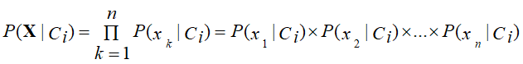

The classification is conducted by deriving the maximum posterior which is the maximal P(Ci|**X**) with the above assumption applying to Bayes theorem. This assumption greatly reduces the computational cost by only counting the class distribution. Even though the assumption is not valid in most cases since the attributes are dependent, surprisingly Naive Bayes has able to perform impressively.

**3.2. Logistic Regression**

Logistic regression is named for the function used at the core of the method, the logistic function.

The logistic function, also called the sigmoid function was developed by statisticians to describe properties of population growth in ecology, rising quickly and maxing out at the carrying capacity of the environment. It’s an S-shaped curve that can take any real-valued number and map it into a value between 0 and 1, but never exactly at those limits.

1 / (1 + e^-value)

Input values (x) are combined linearly using weights or coefficient values (referred to as the Greek capital letter Beta) to predict an output value (y). A key difference from linear regression is that the output value being modelled is a binary value (0 or 1) rather than a numeric value.

Below is an example logistic regression equation:

y = e^ (b0 + b1*x) / (1 + e^ (b0 + b1*x))

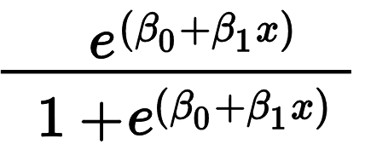

**3.3. Support Vector Machine (SVM)**

Support Vector Machine or SVM is one of the most popular Supervised Learning algorithms, which is used for Classification as well as Regression problems. However, primarily, it is used for Classification problems in Machine Learning.

The goal of the SVM algorithm is to create the best line or decision boundary that can segregate n-dimensional space into classes so that we can easily put the new data point in the correct category in the future. This best decision boundary is called a hyperplane.

SVM chooses the extreme points/vectors that help in creating the hyperplane. These extreme cases are called as support vectors, and hence algorithm is termed as Support Vector Machine.

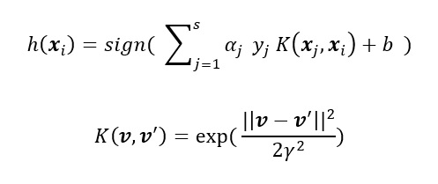

**3.4. Decision Tree Learning**

Decision Trees are a type of Supervised Machine Learning (that is you explain what the input is and what the corresponding output is in the training data) where the data is continuously split according to a certain parameter. The tree can be explained by two entities, namely decision nodes and leaves. The leaves are the decisions or the final outcomes. And the decision nodes are where the data is split.

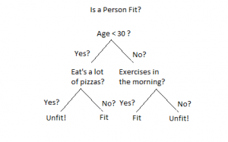

**3.5. Random Forest**

Random forest (RF) is an advanced form of decision trees (DT) which is also a supervised learning model. RF consists of large number of decision trees working individually to predict an outcome of a class where the final prediction is based on a class that received majority votes. The error rate is low in random forest as compared to other models, due to low correlation among trees. Our random forest model was trained using different parameters; i.e., different numbers of estimators were used in a grid search to produce the best model that can predict the outcome with high accuracy. There are multiple algorithms to decide a split in a decision tree based on the problem of regression or classification. For the classification problem, we have used the Gini index as a cost function to estimate a split in the dataset.

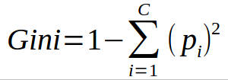

**3.3. Datasets**

The datasets used in this study are open source and freely available online. The data includes both fake and truthful news articles from multiple domains. The truthful news articles published contain true description of real-world events, while the fake news websites contain claims that are not aligned with facts. I have used different datasets in this study. A combined dataset is the collection of articles from the datasets (hereafter referred to as True and Fake). These 2 final Datasets are combined into one large final dataset referred as data.

**3.4. Performance Metrics**

To evaluate the performance of the algorithms, I used confusion matrix. Confusion matrix is a tabular representation of a classification model performance on the test set, which consists of four parameters: true positive, false positive, true negative, and false negative.

**Implementation**

**Data Preproccessing**

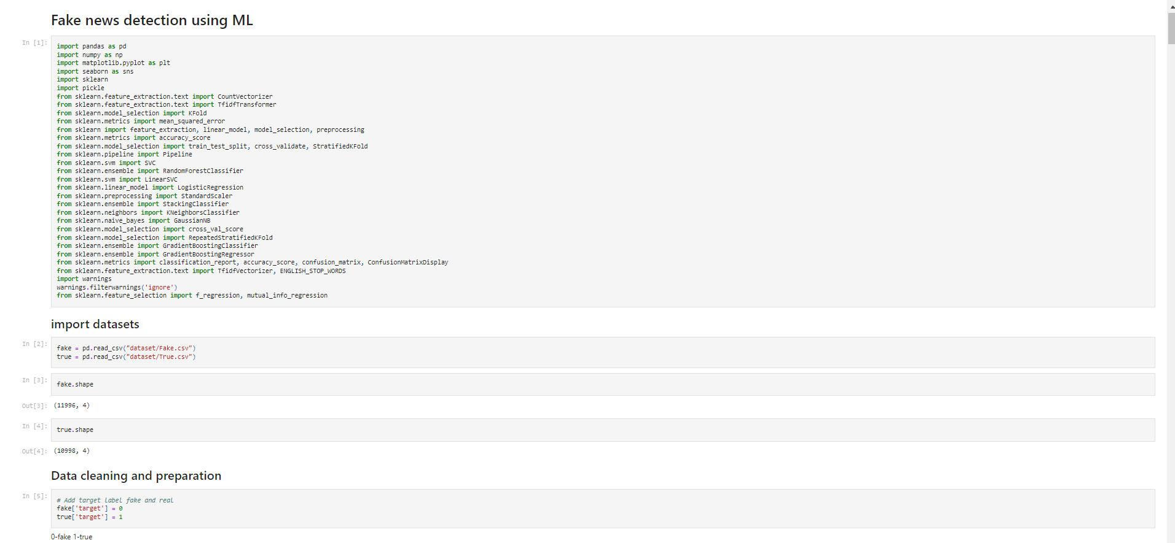

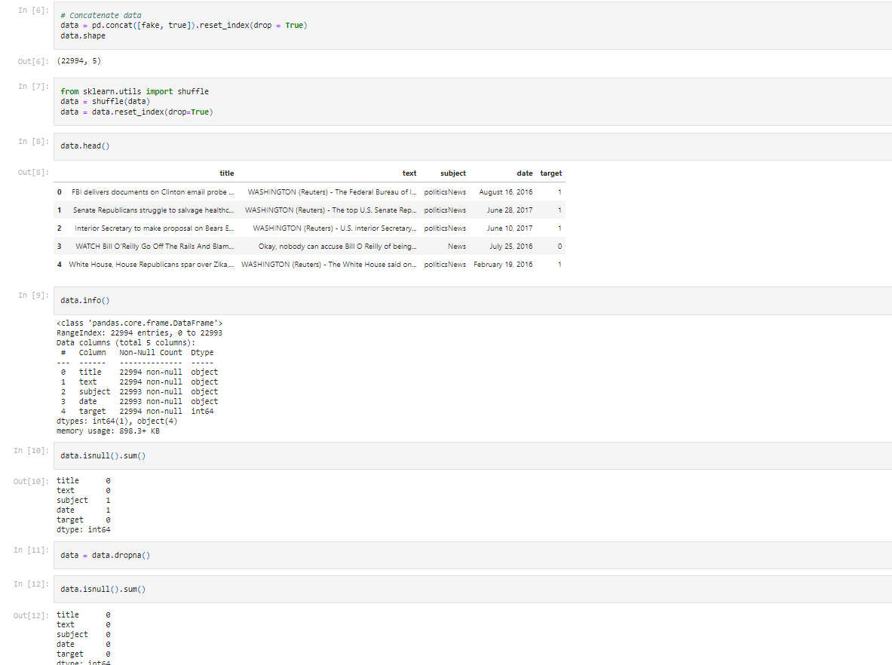

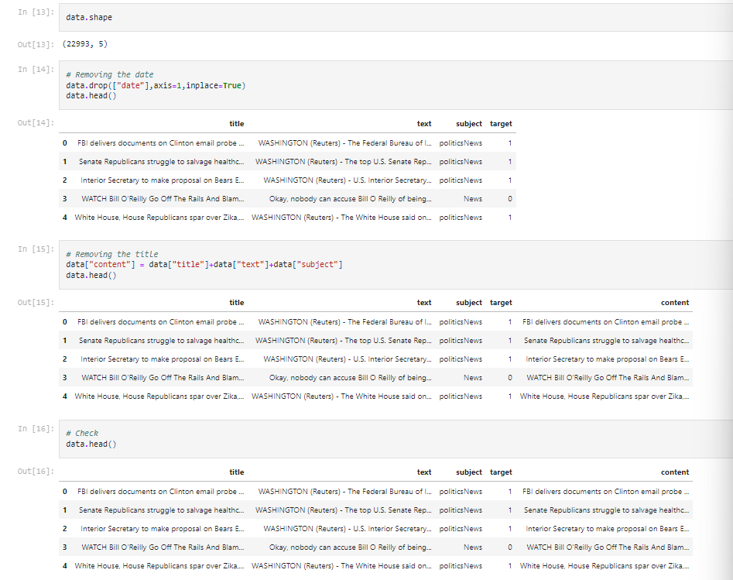

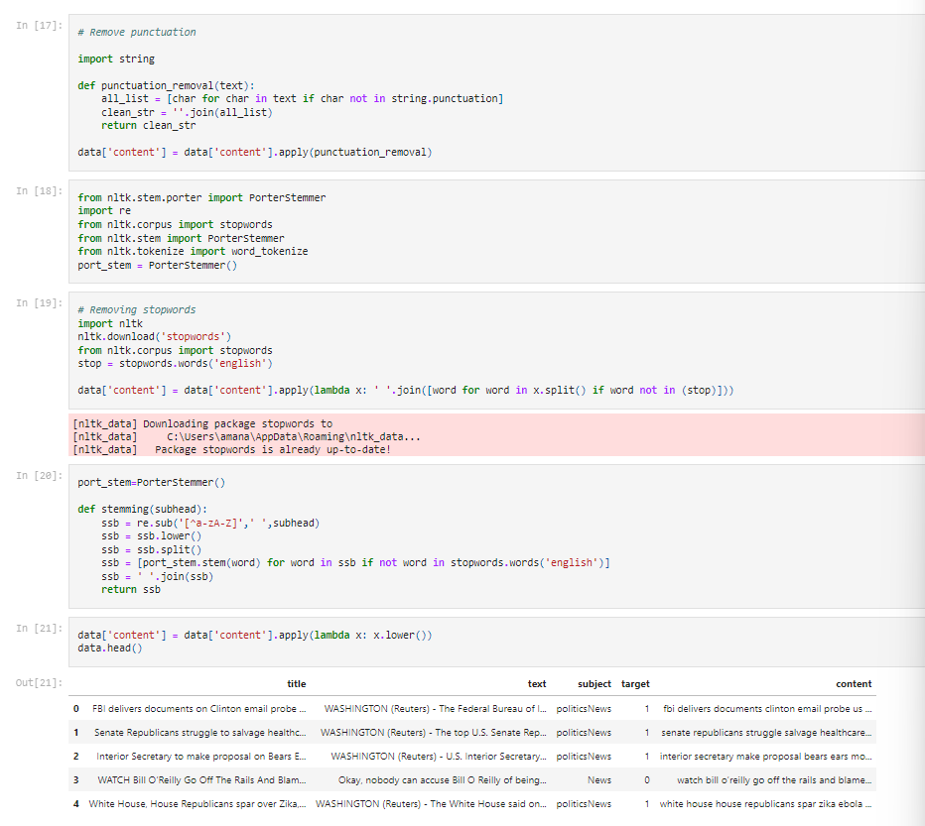

**Data Exploration**

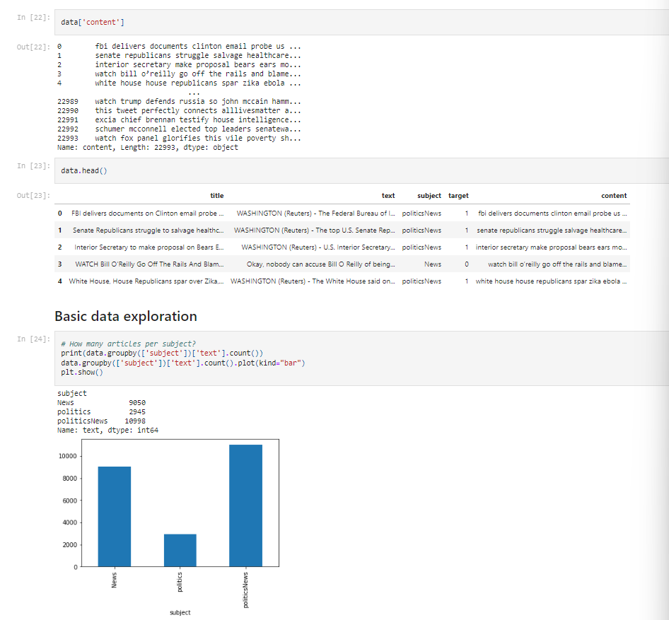

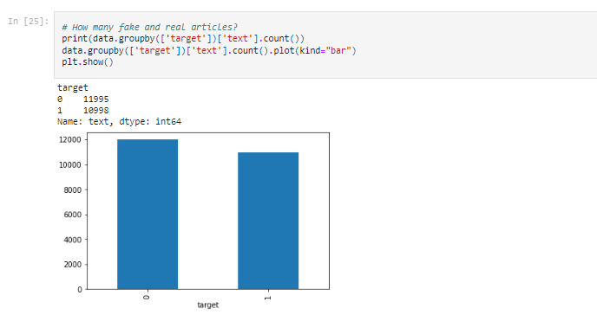

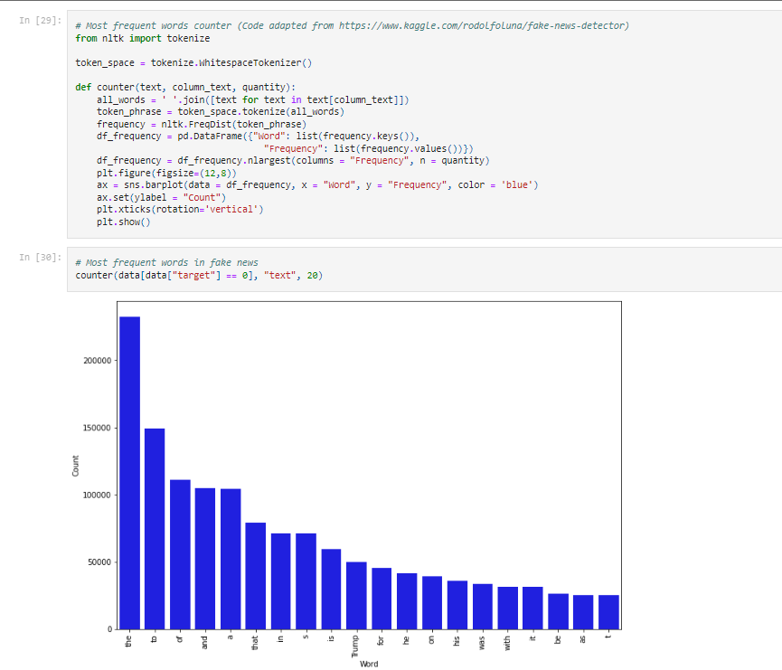

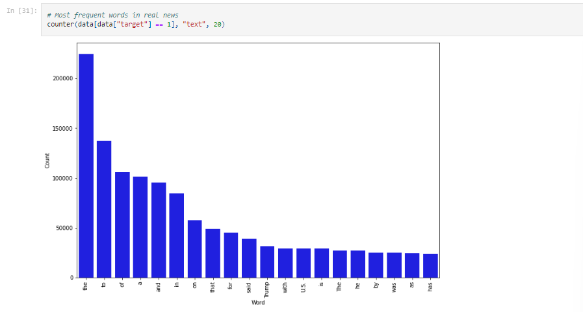

**Modeling**

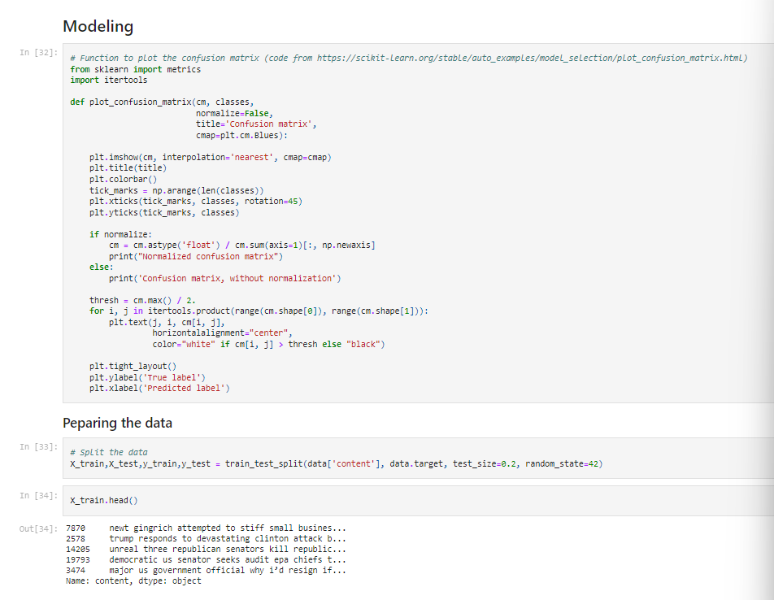

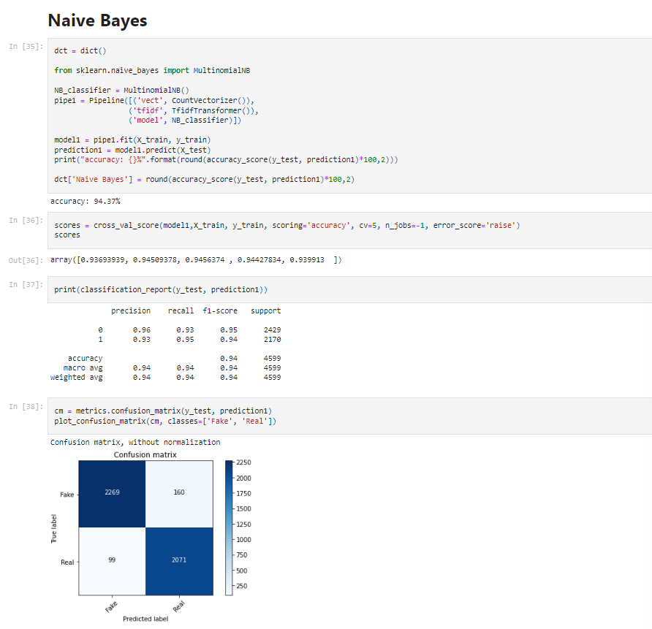

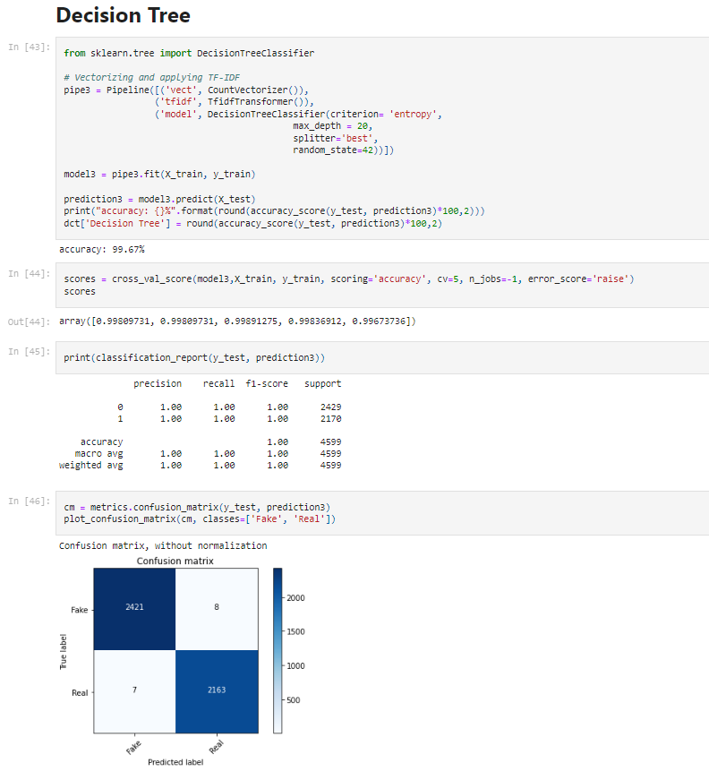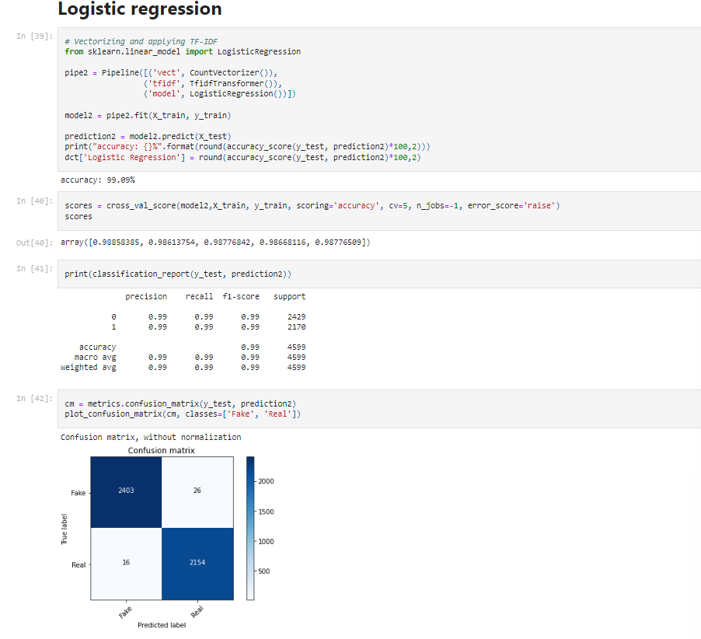

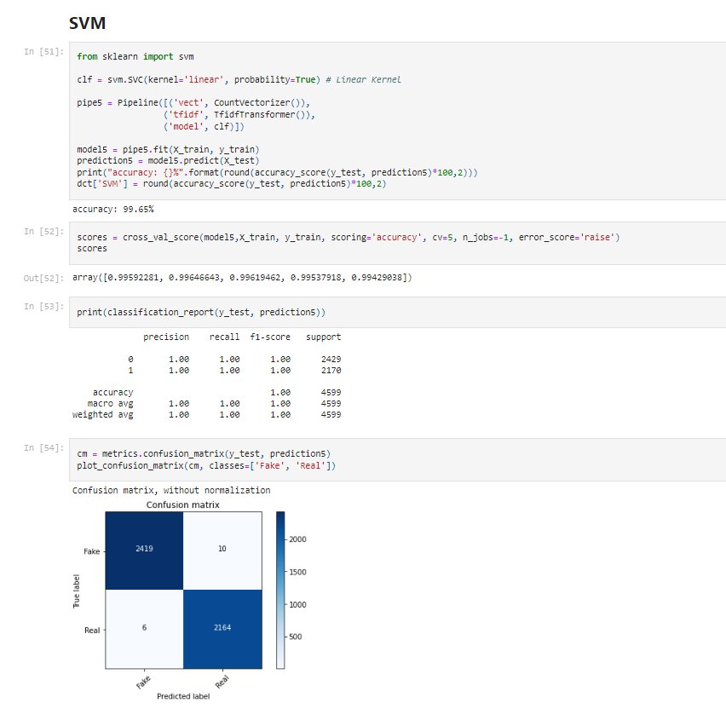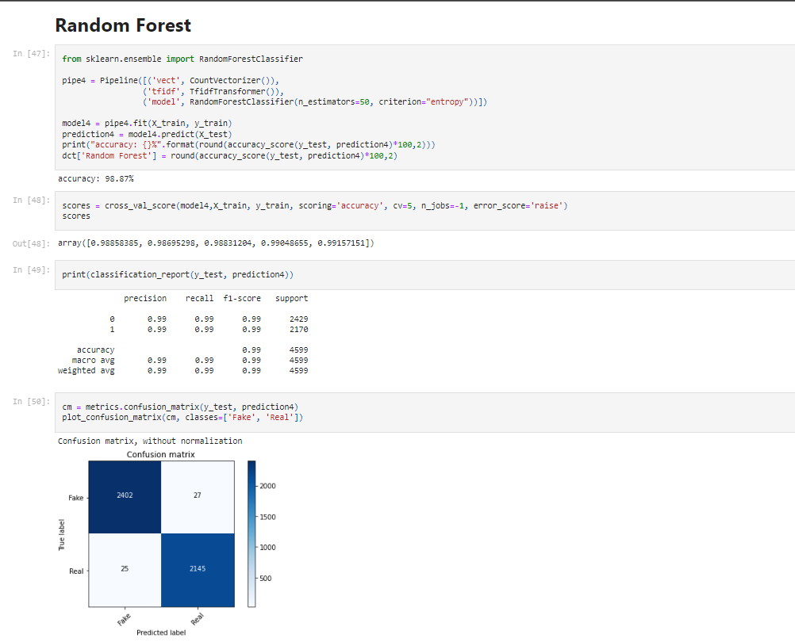

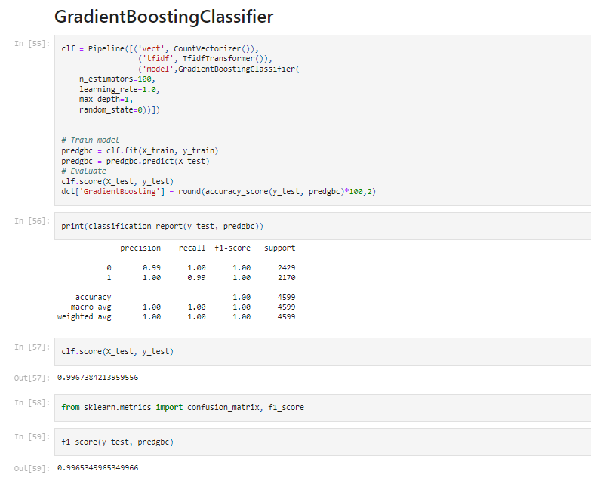

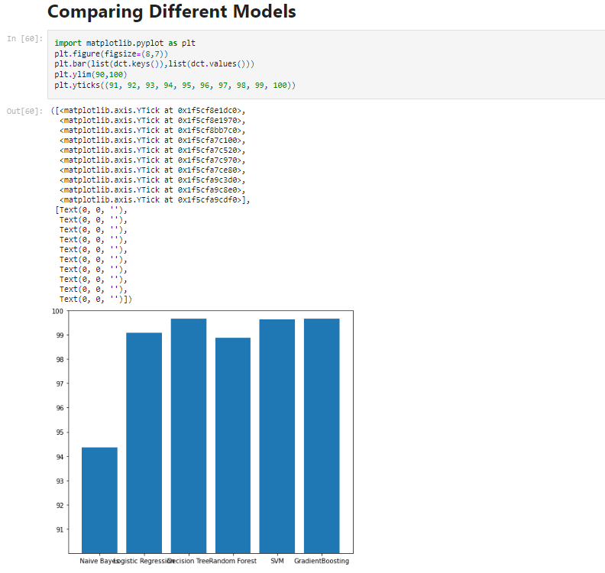

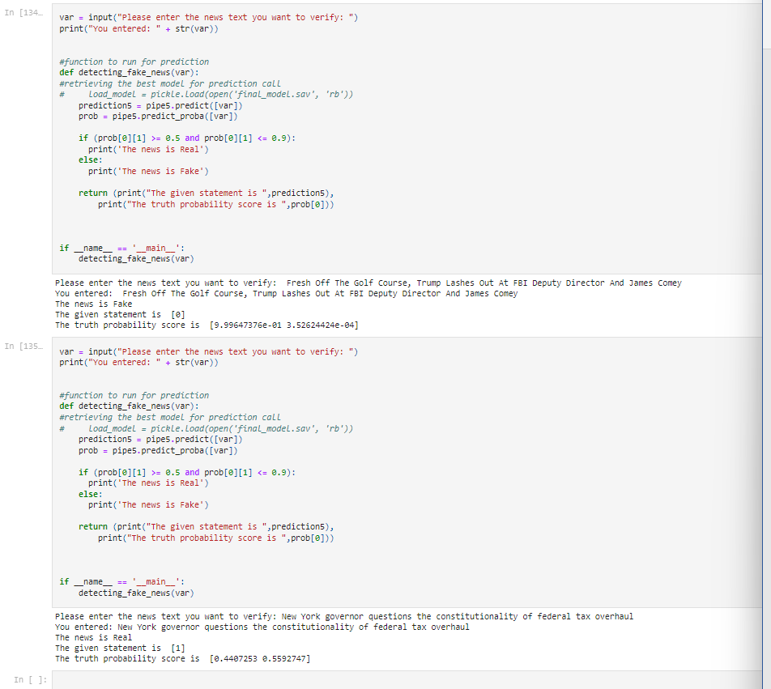

**RESULT ANALYSIS ON PRESENT INVESTIGATION**

**4.1. RESULTS**

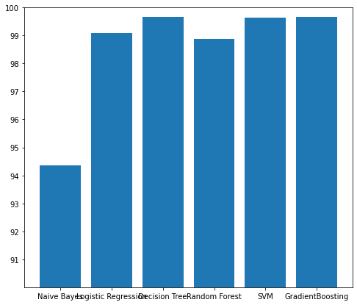

Above graph summarizes the accuracy achieved by each algorithm on the final dataset. It is evident that the maximum accuracy achieved on Decision Tree which is 99.73%.The next highest accuracy is achieved on Gradient Boosting which is 99.67%. The next highest accuracy is achieved on Support Vector Machine (SVM) which is 99.52%. The next highest accuracy is achieved on Random Forest of 99.22%. The next highest accuracy is achieved on Logistic Regression which is 98.91%. The least accuracy is achieved on Naïve Bayes which is 94.37%. Below Table Represents the name of the classifier and accuracy achieved by classifier.

|  |  |
| --- | --- |
| **CLASSIFIER** | **ACCURACY** |
| **Naïve Bayes** | **94.37%** |
| **Support Vector Machine (SVM)** | **99.65%** |
| **Random Forest** | **98.87%** |
| **Logistic Regression** | **99.09%** |
| **Decision Tree** | **99.67%** |

**4.2. Confusion Matrix**

**4.2.1. Naïve Bayes**

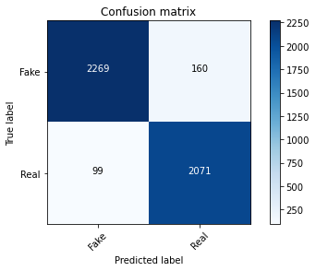

**4.2.2. Logistic Regression**

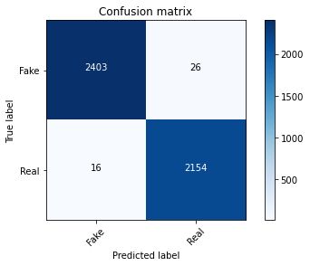

**4.2.3. Decision Tree**

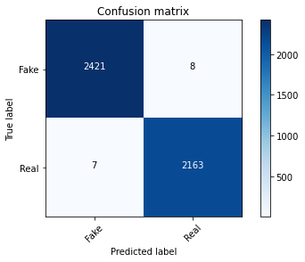

**4.2.4. Random Forest**

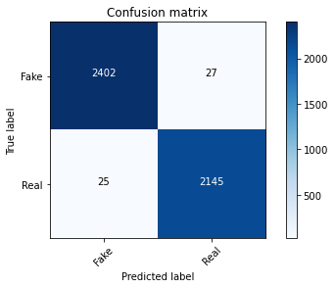

**4.2.5. Support Vector Machine (SVM)**

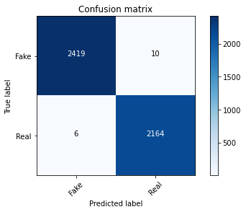

**CONCLUSION**

The task of classifying news manually requires in-depth knowledge of the domain and expertise to identify anomalies in the text. In this research, we discussed the problem of classifying fake news articles using machine learning models and ensemble techniques. The data we used in our work is collected from the KAGGLE and contains news articles from various domains to cover most of the news rather than specifically classifying political news. The primary aim of the research is to identify patterns in text that differentiate fake articles from true news.

The learning models were trained and parameter-tuned to obtain optimal accuracy. Some models have achieved comparatively higher accuracy than others. We used multiple performance metrics to compare the results for each algorithm. The ensemble learners have shown an overall better score on all performance metrics as compared to the individual learners.

Fake news detection has many open issues that require attention of researchers. For instance, in order to reduce the spread of fake news, identifying key elements involved in the spread of news is an important step. Graph theory and machine learning techniques can be employed to identify the key sources involved in spread of fake news. Likewise, real time fake news identification in videos can be another possible future direction.

Finally, this application is only one that would be necessary in a larger toolbox that could function as a highly accurate fake news classifier. Other tools that would need to be built may include a fact detector and a stance detector. In order to combine all of these “routines,” there would need to be some type of model that combines all of the tools and learns how to weight each of them in its final decision.

**APPENDIX A: IMAGES FROM THE PROJECT**

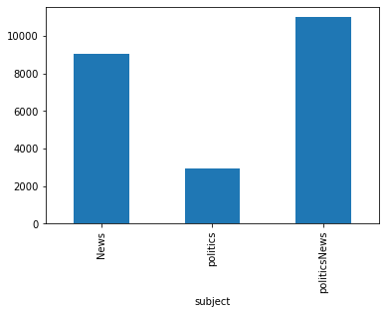 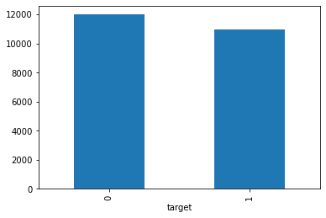

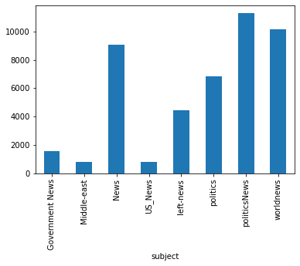

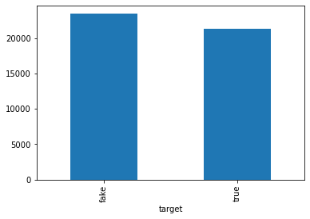

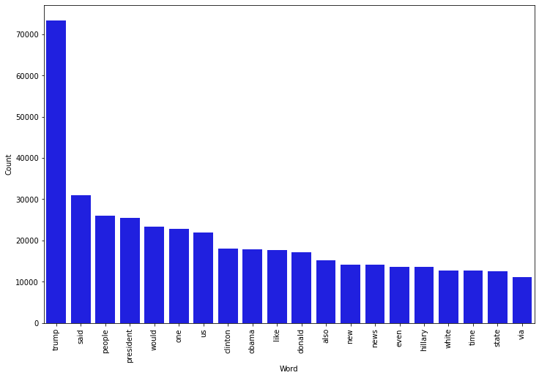

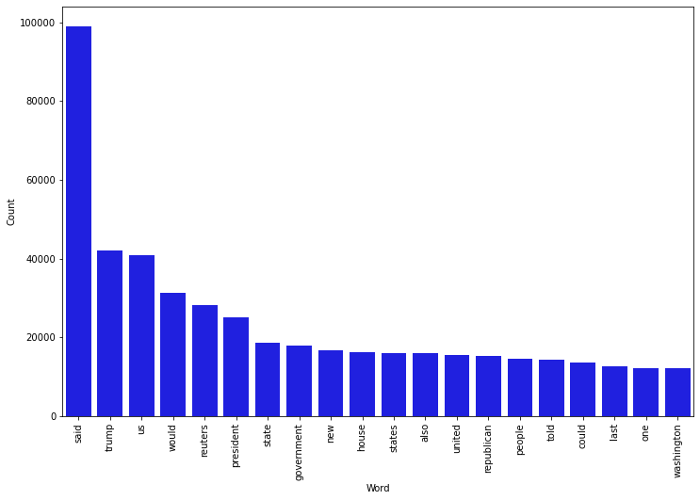

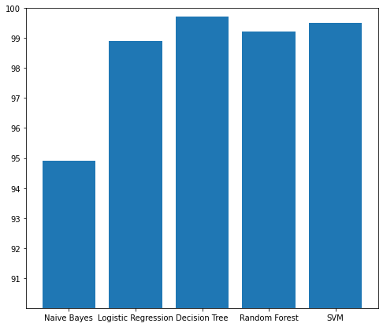

**REFERENCES**

[1] M. Risdal. (2016, Nov) Getting real about fake news. [Online]. Available: https://www.kaggle.com/

mrisdal/fake-news

[2] J. Soll, T. Rosenstiel, A. D. Miller, R. Sokolsky, and J. Shafer. (2016, Dec) The long and

brutal history of fake news. [Online]. Available: https://www.politico.com/magazine/story/2016/12/

fake-news-history-long-violent-214535

[3] C. Wardle. (2017, May) Fake news. it’s complicated. [Online]. Available: https://firstdraftnews.com/

fake-news-complicated/

[4] T. Ahmad, H. Akhtar, A. Chopra, and M. Waris Akhtar, “Satire detection from web documents using

machine learning methods,” pp. 102–105, 09 2014.

[5] C. Kang and A. Goldman. (2016, Dec) In washington pizzeria attack, fake news

brought real guns. [Online]. Available: https://www.nytimes.com/2016/12/05/business/media/

comet-ping-pong-pizza-shooting-fake-news-consequences.html

[6] C. Domonoske. (2016, Nov) Students have ’dismaying’ inability to tell fake news from real,

study finds. [Online]. Available: https://www.npr.org/sections/thetwo-way/2016/11/23/503129818/

study-finds-students-have-dismaying-inability-to-tell-fake-news-from-real

[7] M. T. Banday and T. R. Jan, “Effectiveness and limitations of statistical spam filters,” arXiv preprint

arXiv:0910.2540, 2009.

[8] S. Sedhai and A. Sun, “Semi-supervised spam detection in twitter stream,” arXiv preprint

arXiv:1702.01032, 2017.

[9] A. Bhowmick and S. M. Hazarika, “Machine learning for e-mail spam filtering: Review, techniques

and trends,” arXiv preprint arXiv:1606.01042, 2016.

[10] Fake news challenge stage 1 (fnc-i): Stance detection. [Online]. Available: http://www.

fakenewschallenge.org/

[11] W. Y. Wang, “” liar, liar pants on fire”: A new benchmark dataset for fake news detection,” arXiv preprint arXiv:1705.00648, 2017.

[12] Y. Genes, “Detecting fake news with nlp,” May 2017. [Online]. Available: https://medium.com/

[13] Vernica Prez-Rosas, Bennett Kleinberg, Alexandra Lefevre, and Rada Mihalcea. Automatic detection of fake news.

[14] James W Pennebaker, Martha E Francis, and Roger J Booth. Linguistic inquiry

and word count: Liwc 2001. Mahway: Lawrence Erlbaum Associates, 71(2001):2001,

2001.

[15] Natali Ruchansky, Sungyong Seo, and Yan Liu. Csi: A hybrid deep model for fake

news detection. In Proceedings of the 2017 ACM on Conference on Information and

Knowledge Management, pages 797–806. ACM, 2017.

[16] Eugenio Tacchini, Gabriele Ballarin, Marco L. Della Vedova, Stefano Moret, and Luca

de Alfaro. Some like it hoax: Automated fake news detection in social networks.

[17] James Thorne, Mingjie Chen, Giorgos Myrianthous, Jiashu Pu, Xiaoxuan Wang, and

Andreas Vlachos. Fake news stance detection using stacked ensemble of classifiers.

In Proceedings of the 2017 EMNLP Workshop: Natural Language Processing meets

Journalism, pages 80–83, 2017.