
School of Computer Science and Engineering
J Component Report (Project Paper)

Programme : M. TECH (INTEGRATED) in CSE WITH SPECIALIZATION IN BUSINESS ANALYTIC
Course Title : INFORMATION VISUALIZATION
Course Code : CSE3121
Slot : D2

Title: INDEX DATA OF STOCK MARKET

Team Members: Aman Kumar | 20MIA1144
Garrepally Sai Charan | 20MIA1056
Vishwa Kirthik | 20MIA1165

Faculty: Dr. Arun Kumar Sivaraman Sign:
Date:



Acknowledgement

I obliged to give my appreciation to a number of people without whom I could not have completed this thesis successfully.

I would like to place on record my deep sense of gratitude and thanks to my internal guide Prof. Dr. Arun Kumar Sivaraman, School of Computer Science and Engineering (SCOPE), Vellore Institute of Technology, Chennai, whose esteemed support and immense guidance encouraged me to complete the project successfully.

I would like to thank our HoD Dr. Renta Chintala Bhargavi, School of Computer Science and Engineering (SCOPE) and Project Coordinator Dr. Rabindra Kumar Singh, Vellore Institute of Technology, Chennai, for their valuable support and encouragement to take up and complete this thesis.

Special mention to our Dean Dr. Ganesan R, Associate Dean Dr. S. Geetha, School of Computer Science and Engineering (SCOPE), Vellore Institute of Technology, Chennai, for motivating us in every aspect of software engineering.

I thank our management of Vellore Institute of Technology, Chennai, for permitting me to use the library and laboratory resources. I also thank all the faculty members for giving me the courage and the strength that I needed to complete my goal. This acknowledgment would be incomplete without expressing the whole hearted thanks to my family and friends who motivated me during the course of my work.



Abstract

Without a doubt, stock markets are an important and necessary part of any country's economy. However, the impact of stock markets on a country's economy may differ from the impact of stock markets on other countries' economies. This is due to the impact of stock markets on the economy being determined by several factors, including the organization of stock exchanges, its relationship with other financial system components, and the country's governance system, for example. All these variables are unique to each country. As a result, the impact of stock markets on the economy of a country is distinct. The Indian capital market system has undergone major fundamental institutional changes over the years, resulting in lower transaction costs, increased efficiency, transparency, and safety. All these changes have resulted in the economy's development through stock markets. Therefore, high demand for stock market development is expected. The current paper and visual technology will help to predict the future stock prices based on previous stock data and analyse the stock data. And we are going to help others to understand and easily invest in the stock market with the help of our visualization and it can also help them to predict the data with the data visualization done by Tableau and python.
Project Title v

Contents

Declaration…………………………………………………………………i
Certificate …………………………………………………………………ii
Acknowledgement ………………………………………………………iii
Abstract ……………………………………………………………………iv

Introduction
Index value
Rules and Regulations
Literature Review
Proposed Model
Planning & Requirements
System Design
Implementation of the system
Materials & Methods
Methodology
List of charts (Tableau)
Results & Discussion
Conclusion
References

Introduction

Financial markets are one of our century's most interesting innovations. They have had a substantial impact on a variety of fields, including business, education, employment, technology, and the economy. Investors and academics have been interested in constructing and testing stock price models for a long time. However, due to the markets' dynamic, nonlinear, nonstationary, nonparametric, noisy, and chaotic nature, analyzing stock market movements and price behavior is particularly difficult. Many interconnected factors influence stock markets, including economic, political, psychological, and company-specific elements. The two basic ways to analyze financial markets are technical and fundamental analysis. Investors have used these two basic ways to make decisions to invest in stocks and obtain large rewards with little risks.
Fundamental analysis is composed of three components:
1.Macroeconomic analysis, such as Gross Domestic Product (GDP) and Consumer Price Index (CPI), which examines the impact of the macroeconomic environment on a company's future profit,
2.Industry analysis, which estimates a company's value based on industry status and prospects.
3.Company analysis, which examines a company's current operation and financial status to determine its internal value.
Stock-A is compared to other stocks in the same category using the average growth approximation technique to better understand valuations. For example, if two firms have the same growth rate, the one with the lower Price-to-Earnings (P/E) ratio is better. As a result, the fair price is equal to the earnings multiplied by the target P/E. In the stock brokerage sector, the P/E approach is the most often utilized valuation tool. One of the most well-known groups of dividend discount models is the constant growth approximation technique, such as Gordon's growth model.
Stock market price forecasting is a challenging task. Over the years, several stock market theories have been proposed. They either attempt to explain the nature of stock markets or whether they can be beaten. The Efficient Market Hypothesis (EMH), which asserts that the stock is appropriately valued until something changes, is one such prominent and hotly discussed theory.
There are three variants of EMH
1.The weak form, which is consistent with the random walk hypothesis, which states that stock prices move randomly and that price changes are independent of one another, implying that it is impossible to outperform the market using technical analysis.
2.The semi-strong form, which asserts that prices adjust quickly in response to market and public information such as dividends, earnings releases, and political or economic developments, making abnormal returns impossible to achieve through fundamental analysis.
3.The strong form, which argues that prices represent market, public, and private information, implying that no investor has monopolistic information access.
What is Index?
• Index is a tool that measures change
• Example: Human Development Index measures the development of a country.

What is the Stock Index?
• There are more than 7400 companies listed in both NSE (National Stock Exchange) and BSE (Bombay Stock Exchange). So, to track every company is a challenging task.
• To address this issue, the Stock Index was created.
• Stock Index, as the name implies, refers to changes in stock prices.

How is the Stock Index measured?
• Instead of calculating stock prices of every company they use the top 30 or top 50 companies' stock prices and see how the prices are changing whether they are increasing or decreasing.
• In India, Sensex (a stock market index) is made up of the top 30 stocks on BSE called Sensex30. Nifty (a stock market index) is made up of the top 50 stocks on NSE called Nifty50.
• The selection of these top 30 or top 50 companies will be based on many ways like market capitalization, sector etc... Both the BSE and the NSE utilize market capitalization as a benchmark.
• Market Capitalization = (Stock price) * (Total number of stocks).

Index value:
• Index Value = [(Free float market cap of grouped stocks/Base market cap)* Base index value]
• Free float market capitalization takes only the number of stocks which are publicly available for trade. • Base market capitalization is the total market value of stocks that were formed when Sensex was initially formed
• Base index value for Sensex is 100.
• Base index value for Nifty is 1000.
• So as the Sensex rises then the value of most of the stocks will increase.

U.S. Stock Market Indexes:
• In the United States the S&P 500, Dow Jones Industrial Average, and Nasdaq Composite are the three most broadly followed indexes by both the media and investors. There are more than 5000 other Stock Indexes used in USA.

S&P 500 (Standard & Poor’s 500):
• The Standard & Poor's 500 Index (known commonly as the S&P 500) is an index with 500 of the top companies in the U.S. Stocks are chosen for the index primarily by capitalization
• constituent committee also considers other factors including liquidity, public float, sector classification, financial viability, and trading history.
• It represents approximately 80% of the total value of the U.S. stock market.
• Indexes are usually market-weighted or price-weighted. The S&P 500 Index is a market-weighted index (also referred to as capitalization-weighted).
• So, if the total market value of all 500 companies in the S&P 500 drops by 10%, the value of the index also drops by 10%.

How S&P 500 works?
The S&P 500 tracks the market capitalization of the companies in its index.
A company that has a market cap of $100 billion receives 10 times the representation as a company whose market cap is $10 billion
A committee selects each of the index's 500 corporations based on their liquidity, size, and industry. It rebalances the index quarterly, in March, June, September, and December.

Rules and Regulations:
To get listed by the S&P 500’s committee the companies need to follow some rules and regulations.
1. A company must be in the United States.
2. The company should have an unadjusted market cap of at least $13.1 billion to qualify for the index.
3. At least 50% of the corporation's stock must be available to the public.
4. Its stock price must be at least $1 per share.
5.It must file a 10-K annual report.
6.At least 50% of its fixed assets and revenues must be in the United States.
7.It must have at least four consecutive quarters of positive earnings.

Literature Review:
Our dataset contains stock prices (High, Low, Volume, Close, Open) of various companies. We selected big tech companies (Apple, Google, Microsoft, Amazon) to analyze and visualize our data. We used many Python packages like Pandes, NumPy, Matplotlib, Seaborn, yfinance to analyze and visualize our data. We loaded our data into Python.
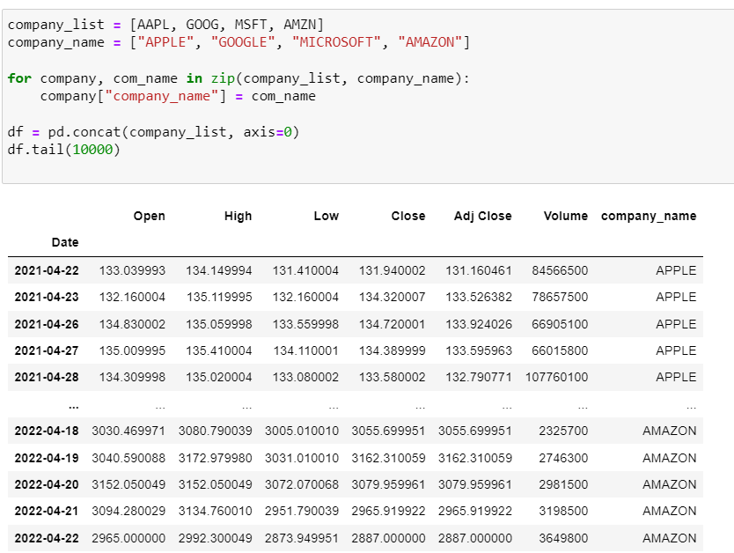
First, we plotted a line graph which tells us about how prices are varying our years of above-mentioned tech companies and then we plotted a graph which will tell us how much volumes of stock are sold over the years.
Then we plotted a graph of moving averages which will clearly tell us about the change in price.
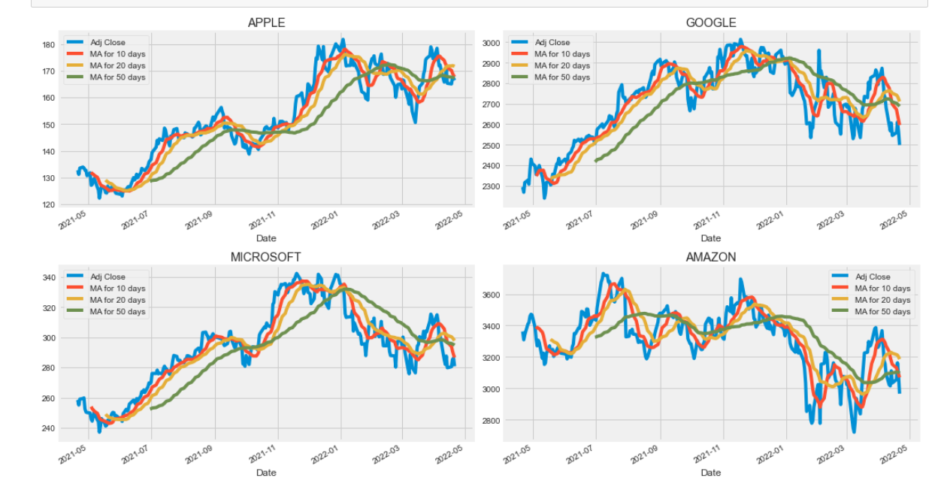We plotted histograms on daily returns of all four stocks.
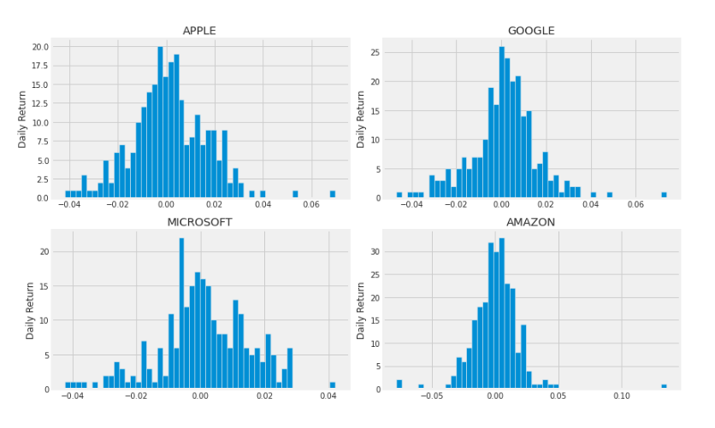
To know the correlation between two companies we plotted scatter plot with trend line, which will tell us the best fit and we can easily say which companies are positively correlated and which companies are negatively correlated.
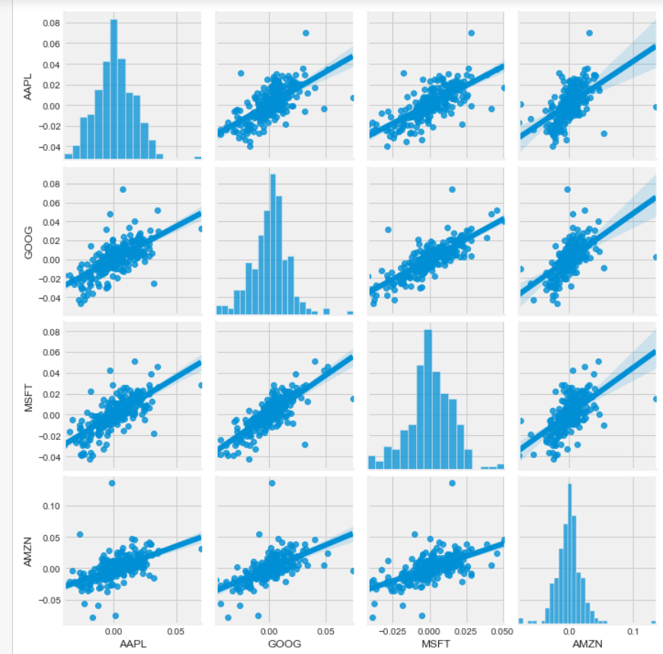
In above graph we can see that Microsoft and Apple are positively correlated.
In the below heat map tell us numerically and visually that Microsoft and Amazon had the strongest correlation of daily stock return. It is also interesting to see that all the technology companies are positively correlated.
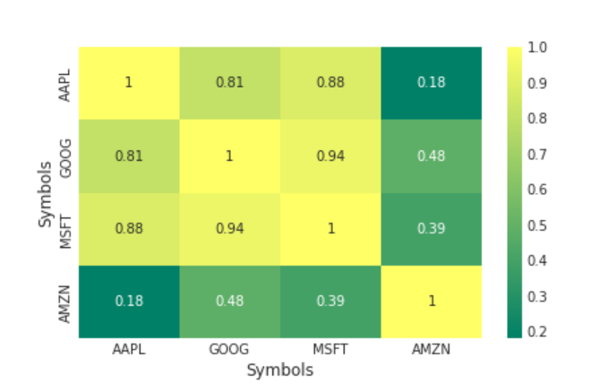
We also plotted a line graph which will tell us about the future predictions.
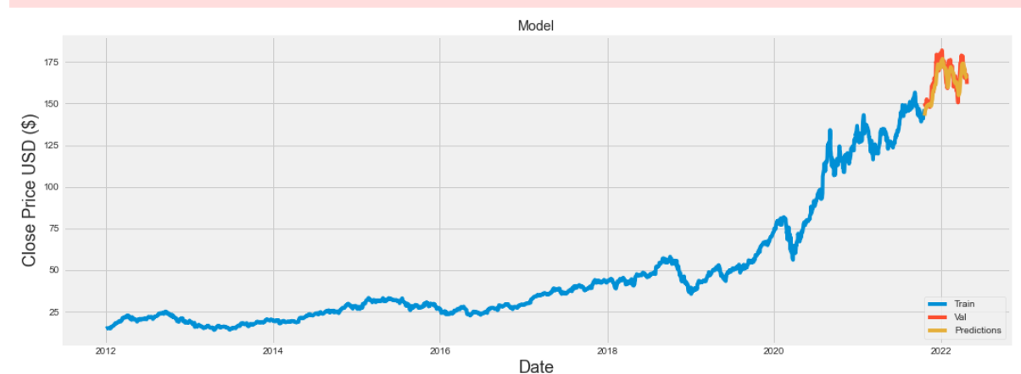

Proposed Model:
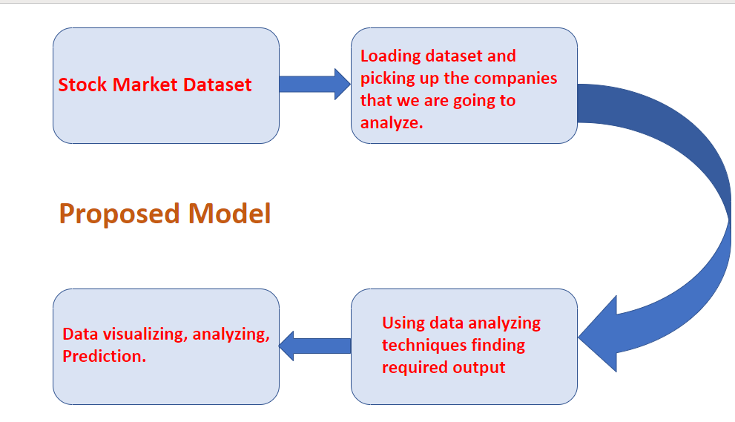

Planning and requirement specification
Stock Market data set and knowledge in python programming and Tableau is required in completing this project. The planning involved acquiring the data set and performing data analysis on the data set to find some information and presenting the information in the form of visualizations. And This dataset is collected data from the stock market daily transaction done by millions of people and it links is: Dataset . So, we are planning to visualise this data by using Tableau and Python code and help others to understand the data and help then to do transaction in Stock market.
System Design
The dataset was first linked in python IDE and Tableau to perform visualization and analysis, and we used Jupyter Notebook for this purpose as the code. After linking the dataset, I started cleaning the data and removed all the null values from the dataset. After that I performed analysis using python and Tableau.

Implementation of the system
After importing the dataset then we can start to do our analysis by plotting graph and summarizing the data. We use Tableau for graph and analysis.
Tableau:
Tableau is a leading data visualization tool used for data analysis and business intelligence. Gartner's Magic Quadrant classified Tableau as a leader for analytics and business intelligence.
Jupyter:
It is a fast, powerful, flexible, and easy to use python IDE to do data analysis and manipulation tool

List of Chart:

This line chart shows increase of stock price over year(2013-2019)
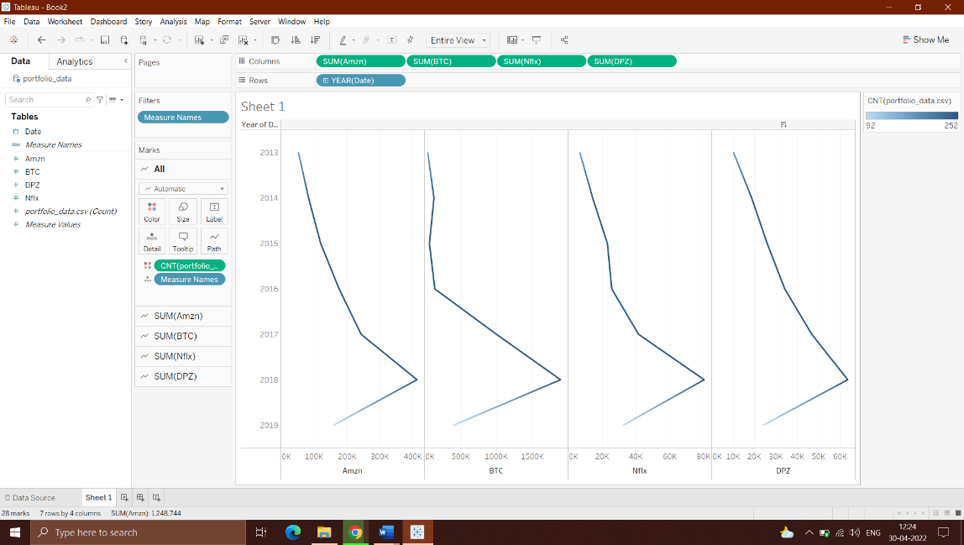

This scatter plot show dividend vs earning of company which show that if company earning in increasing the they are giving more dividend.
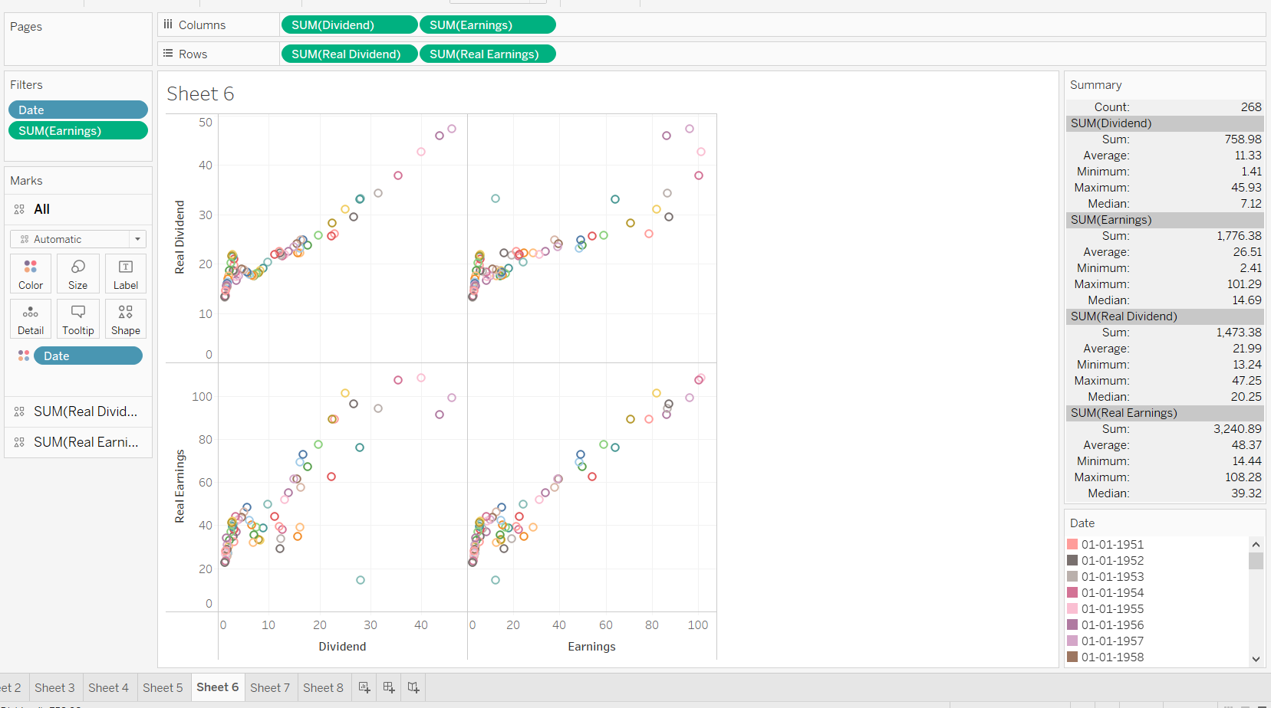
This bar graph shows that company volume
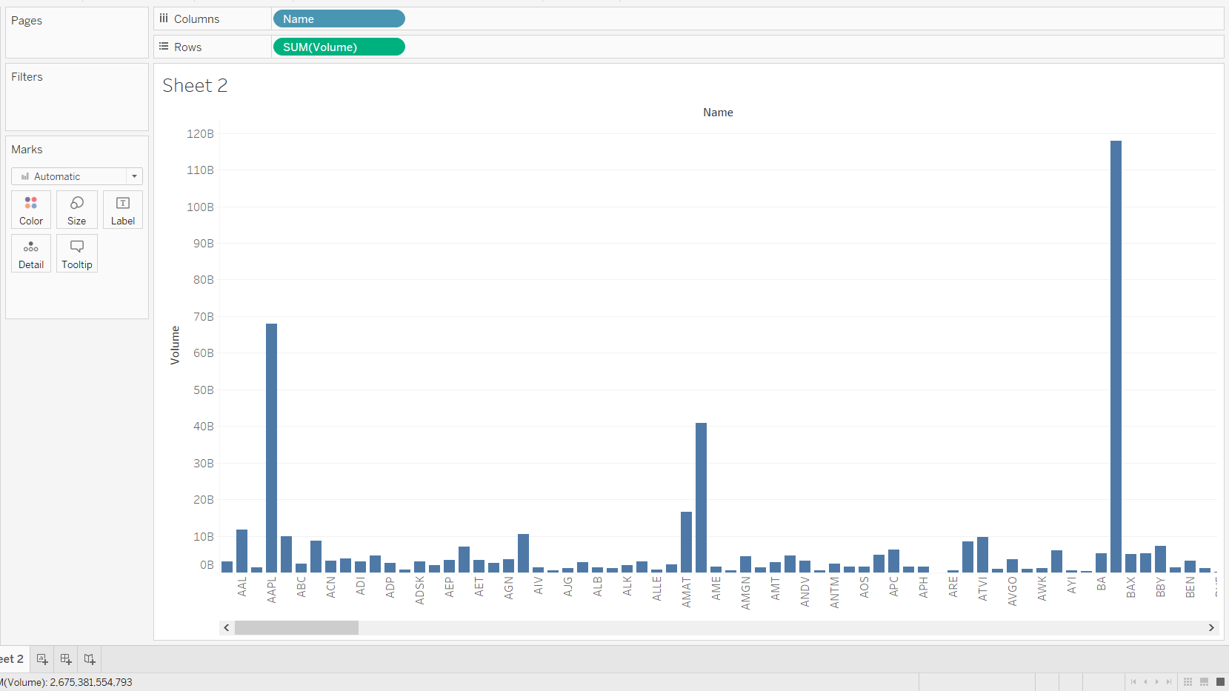

This table shows Apple, Amazon, Google, Microsoft and MSI volume over year
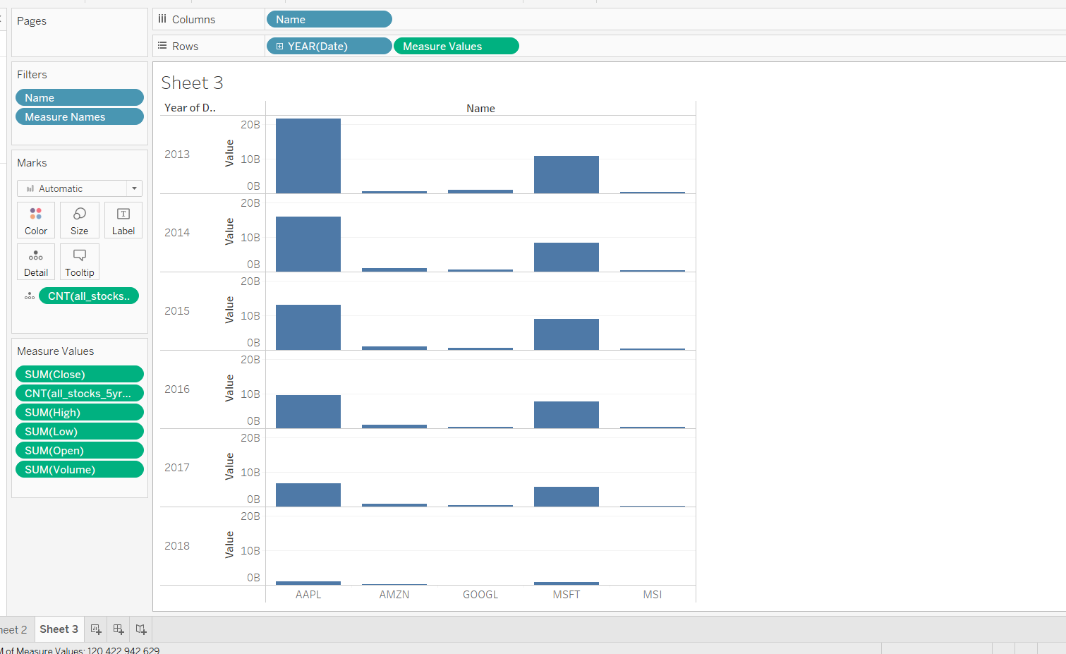

This graph shows which company is doing great and which company is in Top and making high return in investment to investers and help them to filter best company
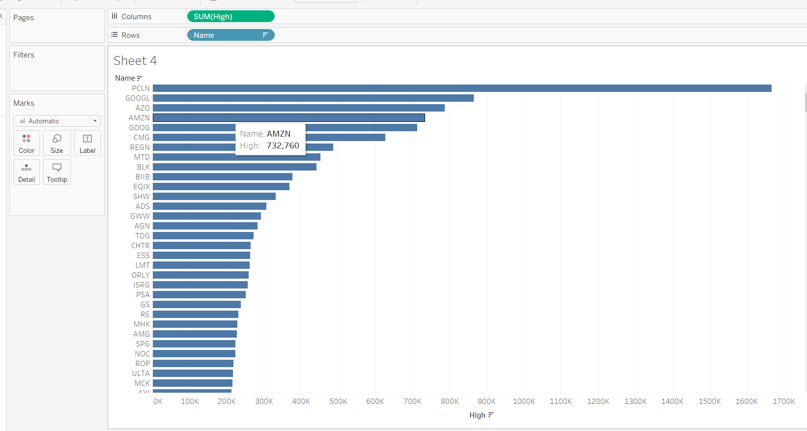

This show regression of stock data to predict relationship between number and predict which company is better.
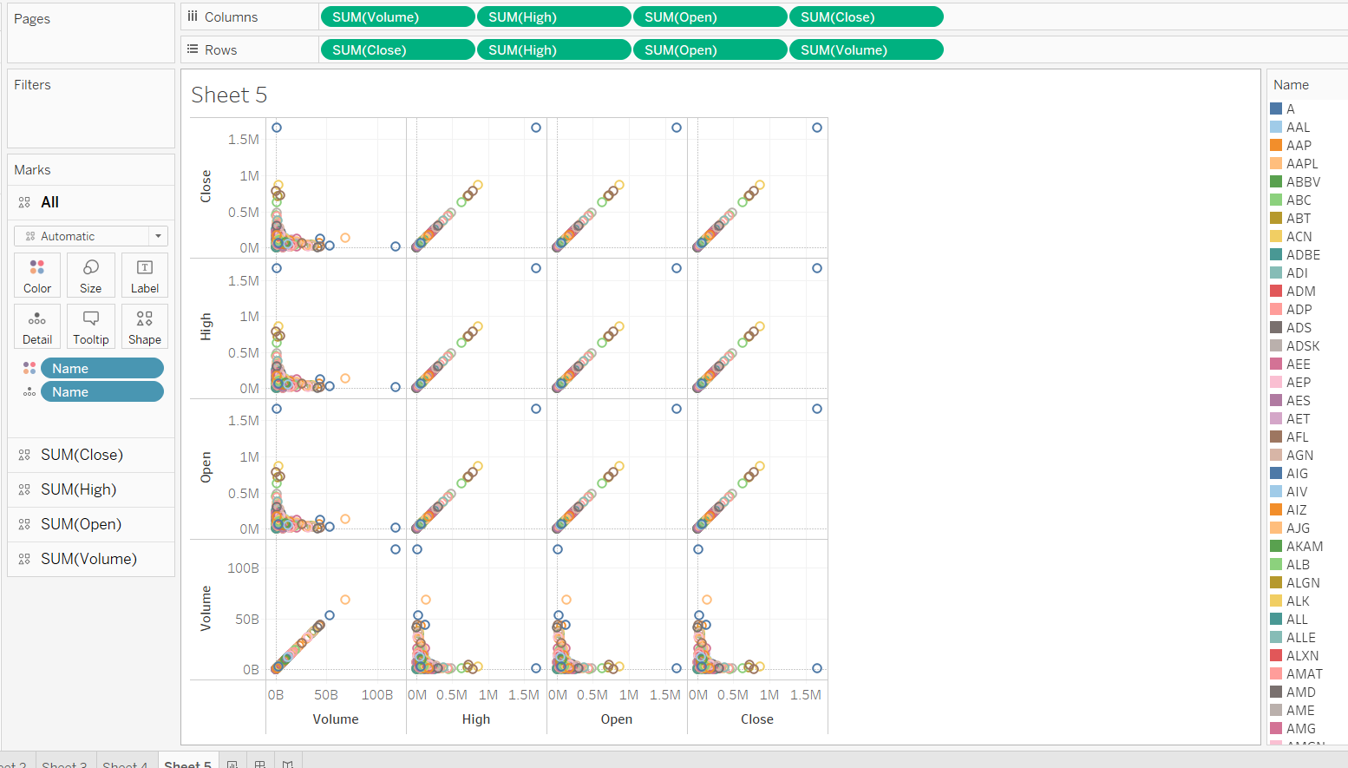
This buble chart shows highest opening compnay with their Details
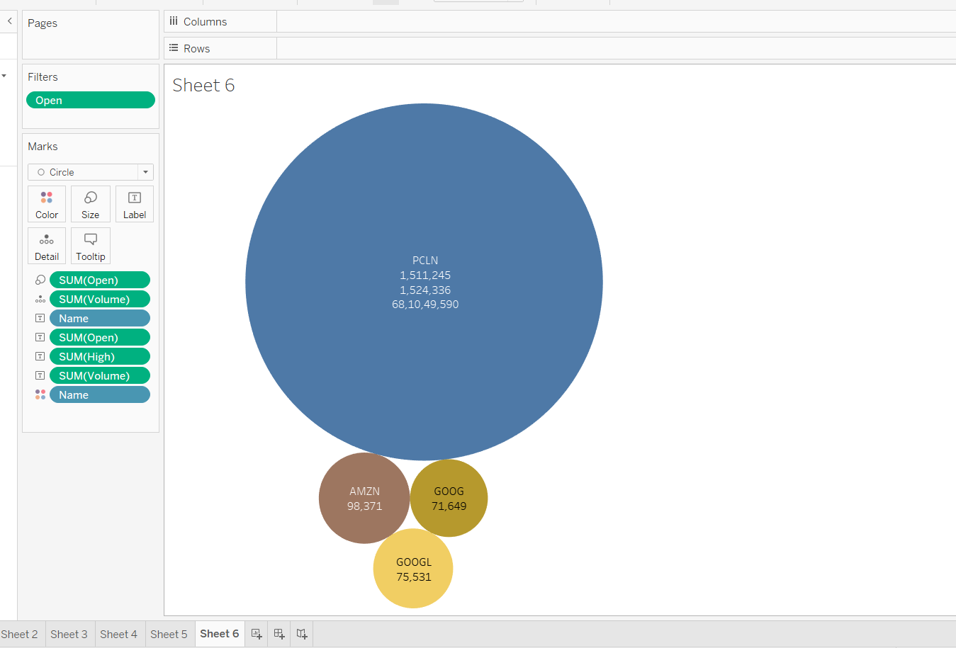

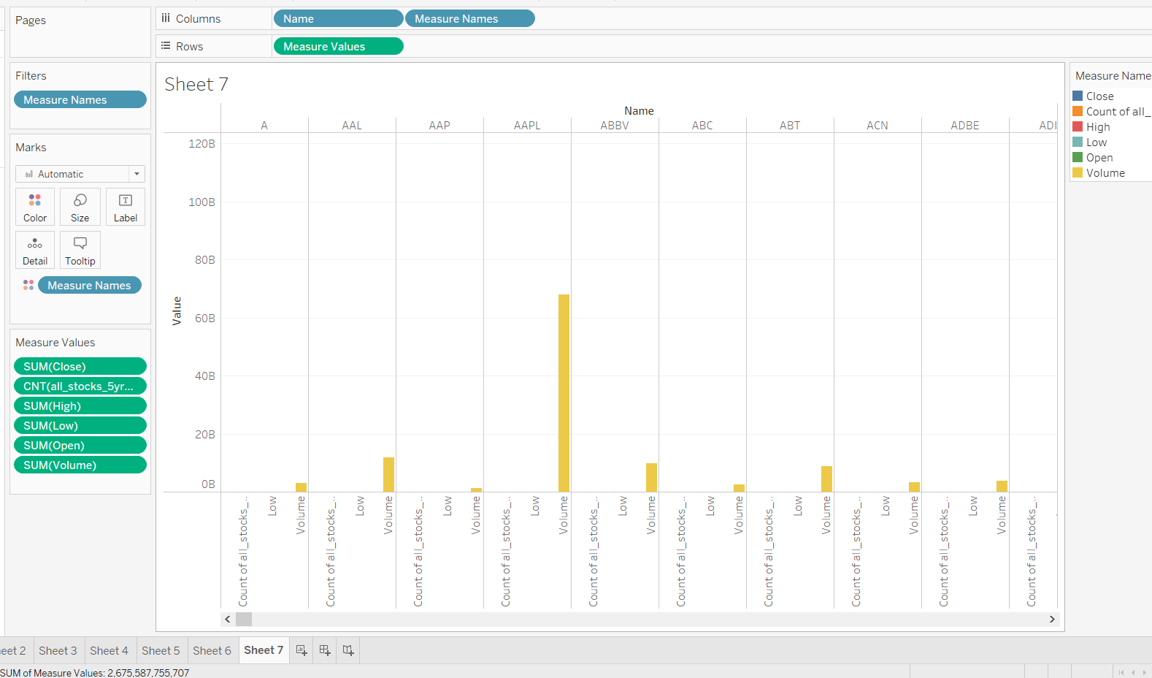
This show higher volume company sometime has low stock price
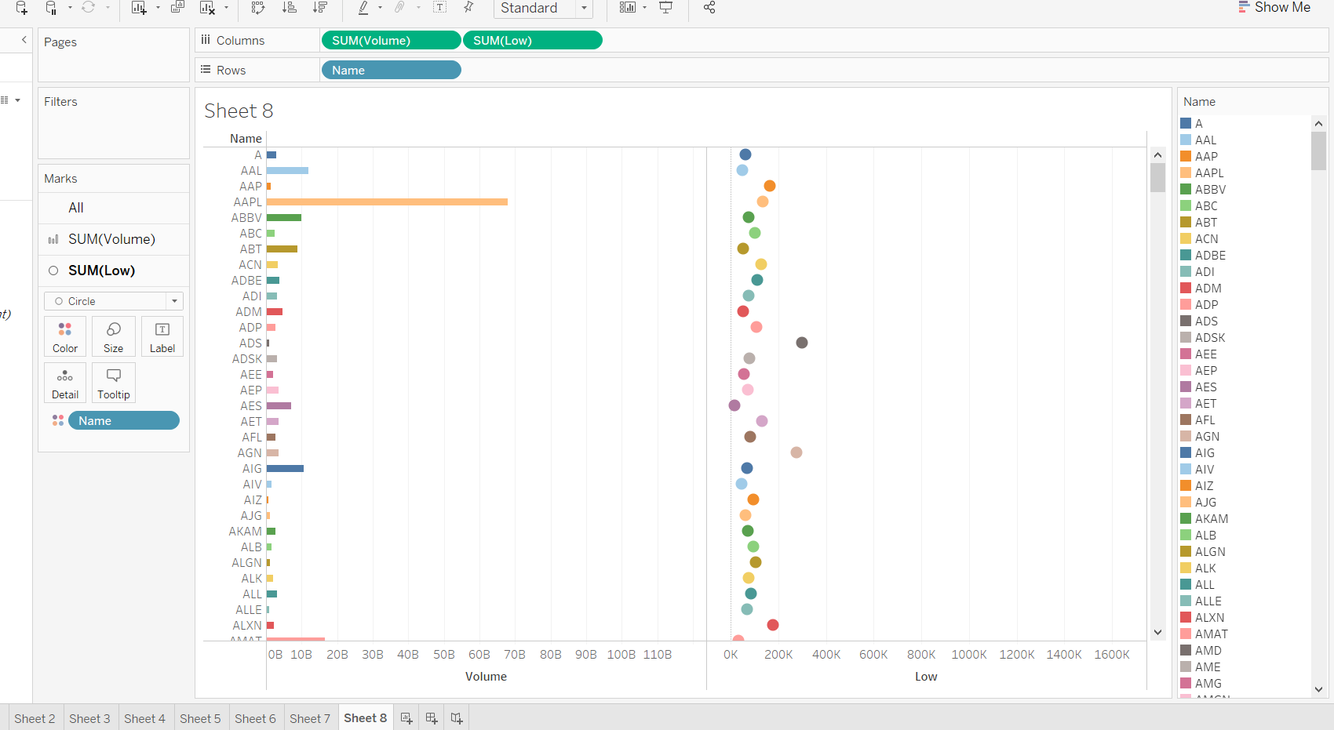

Top few company perfomace over few years
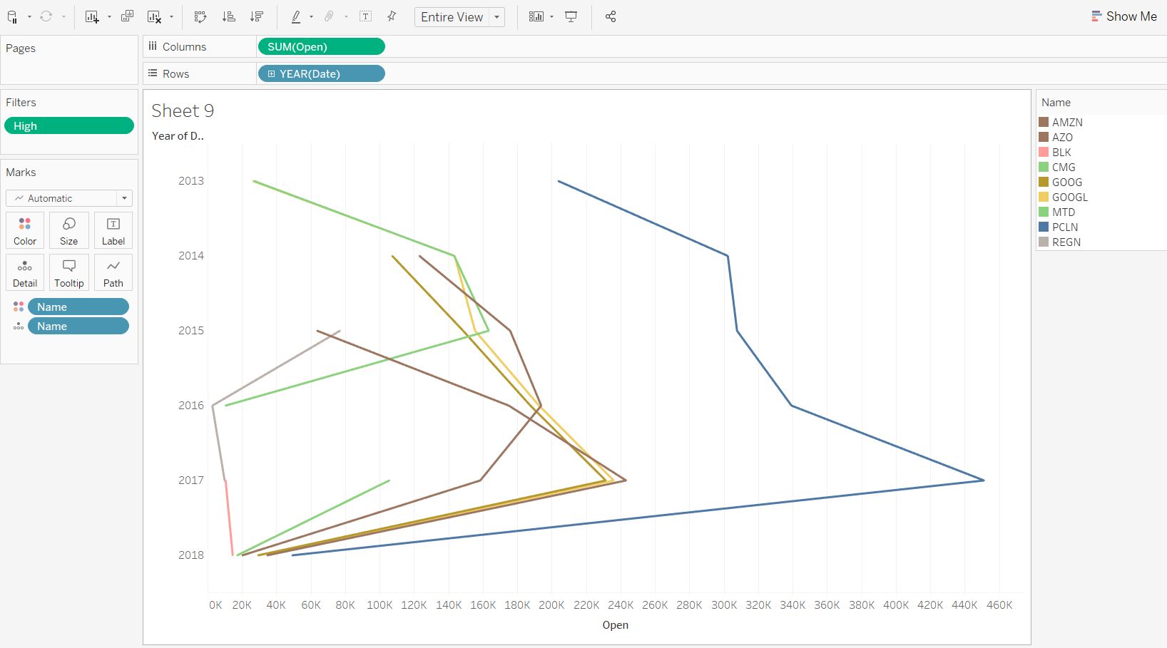

Results and Discussion:
What was the change in price of the stock overtime?
this section we'll go over how to handle requesting stock information with pandas, and how to analyze basic attributes of a stock.

Insert first graph here(closing price graph)

Analysis of apple:
- The first 2 months the adj close was low between 120-130 and then there was a rise in in price to 150 from July to November.
- Reached peak of 180 on January and was consolidated at March
- There was a fake breakdown at February .
- Closing price increased over the year

Analysis of google :
- There was a increase from May till November and also reached its peak at a stock rise of 300
- consolidation till April but dropped down to 2400 at May
- Closing price increased over the years

Analysis of microsoft:
- First 2 months adj close was fluctuating between 240-260
- A increase till 300 on November reached its peak at 340 and was consolidate
- Closing price increased over the years

Analysis of amazon:
- Closing stock became less in 1 year
- Reached its peak at July and August
- Was consolidate from May to December
- Stocks dropped down on January

What was the change in price of the stock over time?
First, we loaded the dataset into python.
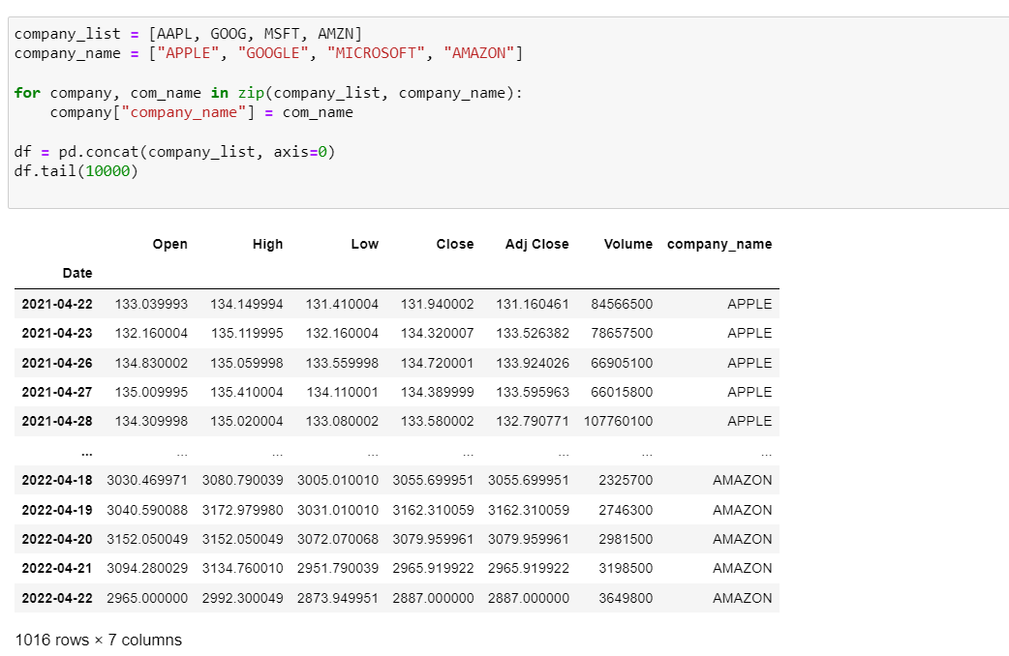--------------
This is the line graph of Closing prices of Apple,Microsoft,Google,Amazon for last 5 years.
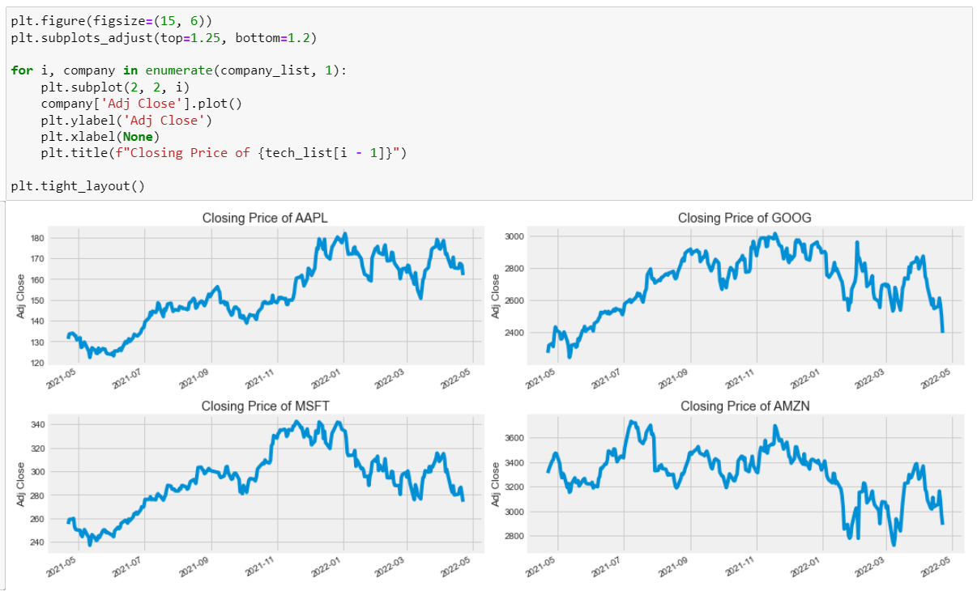-------------------------
Below graph tells us about what volume of stocks traded every year.
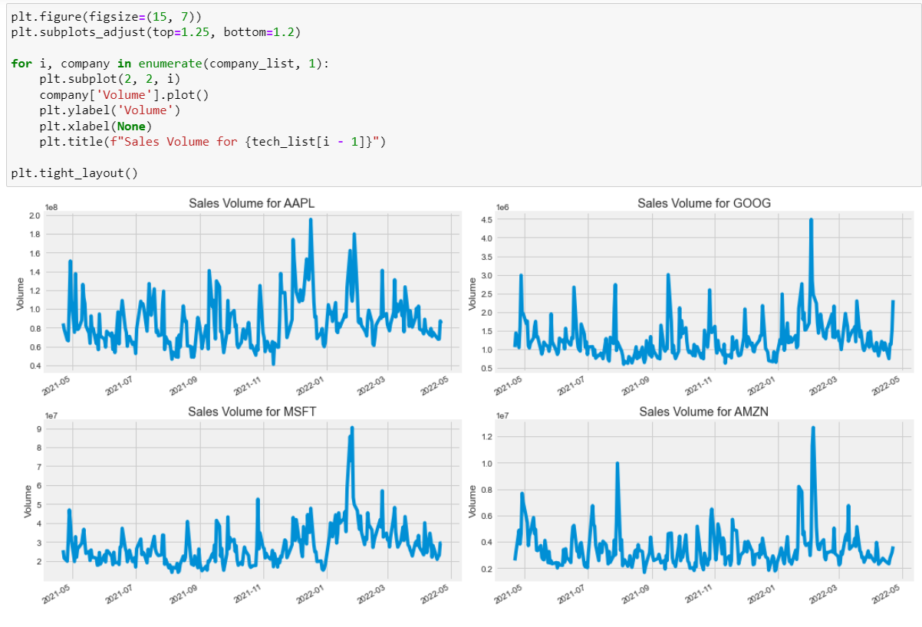-----------------------------
What was the moving average of the various stocks?
Moving Average:
A succession of averages derived from successive segments (typically of constant size and overlapping) of a series of values.

What was the daily return of the stock on average?
What is the correlation between different stocks?
Correlation is a statistical measure that expresses the extent to which two variables are linearly related.
We will compare the daily percentage returns of two stocks to see how closely they are related.
Below are the closing values of the companies using these values we will plot Scatter plot.
A scatter plot is a diagram where each value in the data set is represented by a dot.
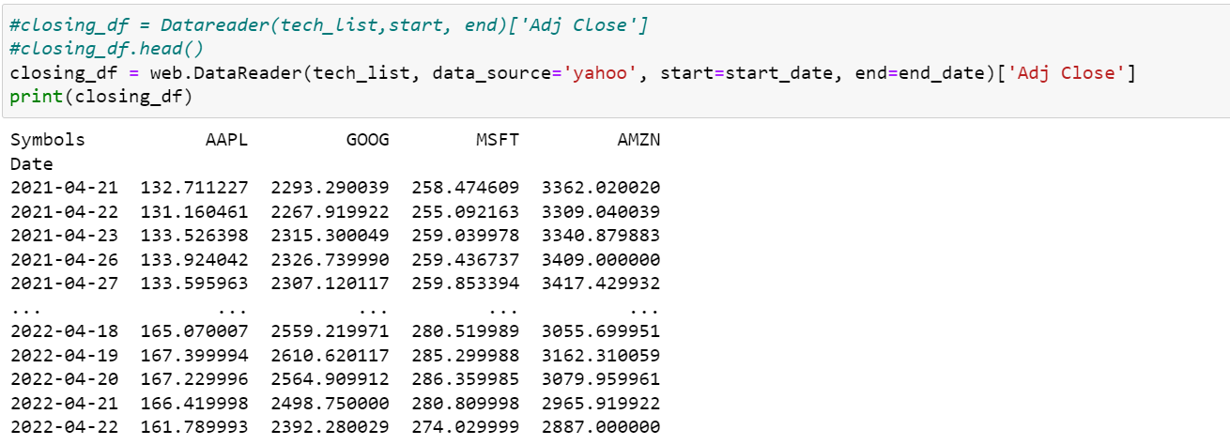---------------------
To begin, we will make a scatter plot of Google vs. Google. We can conclude that our data values are correct because the plot is perfectly linear.
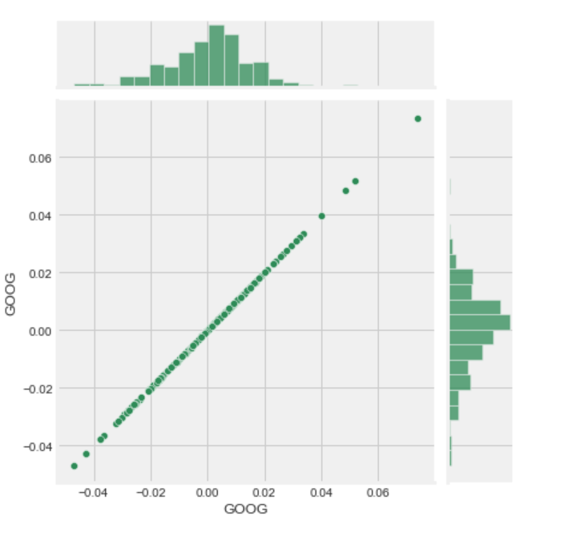
--------------------
When we display a graph between Microsoft and Google, we can see that the numbers are spread randomly and that most of them are in the 0 to 0.02 range.
The X and Y axes depict daily percentage returns.
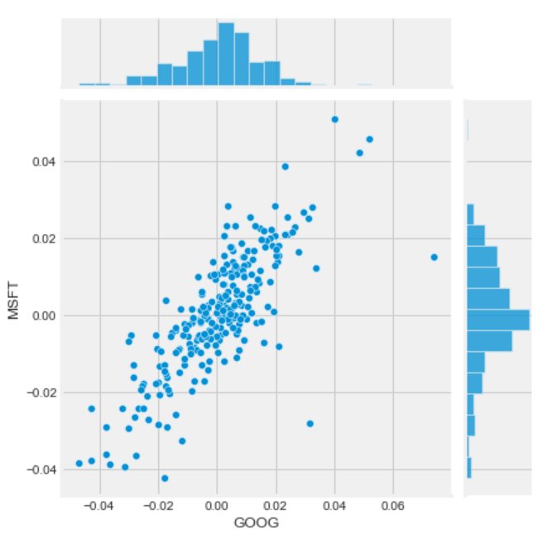
---------------
Trend Line:
A trend line is a straight line that best represents the points on a scatterplot. The trend line may go through some points but need not go through them all. The trend line is used to show the pattern of the data. This trend line may show a positive trend or a negative trend. However, if there is no relationship, then no trend line can be drawn.
The trend line shows the mathematical best fit to the data.
Here most of the companies are in positive correlation.
An interesting correlation is observed between Google and Amazon daily returns.
----------------
To get actual numerical values for the correlation between the stocks' daily return values. By comparing the closing prices, we see an interesting relationship between Microsoft and Apple.
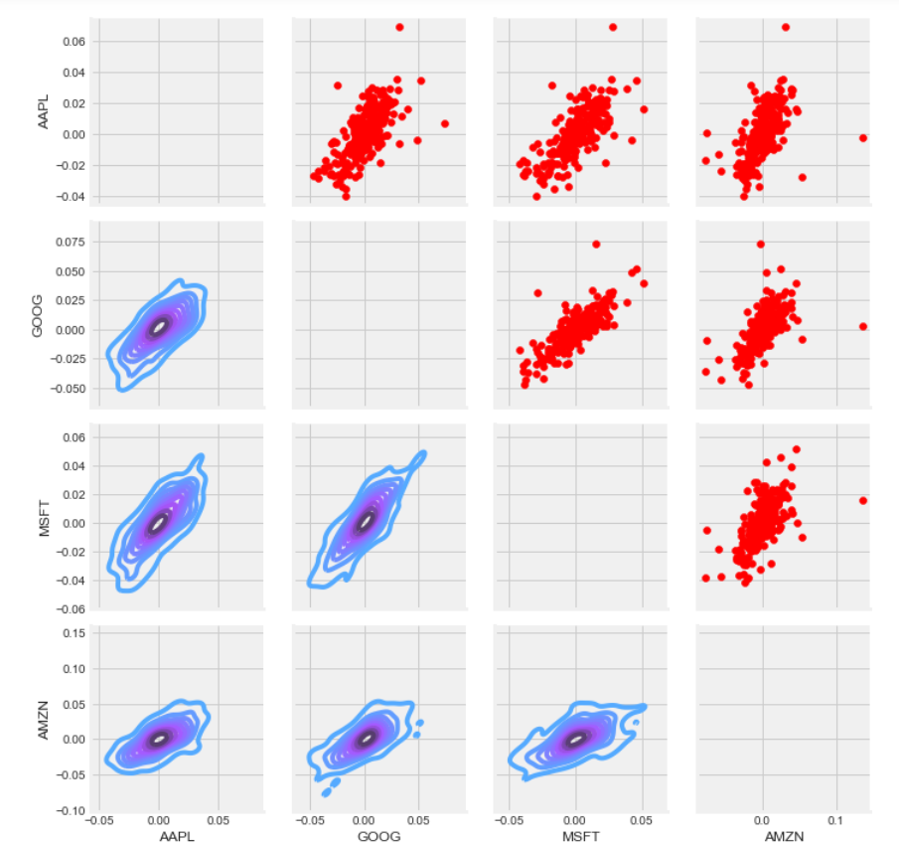
----------------
Below is the heat map of different companies which will give a clear idea how the companies are correlated
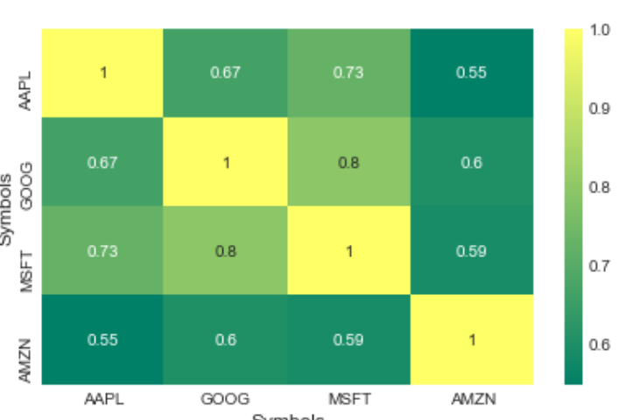
we see here numerically and visually that Microsoft and Amazon had the strongest correlation of daily stock return. It is also interesting to see that all the technology companies are positively correlated.
How much value do we put at risk by investing in a particular stock?
There are many ways we can quantify risk, one of the most basic ways using the information we have gathered on daily percentage returns is by comparing the expected return with the standard deviation of the daily returns.
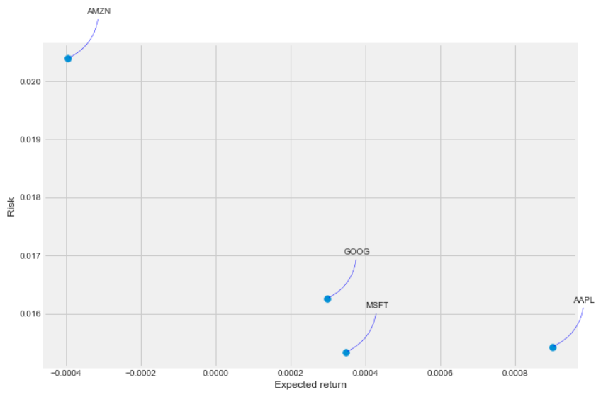
How can we attempt to predict future stock behavior?
(Predicting the closing price stock price of APPLE inc using LSTM).
Below are the stock values of the apple inc.
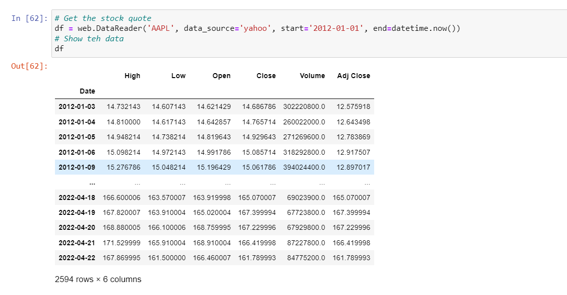------------------
We can see how stock prices have changed over time using the line graph.
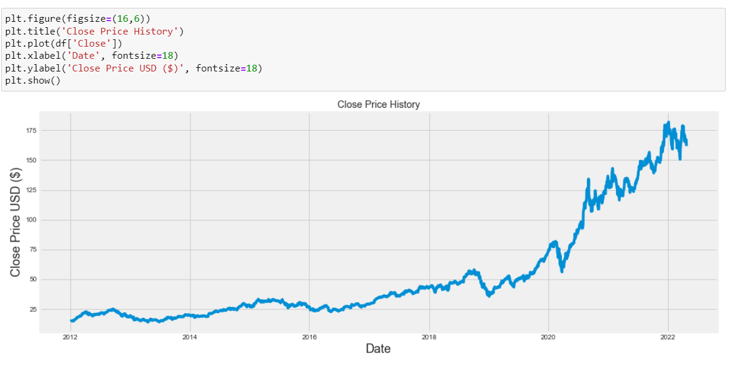----------------
The Root Mean Square Error value is depicted in the figure below. This information is used to verify our model.
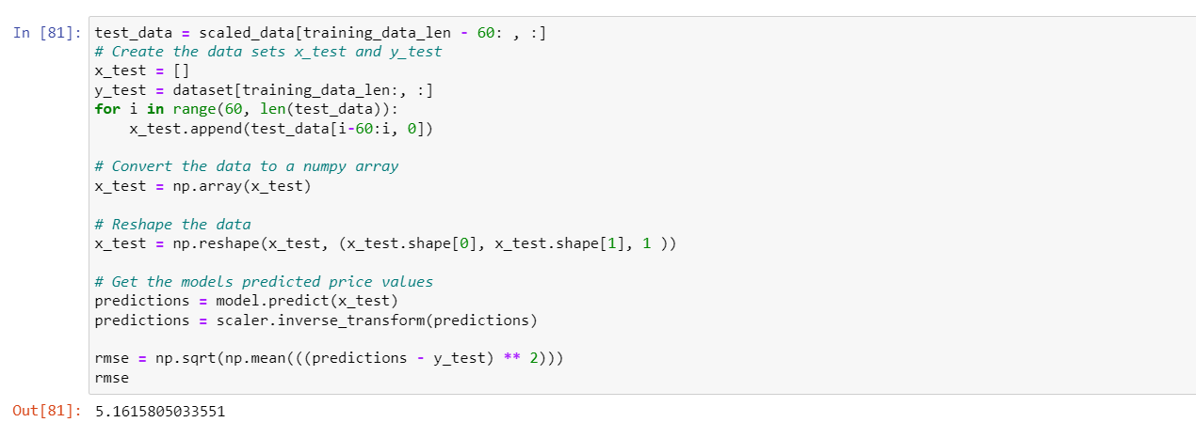-----------------------
To predict the values of future stock prices we first trained the data and then we used that data to predict future values.
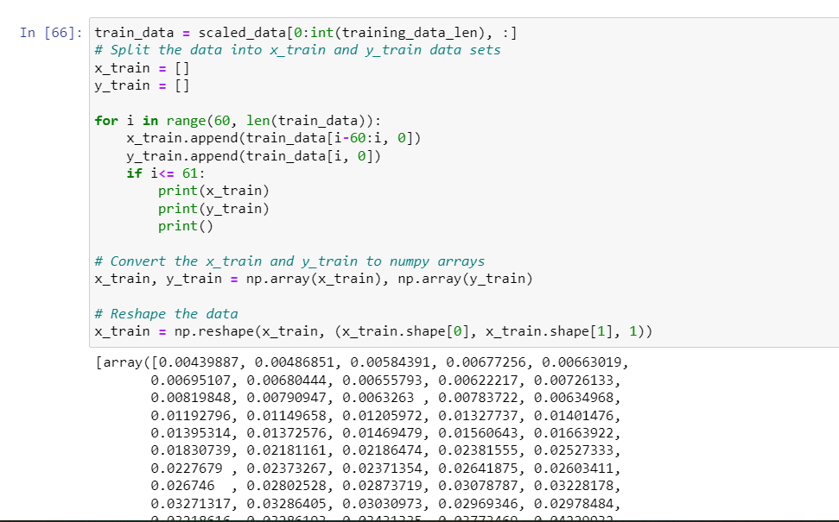----------------------
Below is the prediction graph.
------------------
Below are the prediction values.
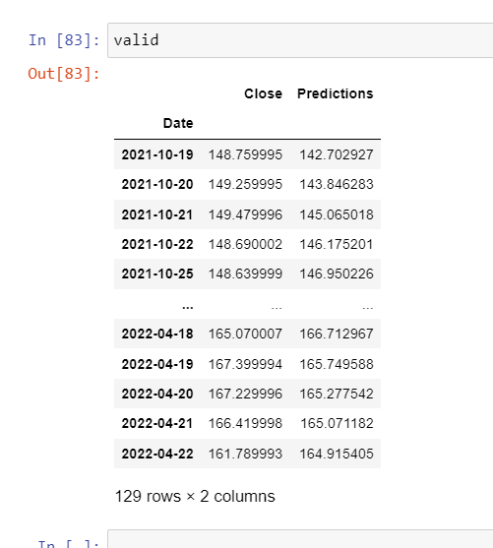

Conclusion
We can easily understand and predict prices by the help of analysis by Tableau and python and we can understand daily returns of stock market by visualization and help us to know when it’s going up and down and it also help in investment in stock and Mutual Funds. The visualization makes easy to invest and understand the company investment and work. This chart and graph give idea about stock market up and down. It also helps other to invest in best company and got better return. Stock market are risky and it helps to take decision but not confirm better returns.

References
[1] NIFTY-50 Stock Market Data (2000 - 2021) . (2021, May 1). kaggle. Retrieved April 29, 2022, from https://www.kaggle.com/datasets/rohanrao/nifty50-stock-market-data
[2] Stock Market Index Data | Macro Trends . (2012). macro trend. Retrieved April 29, 2022
[3] Project Jupyter . (2022). home. Retrieved April 29, 2022, from https://jupyter.org
[4] tablueas. (2012). A Guide to Tableau Uses for Big Data Analysis and Viz
[5] R. Saravanan and P. Sujatha, “A state of art techniques on machine learning algorithms: A perspective of supervised learning approaches in data classification,” in 2018 Second International Conference on Intelligent Computing and Control Systems.
[6] https://thinkingneuron.com/predicting-stock-prices-using-deep-learning-lstm-model-in-python/#:~:text=%20Predicting%20stock
[7] https://towardsdatascience.com/correlation-coefficient-clearly-explained-f034d00b66ac#:~:text=%20What%20is%20the%20range%20of%20the%20correlation,data%20point%20deviates%20from%20the%20mean.%20More%20
[8] https://realpython.com/linear-regression-in-python/
[9] https://www.w3schools.com/python/python_ml_scatterplot.asp
[10] https://www.ck12.org/c/statistics/scatter-plots-and-linear-correlation/lesson/Use-a-Scatterplot-to-Interpret-Data-MSM8/#:~:text=A%20trend%20line%20is%20a,trend%20or%20a%20negative%20tren.
[11] https://chartio.com/learn/charts/what-is-a-scatter-plot/

