1. Home Page on entering url – http://127.0.0.1:5000/home

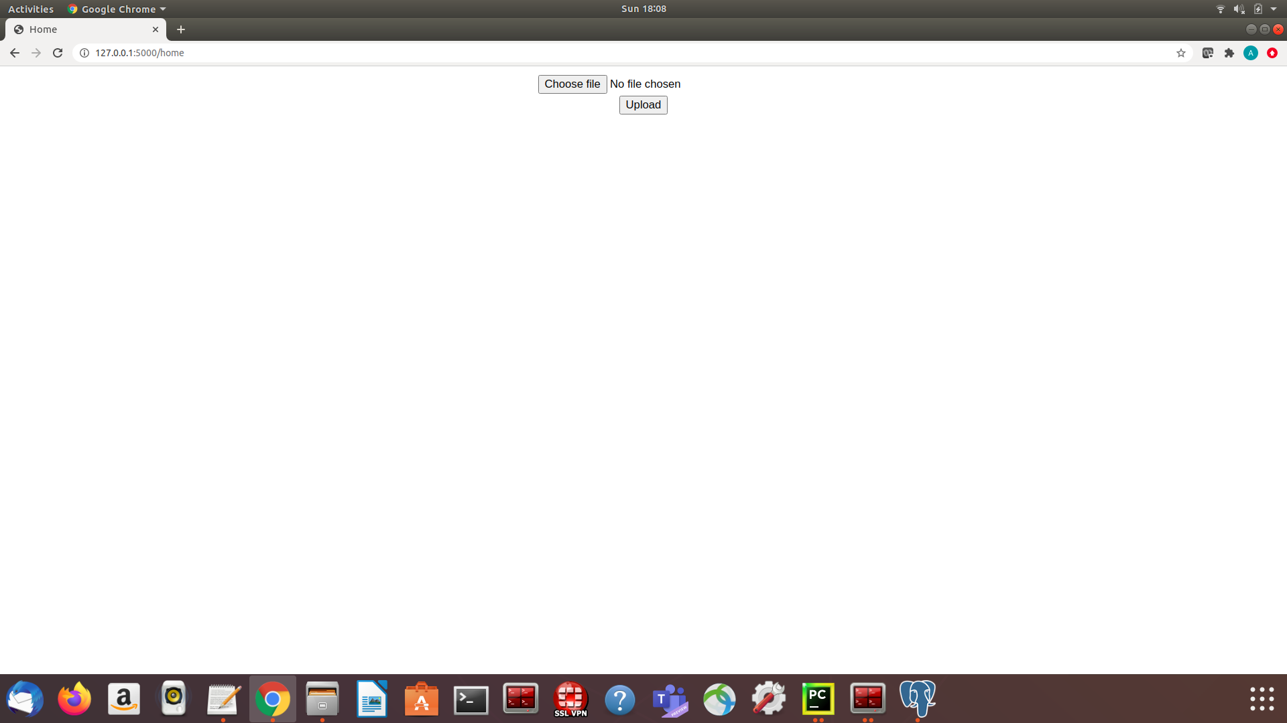

2. File uploaded successfully page and display all records.

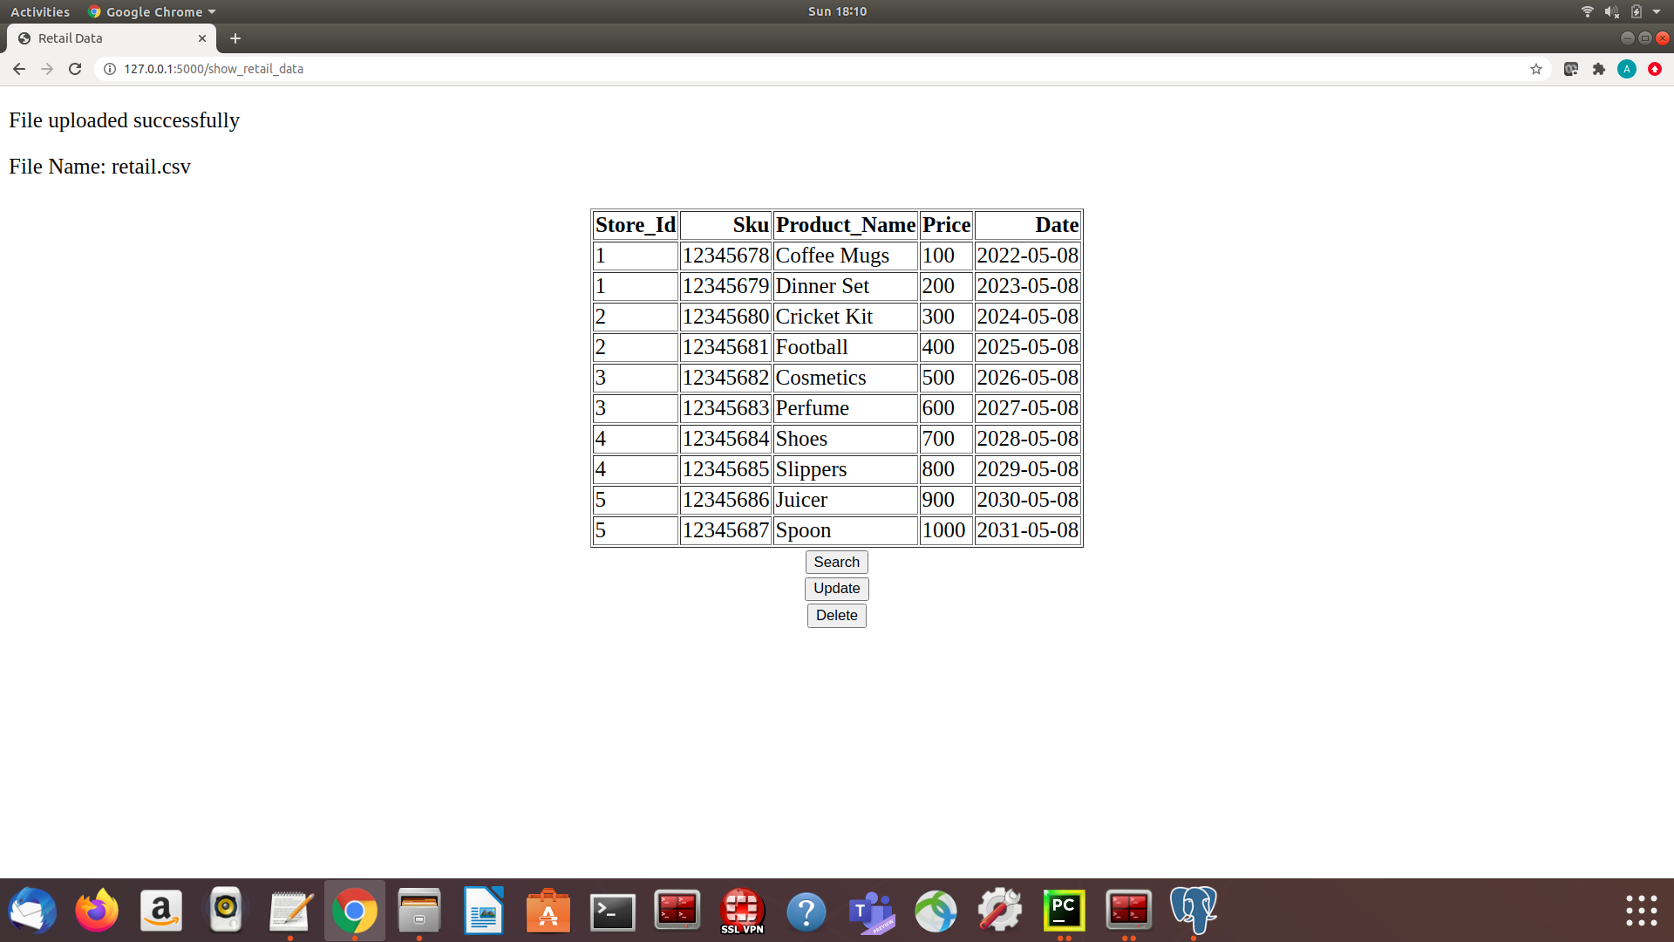

3. Search Form Pop Ups on click of Search button.

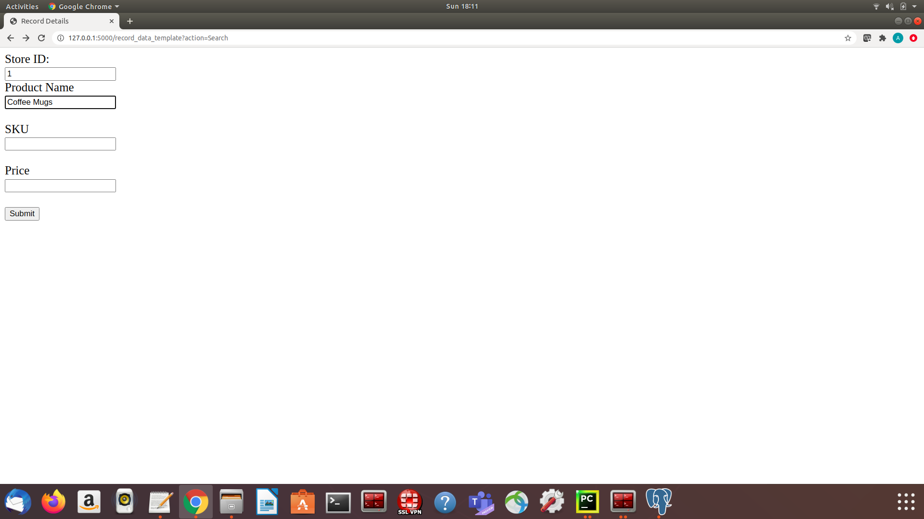

4. Display all records as per given conditions in search form.

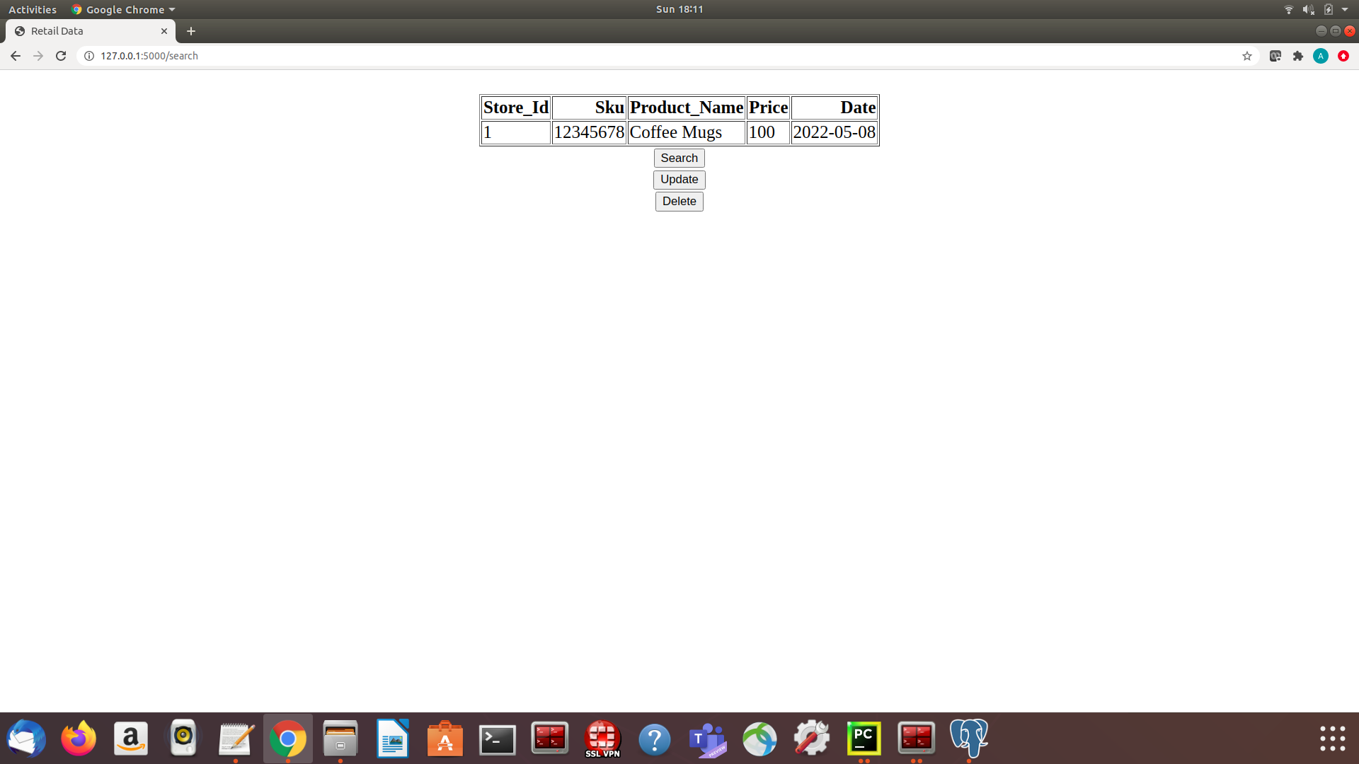

5. Update form pops up on click of Update button.

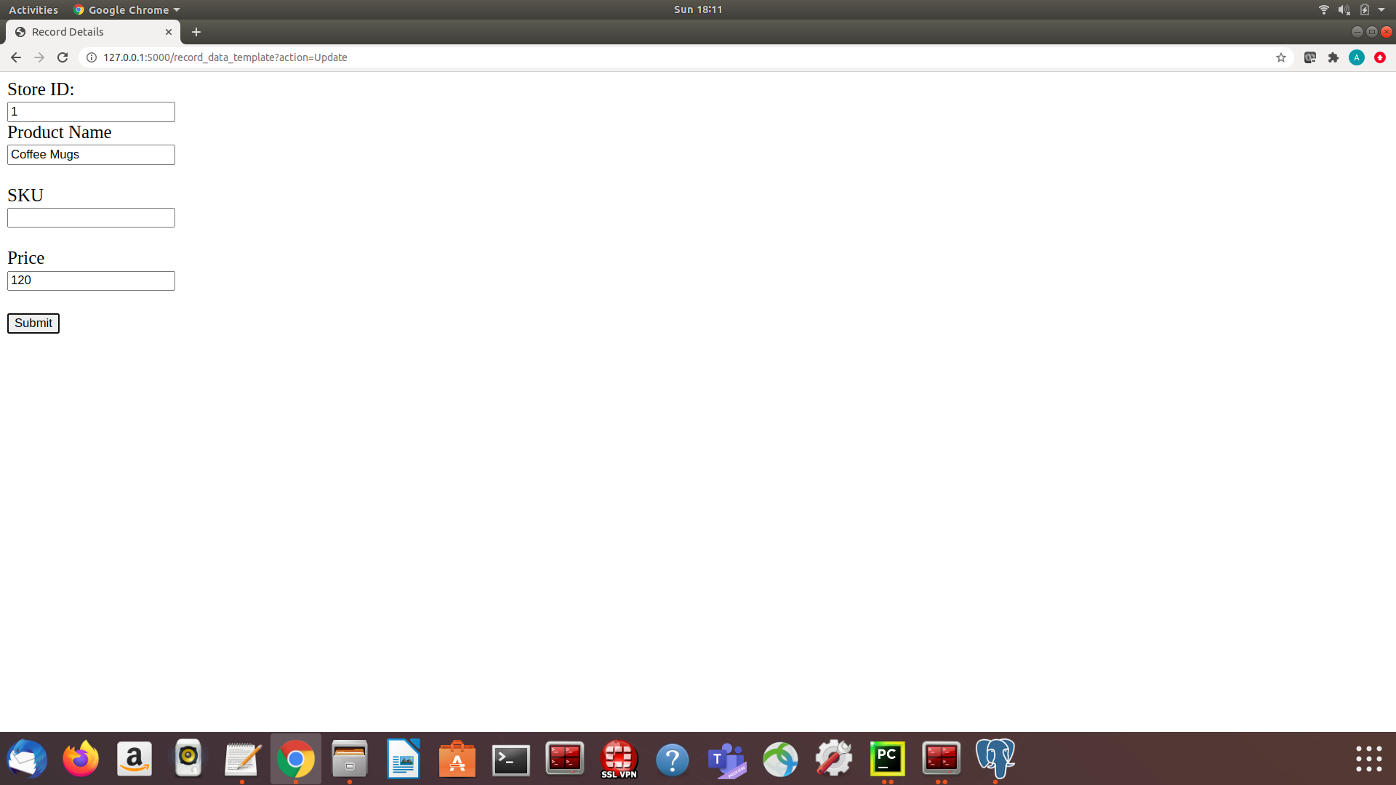

6. Display results after update operation ( price of Coffee Mugs change to 120. )

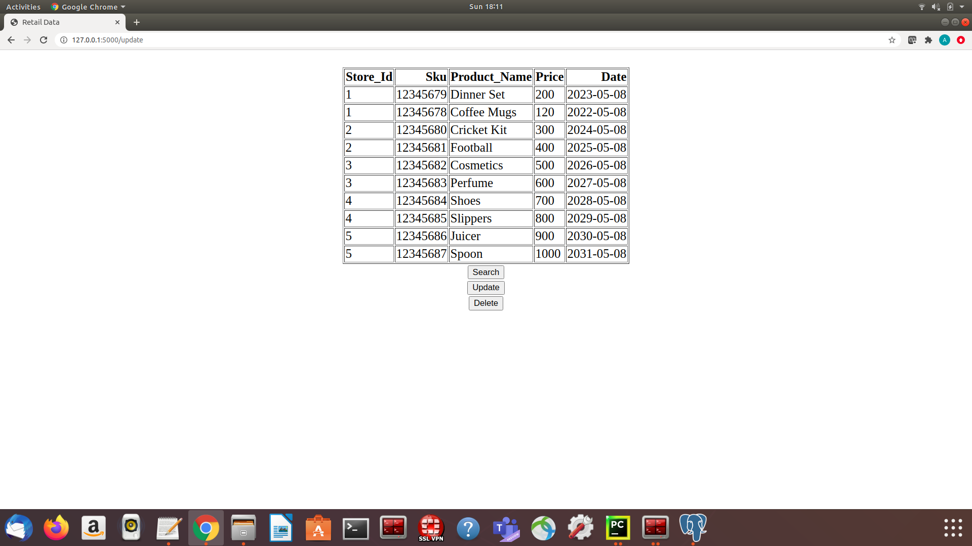

7. Delete form pops up on click of Delete button

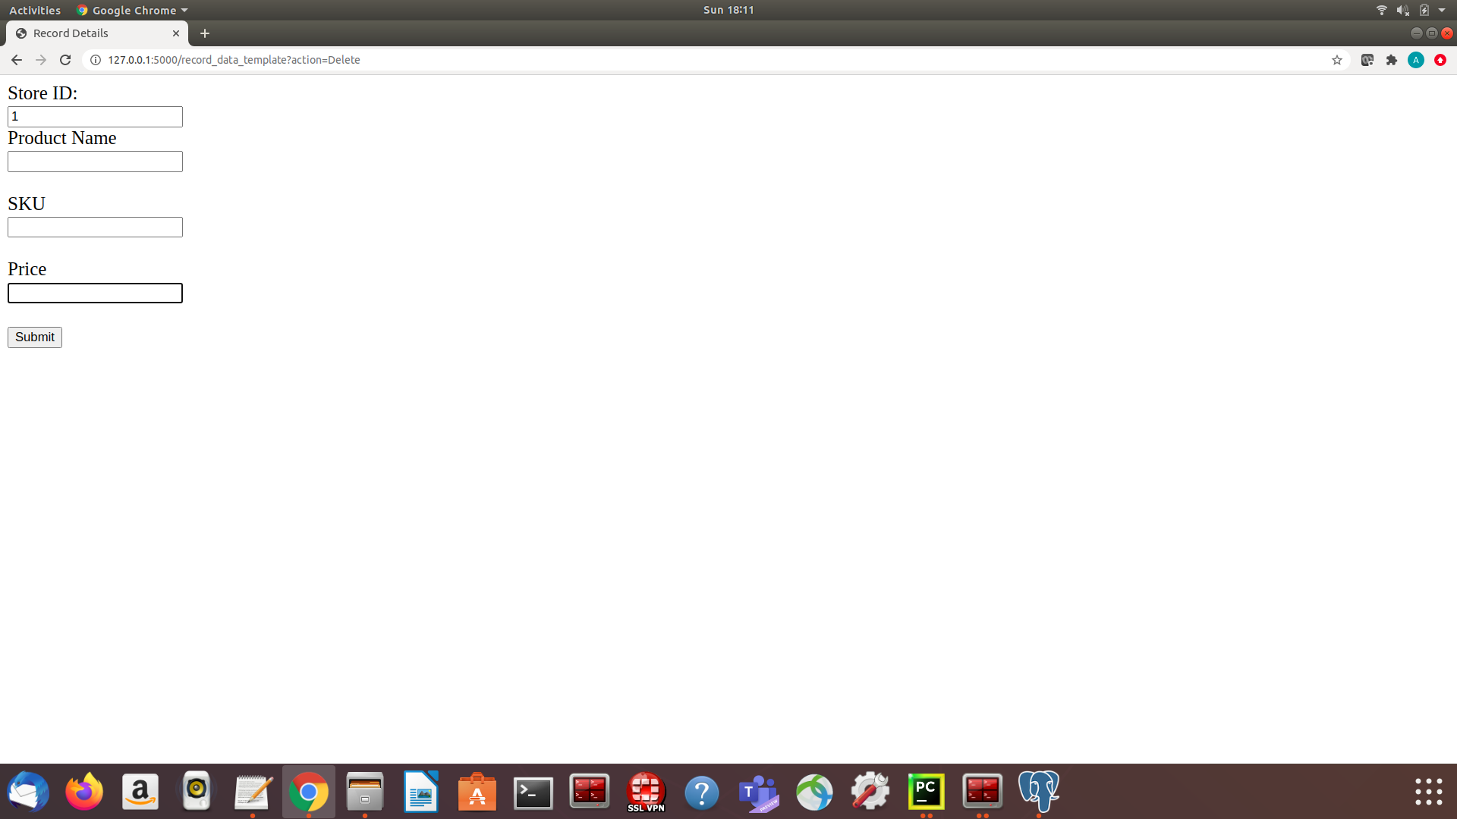

8. Display results after delete operation.

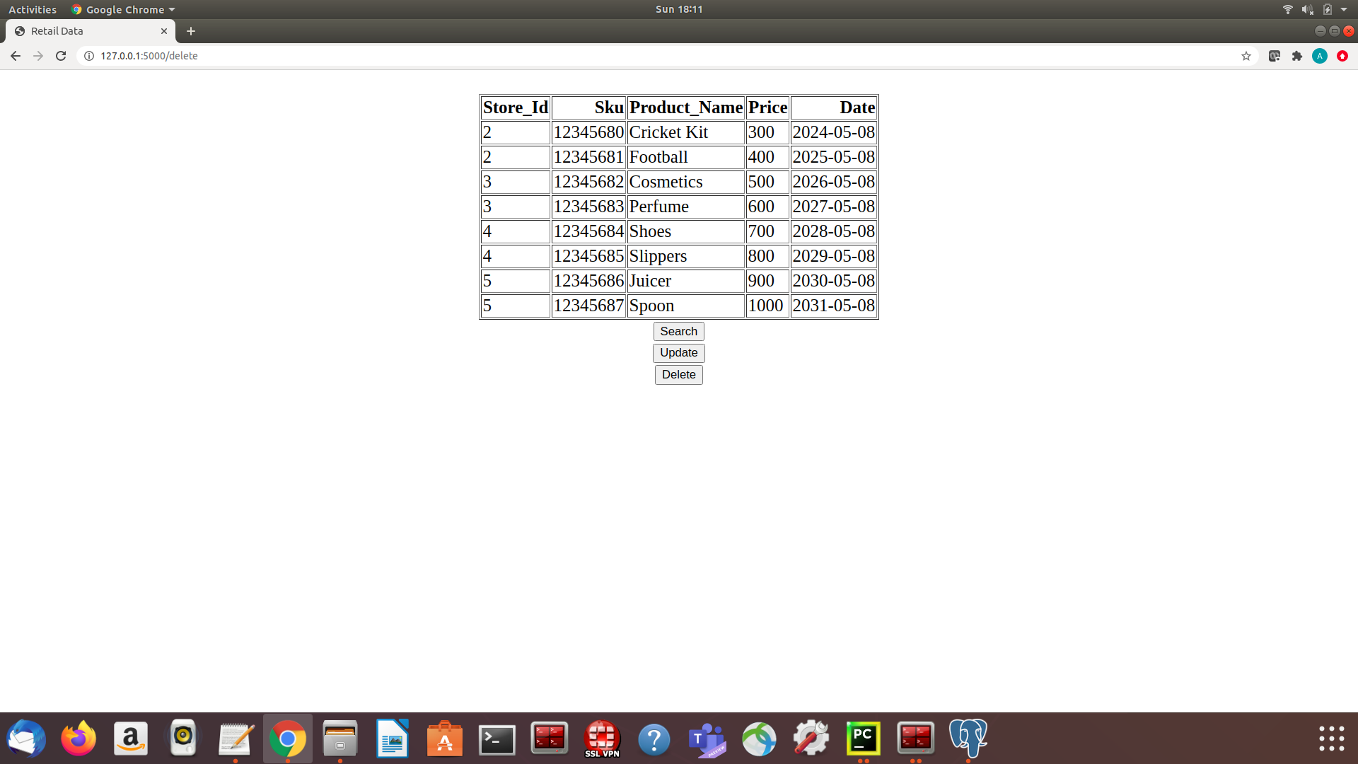

9. Search form pops up for case when records does not exist.

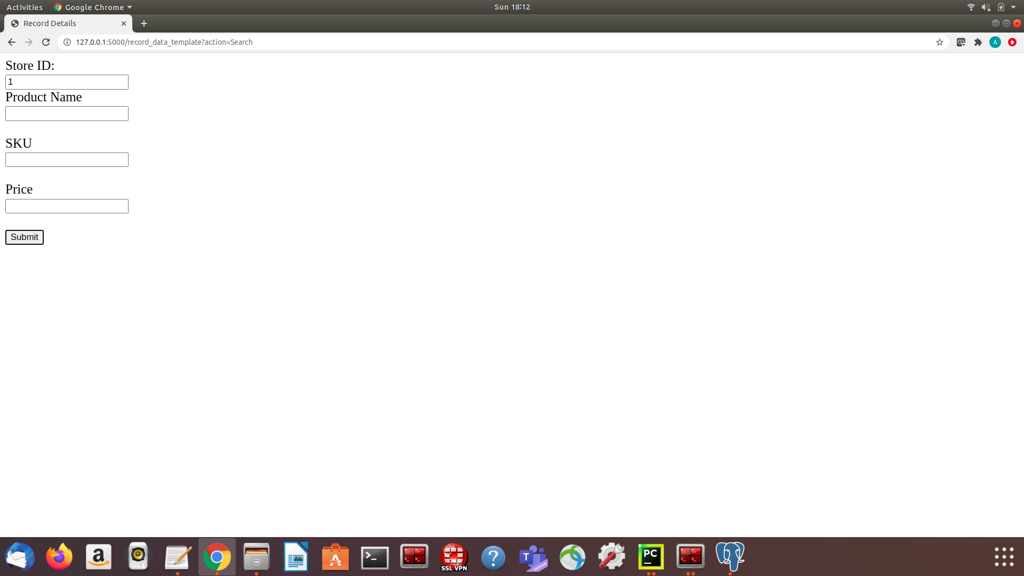

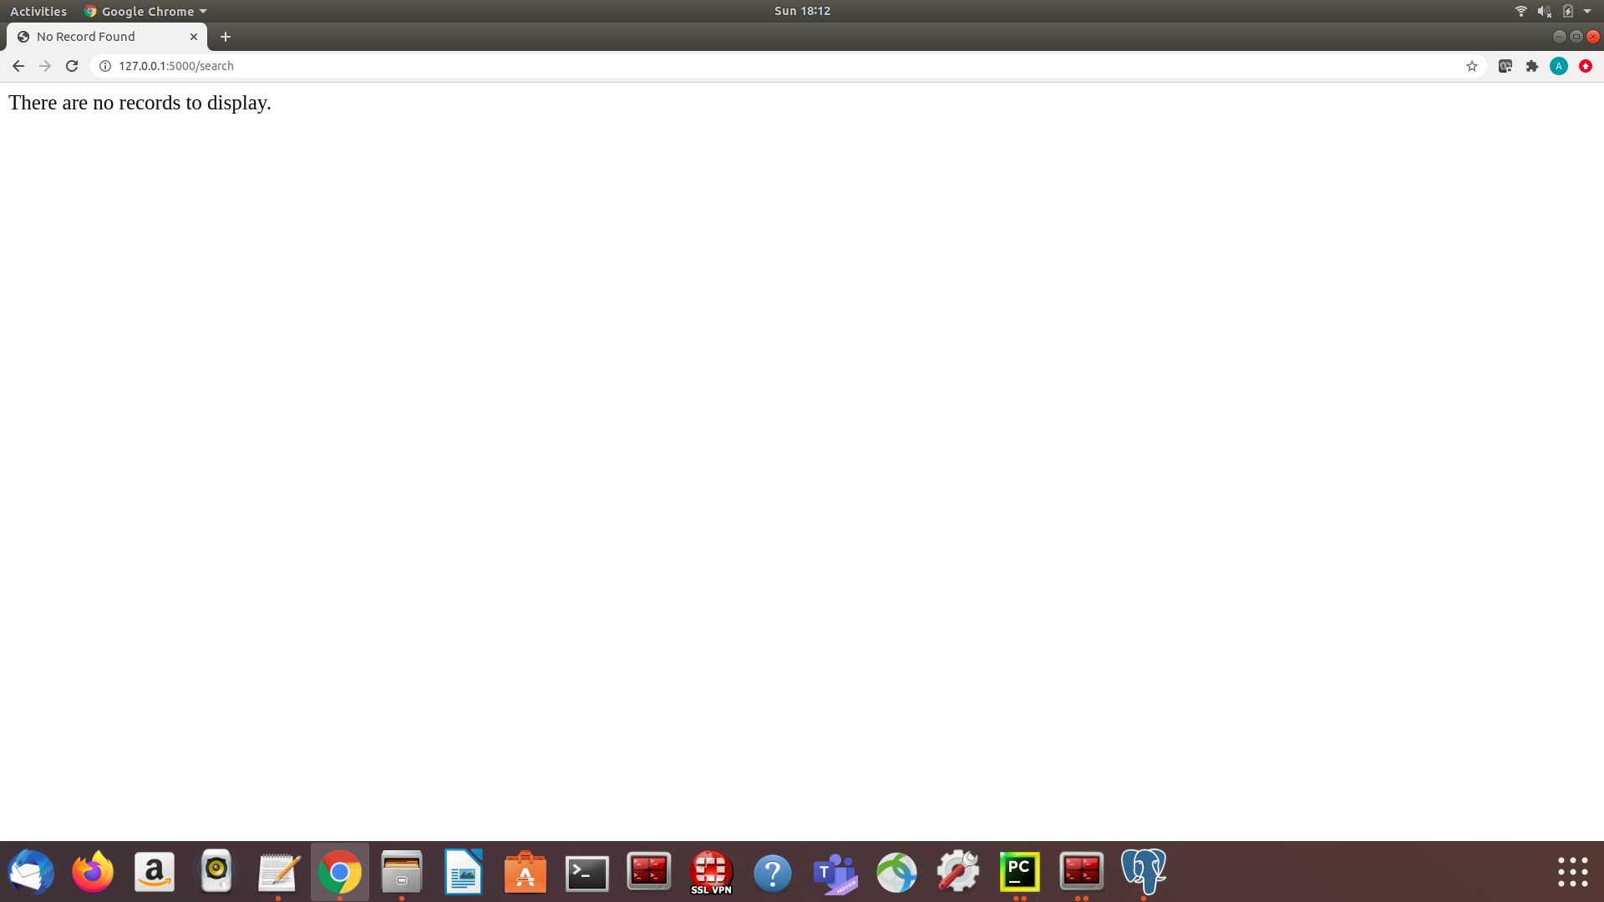

10. Display message i.e. no records to display.

11. Update form pops up for case when no record is for update operation.

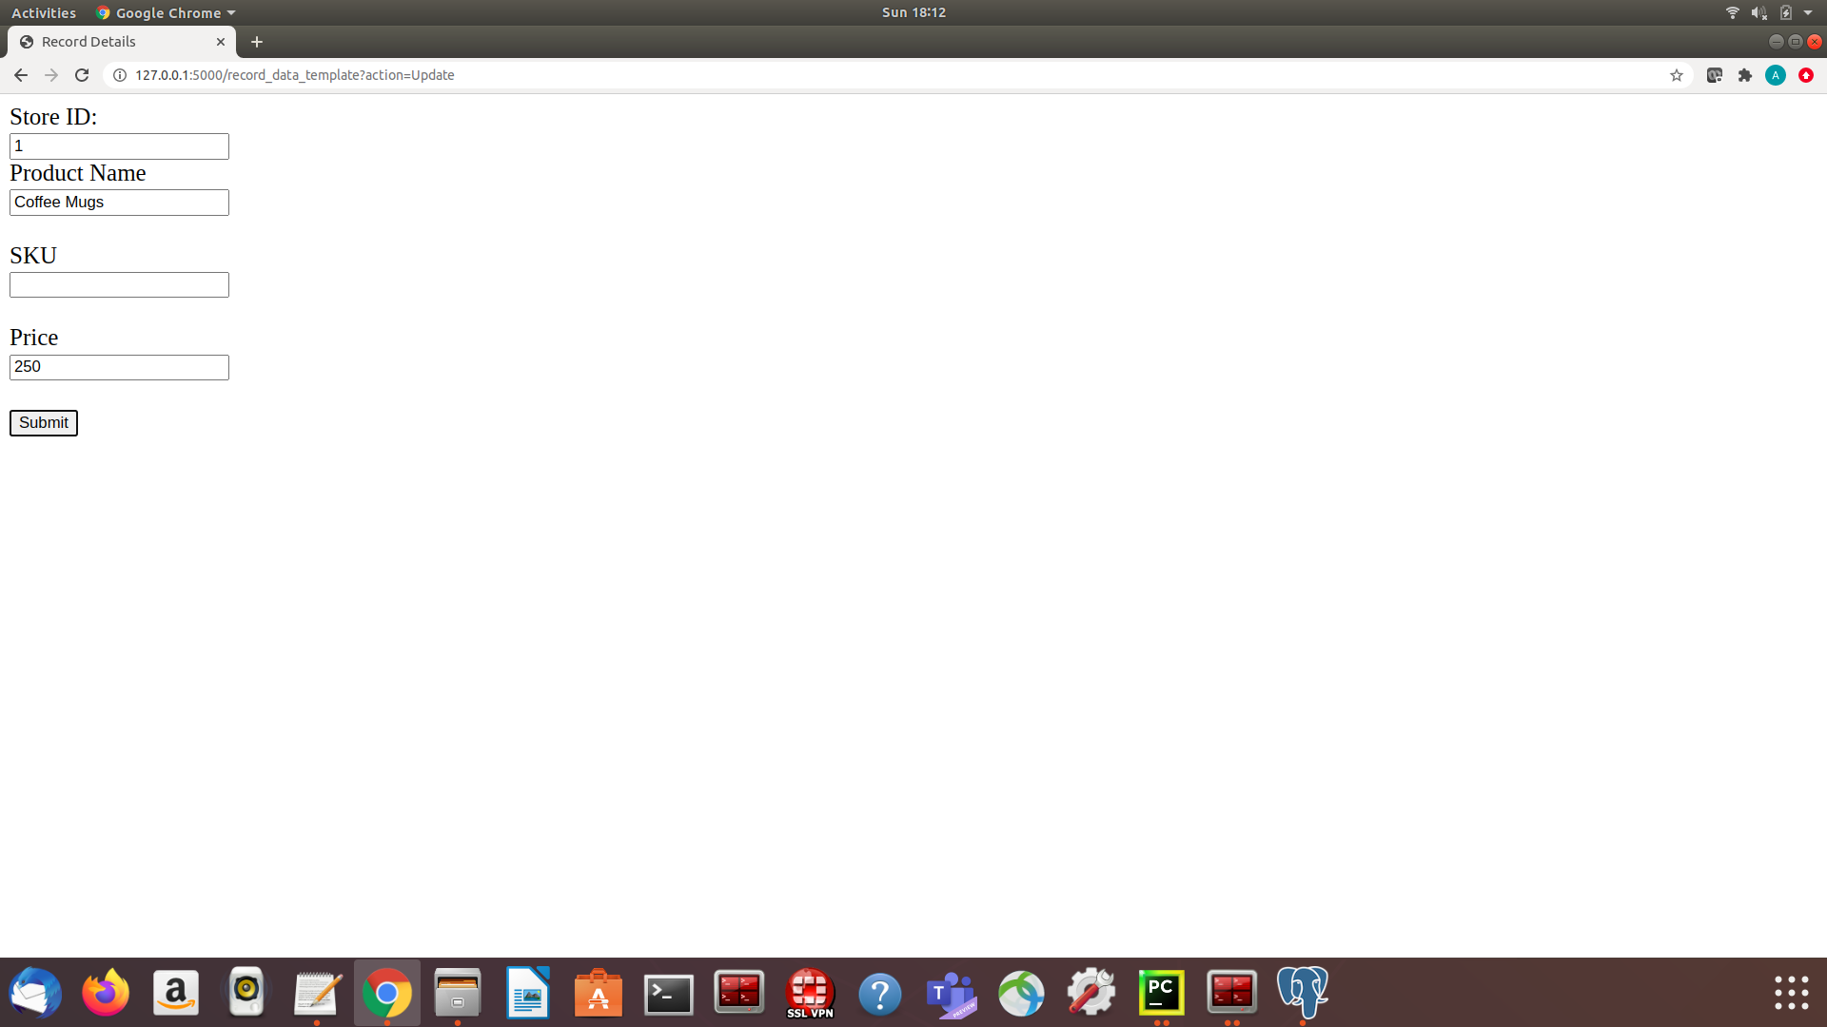

12. Display message i.e. there is no record to undergo update operation.

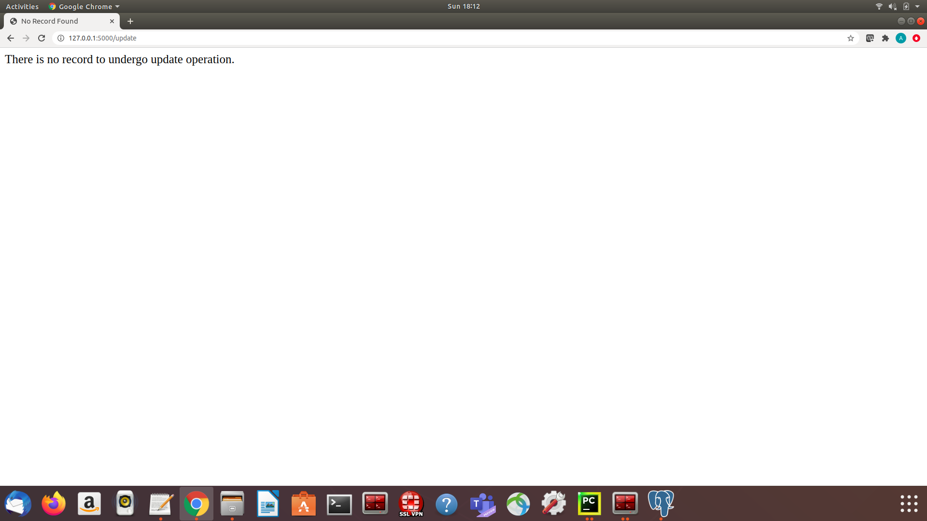

13. Delete form pops up for case when no record is for delete.

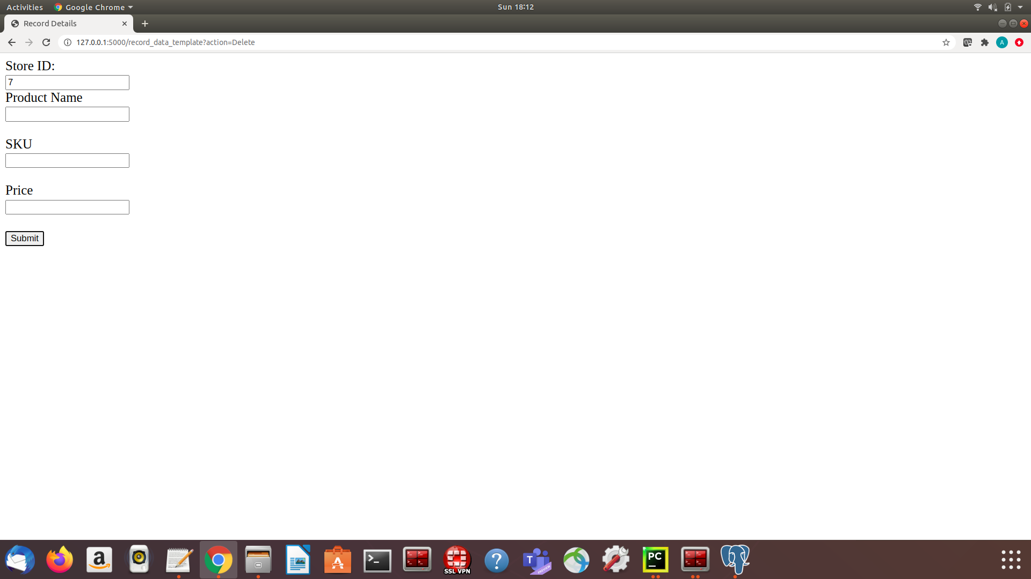

14. Display message i.e. there is no record to undergo delete operation.

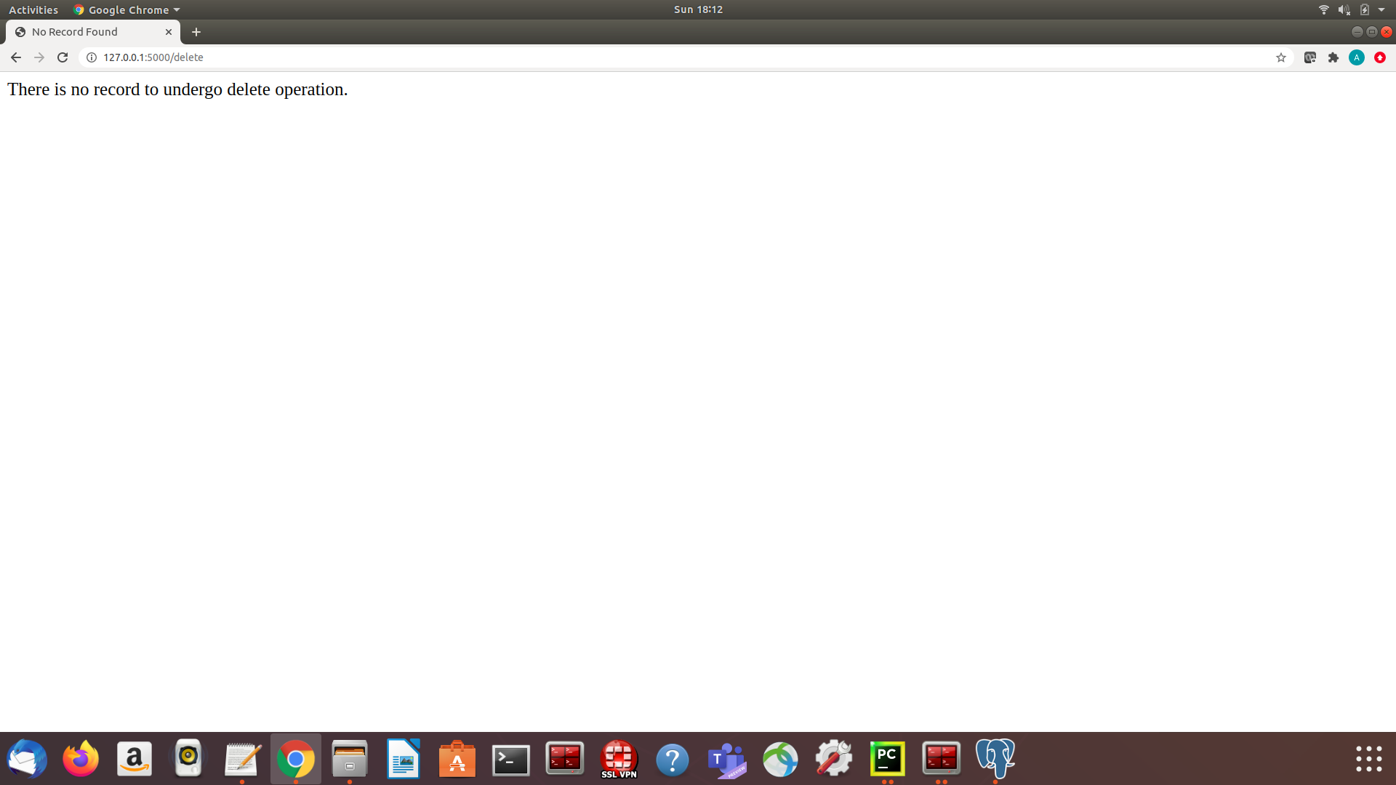

15. Display testing results : Passed all test cases.

