Postman API Testing Evidence
Express.js REST API (Modular MVC)
Name: AMAN
Roll No: SU92-BSCSM-F24-097
Contents
Screenshot 1: Register & Login
Screenshot 2: Category POST (201 Created)
Screenshot 3: Category GET (200 OK)
Screenshot 4: Validation Error (400 Bad Request)
Screenshot 5: Not Found (404 Not Found)
Additional: Server Setup & Running (VS Code Terminal)

Screenshot 1: Register & Login

1a. Register (POST /api/auth/register)
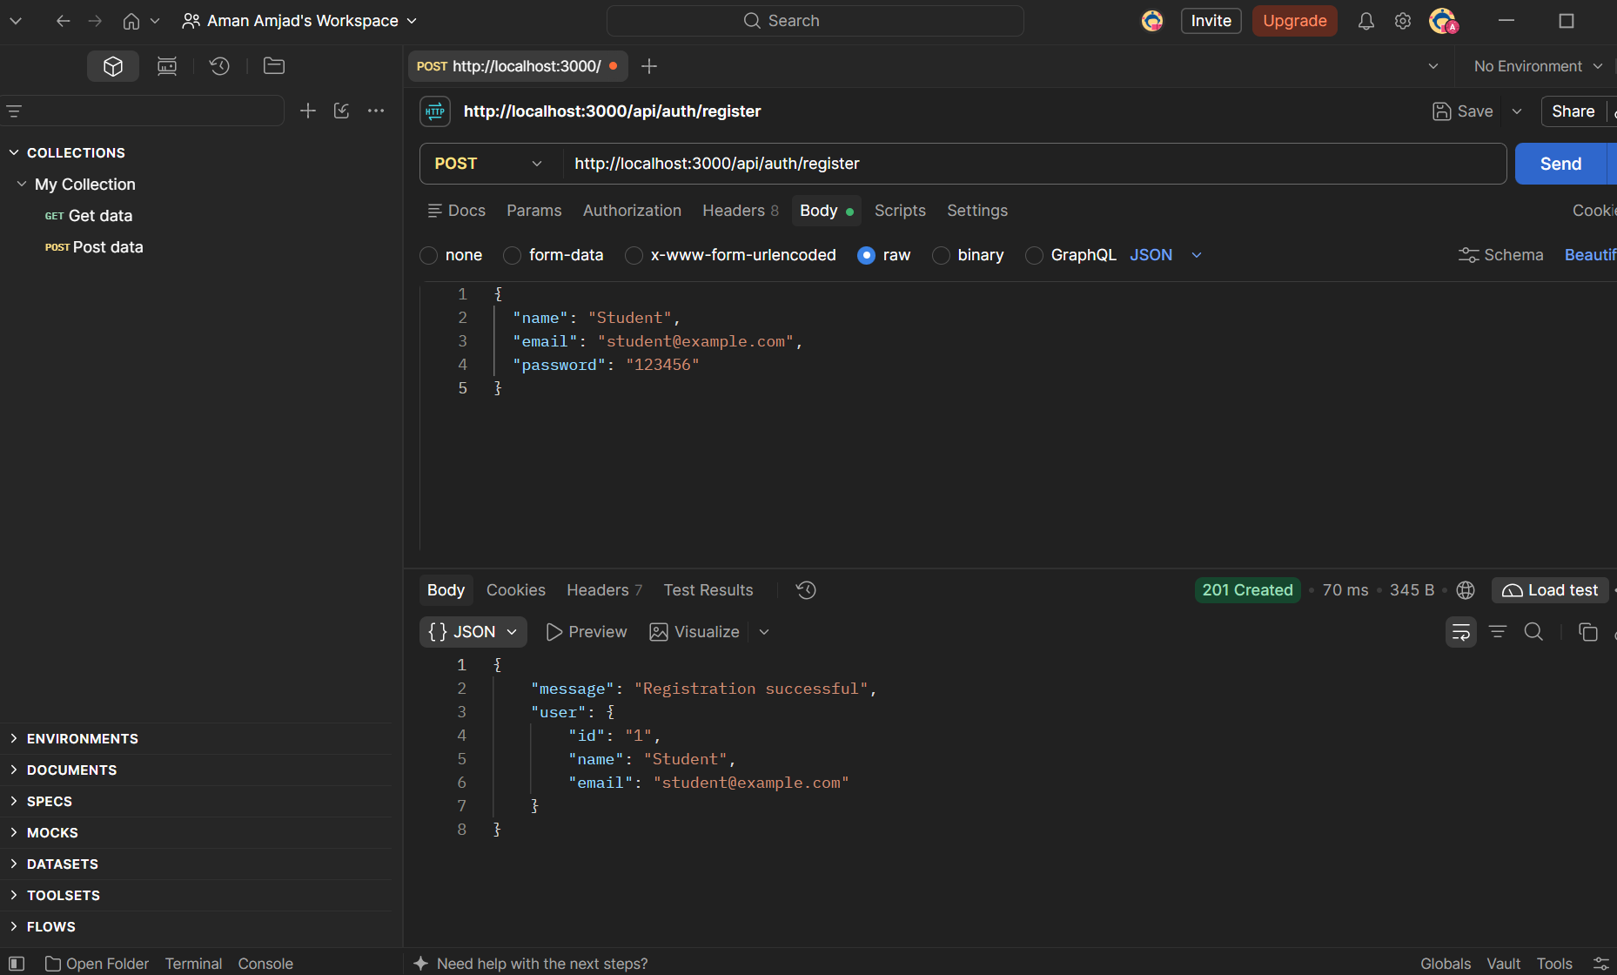

1b. Login (POST /api/auth/login)
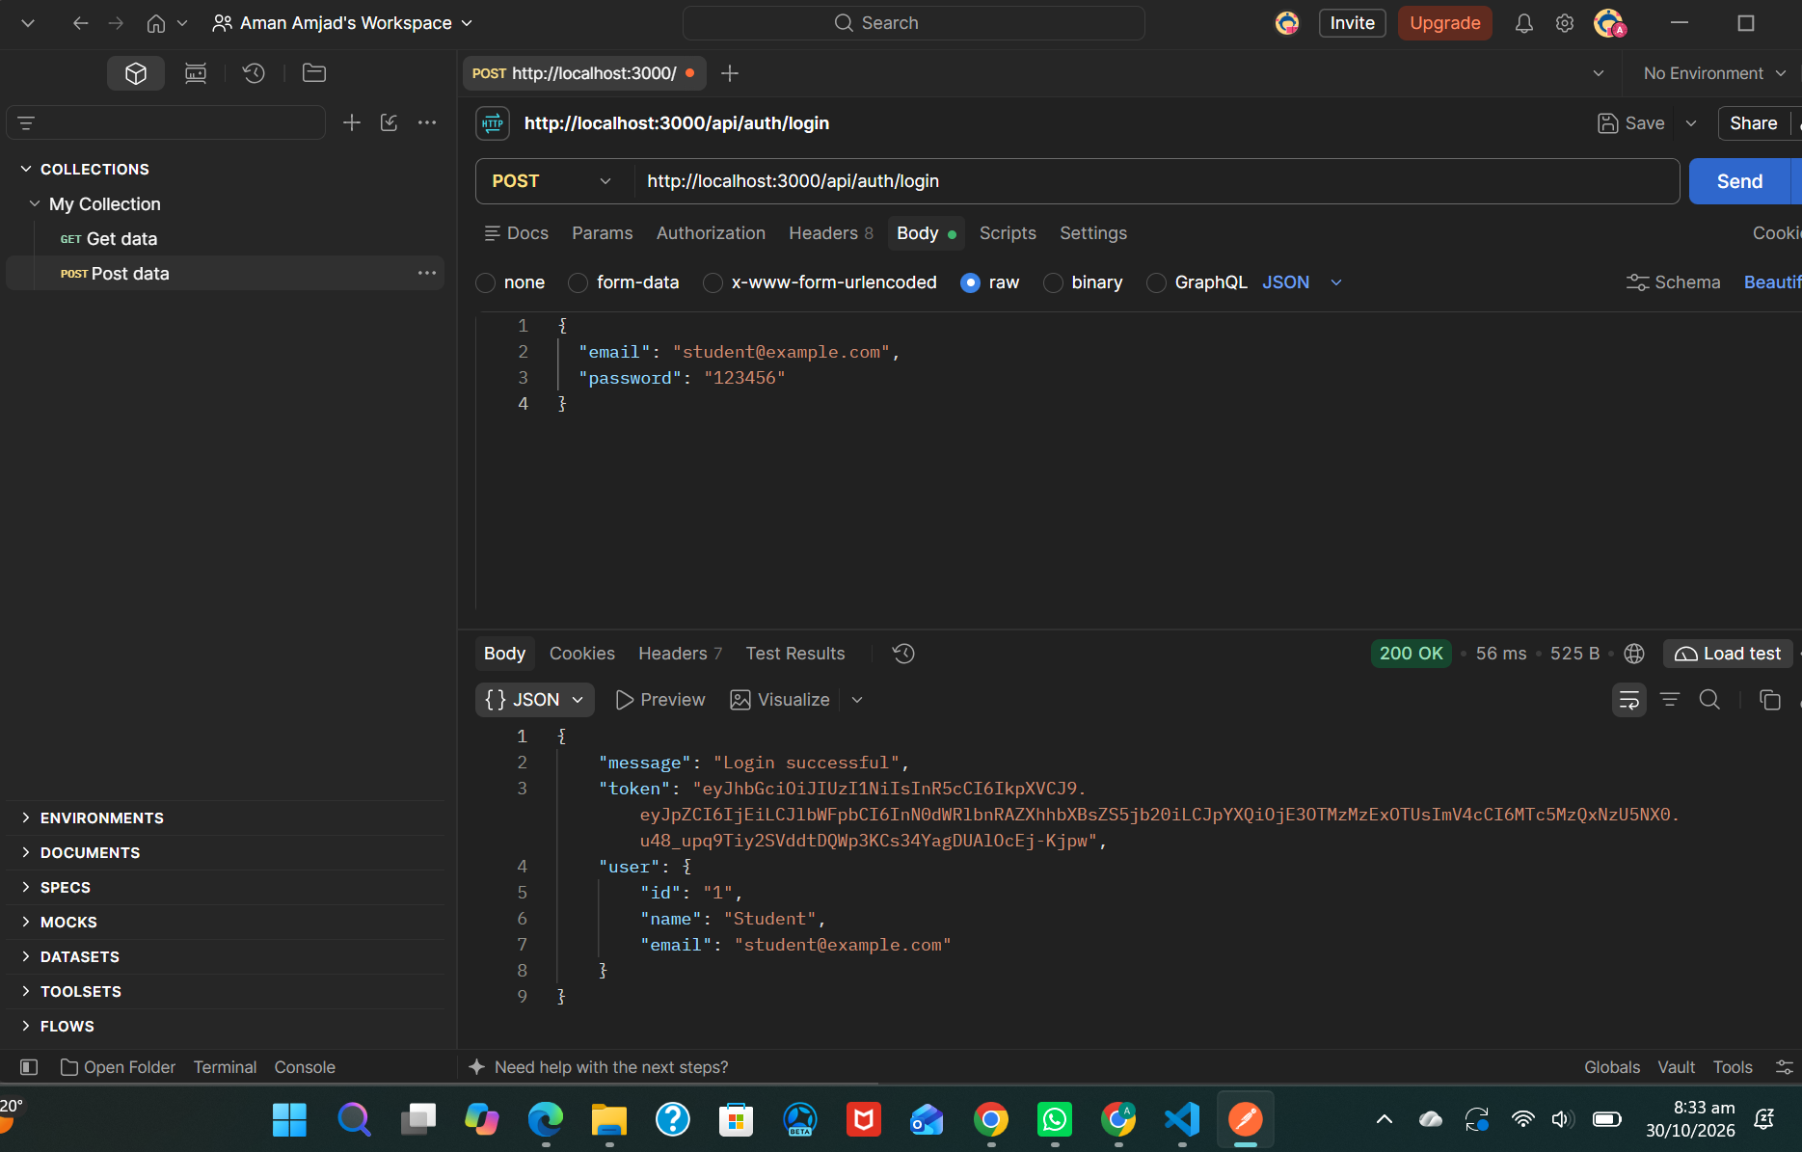

Screenshot 2: Category POST (201 Created)

POST /api/categories
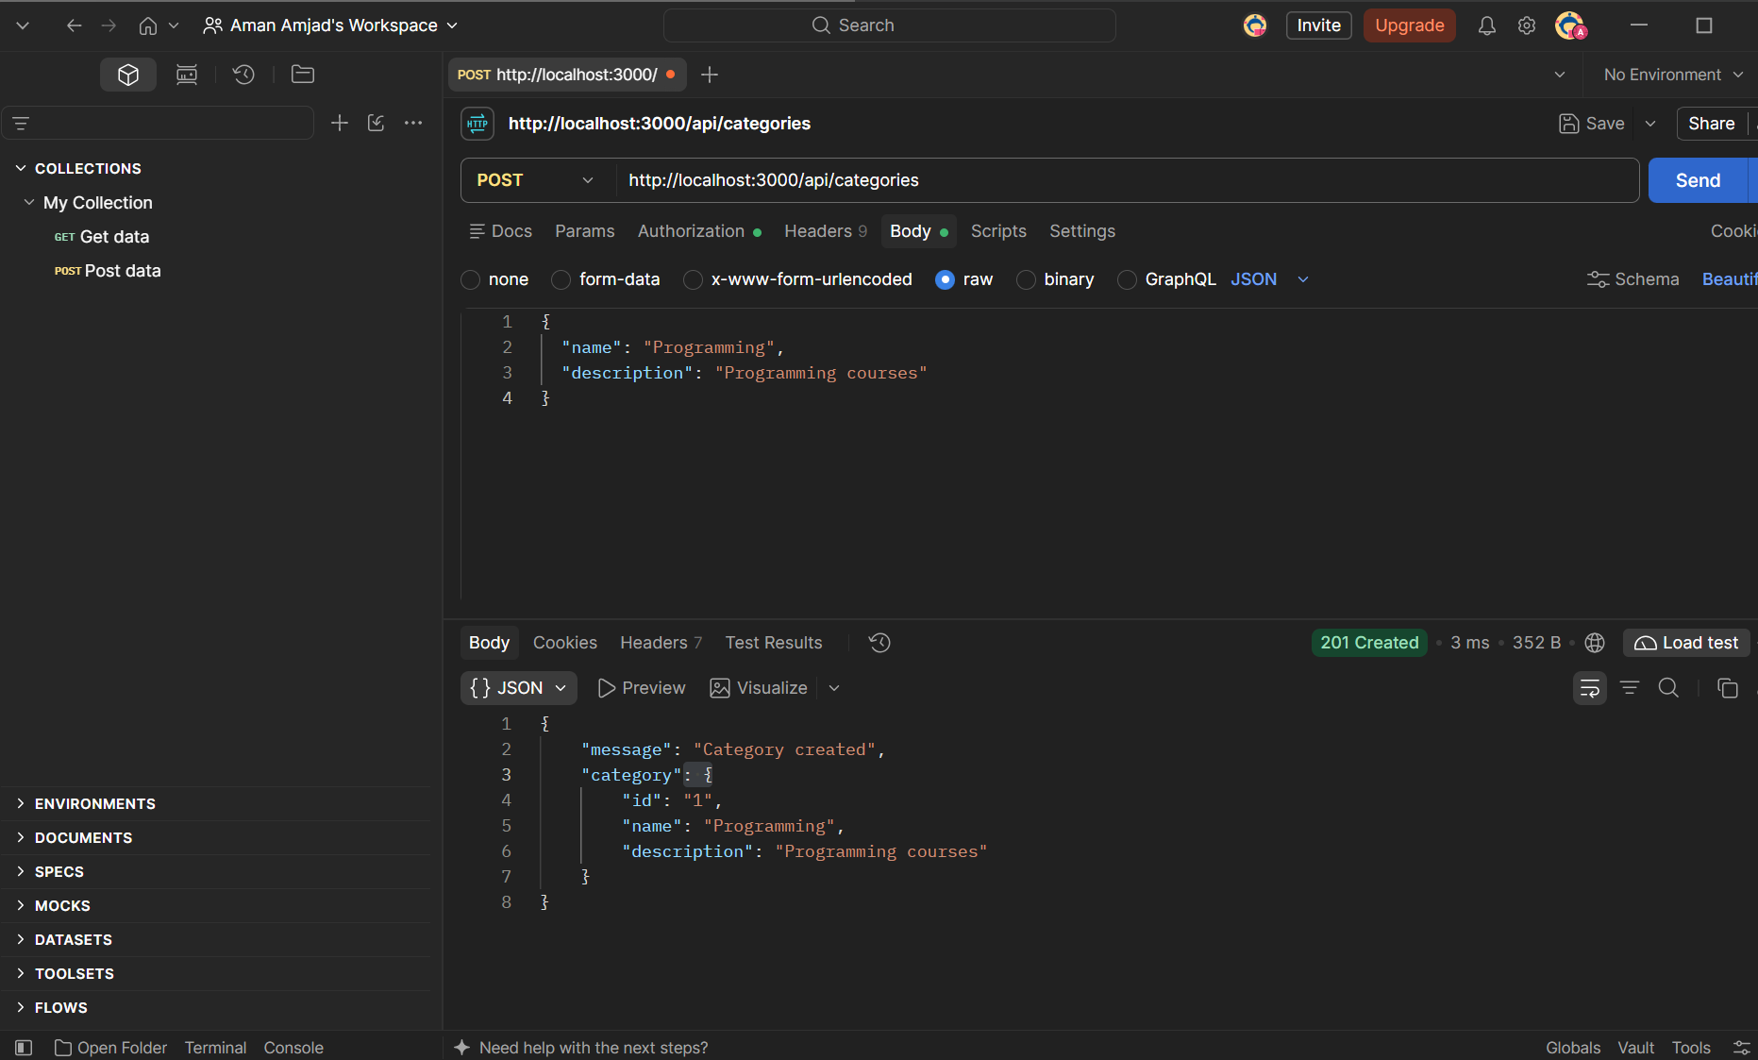

Screenshot 3: Category GET (200 OK)

GET /api/categories
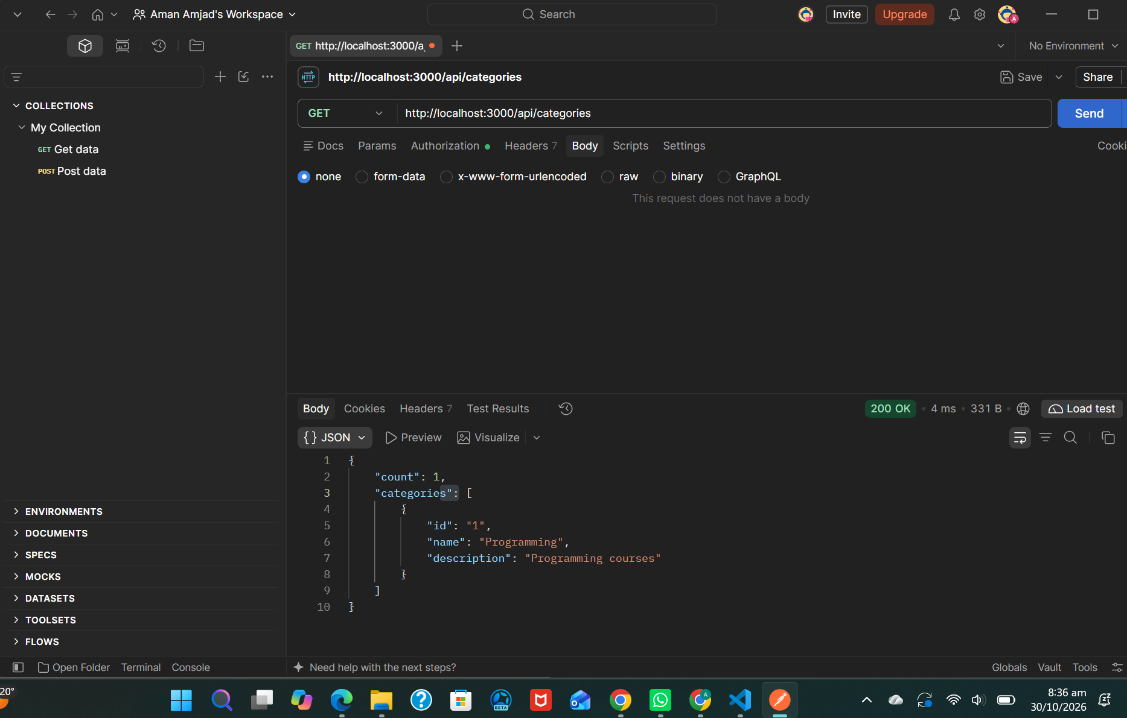

Screenshot 4: Validation Error (400 Bad Request)

POST /api/categories (empty body)
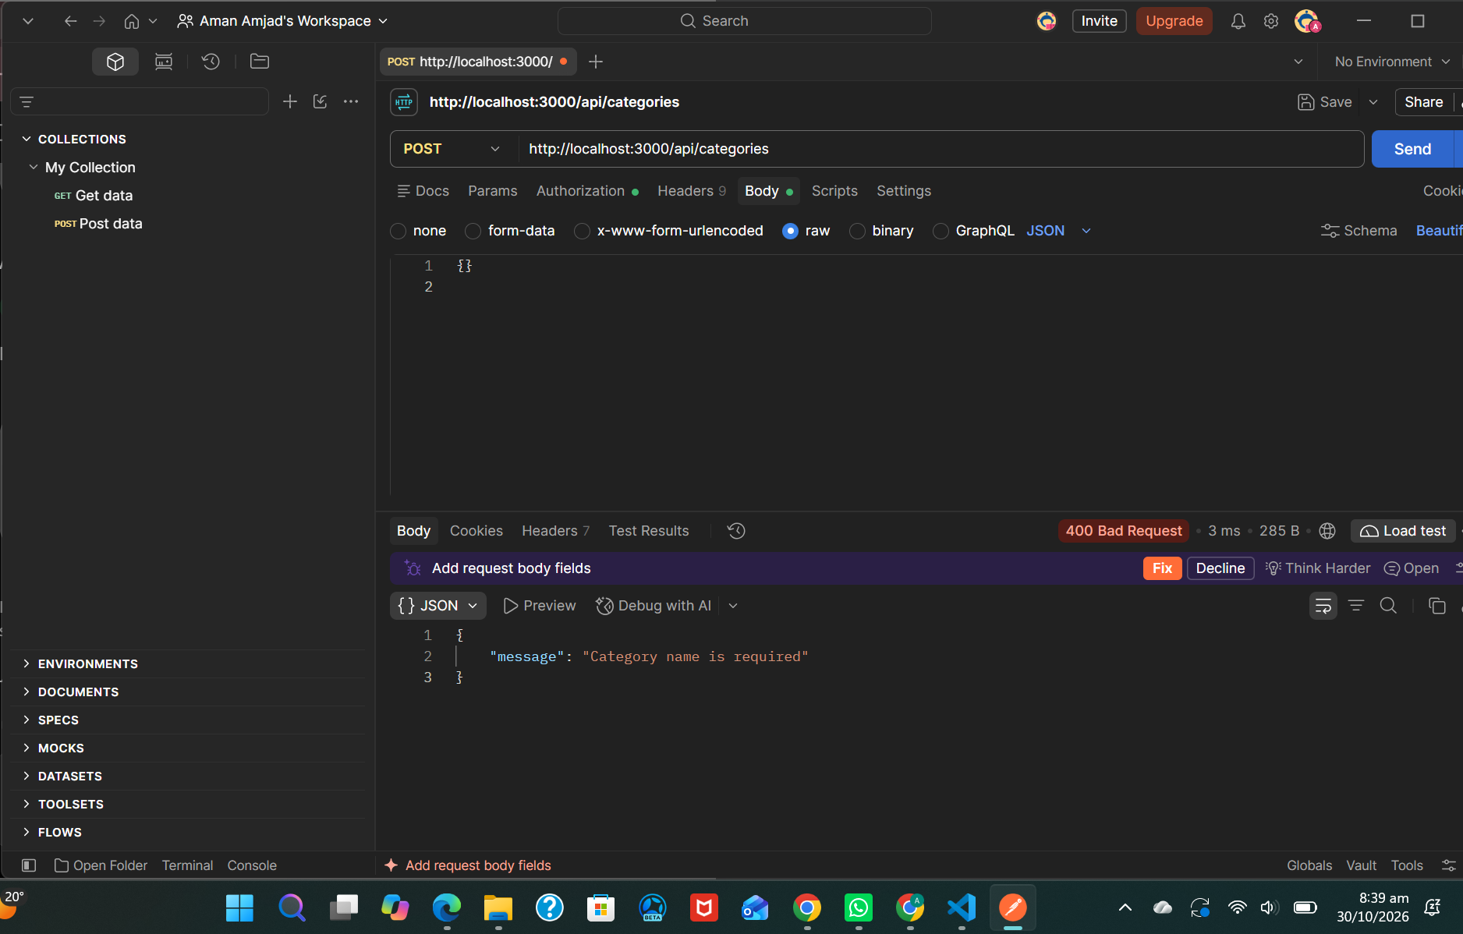

Screenshot 5: Not Found (404 Not Found)

GET /api/categories/9999 (non-existent id)
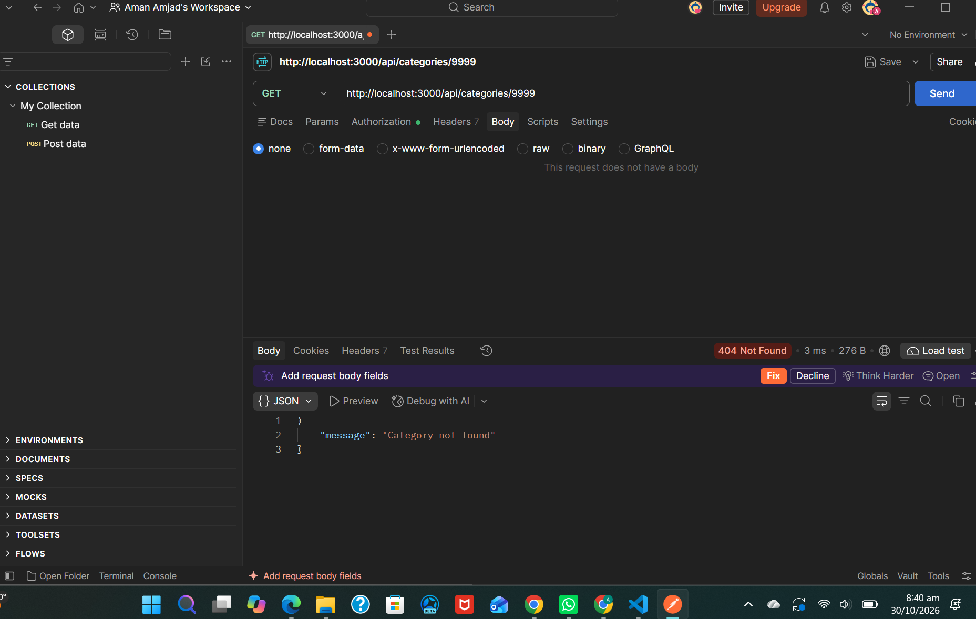

Additional: Server Setup & Running (VS Code Terminal)

A1. npm install and npm start (missing dotenv error)
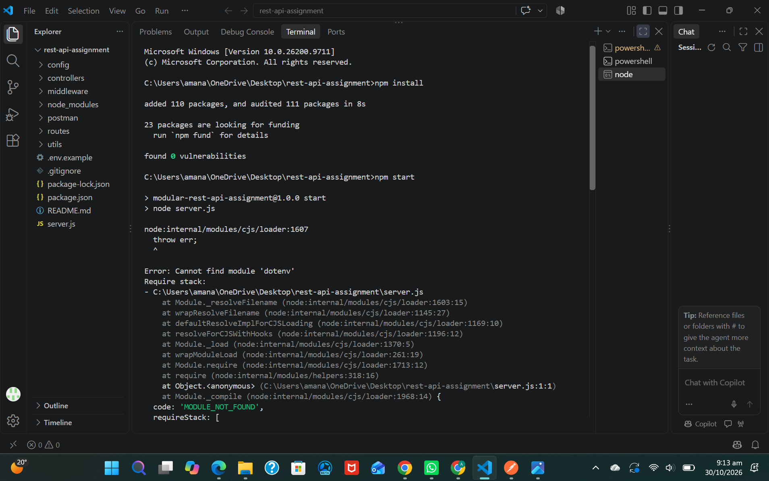

A2. After npm install dotenv: server running on port 3000
