**Name : Antuley Aman Siraj.**

**Roll No. : 23CO25.**

**Class : SE-CO**

**Batch : 01**

**Experiment - 08**

**Aim:** Perform DCL commands

**Execution :**

1. Create User :-

Create user <username> identified by <password>

Eg. Create user 23CO25 identified by 23CO25;

Output :

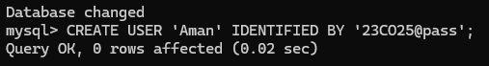

1. Grant permissions :-

Eg. Grant resource, connect to 23CO25;

Grant select, insert, delete, update on student to 23CO25;

Output :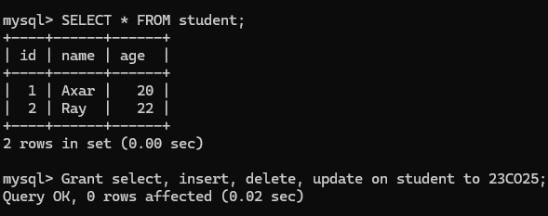

1. Revoke permissions

Eg.

Revoke select, resource, connect from 23CO25;

Revoke insert, delete, update on student from 23CO25;

Output :

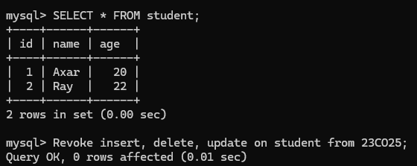

**Conclusion:** Hence we have implemented the various DCL commands