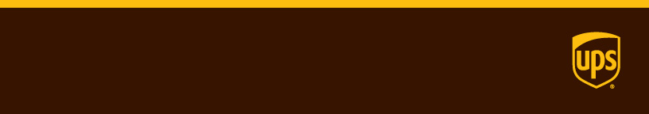

Release Notes

|  |  |  |
| --- | --- | --- |
| **Version 1.78.0**  Sprint end date: 03/09/2018  Branch: Gold  Commits:   * ef671cd * fe35031 –css * 5c2ab75 * 854729c -css * 8d1ebe9 –css * 13ab80a –css * f5d189f * a742ca6 * 68087b9 * be26763 * c7ff2d4 * b4ceadb * 6aa9e3b * c31d1b0 | | Features included  **Feature #1: TFS#560717**  **Feature #2: TFS#420614**  **Feature #3: TFS#595981**  **Feature #4: TFS#417832**  **Tasks Completed**   * **TFS#426973** * **TFS#588260**   [Company Name] |
| Additional Notes:   * Refactored references to Single Page. They now reference Compact View * Added the new date picker and info circle partials to NWS css * All NWS css updates for Compact View were moved to Staging. |  |

**Feature #1: 560717**

HTML: Ship To on separate screen in guided flow

Browser Path:

* NBS - <http://uidev.ups.com/nbs_spa.html#/gfWrapper/whereFrom>

Source Path:

* /P02SGit_UIDEV/src/apps/nbs/angular/component/gfWrapper_component.ts

Additional Notes:

* If you click the continue button Where To will appear as a separate view instead of below the existing view

**Feature #2: 420614**

HTML: UPS Premium Care

Browser Path:

* Guided Flow - <http://uidev.ups.com/nbs_spa.html#/gfWrapper/addons>
* Compact View - <http://uidev.ups.com/nbs_spa.html#/compactView>

Source Path:

* /P02SGit_UIDEV/src/apps/nbs/angular/templates/details_section.tpl.html
* /P02SGit_UIDEV/src/apps/nbs/angular/components/details_component.ts

Additional Notes:

* added UPS Premium Care toggle and review item

**Feature #3: 595981**

HTML: Assiging the correct LP or AH charge (7803)

Browser Path:

* Guided Flow - <http://uidev.ups.com/nbs_spa.html#/gfWrapper/what>
* Compact View - <http://uidev.ups.com/nbs_spa.html#/compactView>

Source Path:

* /P02SGit_UIDEV/src/apps/nbs/angular/templates/what_section.tpl.html
* /P02SGit_UIDEV/src/apps/nbs/angular/component/what_component.ts

Additional Notes:

* Added LP and AH checkboxes to the My Package view

**Feature #4: 417832**

HTML: PO Box on address

Browser Path:

* Guided Flow - <http://uidev.ups.com/nbs_spa.html#/gfWrapper/whereFrom>
* Compact View - <http://uidev.ups.com/nbs_spa.html#/compactView>

Source Path:

* /P02SGit_UIDEV/src/apps/nbs/angular/templates/whereFrom_section.tpl.html
* /P02SGit_UIDEV/src/apps/nbs/angular/component/whereFrom_component.ts
* /P02SGit_UIDEV/src/common/apps/assets/angular/template/cac.tpl.html

Additional Notes:

* Changed the subtext for the CB and added ups-form_group around the CB
* Toggled the Sure Post CB to visible.

**Task #1: 426973**

HTML: Pricing bar updates

Browser Path:

* NBS - <http://uidev.ups.com/nbs_spa.html#/compactView>

Source Path:

* /P02SGit_UIDEV/src/apps/nbs/angular/templates/balanceBar.tpl.html

Additional Notes:

* Removed duplicate Fuel Surcharge.

**Task #2: 588260**

HTML: Add Carbon Neutral and Print Label Instructions to preferences on confirmation page

Browser Path:

* Guided Flow - <http://uidev.ups.com/nbs_spa.html#/confirmation>

Source Path:

* /P02SGit_UIDEV/src/apps/nbs/angular/templates/conf_section.tpl.html

Additional Notes:

* Updated content in the checkbox group for states
  + Default
  + w/Pickup - w/AP delivery
  + w/ Shipping Ticket
  + Set Perfrences - 1st time