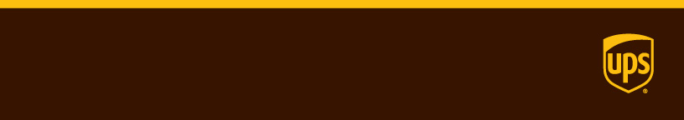

Release Notes

|  |  |  |
| --- | --- | --- |
| **Version 1.73.0**  Sprint end date: 02/02/2018  Branch: Gold  Commits:   * ba7cee1 * 00a4242 * 49859e7 * ae329be * 40c6834 (CSS Update) * 61138b1 * e622da4 * 44e09b9   Additional Notes:   * This task was specifically focused on delivering section 8, 9, 10, 11, 12, and 13 of ER7806 PPC QV Admin D3. This includes pages 41 – 51 of the spec. The rest of the spec will be delivered in subsequent releases. | | Features included  **Feature #1: JIRA USPO-2740**  [Company Name] |
|  |  |

**Feature #1: JIRA UPSO-2850**

ER7806 PPC QV Admin D3 Section 8, 9, 10, 11, 12, and 13 Only

Browser Path:

* View Outbound Page - <http://uidev.ups.com/ppcProfile.html#/preferencePage/quantumView/viewOutbound>
* View Third Party - <http://uidev.ups.com/ppcProfile.html#/preferencePage/quantumView/viewThirdParty>
* View Imports - <http://uidev.ups.com/ppcProfile.html#/preferencePage/quantumView/viewImportAccounts>
* View Inbound - <http://uidev.ups.com/ppcProfile.html#/preferencePage/quantumView/viewInbound>
* Update Account Nickname - <http://uidev.ups.com/ppcProfile.html#/preferencePage/quantumView/updateAcctNickname>
* Create Inbound Location - <http://uidev.ups.com/ppcProfile.html#/preferencePage/quantumView/viewInbound/createInboundLocation>

Source Path:

* src/apps/ppc/assets/angularjs/_templates/ups.ppc-preference-quantumView-users.html
* src/apps/ppc/assets/angularjs/_templates/ups.ppc-preference-quantumView-viewImports.html
* src/apps/ppc/assets/angularjs/_templates/ups.ppc-preference-quantumView-viewInbound.html
* src/apps/ppc/assets/angularjs/_templates/ups.ppc-preference-quantumView-viewOutbound.html
* src/apps/ppc/assets/angularjs/_templates/ups.ppc-preference-quantumView-viewThirdParty.html
* src/apps/ppc/assets/angularjs/_templates/ups.ppc-preference-quantumView-companyServices.html
* src/common/wem/assets/sass/bootstrap/_BS04_table.scss
* src/apps/ppc/assets/angularjs/controllers/ups.ppc.quantumView.controller.js
* src/apps/ppc/assets/angularjs/_templates/ups.ppc-preference-quantumView-createInboundLocation.html
* src/apps/ppc/assets/angularjs/_templates/ups.ppc-preference-quantumView-updateAccountNickname.html
* src/common/apps/assets/angularjs/Base/directives/ups.DOApp.directives.js
* src/common/apps/assets/angularjs/Base/ups.DOApp.js
* src/common/apps/assets/angularjs/Base/services/ups.config.js

Additional Notes:

* “Remove” links on tables will be converted to buttons since they will open up on modals in a subsequent ticket