1. Display your bio-data using Java. It should have Student class to fill your student details, an Address class to display your address, an array of Contact no.s, Family details.

***Answer:import javax.swing.*;***

***import java.awt.*;***

***import java.awt.event.*;***

***class Biodata extends JFrame***

***{***

***private JLabel l1,l2,l3;***

***private JTextField n;***

***private JRadioButton r1,r2;***

***private ButtonGroup g;***

***private JCheckBox c1,c2,c3;***

***private JTextArea a;***

***private JButton b;***

***Biodata()***

***{***

***super("Enter Biodata");***

***Container c = getContentPane();***

***c.setLayout(new FlowLayout());***

***l1 = new JLabel("Name");***

***c.add(l1);***

***n = new JTextField("Enter your name",20);***

***n.setToolTipText("Please enter your name");***

***c.add(n);***

***r1 = new JRadioButton("Male",true);***

***c.add(r1);***

***r2 = new JRadioButton("Female",false);***

***c.add(r2);***

***g = new ButtonGroup();***

***g.add(r1);***

***g.add(r2);***

***l2 = new JLabel("Qualification");***

***c.add(l2);***

***c1 = new JCheckBox("BTech");***

***c.add(c1);***

***c2 = new JCheckBox("MTech");***

***c.add(c2);***

***c3 = new JCheckBox("MCA");***

***c.add(c3);***

***l3 = new JLabel("Address");***

***c.add(l3);***

***a = new JTextArea(10,15);***

***c.add(a);***

***b = new JButton("Show");***

***c.add(b);***

***Handler h = new Handler();***

***b.addActionListener(h);***

***this.setDefaultCloseOperation(JFrame.EXIT_ON_CLOSE);***

***pack();***

***setVisible(true);***

***}***

***class Handler implements ActionListener***

***{***

***public void actionPerformed(ActionEvent e)***

***{***

***String s = ""+n.getText()+"\n";***

***s += (r1.isSelected())?r1.getText()+"\n":r2.getText() +"\n";***

***if(c1.isSelected()) s += (c1.getText()) + " ";***

***if(c2.isSelected()) s += (c2.getText()) + " ";***

***if(c3.isSelected()) s += (c3.getText());***

***s += "\n"+a.getText()+"\n";***

***JOptionPane.showMessageDialog(null,s);***

***}***

***}***

***public static void main(String args[])***

***{***

***new Biodata();***

***}***

***}***

1. Create a HTML page displaying a list of products of a particular category for example soaps, it should contain soap image and below the name of the soap. Clicking on the product name (soap) should take you to a product specification page where the different parameters of the product will be specified.

***Answer:***

***Main File:***

<html>

<head>

<title>Buttermilk Pancakes Recipe</title>

<meta name="viewport" content="width=device-width, initial-scale=1.0">

<style>

@media only screen and (min-width: 750px){

body{

background-color: #fadb14;

font-size:17px;

padding: 0;

margin: 0;

}

.NavSystem{

background-color: #f2c95e;

border-color:#ed9200;

padding:0px

text-align:center;

}

.Navigation{

font-family:Copperplate Gothic;

font-size: 20px;

display:flex;

padding:0 0;

justify-content:space-around;

}

.Navigation li:hover{

background-color:chocolate;

}

.Navigation li:before{

content: none;

}

.Navigation a{

text-decoration: none;

color:white;

display:block;

padding: 0px 10px;

}

.heading{

text-align: center;

color: #3d3837;

background-color: #ed5732;

border-radius:25px;

text-decoration: underline #3d3837;

font-family: Elephant;

margin: 0px 200px;

border-style:inset;

border-width:3px;

border-color:#e8471e;

margin-top:10px;

}

ol{

list-style-type:upper-roman;

}

ul{

list-style:none;

}

ul li:before{

content:"\1F600";

display:inline-block;

width:3em;

}

.ingredients{

margin-right:50px;

}

.items{

border-radius:20px;

background-color: #e0dede;

padding-top:15px;

padding-bottom:15px;

font-family:Eras ITC;

font-size:16px;

margin-right:200px;

padding-right:10px;

}

.images{

display:flex;

justify-content:center;

flex-flow:row wrap;

}

.images li:before{

content:none;

}

.images img{

border-radius:10%;

margin:0 10px;

width:200px;

height:auto;

}

.images img:hover{

width:300px;

height:auto;

}

h3.Extras{

text-align:center;

background-color:#edac32;

font-family:forte;

font-size:25px;

margin:0px 100px;

border-style:inset;

border-color:#f09d02;

}

span{

font-style:italic;

}

.Pancake-Color{

font-style:normal;

color:red;

}

.Taste{

text-decoration:underline;

}

article{

display:flex;

flex-flow:row wrap;

justify-content:center;

}

h1+p{

text-align:center;

}

h3+p{

text-align:center;

}

.recipe{

width:500;

padding:0px 20px;

}

.body2{

padding: 0px 20px;

}

.Nutritions{

justify-content:center;

}

}

@media only screen and (min-width:401px) and (max-width:749px){

body{

background-color: #fadb14;

font-size:17px;

margin: 0;

}

.NavSystem{

background-color: #f2c95e;

border-color:#ed9200;

padding:0px

text-align:center;

}

.Navigation{

font-family:Copperplate Gothic;

font-size: 10px;

display:flex;

padding:0 0;

justify-content:space-around;

}

.Navigation li:hover{

background-color:chocolate;

}

.Navigation li::before{

content: none;

}

.Navigation a{

text-decoration: none;

color:white;

display:block;

padding: 0px 10px;

}

.heading{

text-align: center;

color: #3d3837;

background-color: #ed5732;

border-radius:25px;

text-decoration: underline #3d3837;

font-family: Elephant;

border-style:inset;

border-width:3px;

border-color:#e8471e;

margin-top:10px;

}

ol{

list-style-type:upper-roman;

}

ul{

list-style:none;

}

ul li:before{

content:"\1F600";

display:inline-block;

width:3em;

}

.items{

border-radius:20px;

background-color: #e0dede;

padding-top:15px;

padding-bottom:15px;

font-family:Eras ITC;

font-size:16px;

margin-right:40px;

padding-right:10;

}

.recipe{

width:300;

padding:0px 20px;

}

.images{

display:flex;

justify-content:center;

flex-flow:row wrap;

}

.images li:before{

content:none;

}

.images img{

border-radius:10%;

margin:0 10px;

width:200px;

height:auto;

}

.images img:hover{

width:300px;

height:auto;

}

.body2{

padding: 0px 20px;

}

h1+p{

text-align:center;

}

h3+p{

text-align:center;

}

.Taste{

text-decoration:underline;

}

.span{

font-style:italic;

}

.Pancake-Color{

font-style:normal;

color:red;

}

h3.Extras{

text-align:center;

background-color:#edac32;

font-family:forte;

font-size:25px;

margin:0px 10px;

border-style:inset;

border-color:#f09d02;

}

article{

display:flex;

flex-flow:row wrap;

justify-content:center;

}

.ref{

margin-right:70px;

}

}

@media only screen and (max-width: 400px)

{

body{

background-color: #fadb14;

font-size:17px;

margin: 0;

}

.NavSystem{

background-color: #f2c95e;

border-color:#ed9200;

padding:0px

text-align:center;

}

.Navigation{

font-family:Copperplate Gothic;

font-size: 10px;

display:flex;

flex-flow:wrap;

padding:0 0;

justify-content:space-around;

}

.Navigation li:hover{

background-color:chocolate;

}

.Navigation li::before{

content: none;

}

.Navigation a{

text-decoration: none;

color:white;

display:block;

padding: 0px 10px;

}

.heading{

text-align: center;

color: #3d3837;

background-color: #ed5732;

border-radius:25px;

text-decoration: underline #3d3837;

font-family: Elephant;

border-style:inset;

border-width:3px;

border-color:#e8471e;

margin-top:10px;

}

ol{

list-style-type:upper-roman;

}

ul{

list-style:none;

}

ul li:before{

content:"\1F600";

display:inline-block;

width:3em;

}

.recipe{

padding:0px 20px;

}

.items{

border-radius:20px;

background-color: #e0dede;

padding-top:15px;

padding-bottom:15px;

font-family:Eras ITC;

font-size:16px;

}

.images{

display:flex;

justify-content:center;

flex-flow:row wrap;

}

.images li:before{

content:none;

}

.images img{

border-radius:10%;

margin-right:30px;

width:100px;

height:auto;

}

.images img:hover{

width:150px;

height:auto;

}

.body2{

padding: 0px 20px;

}

h1+p{

text-align:center;

}

h3+p{

text-align:center;

}

.Taste{

text-decoration:underline;

}

.span{

font-style:italic;

}

.Pancake-Color{

font-style:normal;

color:red;

}

h3.Extras{

text-align:center;

background-color:#edac32;

font-family:forte;

font-size:25px;

margin:0px 10px;

border-style:inset;

border-color:#f09d02;

}

article{

display:flex;

flex-flow:row wrap;

justify-content:center;

}

.ref{

margin-right:70px;

}

}

</style>

</head>

<body>

<div class="NavSystem">

<ul class="Navigation">

<li><a href="#Types">Go to Types</a></li>

<li><a href="#Images">Go to Images</a></li>

</ul>

</div>

<div class="body2">

<!--Main Heading-->

<h1 class="heading">Soap</h1>

<p class="first"><em>Soaps</em> are very necessary to maintain daily hygiene.</p>

<article>

<div class="Types">

<p><h3>So here is a list of soaps which you can use :</h3></p>

<ul class="items">

<li>Bathing Soap</li>

<li>Dish washing Soap</li>

<li>Laundry Soap</li>

</ul>

</div>

</article>

<!--Final Look-->

<h3 class="Extras" id="Images"><u>Images of the Soap</u>:</h3>

<p class="Extras">These are the images of the soaps:</p>

<ul class="images">

<div>

<li><a href="bathsoap.html"><img src="bathingsoap.jpg" alt="Take a bath"></li></a>

<li><a href="laundrysoap.html"><img src="LaundrySoap.jpg" alt="Wash clothes"></li></a>

<li><a href="dishsoap.html"><img src="vimbar.jpg" alt="Do your laundry"></li></a>

</div>

</ul>

</body>

</html>

***Hyperlink File 1:***

<html>

<head>

<title>bathsoap</title>

<head>

<style type="text/css">

body{

background-color: #fadb14;

font-size:17px;

padding: 0;

margin: 0;

}

</style>

</head>

<body>

<h3><u>Characteristics:</u></h3>

<ol>

<li>It helps to maintain your hygiene.</li>

<li>It has low concentration of hard material which is safe for your skin.</li>

<li>It has milk essence in it which makes you fragrant.</li>

<li>It reduces sweat flow and maintain freshness.</li>

</ol>

</body>

</head>

</html>

***Hyperlink File 2:***

<html>

<head>

<title>laundrysoap</title>

<head>

<style type="text/css">

body{

background-color: #fadb14;

font-size:17px;

padding: 5;

margin: 5;

}

</style>

</head>

<body>

<h3><u>Characteristics:</u></h3>

<ol>

<li>It helps to remove stain.</li>

<li>It removes any spots in your clothes.</li>

<li>It easily kills all the harmful microbes on your clothes.</li>

<li>It has fibre soothing cheicals.</li>

</ol>

</body>

</head>

</html>

***Hyperlink file 3:***

<html>

<head>

<title>dishsoap</title>

<head>

<style type="text/css">

body{

background-color: #fadb14;

font-size:17px;

padding: 5;

margin: 5;

}

</style>

</head>

<body>

<h3><u>Characteristics:</u></h3>

<ol>

<li>It helps to maintain utensils hygiene.</li>

<li>It has lemon and basil essence which helps in killing germs.</li>

<li>It kills 99.9% germs.</li>

<li>It removes oiliness.</li>

</ol>

</body>

</head>

</html>

***OUTPUT:***

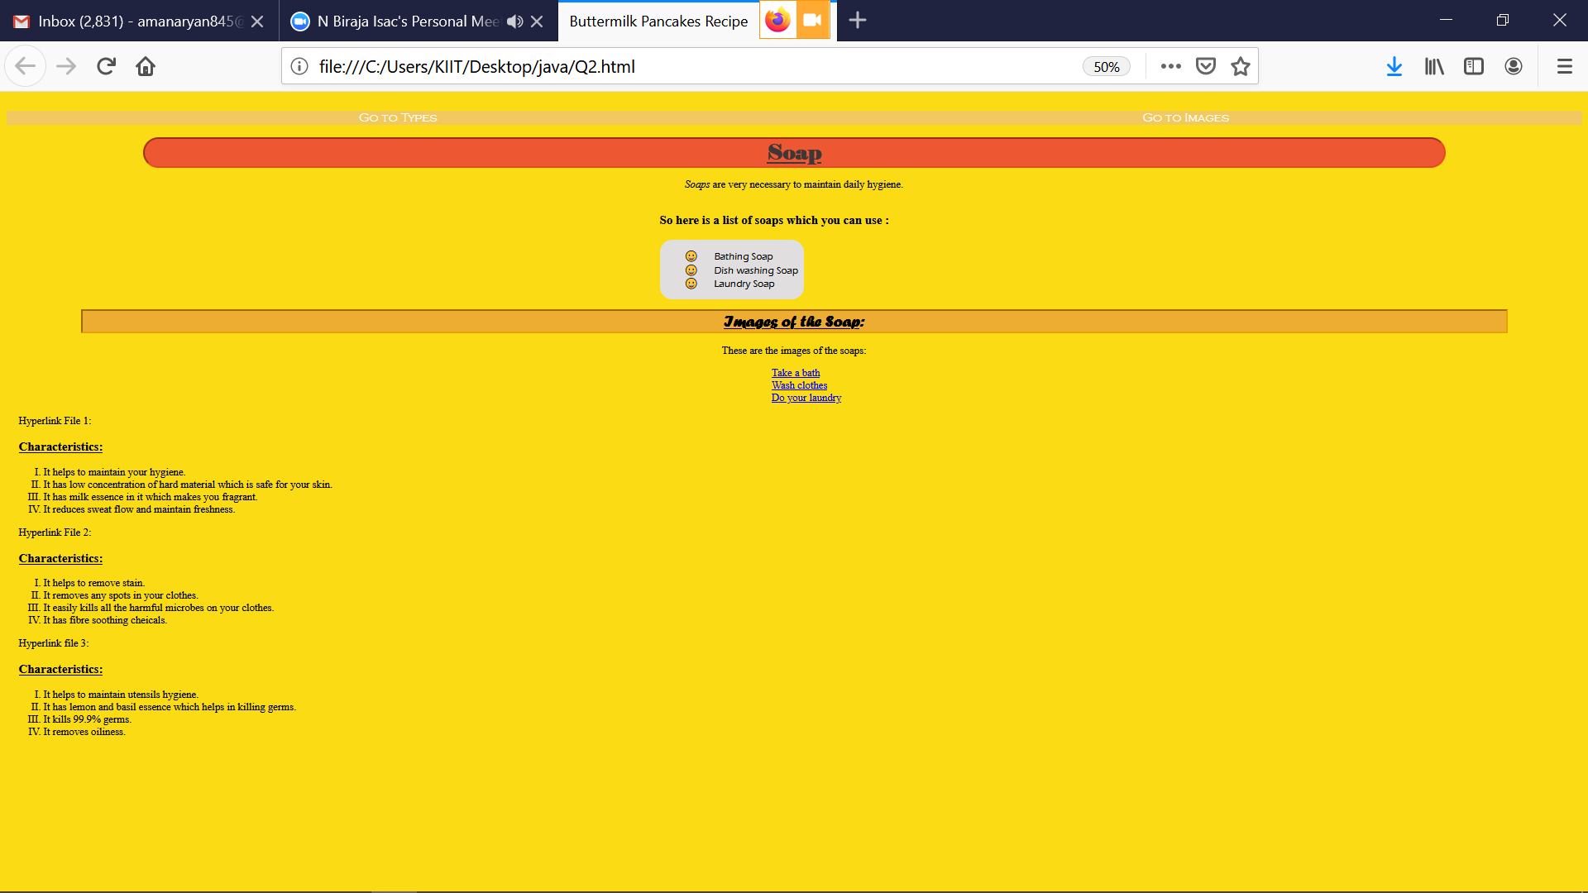

4. Choose an array of your favorite book names. Perform the following String operations on the array. (i) convert them into uppercase and display

(ii) Add "The" in the beginning of each book name and - author name in the end and display.

(iii) Replace the middle of the book name with "-o-" for each book name and display.

***Answer:***

import java.io.*;

import java.util.*;

public class Q4

{

public static void main(String args[])

{

Scanner in=new Scanner(System.in);

System.out.println("Enter the amount of books");

int n,i,j,l;

n=in.nextInt();

String b[],a[]= new String[n];

for(i=0;i<n;i++)

{

System.out.println("Enter the name of the book");

a[i]=in.next();

}

b= new String[n];

for(i=0;i<n;i++)

{

a[i]=a[i].toUpperCase();

b[i]=a[i];

a[i]="The "+a[i];

System.out.println("Enter name of the author");

String s=in.next();

a[i]=a[i]+" "+s;

}

System.out.println("Print Type 1");

for(i=0;i<n;i++)

{

System.out.println(a[i]);

}

for(i=0;i<n;i++)

{

l=b[i].length();

String f,e,tf,te;int fi,li,ll;

ll=a[i].length();

fi=a[i].indexOf(" ");

li=a[i].lastIndexOf(" ");

f=b[i].substring(0,((l/2)));

e=b[i].substring(((l/2)+1),l);

b[i]=f+"o"+e;

a[i]=a[i].substring(0,fi)+" "+b[i]+" "+a[i].substring(li,ll);

}

System.out.println("Print Type 2");

for(i=0;i<n;i++)

{

System.out.println(a[i]);

}

}

}

***OUTPUT:***

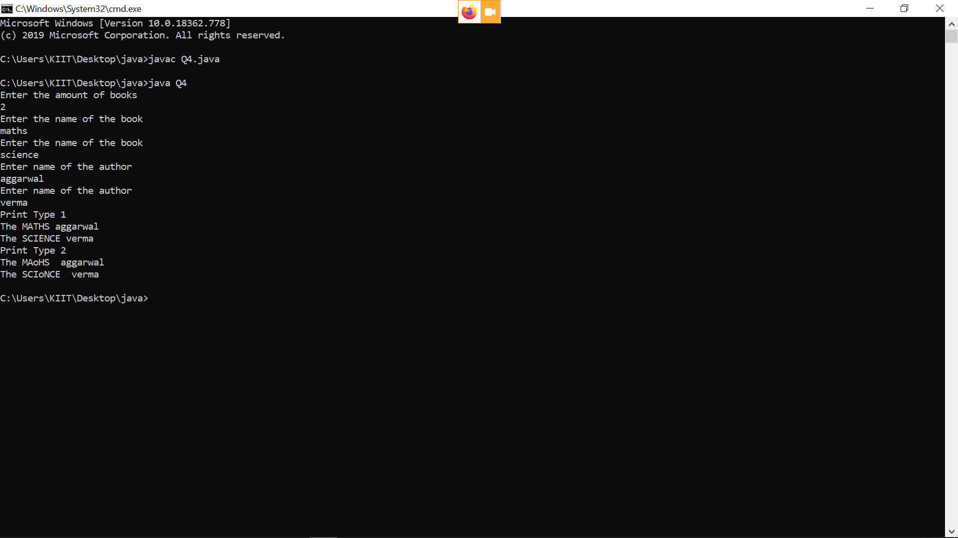

1. You are entering an integer from the keyboard. Your Java program is meant to parse the integer and store it in a integer variable. Suppose by mistake you have entered a string. Demonstrate how you will handle the exception through the program.

***Answer:***

import java.io.*;

import java.util.*;

public class Q5

{

static int inp()

{

Scanner in= new Scanner(System.in);

int i=in.nextInt();

return i;

}

public static void main(String args[])

{

Scanner in= new Scanner(System.in);

int i;

System.out.println("Enter an integer");

try{

i=inp();

}

catch(Exception e)

{

System.out.println("String Entered, Input only integer");

inp();

}

}

}

***OUTPUT:***