E-COMMERCE SALES ANALYTICS PROJECT

1. Project Overview:
This project focuses on analysing e-commerce sales data to identify important patterns and insights related to revenue, orders, products, customers, countries, sales quantity, and purchasing time patterns.
The project uses a complete data analytics workflow, beginning with data cleaning and exploratory data analysis in Python, followed by SQL-based analysis using MySQL, and finally the development of an interactive Power BI dashboard.
The analysis is based on the Online Retail dataset, which contains transactional information such as invoice numbers, product details, quantities, prices, invoice dates, customer IDs, and countries.
The main objective of the project is to transform raw transactional data into meaningful business insights that can help understand sales performance, customer purchasing behaviour, product performance, and geographical sales distribution.

2. Project Objective:
The key objectives of this project are:
  - To clean and prepare the raw e-commerce dataset for analysis.
  - To perform exploratory data analysis using Python.
  - To analyse sales data using SQL queries in MySQL.
  - To calculate important business KPIs such as Total Revenue, Total Orders, Total Quantity, Average Order Value, and Identified Customers.
  - To identify the top-performing products, customers, and countries.
  - To analyse revenue patterns across different hours and months.
  - To create an interactive Power BI dashboard for visual analysis.
  - To convert raw transactional data into actionable business insights.

3. Dataset Description:
The dataset used for this project is the Online Retail dataset, which contains transactional records from an e-commerce retail business.
The dataset includes information about customer purchases, products, quantities, prices, transaction dates, customer identification numbers, and countries. Each record represents a product-level transaction associated with an invoice.
Main Variables
Column | Description
Invoice No | Unique invoice number representing a transaction/order
Stock Code | Unique code assigned to a product
Description | Name or description of the product
Quantity | Number of units purchased
Invoice Date | Date and time of the transaction
Unit Price | Price per unit
Customer ID | Unique customer identification number
Country | Country associated with the customer
Revenue | Calculated sales value based on quantity and unit price

Data Preparation:
The raw dataset was cleaned and prepared using Python before further analysis. The cleaned data was then used for MySQL analysis and imported into Power BI to create the final interactive dashboard.

4. Tools and Technologies Used:
The project was completed using a combination of data analysis, database management, and data visualization tools.
Tool / Technology | Purpose
Python | Data cleaning, preprocessing and exploratory data analysis
Pandas | Data manipulation and analysis
Matplotlib | Data visualization during exploratory analysis
Jupyter Notebook | Developing and documenting Python analysis
MySQL | SQL-based data analysis and querying
Power BI | Interactive dashboard development and visualization
DAX | Creating calculated measures and KPIs in Power BI
Microsoft Excel | Initial handling and review of the dataset

Project Workflow:
Python → MySQL → Power BI
- Python: Cleaned and explored the dataset.
- MySQL: Performed structured SQL analysis.
- Power BI: Created an interactive dashboard to present the findings.

5. Python Data Cleaning and Exploratory Data Analysis:
Python was used as the first stage of the data analytics process. The raw Online Retail dataset was examined, cleaned, and prepared for further analysis.
5.1 Data Cleaning: The following preprocessing activities were performed:
- Examined the structure and data types of the dataset.
- Checked for missing values in important columns.
- Removed records that were not suitable for sales analysis.
- Converted relevant columns into appropriate data types.
- Created a Revenue column using Quantity × Unit Price.
- Checked the dataset for inconsistencies and duplicate records.
- Prepared the cleaned dataset for SQL analysis and Power BI visualization.
5.2 Exploratory Data Analysis: Exploratory analysis was performed to understand the major characteristics and patterns in the sales data.
The analysis focused on:
- Overall sales/revenue performance.
- Order and quantity patterns.
- Top-performing products.
- Customer purchasing patterns.
- Country-wise sales performance.
- Monthly revenue trends.
- Revenue distribution across different hours of the day.
5.3 Key Python Findings:
The cleaned dataset contained the transactional information required for the subsequent SQL and Power BI analysis.
The Python analysis helped identify important sales patterns and provided a reliable foundation for the next stages of the project.
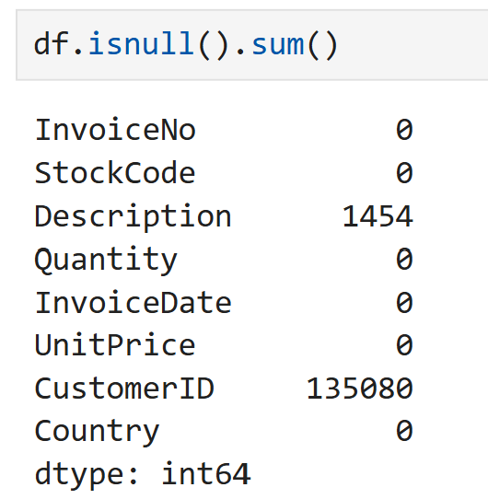
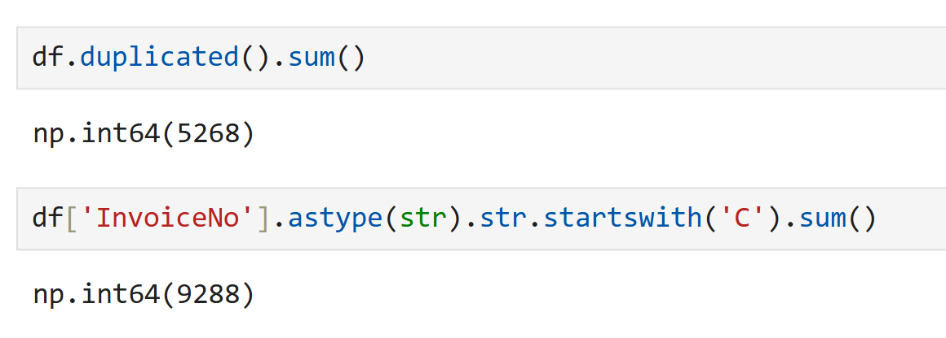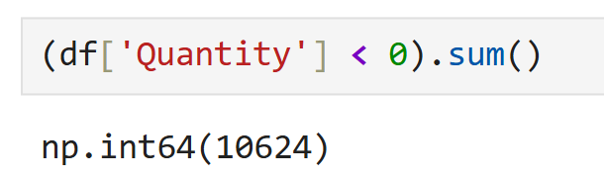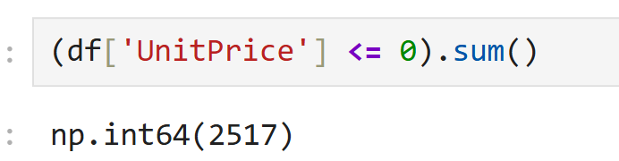
Figure 2: Python Data Cleaning and Exploratory Analysis
6. MySQL Data Analysis:
MySQL was used to perform structured analysis on the cleaned e-commerce dataset. SQL queries were written to examine sales performance, customer behaviour, product performance, and geographical distribution.
6.1 SQL Analysis Performed: The analysis included:
- Calculating total revenue.
- Calculating the total number of orders.
- Calculating total quantity sold.
- Finding the average order value.
- Identifying top-performing products.
- Identifying top customers based on revenue and order activity.
- Analysing revenue by country.
- Analysing sales and purchasing patterns.
- Sorting and filtering records to obtain meaningful business insights.
6.2 SQL Techniques Used: The project used SQL concepts such as:
- SELECT
- WHERE
- GROUP BY
- ORDER BY
- Aggregate functions such as SUM(), COUNT(), and AVG()
- DISTINCT
- Filtering and sorting
- Calculated expressions
6.3 Purpose of SQL Analysis:
The SQL stage helped transform the cleaned transactional data into summarized information that could be used to understand business performance and support the visual analysis created later in Power BI.
7. Power BI Dashboard Development:
Power BI was used to transform the analysed e-commerce data into an interactive dashboard. The dashboard provides a visual overview of sales performance and allows users to explore the data using a date filter.
7.1 Key Performance Indicators:
The dashboard includes the following KPIs:
KPI | Value
Total Revenue | £10.64M
Total Orders | 19.96K
Total Quantity | 5.57M
Average Order Value | £533.17
Identified Customers | 4.34K
7.2 Dashboard Visualizations:
The dashboard contains:
- Monthly Revenue Trend — shows revenue movement across months.
- Top 10 Countries by Revenue — identifies countries generating the highest revenue.
- Top 10 Products by Revenue — highlights the highest-revenue products.
- Top 10 Customers by Revenue — identifies customers contributing the most revenue.
- Top 10 Customers by Orders — shows customers with the highest number of orders.
- Top 10 Countries by Quantity — compares the quantity sold across countries.
- Revenue by Hour of Day — shows when revenue is generated throughout the day.
- Top 10 Countries by Revenue — Share — presents the revenue contribution of leading countries.
- Date Filter — allows users to interactively filter the dashboard by transaction date.

  - DAX Measures: The following DAX measures were created:

- Total Revenue = SUM(ecommerce_sales_cleaned[Revenue])
- Total Orders = DISTINCTCOUNT(ecommerce_sales_cleaned[InvoiceNo])
- Total Quantity = SUM(ecommerce_sales_cleaned[Quantity])
- Average Order Value =DIVIDE([Total Revenue],[Total Orders])
- Identified Customers
=DISTINCTCOUNT(ecommerce_sales_cleaned[CustomerID])
A calculated column was also created to handle missing customer IDs in the customer charts:
- CustomerID_Clean =IF(ISBLANK(ecommerce_sales_cleaned[CustomerID]),"00000",ecommerce_sales_cleaned[CustomerID])
Note: 00000 is a display placeholder for transactions where a CustomerID was unavailable; it does not represent an actual customer.
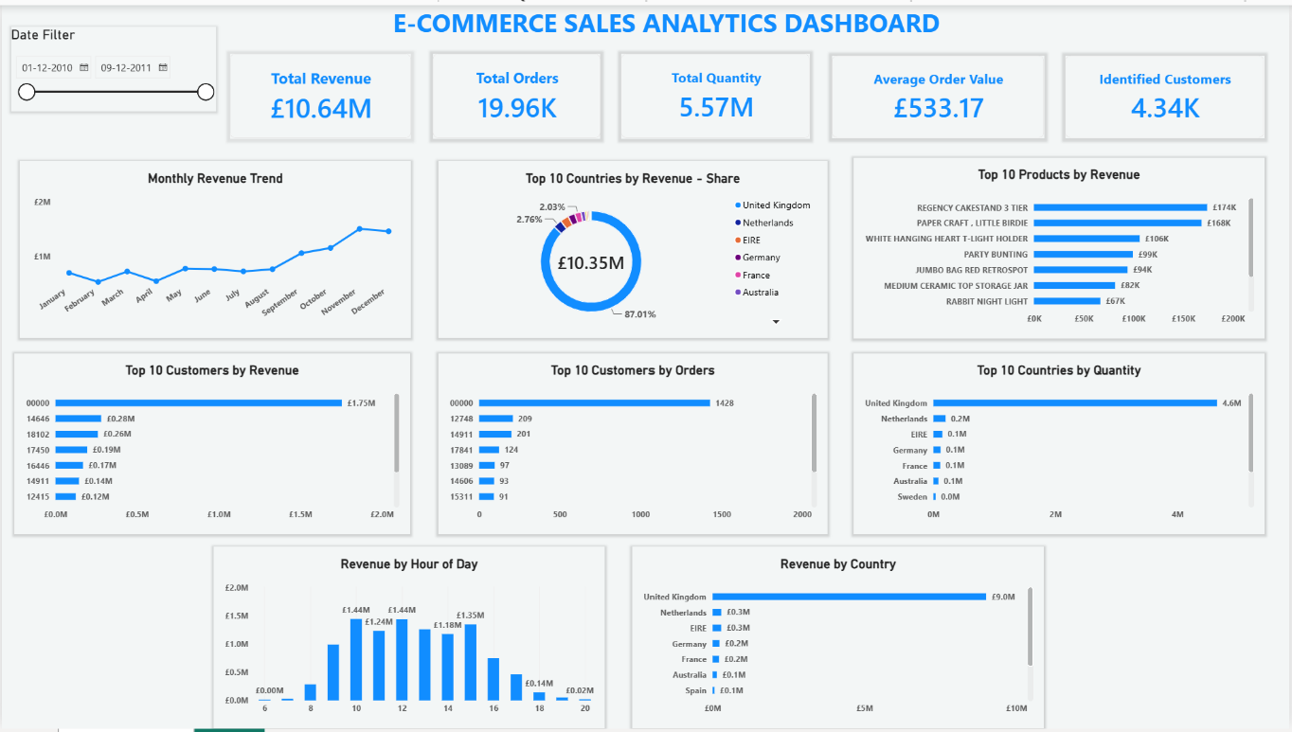
Figure 1: E-Commerce Sales Analytics Dashboard

8. Key Business Insights:
The analysis of the e-commerce dataset produced several important insights regarding revenue, orders, customers, products, and geographical performance.
- Overall Sales Performance: The business generated approximately £10.64 million in total revenue from 19,960 orders, with approximately 5.57 million units sold. The calculated average order value was approximately £533.17.
- Country-wise Performance: The country analysis shows that revenue is concentrated among a relatively small number of markets. The dashboard's Top 10 Countries by Revenue visualization makes it possible to compare the contribution of major markets.
- Product Performance: The Top 10 Products by Revenue visualization highlights the products contributing the highest revenue. This helps identify products that have a significant impact on overall sales.
- Customer Performance: Customer-level analysis was performed using both revenue and order frequency. The Top 10 Customers by Revenue and Top 10 Customers by Orders visuals provide two different perspectives on customer contribution.
- Time-based Sales Pattern: The Monthly Revenue Trend shows changes in revenue across the available months, while the Revenue by Hour of Day visualization highlights differences in revenue generation throughout the day.
- Interactive Analysis: The Power BI date filter allows users to select a specific date range and dynamically examine the corresponding sales performance.
Data limitation: The dataset ends during December 2011, so December represents only a partial month and should not be interpreted as a complete-month performance figure.

9. Business Recommendations:
Based on the analysis performed using Python, MySQL, and Power BI, the following areas can be considered for business improvement:
- Focus on high-revenue markets: Countries contributing significant revenue can be monitored closely and studied for opportunities to maintain and expand sales.
- Monitor high-performing products: Products generating substantial revenue can be tracked for inventory planning and continued availability.
- Understand customer value: Customers with high revenue contribution or frequent orders can be analysed to understand purchasing behaviour and improve customer retention strategies.
- Use time-based sales patterns: Revenue patterns by hour can help businesses understand periods of higher activity and support operational planning.
- Track sales trends regularly: Monthly revenue trends can be monitored to identify changes in sales performance and support future planning.
- Use interactive dashboards for decision-making: The Power BI dashboard can provide management with a convenient way to explore sales performance across different dates, products, customers, and countries.
These recommendations are based on the patterns identified in the available dataset and can be further evaluated using more recent and complete business data.

10. Conclusion:
This project provided an end-to-end analysis of e-commerce sales data using Python, MySQL, and Power BI. The analysis began with data cleaning and exploratory analysis in Python, followed by structured SQL analysis in MySQL and interactive visualization in Power BI.
The project helped transform raw transactional data into meaningful information about revenue, orders, quantity sold, customers, products, countries, and purchasing time patterns. The calculated KPIs provided an overall view of sales performance, while the detailed visualizations helped identify differences across products, customers, geographical markets, months, and hours of the day.
Python played an important role in preparing and understanding the dataset before analysis. Data cleaning ensured that the information was suitable for further processing, while exploratory analysis helped identify important patterns within the transactions.
MySQL was then used to perform structured analysis of the cleaned data. SQL queries helped summarize the dataset and examine different aspects of business performance, including revenue, orders, products, customers, and countries. This stage demonstrated how database querying can be used to convert large transactional datasets into useful analytical information.
Power BI brought the different analytical findings together into an interactive dashboard. The dashboard presents important KPIs and visualizations in a single interface, allowing users to explore sales performance through different perspectives. The date filter also provides interactive analysis by allowing users to examine selected periods.
One important consideration is that the dataset contains transactions only through 9 December 2011, meaning December does not represent a complete month. Therefore, comparisons involving December should be interpreted with this limitation in mind.
Overall, the project demonstrates a complete data analytics workflow—from raw data preparation to analysis, visualization, and business insights. It provided practical experience in Python, SQL, Power BI, data cleaning, exploratory analysis, DAX, dashboard development, and analytical interpretation.
The project also demonstrates how data analytics can support business understanding by presenting complex transactional information in a structured and accessible form. The resulting dashboard can be used as a foundation for further analysis when additional or more recent sales data becomes available.

11. Skills and Learning Outcomes:
This project provided practical experience in the complete data analytics workflow and strengthened the following skills:
- Python: Data cleaning, preprocessing, exploratory data analysis, and visualization.
- Pandas: Data manipulation and analysis.
- MySQL: SQL querying, filtering, grouping, sorting, and aggregation.
- Power BI: Dashboard development, data visualization, and interactive filtering.
- DAX: Creation of calculated measures and KPIs.
- Data Visualization: Presenting analytical findings through charts, KPIs, and dashboards.
- Business Analysis: Interpreting sales, customer, product, geographical, and time-based patterns.
- Data Storytelling: Converting analytical results into clear and understandable business insights.
- Problem Solving: Identifying data issues and preparing the dataset for reliable analysis.

Overall Learning:
The project improved my understanding of how different analytical tools can be combined to solve a business problem. It provided practical experience in moving from raw transactional data to cleaned data, analytical queries, visual dashboards, and business insights.

