***Mohammad Amanat Karim  
 & Vanshika Gupta***

**DESCRIPTION OF APPLICATION**

**Purpose of the application:**

**The primary purpose of this database is to streamline the organization and tracking of appliance repair appointments. It aids both the technicians handling the repairs and the clients requiring these services. The system comprises four core tables:**

1. **Customer: Captures essential details about clients, including their contact and residential information.**
2. **Technician: Holds data about the repair technicians, such as their expertise level and contact details, ensuring the right technician is matched with a job.**
3. **Appointment: Records all repair appointments, detailing the involved customer, technician, and the nature of the service.**
4. **Servicing: Enumerates the various types of repair services, their associated costs, and the technician responsible for them.**

**Integrating these tables allows the database to provide real-time updates on repair specifics, available services, and their respective prices, ensuring efficient operations for all parties.**

**Applications used:**

**In our assignment focused on appointment scheduling and appliance repair, we utilized two primary applications to achieve our objectives: SSMS for the backend and MS Access for the frontend. Let us delineate the roles and functionalities of each.**

**1. SSMS (SQL Server Management Studio) - Backend:**

**In the backend, we employed SQL Server Management Studio (SSMS), which is an integrated environment adept at managing relational databases in Microsoft SQL Server. Here's a breakdown of what we accomplished:**

1. **Scripting: We scripted SQL commands to define, manipulate, and retrieve data.**
2. **ERD (Entity Relationship Diagram): We crafted an ERD to visually illustrate the relational structure of the database, showcasing the tables and their interrelations.   
   A screenshot of a computer

   Description automatically generated**
3. **Update, Insert, Delete: We executed these pivotal CRUD operations to manage our data, ensuring seamless data management.**
4. **Export: We employed this feature to extract data in various formats, be it for sharing or backup purposes.**
5. **Test Data: We incorporated test data to validate the database's functionality and reliability.**
6. **Backup: Recognizing the importance of data safety, we ensured regular backups of our database.**
7. **Restore: We also set up a process to restore the database from backups, safeguarding against potential data loss.**
8. **Execution: We ran several SQL queries and commands to interact and manage the database effectively.**

**2. MS Access - Frontend:**

**For the frontend, we leveraged Microsoft Access, a versatile DBMS from Microsoft. Here are the primary tasks we undertook:**

1. **Linking Tables from Backend: To ensure seamless frontend-backend communication, we linked tables from SSMS to MS Access. This allowed for real-time reflection of backend data on our frontend interfaces.**
2. **Creating Forms: To facilitate user interactions, we designed forms. This provided a user-friendly medium for data input and retrieval, bypassing the need for direct table interactions.**
3. **Reports: We generated comprehensive reports providing visual insights, summaries, and other data representations.**
4. **Updates and Inserts: We made it possible to execute updates and data insertions directly through our frontend forms.**
5. **Imports: We incorporated a mechanism to bring in data from external sources into our Access database seamlessly.**
6. **Relationships: While our ERD in SSMS served as a foundation, we further visualized and reinforced these relationships within MS Access.  
     
   A screenshot of a computer

   Description automatically generated**
7. **Execution: We enabled various operations from the frontend, such as generating reports or running queries, ensuring they intercommunicated effectively with our backend database.**

**In essence, while SSMS provided a robust and intricate backend platform for our database design and management, MS Access rendered an intuitive frontend interface. This dual utilization ensured a blend of potency in database operations and user accessibility. The result was a comprehensive, user-friendly appointment scheduling and appliance repair database system.**

**INSTRUCTIONS**

**Section 1 – How to use the front-end application (Access):**

**Purpose: Microsoft Access provides an efficient platform for organizing and presenting data, with its front-end serving as a streamlined interface for users. This manual is designed for a range of users, from beginners exploring the basics of Access to intermediate users refining data skills, professionals seeking actionable insights, and educators or students delving into practical database applications. By engaging with this guide, users will gain a clear understanding of Access's core functions, recognize the critical role of the front-end, and become adept in utilizing tools like forms and reports.**

**User Instructions to open and use MS Access database:  
  
1.** **To view the tables in MS Access database, Select the “Tables” menu from the Access objects bar. It will display the tables contained. Select and hit “Enter” any table to open it in the MS Access workspace.**

**2. To view the forms in MS Access database, Select the “Forms” menu from the Access objects bar. It will display the forms contained. Select and hit “Enter” any form to open it in the MS Access workspace.**

**3. To view the reports in MS Access database, Select the “Reports” menu from the Access objects bar. It will display the reports. Select and hit “Enter” any report to open it in the MS Access workspace.**

**User Instructions to fill the forms:**

**1. Customer Form:  
**

The customer will describe the problem they are facing using alphabetical letters.

Do not forget to add your email domain. e.g., @gmail.com

Use only 10-digit Number, do not use any special characters like hyphens (-). No need to mention any country code.

Enter the Address using Letters and Numbers separated by Commas (,)

Enter the name of the Customer. Use alphabetical letters only.

Do not input any data, it will be auto generated.

**2. Technician Form:  
**

The customer will describe the problem they are facing using alphabetical letters.

Do not forget to add your email domain. e.g., @gmail.com

Use only 10-digit Number, do not use any special characters such as hyphens (-). No need to mention any country code.

Enter the name of the Technician. Use alphabetical letters only.

Do not input any data, it will be auto generated.

**User Instructions to** **read the reports:**

1. **Customer Report:**A screenshot of a computer

   Description automatically generated
2. **Technician Report:**A screenshot of a computer

   Description automatically generated
3. **Servicing Report:**A screenshot of a service report

   Description automatically generated
4. **Appointment Report:**A close-up of a appointment report

   Description automatically generated

**Section 2** - **How to use the back-end application (SSMS):**

**Purpose: SQL Server Management Studio is a key tool for those working with database operations. It helps manage and protect data, and it comes with many features like running searches, designing databases, monitoring performance, and ensuring strong safety measures. When used for software applications, it makes sure data is accurate and trustworthy. Its easy-to-use design, paired with helpful tutorials and official instructions, is a great help. Overall, SSMS is not only a good tool for managing data but also a great way to learn about advanced database work.**

**Opening a Database:  
Open the SSMS file to open the database in Microsoft Server Management Server Studio (SSMS) to view, modify and update it.**

**Creating Tables:  
Step 1: Open the database and Open “New Query” from the Title ribbon as mentioned in the picture below.**

**Step 2: Run the SQL code to create a new table such as “Customer”, “Technician”, “Servicing” and “Appointment” using the syntax in the picture below.  
**

**Step 3: Run the SQL query using the “Execute” button in the Title bar.**

**Step 4: The table is created after the query is successfully executed in the bottom window.**

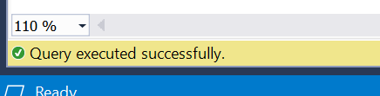

**Inserting values in a Table:**

**Step 1: Select the Database with the table to insert the values.**

**Step 2: Open a ‘Query’ to insert the data through ‘SQL’ statement scripts.**

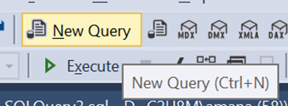

**Step 3: Insert the SQL script with the values for the tables using the syntax below.  
**

**Step 4: Execute the SQL script using the ‘Execute’ button.**

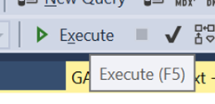

**Step 5: The table will get updated after the query is completed successfully.**

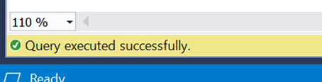

**Updating the values in a Table:**

**Step 1: Select the Database in which the Table is present. Open a “New Query” from the ‘Title bar’.**



**Step 2: Write the SQL script to update the table with the values using the sample syntax below.  
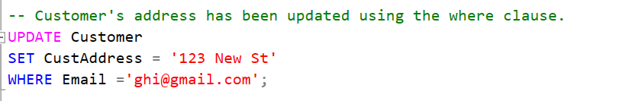**

**Step 3:** **Run the Query using the Execute option in the Title bar.**



**Step 4: After the execution is completed successfully, the update is done in the table.**

**Viewing the Tables:**

**Step 1: Select the database in SSMS.**

**Step 2: Open Query and run the ‘SELECT’ statement for the tables to view.**

**Step 3: Run the Query using the Execute option in the Title bar.**



**Step 4: The table will be displayed in the console at the bottom of the SSMS window.  
**

**Dropping the Tables:**

**We often drop the tables once it is created in a database to avoid repetitions and errors.**

**Step 1: Open the database with the tables created such as ‘Customer’, ‘Technician’, ‘Servicing’, and ‘Appointment’.**

**Step 2: Open a ‘New Query’ and write drop stetements for each table like the sample picture.**

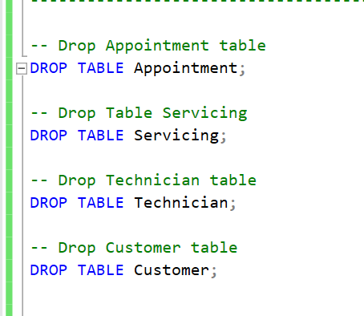

**Step 3: Execute the statements and the tables are dropped after the successful execution without errors.**

**Viewing database diagrams:**

**Step 1: Select the database and open the sub folders of the database to view ‘Database Diagrams’.**

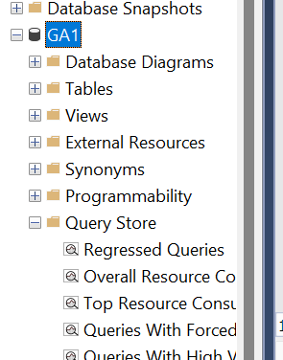

**Step 2: The database diagram will be opened in a new tab in SSMS. It shows the relationships between the tables in the database as shown in the picture below.**

**Section3 – How to backup and restore data:  
   
Backup:**

**Data backup is the process of creating a copy of data so that it can be recovered in the event of data loss.**

**Step 1: Open SSMS.**

**Step 2: Select the Database you want to backup and right click on it.**

**Step 3: Right-click on the database you want to back up and select “Tasks” > “Back Up” as shown in the picture below.  
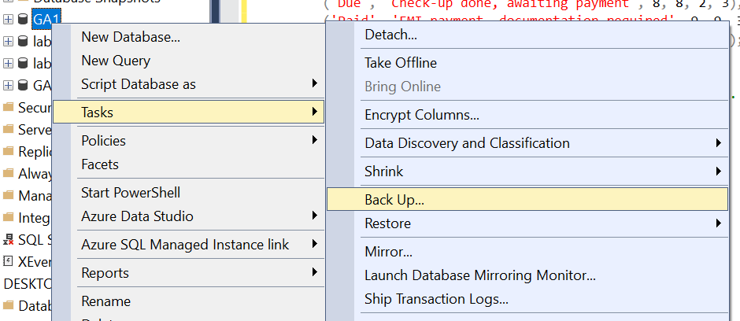**

**Step 4: In the “Back Up Database” dialog box, select the backup type as “copy only backup” and choose your destination for the backup file to store.  
**

**Step 5: Click on the “OK” button to start the backup process. It will some time to take the backup depending on the size of the database.**

**Step 6: Once the backup process is complete, the backup file can be accessed from the destination selected.**

**Restore:**

**Data restore is the process of recovering data from a backup.**

**Step 1: Open SSMS.**

**Step 2: Select the Database you want to backup and right click on it.**

**Step 3: Right-click on the database you want to back up and select “Tasks” >** **“Restore” > “Database” as shown in the picture below.**

**Step 4: In the “Restore Database” dialog box, select the restore destination. Click on “options” from top left menu.**

**Step 5: Unselect the “Take Tail-Log backup” option from the options menu. Click “OK” to initiate the restore process.**

**Step 6: After the restoration is complete, it will show a green bar on the to showing 100% restoration complete.**

**Step 7: Click “OK” on the badge displayed on the screen after the restore is done.**

**Having accomplished these tasks, you now possess a deep understanding of both front-end and back-end operations.**