URL Shortener
Project Architecture and Detailed Description
Spring Boot 3.2.5 | Java 17 | Maven | H2 | Caffeine cache (Redis optional)
Build verified 12 October 2026: all sources compile; 48 of 48 unit tests pass.
Contents
1. Overview
2. Architecture (system view, layers, class guide)
3. Key flows
4. Data model and caching
5. API reference
6. Validation rules
7. Cross-cutting concerns and design decisions
8. Configuration, setup and run
9. Quality, testing and risk
10. Mapping to the assignment deliverables

1. Overview
This project is a production-minded URL shortener. It accepts a long URL, returns a short link, redirects visitors, counts clicks and rejects unsafe input. The emphasis is on correctness under concurrency, security of what it redirects to, clear error handling and testability.
In scope: create, redirect, stats, input validation, caching, rate limiting, health checks. Out of scope: user accounts and link ownership, link deletion, a web UI, multi-region deployment.

1.1 Features
Feature | Behaviour
Shorten | Random 7-character base62 code, or a caller-chosen alias
Redirect | HTTP 302 to the original URL, never cached by browsers
Expiry | Optional ttlSeconds; expired links return 410 Gone
Analytics | Every redirect increments a click counter atomically; stats endpoint
Validation | Only safe http/https targets; abuse and SSRF-style inputs blocked
Rate limiting | Token bucket per client address on write requests
Caching | Read-through cache for code lookups (Caffeine, or Redis by profile)
Errors | RFC 7807 problem JSON with stable error codes
Operations | Actuator health, OpenAPI/Swagger UI, typed configuration

1.2 Technology stack
Concern | Choice
Language / runtime | Java 17
Framework | Spring Boot 3.2.5 (Web, Data JPA, Validation, Cache, Actuator)
Database | H2, file-based by default
Cache | Caffeine by default; Redis under the redis profile
API docs | springdoc OpenAPI 2.5.0
Boilerplate reduction | Lombok (constructor injection, getters/setters, logging)
Tests | JUnit 5, Mockito, Spring Boot Test with MockMvc

2. Architecture

2.1 System view
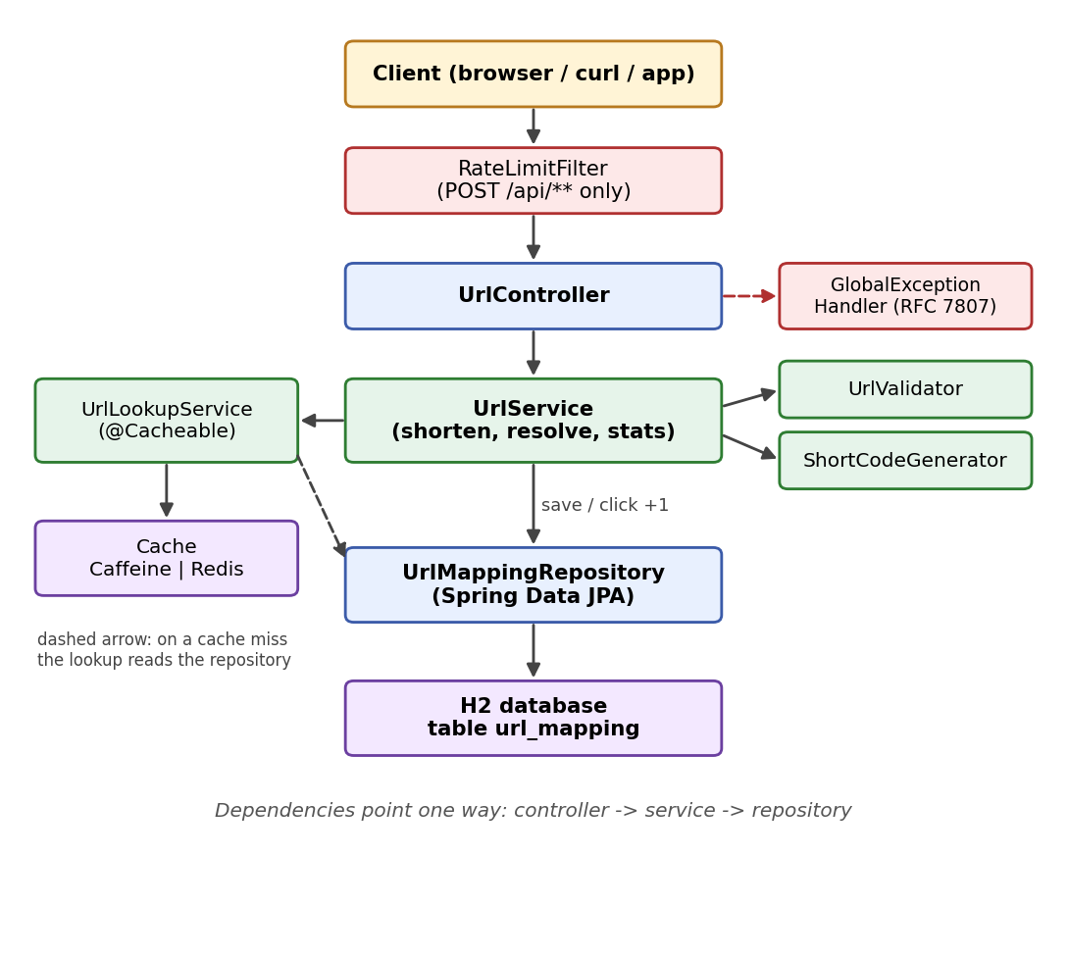
Figure 1. Components and their dependencies

2.2 Layered design
Layer | Package | Responsibility | Must not do
HTTP | controller | Parse requests, bean validation, status codes, error mapping | Business rules, SQL
Business | service | Validation rules, code allocation, expiry, click counting, caching | HTTP concerns
Persistence | repository | Queries and the atomic click update | Business decisions
Domain | entity | The url_mapping table | Logic beyond data
Contract | dto | Request/response shapes (Java records) | Persistence
Config | config | Typed properties, clock bean, rate-limit filter | Business logic
Errors | exception | One business exception with HTTP status and stable code | -

Dependencies point one way only: controller to service to repository. The service layer has no HTTP types, so it is unit-testable with plain mocks.

2.3 Class guide
All classes are under com.demo.springdemo.
Class | Package | What it does
UrlShortenerApplication | root | Entry point; enables caching and configuration-properties scanning
UrlController | controller | POST /api/v1/shorten, GET /{shortCode}, GET /api/v1/urls/{shortCode}/stats
GlobalExceptionHandler | controller | Maps business, validation and unexpected errors to problem JSON; never leaks stack traces
ShortenRequest | dto | Input record with bean-validation annotations
ShortenResponse | dto | shortUrl, shortCode, originalUrl, createdAt, expiresAt
StatsResponse | dto | shortCode, originalUrl, clickCount, createdAt, expiresAt
UrlService | service | Shorten (with retry), resolve (expiry + click), stats
UrlLookupService | service | Cached code lookup, a separate bean so the cache proxy applies
CachedUrl | service | Cache value: target URL and expiry; serializable for Redis
UrlValidator | service | All target-URL safety rules
ShortCodeGenerator | service | Secure random base62 generator
UrlMappingRepository | repository | findByShortCode, atomic incrementClickCount
UrlMapping | entity | JPA entity for table url_mapping
ApiException | exception | Business error with status and stable code, created via factory methods
AppProperties | config | Validated app.* settings
AppConfig | config | Supplies a Clock bean for deterministic expiry tests
RateLimitFilter | config | Token-bucket limiter on POST /api/**

3. Key flows
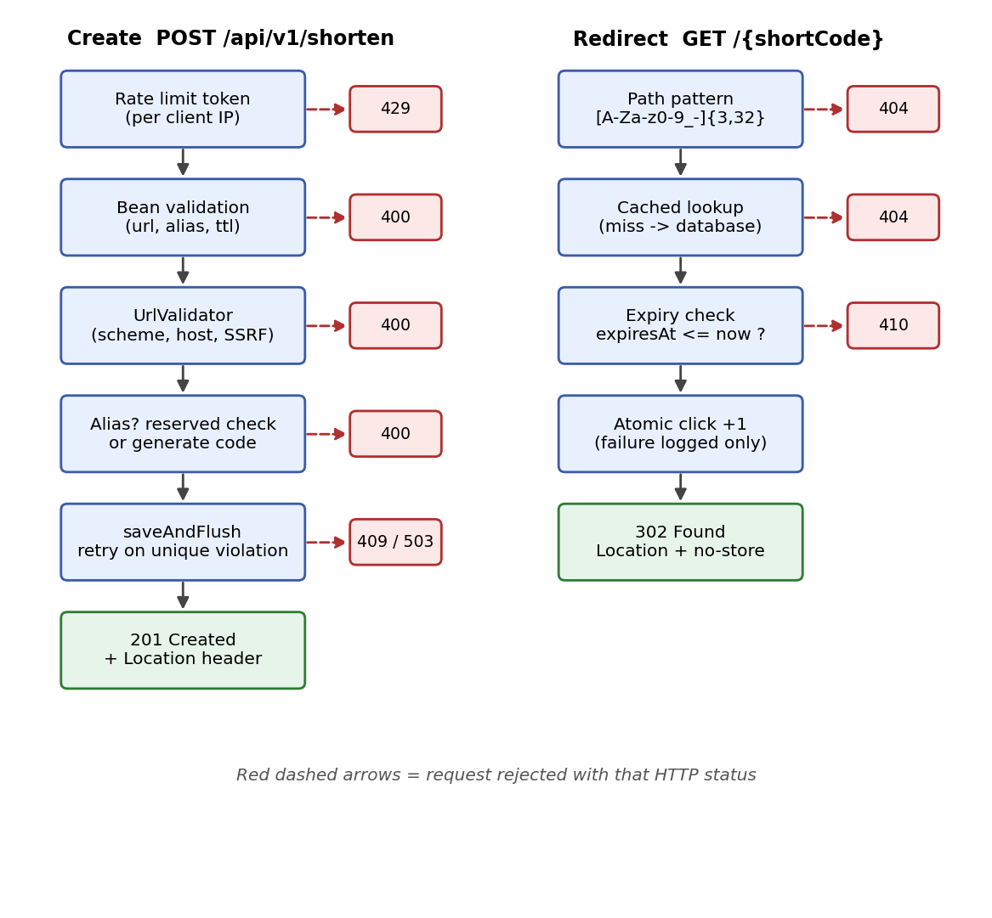
Figure 2. Create and redirect request flows with rejection points

3.1 Create a short link
- RateLimitFilter takes one token for the client address. Empty bucket: 429 with Retry-After.
- The controller runs bean validation: URL not blank and at most 2048 characters, alias pattern, TTL range.
- UrlService calls UrlValidator. Unsafe or malformed URL: 400.
- Custom alias path: reserved-name check, then saveAndFlush. A unique-constraint violation becomes 409.
- Generated code path: up to 5 attempts of generate, insert, and retry on a unique-constraint violation. All attempts failing gives 503.
- Respond 201 with the short URL and a Location header.

3.2 Redirect
- The path pattern [A-Za-z0-9_-]{3,32} filters junk requests (favicon.ico, scanners) before any database access.
- UrlService.resolve calls UrlLookupService.find: a cache hit returns immediately; a miss reads the database and fills the cache.
- No mapping: 404. expiresAt not in the future: 410.
- The click is recorded with one atomic SQL update. If that fails, the error is logged and the redirect still succeeds.
- Respond 302 with Location and Cache-Control: no-store.

3.3 Statistics
The stats endpoint reads the database directly, not the cache, so the click count is always current.

4. Data model and caching

4.1 Table url_mapping
Column | Type | Notes
id | BIGINT, identity | Primary key
short_code | VARCHAR(32) | Unique constraint uk_url_mapping_short_code; also the lookup index
original_url | VARCHAR(2048) | Validated before storage
click_count | BIGINT | Updated only through the atomic increment query
created_at | TIMESTAMP | Set by Hibernate (@CreationTimestamp)
expires_at | TIMESTAMP, nullable | Null means the link never expires

The unique constraint is the real guarantee of code uniqueness. The application never relies on a check-then-insert.

4.2 Caching design
Aspect | Decision
What is cached | CachedUrl(originalUrl, expiresAt) keyed by short code, in cache urls
What is not cached | Click counts and not-found results
Default provider | Caffeine: max 10,000 entries, 10 minute expire-after-write
Optional provider | Redis via profile redis, 10 minute TTL; CachedUrl is Serializable
Expiry correctness | Expiry is checked after the cache read, so cache TTL never extends a link's life
Invalidation | None needed today because links are never edited or deleted. A delete feature must add @CacheEvict.

The click counter used to live inside the cached method in the original code, so cache hits silently skipped counting. Lookup and counting are now separate, and a regression test covers it.

5. API reference
Base URL defaults to http://localhost:8080.

5.1 Create a short link
POST /api/v1/shorten. customAlias and ttlSeconds are optional.
{
"url": "https://example.com/docs",
"customAlias": "docs",
"ttlSeconds": 3600
}
Success: 201 Created, with a Location header equal to the short URL.
{
"shortUrl": "http://localhost:8080/docs",
"shortCode": "docs",
"originalUrl": "https://example.com/docs",
"createdAt": "2026-10-12T20:15:00Z",
"expiresAt": "2026-10-12T21:15:00Z"
}
Status | Code | When
400 | invalid_request | Missing or unsafe URL, bad or reserved alias, bad TTL, malformed JSON
409 | alias_taken | Alias already exists
429 | rate_limited | Too many writes; see the Retry-After header
503 | code_generation_failed | Five random codes in a row collided

5.2 Redirect
GET /{shortCode}
Status | Meaning
302 | Location is the original URL; Cache-Control: no-store
404 | link_not_found (also for paths that do not match the code pattern)
410 | link_expired

5.3 Statistics
GET /api/v1/urls/{shortCode}/stats. Returns 404 link_not_found for unknown codes. Expired links still show stats.
{
"shortCode": "docs",
"originalUrl": "https://example.com/docs",
"clickCount": 42,
"createdAt": "2026-10-12T20:15:00Z",
"expiresAt": "2026-10-12T21:15:00Z"
}

5.4 Error format
Every error uses application/problem+json. Bean-validation failures add an errors object keyed by field name, for example errors.url.
{
"title": "Bad Request",
"status": 400,
"detail": "only http and https urls are allowed",
"code": "invalid_request"
}

5.5 Operations endpoints
Path | Purpose
/actuator/health | Liveness and database health
/swagger-ui.html | Interactive API documentation

6. Validation rules

6.1 Target URL
- Trimmed; must not be empty; at most app.max-url-length characters (default 2048).
- Parsed with java.net.URI; spaces and control characters are rejected, which also blocks header-injection attempts.
- Scheme must be http or https. This rejects javascript:, data:, file: and ftp:.
- A host must be present, and user info (user:password@) is rejected.
- The host must not equal the service's own host from app.base-url, which prevents redirect loops.
- Unless app.allow-private-hosts is true, these hosts are rejected: localhost; names ending in .localhost, .local, .internal or .lan; IP literals that are loopback, any-local, link-local, site-local, multicast, IPv6 unique-local (fc00::/7) or carrier-grade NAT (100.64.0.0/10); IPv4-mapped IPv6 addresses (the JDK reads these as IPv4); and numeric or hex hosts such as 2130706433 or 0x7f.0.0.1.
Hostnames are not resolved through DNS during validation.

6.2 Custom alias and TTL
- Alias: 3 to 32 characters from A-Z a-z 0-9 _ -. Reserved, compared case-insensitively: api, actuator, h2-console, swagger-ui, error, health. Other aliases are case-sensitive.
- TTL: ttlSeconds from 1 to 31,536,000 (one year). Omitted means the link never expires.

7. Cross-cutting concerns and design decisions

7.1 Cross-cutting concerns
- Security: only safe http/https targets; random unguessable codes; parameterised SQL through JPA; rate limiting keyed on the socket address rather than X-Forwarded-For, so clients cannot spoof their identity.
- Error handling: one response format for every error, RFC 7807 problem JSON with a stable code. Unexpected errors return a generic 500 and are logged in full server-side.
- Configuration: typed AppProperties, validated at startup so the app fails fast. Environment variables override YAML through Spring relaxed binding.
- Observability: Actuator health endpoint; collisions and click-recording failures are logged at WARN.
- Transactions: UrlService is deliberately not transactional at class level. A constraint violation inside a transaction would make it rollback-only and break the retry loop, so each repository call runs in its own short transaction.

7.2 Key design decisions
Decision | Alternatives | Why this one
HTTP 302 redirect | 301 | 301 is cached by browsers, hiding clicks and ignoring expiry
Random base62 codes | Sequential ids, URL hash | Not enumerable; hashing creates collisions for the same URL
Insert, retry on constraint violation | Check existence, then insert | Check-then-insert is a race under concurrency
Atomic UPDATE click_count + 1 | Load, increment, save | Read-modify-write loses updates under concurrent clicks
Separate UrlLookupService bean | @Cacheable on UrlService | Cache annotations work via proxies; self-calls bypass them
Best-effort click recording | Fail redirect on analytics error | Redirect availability matters more than one analytics row
In-memory token bucket | Redis or gateway limiter | No extra infrastructure on one node; scale-out path documented
H2 file database | PostgreSQL | Runs anywhere with no setup; portable JPA schema
Records for DTOs and config | Mutable classes | Immutable, concise, validated

7.3 Failure scenarios
Scenario | Behaviour
Random code collision | Retry up to 5 times, then 503 with a retry message
Alias already taken | 409 alias_taken
Database error while recording a click | Logged; redirect still succeeds
Redis profile: cache unavailable | Cache errors surface per Spring defaults; the Caffeine default has no network dependency
Malicious or malformed URL | 400 before anything is stored
Write flood from one client | 429 with Retry-After; tracked clients capped at 10,000
Unexpected exception | Generic 500 body; detail only in server logs

8. Configuration, setup and run

8.1 Configuration
Set in application.yml, or override with environment variables such as APP_BASE_URL. Invalid values stop the application at startup.
Property | Default | Meaning
app.base-url | http://localhost:8080 | Builds short URLs and detects self-links
app.code-length | 7 | Generated code length, 4 to 16
app.max-url-length | 2048 | Longest accepted target URL
app.rate-limit-per-minute | 60 | Write requests per client per minute
app.allow-private-hosts | false | Development switch to allow localhost targets
spring.cache.caffeine.spec | maximumSize=10000,expireAfterWrite=10m | Default cache sizing
spring.datasource.url | H2 file ./data/urlshortener | Database location

8.2 Setup and run
Prerequisites: JDK 17 and Maven 3.9 or newer.
mvn clean verify # compile and run tests
mvn spring-boot:run # start on port 8080
mvn spring-boot:run -Dspring-boot.run.profiles=redis # Redis cache
Integration tests need the Maven Failsafe plugin in the pom, because the default test plugin only runs classes named *Test. Smoke test:
curl -s -X POST localhost:8080/api/v1/shorten -H "Content-Type: application/json" -d "{\"url\":\"https://example.com/docs\"}"
curl -i localhost:8080/<shortCode>
curl -s localhost:8080/api/v1/urls/<shortCode>/stats

9. Quality, testing and risk

9.1 Problems found in the original code and the fixes
Problem | Impact | Fix
@NoArgsConstructor on a service with final fields | Did not compile | Removed; constructor injection only
@Cacheable on the click-incrementing method | Cache hits skipped counting; wrong analytics | Lookup and counting separated; regression test
No caching starter and no @EnableCaching | Cache annotation had no effect | Dependencies and annotation added
Read-increment-save for clicks | Lost updates under concurrency | Single atomic SQL update
Check-then-insert for codes | Race producing duplicates or errors | Insert, retry on unique violation
No URL validation | Accepted javascript:, file:, localhost, cloud metadata addresses | UrlValidator
catch (RuntimeException) returning 404 | Hid real server errors | Specific exceptions via a global handler
Raw Map body, hardcoded base URL | Weak contract, not configurable | Validated DTO records, app.base-url
@Data on the JPA entity | Risky generated equals/hashCode/toString | Explicit getters and setters
No application class; package/artifact mismatch | Not runnable as a unit | Application class added, structure aligned

9.2 Testing approach
Unit tests use mocks and a fixed clock, so they are fast and deterministic. Integration tests start the application with an in-memory H2 database and exercise the real HTTP layer.
Test class | Type | Tests | Status
UrlValidatorTest | Unit | 37 | Passing (Maven build, 12 Oct 2026)
UrlServiceTest | Unit | 11 | Passing (Maven build, 12 Oct 2026)
UrlControllerIT | Integration | 9 | Written; result not yet confirmed
RateLimitIT | Integration | 1 | Written; result not yet confirmed

- Unit coverage: valid and invalid URLs, collision retry and exhaustion, alias conflict, reserved alias, TTL arithmetic, the exact expiry boundary, click counting, and click-recording failure not breaking the redirect.
- Integration coverage: create-redirect-stats flow, three redirects all counted even when served from cache, alias conflict, unsafe URLs, missing fields, malformed JSON, unknown and expired links, health, and the rate limiter.
- Update the status column once mvn clean verify runs the integration tests green.

9.3 Security considerations
- Redirect targets are restricted to safe public http and https URLs.
- Codes come from SecureRandom and are not guessable or enumerable.
- All SQL is parameterised through JPA; error responses never include stack traces or internals.
- Sensitive configuration should come from environment variables, not committed files.

9.4 Assumptions
- Single-tenant service: any caller may create links and read stats.
- Links are never edited or deleted, so no cache invalidation is needed.
- UTC timestamps everywhere.
- One application instance for the default setup.
- Creating the same URL twice returns two different codes (no de-duplication).

9.5 Limitations and trade-offs
Limitation | Trade-off or planned answer
H2 single-node database | Zero setup; move to PostgreSQL with Flyway migrations for production
In-memory rate limiter | Per-instance limits; use Redis or a gateway when scaling out
Synchronous click recording | Simple and consistent; make asynchronous at higher traffic
No authentication on stats | Fine for a demo; add API keys or ownership before real use
No DNS resolution during validation | A hostname that later resolves to a private address is not caught (DNS rebinding)
ddl-auto=update | Convenient; unsuitable for controlled production schema changes
No link deletion | Keeps caching simple; adding it requires cache eviction
Rate limiter ignores X-Forwarded-For | Safe against spoofing, but behind a reverse proxy all clients share one address until proxy handling is configured

9.6 Scalability path
- Replace H2 with PostgreSQL and add migrations (Flyway).
- Switch the cache to Redis (profile already provided) so instances share it.
- Move rate limiting to Redis or an API gateway so limits hold across instances.
- Record clicks asynchronously (queue or batched writes) if redirect volume grows.
- Add authentication and link ownership before exposing stats publicly.

10. Mapping to the assignment deliverables
Deliverable | Where it is covered
Working prototype | Sections 2, 5 and 8; builds and runs with Maven
Architecture overview | Sections 2, 3, 4 and 7 (components, control flow, key decisions)
Testing approach, limitations, trade-offs | Sections 9.2 and 9.5
Risks and validation | Sections 6, 7.3, 9.1 and 9.3
Setup instructions | Section 8
Assumptions | Section 9.4
AI-assisted workflow, traceability, greenfield / brownfield / ambiguous scenarios | Not included. These must reflect how the engineer actually worked with AI, so add them from your own session notes.

