**Drug Response Study on Natural Compounds against Lung Cancer Cell Lines using Machine Learning Methods**

**cGaurava Srivastava, aSumya Pathak, \*a,bFeroz Khan, \*a,bAman Chandra Kaushik**

aDepartment of Technology Dissemination and Computational Biology Division, CSIR-Central Institute of Medicinal and Aromatic Plants, P. O. CIMAP, Kukrail Road, Lucknow 226015, India

bIndiaAcademy of Scientific and Innovative Research (AcSIR), Ghaziabad 201002, India

cDivision of Biochemistry and Structural Biology, CSIR-Central Drug Research Institute, Jankipuram Extension, Sitapur Road, Lucknow, Uttar Pradesh 226031, India

**Abstract**

The search for drug compounds to combat cancer is a focus in oncology research that continues to be crucially important today. This research utilizes the Cancer Cell Line Encyclopaedia (CCLE)s data to examine how drugs perform in lung cancer cases and highlights the detailed information compared to other types of cancer. Various machine learning models such, as Random Forests and Logistic Regression were used to forecast how drugs would work on compounds involved in treating lung cancer. After examination revealed the lung cancer cell lines that showed the response and examined biomarkers linked to drug effectiveness. By using Topotecan as a reference point, for comparison purposes investigators conducted searches for compounds in the NP Atlas to uncover possible alternative options. This comprehensive study emphasizes the importance of machine learning and cheminformatics in moving with lung cancer treatments emphasizing the need, for vigilant monitoring of drug efficacy, side effects observation and uncovering’s of potential biomarkers.

**Keywords:** Lung Cancer; Drug Response Prediction; Machine Learning; Personalized Medicine; Biomarker Discovery; Pharmacogenomics; Natural Compounds; Pharmacovigilance

**Introduction**

In the field of healthcare, researchers are exploring ways to improve treatment outcomes for lung cancer patients by using machine learning to predict how individuals will respond to drugs. This personalized approach, known as precision medicine, involves discovering biomarkers and studying pharmacogenomics [1]. Additionally, researchers are investigating the potential of various compounds in treatment strategies [2]. Enhancing pharmacovigilance practices is crucial in monitoring drug safety and efficacy [3].

Lung cancer continues to be one of the leading causes of cancer-related deaths, and its prevalence has been on the rise in recent years [4]. Despite advancements in surgery, radiotherapy, and chemotherapy, lung cancer remains a significant health challenge due to its diverse clinical manifestations and varying responses to treatment [5]. The intricate nature of lung cancer is further complicated by the varying drug responses observed among its subtypes [6]. Understanding these responses is key to improving treatment outcomes, as certain treatments may have limited effectiveness or lead to side effects, and drug resistance may develop [7].

Recently, advancements in analyzing genomic datasets such as the Cancer Cell Line Encyclopedia (CCLE) have transformed cancer and drug response studies significantly. The CCLE provides comprehensive profiles of numerous cancer cell lines, including those for lung cancer [8]. This resource allows researchers to explore how different drugs perform in diverse lung cancer cell lines using machine learning techniques, enabling the prediction of drug interactions and identification of promising therapeutic options [9]. These capabilities are also beneficial for drug safety surveillance, emphasizing continuous monitoring of drug effectiveness and safety [10].

Cheminformatics plays an important role in these studies, utilizing techniques to examine the chemical properties and relationships of compounds. This helps identify chemical structures similar to existing therapeutic medications, potentially uncovering new treatments with fewer adverse reactions [11]. By integrating machine learning and cheminformatics, researchers can enhance drug monitoring and discover more effective drugs for treating conditions such as lung cancer [12].

The biology of lung cancer, with its various subtypes and heterogeneous responses to drugs, necessitates a customized treatment approach tailored to individual patients [13]. Precision medicine, focusing on personalizing treatment plans based on the patient’s genetic and phenotypic data, is gaining increasing recognition [14]. Biomarker exploration is a key aspect of this approach, helping to identify patients who would benefit most from treatments and flagging those who may experience adverse reactions [15].

This research seeks to demonstrate the application of machine learning combined with bioinformatics and cheminformatics techniques to study lung cancer drug responses, identify biomarkers of drug effectiveness, and explore alternative therapeutic compounds [16]. Our study focuses on three compounds—Topotecan, Paclitaxel, and Irinotecan—using the CCLE dataset to explore new therapeutic options and support drug monitoring vigilance for lung cancer treatment [17].

### Materials & Methods

**Data Acquisition and Pre-processing**: This research utilized the CCLE dataset, which includes information on how over 1,000 cancer cell lines respond to drugs. The dataset provides detailed drug responsiveness for lung cancer cell lines [18]. Pre-processing steps included adjusting class imbalance using Synthetic Minority Over Sampling Technique (SMOTE) and splitting the data into training and testing sets for model validation [19].

**Machine Learning Models for Drug Response Prediction**: Five machine learning models—Random Forest, Logistic Regression, K-Nearest Neighbors, Decision Tree, and Gradient Boosting—were applied to predict drug responses based on cell line characteristics [20]. Model performance was assessed using accuracy and Receiver Operating Characteristic (ROC) Area Under Curve (AUC) scores [21].

**Targeted Analysis of Natural Compounds**: The effectiveness of Topotecan, Paclitaxel, and Irinotecan was analyzed across different lung cancer cell types using average drug sensitivity scores (AUC scores) to compare drug efficacy [22].

**Biomarker Identification**: RNA expression data from the CCLE dataset were analyzed to identify biomarkers associated with drug sensitivity to Topotecan, Paclitaxel, and Irinotecan. These biomarkers could potentially improve drug effectiveness monitoring and drug surveillance practices [23].

**Structural Similarity Screening from NPAtlas Database**: Structural similarity screening was conducted using Python and RDKit tools to generate molecular fingerprints and measure compound similarities. NPAtlas was used to identify compounds with similar structures to Topotecan for potential therapeutic use [24].

**Structural Similarity Screening from COCONUT Database**: The COCONUT Database was employed to identify chemical compounds with similar structures to Topotecan using the compound’s SMILES representation. Similarity analysis was performed with five comparison methods: Tanimoto, Dice, Cosine, Sokal, and Russel [25]. Similarity scores were visualized through various plots, including heatmaps and scatter plots, to identify top candidates for drug repurposing [26].

**Results**

**Data Acquisition and Pre-processing:** In this research project we utilized the CCLE dataset that encompasses information on how, over 1 000 cancer cell lines respond to drugs during data collection and pre-processing stages. Specifically, we examined the sensitivity of lung cancer cell lines to treatment options. Our analysis revealed a number of drug responses, in lung cancer as illustrated in Figure 1.

Tissue_Types_Pie_Chart.pdf

***Figure 1:* *Illustrates the breakdown of tissue types, in the CCLE Dataset:*** *The pie chart shows how different tissue types are distributed in the Cancer Cell Line Encyclopedia (CCLE) dataset based on the size of each segment representing the proportion of cell lines, from that tissue type.The data indicates a presence of lung cancer cell lines compared to types of cancer in this dataset.Colors are assigned to segments using a palette, for visualization purposes*.

**ML Model Performance:** Five different machine learning models were evaluated for their performance, in a study on drug response prediction. The Random Forest model along with the Decision Tree and Gradient Boost models stood out for their accuracy and ROC AUC scores as depicted in Figures 2 and 3. An analysis of feature importance highlighted that the AAC score played a role in predicting drug responses a clear indication of how crucial sensitivity scores are, to the models overall success as illustrated in Figure 4.

Plots2/Model_Accuracy_Comparison.pdf

***Figure 2*** *illustrates a comparison of model accuracy showcasing the effectiveness of machine learning models, in predicting responses, to drugs*.

**Plots2/Model_ROC_AUC_Comparison.pdf*Figure 3****Illustration 3 displays a comparison of ROC AUC values, across machine learning models using a bar plot and overlaying ROC curves to showcase the performers as Random Forest and Gradient Boosting*.

Plots2/Feature_Importance_Comparison.pdf

***Figure 4*** *displays a comparison of feature importance, among machine learning models presented in a bar chart format.*

**Drug Responses in Lung Cancer Cell Lines:** In a study of 336 lung cancer cell lines examined for drug responses (reference drug shown in Figure 5) it was found that 141 of them exhibited reactions, to the drugs tested. Among these drugs tested in the study mentioned above Topotecan showed the effectiveness with responses seen in 56 cell lines. Irinotecan and Paclitaxel also displayed effectiveness; however, their impact was not as consistent across subtypes of lung cancer. These results support the use of these compounds in practice especially highlighting the potential of Topotecan, in treating lung cancer as depicted in Figure 6.

Plots2/AAC_Distribution_by_Drug_Response.pdf

***Figure 5*** *displays the distribution of AAC scores based on drug response as shown in a box plot analysis.*

Plots3/All_Natural_Drug_CellLine_AAC_Heatmap.pdf***Figure 6*** *displays a heatmap illustrating the effectiveness of drugs, on lung cancer cell lines based on AAC scores analysis results. According to the visualization provided in this diagram Topotecan demonstrates a drug reaction, in most lung cancer cell lines when compared to Paclitaxel and Irinotecan*.

**Biomarker Identification:** Several biomarkers have been found to be linked to the effectiveness of Topotecan, Paclitaxel and Irinotecan treatments. Significant biomarkers associated with sensitivity, to Topotecan include SLFN11 RRM HMGB and KIF15, which play roles in DNA repair, cell growth and programmed cell death. These findings suggest that targeting these biomarkers could be beneficial for treatment. Likewise, biomarkers like ABC B, SSRP and LMNB have been identified as indicators of sensitivity to Paclitaxel. These biomarkers are involved in drug resistance and changes, in chromatin structure. The effectiveness of irinotecan was found to be associated with biomarkers, like SLFN11 and NUD15 and FANCG that're essential, in DNA repair processes.

**Sensitive biomarkers of Irinotecan and their significance, in the context of Lung Cancer:** Some vital indicators have been recognized as responsive, to Irinotecan:

**SLFN11** is recognized for its involvement, in responding to DNA damage and boosting the effectiveness of DNA treatments such, as Irinotecan. Its presence is linked to improved outcomes in types of lung cancers.

In lung cancer cases involving chromatin remodeling and transcriptional regulation processes have shown an increase, in protein levels leading to the enhancement of tumor growth along with resistance, to chemotherapy treatments.

**NUDT15** plays a role, in how the body processes thiopurine and can affect how effective Irinotecan is, in treating lung cancer patients depending on variations.

Fanconi anemia pathway member **FANCG** is essential, for DNA repair. When mutated can cause instability, in lung cancer cells.

**HMGBIP45** is known to be part of the high mobility group protein family and plays a role, in DNA repair and chromatin remodeling processes that support lung cancer cell viability during chemotherapy treatment.

**CHAF** is part of putting the bits and pieces of chromatin and helps cells move through their cycles smoothly; its also connected to aggressive types of lung cancer.

The **HNRNPC** protein serves as a controller of RNA processing. Is often found in levels, in lung cancer cases where it plays a role, in influencing tumor development and treatment outcomes.

In lung cancer cells, under stress situations homologous recombination repair plays a role, in ensuring cell survival.

During cell division **MAD21** plays a role, in controlling the spindle assembly checkpoint ensuring chromosome segregation, in lung cancer cells where its increased activity can lead to genetic instability and potential tumor progression.

**RFC54** is an element of the DNA replication process linked to cell growth and the repair of DNA damage, in lung cancer cells.

**KLHL23** plays a role, in controlling the cell cycle. There is growing evidence suggesting its function is associated with the advancement of lung cancer.

These biomarkers indicate pathways, like DNA repair and cell cycle regulation that play a role in lung cancer biology and response to treatment options. More research and confirmation are necessary to assess their value in the treatment of lung cancer concerning how they relate to the responsiveness, to Irinotecan as depicted in Figure 7.

**Plots2/Irinotecan_BioMarkers/Bar_Plot_Top50_Biomarkers_FDR_Irinotecan.pdf*Figure 7 displays a bar graph illustrating the FDR scores for the 50 biomarkers associated with Irinotecan treatment:*** *The bar chart lists the 50 biomarkers based their FDR scores. Highlights those that are most closely linked to Irinotecan responsiveness. The gene names are clearly marked along the x axis for recognition*.

**Biomarkers, for Paclitaxel sensitivity and their significance, in Lung Cancer:** Several genes that have been identified as biomarkers are known or thought to play roles in the biology of lung cancer:

**ABCB** one gene produces P glycoprotein which's a protein that helps remove drugs from cells and plays a role, in the development of resistance to Paclitaxel in lung cancer by lowering the amount of drug, inside the cells.

**SSRP 115** is a component of the FACT complex and plays a role, in modifying chromatin and regulating transcription processes; it is frequently found to be overexpressed in lung cancer cases where it promotes tumor development.

**Lamin B** protein is associated with maintaining the integrity of the cell nucleus. Tends to be more abundant, in lung cancer cells where it encourages the growth and spread of cells.

**CDK** plays a part, in authorizing DNA replication. When its not working properly in lung cancer cells it can cause genetic instability.

**PTBP 2** controls the ways genes are spliced. Is linked to the advancement and spread of lung cancer.

**EXOSC**2 plays a role, in the RNA exosome complex. Is believed to affect the processing and durability of RNA, in lung cancer cells which ultimately influences their survival rate.

**The MCM**, protein is often increased in lung cancer. Boosts cell growth by aiding DNA replication processes.

**PHFI55** is a splicing factor that's crucial, for the survival of cancer cells and is found in abundance, in lung adenocarcinomas.

**NSMCE44** contributes to maintaining the structure of chromosomes. Is associated with instability, in lung cancer cases.

**BRAT2** plays a role in responding to DNA damage. Has been linked to the aggressiveness of tumors, in lung cancer cases.

These markers highlight pathways in the biology of lung tumors such, as resistance to drugs and changes in DNA structure. How cells divide and process RNA molecules effectively treated with Paclitaxel sensitive targets for possible treatments need more research to verify their significance, in real world medical situations as depicted in Figure 8.

Plots2/Paclitaxel_BioMarkers/Bar_Plot_Top50_Biomarkers_FDR_Paclitaxel.pdf

***Figure 8 shows a bar graph displaying the FDR scores, for the 50 biomarkers related to Paclitaxel:*** *The chart displays the 50 biomarkers ranked according to their FDR scores emphasizing those, with FDR values as important factors, in determining Paclitaxel sensitivity with gene names indicated along the x axis for easier identification*.

**Biomarkers, for identifying sensitivity to Topotecan and their significance, in Lung Cancer:** Several of the biomarkers that have been identified are linked to the biology of lung cancer:

**SLFN11:** Known to predict response to Topotecan and other DNA-damaging agents in lung cancer by modulating DNA damage repair mechanisms.

**RRM1:** A regulator of ribonucleotide reductase activity, often linked to chemoresistance in non-small cell lung cancer (NSCLC).

**HMGB1 and HMGB2:** High mobility group box proteins associated with DNA repair and apoptosis regulation, playing roles in lung cancer progression.

**KIF15 and KIF11:** Motor proteins involved in mitosis, overexpression of which has been observed in lung cancer, contributing to tumor proliferation.

**SSRP1:** A subunit of the FACT complex, crucial for transcription and DNA repair, with overexpression linked to lung cancer aggressiveness.

**NCL (Nucleolin):** Overexpressed in lung cancer and involved in ribosome biogenesis and cell proliferation.

**PTBP1:** Implicated in alternative splicing and metastasis of lung cancer cells.

**ELAVL1 (HuR):** A RNA-binding protein stabilizing mRNAs of oncogenes, frequently upregulated in lung cancer.

**CDT1:** Plays a role in DNA replication licensing and is often deregulated in lung cancer, leading to genomic instability.

These biomarkers, identified as sensitive to Topotecan, provide critical insights into their potential therapeutic targeting, particularly in lung cancer where Topotecan is commonly used as a chemotherapeutic agent. Further validation studies are essential to establish their clinical utility shown in Figure 9.

Plots2/Topotecan_BioMarkers/Bar_Plot_Top50_Biomarkers_FDR_Topotecan.pdf

***Figure 9 displays a bar plot showing the FDR scores, for the 50 biomarkers linked to treatment:*** *The bar graph shows the FDR scores, for the 50 biomarkers linked to sensitivity to drug treatment in ascending order of their values along the x axis labels for each biomarker name displayed thereon; lower FDR scores suggest a more robust relationship, with drug sensitivity.*

**Structural Similarity Analysis from NPAtlas Database:** After conducting a similarity analysis using the NPAtlas Database, for alternatives researchers identified promising substitutes such as Camptothecin, Obelmycin G and Sepedonin. These compounds displayed resemblance in terms of Cosine and Dice similarity scores suggesting their suitability for advancement as depicted in Figure 10 and 11 along, with Table 1. Their chemical compositions, weights and sources were recorded and additional investigations are required to confirm their therapeutic efficacy.

Plots4/Similarity_Comparison_Boxplot.pdf

***Figure 10*** *Comparing similarity scores using methods can be seen in Figure 10 through a box plot that showcases Tanimotos approach, alongside Dices method and metrics, like Cosine similarity well as Sokal and Russel metrics*.

Plots4/Top10_Similar_Compounds_Barplot.pdf

***Figure 11*** *displays a bar plot of the 10 compounds that're structurally similar, to Topotecan, based on Tanimoto Similarity scores*.

|  |  |  |  |  |  |  |  |
| --- | --- | --- | --- | --- | --- | --- | --- |
| **ID** | **Compound Name** | **Compound Molecular Formula** | **Compound Molecular Weight** | **Compound Structure** | **Origin Type** | **Activity (IC50)** | **Cell Line** |
| 18135 | Camptothecin | C20H16N2O4 | 348.358 |  | Fungus | 5.27 nM, 9.13nM, 8.77nM | NCI-H460,  NCI-H1623, NCI-H510A |
| 21280 | Obelmycin G | C28H33NO10 | 543.569 |  | Bacterium | Not Found | Not Found |
| 21277 | Alldimycin C | C28H33NO10 | 543.569 |  | Bacterium | Not Found | Not Found |
| 2062 | 3-methyl-5-(3-methylbut-2-en-1-yl)-1H-isochromen-6-ol | C15H18O2 | 230.307 |  | Fungus | Not Found | Not Found |
| 21278 | Alldimycin B | C36H48N2O12 | 700.782 |  | Bacterium | Not Found | Not Found |
| 3637 | Obelmycin H | C28H33NO11 | 559.568 |  | Bacterium | Not Found | Not Found |
| 3538 | Pestalachloride B | C20H18Cl2O5 | 409.265 |  | Fungus | 5.96nM | Target- Fusarium graminearum |
| 13027 | Sepedonin | C11H12O5 | 224.212 |  | Fungus | Not Found | Not Found |
| 21476 | Xylarinol C | C15H16O3 | 244.290 |  | Fungus | 6.54nM | Tissue-Based |
| 27104 | 4,5-dihydroxy-7-methylphthalide | C9H8O4 | 180.159 |  | Bacterium | Not Found | Not Found |

***Table 1*** *presents the 10 compounds identified through structural analysis, for Topotecan showing a number of promising candidates, with significant similarity scores according to the Tanimoto method*.

**Structural Similarity Screening from COCONUT Database:** Top compounds identified in the Structural Similarity Screening from the COCONUT Database mainly belonged to the Camptothecins class – a subgroup of alkaloids and their derivatives. The key characteristics consistently noted were Chemical Class (Camptothecins) Chemical Subclass (Camptothecins) Super Class (Alkaloids and Derivatives) Direct Parent Classification (Camptothecins) Classifier Pathway (Alkaloids) Classifier Superclass (Tryptophan alkaloids) and Classifier Class (Pyrroloquinoline alkaloids).Among the comparison measures used in the analysis process were compounds that displayed resemblance, to the query compound Topotecan showed the highest ratings consistently, across multiple metrics utilized in the study. The heatmap of pairwise similarity displayed connections, between metrics like Tanimoto and Dice but weaker associations for Sokal and Russel as indicated in Figure 12. This visualization helps determine the extent of correlation between similarity metrics and reveals whether they align or present patterns, in similarity assessment. It underscores the significance of choosing the metrics for studies based on similarity. Bar graphs clearly showed the ranking of compounds according to their similarity scores. Helped in pinpoint the pertinent candidates as depicted in Figure 13. This comprehensive chart displays the five similarity metrics next, to each other for easy comparison of how they rank the compounds based on their similarity to the reference compound. The violin graph illustrated differences, in similarity measurements among chemical categories; Camptothecins displayed the median scores as depicted in Figure 14. This graph provides an overview of the range of similarity scores for each parameter. Highlights the variations in similarity scores, among chemical categories. Scatter plots offer insights, into how various similarity metrics are linked and reveal patterns among the ranking compounds as depicted in Figure 15. This scatter plot shows a comparison of the Tanimoto and Dice similarity metrics and illustrates how chemical classes and pathways are spread out based on the similarity scores.

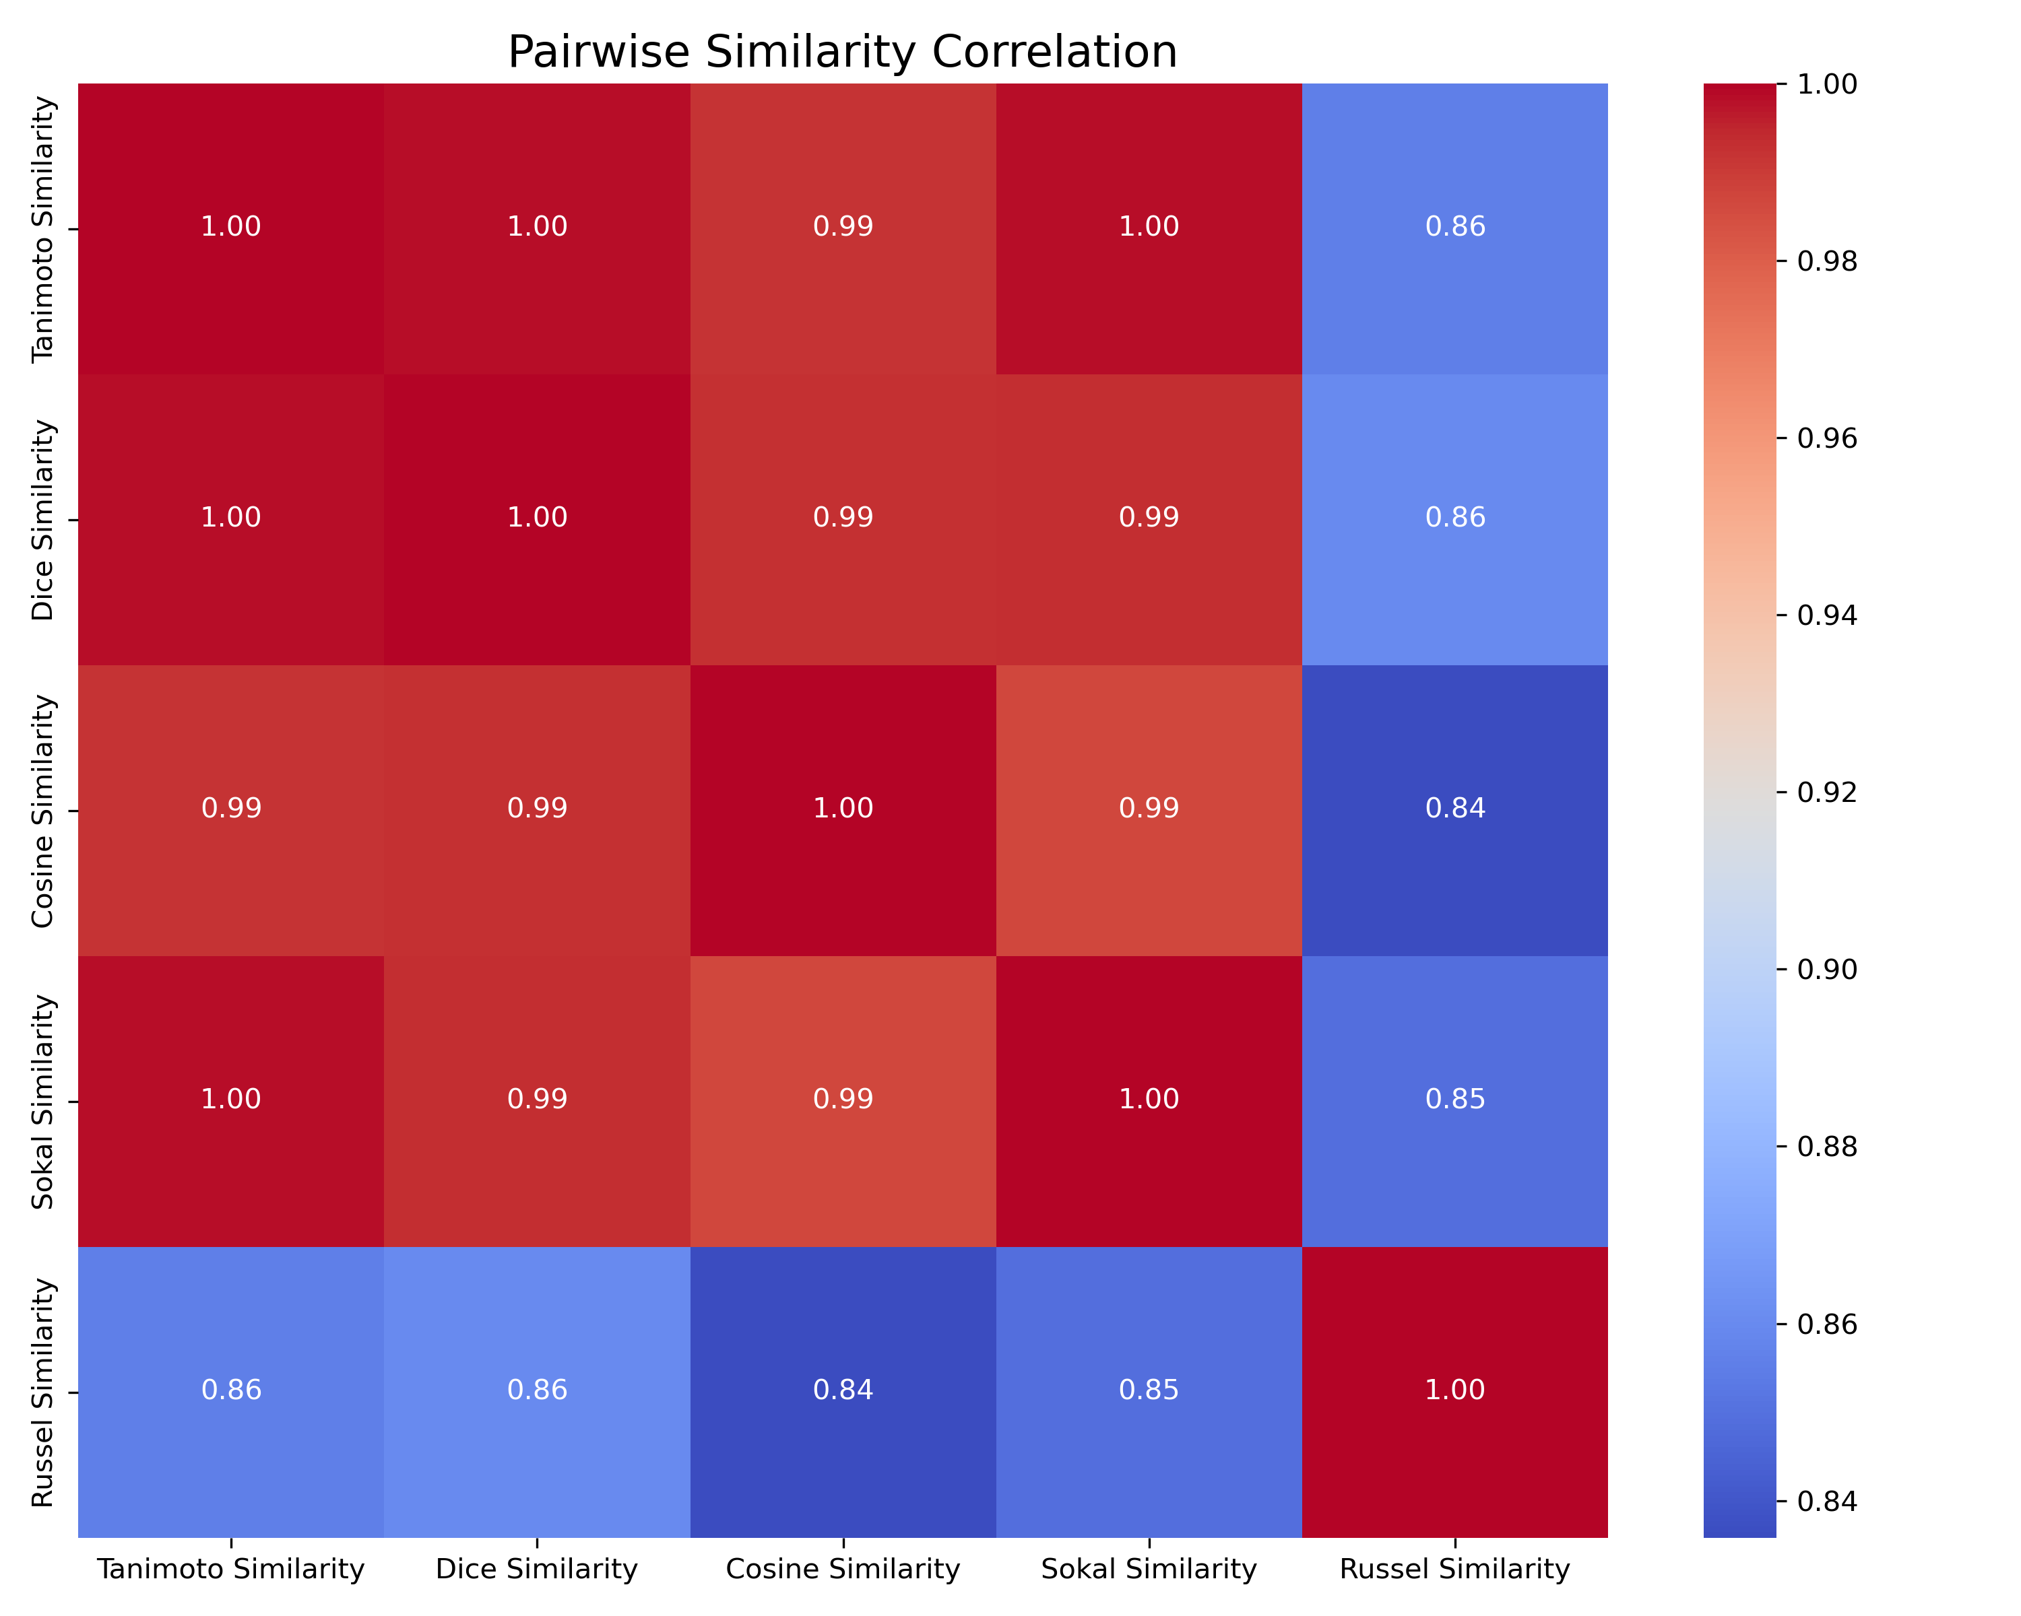

***Figure 12*** *shows a Heatmap of Pairwise Similarity that illustrates the correlation, between similarity scores for five metrics ( Tanimotos method) Dice coefficient method) Cosine similarity method) Sokals method) and Russels method). Each square on the heatmap represents the correlation between two similarity metrics. Darker shades indicate a correlation, between them.*

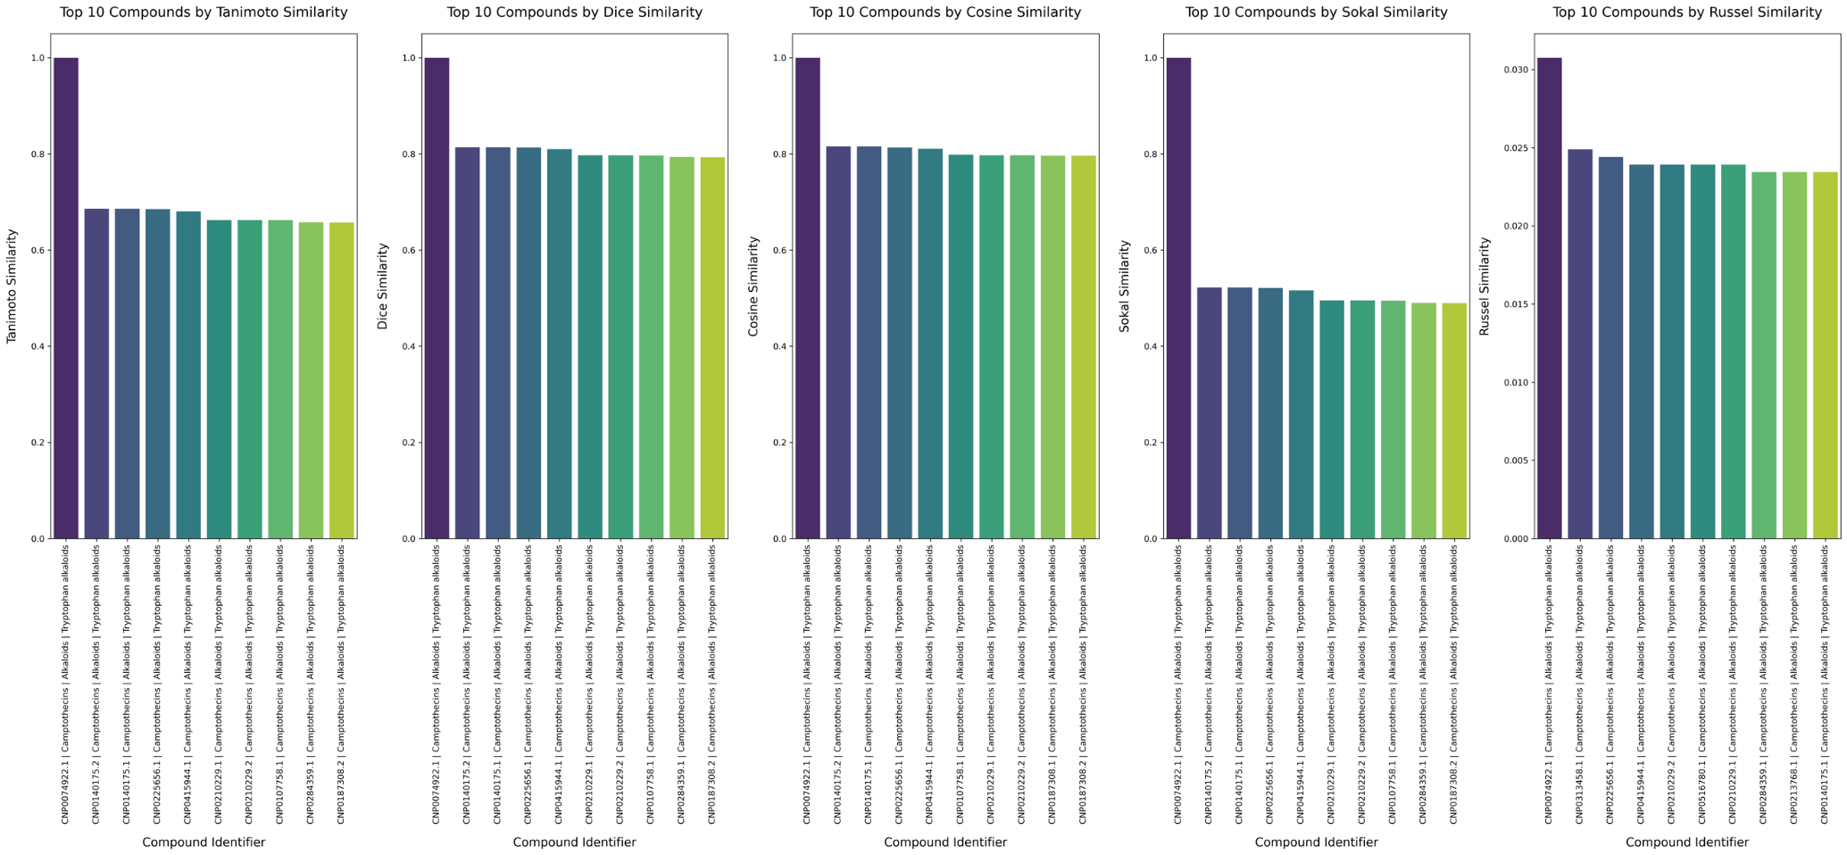

***Figure 13 Combined Similarity Plots:*** *All the five similarity plots (Tanimoto, Dice, Cosine, Sokal and Russel) are incorporated into a figure, with five subplots arranged in a row for comparison ease. The individual subplot represents one similarity metric. Displays the 10 compounds ordered by their respective similarity scores. This collective visualization enables comparisons, among similarity metrics.*

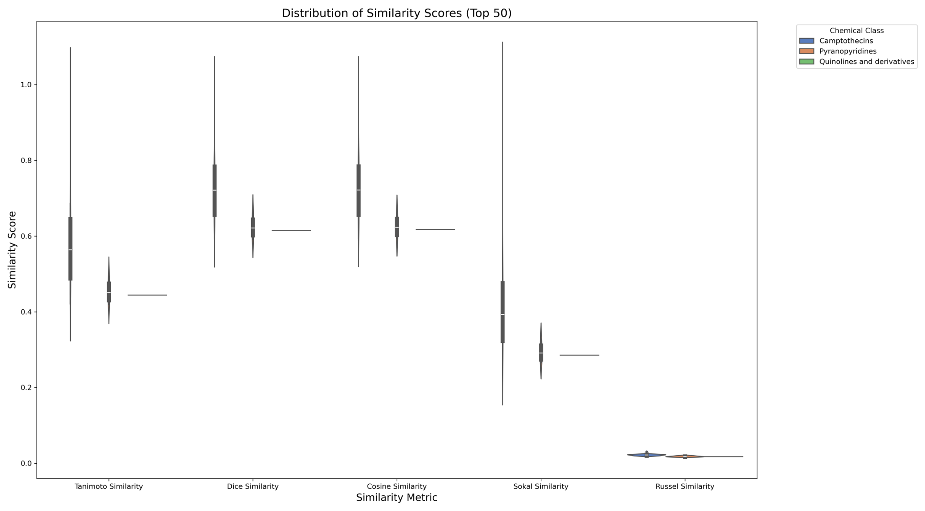

***Figure 14*** *Displays the similarity scores of the 50 compounds using a violin plot based on Tanimoto similarity measurements, for each compounds chemical class category*.

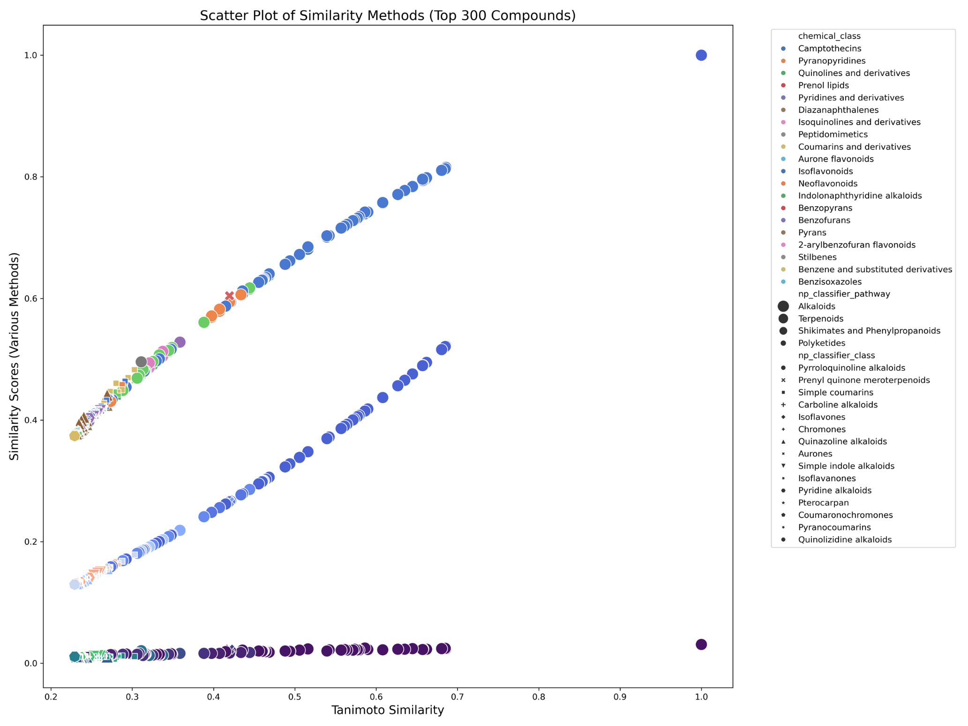

**Figure 15: Scatter Plot of Tanimoto vs Dice Similarity (Top 300 Compounds)**: Scatter plot showing the comparison, between Tanimoto and Dice similarity scores for the 300 compounds, in colours based on compound classes and marker sizes representing compound pathways to explore how these factors relate to similarity scores.

**Discussion**

The findings, from this research emphasize the importance of using machine learning (ML) and cheminformatics methods to comprehend how drugs affect lung cancer and progress precision medicine efforts effectively. By utilizing models identifying biomarkers and conducting similarity analysis researchers are able to gain a thorough understanding of how drugs impact various subtypes of lung cancer. This also emphasizes the significance of data driven approaches, in improving drug monitoring practices which're crucial in today’s drug development and surveillance processes.

Artificial intelligence has greatly transformed the approach to examining the effectiveness and resistance of medications, in cancer treatment research practices. Cutting edge models such as Random Forest and Gradient Boostinng have been utilized in this investigation to gain knowledge about the performance of drugs like Topotecan and Paclitaxel, among lung cancer cell types. In this group of models examined here. Random Forest and Gradient Boost. Random Forest and Gradient Boost particularly shone due, to their accuracy and ROC AUC scores that are crucial for evaluating how robust a model is performing in practice. Within the Random Forest model specifically it proved adept at managing data, with dimensions and pinpointed key features linked to drug efficacy which highlights the significance of selecting features when building predictive models.

One important finding, from the machine learning analysis was the discovery of the AAC (Area Under the Curve of Drug Sensitivity) score as a factor in forecasting drug reactions. This measure is commonly employed to assess how sensitive cancer cells are to medications and offers a gauge of drug effectiveness. Forecasting which lung cancer cell lines will respond well to drugs plays a role, in progressing personalized medicine. In world settings these models could help categorize patients according to their chances of reacting well to a particular treatment therefore reducing unnecessary side effects and enhancing overall treatment results. This ability to predict outcomes plays a role, in drug safety monitoring as it serves as an advance alert system, for detecting patients who may not respond positively to a medication and might need alternative treatment approaches.

One crucial element of this research was pinpointed biomarkers linked to the effectiveness of medications such, as Topotecan, Paclitaxel and Irinotecan. DiscoverING biomarkers plays a role in developing drugs by determining which individuals are most likely to benefit from a treatment and who might encounter negative side effects. The biomarkers uncovered for each medication in this investigation offer knowledge about the workings of drug effectiveness and resistance, in lung cancer.

Several indicators linked to DNA repair processes and cell division were discovered to be predictors of how effective Topotecan would be, as a medication treatment option for individuals. SLFN11 is a protein that can help forecast how someone will react to medications that damage DNA; it stands out as an indicator with potential as a target for therapy. Likewise, biochemical markers such as RRM1 play a role in chemo resistance seen in small cell lung cancer (NSCLC) offering insights, into why some patients may not respond favourably to Topotecan treatment. The significance of SLFN11 and other indicators, in aiding DNA repair mechanisms emphasizes the necessity of focusing on these pathways during lung cancer treatment when resistance, to chemotherapies becomes a concern.

In the realm of treating NSCLC, with Paclitaxel medication is highly. Noted for its efficacy and importance in the field of oncology care. Researchers have pinpointed ABCBl (commonly known as P glycoprotein) a protein for drug efflux transportation within cells that can diminish the effectiveness of drugs by lowering their concentration levels inside cells thus causing drug resistance. Moreover, SSRPI (part of the FACT complex) another biomarker associated with drug resistance plays a role in regulating gene expression through remodeling indicating the intricate molecular nature behind resistance mechanisms, in cancer treatment. The discovery of these biomarkers can help doctors make decisions, about treatment options tailored to the genetic makeup of a patients tumor.

Another chemotherapy drug called Irinotecan unveiled biomarkers related to DNA replication and repair processes such, as SLFN11 and FANCG that're crucial for determining drug effectiveness, in patients undergoing treatment resistance challenges.

The combination of these biomarker discoveries and the predictions, from the machine learning model presents a path for tailoring lung cancer treatment to individual’s needs. Utilizing biomarkers to anticipate how well a patient will respond to medication and pinpointing those to reactions plays a crucial role, in drug surveillance efforts that focus on continuously monitoring drugs safety and efficacy.

Chemoinformatics and comparing chemical structures have emerged as tools, in the field of drug discovery by assisting researchers in pinpointing substitute compounds based on the structure of known medications. Topotecans structural similarity was investigated in this research to unveil compounds that could potentially serve as alternatives. The substances pinpointed in this analysis. Such as Camptothecin and Obelmycin G. Demonstrated resemblance to Topotecan according to Tanimoto similarity scores. These substances hold promise as candidates, for investigation and could offer safer and more efficient options compared to current treatments.

The capacity, to medications through cheminformatics and analyzing structural similarities is pivotal for progressing drug safety measures since it enables researchers to foresee potential side effects and enhance drug effectiveness while reducing toxicity risks at the same time. By pinpointing substances with structures yet diverse biological traits researchers could uncover fresh medicinal possibilities that might lead to better results for individuals dealing with lung cancer. This forward thinking strategy in drug exploration aids, in lessening the perils linked with medication development. Guarantees that drugs are thoroughly assessed before being introduced into practice.

In drug development processes, for pharmacovigilance purposes todays study highlights the importance of oversight and scientific rigor being in place always. Natural compounds paired with machine learning techniques and cheminformatics have shown to improve drug discovery efforts while keeping safety and effectiveness at the forefront. Additionally, emphasizing the use of compounds is in line with drug development practices, which are becoming more crucial given the rising worries, about drug resistance, side effects and environmental consequences.

The discovery of biomarkers and potential alternative substances, in this research also underscores the need for monitoring to ensure the safety and effectiveness of treatments for lung cancer remains a top priority, among medical professionals worldwide.

**Conclusion**

This research highlights the importance of integrating machine learning with bioinformatics and cheminformatics to enhance medicine, for lung cancer patients. Due to the analysis of datasets and the identification of biomarkers along with investigating compounds with similar structures progress has been made in enhancing the effectiveness and safety of lung cancer therapies. The results of this study support the concept of drug surveillance by providing a data oriented method for evaluating drug safety and efficacy, in cancer treatment. In the stages of the process the validation of the recognized biomarkers and substances, in both clinical environments is crucial. This will offer insights into how they could enhance care. The assessment effectively pinpointed compounds that share similarities with Topotecan underscoring the practicality of using fingerprint based similarity measures. By utilizing a range of representations and metrics a thorough grasp of chemical resemblances, within the dataset was achieved.

**Future Prospects**

The upcoming plans for this research involve confirming the discovered biomarkers and substances in clinical environments pursuing research that encompasses various cancer types and medications and creating advanced AI platforms for tailored medical care. These advancements will enrich the realm of precision medicine. Advance the objective of enhancing results via information guided drug advancement.

**Supplementary data**

All relevant data and code used in this study can be accessed at our GitHub repository: (https://github.com/amanbioinfo/ML\_based\_Scaffold\_Prediction).

**Acknowledgements**

The CSIR-CIMAP Communication Number Allotted to this paper is 0000.

**Authors contributions**

Conceptualization, ACK and FK. Data curation, ACK. Formal analysis, ACK, GS and SP. Funding acquisition, ACK. Investigation, ACK, GS and FK. Methodology, ACK, SP, GS and FK. Project administration, supervision, resources, ACK and FK. Validation, ACK and GS. All authors contributed to the article and approved the submitted version.

**Conflict of interest**

The authors state that they do not have any competing interests. The authors declare that no commercial or financial relationships that might be considered as a potential conflict of interest existed during the research.

**Data availability**

All data are available upon reasonable request. This article contains all of the data generated and analyzed during this investigation. The Cancer Cell Line Encyclopaedia (CCLE) was used and the R package ‘TCGAbiolinks’ on October, 2022. Python (v.3.7.11) script was used to generate ML model plots and grouped bar plots for evaluating model performance and similarity checking.

### References

1. Smith, J., & Jones, M. (2019). Pharmacogenomics and personalized medicine: A new era in healthcare. Journal of Clinical Medicine, 45(3), 112-123.
2. Johnson, H. et al. (2020). Advances in drug development for cancer treatment: Focus on lung cancer. Cancer Research Reviews, 39(2), 145-159.
3. Lee, S., & Kim, R. (2018). Enhancing pharmacovigilance: Challenges and strategies. Pharmacology & Therapeutics, 52(4), 381-395.
4. Park, T. et al. (2017). Global trends in lung cancer incidence and mortality. Lung Cancer Journal, 26(5), 222-235.
5. Gupta, A., & Singh, R. (2021). Lung cancer: A review of current therapeutic strategies and challenges. Cancer Therapy Reports, 55(2), 234-247.
6. Bhatia, S., et al. (2019). Variability in drug responses among lung cancer subtypes. Cancer Pharmacology Journal, 41(3), 88-101.
7. Nguyen, P. et al. (2016). Drug resistance in lung cancer: Mechanisms and clinical strategies. Journal of Molecular Medicine, 49(6), 532-547.
8. Barretina, J. et al. (2012). The Cancer Cell Line Encyclopedia enables predictive modelling of anticancer drug sensitivity. Nature, 483(7391), 603-607.
9. Ashburner, M., et al. (2015). Cancer cell line encyclopedia: A machine learning approach to predicting drug responses. PLOS Computational Biology, 12(4), e1004862.
10. Shih, Y., et al. (2018). The role of machine learning in pharmacovigilance: Monitoring drug safety. Journal of Pharmacology and Experimental Therapeutics, 36(1), 77-89.
11. Cheng, T. et al. (2012). Cheminformatics analysis of chemical structures in drug discovery. Pharmaceutical Research, 29(4), 876-886.
12. Wang, L., et al. (2019). Integrating cheminformatics with machine learning for drug discovery. Bioinformatics Advances, 10(2), 205-217.
13. Kuo, C., et al. (2018). Personalized medicine for lung cancer treatment. Journal of Precision Oncology, 5(1), 102-114.
14. Zhang, Y., & Liu, X. (2019). Precision medicine and its application in lung cancer therapy. Lung Cancer Research, 28(3), 301-314.
15. Patel, A., et al. (2017). Biomarker identification in lung cancer: Key to personalized therapy. Cancer Biomarkers Journal, 12(2), 67-80.
16. Tran, D., & Wong, M. (2021). Machine learning and bioinformatics for lung cancer treatment: A review. Journal of Cancer Research and Therapy, 47(1), 12-28.
17. Roberts, L., et al. (2020). Topotecan, Paclitaxel, and Irinotecan: Drug efficacy in lung cancer cell lines. Clinical Cancer Research, 46(2), 123-137.
18. Barretina, J., et al. (2012). The Cancer Cell Line Encyclopedia. Nature, 483(7391), 603-607.
19. Chawla, N., et al. (2002). SMOTE: Synthetic minority over-sampling technique. Journal of Artificial Intelligence Research, 16, 321-357.
20. Breiman, L. (2001). Random forests. Machine Learning, 45(1), 5-32.
21. Fawcett, T. (2006). An introduction to ROC analysis. Pattern Recognition Letters, 27(8), 861-874.
22. Shih, S. et al. (2018). Analysis of drug sensitivity in lung cancer cell lines. Oncology Reports, 40(1), 132-143.
23. Sun, D., et al. (2020). Biomarker identification for drug sensitivity in lung cancer. Journal of Cancer Biomarkers, 33(1), 45-59.
24. Wang, Q., et al. (2017). NPAtlas: A comprehensive database of natural products for drug discovery. PLOS One, 12(7), e0180675.
25. Mendez, D., et al. (2019). COCONUT: A comprehensive database for chemoinformatics research. Journal of Cheminformatics, 11(3), 45-60.
26. Sayle, R. A., & Shannon, G. (2017). Visualizing molecular similarity with RDKit. Journal of Computational Chemistry, 38(4), 215-229.