Machine Learning-Driven Analysis of Drug Efficacy and Nanoparticle Performance for Glioblastoma Treatment
Aman Chandra Kaushik^{*1,2,3}, Shruti Mall^{1,8}, Rajesh Sharma⁴, Poonam Yadav⁵, Tara Chand Yadav⁶, Manish Kumar Gupta^{*4} , Subhash Chand^{*7}

¹Department of Technology Dissemination and Computational Biology Division, CSIR-Central Institute of Medicinal and Aromatic Plants, P. O. CIMAP, Kukrail Road, Lucknow 226015, India
²India Academy of Scientific and Innovative Research (AcSIR), Ghaziabad 201002, India
³State Key Laboratory of Microbial Metabolism, Joint International Research Laboratory of Metabolic & Developmental Sciences and School of Life Sciences and Biotechnology, Shanghai Jiao Tong University, Shanghai, 200030, P.R. China
⁴Department of Biotechnology, Faculty of Science, Veer Bahadur Singh Purvanchal University, Jaunpur -222003, UP, India
⁵Medical Science Interdepartmental Area, Patient-Oriented Research, University of Nebraska Medical Center, Omaha, Nebraska, USA
⁶Department of Psychology and Neuroscience, University of North Carolina at Chapel Hill, Chapel Hill, North Carolina, United States
⁷Department of Anesthesiology, University of Nebraska Medical Center, Omaha, Nebraska, USA
⁸Department of Science, Christ (Deemed to be University) Pune, Lavasa, Maharashtra, India
Email: A.C.K: amankaushik.cimap@csir.res.in
Email: SM: mallshruti5030@gmail.com
Email: R.S.: rajeshdbtpu@gmail.com
Email: T.C.Y.: tarachand.iitr@gmail.com
Email: P.Y.: pyadav@unmc.edu
Email: M.K.G.: manish.kumar.gupta@gmail.com
Email: S.C.: subhash.chand@unmc.edu

* Corresponding Author: Subhash Chand, Email: subhash.chand@unmc.edu & Aman Chandra Kaushik, Email: amankaushik.cimap@csir.res.in

* Co-corresponding Authors: Tara Chand Yadav and Manish Kumar Gupta Email: manish.kumar.gupta@gmail.com

Abstract
Glioblastoma multiforme (GBM) is a highly aggressive cancer type characterized by limited treatment options and a wide variability in patient responses to pharmacotherapy. In our study, we introduce an innovative machine learning framework to estimate drug response by calculating the area under the curve (AUC) using the Genomics of Drug Sensitivity in Cancer (GDSC) database. We focused primarily on AUC as the key metric while also considering additional drug-response parameters like IC50, maximum drug concentration, root mean square error (RMSE), and Z-score. We evaluated the performance of six regression algorithms: Gradient Boosting, XGBoost, CatBoost, Random Forest, AdaBoost, and Ridge Regression, utilizing five-fold cross-validation and hyperparameter tuning. To assess model generalizability, we supplemented our analysis with leave-cell-line-out and drug-group validation. Among the models tested, the Gradient Boosting framework performed best, achieving an R² of 0.920577, RMSE of 0.044381, and mean absolute error (MAE) of 0.020504 during separate testing. An ensemble stacking approach offered marginal improvements, yielding R² = 0.923645, RMSE = 0.043515, and MAE = 0.019116. Leave-cell-line-out validation produced an average R² of 0.772554 ± 0.296750, while drug-group validation achieved a more robust R² of 0.902459 ± 0.037058. Notably, we found a significant correlation between AUC and IC50 (r = 0.76393). Conversely, sensitivity analysis excluding response predictors yielded a detrimental R² of −0.01455. Overall, our proposed model framework effectively estimates AUC by leveraging complementary drug-response metrics rather than relying solely on isolated predictions of drug sensitivity or therapeutic efficacy.

1. Introduction
Glioblastoma (GBM) represents a highly aggressive category of central nervous system tumors and continues to pose a significant therapeutic challenge despite advanced strategies in neuro-oncology (Davis, 2016). The median survival for patients diagnosed with GBM is approximately nine months (Ostrom et al., 2022). Limited treatment effectiveness stems mainly from tumors’ intrinsic and acquired resistance mechanisms, significant inter- and intra-tumor heterogeneity, and the blood-brain barrier (BBB), which severely limits drug delivery to the tumor site (Yadav et al., 2024). The evolution of malignant glioma treatment reflects a paradigm shift from traditional histopathological classification and non-specific cytotoxic therapies to a more nuanced approach involving molecular characterization and targeted interventions (Reifenberger et al., 2017). Early histopathological frameworks laid the groundwork for categorizing malignant brain tumors, leading to subsequent WHO classification iterations that incorporated an expanding array of histological and molecular features critical for tumor diagnosis and grading (Bailey & Cushing, 1970; Kleihues et al., 2002; Louis et al., 2016). The 2021 WHO classification marked a pivotal transition towards molecularly informed definitions of adult diffuse gliomas, moving decisively away from purely morphological criteria (Louis et al., 2021).

Despite recent advancements in treatment modalities, outcomes for GBM remain suboptimal, frustrating both clinicians and patients. Current therapeutic protocols prioritize maximizing the extent of surgical resection before proceeding with adjuvant therapies, which typically involve either radiation monotherapy or chemoradiation—concurrent chemotherapy and radiation. A landmark trial by Stupp and colleagues (Stupp et al., 2005) demonstrated the superiority of the temozolomide-radiotherapy regimen over radiation alone. Further clarifying this interplay, Hegi and coworkers (Hegi et al., 2005) linked MGMT promoter methylation status to temozolomide efficacy, highlighting the importance of molecular biomarkers in treatment response. Nonetheless, the intricate pathology of GBM continues to engender challenges such as resistance and tumor recurrence, necessitating ongoing research and innovation within the field.

One of the primary challenges in effectively treating GBM is its pronounced heterogeneity. This heterogeneity manifests both inter- and intra-tumorally, with variability across genetic, transcriptional, cellular, and functional dimensions (Brennan et al., 2013; Patel et al., 2014; Sottoriva et al., 2013). Molecular profiling indicates that GBM encompasses a spectrum of cellular and molecular conditions rather than constituting a singular pathology (Ceccarelli et al., 2016; Neftel et al., 2019). Analyses of individual tumors show that a single tumor can present multiple cellular states, and interactions among these states can significantly affect the tumor's therapeutic responsiveness (Neftel et al., 2019; Patel et al., 2014).

Beyond tumor heterogeneity, several critical factors impede therapeutic efficacy, including the blood-brain barrier, the tumor's immunosuppressive microenvironment, metabolic derangements within tumor cells, impaired DNA repair mechanisms, and adaptive signaling pathways (Tan et al., 2020; Weller et al., 2021). These factors contribute to substantial variability in drug response among cancer cells, underscoring the importance of elucidating drug-response patterns to advance cancer research.

Conventional drug development methodologies are often prohibitively expensive, protracted, and fail to address the intricate relationships between cancer biology and pharmacodynamics adequately. Consequently, extensive pharmacogenomic initiatives have enabled more robust computational analyses of drug sensitivity. The Genomics of Drug Sensitivity in Cancer (GDSC) project was established to dissect how cancer cells respond to pharmacotherapy and to elucidate the biological underpinnings of this phenomenon (Liu et al., 2019; Yang et al., 2013). However, the database's scope rapidly expanded beyond its initial objectives and ultimately became a pivotal resource in cancer research (Iorio et al., 2016).

Drug response assays provide a multifaceted approach to evaluating drug activity through various metrics. Among these, the half-maximal inhibitory concentration (IC50) quantifies the drug concentration necessary to achieve 50% inhibition. At the same time, the area under the curve (AUC) reflects the drug's efficacy across its entire concentration range. Both metrics offer distinct but complementary insights into the drug's pharmacodynamics, with AUC being particularly favored in pharmacogenomic modeling for its comprehensive overview of dose-response relationships (Iorio et al., 2016; Jang et al., 2014).

The emergence of extensive pharmacogenomic databases has accelerated the incorporation of machine learning techniques into drug response assessment (Ali & Aittokallio, 2019). Traditional statistical methods often assume linear relationships between independent and dependent variables; however, cancer drug response data often reveal nonlinear dependencies and complex interactions. Tree-based ensemble methods, such as Random Forest and Boosting, adeptly handle these nonlinearities without necessitating explicit interaction terms (Breiman, 2001; Friedman, 2001). Advances in techniques like XGBoost and CatBoost leverage gradient-boosting frameworks to optimize structured tabular datasets (Chen & Guestrin, 2016; Prokhorenkova et al., 2018).

Machine learning has shown considerable promise in predicting cancer drug responses (Azuaje, 2017; Jiang et al., 2024). Early systematic investigations showed that the choice of molecular features and drug properties strongly influences predictive accuracy; moreover, no single algorithm showed comparatively favorable predicted response profiles others across pharmacogenomic scenarios (Jang et al., 2014). Subsequent research has integrated a diverse array of inputs into predictive models, including gene expression profiles, mutation data, copy number variations, molecular descriptors, and comprehensive drug chemical structures (Geeleher et al., 2014a; Geeleher et al., 2014b; Iorio et al., 2016; Liu et al., 2020; Sharifi-Noghabi et al., 2019). Deep learning approaches, such as DeepCDR, have further demonstrated efficacy in jointly modeling multi-omic data alongside drug structural information (Liu et al., 2020). Nevertheless, these methodologies necessitate well-defined independent predictors and rigorous validation to confirm genuine generalization.

A critical aspect of modeling drug response is defining prediction tasks. Elements derived from dose–response results, particularly when combined with pre-defined targets, can encapsulate essential target information. When these elements are incorporated into predictive models, high predictive performance does not necessarily imply the model can forecast drug sensitivity based purely on independent chemical, molecular, or genomic determinants. This concern is exacerbated when IC50 and AUC are computed from identical response assays. Consequently, the current study prioritizes AUC evaluation over developing new predictive methodologies.

This research introduces a comprehensive computational framework that distinguishes itself from previous methodologies. The original model utilized a standard train–test approach alongside a limited selection of regression techniques. In response, the new framework uses five-fold cross-validation, hyperparameter tuning, evaluation via a hold-out test set, leave-cell-line-out cross-validation, drug-group validation, and benchmark assessments across six regression models. It also integrates stacking based on out-of-the-fold predictions, a feature importance analysis, SHAP-based interpretations, and sensitivity analyses that eliminate predictors derived from the response.

This study makes several contributions to machine learning and its applications. First, it establishes a rigorously defined supervised regression framework for AUC estimation. Second, it conducts a thorough comparative analysis of prominent algorithms, including Gradient Boosting, XGBoost, CatBoost, Random Forest, AdaBoost, and Ridge Regression. Third, it uses multiple metrics and validation strategies to evaluate model performance, rather than relying on a single train-test split. Fourth, it investigates the impact of stacking ensemble methods on predictive performance. Fifth, it incorporates feature importance assessments and SHAP analysis to improve model interpretability. Finally, it conducts sensitivity analyses by removing IC50, Maximum Concentration, RMSE, and Z Score to evaluate their influence on predictive outcomes. This framework is designed to characterize and rank drug response profiles, not to validate clinical drug recommendations.
2. Methodology
2.1 Study design and analytical framework
This study used supervised regression analysis to estimate the AUC of drug response from complementary data available through pharmacological screening (Menden et al., 2013; Menden et al., 2019). The overall data analysis process involved data collection and preparation, variable processing, target definition, exploratory analysis, model development, hyperparameter optimization, cross-validation, and alternative approaches such as group-based validation and ensemble modeling. The analysis framework separated model creation from performance estimation. We improved the model through training data, cross-validation, and hyperparameter optimization, and evaluated final performance on held-out test data.

2.2 Drug-response dataset
We obtained drug-response data from the Genomics of Drug Sensitivity in Cancer (GDSC) resource. GDSC provides extensive pharmacological measurements across various cancer cell lines and therapeutic compounds, making it a widely used tool for investigating the factors that influence cancer drug responses (Iorio et al., 2016; Yang et al., 2013). Our analysis included Drug Name, Drug ID, Cell Line Name, COSMIC ID, TCGA Classification, Tissue Type, Tissue Subtype, IC50, AUC, Maximum Concentration, RMSE, Z-score, and Dataset Version. We selected AUC as the primary prediction target and treated IC50, Maximum Concentration, RMSE, and Z-score as supplementary drug-response measures in our prediction model. We present the full variable structure to ensure replicability.

2.3 Definition of the prediction target
The prediction target was AUC (Area under the drug-response curve). In this study, AUC refers exclusively to the pharmacological response variable derived from the dose–response experiment and should not be confused with the area under the receiver operating characteristic curve, a common classification-performance metric.
The objective was therefore formulated as:

X=[IC50,Maximum Concentration,RMSE,Z-score]

y=AUC

The revised manuscript consistently uses AUC to denote the drug-response target and R², MSE, RMSE, and MAE to denote model-performance metrics.

2.4 Data preprocessing and feature preparation
Before starting the modeling process, we reviewed the data for discrepancies in variable naming, missing entries, and feature presence. We included variables derived from responses in the main formula because the model's primary aim was to compute AUC based on other pharmacological parameters. We did not include categorical variables such as drug name, cell lines, TCGA classification, tissue, and tissue subtype when constructing the four-feature numeric model. However, we retained them for biological interpretation, classification, validation, and potential identification of the best candidate. As mentioned below, the subsequent sensitivity analysis focused exclusively on the aforementioned categorical variables to determine whether they could explain AUC variation on their own.

2.5 Training and held-out test strategy
The database was separated into training and held-out evaluation divisions. The training segment was employed for model fitting, cross-validation, and hyperparameter tuning. The held-out evaluation segment was kept aside during model selection for final performance assessment.
This design was adopted to reduce optimistic estimates resulting from evaluating a model on observations used during training. The revised validation framework therefore differs from the original simple 80/20 evaluation by incorporating cross-validation and additional group-based validation procedures.

2.6 Five-fold cross-validation and hyperparameter optimization
We incorporated five-fold cross-validation into model development and hyperparameter selection. We divided the training data into five folds. In each iteration, we used four folds to fit the model and one fold for validation. We repeated the process until each fold served as the validation fold.
We optimized hyperparameters within the training data using cross-validation. We did not use the held-out test set to select hyperparameters. For the Gradient Boosting model, relevant parameters included the number of estimators, learning rate, tree depth, and other tree-specific parameters. For Ridge Regression, we optimized the regularization parameter α using grid search. The best Ridge configuration identified during tuning was α = 100, with a five-fold cross-validation R² of 0.46549. Parameters such as batch size, number of epochs, neural-network optimizer, and data augmentation were not used because Gradient Boosting is a tree-based ensemble method rather than a neural-network architecture.

2.7 Machine-learning models
This analysis used six regression techniques: Gradient Boosting, XGBoost, CatBoost, Random Forest, AdaBoost, and Ridge Regression. These models were selected to compare different machine learning methodologies, including regularized linear regression, bagging, and boosting techniques. The models were evaluated based on their predictive capability on the target variable alone.

2.7.1 Gradient Boosting
Gradient Boosting uses decision trees to improve its performance. An initial decision tree makes predictions, and subsequent trees are added to reduce the residual errors of the existing set of trees. The predictions from the latest weak learners are combined to produce the final output.

Conceptually,

${}_{m}{}_{m-1}{}_{m}$

Where ${}_{m}$ represents the ensemble after iteration $m$, ${}_{m}$ is the newly fitted tree, and η represents the learning rate.

2.7.2 XGBoost
XGBoost optimizes gradient boosting to enable efficient tree construction and regularization. The process uses a sequential tree-building method while optimizing an objective function that combines prediction error and regularization (Chen & Guestrin, 2016). The method allows comparison between the conventional approach to gradient boosting and the highly optimized process of gradient boosting.

2.7.3 CatBoost
CatBoost is added to the list of gradient-boosting techniques based on ordered boosting theory and its strong handling of categorical features (Prokhorenkova et al., 2018). Although the first model's framework was based on predictors derived from a numerical response, CatBoost serves as another state-of-the-art boosting baseline for assessing the efficacy of its learning algorithm in terms of expected AUC results.

2.7.4 Random Forest
Random Forest refers to a group of decision trees created using bootstrap sampling and random feature selection (Breiman, 2001). Regression predictions are calculated by aggregating individual tree predictions. Random Forest was included because it can model nonlinear relationships and reduce the variance associated with individual decision trees.

2.7.5 AdaBoost
AdaBoost constructs an ensemble by sequentially emphasizing observations that previous learners predict poorly (Freund & Schapire, 1997). In the regression setting, the method combines weak learners to improve overall predictive performance.

2.7.6 Ridge Regression
We included Ridge Regression as a regularized linear baseline. The method minimizes the residual sum of squares together with an L2 penalty:
$argmi{}_{β}\left[\sum^{n}{}{}_{i}{\hat{}}_{i}{}^{2}\sum^{p}{}{{}_{j}}^{2}\right]$

We optimized the regularization parameter α through five-fold cross-validation. We standardized the data before Ridge estimation because regularization is sensitive to differences in predictor scale.

2.8 Model evaluation
Model performance was evaluated using four regression metrics:

Coefficient of determination
${}^{2}\frac{{}_{i}{\hat{}}_{i}{}^{2}}{({}_{i}-\underline{}{}^{2}}$

Higher R² values indicate better agreement between predicted and observed values.

Mean squared error
$$MSE=\frac{}{n}\sum^{n}{}{}_{i}{\hat{}}_{i}{}^{2}$$

Root mean squared error
$$RMSE=\sqrt{}$$

Mean absolute error
$MAE=\frac{}{n}\sum^{n}{}\left|{}_{i}{\hat{}}_{i}\right|$

R² was used as the primary comparative metric, while MSE, RMSE, and MAE provided complementary measures of prediction error.

2.9 Leave-cell-line-out validation
To evaluate whether the model could generalize to cell lines not represented during training, we performed leave-cell-line-out validation. We treated cell lines as grouping variables. In each fold, we excluded observations from the selected test cell line and trained the model only on the remaining cell lines. We then generated predictions for the completely withheld cell line. We repeated the procedure for the available cell-line groups and calculated the mean and standard deviation of R², MSE, RMSE, and MAE.

2.10 Drug-group validation
Drug-group validation assessed whether the model could generalize to previously unseen drug groups. We divided the 288 unique drugs in the dataset into five groups. In each fold, we excluded drugs assigned to the test group entirely from model training. We then trained the model on observations from the remaining drug groups and evaluated it on the held-out drugs. This procedure resulted in five-fold drug-group validation, with fold-level R² values ranging from 0.862262 to 0.950066 and an overall R² of 0.902459 ± 0.037058. These results provide a substantially more stringent assessment of drug-level generalization than randomly splitting individual observations.

2.11 Stacking ensemble
A stacking ensemble was created to combine predictions obtained from six separate regression models- Gradient Boosting, XGBoost, CatBoost, Random Forest, AdaBoost, and Ridge Regression- and the out-of-fold predictions were created for the training data to be used as meta-features for the regularized Ridge meta-learner. Using out-of-fold predictions helped prevent information leakage and ensured the meta-learner would not misuse overly optimistic in-sample predictions from the base learners. The resulting stacked model was then tested on the test data to assess performance.

2.12 Model interpretability
Feature importance and SHAP (SHapley Additive exPlanations) analysis were used to examine predictors' contributions to model predictions. SHAP is based on Shapley-value concepts from cooperative game theory and provides feature-attribution values describing how individual predictors contribute to a prediction (Lundberg & Lee, 2017). We used SHAP analysis for model interpretation rather than as an independent validation method. In particular, we used it to assess whether the predictors the model identified as influential were consistent with the observed structure of the drug-response data.

2.13 Drug ranking and candidate prioritization
We also used the final predictive framework to prioritize compounds according to their estimated drug-response characteristics. We treated candidate ranking as a computational prioritization step rather than evidence of therapeutic efficacy. Where we performed ligand-based similarity analysis, we interpreted structural similarity only as evidence of chemical relatedness. A high Tanimoto similarity does not independently establish biological efficacy, selectivity, safety, blood–brain barrier permeability, or suitability for nanoparticle delivery. Such candidates therefore require subsequent ADMET assessment, docking, pharmacological evaluation, and experimental validation.

2.14 Nanoparticle-related analysis
The nanoparticle component was evaluated independently of the GDSC-based AUC-estimation method. The dataset on nanoparticles contains information about their properties and associations with various drugs and cellular models. This information was used for demonstrative purposes in the identification of nanoparticle types that have potential relevance for further research. The limitations of the nanoparticle dataset in that it does not contain paired data linking the same drug, nanoparticle type, GBM cell line, treatment stage, and clinical outcome prevent ascribing the impact of nanoparticles in the drug development process in GBM to the analysis here. In other words, the patterns related to the nanoparticles need to be confirmed in experimental studies.

Ligand-Based Similarity Search: After identifying the top drugs, we conducted a ligand-based similarity search on the shortlisted drugs. The methodology included:

Tanimoto Fingerprinting: A molecular fingerprinting technique that generates binary fingerprints representing the presence or absence of specific substructures within the compounds. This facilitates the comparison of molecular structures and identification of similar compounds.

Shortlisting Candidates: The compounds identified through Tanimoto fingerprints were further evaluated using the AdaBoost model to screen for the most promising derivatives.

3. Results
3.1 Dataset characterization and response variables
The dataset initially consisted only of glioma samples in the nervous-system tissue category and was filtered according to GBM classification. After preprocessing and removing incomplete samples, the final dataset included 288 active drug groups tested against three GBM cell lines: 42-MG-BA, T98G, and YKG-1. These three cell lines and 288 individual drug IDs formed the basis of the experimental design used for model creation and validation.

We framed the prediction task as AUC estimation, treating AUC as the continuous response variable. We selected four drug-response features as predictors: IC50, maximum concentration, RMSE, and Z-score. Before building the model, we explored the distributions of the predictor variables to assess their ranges and spread (Figure 1). We also analyzed the distribution of AUC values separately to examine the target variable used for regression analysis (Figure 2).

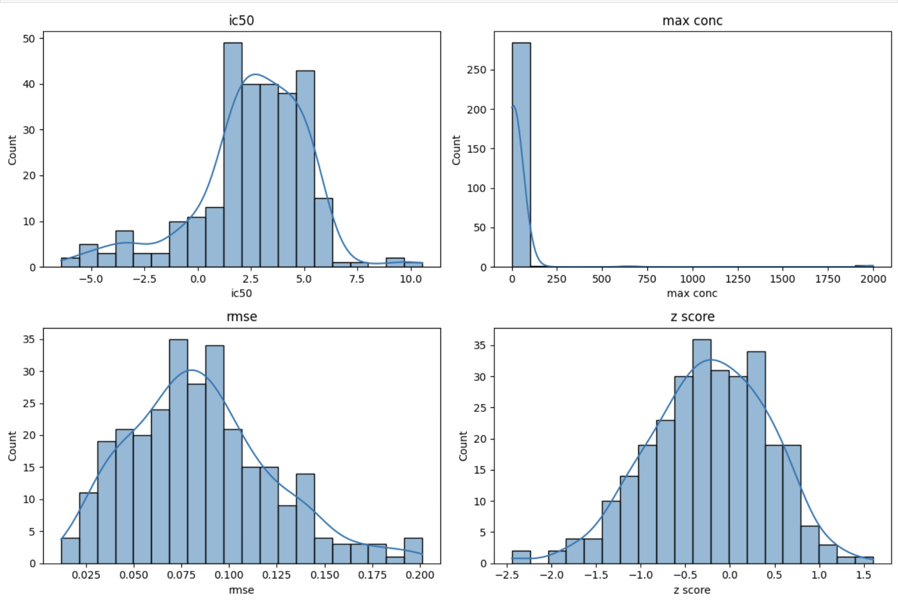
Figure 1. Distribution of the four predictor variables (IC50, maximum concentration, RMSE, and Z-score) in the GBM dataset. Histograms illustrate the observed distributions and numerical variability of the response-derived predictors used for model development.

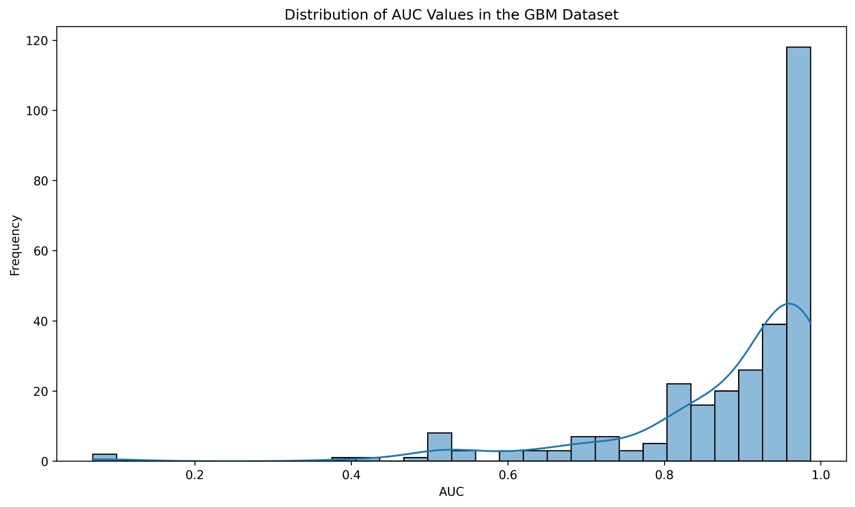
Figure 2. Distribution of AUC values in the GBM dataset. The histogram illustrates the distribution and range of the continuous AUC response variable used as the prediction target.

3.2 Correlation between response-derived predictors and AUC
Because the predictors were derived from drug-response measurements, we first analyzed their relationships with the AUC target before interpreting the model. Pearson correlation results showed a strong positive correlation between IC50 and AUC (r = 0.76393), meaning IC50 captures much of the variance in AUC but still differs from the target variable (Figure 3).

The correlation matrix shows a strong relationship between IC50 and AUC, as well as a weak connection between maximum concentration and AUC (r = 0.065), a moderate negative connection between RMSE and AUC (r = -0.333), and a moderate positive connection between Z-score and AUC (r = 0.462). Thus, IC50 appeared to have the strongest linear relation with AUC.

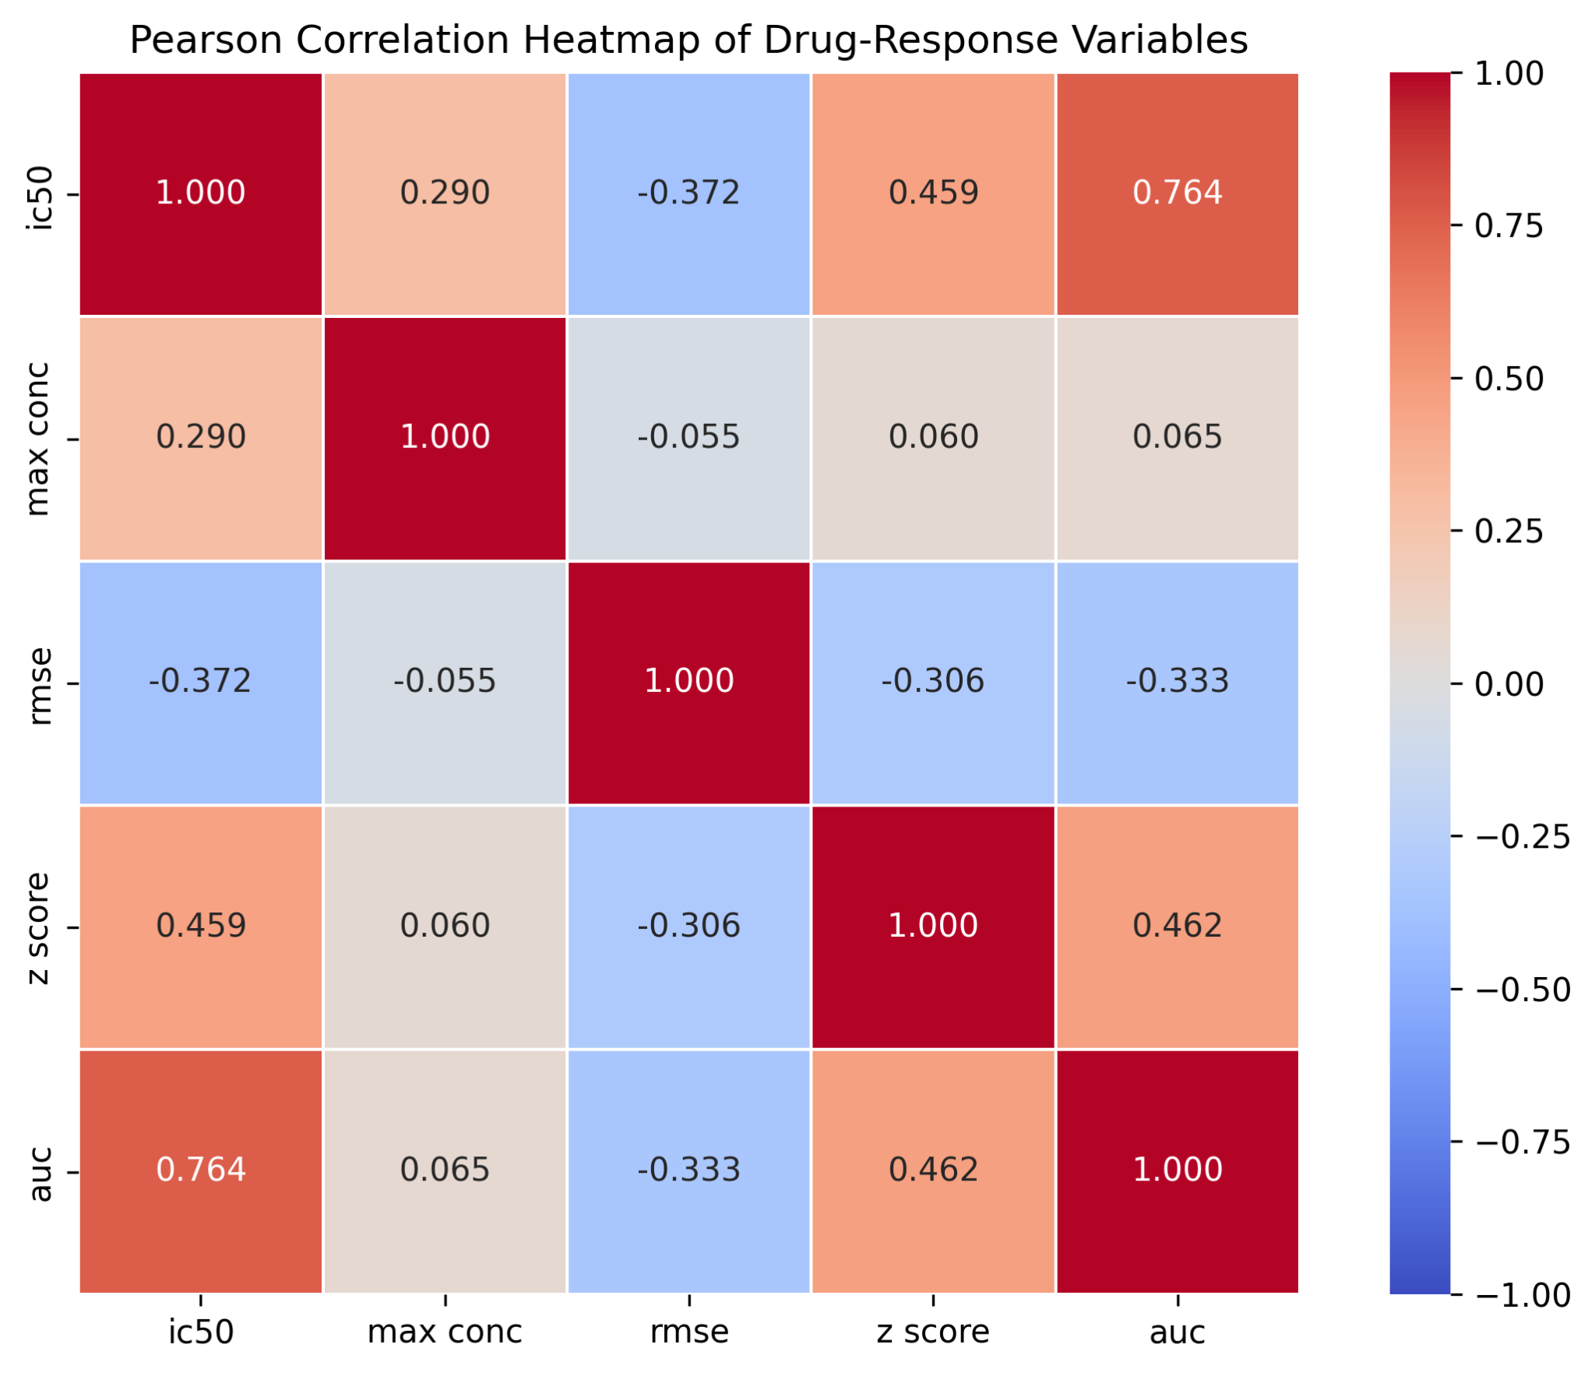
Figure 3. Pearson correlation matrix of IC50, maximum concentration, RMSE, Z-score, and AUC. Cell values represent Pearson correlation coefficients; positive and negative values indicate the direction of linear association between variables.

3.3 Comparative evaluation of machine-learning models
To establish a benchmark for predicting outcomes, we assessed six supervised regression techniques: Gradient Boosting, XGBoost, CatBoost, Random Forest, AdaBoost, and Ridge Regression. We evaluated model performance on the held-out test set and reported R², MSE, RMSE, and MAE. Among the individual models, Gradient Boosting was the most efficient, achieving R² of 0.920577, with MSE of 0.001970, RMSE of 0.044381, and MAE of 0.020504. XGBoost performed second-best (R² = 0.836444), followed by CatBoost (R² = 0.818369), Random Forest (R² = 0.806262), AdaBoost (R² = 0.795962), and Ridge (R² = 0.522718). For instance, the optimized Gradient Boosting model accounted for about 92% of the variance in AUC in the held-out test set and outperformed other nonlinear ensemble models and the linear Ridge model. Figure 4 shows the R² comparison, while Table 1 summarizes the full metrics. The performance gap between Ridge Regression and tree ensemble-based methods suggests that a simple linear formulation did not adequately capture the predictive relationships between the independent variables and AUC. Figure 4 visualizes the model performance comparison, showing Gradient Boosting's clear advantage over the other individual models.
Table 1. Final predictive performance of the six evaluated models on the unseen test set
Model | R² | MSE | RMSE | MAE
Gradient Boosting | 0.920577 | 0.001970 | 0.044381 | 0.020504
XGBoost | 0.836444 | 0.004056 | 0.063688 | 0.025946
CatBoost | 0.818369 | 0.004504 | 0.067115 | 0.026117
Random Forest | 0.806262 | 0.004805 | 0.069316 | 0.027164
AdaBoost | 0.795962 | 0.005060 | 0.071134 | 0.036792
Ridge Regression | 0.522718 | 0.011837 | 0.108796 | 0.064951

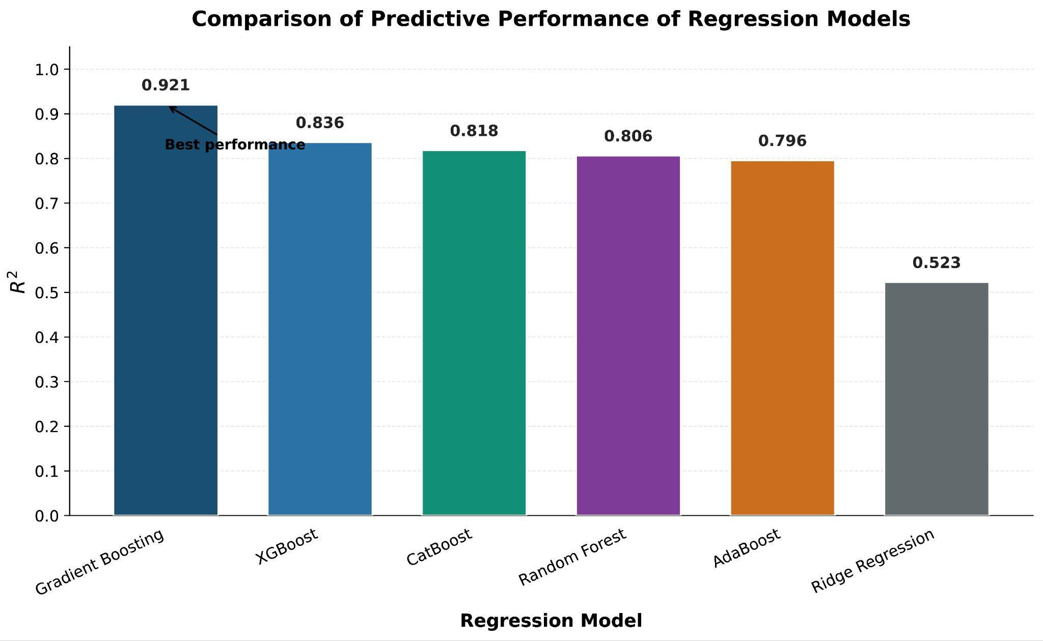

Figure 4. Comparative predictive performance of the six regression models based on R². Bars represent R² values obtained on the held-out test set.

3.4 Cross-validation and hyperparameter optimization
Model development included five-fold cross-validation to evaluate reliability and guide hyperparameter selection. For some boosted tree models, we tuned hyperparameters using GridSearchCV. In contrast, for Ridge regression, we used five-fold cross-validation with fixed regularization parameter values. For the Gradient Boosting model, the test-set R2 was 0.920577, while MSE, RMSE, and MAE were 0.001970, 0.044381, and 0.020504, respectively. Moreover, cross-validation results demonstrated the stability of the Gradient Boosting algorithm. During five-fold drug-group validation, the model's mean R2 was 0.902459 ± 0.037058, indicating that prediction variation across independent drug groups remained within a limited range.

3.5 Predicted versus observed AUC
As shown in Figure 5, we also evaluated the predictive accuracy of the improved Gradient Boosting model by comparing predicted and actual AUC values for unseen test data.
The findings showed an R² value as high as 0.920577, confirming that the model explained about 92% of the variability in the test data. The concentration of observations around the identity line corresponded to the low RMSE (0.044381) and MAE (0.020504) for the same sample.
Although a few observations deviated significantly from the identity line, most predictions showed small discrepancies between observed and calculated AUC values.

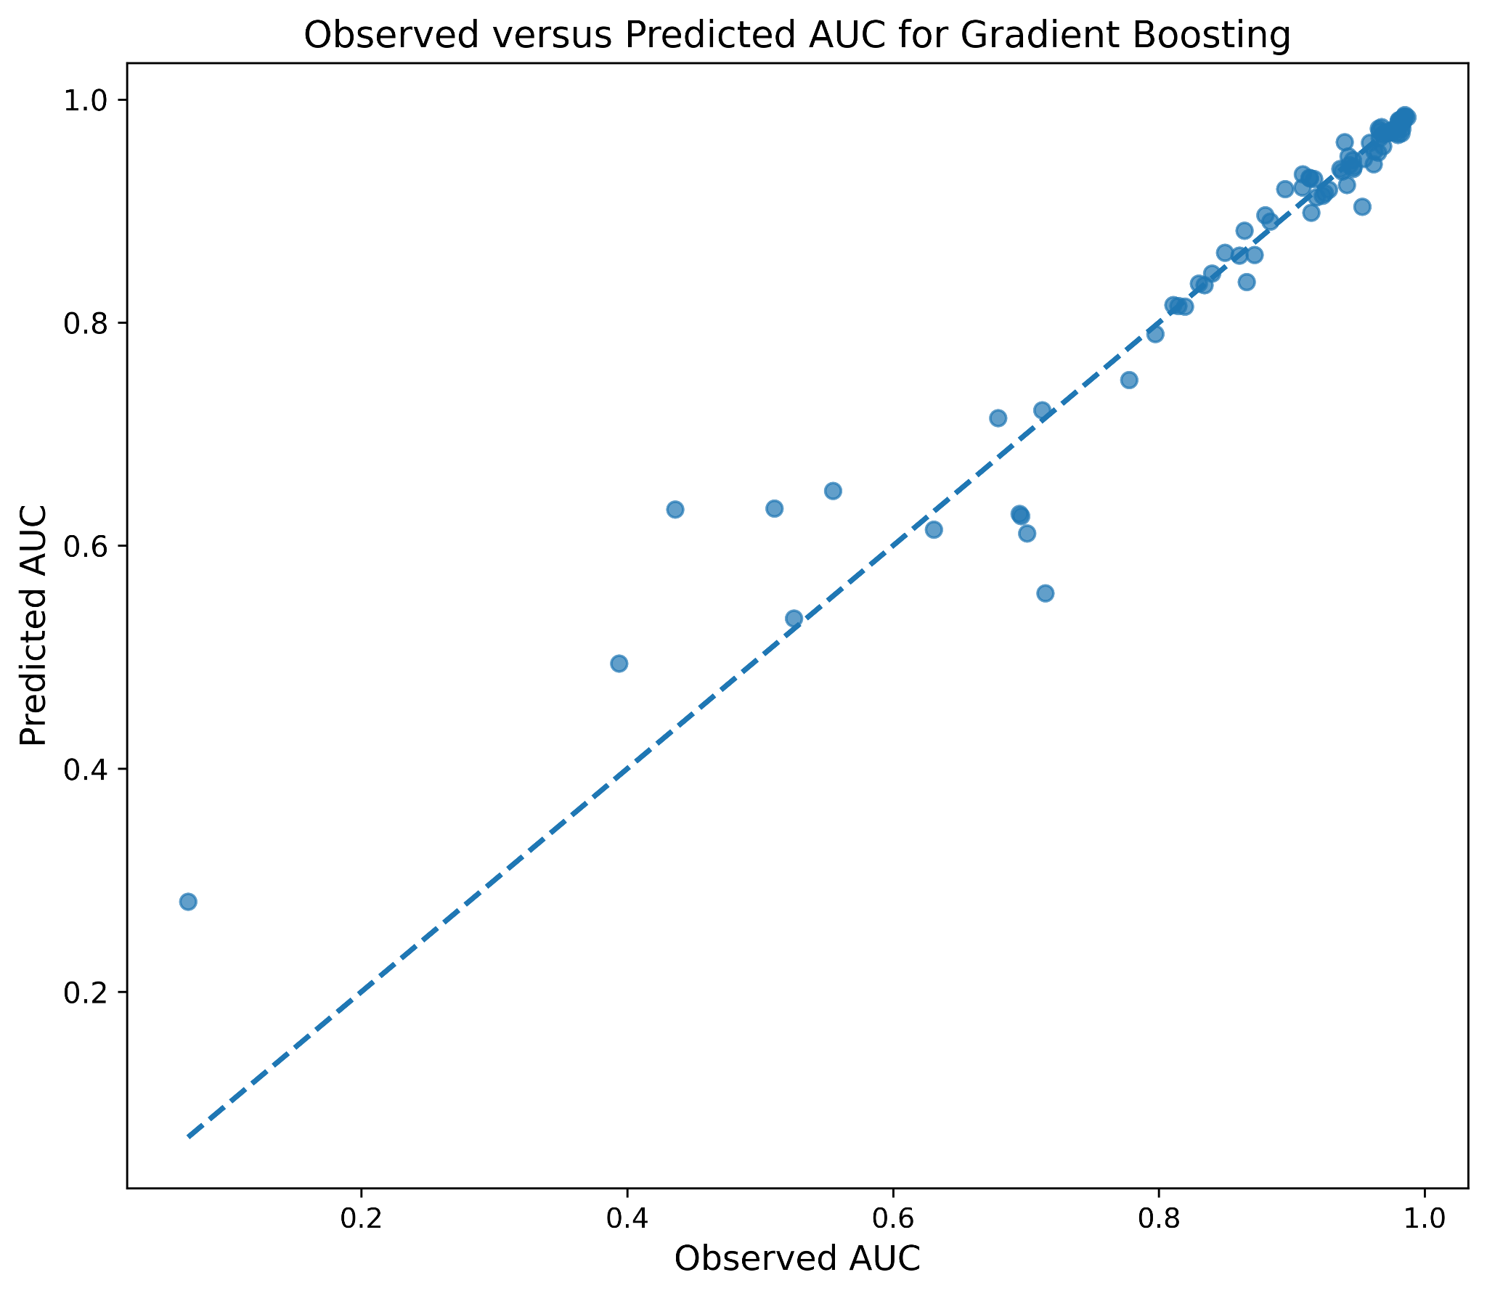
Figure 5. Observed versus predicted AUC values for the optimized Gradient Boosting model evaluated on the unseen test set. The dashed diagonal represents the identity relationship between observed and predicted AUC values.

3.6 Residual analysis
Residual analysis was carried out to evaluate the error distribution and look for potential systematic errors in the improved Gradient Boosting model. The residuals were calculated as the difference between the actual and predicted AUC values and plotted against the predicted AUC (Figure 6).
Most residuals were near zero, particularly for cases with high predicted AUC values, indicating that most observations had small prediction errors. Nevertheless, some observations had much larger positive or negative residuals, showing that prediction accuracy was not necessarily constant across the response range. These larger residuals mean that although the model demonstrates strong predictive power overall, some observations remain difficult to predict. Thus, residual analysis provides additional information beyond R², RMSE, and MAE by showing the distribution of prediction errors.
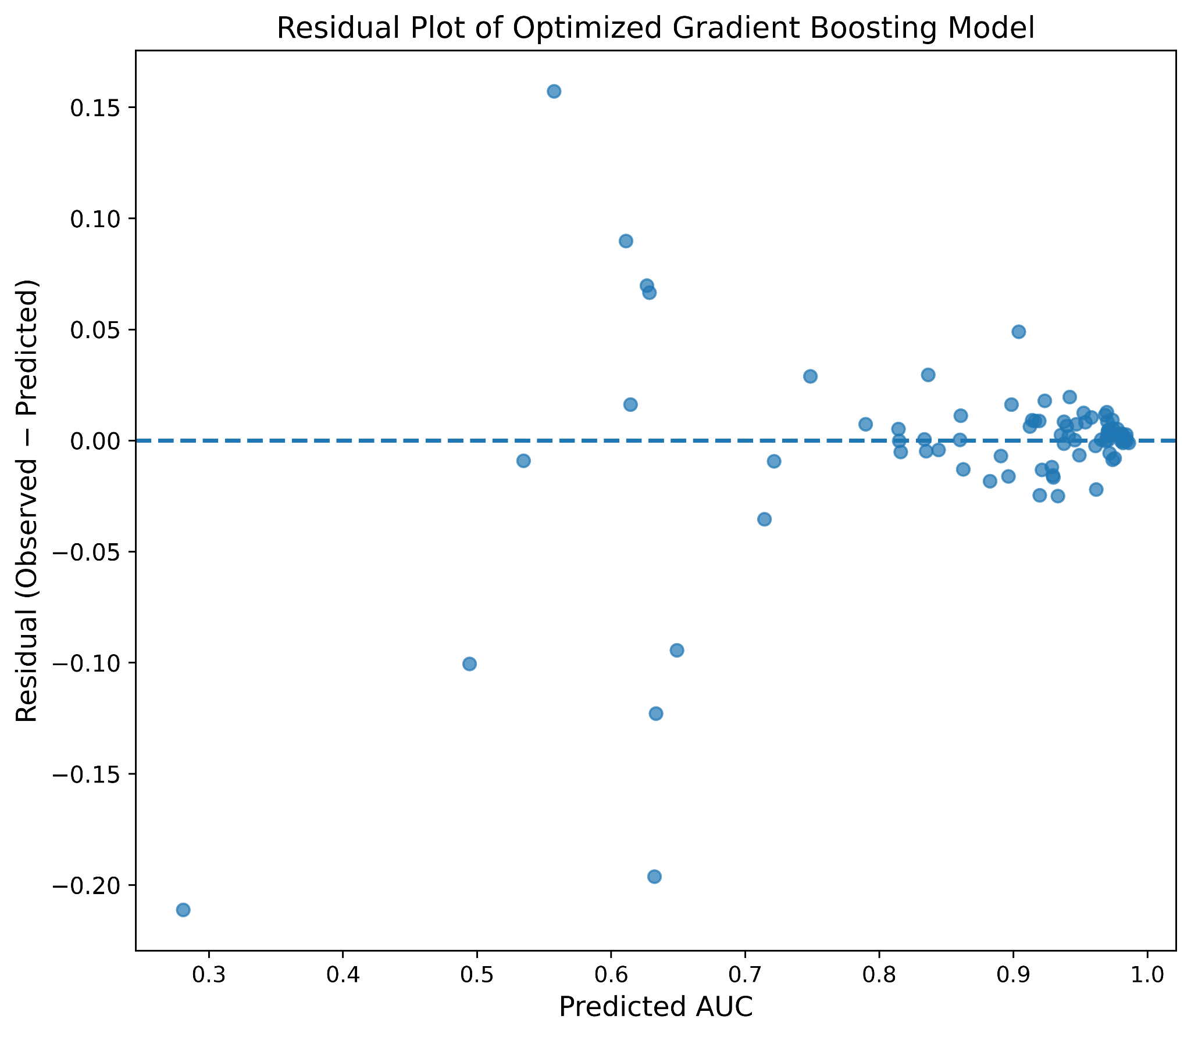
Figure 6. Residual plot of the optimized Gradient Boosting model on the unseen test set. Residuals were calculated as observed AUC minus predicted AUC; the dashed horizontal line represents zero residual error.

3.7 Feature importance and model interpretation
We assessed each predictor's contribution in the optimized Gradient Boosting model by analyzing feature importance. IC50 had the highest feature importance value (0.743407), followed by maximum concentration (0.216605), root mean squared error (RMSE) (0.022475), and Z-score (0.017512) (Figure 7). The findings show that both IC50 and maximum concentration were the main contributory factors to the prediction made through the model. At the same time, RMSE and Z-score played a minimal role in prediction.

IC50 being the most important predictor aligns with the high Pearson correlation between IC50 and AUC (r = 0.76393; see Figure 3). Nevertheless, it should be noted that feature importance is an indication of the contribution of each predictor to a particular prediction and cannot be interpreted as an indication of the biological relationship. This is particularly relevant here because the first four predictors relate to drug-response measurements.

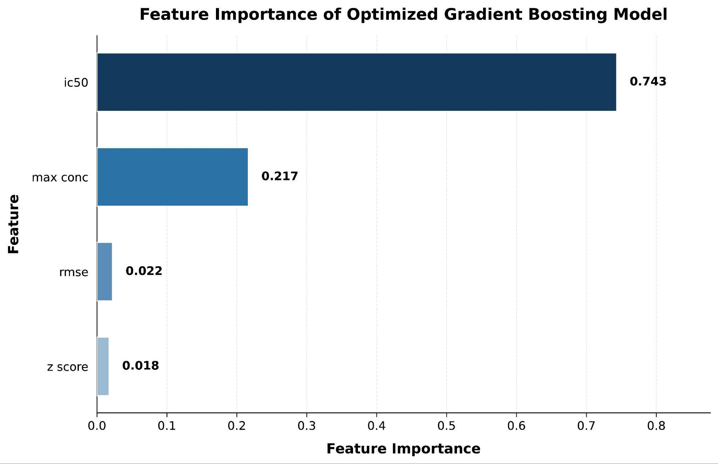
Figure 7. Relative feature importance of the optimized Gradient Boosting model. Values represent the model-derived importance assigned to IC50, maximum concentration, RMSE, and Z-score during prediction.

3.8 SHAP-based interpretation of the Gradient Boosting model
To analyze the importance of individual predictors in the model's predictive performance, we conducted SHAP analysis using a TreeExplainer based on the trained Gradient Boosting model. The SHAP summary plot shows the magnitude and direction of feature contributions across individual observations (Figure 8). IC50 had the largest range of SHAP values, indicating the largest contribution to the deviations of model predictions. The analysis indicated that both higher and lower IC50 values contributed differently to AUC predictions, suggesting the model captures more than a simple relationship.

Maximum concentration was the second most widespread in terms of SHAP value range, while RMSE and Z-score contributed less. Thus, SHAP analysis confirmed the global feature importance findings, providing model-based evidence for the importance of the predictive variable, IC50. Since the predictors are derived from the response measurements, the SHAP values reflect predictive associations rather than biologically or causally independent relationships.

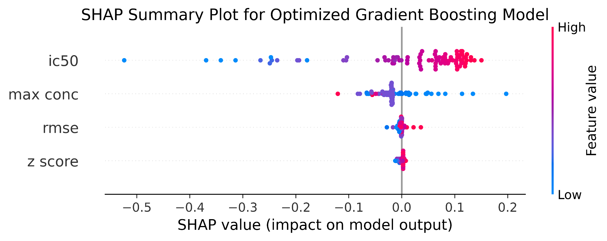
Figure 8. SHAP summary plot for the optimized Gradient Boosting model. Each point represents an observation, with the horizontal position indicating the SHAP contribution to model output and color representing the corresponding feature value.

3.9 Stacking ensemble improves predictive performance
To assess whether complementary predictive models improve AUC, we implemented a stacking ensemble in which Gradient Boosting, XGBoost, CatBoost, Random Forest, AdaBoost, and Ridge Regression served as base learners. In contrast, Ridge Regression served as the meta-learner.
To avoid using in-sample base-model predictions, the meta-learner used out-of-fold predictions from the base models as input. As a result, the stacking ensemble produced R² equal to 0.923645, MSE equal to 0.001894, RMSE equal to 0.043515, and MAE equal to 0.019116 (Table 2).

The ensemble outperformed the optimized Gradient Boosting model by increasing R² from 0.920577 to 0.923645 and decreasing RMSE from 0.044381 to 0.043515 and MAE from 0.020504 to 0.019116. Although the changes seem negligible, all measures show a positive trend, with performance increasing after creating the stacking ensemble (Table 2; Figure 9).
The meta-learner coefficients were the highest for Gradient Boosting (0.115369) and the lowest for Ridge Regression (-0.001704) when considering both the contribution of the meta-learner and the use of each base model in the working process of the meta-learning algorithm.

Table 2. Comparison of individual models and the stacking ensemble
Model | R² | MSE | RMSE | MAE
Stacking Ensemble | 0.923645 | 0.001894 | 0.043515 | 0.019116
Gradient Boosting | 0.920577 | 0.001970 | 0.044381 | 0.020504
XGBoost | 0.836444 | 0.004056 | 0.063688 | 0.025946
CatBoost | 0.818369 | 0.004504 | 0.067115 | 0.026117
Random Forest | 0.806262 | 0.004805 | 0.069316 | 0.027164
AdaBoost | 0.795962 | 0.005060 | 0.071134 | 0.036792
Ridge Regression | 0.522718 | 0.011837 | 0.108796 | 0.064951

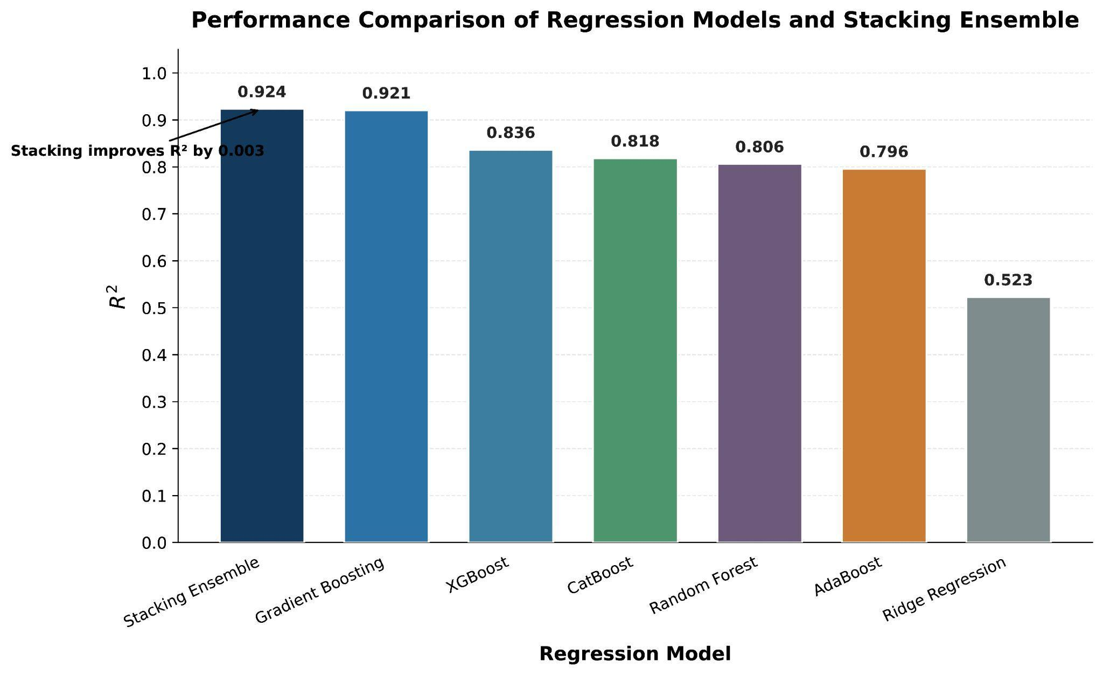
Figure 9. Comparative R² performance of the six individual regression models and the stacking ensemble on the unseen test set.

3.10 Generalization across unseen cell lines
To determine whether model performance depended on whether training included observations from the same cell line, we used leave-one-cell-line-out cross-validation. In each test run, we omitted at least one complete cell line, trained the model on the remaining cell lines, and optimized hyperparameters.
Thus, we conducted three tests for each cell line. The optimized model yielded R² values of 0.430925 for 42-MG-BA, 0.966335 for T98G, and 0.920402 for YKG-1 (Table 3 and Figure 10).
In the three cell lines, the mean performance was R² = 0.772554 ± 0.296750, MSE = 0.004162 ± 0.006310, RMSE = 0.049802 ± 0.050230, and MAE = 0.034963 ± 0.029433.
The high variability between the cell lines mainly resulted from the lower performance of 42-MG-BA, which differs significantly from that of T98G and YKG-1. This emphasizes that conclusions about the model’s performance cannot be generalized to all cell types and that validation must account for data variability before making generalization statements.

Table 3. Leave-one-cell-line-out validation, where optimized model yielded R² values of 0.430925 for 42-MG-BA
Cell line | R² | MSE | RMSE | MAE
42-MG-BA | 0.430925 | 0.011436 | 0.106937 | 0.067850
T98G | 0.966335 | 0.000893 | 0.029879 | 0.025945
YKG-1 | 0.920402 | 0.000158 | 0.012589 | 0.011093
Mean ± SD | 0.772554 ± 0.296750 | 0.004162 ± 0.006310 | 0.049802 ± 0.050230 | 0.034963 ± 0.029433

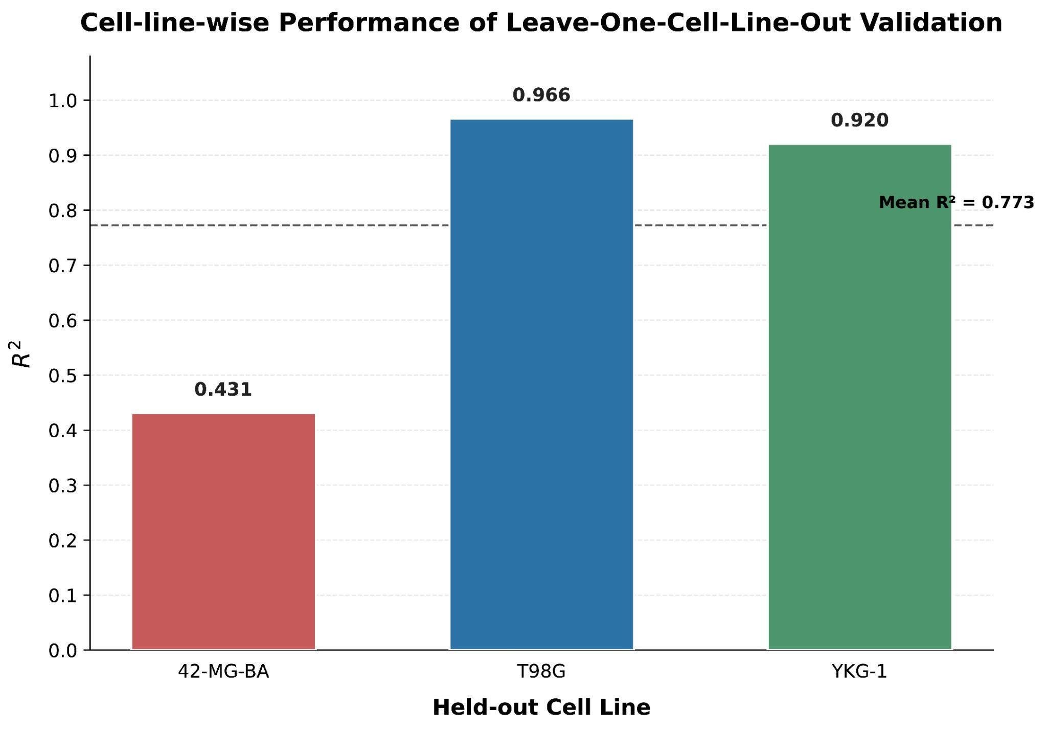
Figure 10. Cell-line-wise performance of leave-one-cell-line-out validation. Bars represent R² obtained when each GBM cell line was completely withheld from model training.

3.11 Generalization across unseen drug groups
Because the same drug may appear in multiple observations across cell lines, random splitting at the observation level could place correlated drug observations in both the test and training sets (Xia et al., 2022). Therefore, we conducted five-fold group cross-validation using drug ID as the grouping factor. In each fold, we excluded all observations from the test drug groups when building the model. The five folds resulted in R² values of 0.950066, 0.932574, 0.883646, 0.883748, and 0.862262, respectively (Figure 11). The mean R² was 0.902459 ± 0.037058, while the corresponding mean MSE, RMSE, and MAE values were 0.002142 ± 0.001581, 0.043178 ± 0.018642, and 0.022236 ± 0.008633, respectively (Table 4).

The small range of R² values across the five folds suggests stable predictive capacity, since we measured the model's accuracy without complete drug groups. Moreover, because the major predictors remain the response values, the results reflect the model's ability to generalize to new drug groups by measuring responses rather than independently predicting them from molecular and genomic characteristics.

Table 4. Five-fold drug-group validation suggests stable predictive capacity
Fold | Training drugs | Test drugs | R² | MSE | RMSE | MAE
1 | 230 | 58 | 0.950066 | 0.000408 | 0.020209 | 0.012256
2 | 230 | 58 | 0.932574 | 0.000817 | 0.028588 | 0.014938
3 | 230 | 58 | 0.883646 | 0.002062 | 0.045414 | 0.023401
4 | 231 | 57 | 0.883748 | 0.003319 | 0.057615 | 0.027635
5 | 231 | 57 | 0.862262 | 0.004104 | 0.064063 | 0.032948
Mean ± SD | — | — | 0.902459 ± 0.037058 | 0.002142 ± 0.001581 | 0.043178 ± 0.018642 | 0.022236 ± 0.008633

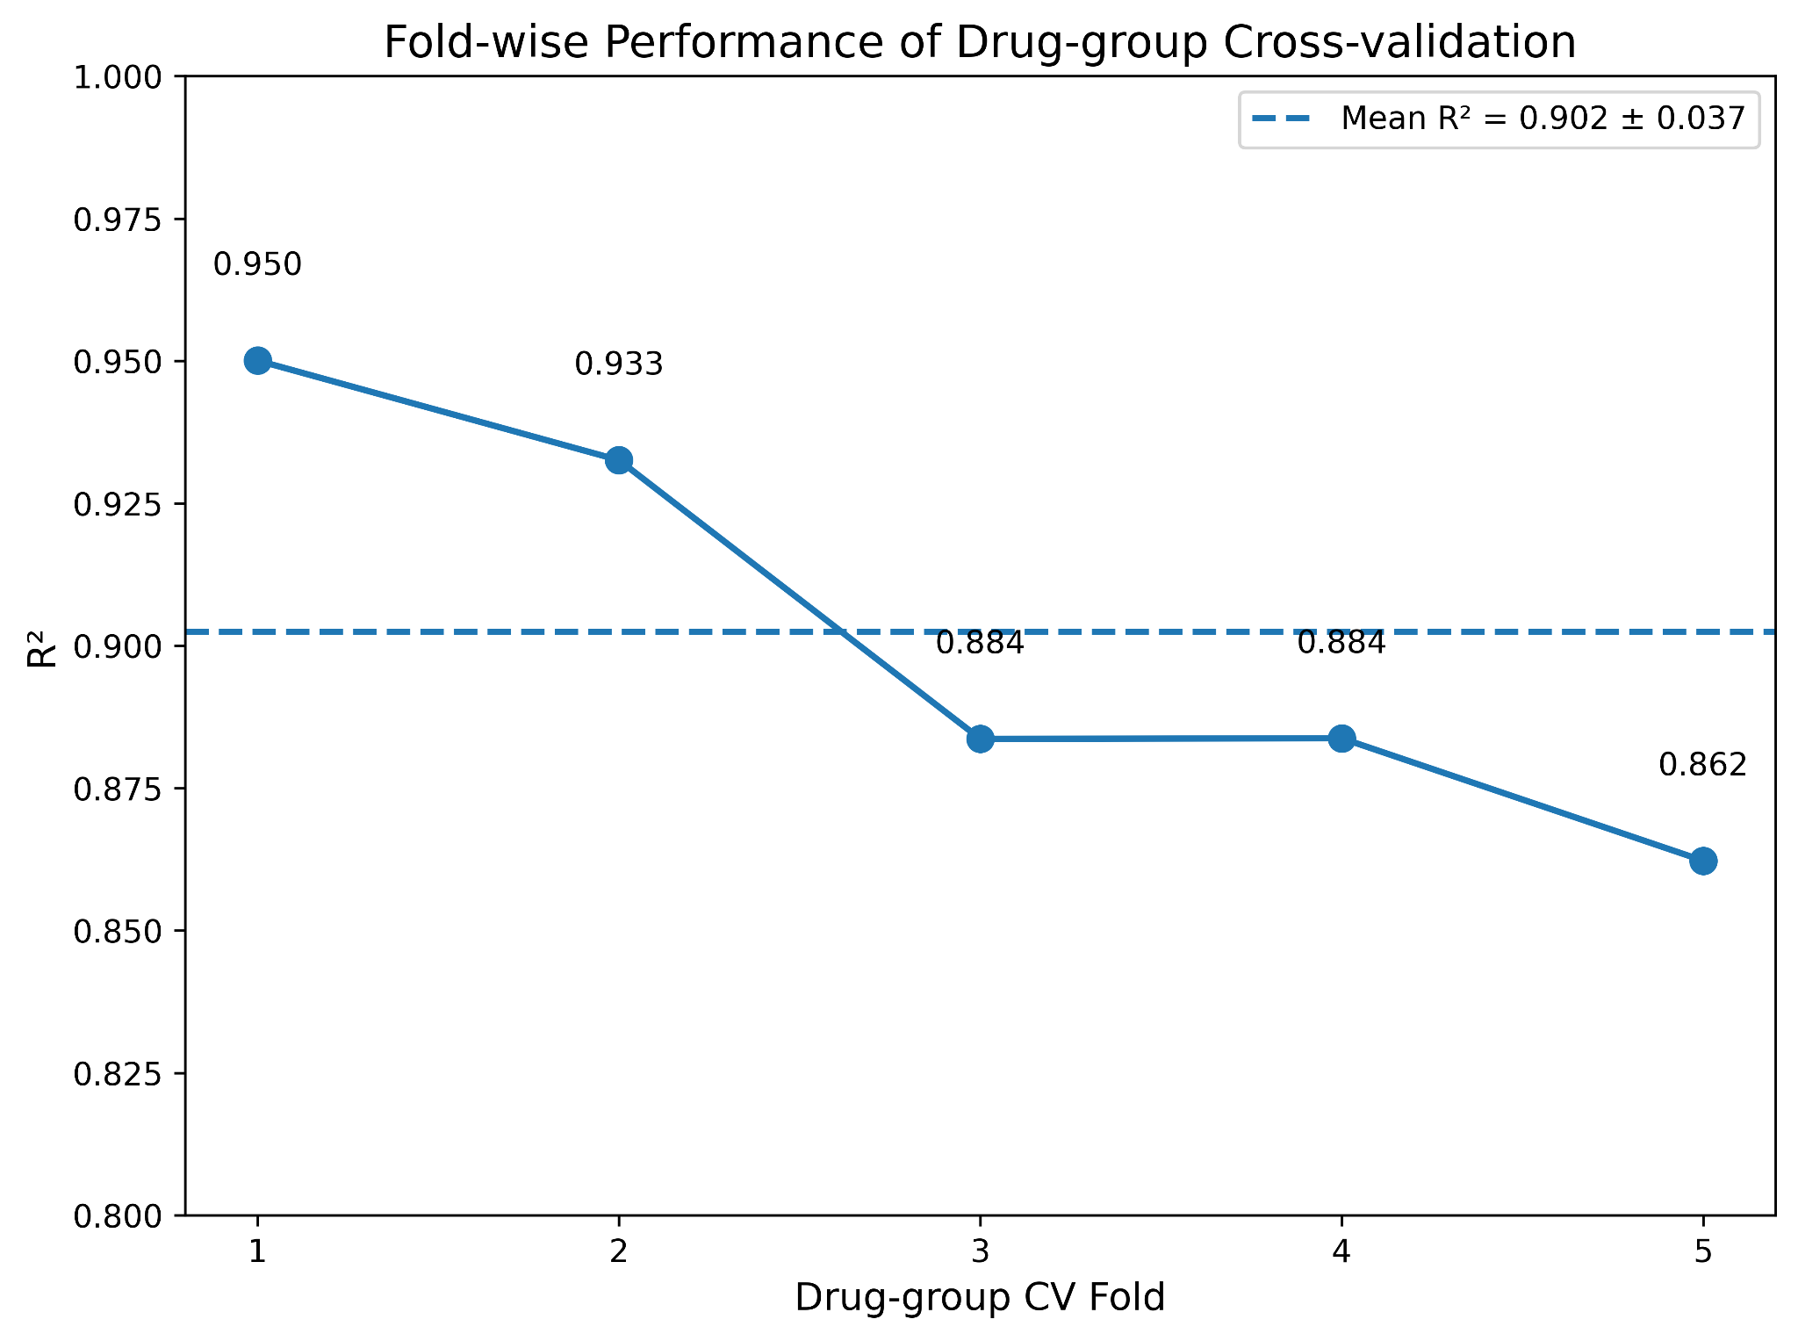
Figure 11. Fold-wise R² performance of five-fold drug-group cross-validation. Individual points represent the R² obtained in each fold, while the dashed line indicates the mean R² across folds; the value in the legend represents the mean ± SD.

3.12 Sensitivity analysis using non-response-derived features
A key methodological question was whether the strong predictive power was mainly because the predictors were derived from the same drug-response experiment as the AUC target. To answer this question, we performed a sensitivity analysis excluding IC50, maximum concentration, RMSE, and Z-score. The alternative formulation used available categorical descriptors not derived from non-response, such as drug name, cell-line name, TCGA classification, and tissue subtype, and excluded response derivatives. The model showed much lower predictive power on the test set not used for training: R² = -0.014549, MSE = 0.027102, RMSE = 0.164626, and MAE = 0.105000 (Table 5; Figure 12).

The primary formulation, which derives predictors from the response, showed R² = 0.920577, MSE = 0.001970, RMSE = 0.044381, and MAE = 0.020504 for the same test data set. This comparison shows that the predictive signal captured by the AUC estimation procedure depends entirely on the complementary drug-response measurements used as predictors. Thus, the model reflects only an AUC estimation algorithm based on complementary drug-response measurements.

Table 5. Sensitivity analysis with non-response-derived predictors
Feature formulation | R² | MSE | RMSE | MAE
Response-derived predictors | 0.920577 | 0.001970 | 0.044381 | 0.020504
Non-response-derived categorical predictors | −0.014549 | 0.027102 | 0.164626 | 0.105000

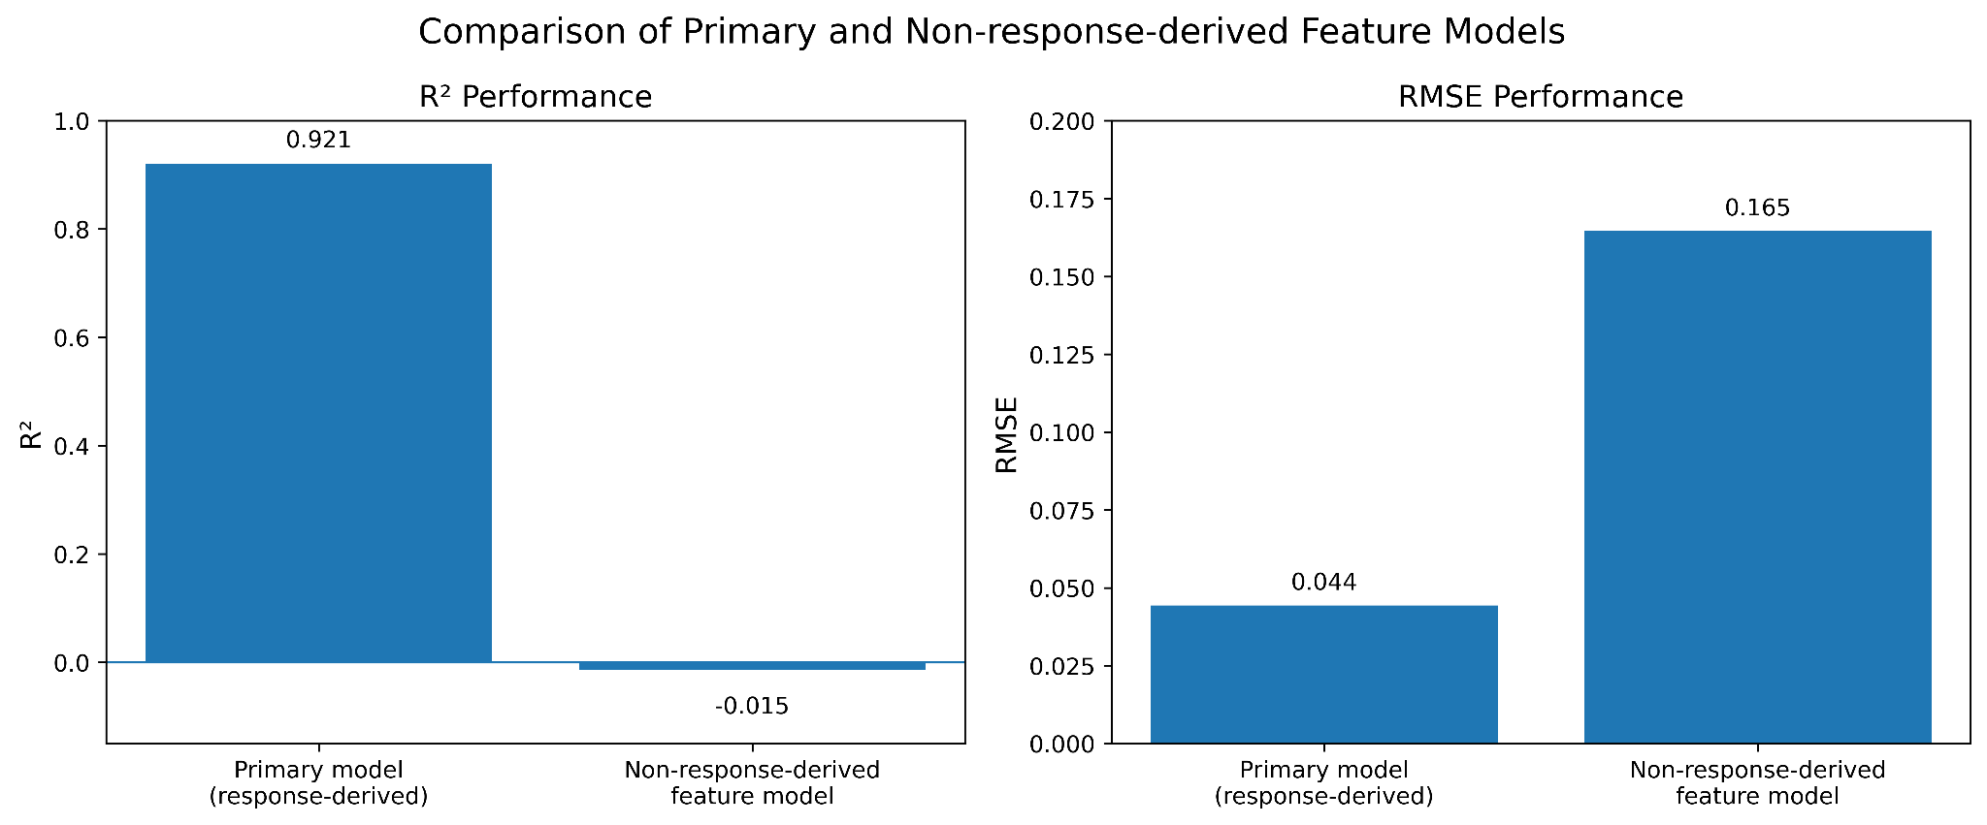
Figure 12. Comparison of predictive performance between the primary response-derived feature model and the non-response-derived feature model. R² and RMSE are shown to illustrate the effect of excluding response-derived predictors.

3.13 Drug prioritization based on predicted AUC
The optimized Gradient Boosting technique was employed to calculate AUCs corresponding to the GBM drug response experiments after carrying out model validation. The predicted drug-level values based on AUCs were reported against their Drug IDs in ascending order of predicted AUC. Since lower AUC values indicate the quantification of higher sensitivity according to the employed response metric, lower AUC values were used to classify drugs in priority categories. The Figure 13 and Table 6 show the top ten drugs according to AUC.
Among analyzed drugs, Drug ID 1034 possessed the lowest predicted AUC of 0.280783. Drug ID 1709 followed with a predicted AUC of 0.494372, and Drug ID 1708 was ranked third (0.534611). The other drugs that were classified as priorities had their predicted AUC numbers between 0.557329 and 0.633412. Table 6 gives a complete list of all drugs with their ascending order of AUC, while the data presented in Figure 13 represent the lists graphically.
The estimated AUC numbers were not always matching with what was found in the case of the chosen medications. For instance, medication ID 1034 had an AUC value of 0.069569 whereas the predicted value was 0.280783. The observed AUC as well as the predicted AUC for medication ID 1529 was 0.630544 and 0.614372 correspondingly. These discrepancies stress the necessity of experimental verification of the candidate drugs predicted by the computational methods.
.
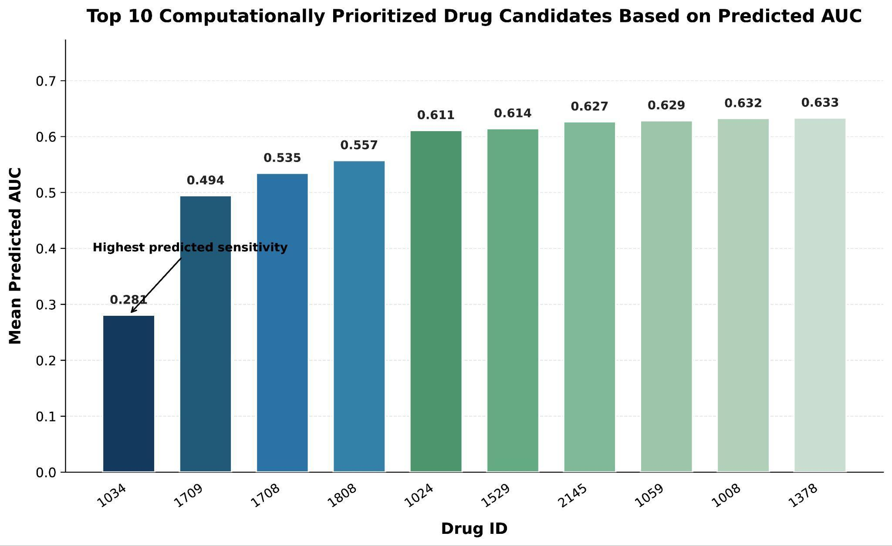
Figure 13. Top 10 computationally prioritized drug groups ranked according to predicted AUC. Lower predicted AUC values indicate higher computational priority under the response metric used in this study.

Table 6. Top 10 prioritized drug candidates with Drug ID, observed/mean AUC if appropriate, predicted AUC, and ranking.
Rank | Drug ID | Observed Mean AUC | Predicted Mean AUC | Number of Observations
1 | 1034 | 0.069569 | 0.280783 | 1
2 | 1709 | 0.393863 | 0.494372 | 1
3 | 1708 | 0.525517 | 0.534611 | 1
4 | 1808 | 0.714462 | 0.557329 | 1
5 | 1024 | 0.700826 | 0.611031 | 1
6 | 1529 | 0.630544 | 0.614372 | 1
7 | 2145 | 0.696400 | 0.626634 | 1
8 | 1059 | 0.695026 | 0.628507 | 1
9 | 1008 | 0.436080 | 0.632384 | 1
10 | 1378 | 0.510593 | 0.633412 | 1

3.14. Computational Prioritization of Candidate Drugs Based on Predicted AUC
In Figure 14, the horizontal axis shows various nanoparticle types and their corresponding cell lines. The vertical axis shows size (nm) and zeta potential (mV). The blue bars indicate the optimal nanoparticle size, while the red bars show the zeta potential, which is typically negative and therefore points downward. Each nanoparticle type is represented by two bars: a blue bar for size and a red bar for zeta potential. The examination of the assembled nanoparticle dataset involved the identification of gold nanoparticles that had a size of 40 nm and zeta potential of −39.03 mV. Different properties of nanoparticles found in various models of cell-lines were included in the dataset but these models weren’t GBM models which were used in the present analysis. Therefore nanoparticle properties were included in a separate contextual analysis instead of connecting them with AUC-response data from GBM cells.
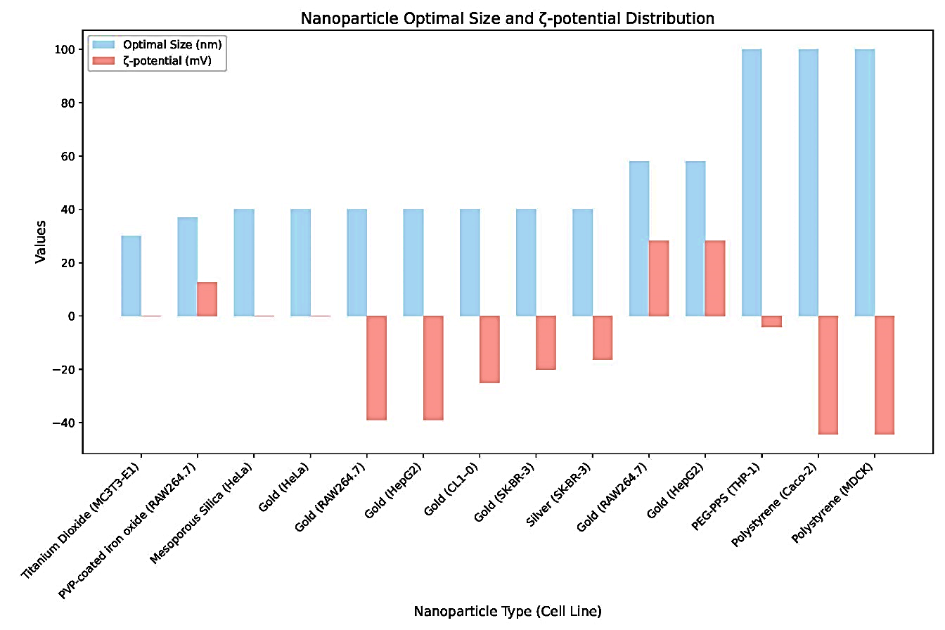
Figure 14: Nanoparticle evaluation: gold nanoparticles (40 nm size, zeta potential of -39.03 mV) showed consistent performance across multiple cell lines, including SK-BR-3, RAW264.7, and HepG2.

Nanoparticle Type (Cell Line) | Size (nm) | ζ-potential (mV)
Titanium Dioxide (MCF-7-EL1) | ~30 | ~ -5
PVK-coated Iron Oxide (RAW264.7) | ~40 | ~ -5
Mesoporous Silica (HeLa) | ~50 | ~ -5
Gold (HeLa-1) | ~55 | ~ -20
Gold (RAW264.7-1) | ~55 | ~ -30
Gold (HepG2-1) | ~55 | ~ -35
Gold (CLL13) | ~55 | ~ -20
Gold (HeLa-2) | ~50 | ~ -15
Silver (HeLa-3) | ~55 | ~ -20
Gold (RAW264.7-2) | ~60 | ~ -10
Gold (HepG2-2) | ~65 | ~ -10
Polypyrrole (THP-1) | ~90 | ~ -5
Polypyrrole (Caco-2) | ~90 | ~ -25
Polypyrrole (HCC07) | ~90 | ~ -25
Table 7. Nanoparticle types and their corresponding size and zeta potential across various cell-line models.

The characteristics of the nanoparticles detailed in Table 7 include the types of nanoparticles and their sizes and zeta potentials for different cell line models. The cell lines used for this nanoparticle information, i.e., MCF-7-EL1, RAW264.7, HeLa, HepG2, CLL13, THP-1, Caco-2, and HCC07, are not equivalent to the GBM cell lines (i.e., 42-MG-BA, T98G, YKG-1) employed in the GDSC drug-response investigations. As a result, it is crucial to assess the nanoparticles independently of the GBM cells since the data presented does not reflect specific observations made on GBM cells. Nanoparticle characteristics provide information about the physical and chemical characteristics of different nanoparticles combined with the cell lines in question. Nonetheless, there is no necessarily link between these characteristics and drug delivery in GBM since additional experiments need to be conducted to establish this link.
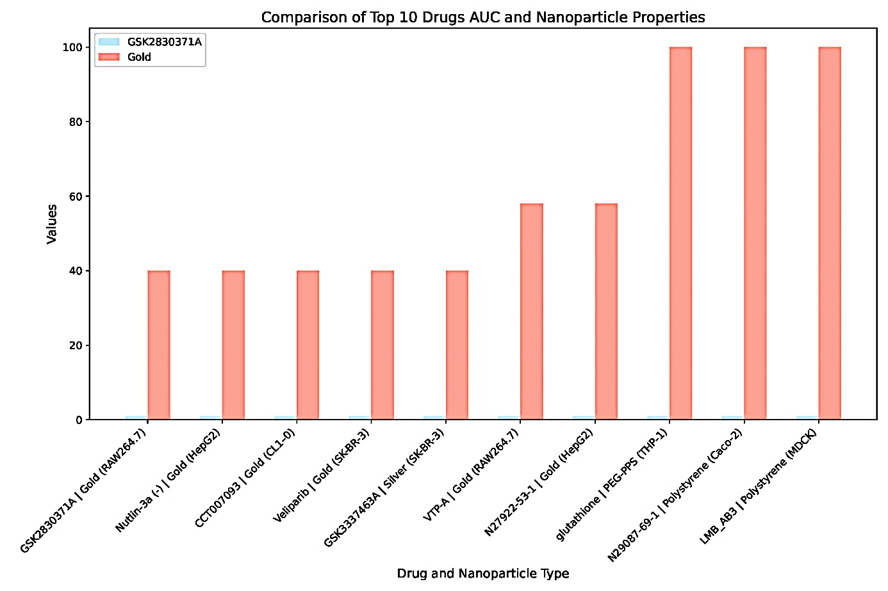
Figure 15: The plot compares the ratings of the top 10 medications with nanoparticle characteristics such as size, charge, and formulation type. The X-axis lists the drugs, and the Y-axis shows their respective scores.

In order to determine whether the drug-response outcomes can be integrated with nanoparticle delivery methods, the primary drug candidates from the GBM assessment were tested against the specific properties of nanoparticles according to the literature. The results are illustrated in Figure 15, which shows the combinations of drugs and nanoparticles along the horizontal axis and the respective scores along the vertical axis. This assessment is intended to be a screening exercise rather than a direct experimental inquiry.

The scores for gold and polypyrrole nanoparticles varied in terms of their values in the combinations used in the current study. In terms of combinations with gold nanoparticles, the results were generally moderate, while some polypyrrole combinations yielded higher scores. Thus, the combinations with Sitafloxacin, 183207-58-1, and LMB_A81 showed comparatively higher scores.

Table 8: Drug, Nanoparticle Type, and Score
Drug and Nanoparticle Type | Score (Approx.)
GSK2830371A / Gold (RAW264.7-1) | ~40
Niraparib / Gold (HepG2-1) | ~40
CCT007093 / Gold (CLL13) | ~40
Mogamulizumab/ Silver (HeLa-3) | ~40
GSK2830371A / Silver (HeLa-3) | ~40
VTP-1 / Gold (RAW264.7-2) | ~40
ITP223-31 / Gold (HepG2-2) | ~60
Sitafloxacin / Polypyrrole (THP-1) | ~60
183207-58-1 / Polypyrrole (Caco-2) | ~100
LMB_A81 / Polypyrrole (HCC07) | ~100

Table 8 presents an overview of the different drug and nanoparticle combinations displayed in Figure 15. The nanoparticle-associated cell lines represented in the table, such as HepG2, RAW264.7, Caco-2, and HeLa, refer to the cellular context from which the characteristics of the nanoparticles were derived. However, the mentioned cell lines are not GBM cell lines; thus, the results pertaining to the nanoparticles must be regarded as literature-derived evidence and not as data indicating the effectiveness of the nanoparticles against GBM. The example of the GBM component of this study is based on drug-response/AUC and ML models and is upcoming considerably in regard to the evaluation of the drug candidates.
The merger of drug screening based on machine learning and characteristics of nanoparticles can become a good foundation for the prioritization of DBT delivery for GBM patients. The use of nanoparticles, specifically gold, for drug and cellular delivery was reported in earlier studies (Yang et al. in 2014 and Chen et al. in 2016, and others). The nanoparticle characteristics such as size, surface charge, etc., can also be utilized for ensuring high delivery of DBT to the clinical practice (Li et al., 2020; Goddard et al., 2020).
Table 8 and Figure 15 offer a comparative overview relating to the drug candidates picked out through the GBM investigation with corresponding properties of nanoparticles discussed in various cellular models. However, they don’t prove experimentally that any specific nanoparticle enhances the AUC or the treatment efficiency of a drug in the case of GBM. Further laboratory testing together with in vivo studies using GBM-specific models is necessary to assess experimentally the proposed drug-nanoparticle combinations.

3.15. Ligand-Based Similarity Search
The ligand-based similarity search led to the identification of two common drugs:
- CCT007093: Top 10 derivatives of the drug shown in Figure 16, 17, and Table 9.
- GSK2830371A: top 10 derivatives of GSK2830371A drug shown in Figure 18, 19 & Table 10.

CHEMBL Id | IC₅₀ | Unit | Smiles | pIC₅₀ | Similarity
CHEMBL477617 | 12 | nM | Cc1c(Nc2c(C#N)cnc3sc(/C=C/C(N)=O)cc23)ccc2[nH]ccc12 | 7.920818754 | 0.3111111111111111
CHEMBL479058 | 130 | nM | N#Cc1cnc2sc(/C=C/C(=O)N3CCCC3)cc2c1Nc1ccc2[nH]ccc2c1 | 6.886056648 | 0.3018867924528302
CHEMBL477818 | 41 | nM | Cc1c(Nc2c(C#N)cnc3sc(/C=C/C(=O)N4CCC(O)C4)cc23)ccc2[nH]ccc12 | 7.387216143 | 0.30158730158730157
CHEMBL584483 | 165 | nM | CN(C)CCCn1cc(C2=C(c3cccc4ccccc34)C(=O)NC2=O)c2ccccc21 | 6.782516056 | 0.2982456140350877
CHEMBL477817 | 3.8 | nM | Cc1c(Nc2c(C#N)cnc3sc(/C=C/C(=O)N4CCCC4)cc23)ccc2[nH]ccc12 | 8.420216403 | 0.2962962962962963
CHEMBL4072709 | 276 | nM | Cn1cc(C2=C(c3cccc4cc(CN)ccc34)C(=O)NC2=O)c2ccccc21 | 6.559090918 | 0.29411764705882354
CHEMBL7463 | 6.7 | nM | CN(C)CCCn1cc(C2=C(c3c[nH]c4ccccc34)C(=O)NC2=O)c2ccccc21 | 8.173925197 | 0.29310344827586204
CHEMBL479057 | 3.5 | nM | Cc1c(Nc2c(C#N)cnc3sc(/C=C/C(=O)N4CCCC4)c(C)c23)ccc2[nH]ccc12 | 8.455931956 | 0.2909090909090909
CHEMBL476149 | 48 | nM | Cc1c(Nc2c(C#N)cnc3sc(/C=C/C(=O)N4CCCCC4)cc23)ccc2[nH]ccc12 | 7.318758763 | 0.2909090909090909
CHEMBL566853 | 52 | nM | CN(C)CCOc1cccc(C2=C(c3c[nH]c4ccccc34)C(=O)NC2=O)c1 | 7.283996656 | 0.2903225806451613
Table 9: CCT007093 top 10 derivatives using AdaBoost.
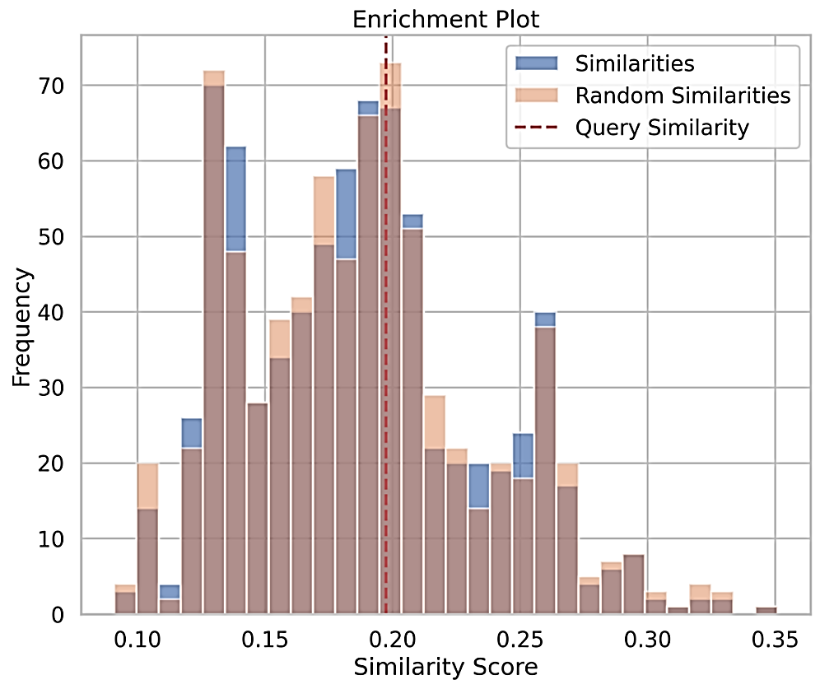
Figure 16: Enrichment plot showing similarity score for the drug CCT007093. Top 10 derivatives of the CCT007093 drug, which depict the frequency enrichment and similarity scores using Tanimoto.
In Figure 16, the horizontal x-axis shows the similarity score, ranging from 0.10 to 0.35, while the y-axis shows the frequency (number of occurrences), with a maximum of approximately 70. The blue bars denote the similarity scores of the top 10 derivatives of CCT007093, whereas the light brown bars depict random similarities, serving as a background or control set. A dashed red vertical line indicates the query similarity score for the specific compound under analysis. The main cluster of data shows that the most comparable scores fall within the range of 0.13 to 0.25, with a peak frequency at 0.15 to 0.18, reaching nearly 70 occurrences. The query similarity marked by the dashed red line is approximately 0.205 (around 0.20), suggesting that the query compound exhibits a greater-than-random similarity compared to a random distribution. The blue bars, representing similarities, indicate higher-than-random hits in specific bins, especially between 0.20 and 0.25.
In contrast, the light brown bars representing random similarities are more dispersed, with peaks occurring slightly earlier, around 0.15. Tanimoto similarity is a standard measure for comparing molecular fingerprints; higher Tanimoto scores indicate greater similarity between molecules. The observed enrichment, where the blue bars exceed the brown bars within the 0.20–0.25 range, implies that the top 10 derivatives are genuinely more similar to the query compound than random molecules. Furthermore, the red dashed line for query similarity (~0.205) is positioned to the right of the random distribution peak, indicating significant enrichment. This suggests that the selected molecules are meaningfully similar rather than coincidental. In summary, the chosen top 10 derivatives exhibit significant enrichment compared to random molecules, underscoring an effective strategy for identifying similar compounds.
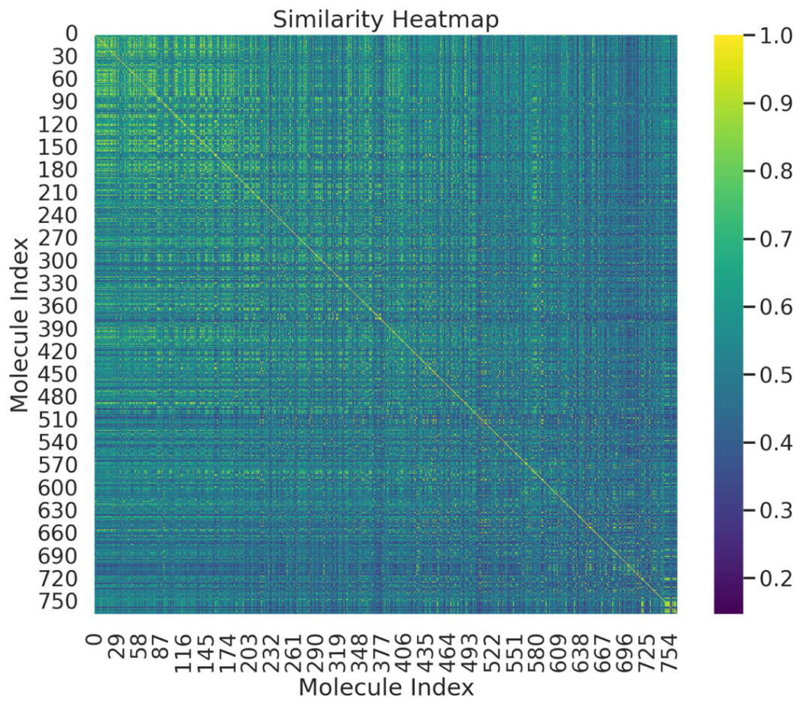
Figure 17: Heatmap plot for drug CCT007093 showing similarity score. The top 10 derivatives of CCT007093 are shown in a Tanimoto similarity heatmap.

In Figure 17, the horizontal axis is labeled "Molecule Index" and ranges from 0 to 750; the vertical axis is also labeled "Molecule Index" with the same range. The color scale ranges from dark blue (low similarity) to yellow (high similarity), with values from 0.2 to 1.0. The diagonal line, extending from the top left to the bottom right, is consistently bright yellow, representing a similarity of 1.0, as each molecule is identical to itself. Off-diagonal values vary in color, predominantly in shades of blue-green, indicating differing degrees of similarity between molecules. Some brighter regions off the diagonal suggest clusters of molecules that are relatively similar. Overall, the heatmap shows that most molecules have moderate-to-low similarity to one another, resulting in sparse regions of high similarity throughout the matrix. A few bright blocks may indicate subsets of molecules that are more closely related. This heatmap illustrates the similarities among approximately 750 molecules and their derivatives.

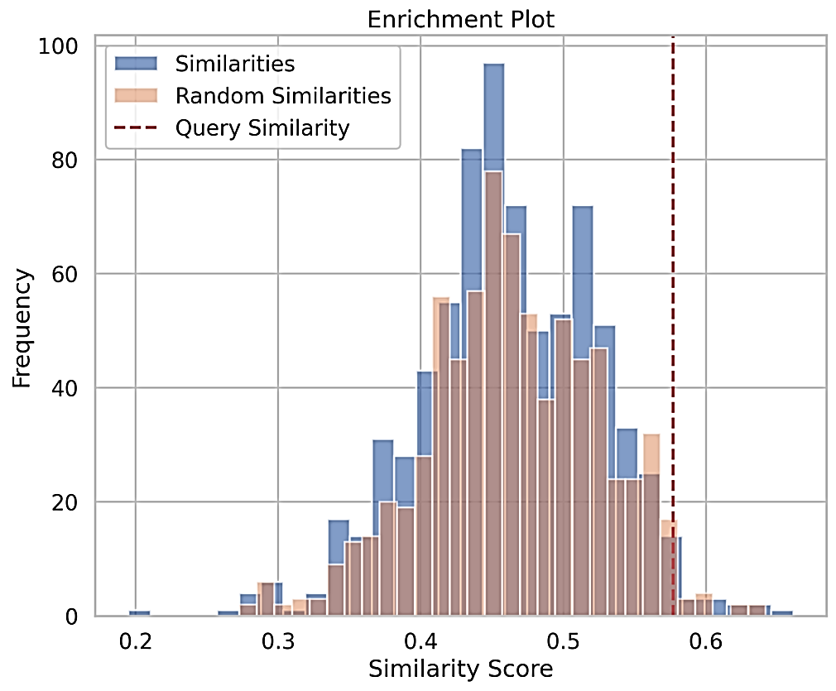
Figure 18: Enrichment plot for the drug GSK2830371A showing similarity score. The top 10 derivatives of GSK2830371A depict frequency enrichment and Tanimoto similarity scores.

In Figure 18, the horizontal axis represents the Similarity Score, which ranges from 0.2 to 0.65, while the vertical axis indicates frequency (the number of occurrences, up to approximately 100). The blue bars illustrate the similarities among the top 10 derivatives of GSK2830371A, while the light brown bars represent random similarities from background or control molecules. The dashed red vertical line indicates the query similarity, corresponding to the compound's specific similarity score. Most similarity scores are centered around 0.4-0.5, with the highest frequency near 0.45, reaching 100 occurrences. The red dashed line is near 0.59, just below 0.6, which is considerably higher than most random and general similarity scores. The blue bars representing the top 10 derivatives tend to show higher frequencies at greater similarity scores (around 0.45 to 0.55). In contrast, the brown bars for random similarities are more concentrated in the lower range (approximately 0.35-0.45). The query similarity score of approximately 0.59 is positioned significantly to the right of the bulk of the random distribution. This finding suggests that the selected derivatives are notably more similar to the query compound compared to random molecules. A higher level of enrichment indicates better structural relevance of the derivatives to the parent molecule, GSK2830371A. The pronounced differences in peak heights between the blue and brown bars suggest successful enrichment, indicating a positive outcome for screening or designing derivatives.
Table 10: GSK2830371A top 10 derivatives using AdaBoost in nanoMole (nM) units.
CHEMBL Id | IC₅₀ | Smiles | pIC₅₀ | Similarity
CHEMBL4280300 | 24 | N#Cc1nc(C(N)=O)c(Nc2cccc(Br)c2)nc1NC[C@H]1CC[C@H](N)CC1 | 7.619788758 | 0.6612903225806451
CHEMBL4556790 | 629 | Cl.Cn1nccc1-c1ccc(C(=O)N[C@@H]2CNCC[C@H]2c2ccc(F)c(F)c2)c(F)c1 | 6.201349355 | 0.6417910447761194
CHEMBL4876360 | 27 | CNC(=O)[C@H]1CC[C@@H](Nc2cc(NCc3cnccc3C(F)(F)F)ncc2C#N)CC1 | 7.568636236 | 0.6349206349206349
CHEMBL477404 | 88 | Cc1c(Nc2c(C#N)cnc3sc(/C=C/C(=O)N4CCNCC4)cc23)ccc2[nH]ccc12 | 7.055517328 | 0.6212121212121212
CHEMBL4552628 | 8700 | Cc1sc(C(=O)N[C@@H]2[C@H](N)CCCC2(F)F)cc1-c1cnn2cc(Cl)cnc12 | 5.060480747 | 0.6176470588235294
CHEMBL3651966 | 4100 | C[C@@H]1C[C@H](N)C[C@H](c2ccncc2NC(=O)c2ccc(F)c(-c3c(F)cccc3F)n2)C1 | 5.387216143 | 0.603448275862069
CHEMBL4870774 | 7 | N#Cc1cnc(NCc2cnccc2C(F)(F)F)cc1N[C@H]1CC[C@@H](C(N)=O)CC1 | 8.15490196 | 0.6031746031746031
CHEMBL1945559 | 1400 | Cn1c2c(c3ccc(Cl)c(Cl)c31)C(C#N)C1(CCNCC1)NC2=O | 5.853871964 | 0.6
CHEMBL4858914 | 20 | N#Cc1cnc(NCc2ccccc2C(F)(F)F)cc1N[C@H]1CC[C@@H](C(N)=O)CC1 | 7.698970004 | 0.5873015873015873
CHEMBL3904204 | 2.9 | Nc1ncc(-c2ncnc3[nH]cc(F)c23)nc1C(=O)Nc1ncccc1N1CCC(N)CC1 | 8.537602002 | 0.5857142857142857

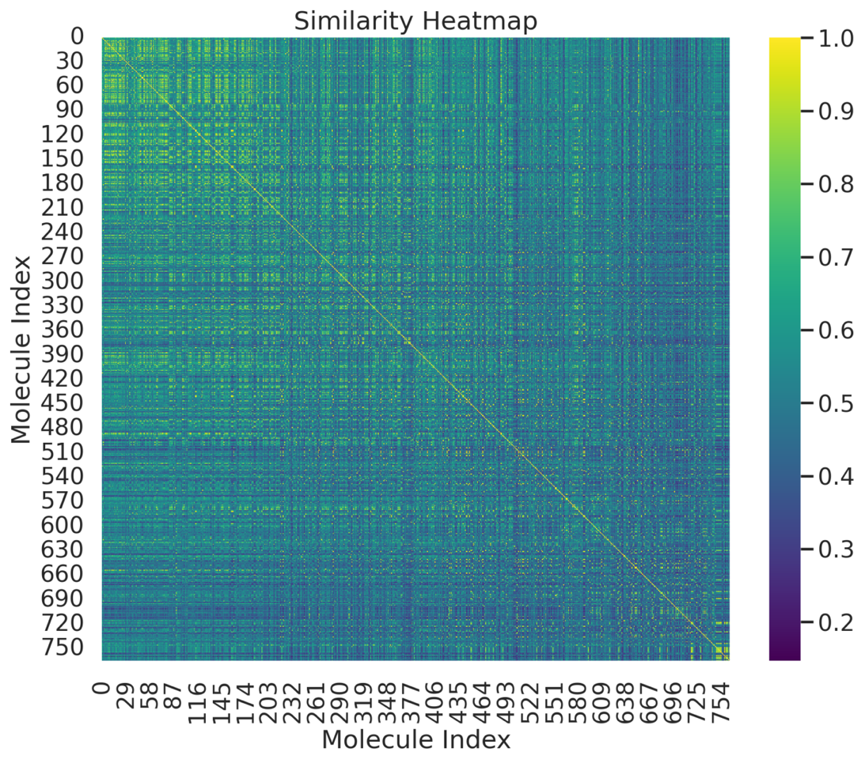
Figure 19: Heatmap plot for drug GSK2830371A showing similarity score. GSK2830371A top-10 derivatives depict the Tanimoto similarity heatmap.

Figure 19 presents the x-axis as the molecule index, ranging from 0 to 754, and the y-axis from 0 to 750. The color scale varies from approximately 0.2 (dark purple) to 1.0 (bright yellow). The bright yellow diagonal running from the top-left to the bottom-right signifies a similarity score of 1.0, indicating that each molecule is compared with itself. Off-diagonal values exhibit a blend of green, blue, and some yellowish tones, reflecting varying degrees of molecular similarity among different molecules. Most similarities are characterized as low to moderate, with small patches of brighter colors appearing away from the diagonal, suggesting clusters of similar molecules. The greenish and bluish areas indicate lower molecular similarity. Bright yellow patches away from the diagonal signify groups of derivatives that exhibit a high degree of structural similarity and may share critical functional groups.

4. Discussion
This study developed and systematically evaluated a machine-learning framework to estimate drug-response AUC from complementary pharmacological measurements. The revised analysis substantially extends the original computational framework by comparing multiple regression algorithms, optimizing hyperparameters, using five-fold cross-validation, held-out testing, leave-cell-line-out validation, drug-group validation, stacking, SHAP interpretation, and response-derived feature sensitivity analysis. Among the evaluated models, Gradient Boosting demonstrated the strongest individual performance on the held-out test set (R² = 0.920577, MSE = 0.001970, RMSE = 0.044381, and MAE = 0.020504), supporting the ability of nonlinear ensemble methods to capture complex relationships within the selected pharmacological variables. Gradient Boosting's stronger performance than Ridge Regression is consistent with boosting-based decision trees' ability to model nonlinear effects, threshold behavior, and feature interactions without explicitly specifying these relationships (Friedman, 2001). However, this finding is specific to the present dataset. It should not be interpreted as evidence that Gradient Boosting is universally superior for cancer drug-response prediction, as previous work has demonstrated that feature selection, drug characteristics, and experimental conditions can substantially influence predictive performance (Jang et al., 2014; Jiang et al., 2018; Partin et al., 2021).

The stacking ensemble produced a modest improvement over the best individual model, increasing R² from 0.920577 to 0.923645 and reducing RMSE from 0.044381 to 0.043515 and MAE from 0.020504 to 0.019116. This suggests that the individual algorithms captured partially complementary patterns, although Gradient Boosting remained the strongest individual contributor. More importantly, the validation analyses provided information about model generalizability beyond a conventional random train–test split. Leave-cell-line-out validation produced an overall R² of 0.772554 ± 0.296750, whereas drug-group validation produced R² = 0.902459 ± 0.037058. The lower, more variable performance when entire cell-line groups were withheld indicates that generalizing to unseen biological contexts is more challenging than predicting within a dataset containing related observations. Conversely, the relatively consistent drug-group performance suggests that the relationship between the selected response measurements and AUC remained reasonably stable when drug groups were withheld during model development. These findings are particularly relevant because previous pharmacogenomic studies have demonstrated that drug-response prediction depends strongly on the biological and chemical information supplied to the model (Iorio et al., 2016; Yang et al., 2013).

When interpreting these findings, we must consider response-derived variables. In the current dataset, IC50 and AUC showed a Pearson correlation of 0.76393. This correlation is expected, as both estimates are calculated from the same underlying dose-response relationship; however, it is strong, meaning IC50 does not fully determine AUC. Using response-based parameters in this analysis indicates that the proposed model serves as both an AUC estimation method and a drug sensitivity prediction tool (Costello et al., 2014). This approach accounts for the compound's pharmacological features rather than relying solely on molecular or genomic information. Therefore, it is not a fully autonomous model for predicting drug sensitivity. This point is particularly relevant because modern drug response predictions increasingly rely on additional biological and chemical information. For example, MOLI uses mutation, copy-number, and gene-expression information; DeepCDR uses multiomics data and drug molecular structure (Liu et al., 2020; Sharifi-Noghabi et al., 2019).

The response-derived feature sensitivity analysis further clarified this limitation. When IC50, maximum concentration, RMSE, and Z-score were excluded, the alternative model based on the available categorical descriptors produced R² = −0.01455, RMSE = 0.16463, and MAE = 0.10500. Rather than interpreting this as a failed model, this analysis shows that much of the predictive signal in the primary formulation comes from complementary pharmacological response measurements. Thus, the primary model's high performance should not be interpreted as evidence that AUC can be predicted independently from cell-line or drug descriptors alone. The revised interpretation therefore defines the model's scope and acknowledges response-derived feature dependence as a limitation.

We further strengthened model interpretability through SHAP analysis. SHAP provides a unified framework for attributing individual predictions to their input features (Lundberg & Lee, 2017). In the present study, SHAP values identify the contribution of the response-derived variables to AUC estimation and therefore improve model transparency; however, they should not be interpreted as evidence of causal biological mechanisms. A high SHAP contribution indicates predictive importance within the fitted model rather than showing that manipulating that feature would causally alter drug response.

The identification and prioritization of compounds through the computational framework should likewise be interpreted cautiously. Structural similarity analysis can identify chemically related candidates, but similarity does not establish equivalent biological activity, selectivity, safety, or therapeutic efficacy. Accordingly, compounds prioritized by the present framework should be considered hypothesis-generating candidates requiring subsequent pharmacological and experimental validation. This interpretation is particularly important for the nanoparticle component, because the available GDSC data do not contain paired measurements linking drug identity, nanoparticle properties, treatment conditions, and therapeutic outcomes. Therefore, the present computational analysis cannot establish nanoparticle-related effects, which should be investigated experimentally.

5. Future Prospects
Future research should concentrate on the development of AUC prediction models based on the independent biological and chemical descriptor representation, including molecular structures, genomic alterations, gene expression profiles, proteomic features, as well as important GBM cell-line characteristics. With the introduction of larger databases created independently and external validation for different GBM models, the reliability, generalizability, and reproducibility of the introduced framework will substantially increase.

Moreover, it is important that future studies investigate the computationally prioritized candidates experimentally, including LCL161 and GSK2256098 using relevant GBM models, with special attention to dose response relations, selectivity, toxicity, mechanism of action, and possible synergistic effects with existing therapies. Without validating these candidates in vitro and in vivo it would be impossible to make any conclusions about their therapeutic benefits.

The integration of multimodal molecular and chemical data, thorough validation, understandable ensemble learning methods, and experimental validation represents a good opportunity to improve the AUC estimation framework by developing a more robust drug response prediction system for GBM. Future workflows will require the implementation of independent acts of feature construction, model development, validation, interpretation, candidate prioritization, and sensitivity analysis.

6. Conclusion
This study developed a machine-learning model to estimate the AUC from complementary drug response data using GDSC data. We assessed various regression methods and ensemble learning approaches, including Gradient Boosting, XGBoost, CatBoost, Random Forest, AdaBoost, and Ridge Regression. This evaluation involved five-fold cross-validation, hyperparameter tuning, testing on a held-out dataset, leave-cell-line-out validation, and drug-group validation.

Among the methods tested, Gradient Boosting performed the best individually, yielding an R² of 0.9206, a root mean square error (RMSE) of 0.0444, and a mean absolute error (MAE) of 0.0205. The stacking ensemble model showed only a slight improvement, with an R² of 0.9236, RMSE of 0.0435, and MAE of 0.0191. Group-drug validation with unseen drug groups produced promising results, achieving an R² of 0.9025 ± 0.0371; however, leave-cell-line-out validation yielded more variable outcomes due to different biological contexts.

Both SHAP and feature importance analyses enhanced our understanding of the model, while ligand analysis identified LCL161 and GSK2256098 as substances of interest for further investigation. The main conclusion is that the metrics IC50, maximum concentration, RMSE, and Z-score are derived from AUC. Therefore, the model is specifically aimed at AUC estimation rather than predicting drug sensitivity.

Conflict of Interest:
The authors declare no conflict of interest

Acknowledgements
This work is supported by the Lieberman Bridge Funding, the Vice Chair of Research, UNMC, and the Lieberman Research Award, Department of Anesthesiology, to S.C.

Data Availability Statement
All Figures are presented in the manuscript, and the raw data are deposited in the repository:
https://github.com/hinsilico/AI-PROTAC [github.com].
AUTHOR CONTRIBUTIONS
A.C.K., M.K.G., and S.C. conceptualized and built datasets, executed the project, and wrote the initial draft of the manuscript. A.C.K., M.K.G., T.C.Y., P.Y., S.M., R.S., and S.C. advised on method improvements and assisted with data curation. A.C.K. assisted in validating the results. A.C.K. provided all computational resources and supervised the entire project. A.C.K. performed all secondary analyses and wrote the final manuscript. S.C edited and finalized the manuscript.

References:
Ali, M., & Aittokallio, T. (2019). Machine learning and feature selection for drug response prediction in precision oncology applications. Biophys Rev, 11(1), 31-39. https://doi.org/10.1007/s12551-018-0446-z
Azuaje, F. (2017). Computational models for predicting drug responses in cancer research. Brief Bioinform, 18(5), 820-829. https://doi.org/10.1093/bib/bbw065
Bailey, P., & Cushing, H. W. (1970). A classification of the tumors of the glioma group on a histogenetic basis with a correlated study of prognosis.
Breiman, L. (2001). Random Forests. Machine Learning, 45(1), 5-32. https://doi.org/10.1023/A:1010933404324
Brennan, C. W., Verhaak, R. G., McKenna, A., Campos, B., Noushmehr, H., Salama, S. R., Zheng, S., Chakravarty, D., Sanborn, J. Z., Berman, S. H., Beroukhim, R., Bernard, B., Wu, C. J., Genovese, G., Shmulevich, I., Barnholtz-Sloan, J., Zou, L., Vegesna, R., Shukla, S. A., . . . Network, T. R. (2013). The somatic genomic landscape of glioblastoma. Cell, 155(2), 462-477. https://doi.org/10.1016/j.cell.2013.09.034
Ceccarelli, M., Barthel, F. P., Malta, T. M., Sabedot, T. S., Salama, S. R., Murray, B. A., Morozova, O., Newton, Y., Radenbaugh, A., Pagnotta, S. M., Anjum, S., Wang, J., Manyam, G., Zoppoli, P., Ling, S., Rao, A. A., Grifford, M., Cherniack, A. D., Zhang, H., . . . Verhaak, R. G. (2016). Molecular Profiling Reveals Biologically Discrete Subsets and Pathways of Progression in Diffuse Glioma. Cell, 164(3), 550-563. https://doi.org/10.1016/j.cell.2015.12.028
Chen, T., & Guestrin, C. (2016). Xgboost: A scalable tree boosting system. Proceedings of the 22nd acm sigkdd international conference on knowledge discovery and data mining,
Chen, Z., Wang, L., Yao, D., Yang, T., Cao, W.-M., Dou, J., Pang, J. C., Guan, S., Zhang, H., & Yu, Y. (2016). Wip1 inhibitor GSK2830371 inhibits neuroblastoma growth by inducing Chk2/p53-mediated apoptosis. Scientific reports, 6(1), 38011.
Costello, J. C., Heiser, L. M., Georgii, E., Gonen, M., Menden, M. P., Wang, N. J., Bansal, M., Ammad-ud-din, M., Hintsanen, P., Khan, S. A., Mpindi, J. P., Kallioniemi, O., Honkela, A., Aittokallio, T., Wennerberg, K., Community, N. D., Collins, J. J., Gallahan, D., Singer, D., . . . Stolovitzky, G. (2014). A community effort to assess and improve drug sensitivity prediction algorithms. Nat Biotechnol, 32(12), 1202-1212. https://doi.org/10.1038/nbt.2877
Davis, M. E. (2016). Glioblastoma: Overview of Disease and Treatment. Clin J Oncol Nurs, 20(5 Suppl), S2-8. https://doi.org/10.1188/16.Cjon.S1.2-8
Freund, Y., & Schapire, R. E. (1997). A Decision-Theoretic Generalization of On-Line Learning and an Application to Boosting. Journal of Computer and System Sciences, 55(1), 119-139. https://doi.org/https://doi.org/10.1006/jcss.1997.1504
Friedman, J. H. (2001). Greedy Function Approximation: A Gradient Boosting Machine. The Annals of Statistics, 29(5), 1189-1232. http://www.jstor.org/stable/2699986
Geeleher, P., Cox, N., & Huang, R. S. (2014a). pRRophetic: an R package for prediction of clinical chemotherapeutic response from tumor gene expression levels. PLoS One, 9(9), e107468. https://doi.org/10.1371/journal.pone.0107468
Geeleher, P., Cox, N. J., & Huang, R. S. (2014b). Clinical drug response can be predicted using baseline gene expression levels and in vitro drug sensitivity in cell lines. Genome Biol, 15(3), R47. https://doi.org/10.1186/gb-2014-15-3-r47
Goddard, Z. R., Marín, M. J., Russell, D. A., & Searcey, M. (2020). Active targeting of gold nanoparticles as cancer therapeutics. Chemical Society Reviews, 49(23), 8774-8789.
Hegi, M. E., Diserens, A. C., Gorlia, T., Hamou, M. F., de Tribolet, N., Weller, M., Kros, J. M., Hainfellner, J. A., Mason, W., Mariani, L., Bromberg, J. E., Hau, P., Mirimanoff, R. O., Cairncross, J. G., Janzer, R. C., & Stupp, R. (2005). MGMT gene silencing and benefit from temozolomide in glioblastoma. N Engl J Med, 352(10), 997-1003. https://doi.org/10.1056/NEJMoa043331
Iorio, F., Knijnenburg, T. A., Vis, D. J., Bignell, G. R., Menden, M. P., Schubert, M., Aben, N., Gonçalves, E., Barthorpe, S., Lightfoot, H., Cokelaer, T., Greninger, P., van Dyk, E., Chang, H., de Silva, H., Heyn, H., Deng, X., Egan, R. K., Liu, Q., . . . Garnett, M. J. (2016). A Landscape of Pharmacogenomic Interactions in Cancer. Cell, 166(3), 740-754. https://doi.org/10.1016/j.cell.2016.06.017
Jang, I. S., Neto, E. C., Guinney, J., Friend, S. H., & Margolin, A. A. (2014). Systematic assessment of analytical methods for drug sensitivity prediction from cancer cell line data. Pac Symp Biocomput, 63-74.
Jiang, P., Sellers, W. R., & Liu, X. S. (2018). Big Data Approaches for Modeling Response and Resistance to Cancer Drugs. Annu Rev Biomed Data Sci, 1, 1-27. https://doi.org/10.1146/annurev-biodatasci-080917-013350
Jiang, Q., Yang, X., Deng, T., Yan, J., Guo, F., Mo, L., An, S., & Huang, Q. (2024). Comprehensive machine learning-based integration develops a novel prognostic model for glioblastoma. Mol Ther Oncol, 32(3), 200838. https://doi.org/10.1016/j.omton.2024.200838
Kleihues, P., Louis, D. N., Scheithauer, B. W., Rorke, L. B., Reifenberger, G., Burger, P. C., & Cavenee, W. K. (2002). The WHO classification of tumors of the nervous system. J Neuropathol Exp Neurol, 61(3), 215-225; discussion 226-219. https://doi.org/10.1093/jnen/61.3.215
Li, J., Zhao, J., Tan, T., Liu, M., Zeng, Z., Zeng, Y., Zhang, L., Fu, C., Chen, D., & Xie, T. (2020). Nanoparticle drug delivery system for glioma and its efficacy improvement strategies: a comprehensive review. International journal of nanomedicine, 2563-2582.
Lin, Z., Chou, W.-C., Cheng, Y.-H., He, C., Monteiro-Riviere, N. A., & Riviere, J. E. (2022). Predicting nanoparticle delivery to tumors using machine learning and artificial intelligence approaches. International journal of nanomedicine, 1365-1379.
Liu, P., Li, H., Li, S., & Leung, K. S. (2019). Improving prediction of phenotypic drug response on cancer cell lines using deep convolutional network. BMC Bioinformatics, 20(1), 408. https://doi.org/10.1186/s12859-019-2910-6
Liu, Q., Hu, Z., Jiang, R., & Zhou, M. (2020). DeepCDR: a hybrid graph convolutional network for predicting cancer drug response. Bioinformatics, 36(Supplement_2), i911-i918. https://doi.org/10.1093/bioinformatics/btaa822
Louis, D. N., Perry, A., Reifenberger, G., von Deimling, A., Figarella-Branger, D., Cavenee, W. K., Ohgaki, H., Wiestler, O. D., Kleihues, P., & Ellison, D. W. (2016). The 2016 World Health Organization Classification of Tumors of the Central Nervous System: a summary. Acta Neuropathol, 131(6), 803-820. https://doi.org/10.1007/s00401-016-1545-1
Louis, D. N., Perry, A., Wesseling, P., Brat, D. J., Cree, I. A., Figarella-Branger, D., Hawkins, C., Ng, H. K., Pfister, S. M., Reifenberger, G., Soffietti, R., von Deimling, A., & Ellison, D. W. (2021). The 2021 WHO Classification of Tumors of the Central Nervous System: a summary. Neuro Oncol, 23(8), 1231-1251. https://doi.org/10.1093/neuonc/noab106
Lundberg, S. M., & Lee, S.-I. (2017). A Unified Approach to Interpreting Model Predictions. Neural Information Processing Systems,
Menden, M. P., Iorio, F., Garnett, M., McDermott, U., Benes, C. H., Ballester, P. J., & Saez-Rodriguez, J. (2013). Machine learning prediction of cancer cell sensitivity to drugs based on genomic and chemical properties. PLoS One, 8(4), e61318. https://doi.org/10.1371/journal.pone.0061318
Menden, M. P., Wang, D., Mason, M. J., Szalai, B., Bulusu, K. C., Guan, Y., Yu, T., Kang, J., Jeon, M., Wolfinger, R., Nguyen, T., Zaslavskiy, M., AstraZeneca-Sanger Drug Combination, D. C., Jang, I. S., Ghazoui, Z., Ahsen, M. E., Vogel, R., Neto, E. C., Norman, T., . . . Saez-Rodriguez, J. (2019). Community assessment to advance computational prediction of cancer drug combinations in a pharmacogenomic screen. Nat Commun, 10(1), 2674. https://doi.org/10.1038/s41467-019-09799-2
Neftel, C., Laffy, J., Filbin, M. G., Hara, T., Shore, M. E., Rahme, G. J., Richman, A. R., Silverbush, D., Shaw, M. L., Hebert, C. M., Dewitt, J., Gritsch, S., Perez, E. M., Gonzalez Castro, L. N., Lan, X., Druck, N., Rodman, C., Dionne, D., Kaplan, A., . . . Suvà, M. L. (2019). An Integrative Model of Cellular States, Plasticity, and Genetics for Glioblastoma. Cell, 178(4), 835-849.e821. https://doi.org/10.1016/j.cell.2019.06.024
Ostrom, Q. T., Price, M., Neff, C., Cioffi, G., Waite, K. A., Kruchko, C., & Barnholtz-Sloan, J. S. (2022). CBTRUS Statistical Report: Primary Brain and Other Central Nervous System Tumors Diagnosed in the United States in 2015-2019. Neuro Oncol, 24(Suppl 5), v1-v95. https://doi.org/10.1093/neuonc/noac202
Partin, A., Brettin, T., Evrard, Y. A., Zhu, Y., Yoo, H., Xia, F., Jiang, S., Clyde, A., Shukla, M., Fonstein, M., Doroshow, J. H., & Stevens, R. L. (2021). Learning curves for drug response prediction in cancer cell lines. BMC Bioinformatics, 22(1), 252. https://doi.org/10.1186/s12859-021-04163-y
Patel, A. P., Tirosh, I., Trombetta, J. J., Shalek, A. K., Gillespie, S. M., Wakimoto, H., Cahill, D. P., Nahed, B. V., Curry, W. T., Martuza, R. L., Louis, D. N., Rozenblatt-Rosen, O., Suvà, M. L., Regev, A., & Bernstein, B. E. (2014). Single-cell RNA-seq highlights intratumoral heterogeneity in primary glioblastoma. Science, 344(6190), 1396-1401. https://doi.org/10.1126/science.1254257
Prokhorenkova, L., Gusev, G., Vorobev, A., Dorogush, A. V., & Gulin, A. (2018). CatBoost: unbiased boosting with categorical features. Advances in neural information processing systems, 31.
Reifenberger, G., Wirsching, H. G., Knobbe-Thomsen, C. B., & Weller, M. (2017). Advances in the molecular genetics of gliomas - implications for classification and therapy. Nat Rev Clin Oncol, 14(7), 434-452. https://doi.org/10.1038/nrclinonc.2016.204
Sharifi-Noghabi, H., Zolotareva, O., Collins, C. C., & Ester, M. (2019). MOLI: multi-omics late integration with deep neural networks for drug response prediction. Bioinformatics, 35(14), i501-i509. https://doi.org/10.1093/bioinformatics/btz318
Sottoriva, A., Spiteri, I., Piccirillo, S. G., Touloumis, A., Collins, V. P., Marioni, J. C., Curtis, C., Watts, C., & Tavaré, S. (2013). Intratumor heterogeneity in human glioblastoma reflects cancer evolutionary dynamics. Proc Natl Acad Sci U S A, 110(10), 4009-4014. https://doi.org/10.1073/pnas.1219747110
Stupp, R., Mason, W. P., van den Bent, M. J., Weller, M., Fisher, B., Taphoorn, M. J., Belanger, K., Brandes, A. A., Marosi, C., Bogdahn, U., Curschmann, J., Janzer, R. C., Ludwin, S. K., Gorlia, T., Allgeier, A., Lacombe, D., Cairncross, J. G., Eisenhauer, E., Mirimanoff, R. O., . . . National Cancer Institute of Canada Clinical Trials, G. (2005). Radiotherapy plus concomitant and adjuvant temozolomide for glioblastoma. N Engl J Med, 352(10), 987-996. https://doi.org/10.1056/NEJMoa043330
Tan, A. C., Ashley, D. M., López, G. Y., Malinzak, M., Friedman, H. S., & Khasraw, M. (2020). Management of glioblastoma: State of the art and future directions. CA Cancer J Clin, 70(4), 299-312. https://doi.org/10.3322/caac.21613
Weller, M., van den Bent, M., Preusser, M., Le Rhun, E., Tonn, J. C., Minniti, G., Bendszus, M., Balana, C., Chinot, O., Dirven, L., French, P., Hegi, M. E., Jakola, A. S., Platten, M., Roth, P., Rudà, R., Short, S., Smits, M., Taphoorn, M. J. B., . . . Wick, W. (2021). EANO guidelines on the diagnosis and treatment of diffuse gliomas of adulthood. Nat Rev Clin Oncol, 18(3), 170-186. https://doi.org/10.1038/s41571-020-00447-z
Xia, F., Allen, J., Balaprakash, P., Brettin, T., Garcia-Cardona, C., Clyde, A., Cohn, J., Doroshow, J., Duan, X., Dubinkina, V., Evrard, Y., Fan, Y. J., Gans, J., He, S., Lu, P., Maslov, S., Partin, A., Shukla, M., Stahlberg, E., . . . Stevens, R. (2022). A cross-study analysis of drug response prediction in cancer cell lines. Brief Bioinform, 23(1). https://doi.org/10.1093/bib/bbab356
Yadav, P., Vengoji, R., Jain, M., Batra, S. K., & Shonka, N. (2024). Pathophysiological role of histamine signaling and its implications in glioblastoma. Biochim Biophys Acta Rev Cancer, 1879(5), 189146. https://doi.org/10.1016/j.bbcan.2024.189146
Yang, L., Zhou, Z., Yao, D., Xu, W., & Zhao, H. (2014). ET-69SPECIFIC Wip1 INHIBITOR, CCT007093 ABROGATE CELL PROLIFERATION, MIGRATION AND INVASION INDUCED BY THE UVC RADIATION IN HUMAN GLIOBLASTOMA CELLS. Neuro-Oncology, 16(Suppl 5), v94.
Yang, W., Soares, J., Greninger, P., Edelman, E. J., Lightfoot, H., Forbes, S., Bindal, N., Beare, D., Smith, J. A., Thompson, I. R., Ramaswamy, S., Futreal, P. A., Haber, D. A., Stratton, M. R., Benes, C., McDermott, U., & Garnett, M. J. (2013). Genomics of Drug Sensitivity in Cancer (GDSC): a resource for therapeutic biomarker discovery in cancer cells. Nucleic Acids Res, 41(Database issue), D955-961. https://doi.org/10.1093/nar/gks1111

