SLM Data Investigation and Training Handbook
  - TalentTensor 350M data discovery training and evaluation plan
Audience First time small language model trainers data engineers and reviewers
Scope Local data under F SLM and the training implementation under F SLM SLM_training
Review date 17 October 2026
Main recommendation Use clean raw text for pretraining. Use validated input and target pairs for supervised fine tuning. Keep a locked candidate and query test set before any model facing processing. Use preference or reinforcement learning only after the supervised model and output level feedback are reliable.
Writing method This handbook uses short direct sentences defined terms and consistent verbs. It is inspired by ASD STE 100 Issue 9. It does not claim formal ASD STE 100 compliance.

How to use this handbook
- Read Parts 1 to 4 before you move any data into a training split.
- Use Parts 5 to 9 to build the tokenizer pretraining SFT and evaluation workflow.
- Use Part 10 when you design preference data or an RL experiment.
- Use Part 12 as an implementation checklist.
- Use Part 13 for interview preparation and design reviews.
- Use the appendices when you need exact column names and source paths.
Important status The YAML files define a plan. They do not prove that a successful training run exists. The recorded first run stopped because required Python packages were missing. The data configuration also contains stale volume paths. Fix these items before a real build.

Document map
Part | Subject | Reader outcome
1 | Basic concepts | Understand rows columns tokens splits and training stages
2 | System objective | Know what the model must produce and what each task means
3 | Data inventory | See every main dataset its schema size sample profile and role
4 | Data choice | Know which data to include exclude or quarantine
5 | Preparation | Apply privacy quality deduplication label and leakage rules
6 | Model architecture | Understand how the 350M transformer processes the data
7 | Training curriculum | Understand every stage and its effect on model weights
8 | Extraction SFT | Build resume to JSON examples without target leakage
9 | Relevance SFT | Build query or JD plus resume examples with reliable labels
10 | Preference and RL | Know when RL is valid and when it is not
11 | Evaluation | Measure quality without contaminating the test set
12 | Execution plan | Run a safe pilot and make go or no go decisions
13 | Interview questions | Explain the design at a senior engineering level
Appendices | Schemas and evidence | Find exact columns and configuration sources

Part 1 Basic concepts
A dataset is a collection of records. A row is one record. A column is one field in that record. A schema lists the column names and types. A model does not read rows directly. A tokenizer converts text into token IDs. The training process reads sequences of token IDs and updates model weights.
Term | Plain meaning | Why it matters
Document | One resume job post article or task example | A document is cleaned split and tokenized before training
Row | One record in a table | Several judge rows can describe the same query and resume pair
Column | One named field | A column can be input target metadata or a field that must be removed
Physical type | How a file stores a value | A numeric score can be stored as text and must be parsed
Semantic type | What the value means | An identifier and a numeric measurement need different checks
Token | A tokenizer unit that can be a word part character or byte sequence | Context length and compute use tokens instead of characters
Label | The desired answer for a supervised example | A score verdict or JSON object can be a label
Feature | Information shown to the model | Protected or identifying features can create harmful shortcuts
Split | A train validation development or test assignment | The split controls what the model can see
Leakage | Test information reaches a model facing process | Leakage makes weak systems appear strong
Pretraining | Next token learning on large text collections | It teaches language patterns and domain vocabulary
SFT | Supervised fine tuning on input and target pairs | It teaches extraction relevance and output format
Preference tuning | Learning from a better and worse answer for the same prompt | It can improve answer behavior after SFT
RL | A policy samples an output and receives a reward | It requires a reward that grades the sampled output
Calibration | A mapping from model scores to useful probabilities | A raw logit is not a trustworthy probability

Three kinds of learning signal
Raw text answers the question What does this language look like. Structured pairs answer the question What output must the model produce. Evaluation data answers the question How well does the model work on unseen cases. These signals are not interchangeable.
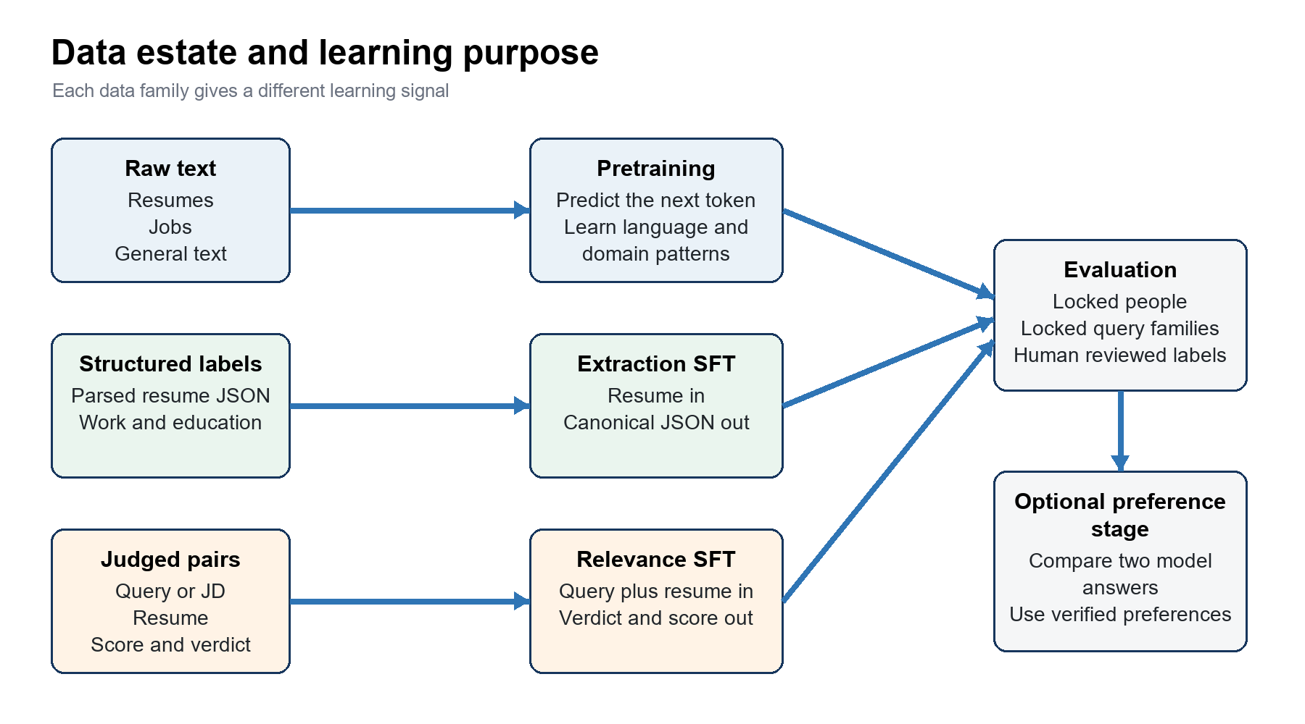
Figure 1 Data estate and learning purpose

Part 2 System objective
The project trains one decoder only model from random weights. The model must support two production tasks. The first task extracts structured resume facts. The second task estimates whether a candidate matches a query or job description.
Task | Input | Target output | Main failure
Resume extraction | A pseudonymized resume | Canonical JSON with grounded fields | The model invents a field or copies a private value
Fast relevance | A query or JD and a candidate resume | A relevant or not relevant verdict and calibrated score | The model uses identity or misses a hard constraint
Reasoned relevance | The same pair with a reasoning task token | A short grounded checklist reason and verdict | The explanation sounds correct but has no evidence
Optional classification | Resume or profile text | Domain role or category | The label taxonomy is inconsistent

The same weights serve all tasks. Each stage changes those weights. Replay data protects earlier abilities when a later task is learned. Calibration changes the decision mapping. It does not change the transformer weights.

Success criteria
- The extraction output is valid JSON and every important field is grounded in the resume.
- The relevance score ranks good candidates above weak candidates for the same request.
- The relevance probability is calibrated on validation data.
- The model does not use names emails phone numbers citizenship gender birth date salary or fired status as relevance shortcuts.
- The locked people and locked query families never enter tokenizer sampling pretraining SFT teacher labeling or preference work.
- The model fits the target inference hardware and latency budget.

Part 3 Data inventory
The inventory below separates physical file size from token size. Physical size measures compressed files on disk. Token size measures text after tokenization. These values are not equal. Token estimates are provisional until the final TalentTensor tokenizer packs the data.

Inventory size and token estimate
Data name | Rows or items | Files | Disk size | Columns | Total token size
Turing current resumes | 5,555,173 | 7 | 26.48 GiB | 30 | Estimated 5 to 6B resume tokens before final tokenizer packing
Older resume export | 7,460,148 | 25 | 21.04 GiB | 27 | Do not add its full token estimate to the current export because 5,468,392 IDs overlap
Turing work experience | 18,517,943 | 4 | 5.20 GiB | 31 | Not additive to pretraining because the facts overlap resume text
Turing education | 11,510,118 | 3 | 0.63 GiB | 24 | Not additive to pretraining because the facts overlap resume text
Consolidated relevance judgments | 2,743,560 | 1 | 3.92 GiB | 192 | About 0.4B task tokens before filtering and split removal
Candidate JD evaluation 159K | 158,671 | 1 | 0.32 GiB | 12 | About 245M input tokens by the existing character estimate
HF resume JD match small train | 6,241 | 1 | 0.03 GiB | 2 | Measure with the final tokenizer
HF resume JD match small test | 1,759 | 1 | 0.01 GiB | 2 | Measure with the final tokenizer
HF resume JD match large train | 80,017 | 2 | 0.24 GiB | 6 | Measure with the final tokenizer
HF resume JD match large test | 13,716 | 1 | 0.04 GiB | 6 | Measure with the final tokenizer
Djinni candidate profiles | 210,250 | 1 | 0.22 GiB | 11 | About 0.10B estimated tokens
Djinni jobs | 141,897 | 1 | 0.14 GiB | 10 | About 0.07B estimated tokens
WDC JobPosting | 14 compressed parts were identified in the source inventory | 14 | 4.62 GiB | Mixed | About 1.0 to 1.65B estimated job tokens after English filtering and deduplication
FineWeb Edu local shards | 2,916,000 | 4 | 8.02 GiB | 10 | Source token_count sum is 3.010B for the four local shards
English Wikipedia local shards | 4,844,934 | 31 | 7.31 GiB | 4 | About 3.3B estimated tokens for the 31 local shards
Cosmopedia v2 local shards | 1,505,156 | 4 | 4.38 GiB | 6 | Source token_length sum is 1.210B for the four local shards
Curated relevance | 296 | 1 | 0.00 GiB | 22 | Small reviewed set. Measure after the train and locked-test split
Curated extraction | 250 | 1 | 0.00 GiB | 13 | Small reviewed set. Measure after the train and locked-test split
Curated fraud | 481 | 1 | 0.01 GiB | 21 | Separate future task. Do not mix into relevance training

Token interpretation The FineWeb and Cosmopedia totals use source token columns. Wikipedia resume JD and WDC totals are estimates. The work and education rows are labels and checks. Do not add them to the unique pretraining token total because they repeat resume facts.

Head and tail sample profile
Head means the first physical row in the first file. Tail means the last physical row in the last file. File order is not a quality order. The table shows lengths and safe metadata. It does not show names contact details resume text or full job text.
Data name | Source size | Head record profile | Tail record profile | Investigation finding
Turing current resumes | 26.48 GiB | resume plain 1,930 chars; education 164 chars; work experience 1,922 chars; role Web Frontend | resume plain 7,457 chars; parsed resume data 8,469 chars; domain SWE; subdomain Software developers; role Machine Learning; full time experience in months 36 | Resume and parsed JSON availability differs by row. Build explicit presence flags.
Older resume export | 21.04 GiB | resume plain 6,383 chars; resume 32 chars; years of experience 35 | resume plain 4,798 chars; resume 34 chars; parsed resume data 9,175 chars; years of experience 28 | Use only missing people after ID and near duplicate resolution.
Turing work experience | 5.20 GiB | company 43 chars; details 122 chars | position 16 chars; company 22 chars; details 238 chars | Dates and text fields can be empty. Validate each item.
Turing education | 0.63 GiB | degree 17 chars; college 44 chars | degree 16 chars; college 45 chars; subject 16 chars | Degree college and dates need normalization and plausibility checks.
Consolidated relevance judgments | 3.92 GiB | query 92 chars; reason 113 chars | query 41 chars; reason 135 chars | Many judge columns are sparse. Consolidate by unique pair.
Candidate JD evaluation 159K | 0.32 GiB | resume text 8,114 chars; jd text 1,762 chars; label No Fit | resume text 1,070 chars; jd text 1,155 chars; label 0 | The label encoding is inconsistent at the edges. Normalize it before SFT.
HF resume JD match small train | 0.03 GiB | text 10,730 chars; label No Fit | text 7,779 chars; label Good Fit | The pair is stored in one text field. Parse its prompt format consistently.
HF resume JD match large train | 0.24 GiB | resume 5,958 chars; jd 2,112 chars; label Potential Fit; source generated_smart; resume domain finance; jd domain finance | resume 5,436 chars; jd 1,534 chars; label No Fit; source generated_smart; resume domain data; jd domain data | Resume and JD are separate. Keep the published source and domain metadata for audit only.
Djinni candidate profiles | 0.22 GiB | CV 2,748 chars; Moreinfo 1,339 chars; Looking For 1,320 chars; Highlights 87 chars; English Level fluent; Experience Years 11.0; CV lang en | CV 1,243 chars; Moreinfo 709 chars; Highlights 532 chars; English Level fluent; Experience Years 9.0; CV lang en | Language and field coverage vary. Filter by supported language and text quality.
Djinni jobs | 0.14 GiB | Long Description 388 chars; English Level intermediate; Long Description lang en | Long Description 4,140 chars; English Level intermediate; Long Description lang en | Job descriptions vary greatly in length. Remove boilerplate and duplicate posts.
FineWeb Edu local shards | 8.02 GiB | text 3,665 chars; language en; language score 0.9743200540542603; token count 845; score 2.75; int score 3 | text 1,394 chars; language en; language score 0.9567914009094238; token count 263; score 3.796875; int score 4 | Source token counts are available. Recount after cleaning and final tokenization.
English Wikipedia local shards | 7.31 GiB | title 9 chars; text 46,064 chars | title 61 chars; text 1,596 chars | Article lengths vary by more than one order of magnitude. Pack across document boundaries carefully.
Cosmopedia v2 local shards | 4.38 GiB | prompt 1,699 chars; text 4,324 chars; seed data 7 chars; token length 805; audience college_students; format textbook | prompt 1,613 chars; text 2,911 chars; seed data 7 chars; token length 574; audience middle_school_students; format textbook_unconditionned_topic | Prompt and generated text are separate. Use the text for pretraining after quality review.
Curated relevance | 0.00 GiB | query 31 chars; resume 4,000 chars | query 22 chars; resume 901 chars | The first record contains a 4000 character resume view. Preserve the judge visible view.
Curated extraction | 0.00 GiB | resume 55,202 chars | resume 7,370 chars | Some resumes are very long. Evaluate truncation and long context behavior.
WDC JobPosting | 4.62 GiB | Not read because this source uses compressed JSON or mixed files | Not read because this source uses compressed JSON or mixed files | The source uses compressed mixed files. Parse and profile after decompression.

Column families and semantic types
Column family | Examples | Semantic type | Model use | Required rule
Identity | talent_id resume_id developer_id pair_id | Identifier | Join split and audit only | Do not show raw IDs to the model
Resume text | resume_plain resume resume_text CV | Long text | Pretraining input or SFT input | Pseudonymize clean deduplicate and length profile
Parsed resume | parsed_resume_data work_experience education | JSON stored as text or structured rows | Extraction SFT target and validation | Parse validate project and ground every field
Query or JD | query jd jd_text Long Description | Long text | Job pretraining or relevance input | Normalize family preserve hard constraints and deduplicate
Relevance label | label score verdict gpt_score | Category or number often stored as text | SFT target or preference source | Normalize scale keep uncertainty and provenance
Judge evidence | reason failed evidence constraint_check | Text or serialized list | Optional grounded explanation target | Remove unsupported claims and judge boilerplate
Source metadata | source_file model judge_date URL | Audit metadata | Lineage split and error analysis | Do not feed shortcuts to the model
Protected or sensitive | name email phone birth date gender citizenship salary fired | Private or sensitive data | Usually no model use | Remove transform or justify with governance approval

Dataset columns and learning value
Data name | Important columns | What the model can learn | Best stage
Turing current resumes | resume_plain parsed_resume_data summary education work_experience domain subdomain role | Resume language role skill work and education patterns plus extraction mapping | Pretraining and extraction SFT
Older resume export | resume_plain parsed_resume_data resume_parse_status fingerprint and account fields | Incremental resume coverage only for people missing from the current export | Pretraining and extraction SFT after merge
Work and education | position company details dates degree college subject CGPA | Structured checks and grounded extraction targets | Extraction target preparation
Consolidated relevance | query resume_id resume score verdict reason evidence judge runs | Query candidate fit hard constraint behavior and uncertainty | Relevance SFT then preference construction
Candidate JD 159K | resume_text jd_text label source domains | Direct JD candidate fit across domains | Relevance SFT with a locked person pool
HF small match | text label | External long JD match examples | Train split SFT and published test evaluation
HF large match | resume jd label source resume_domain jd_domain | Additional synthetic and generated fit examples | Low weight SFT after quality and duplicate checks
Djinni profiles | CV Position Looking For Highlights language experience | Public candidate profile style and role vocabulary | Resume pretraining
Djinni jobs | Long Description Position experience keyword language | Job requirement phrasing and constraint vocabulary | Job pretraining
FineWeb Edu | text language token_count quality scores | General grammar explanation and broad knowledge | General pretraining
Wikipedia | id url title text | Factual and entity context | General and selected knowledge pretraining
Cosmopedia v2 | prompt text token_length audience format seed_data | Long explanatory and educational prose | General pretraining after quality filter
WDC JobPosting | Schema org JobPosting fields after parse | Large job posting coverage | Job pretraining after rights and quality review
Curated sets | Reviewed task fields and notes | High value validation of relevance extraction and fraud cases | Reserve locked subset then SFT remainder

Important measured findings
- The current resume export has 5555173 people and 5539424 nonempty resume texts.
- The current export has 3507029 parsed resume payloads. A parse payload is not automatically a valid target.
- The older export has 7460148 rows. It shares 5468392 talent IDs with the current export.
- The consolidated relevance file has 2743560 judge rows but about 375566 unique query and resume pairs.
- The relevance file has 192 columns. Many columns are repeated judge runs or sparse review fields.
- The candidate JD file has 158671 rows. Its edge labels include both words and numeric text. Normalize the label vocabulary.
- The local general corpus includes 2916000 FineWeb Edu documents 4844934 Wikipedia articles and 1505156 Cosmopedia documents.
- The current pipeline output is empty. Run a complete build before you accept final packed token counts.

Part 4 Data choice
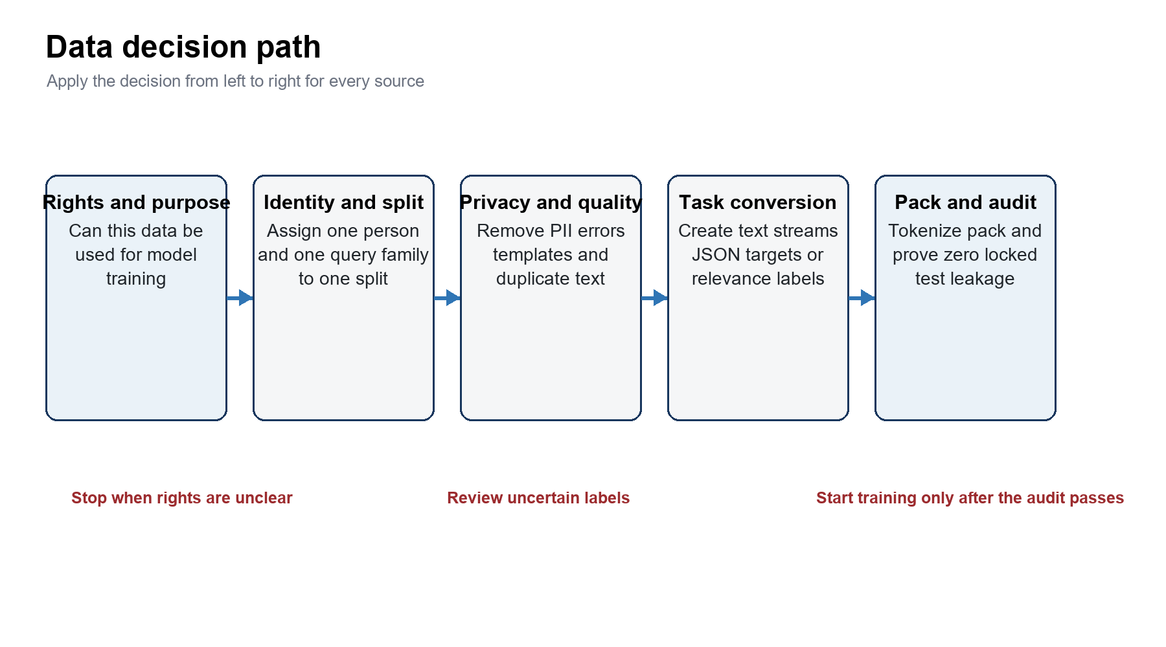
Figure 2 Data decision path

Final selection matrix
Data | Decision | Stage | Processing level | Reason
Current resumes from train people | Include | Pretraining | Heavy governance and light task conversion | They are the main domain language source
Current resume and parsed JSON pairs | Include a high confidence subset | Extraction SFT | Heavy target validation | They directly teach resume to structure mapping
Older export missing people | Include only incremental people | Pretraining and extraction SFT | Identity merge and full cleaning | It adds coverage without duplicate examples
Work and education tables | Include as checks and targets | Extraction preparation | Normalize dates and reconcile with text | They improve target precision and grounding
GPT query plus resume judgments | Include after consolidation | Relevance SFT | Group runs normalize labels keep uncertainty | They directly supervise query candidate relevance
Candidate JD 159K | Include train portion | Relevance SFT | Normalize labels split by person and JD family | It matches the intended deployment interface
Two HF match collections | Include train data at controlled weight | Relevance SFT | Decontaminate inspect generation source and preserve test files | They add long JD and cross domain examples
Curated evaluated records | Split before use | Locked test plus SFT remainder | Human review and registry update | Using all rows for training removes independent evidence
FineWeb Edu | Include | General pretraining | Rights language quality dedupe tokenize pack | It improves general language and explanation ability
Wikipedia | Include | General and knowledge pretraining | Filter markup dedupe and select entity articles | It adds factual language and entity context
Cosmopedia | Include with quality cap | General pretraining | Remove weak synthetic patterns and duplicates | It adds structured educational prose
Djinni profiles and jobs | Include | Resume and job pretraining | Language quality boilerplate and duplicate checks | They add public domain style examples
WDC JobPosting | Conditional include | Job pretraining | Rights parse English quality and cross part dedupe | It can add broad job coverage after review
Fraud labels fired data and interviews | Keep separate | Future task or evaluation | New purpose consent and bias review | They can contaminate relevance with sensitive shortcuts
SAGI Teich and Opus | Quarantine | No stage yet | License provenance quality and duplication review | General reasoning data is not needed until governance passes

Data that can use a near direct text path
No source should go to training with zero processing. Near direct means that the content does not need a task label. The text still needs rights checks split checks privacy checks quality filters deduplication tokenization and packing.
Source | Direct training form | Minimum required processing
FineWeb Edu | Clean text documents | Language and quality thresholds URL and text dedupe license record final tokenizer
Wikipedia | Title plus article text | Markup cleanup redirect handling duplicate control attribution and final tokenizer
Cosmopedia | Selected text field | Synthetic quality filter prompt residue removal duplicate control and source weight cap
Djinni jobs | Position plus job description | Boilerplate removal language check duplicate job families and final tokenizer
WDC jobs | Rendered job posting text | Schema parse rights review English filter field normalization and cross part dedupe
Train split resumes | Pseudonymized clean resume text | Identity split PII removal quality detection exact and near dedupe and length cap

Data that needs task construction
Source | Input | Target | Why processing is required
parsed_resume_data | resume_plain | Canonical filtered JSON | Raw JSON can contain schema objects private fields inconsistent keys and unsupported facts
Work and education rows | Resume text | Normalized work and education arrays | Dates duplicates empty fields and disagreements must be resolved
GPT relevance judgments | Exact judge visible query and candidate text | Verdict soft probability and optional grounded evidence | Repeated runs are correlated and score scales are not calibrated probabilities
Candidate JD 159K | JD plus resume | Normalized three class or binary target | Labels use mixed encodings and the split must block person and JD leakage
Curated evaluations | Task specific prompt | Reviewed target | A locked subset must be selected before the remaining rows enter SFT

Part 5 Data preparation
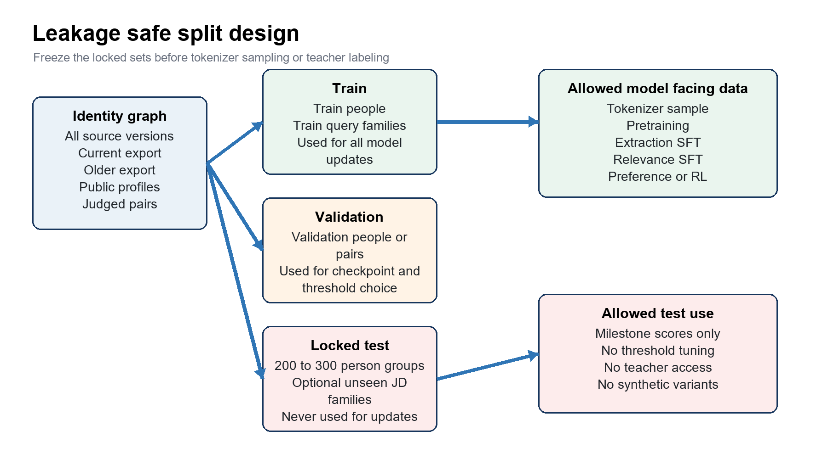
Figure 3 Leakage safe split design

Correct order of operations
1. Write a data use policy for every source. Record ownership license consent and allowed task.
2. Select 200 to 300 candidate person groups for the locked simple JD and resume test.
3. Create query and JD families. Lock whole families when you need unseen request evaluation.
4. Resolve each record to one person group across the current export older export public profiles and judged pairs.
5. Assign each person group and query family to one split in a versioned registry.
6. Choose one canonical resume per person. Prefer the newest valid source.
7. Pseudonymize resume pretraining text. Use neutral placeholders in relevance inputs when identity must not affect scoring.
8. Remove empty corrupted template only non resume and keyword stuffed documents.
9. Normalize Unicode bullets whitespace dates months languages and common PDF artifacts.
10. Deduplicate exact text and near duplicates across every source group.
11. Validate extraction targets against resume text and structured tables.
12. Consolidate relevance judgments by query family and person group.
13. Tokenize with the final tokenizer. Pack streams by training task and source group.
14. Run leakage privacy label and format audits. Stop if a required check fails.

Privacy rules
Field | Pretraining | Extraction target | Relevance input | Reason
Name | Replace with a consistent synthetic name | Synthetic name only if contact extraction is required | Use a neutral placeholder | Reduces memorization and identity shortcuts
Email phone URL | Replace or remove | Only synthetic values that appear in input | Remove or use placeholders | Direct identifiers are not relevance evidence
City country | Keep only if policy allows | Canonical location can be kept | Keep only when deployment queries use location | Location can be a legitimate constraint but needs bias review
Gender birth date | Remove | Remove | Remove | Protected or highly sensitive and unnecessary for the main tasks
Citizenship | Remove unless lawful task requires it | Usually remove | Do not use by default | It can create discrimination and legal risk
Salary rate | Remove from generic text if not needed | Do not extract by default | Include only when production uses an explicit rate constraint | Training must match the approved product behavior
Fired fraud | Do not include | Do not include | Do not include | These are separate sensitive tasks with different labels

Extraction target validation
Check | Pass rule | Failure action
JSON parse | The target parses and matches the canonical schema | Repair only with a deterministic rule or drop
Schema object detection | The payload contains candidate values rather than JSON schema definitions | Drop the target and count the failure
Grounding | Important strings match evidence in the resume or trusted tables | Remove the unsupported item or send to review
Date logic | Start and end dates are plausible and current work is represented consistently | Normalize unknown values and reject impossible sequences
Skill normalization | Aliases map to one taxonomy ID and years do not exceed career length | Map review or drop the skill item
Protected fields | The target excludes disallowed fields | Remove and rerun the privacy audit
Length | The target is compact enough for the output budget | Project to essential fields and cap repeated items

Relevance label consolidation
1. Build one key from the normalized query or JD family and the person group.
2. Keep the exact candidate text version and character limit that each judge saw.
3. Parse all score and verdict fields into a documented canonical scale.
4. Remove judge errors and records without a usable input pair.
5. Treat repeated runs from the same model and prompt as one correlated source.
6. Compute source level summaries before you combine different judges.
7. Keep score mean minimum maximum standard deviation judge count and verdict agreement.
8. Use a soft target for uncertain pairs. Route contradictions and low agreement pairs to human review.
9. Keep hard negative candidates and constraint failures. Do not balance away realistic difficulty.

Part 6 Model architecture
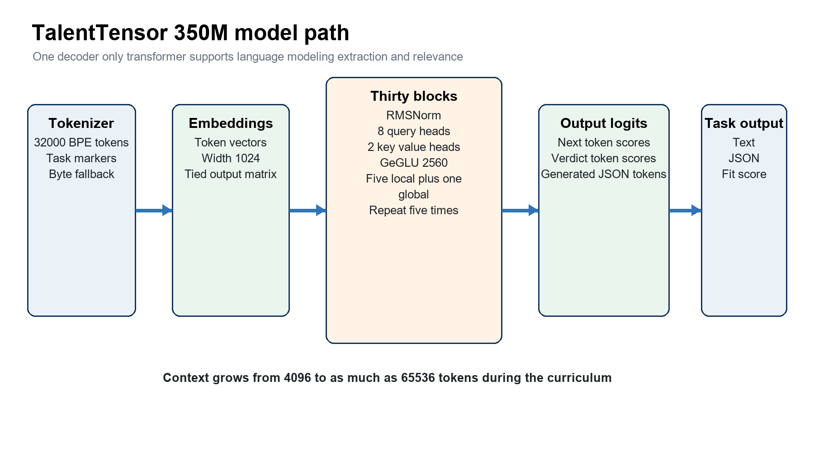
Figure 4 TalentTensor 350M model path
TalentTensor 350M is a decoder only transformer. It predicts the next token from earlier tokens. The same operation supports pretraining and SFT. SFT changes the examples and the loss mask. It does not replace the transformer with a separate task network.
Component | Configured value | Function | Training implication
Parameters | About 347.5 million | Stores learned token and pattern associations | Needs billions of processed tokens and careful regularization
Vocabulary | 32000 SentencePiece BPE tokens with byte fallback | Converts text to stable IDs | Train it only on train split documents and freeze it before packing
Model width | 1024 | Size of each token representation | Sets most matrix dimensions and memory use
Layers | 30 | Applies repeated attention and feed forward transformations | Five blocks of five local layers and one global layer
Attention | 8 query heads and 2 key value heads with head size 128 | Combines evidence and reduces key value cache | Useful for long context inference but must be tested
Local window | 1024 tokens | Limits most layers to recent context | Reduces attention cost and favors nearby resume evidence
Global pattern | Every sixth layer is global | Connects distant sections | Five global layers can propagate long range evidence
Feed forward | GeGLU hidden size 2560 | Transforms each token after attention | Holds much of the model capacity
Normalization | RMSNorm with sandwich and query key normalization in the implementation | Controls activation scale | Helps stability and needs checkpoint compatible export
Position | Local RoPE base 10000 and global base 1000000 | Encodes token position | Long context continuation adapts weights to larger distances
Embeddings | Input and output weights are tied | Uses one matrix for reading and scoring tokens | Saves parameters and couples input and output representation
Context | 4096 then optional 16384 then up to 65536 | Defines the largest accepted sequence | Capacity alone does not prove long distance reasoning

How one relevance example moves through the model
1. The prompt builder inserts task query candidate and answer markers.
2. The tokenizer converts the prompt into token IDs.
3. The embedding matrix converts each ID into a 1024 value vector.
4. Local attention layers connect nearby requirements and resume evidence.
5. Global attention layers connect evidence that is far apart.
6. The final hidden vector at the answer position produces token logits.
7. The relevant and not relevant logits form a raw decision score.
8. Validation data fits a temperature and threshold for deployment.

Part 7 Training curriculum
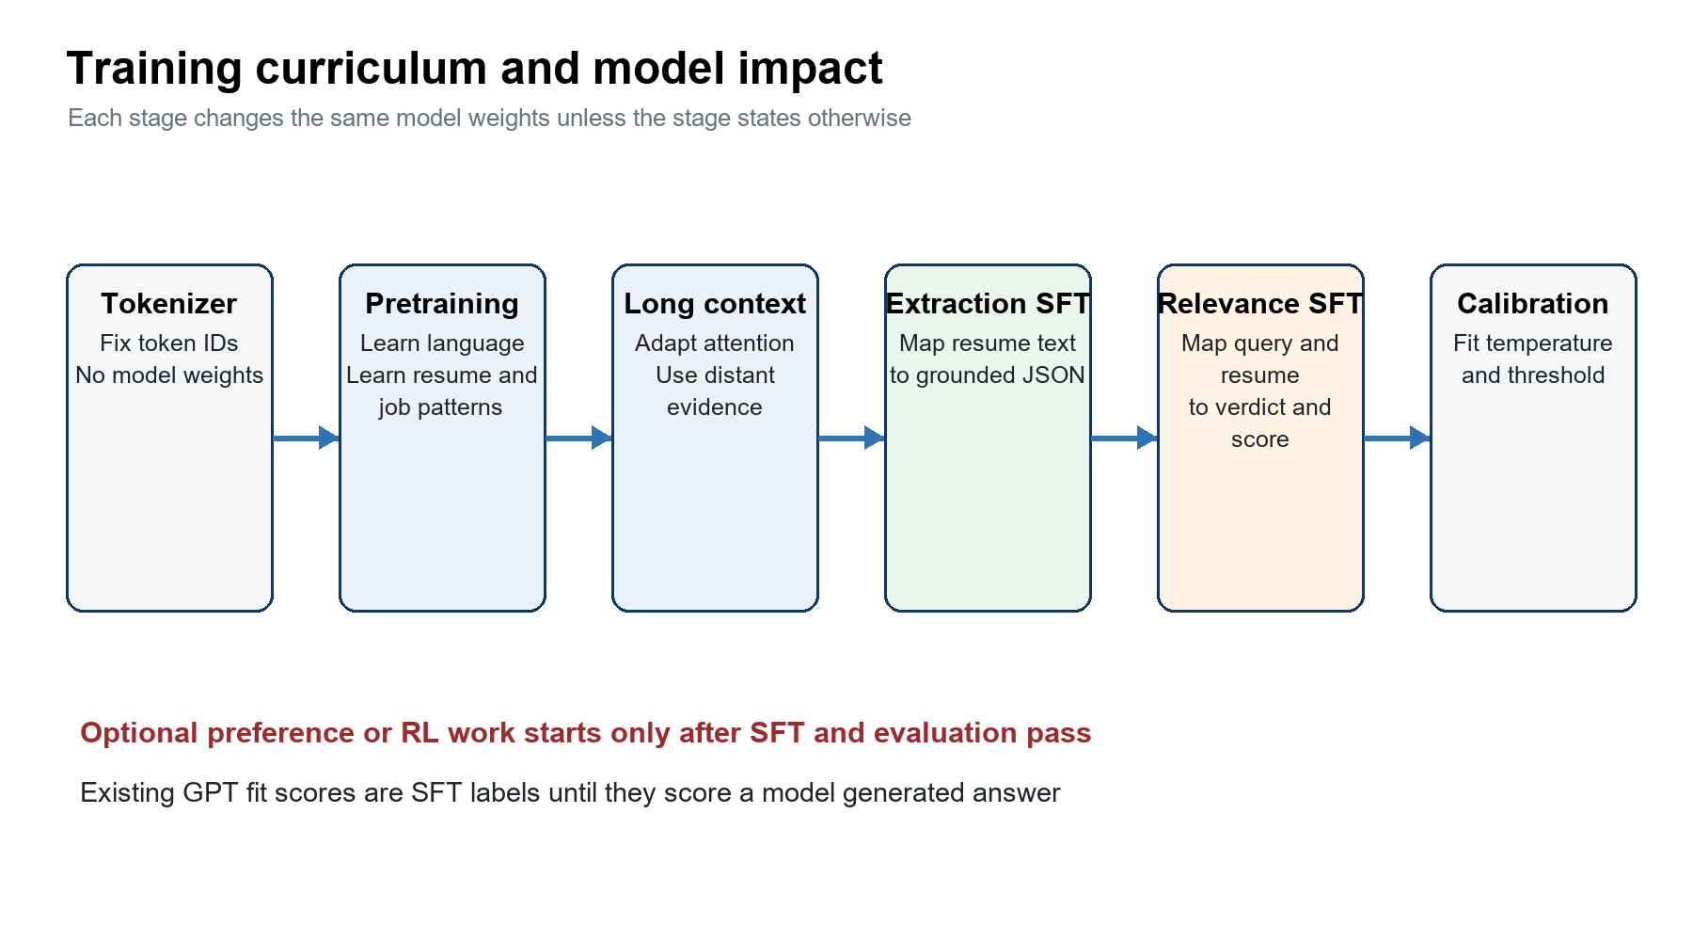
Figure 5 Training curriculum and model impact
Stage | Data | Configured amount | What changes | Main risk
Tokenizer | Train split samples from resume job knowledge and general groups | 400000 sample documents in the data plan | Token vocabulary and IDs only | Test text enters the tokenizer or special tokens drift
Stage 1 pretraining | Resume 50 percent jobs 12 percent knowledge 1.5 percent general 36.5 percent | 12.0B processed tokens at 4096 context | All transformer weights learn language and domain patterns | Private data duplication or weak generalization from repeated text
Stage 1b context | Long documents plus short context replay | Optional 0.2B bridge then 0.5B compute equivalent | Attention and position behavior adapt to long distances | Short context regression and high compute cost
Stage 2 extraction SFT | Extraction 75 percent classification 5 percent pretraining replay 20 percent | 1.2B processed tokens | Weights learn resume to JSON mapping | Hallucinated fields and target leakage
Stage 3 relevance SFT | Fast relevance 45 percent think 15 percent extraction 25 percent classification 5 percent replay 10 percent | 0.8B processed tokens | Weights learn verdict score explanation and task retention | Teacher bias poor calibration and forgetting
Calibration | Validation logits and labels | Fit after the checkpoint is chosen | Temperature and threshold only | Using the locked test for threshold choice
Optional preference or RL | New response preferences or verifiable rewards | No production config exists | Further weight updates from output feedback | Reward hacking and false explanations

Stage 1 pretraining
Pretraining teaches the model to predict text. It learns spelling grammar resume structure job requirements skills occupations and general language. It does not learn the final employer relevance rule because raw text has no query candidate target.
General data belongs in this stage. FineWeb Edu Wikipedia and Cosmopedia help a model that starts from random weights. They improve broad syntax common facts and explanatory language. The model still needs a large resume share because the deployment domain is specialized.
The 12B value is processed tokens. The trainer can see the same source text more than once. Unique source tokens and processed tokens must be reported separately. Track effective epochs for every group. A small knowledge group can be repeated too often even when its mix weight looks small.

Stage 1b long context continuation
Long context continuation starts from the pretraining checkpoint. It uses a lower learning rate and longer sequences. It does not add layers. It adapts existing attention and position behavior. Use tests that place required evidence near the start and end of long inputs. A 65536 token limit is useful only when the model can retrieve and use distant evidence.

Stage 2 extraction SFT
The input is resume text. The target is a compact validated JSON object. The loss applies to answer tokens. The model sees the prompt but is not rewarded for copying it. Pretraining replay helps the model retain language skill while it learns a narrow output schema.

Stage 3 relevance SFT
The input is the exact query or JD and the candidate text. The target includes the decision token. A five times verdict weight prevents a long explanation from dominating the task loss. Soft verdict targets can preserve judge uncertainty. Extraction replay protects the earlier extraction task.

Part 8 Extraction SFT
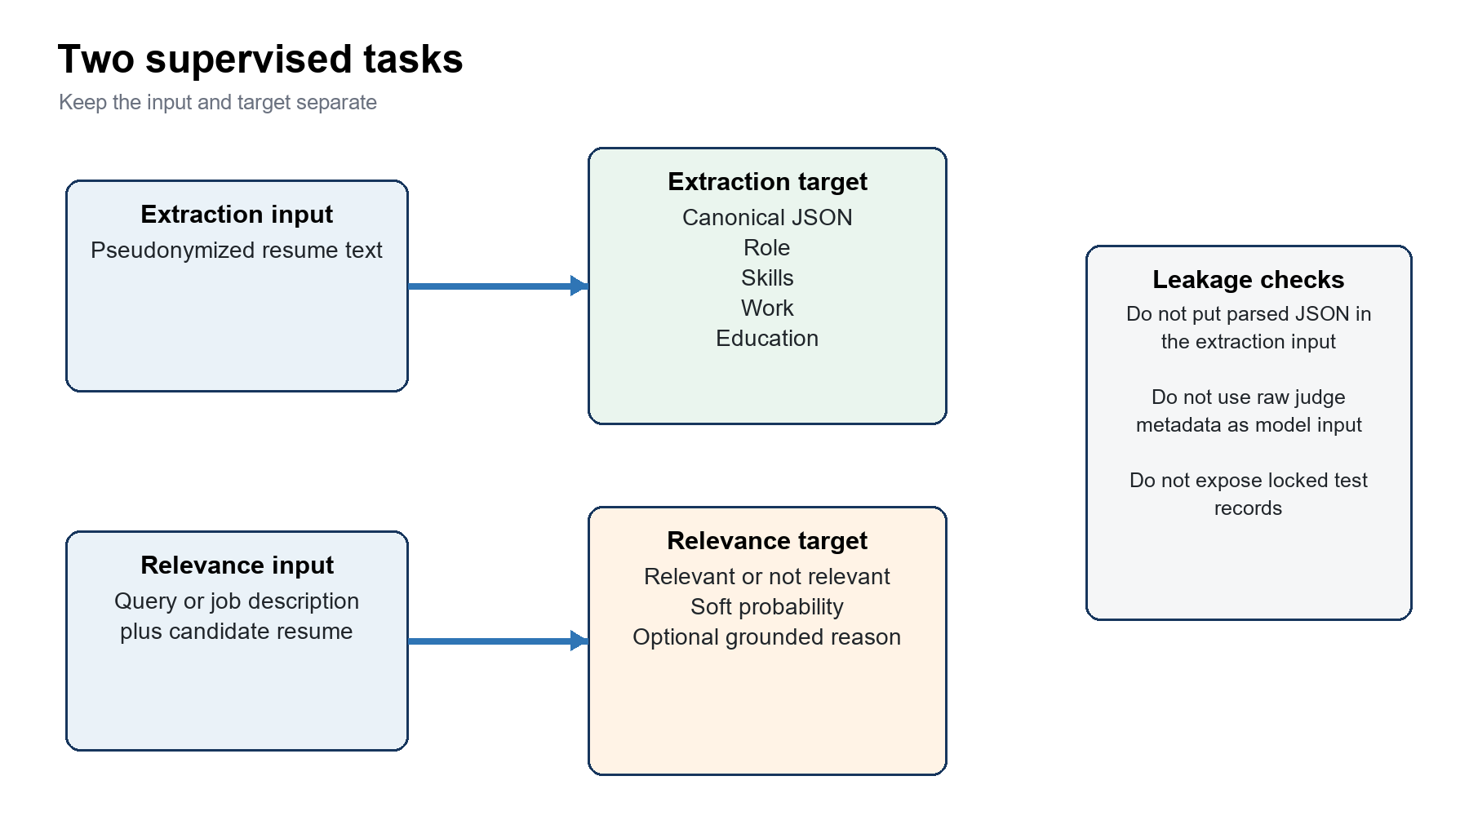
Figure 6 Supervised task design

Correct use of parsed resume data
Use resume_plain as the extraction input. Use parsed_resume_data as a source for the target. Do not place parsed_resume_data in the input. That design would reveal the answer and create target leakage.
Field | Input or target | Rule | Benefit
resume_plain | Input | Pseudonymize normalize and keep the evidence needed for every target field | The model learns to read real resume layout
parsed_resume_data | Target source | Parse validate remove protected fields and project to one schema | Provides broad extraction supervision
work experience table | Target validator | Normalize dates and compare company and position evidence | Reduces parse errors and unsupported work items
education table | Target validator | Normalize degree college subject dates and CGPA | Reduces inconsistent education outputs
skill taxonomy | Target normalizer | Map aliases to one skill ID and keep confidence | Prevents duplicate skill spellings
curated extraction | Locked test and reviewed SFT remainder | Freeze the split before any training | Provides a higher quality measure and examples

Recommended canonical target
Use a small schema first. Include role summary skills with evidence work items education items and location only when the product needs it. Do not ask a 350M model to reproduce every raw parse key. A smaller schema improves consistency and reduces unsupported output.
Example target structure
{
"role": "data engineer",
"skills": [{"name": "sql", "years": 4}],
"work": [{"position": "data engineer", "company": "COMPANY_1", "start": "2021-01", "end": null}],
"education": [{"degree": "bachelor", "subject": "computer science"}]
}

Extraction sampling strategy
- Start with a few hundred thousand high confidence examples instead of all 3.5 million parses.
- Stratify by resume length role domain language number of jobs and number of education items.
- Oversample rare but valid structures. Do not oversample noisy targets.
- Keep target length within the decode budget. Truncate the number of repeated low value items with a documented rule.
- Add hard examples after the basic schema reaches stable JSON validity and grounding scores.

Part 9 Relevance SFT
Query or JD plus resume judgments should be a main SFT source. They directly match the deployment task. The raw rows still require consolidation. A GPT score is a teacher label. It is not an objective fact and it is not automatically a probability.
Source | Recommended SFT use | Locked evaluation use | Reason
Consolidated GPT and Gemini judgments | Use stable consensus pairs and soft uncertain targets | Keep unseen query and person slices | Large direct task source with repeated correlated judge runs
Candidate JD 159K | Use most person and JD families for SFT | Freeze 200 to 300 candidate person groups and an optional JD family slice | Closest to the simple JD and resume scoring interface
HF small train | Use after parsing and duplicate checks | Keep the 1759 official test rows untouched | External long JD signal and external benchmark
HF large train | Use at a low controlled weight after synthetic quality review | Keep its 13716 test rows untouched | Adds volume but contains generated and synthetic sources
Curated relevance 296 | Use only the post split remainder | Reserve a human reviewed locked subset | Small high value evidence must remain independent

The 200 to 300 candidate test pool
1. Select person groups instead of individual rows.
2. Stratify by relevance class domain resume length experience difficulty and label confidence.
3. Include both candidates with clear fit and candidates with hard near miss failures.
4. Remove every version of these people from tokenizer samples pretraining extraction SFT relevance SFT teacher labeling synthetic generation and preference data.
5. Freeze the IDs labels source versions and evaluation prompts in the registry.
6. Use validation candidates for threshold tuning. Use the locked pool only for milestone reports.
7. Bootstrap confidence intervals by person group or query family. Do not bootstrap correlated rows as independent observations.
Recommended test design Create an unseen candidate slice and an unseen JD family slice. Add a doubly unseen slice when sample size allows. Report each slice separately because it answers a different product question.

Label mapping
Raw signal | Canonical representation | Use
Relevant or Good Fit | Positive class | Verdict target
Not relevant or No Fit | Negative class | Verdict target
Potential Fit | Soft probability such as 0.6 only after validation | Uncertain target
Zero to ten judge score | Stored teacher score plus validation fitted probability | Auxiliary target and analysis
Several repeated same model scores | One source summary with mean range and variance | Uncertainty metadata
Independent judges | Separate source estimates and agreement | Confidence and review routing
Reason and failed constraints | Grounded short checklist | Optional think target and future reward components

Pointwise pairwise and listwise learning
Method | Example | Best use | Status here
Pointwise | One query and candidate with a relevance label | Calibrated binary fit score | Main Stage 3 SFT
Pairwise | Two candidates for one query with a preferred order | Ranking candidates within a pool | Optional RankNet style supervised loss
Listwise | A full candidate list with graded labels | Optimize ranking metrics directly | Future work because complete reliable pools are limited
Preference tuning | Two model answers for the same input | Improve output behavior and grounded explanations | Future data construction

Part 10 Preference and reinforcement learning
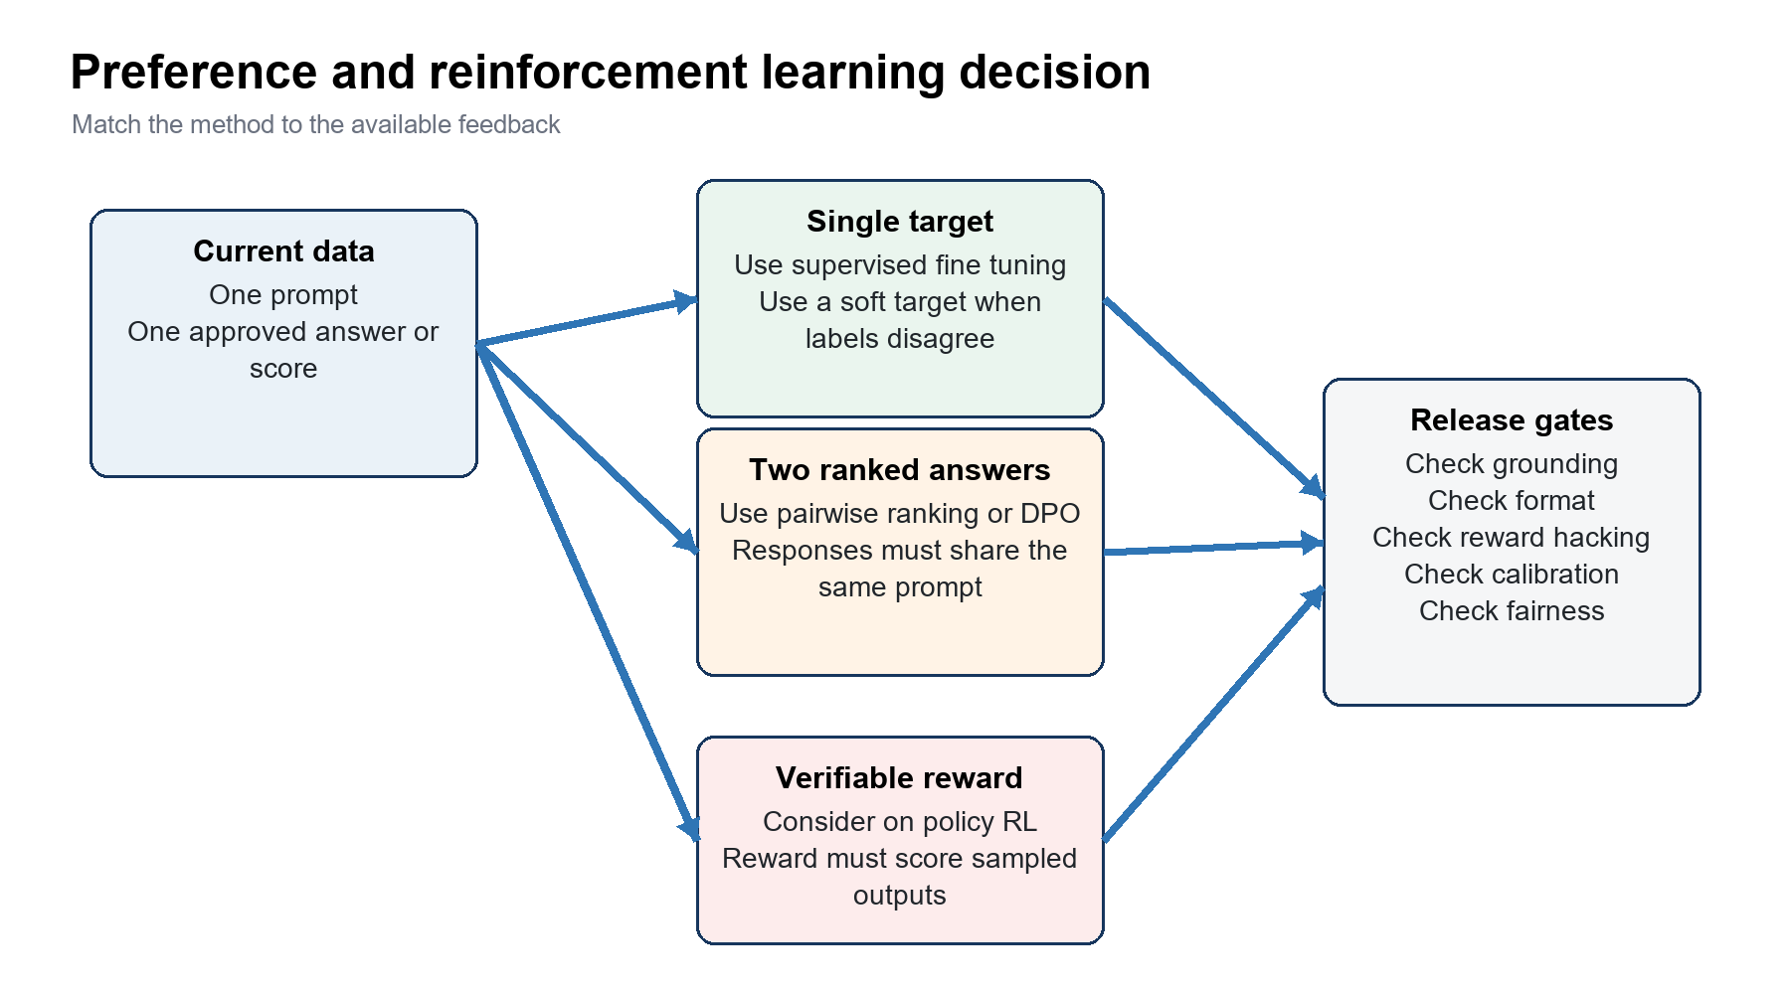
Figure 7 Preference and reinforcement learning decision
The repository does not contain a production RL stage. Stage 3 is SFT. The optional RankNet loss is supervised ranking. A query resume score from GPT grades candidate fit. It does not grade a sampled model answer. Therefore it is not a direct RL reward.
Method | Data required | What it optimizes | Recommendation
SFT | One prompt and one target or soft target | Likelihood of the desired answer | Use now for extraction and relevance
Pairwise ranking | One query and two candidates with an order | Relative candidate score | Use as a supervised ablation before RL
DPO or preference tuning | One prompt with chosen and rejected model answers | Preference between complete responses | Pilot after stable SFT with human reviewed preferences
Reward model | Prompts responses and preference labels | A learned score for model responses | Use only when preference volume and judge quality justify it
Verifiable reward RL | On policy outputs and deterministic or audited checks | Expected reward for sampled outputs | Consider only for valid JSON grounded evidence and constraint following
On policy distillation | Student output and teacher critique or corrected answer | Improved output under teacher feedback | Often a simpler first experiment than policy optimization

How to convert current data for preference work
1. Start from a frozen SFT checkpoint and a train or preference split prompt.
2. Generate two or more complete answers from the model or from controlled candidate checkpoints.
3. Ask a human or audited judge to compare answers to the same prompt.
4. Require the comparison to check verdict correctness evidence grounding format and unsupported claims.
5. Keep the original prompt both responses chosen label reviewer source and uncertainty.
6. Remove prompts that belong to the locked test or near duplicate it.
7. Train a small DPO or supervised preference pilot.
8. Compare the pilot with the exact SFT baseline on untouched slices.

Possible verifiable reward
Reward component | Example check | Reason
Format | JSON parses and required keys have valid types | The check is deterministic
Verdict | Decision agrees with a trusted held out consensus label | It protects the main task
Constraint checklist | Every required constraint has pass fail or unknown | It rewards complete reasoning
Grounding | Quoted or normalized evidence exists in the input | It penalizes fabricated support
Uncertainty | Unknown is allowed when the resume lacks evidence | It reduces forced confident guesses
Length | Reason stays under the product budget | It controls latency and verbosity
Safety and privacy | Output does not reveal redacted identity or infer protected traits | It protects candidates and reduces bias

Stop rule Do not ship a preference or RL checkpoint when it improves the reward but reduces locked test quality calibration grounding fairness or latency beyond the approved budget.

Part 11 Evaluation
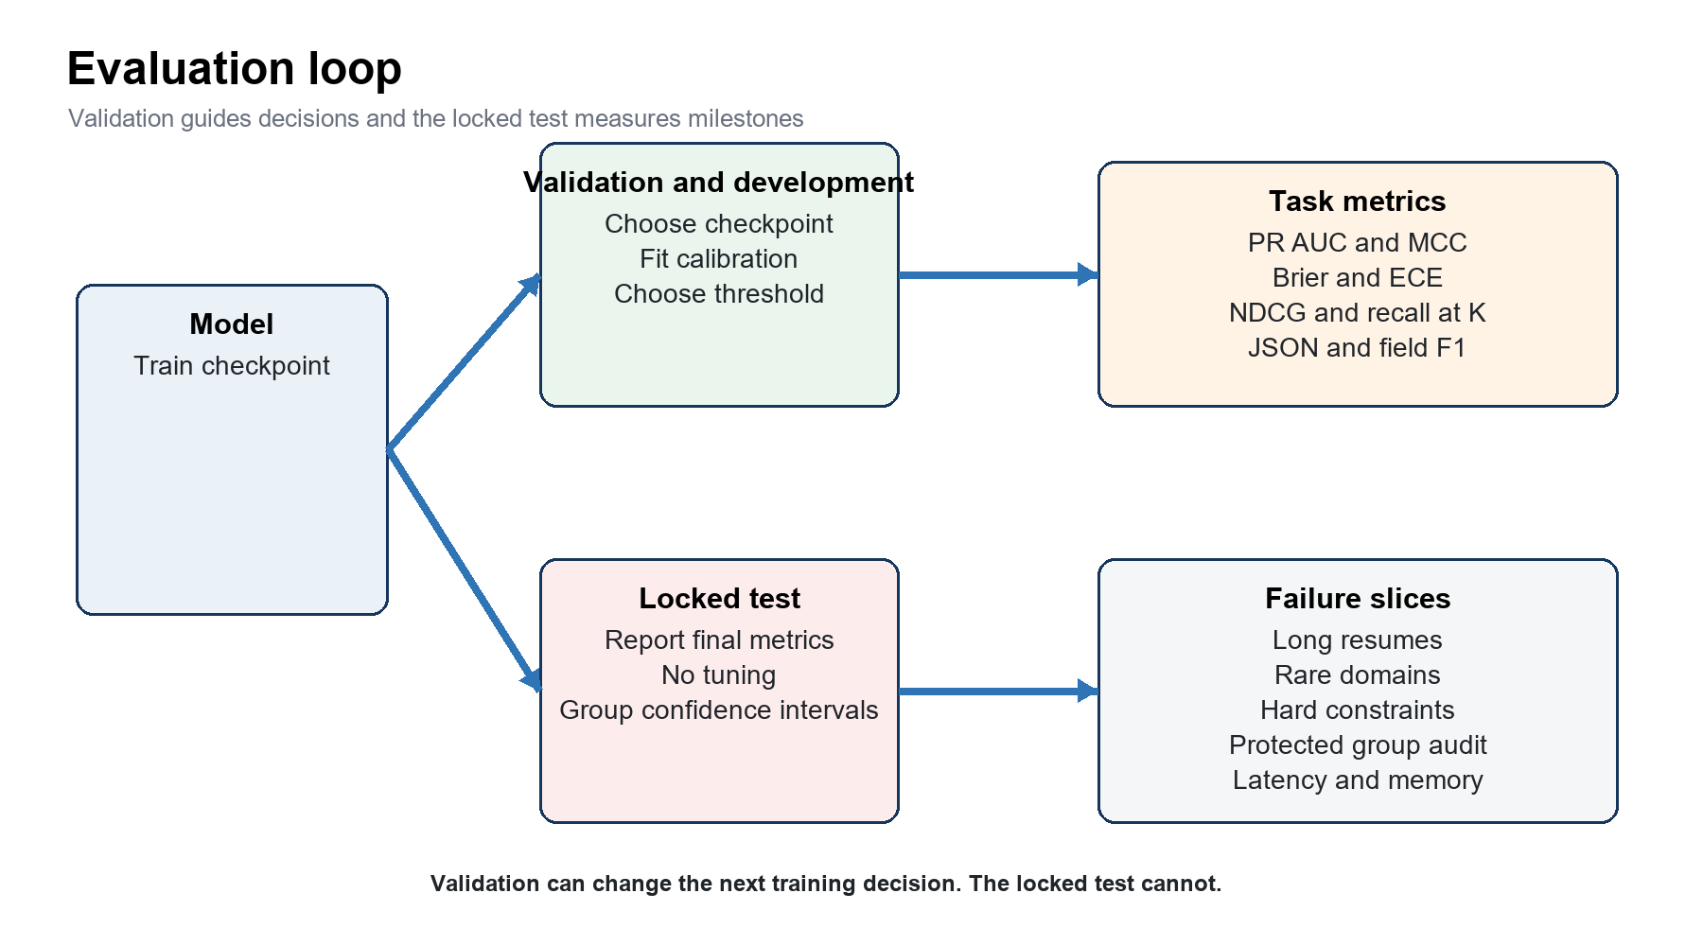
Figure 8 Evaluation loop
Task | Primary metrics | Required slices | Interpretation
Pretraining | Validation loss and perplexity by source group | Resume jobs knowledge general long and short | Lower is better only on clean unseen validation text
Extraction | JSON validity field precision recall F1 date accuracy grounded field rate | Long resumes many jobs rare formats multilingual dates | Validity alone does not detect hallucinated values
Binary relevance | PR AUC ROC AUC F1 MCC recall at fixed precision | Stable labels risky labels domains hard constraints | Use PR AUC and MCC when classes are imbalanced
Calibration | Brier score ECE reliability bins | Seen and unseen query families and people | A high ranking score can still have poor probabilities
Ranking | NDCG at K MAP recall at K pairwise accuracy | Per query candidate pools and hard negatives | Evaluate groups instead of independent rows
Operations | Latency tokens per second memory export parity | 4096 16384 and 65536 inputs and quantized serving | Quality gains must fit the deployment budget
Fairness | Error and selection rates by approved audit groups | Geography language career gaps and proxy checks | Do not infer protected attributes for model input

Evaluation sets
Set | Held out unit | Allowed use | Question
Train | Nothing beyond duplicate controls | Weight updates | Can the model learn the task
Validation | Pairs or people on train query families | Early stopping calibration threshold | Which checkpoint and decision rule should be used
Development | Unseen query families or diagnostic candidates | Ablations prompt design and data decisions | Which design generalizes better
Locked candidate test | 200 to 300 person groups across all stages | Milestone reports only | Does the model score people it never read
Locked JD test | Whole JD or query families | Milestone reports only | Does the model generalize to new requirements
Doubly unseen | Both people and request families | Milestone reports only | How does the model behave under the hardest shift
External HF tests | Published test files | External comparison only | Does the model transfer to another label source
Human reviewed gold | Reviewed examples outside model facing work | Error analysis and final evidence | How accurate are teacher labels and model outputs

Part 12 Execution plan

Beginner safe pilot
1. Fix the F drive source paths and install sentencepiece safetensors torch and the required ROCm stack.
2. Create the person and query family registry. Freeze the locked sets.
3. Build a small clean sample from each selected source. Produce a rejection report.
4. Train the 32000 token tokenizer only on train split documents.
5. Pack a short pretraining pilot and verify task markers document boundaries and token counts.
6. Run a small Stage 1 job. Test checkpoint save resume and loss reduction.
7. Build 10000 to 50000 high confidence extraction pairs. Verify answer only masks.
8. Run a small extraction SFT job and measure JSON validity and grounding.
9. Build consolidated relevance pairs with the exact judge visible candidate view.
10. Run a small relevance SFT job and measure ranking calibration and extraction retention.
11. Increase the data budget only after the pilot passes leakage privacy and quality checks.
12. Run the full curriculum. Record code config data and tokenizer fingerprints for every checkpoint.

Stage gates
Gate | Required evidence | Decision if failed
Data rights | Source license consent and purpose record | Exclude or quarantine the source
Split | Zero person group and required query family overlap | Rebuild the registry and all derived data
Privacy | Residual PII audit below the approved target | Improve pseudonymization and drop leaking records
Extraction labels | High JSON validity grounding and date consistency | Reduce target scope or send records to review
Relevance labels | Documented scale agreement and error rate | Use soft targets relabel or drop weak pairs
Packed data | Stable tokenizer digest prompt digest counts and no leakage | Do not start training
Stage transition | Target gain and no unacceptable regression | Adjust mix learning rate or replay
Release | Locked test confidence intervals fairness and latency | Do not deploy the checkpoint

Recommended first production data mix
Stage | Recommended starting data | Reason
Tokenizer | Balanced train only sample from resumes jobs FineWeb Wikipedia and Cosmopedia | Avoid a vocabulary that overfits one source
Pretraining | Configured 50 percent resume 12 percent job 1.5 percent knowledge 36.5 percent general with per source caps | Matches the repository plan and limits small corpus repetition
Extraction SFT | A high confidence subset of current resume pairs plus structured table checks and curated train remainder | Quality is more important than using all parses
Relevance SFT | Stable consolidated pairs candidate JD train split HF train data and curated train remainder | Combines direct task data with external diversity
Preference pilot | A small human reviewed set of chosen and rejected answers from the SFT model | Creates output level feedback that current labels do not provide
Locked evaluation | 200 to 300 person groups unseen JD families curated gold and official HF tests | Preserves independent evidence

Part 13 Interview questions and detailed answers
These questions test design judgment. A strong answer states the training signal the leakage risk the metric and the decision rule. The answer should separate measured facts from recommendations.

Question 1 Raw resume text and relevance labels
Prompt Why can raw resume text improve a model but still fail to teach candidate relevance
Detailed answer Raw resume text supports next token learning. It teaches vocabulary structure common skill names role descriptions and relationships between nearby resume fields. It does not define what a particular query requires. Relevance is conditional. The same candidate can be relevant for one request and irrelevant for another. The model needs paired examples that include the query or job description the candidate evidence and a target verdict or ranking. Raw resumes can improve the representation used by relevance SFT but cannot replace task labels. The correct curriculum uses train split resume text during pretraining and then uses query candidate pairs during SFT. The evaluation must hold out people and query families according to the intended claim.
Strong answer signals The candidate mentions conditional relevance paired supervision stage order and held out identity groups.
Common mistake The candidate says that more raw resumes automatically teach the employer decision rule.

Question 2 General data in pretraining
Prompt Why should FineWeb Wikipedia and Cosmopedia be used in pretraining instead of the relevance SFT stage
Detailed answer These sources contain text but no verified mapping from a query and a candidate to a relevance decision. Their learning signal is next token prediction. They improve grammar broad facts explanation style and text diversity for a model that starts from random weights. If they enter relevance SFT as ordinary examples they dilute the task objective because no relevance target exists. They can remain as a small pretraining replay stream during SFT. This replay protects general language ability while task examples teach extraction or relevance. The mix needs per source validation because synthetic text and repeated articles can dominate even when the total volume looks large.
Strong answer signals The candidate separates objective from content and explains SFT replay and source caps.
Common mistake The candidate calls all text SFT data or claims general data has no value for a domain model.

Question 3 Parsed resume data as a target
Prompt How should resume_plain and parsed_resume_data be used for extraction training
Detailed answer Use resume_plain as the input and a validated projection of parsed_resume_data as the target. First parse the JSON and reject schema objects or malformed payloads. Remove protected and unnecessary fields. Normalize dates skills roles and location. Cross check work and education items against the resume and structured tables. Keep only grounded facts. Then serialize the target with one stable key order and schema. Do not put parsed_resume_data in the prompt because the model could copy the answer. Do not pretrain indiscriminately on raw parse JSON because it can teach private or incorrect values. Answer only loss should apply to the target tokens while the model attends to the resume prompt.
Strong answer signals The candidate explains leakage grounding canonical schemas and answer only masking.
Common mistake The candidate uses the raw parse as both input and target or assumes an OpenAI parse is gold.

Question 4 Identity based leakage
Prompt How do you prevent leakage when one person has several accounts or resume versions
Detailed answer Create a person graph before any split. Link records with trusted candidate IDs normalized one way email hashes profile handles fingerprint IDs and reviewed near duplicate resume text. Assign the full person group to one split. Select one canonical resume for training but retain lineage to every source version. Run exact and near duplicate checks across public profiles and old exports because the same person can appear without the same internal ID. The tokenizer sample teacher requests synthetic generation and preference prompts must use the same registry. A row level split is insufficient because two accounts or two versions can cross the boundary.
Strong answer signals The candidate uses a person group registry and applies it to every model facing stage.
Common mistake The candidate hashes talent_id separately inside each task or checks overlap only after training.

Question 5 Query family leakage
Prompt Why should near duplicate queries and job descriptions be grouped before splitting
Detailed answer A row split can place a query template in training and a minor rewrite in test. The model can then reuse the same constraint pattern without generalizing to a new request. Normalize case spacing punctuation numbers and common template text. Use similarity methods to propose query or JD families and review ambiguous merges. Assign whole families to train development or test. Keep a separate unseen candidate slice when production also needs new person evaluation. Report seen request and unseen request results separately because they answer different questions.
Strong answer signals The candidate explains the deployment claim and distinguishes query and candidate axes.
Common mistake The candidate assumes different query IDs mean independent requests.

Question 6 Correlated teacher runs
Prompt Why are ten outputs from the same judge model not ten independent labels
Detailed answer The runs share model weights prompt design evidence and systematic bias. Sampling changes can create variation but do not create independent expertise. Treat repeated runs as one correlated source. Compute a mean range and variance for that source. Then compare it with a different judge family or a human review. Independence matters because a simple majority of correlated runs can create false confidence. Store provenance so later audits can identify which prompts model versions and dates produced each label.
Strong answer signals The candidate discusses correlation provenance source level aggregation and independent review.
Common mistake The candidate counts every stochastic run as a separate voter.

Question 7 Soft relevance targets
Prompt When should a relevance target be soft instead of hard
Detailed answer Use a soft target when the label represents real uncertainty rather than an annotation error. Examples include Potential Fit classes scores near the decision boundary and disagreement between credible independent judges. Map the evidence to a probability only with a documented rule and validate the mapping on human reviewed data. Keep the original verdict score range variance and judge count. Compare soft and hard target ablations. A soft target can improve calibration but can also preserve teacher bias. Do not use a soft target to hide a broken prompt missing resume text or contradictory labels.
Strong answer signals The candidate distinguishes aleatoric uncertainty from data errors and proposes validation.
Common mistake The candidate converts every ten point score directly to score divided by ten.

Question 8 Teacher score calibration
Prompt Why is a GPT score of eight not automatically an 0.8 probability of relevance
Detailed answer A rating scale and a probability scale have different definitions. A score of eight may mean strong fit under a rubric. It does not state that eight of ten similar candidates are relevant. Judge prompts and models can also use the scale unevenly. Keep the raw score as teacher metadata. Train a verdict or auxiliary score target if it helps. Fit a probability mapping on validation logits and verified labels. Evaluate Brier score expected calibration error and reliability bins. Freeze the mapping before the locked test.
Strong answer signals The candidate explains scale semantics validation fitted mapping and calibration metrics.
Common mistake The candidate treats rating divided by ten as ground truth probability.

Question 9 Locked candidate pool design
Prompt How would you create a useful 200 to 300 candidate locked test pool
Detailed answer Sample person groups instead of rows. Stratify by label domain resume length experience and difficulty. Include clear positives clear negatives and hard near misses. Check representation for the supported geographies and languages without using protected traits as model inputs. Freeze every source version of each selected person before tokenizer sampling or teacher generation. Pair the people with a fixed set of JDs or query families. Add enough candidates per query for ranking metrics. Use validation for thresholds. At milestone evaluation bootstrap by person group or query family and report the interval with the point estimate.
Strong answer signals The candidate covers stratification registry timing ranking pools and group confidence intervals.
Common mistake The candidate selects 300 random rows after SFT and calls them unseen.

Question 10 Token estimates
Prompt How do you explain the difference between disk size character count unique tokens and processed tokens
Detailed answer Disk size depends on Parquet compression and repeated values. Character count measures decoded text before tokenization. Unique token count is the tokenized size of cleaned deduplicated source documents. Processed tokens count every token read by the optimizer and therefore includes replay and repeated epochs. These values answer different questions. Storage planning uses disk size. Context analysis uses per document tokens. Data sufficiency uses unique tokens and diversity. Training compute uses processed tokens. The final pack report must use the frozen tokenizer because a four characters per token estimate can be wrong for code names multilingual text and formatting artifacts.
Strong answer signals The candidate names all four quantities and ties each to a decision.
Common mistake The candidate adds compressed file bytes and calls the result training tokens.

Question 11 Hybrid attention architecture
Prompt Why use five local attention layers followed by one global layer
Detailed answer Local attention limits most layers to the previous 1024 tokens. This reduces attention cost and key value cache use while preserving detailed local processing. Every sixth global layer can connect distant resume sections and propagate information across the sequence. Repeating the pattern gives five global communication points across thirty layers. The design is a compute quality tradeoff. It must be validated with distant evidence tests and short context regression tests. The pattern does not guarantee that a 64K model uses the full context correctly.
Strong answer signals The candidate explains compute cache information flow and the need for empirical tests.
Common mistake The candidate claims local attention can never represent distant evidence or that global layers prove long context skill.

Question 12 Grouped query attention
Prompt What does eight query heads and two key value heads change
Detailed answer The model keeps eight query projections but shares two key and value projections across groups of query heads. This reduces the key value cache compared with eight independent key value heads. The saving matters at long context and during decoding. The queries can still attend with different projections. The tradeoff is lower key value diversity. The head dimension of 128 and the two key value heads are architectural choices that need quality and latency tests on the target hardware.
Strong answer signals The candidate explains cache savings and the quality tradeoff.
Common mistake The candidate says grouped query attention reduces the number of query heads.

Question 13 Long context evidence
Prompt What evidence is required before you claim that a 65536 token model works at long context
Detailed answer Show more than a successful forward pass. Build tests with required facts at controlled distances and distractors between them. Measure retrieval and task accuracy as distance and total length grow. Include extraction fields near the end of long resumes and relevance constraints that require evidence from separated sections. Compare the long context checkpoint with the 4096 checkpoint. Check short input regression latency memory and export parity. A maximum position setting proves capacity. It does not prove reliable use.
Strong answer signals The candidate proposes distance controlled evaluation and operational tests.
Common mistake The candidate reports only that the model accepts a 64K tensor.

Question 14 Answer only loss
Prompt Why should SFT compute loss on the answer while still showing the prompt
Detailed answer The prompt supplies the condition for the answer. The model must attend to it. Penalizing every prompt token can waste task weight on reproducing input text that the application already knows. Answer only loss focuses the gradient on JSON verdict and reason tokens. The prompt must still be tokenized with stable boundaries and the mask must include the first answer token. Unit tests should verify the mask around task markers. Pretraining replay handles general next token learning separately.
Strong answer signals The candidate explains conditioning gradient focus marker tests and replay.
Common mistake The candidate removes the prompt from the forward pass or masks the first answer token by mistake.

Question 15 Verdict token weighting
Prompt Why might the relevance decision token receive more loss weight than the explanation
Detailed answer A reason can contain many tokens while the verdict can be one token. Without weighting the model can reduce average answer loss by improving fluent explanations while the actual decision changes little. A higher verdict weight gives the business decision more influence. It is still a hyperparameter. Compare decision metrics calibration explanation grounding and gradient norms. Too much weight can make the model ignore reasoning quality or become overconfident.
Strong answer signals The candidate connects token counts to objective weighting and proposes balanced evaluation.
Common mistake The candidate assumes a larger weight always improves accuracy.

Question 16 Replay and forgetting
Prompt Why do Stage 2 and Stage 3 include earlier task and pretraining replay
Detailed answer Fine tuning on a narrow output can shift weights away from earlier language and extraction behavior. Replay keeps a controlled sample of earlier objectives in the batch mix. Stage 2 uses pretraining replay. Stage 3 uses extraction classification and pretraining replay. Measure both the new task gain and the retained task scores. Replay can create gradient conflict or slow learning. The repository includes periodic gradient diagnostics for this reason. Adjust the mix from evidence rather than keeping a fixed percentage by habit.
Strong answer signals The candidate explains catastrophic forgetting multi task tradeoffs and retention metrics.
Common mistake The candidate treats replay as free or never tests whether it harms the new task.

Question 17 Pointwise and pairwise relevance
Prompt When would you add a pairwise ranking loss to pointwise relevance SFT
Detailed answer Add it when the product ranks several candidates for the same request and reliable within query order labels exist. Pointwise labels teach absolute fit and support calibration. Pairwise loss teaches that candidate A should score above candidate B. Build pairs within one query family and favor informative hard negatives. Keep the pointwise objective so scores remain interpretable. Evaluate NDCG recall at K pairwise accuracy and calibration. Pairwise RankNet is supervised learning because it uses fixed labeled pairs and a differentiable loss.
Strong answer signals The candidate ties the method to ranking deployment and preserves calibration checks.
Common mistake The candidate calls pairwise ranking reinforcement learning.

Question 18 SFT preference tuning and RL
Prompt Explain the difference between SFT DPO and policy optimization in this project
Detailed answer SFT uses one target or soft target and increases its likelihood. DPO uses a chosen and rejected complete answer for the same prompt and directly changes the policy toward the chosen response relative to a reference. Policy optimization samples answers from the current policy and updates weights from a reward. The current judge scores describe candidate fit. They support SFT. They become preference data only after two model responses to the same prompt are compared. They become an RL reward only when a checked evaluator grades the sampled response.
Strong answer signals The candidate defines the data contract for each method and maps current labels correctly.
Common mistake The candidate says any numeric label is an RL reward.

Question 19 Reward hacking
Prompt How would you test an RL reward for grounded relevance explanations
Detailed answer Decompose the reward into format verdict constraints grounding uncertainty privacy and length. Create adversarial outputs that are fluent but cite missing evidence repeat keywords exploit parser defaults or give the correct verdict with a false reason. Confirm that these outputs receive lower reward. Hold out templates from reward development. Compare reward with human judgments on a blind sample. Track each component separately because a high total can hide a failed safety component. Evaluate the trained policy on metrics that are not part of the reward.
Strong answer signals The candidate proposes adversarial reward tests independent metrics and component reporting.
Common mistake The candidate optimizes one judge score and reports the same score as proof of improvement.

Question 20 Calibration and threshold choice
Prompt How should the final relevance threshold be selected
Detailed answer Choose the checkpoint first with development criteria. Fit temperature scaling on validation logits and labels. Select the threshold from a product objective such as maximum recall at a required precision or a defined false positive cost. Freeze the temperature and threshold. Evaluate them once on the locked test. Report reliability bins Brier score expected calibration error and the operating point confusion matrix. Refit only when the model data or target population changes and treat that as a new version.
Strong answer signals The candidate separates ranking checkpoint calibration operating point and locked test.
Common mistake The candidate searches the test set for the threshold that produces the best F1.

Question 21 Metrics for imbalanced relevance
Prompt Which metrics would you use when relevant candidates are rare
Detailed answer Use PR AUC because it focuses on positive class precision and recall. Report recall at the required precision because hiring workflows often limit review capacity. Use MCC or balanced accuracy for a thresholded summary. Report ROC AUC as a secondary ranking measure. Add Brier score and ECE for probability quality. For candidate lists use NDCG at K recall at K and MAP. Report per query distributions and confidence intervals because a high global score can hide failed requests.
Strong answer signals The candidate combines ranking classification calibration and group level reporting.
Common mistake The candidate reports only accuracy or ROC AUC.

Question 22 Extraction hallucination diagnosis
Prompt How would you separate extraction hallucination from ordinary field recall errors
Detailed answer Parse the output first. For every predicted value search for exact normalized or approved fuzzy evidence in the resume and trusted tables. A predicted value without evidence is an unsupported field. A source fact that is absent from the output is a recall miss. A wrong normalized value is a precision error. Report JSON validity field precision recall F1 grounded field rate and unsupported item rate separately. Slice by field because dates employers skills and education fail differently. Review false grounding matches to prevent a loose fuzzy rule from hiding hallucinations.
Strong answer signals The candidate defines distinct error categories and field specific evidence checks.
Common mistake The candidate uses JSON validity as the only extraction quality measure.

Question 23 Baseline comparison
Prompt What evidence is needed before claiming the 350M model beats a 4B baseline
Detailed answer Use the same locked inputs prompt information context limit where feasible decision calibration and metrics. Record inference precision quantization hardware latency memory and token budget. Compare confidence intervals and per query results. A smaller model may win on latency while losing some quality. State the tradeoff instead of selecting one metric. Verify that neither model saw the test data through pretraining or teacher generation when the claim requires strict independence. Report unfavorable slices and export parity.
Strong answer signals The candidate defines a fair protocol and includes statistical operational and leakage evidence.
Common mistake The candidate compares one tuned model with one untuned baseline on a reused test set.

Question 24 Synthetic and generated relevance data
Prompt How would you decide whether the larger generated resume JD collection helps
Detailed answer Inspect source categories label balance duplication template similarity and domain coverage. Build train only additions after decontamination. Run an ablation from the same base checkpoint with and without the data. Keep the validation and locked tests fixed. Measure overall metrics calibration and human reviewed difficult slices. Cap the source weight so generated patterns do not replace real judged pairs. If gains appear only on similar synthetic tests the data may teach template recognition rather than deployment relevance.
Strong answer signals The candidate proposes source profiling weight caps fixed split ablation and human slices.
Common mistake The candidate assumes more generated rows always improve generalization.

Question 25 Data lineage and reproducibility
Prompt What must be recorded so another engineer can reproduce a checkpoint
Detailed answer Record source file hashes source versions rights records registry version cleaning configuration rejection counts pseudonymization policy tokenizer model prompt and packed data digests. Record code commit training YAML random seeds hardware optimizer state checkpoints and evaluation calibration files. Keep the lineage from each packed example to its source without exposing private values. A checkpoint name alone is insufficient. Reproducibility also requires the exact split and data order because both affect optimization and evaluation.
Strong answer signals The candidate covers data code tokenizer prompt split model and calibration artifacts.
Common mistake The candidate records only the model config and final weights.

Appendix A Exact schemas
This appendix lists exact column names for the main Parquet sources. The Turing physical types come from the local snapshot schema. Other type descriptions in the handbook are semantic types unless stated otherwise.

Current resume export columns
Column and physical type | Column and physical type | Column and physical type
talent_id INT64 | name BYTE_ARRAY | email BYTE_ARRAY
phone_number BYTE_ARRAY | location BYTE_ARRAY | country BYTE_ARRAY
country_citizenship BYTE_ARRAY | education BYTE_ARRAY | university BYTE_ARRAY
work_experience BYTE_ARRAY | industry BYTE_ARRAY | linkedin_url BYTE_ARRAY
github_url BYTE_ARRAY | summary BYTE_ARRAY | resume_plain BYTE_ARRAY
parsed_resume_data BYTE_ARRAY | is_experience_in_frontier_geo BYTE_ARRAY | full_time_experience_in_months INT64
domain_id INT64 | domain BYTE_ARRAY | subdomain_id INT64
subdomain BYTE_ARRAY | role BYTE_ARRAY | expected_salary_amount FIXED
expected_salary_amount_yearly FIXED | salary_local_currency BYTE_ARRAY | salary_in_USD FIXED
display_github_in_resume INT64 | display_linkedin_in_resume INT64 | display_portfolio_screenshots_in_resume INT64

Work experience columns
Column and physical type | Column and physical type | Column and physical type
id INT64 | developer_id INT64 | position BYTE_ARRAY
company BYTE_ARRAY | start_year INT64 | start_month BYTE_ARRAY
end_year INT64 | end_month BYTE_ARRAY | details BYTE_ARRAY
url BYTE_ARRAY | contribution BYTE_ARRAY | outcome BYTE_ARRAY
created_date INT64 | updated_date INT64 | employment_type BYTE_ARRAY
company_industry_tier_id INT64 | industry BYTE_ARRAY | department BYTE_ARRAY
seniority BYTE_ARRAY | country_id INT64 | state BYTE_ARRAY
city BYTE_ARRAY | work_mode BYTE_ARRAY | company_id INT64
domain_id INT64 | sub_domain_id INT64 | duration_in_months INT64
bq_created_dt INT64 | bq_updated_dt INT64 | bq_created_by BYTE_ARRAY
bq_updated_by BYTE_ARRAY

Education columns
Column and physical type | Column and physical type | Column and physical type
id INT64 | developer_id INT64 | level BYTE_ARRAY
degree BYTE_ARRAY | college BYTE_ARRAY | start_year INT64
start_month BYTE_ARRAY | end_year INT64 | end_month BYTE_ARRAY
country_id INT64 | cgpa FIXED | cgpa_scale INT64
university_subject_tier_id INT64 | subject BYTE_ARRAY | description BYTE_ARRAY
domain_id INT64 | subject_id INT64 | university_id INT64
city BYTE_ARRAY | subdomain_id INT64 | bq_created_dt INT64
bq_updated_dt INT64 | bq_created_by BYTE_ARRAY | bq_updated_by BYTE_ARRAY

Older resume export columns
Column | Column | Column
talent_id | country | city_of_residence
state | linkedin_url | github_url
hourly_rate | salary_local_currency | years_of_experience
calculated_years_of_experience | current_seniority | resume
resume_plain | parsed_resume_data | resume_parse_status
resume_parse_error | resume_upload_date | developer_updated_date
account_email | account_phone | account_full_name
finger_print_id | account_created_date | account_updated_date
account_is_verified | account_is_deleted | element

Candidate JD evaluation 159K columns
Column | Column | Column
pair_id | resume_id | jd_id
source_dataset | source_file | source_row
resume_text | jd_text | label
source | resume_domain | jd_domain

HF resume JD match small train columns
Column | Column | Column
text | label

HF resume JD match large train columns
Column | Column | Column
resume | jd | label
source | resume_domain | jd_domain

Djinni candidate profiles columns
Column | Column | Column
Position | Moreinfo | Looking For
Highlights | Primary Keyword | English Level
Experience Years | CV | CV_lang
id | __index_level_0__

Djinni jobs columns
Column | Column | Column
Position | Long Description | Company Name
Exp Years | Primary Keyword | English Level
Published | Long Description_lang | id
__index_level_0__

FineWeb Edu local shards columns
Column | Column | Column
text | id | dump
url | file_path | language
language_score | token_count | score
int_score

English Wikipedia local shards columns
Column | Column | Column
id | url | title
text

Cosmopedia v2 local shards columns
Column | Column | Column
prompt | text | token_length
audience | format | seed_data

Curated relevance columns
Column | Column | Column
query | bucket | resume_id
gpt_score | occurrence_count_in_dataset | name
role | city | country
continent | years_of_experience | availability
skills | additional_skills_v1 | work_experience
education | certifications | languages
language_challenges | projects | resume
note

Curated extraction columns
Column | Column | Column
resume_id | source | country
frontier_company | company_id | company_matched_via
frontier_university | university_id | university_matched_via
KEEP | Domain | resume
resume_len

Curated fraud columns
Column | Column | Column
talent_id | candidate_name | account_name
country | experience_years | hourly_rate
rate_currency | linkedin_url | linkedin_retrieval_status
linkedin_connection_count | shared_device | shared_linkedin_cluster
shared_phone_cluster | shared_email_cluster | shared_work_education_cluster
dataset | ground_truth_krishna_updated | ground_truth_krishna_old
adjudicator | developer | raw_record_json

Consolidated relevance columns
The consolidated relevance Parquet has 192 columns. The local schema reader reports the sampled physical values as strings. Parse numeric scores flags lists and dates into explicit semantic types before use.
Field | Field | Field | Field
source_folder | source_file | query_id | domain
query | retrieval_mode | semantic_weight | lexical_weight
rank | resume_id | name | score
verdict | failed | source | reason
model | bench_query_id | rid | bench_name
disagreement | bench_verdict | our_verdict | bench_score
our_score | bench_failed | our_failed | bench_reason
our_reason | experiment | arm | semantic_pool_size
additional_skills_v1 | as1 | kept | es_score
semantic_score | screen_rank | screen_score | screen_verdict
screen_reason | role | location | years_of_experience
availability | skills | work_experience | education
certifications | languages | language_challenges | publications
projects | resume | judged_by | judge_date
gpt_score | gpt_verdict | gpt_reason | gemini_score_run_0
gemini_reason_run_0 | gemini_verdict_run_0 | gemini_score_run_1 | gemini_reason_run_1
gemini_verdict_run_1 | gemini_score_run_2 | gemini_reason_run_2 | gemini_verdict_run_2
gemini_score_run_3 | gemini_reason_run_3 | gemini_verdict_run_3 | gemini_score_run_4
gemini_reason_run_4 | gemini_verdict_run_4 | gemini_score_run_5 | gemini_reason_run_5
gemini_verdict_run_5 | gemini_score_run_6 | gemini_reason_run_6 | gemini_verdict_run_6
gemini_score_run_7 | gemini_reason_run_7 | gemini_verdict_run_7 | gemini_score_run_8
gemini_reason_run_8 | gemini_verdict_run_8 | gemini_score_run_9 | gemini_reason_run_9
gemini_verdict_run_9 | gemini_score_run_10 | gemini_reason_run_10 | gemini_verdict_run_10
gemini_score_run_11 | gemini_reason_run_11 | gemini_verdict_run_11 | gemini_score_mean

Consolidated relevance columns continued
Field | Field | Field | Field
gemini_score_std | gemini_score_min | gemini_score_max | gemini_runs
gemini_relevant_count | gemini_verdict_majority | gemini_verdict_stable | gemini_score
score_diff | gemini_verdict | verdict_agree | gemini_reason
is_error | gpt_rank | band | yoe
adjudication | fault | confidence | failure_mode
failure_field | independent_review | evidence | evidence_from_row
name_x | id | name_y | city
country | continent | rate | resume_plain_text
failed_certification | failed_domain | failed_education | failed_employment_type
failed_language | failed_location | failed_rate | failed_skills
failed_success | failed_work_experience | failed_yoe | sub_domain
gemini_failed_fields | gpt_failed_fields | c0_capped_score | c0_cap
c0_confirmed_failures | c0_unverifiable_hard | c0_constraints | manual_review
bin | final_bin | need_help_to_review | role_platform_tag
constraint_check | yoe_field | independent_verdict | independent_score
data_integrity_flags | both_relevant | any_relevant | relevance
agree | score_delta | sub_category | screen
screen_keep | failure_by | failure_reason | rank_gemini_lite
score_gemini_lite | verdict_gemini_lite | failed_gemini_lite | source_gemini_lite
reason_gemini_lite | rank_gemini | score_gemini | verdict_gemini
failed_gemini | source_gemini | reason_gemini | rank_nano
score_nano | verdict_nano | failed_nano | source_nano
reason_nano | rank_flash | score_flash | verdict_flash
failed_flash | source_flash | reason_flash | failed_reason

Appendix B Decision record
Decision | Recommended value | Reason
Base model | TalentTensor 350M | The repository config and available data support a first small model pilot
General data stage | Pretraining and small replay only | General corpora do not contain relevance targets
Parsed resume use | Extraction target source | It is the answer to predict and must not appear in the input
GPT relevance use | Relevance SFT after consolidation | It directly supervises query candidate fit
Candidate JD use | SFT train majority and lock 200 to 300 candidate groups | It matches the intended simple scoring task
Curated evaluated data | Lock a subset then train the remainder | Independent evaluation must survive
Current RL decision | Do not run production RL yet | No output level preference or verified reward dataset exists
First advanced step | Supervised pairwise ranking or small DPO pilot | It is easier to verify than policy optimization
Main release rule | No model update may see the locked people or query families | This preserves a valid generalization claim

Appendix C Source and configuration evidence
Source | Evidence used
F:\SLM\SLM_training\model\slm_model\config.py | Model width layers heads attention pattern position encoding and presets
F:\SLM\SLM_training\model\slm_model\model.py | Forward pass losses and transformer implementation
F:\SLM\SLM_training\model\slm_model\prompting.py | Task tokens and prompt formats
F:\SLM\SLM_training\training\configs\stage1_pretrain.yaml | Stage 1 12B token pretraining plan
F:\SLM\SLM_training\training\configs\stage1b0_16k.yaml | Optional 16K bridge
F:\SLM\SLM_training\training\configs\stage1b_long_context.yaml | Long context continuation
F:\SLM\SLM_training\training\configs\stage2_extraction.yaml | Extraction SFT mix and token budget
F:\SLM\SLM_training\training\configs\stage3_relevance.yaml | Relevance SFT mix and evaluation settings
F:\SLM\SLM data cleaning_prep\data_pipeline\configs\data_config.yaml | Data paths split rules quality settings and packing
F:\SLM\SLM data cleaning_prep\data_for_training.md | Measured source counts data design and leakage plan
F:\SLM\training_data\t7_snapshot\schema.json | Turing row counts columns physical types and null statistics
F:\SLM\SLM_training\artifacts\reports\training_data_profile.json | Privacy safe head tail row size and column profile used in this handbook
https://www.asd-ste100.org/ | Official ASD STE 100 Simplified Technical English page
https://www.asd-ste100.org/STE_downloads.html | Official Issue 9 download and AI writing caution

Evidence rule A configuration value is a planned setting. A measured training report is required before any quality throughput or duration claim.

