Project-Based Assessment Report
Domain-Specific Generative AI Chatbot Using APIs
Project Name: Campus Mate - The LPU Intelligence Hub
Domain: Education & University Administration (Campus Assistant)
Team Members:
1. Aman Chopra (Roll No: 59, Reg No: 12406294)
2. Aditya Thakur (Roll No: 26, Reg No: 12412223)
Guide/Faculty Name: _______________________

1. Introduction
In a large university ecosystem, students frequently face challenges navigating complex administrative systems, academic guidelines, and campus facilities. Finding immediate and accurate answers regarding UMS (University Management System), RMS (Request Management System), attendance, and placement rules is critical. Campus Mate is an innovative, domain-specific Generative AI chatbot designed to solve this real-world problem. Serving as an intelligent campus assistant, Campus Mate actively retrieves factual LPU guidelines to answer user queries. By leveraging the Groq Generative AI API (LLaMA 3.3 70B) integrated with a custom Retrieval-Augmented Generation (RAG) pipeline, Campus Mate provides a practical, responsible, and highly interactive AI solution that delivers a positive societal impact by drastically reducing administrative bottlenecks and fostering a smoother campus life for students.

2. Assessment Objective
This project successfully fulfills the core assessment objectives:
• Real-World Problem Identification: Addresses the lack of accessible, instant platforms for resolving student academic and administrative queries.
• Generative AI Application: Utilizes the Groq LLaMA 3.3 70B API to dynamically generate context-aware, highly accurate answers based on the user's input and matched dataset context.
• Technical Competence: Demonstrates a robust integration of RESTful APIs and machine learning embeddings within a custom-built, responsive Flask web application using Vanilla JavaScript.
• Design & Technical Decisions: Employs modern web technologies (Glassmorphism UI, real-time particle background animations) to create a seamless, engaging user experience.

3. Project Description
Campus Mate is tailored specifically for the Education and University Administration domain. Unlike general-purpose AI assistants (like standard ChatGPT) that might hallucinate university policies, Campus Mate is heavily constrained by system-level instructions and a strict RAG architecture to always rely on the verified dataset. It acts as an elite campus guide that retrieves specific protocols, identifies relevant departments (like DSW or Block 34), and provides step-by-step navigation for university portals, ensuring the interaction remains focused entirely on factual student assistance.

4. Scope and Requirements
Mandatory Requirements Fulfilled:
• Clear Domain Definition: Education, specifically focused on campus administration and academic support.
• Generative AI API: Integrates Groq's LLaMA 3.3 70B API for high-speed natural language understanding and generation.
• Domain-Constrained Responses: System prompts strictly forbid the AI from using external knowledge, ensuring the output remains domain-relevant (LPU guidelines).
• Working Prototype: A fully functional, highly polished Flask web application featuring dynamic DOM manipulation and a responsive interface.
Optional Enhancements Implemented:
• Semantic Search Engine: Uses the all-MiniLM-L6-v2 transformer model to convert user questions into embeddings for accurate context matching.
• Keyword Boosting: A fail-safe mechanism that boosts specific highly-critical university keywords (RMS, UMS, Duty Leave) into the context.
• Advanced User Interface: Features a premium Glassmorphism design, ambient glow effects, quick-action chips, and responsive toast notifications.

5. Tools and Technologies
• Generative AI API: Groq API (LLaMA 3.3 70B Versatile)
• Programming Languages: HTML5, CSS3, JavaScript (Vanilla ES6+), Python 3
• Frameworks/Libraries: Flask (Backend Server), Scikit-Learn (TF-IDF & Cosine Similarity), SentenceTransformers (Embeddings)
• Deployment/Hosting: Ready for Render / Heroku Web Application Hosting.

6. Data Collection and Domain Knowledge Preparation
To ensure Campus Mate functions effectively as a university assistant, domain knowledge regarding academic rules, placement criteria, and administrative processes was meticulously curated.
• Sources Studied: Over 1,590+ verified Q&A pairs were curated covering attendance rules, bonafide certificates, examination patterns (CA/MTE/ETE), and hostel regulations.
• Influence on Prompt Design: The gathered domain knowledge was used to engineer a robust System Prompt. Instead of a generic prompt, the system instruction explicitly commands the model to:
1. Only use facts from the provided DATABASE CONTEXT.
2. Provide a natural, conversational response using Markdown formatting.
3. Use bullet points for sequences (e.g., UMS -> RMS -> DL).
4. Refrain from hallucinating if information is missing from the context.

7. Model Configuration Awareness
Understanding model behavior parameters is critical for Campus Mate's success. When interfacing with the Groq API, the following configurations are heavily optimized:
• Temperature (Creative vs. Factual): For a university assistant bot, a very low temperature (0.2) is ideal. Since the bot provides administrative policies and rules, creativity is not desired. A low temperature ensures arguments are deterministic, factual, and strictly aligned with the retrieved context without hallucinating non-existent university rules.
• Output Token Limit: Set to 800 tokens to ensure the responses remain concise, clear, and readable on mobile devices without cutting off abruptly.
• Semantic Fallback Threshold: The Cosine Similarity threshold is strictly monitored (0.20-0.25). If confidence is too low, the API call is bypassed entirely, and a fallback mechanism informs the student that the data is unavailable.

8. System Architecture & Workflow Flowchart
The following diagram illustrates the complete data flow from the user interface, through the semantic search pipeline, to the Generative AI API.
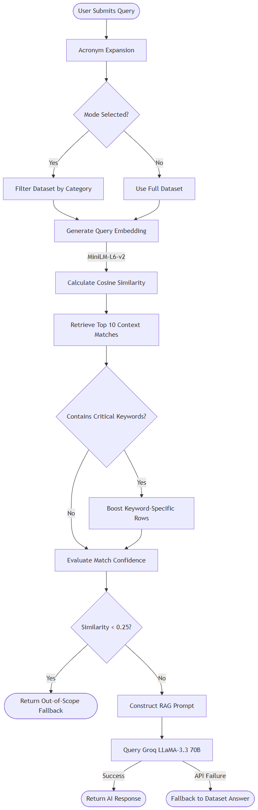

9. Implementation Evidence

API Call Screenshot
The code snippet below demonstrates the successful integration of the Generative AI API (Groq) with the backend:
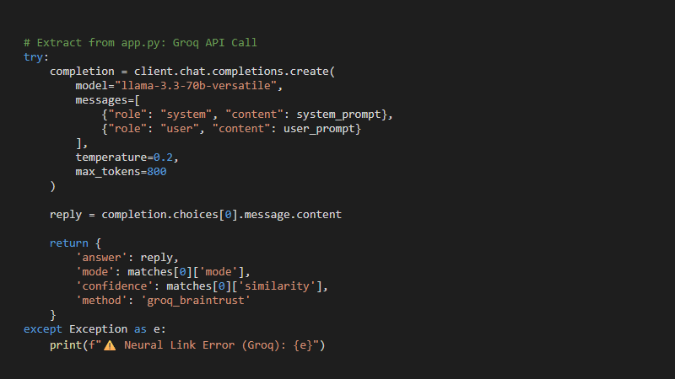

Chatbot Working Interface
The user interface features a premium Glassmorphism design handling dynamic queries:
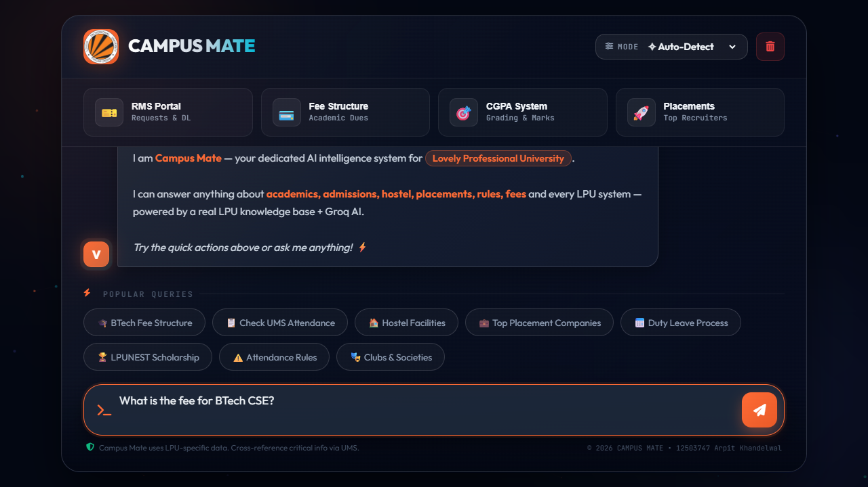

10. GitHub Repository Link
Repository URL: https://github.com/amanch0pra/campusmate

