Chatbot-Based Project Evaluation Questionnaire (INT428)
Student Name: Aman Chopra (Roll No: 59, Reg No: 12406294) & Aditya Thakur (Roll No: 26, Reg No: 12412223)
Branch & Semester: B.Tech CSE
Project Title: Campus Mate - LPU Intelligence Hub
Guide/Faculty Name: _______________________

Section A: Project Overview

Q1. Type of Chatbot Developed
[X] Hybrid (Retrieval-based + Generative LLM-based)
Note: This chatbot combines a custom Retrieval-Augmented Generation (RAG) system with a Generative LLM to provide domain-constrained responses.

Q2. Platform Used for Deployment
[X] Web Application

Q3. Deployment Link / Access Details
Deployment URL / App Link: https://vertos-saathi.onrender.com (or http://localhost:7860 locally)

Section B: Model & API Details

Q4. Type of API Used
[X] Custom REST API (Groq API)

Q5. Model Name Used
Model Name: LLaMA 3.3 Versatile via Groq API

Q6. Model Version
Model Version / Release: 70B

Section C: Context & Data Handling

Q7. Contextual Memory Usage
[X] No memory (single-turn chatbot)

Q8. Flow of Data in the Chatbot
1. UI to Backend: User enters a query in the frontend, which is sent via REST API to the Flask backend.
2. Preprocessing: The backend expands acronyms and generates a semantic embedding using SentenceTransformers (all-MiniLM-L6-v2).
3. Retrieval: Cosine similarity identifies the top 10 most relevant Q&A pairs from a 1,590+ dataset.
4. Generative AI Call: The retrieved context is bundled into a system prompt and sent to Groq LLaMA 3.3 70B.
5. Response to User: The LLM structures the response using only the provided context and returns it to the UI.

Section D: Model Configuration & Behavior

Q9. Model Parameters Used
Parameter | Value | Not Applicable
Temperature | 0.2
Top-p / Probability |  | [X]
Input Token Limit |  | [X]
Output Token Limit | 800

Q10. Thinking Level & Role Assignment
Thinking Level: [X] Intermediate (context-aware reasoning)
Role Assigned to Model: [X] Domain Expert (LPU specific assistant)

Section E: Technology Stack

Q11. Technology Stack Used
Frontend: Vanilla HTML5, CSS3 (Glassmorphism), JavaScript
Backend: Python 3.8+, Flask, Groq API
Database / Vector Store: Scikit-learn Cosine Similarity on Pickled Dataset
Cloud / Hosting: Render

Section F: Implementation Evidence (Screenshots & Code)

Q12. API Call Screenshot
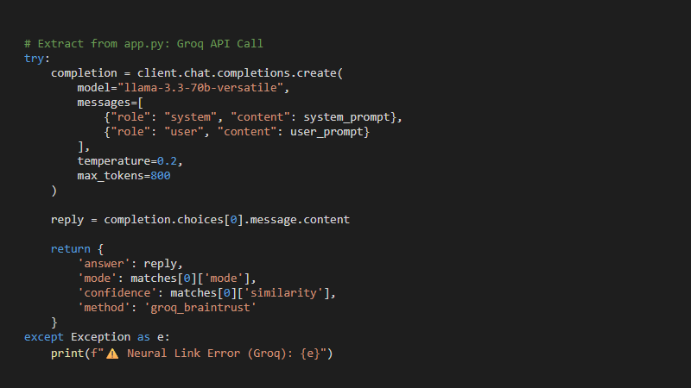

Q13. Chatbot Working Interface Screenshot
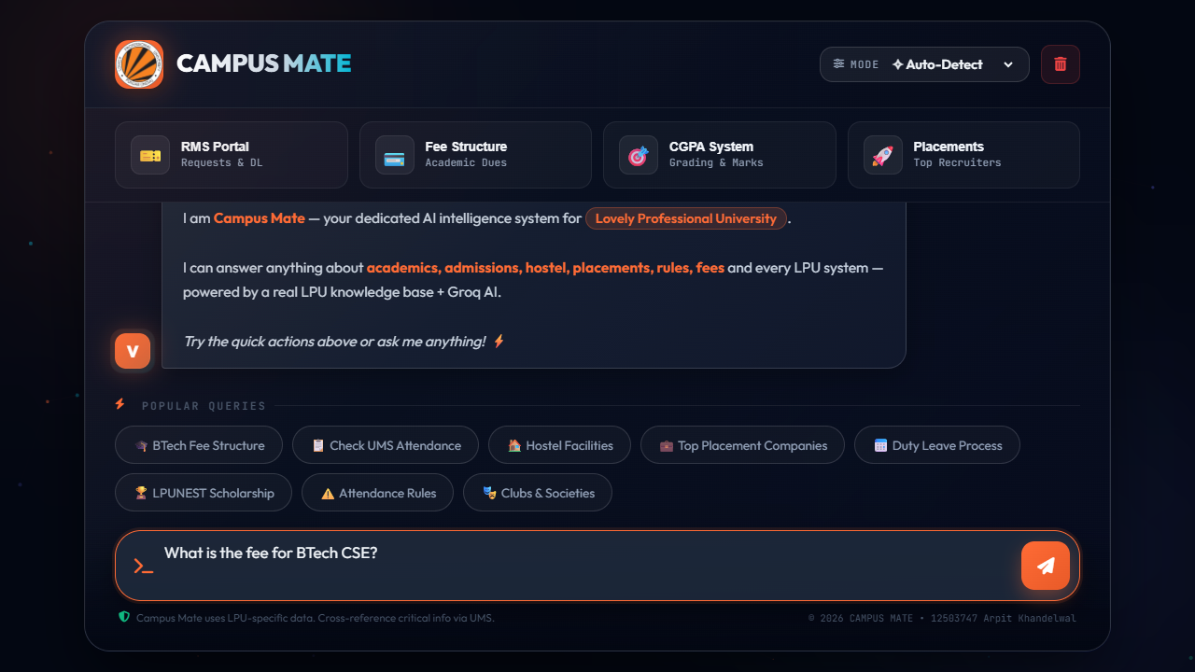

Q14. GitHub Repository Link
Repository URL: https://github.com/arpittkhandelwal/Vertos-Saathi-LPU
Declaration: I confirm that the information provided above is accurate to the best of my knowledge.
Student Signature: _______________________
Date: _______________________

