**APPENDEX 1**

**RESTAURANT WEBSITE**

**END TERM REPORT**

**BY**

**AMAN KUMAR CHAUHAN, BALIBHADRA SINGH,**

**AND YASHWANTH SAI**

**SECTION –K19FG**

**ROLL NUMBER – 29, 28, 30**



**School of Computer Science Engineering**

**Lovely Professional University, Jalandhar**

**APPENDIX 2**

**Student Declaration**

This is to declare that this report has been written by me/us. No part of the report is copied from other sources. All information included from other sources have been duly acknowledged. I/We aware that if any part of the report is found to be copied, I/we are shall take full responsibility for it.

**Name: AMAN KUMAR CHAUHAN**

**Roll no: 29**

**Name: BALIBHADRA SINGH**

**Roll no: 28**

**Name: YASHWANTH SAI**

**Roll no.30**

**APPENDIX 3**

**TABLE OF CONTENTS**

**TITLE: RESTAURANT WEBSITE**

1. **Introduction**
2. **Background of online restaurant website**
3. **Purpose**
4. **Scope of the project**
5. **Methodology**
6. **References**

**INTRODUCTION**

Online restaurant website can be used extensively on the internet for booking and ordering food online. So, we have made this webpages in order to do so. With the use of HTML5 and CSS with the help of the various group members.

**BACKGROUND OF ONLINE RESTAURANT WEBSITE**

Using the website of online restaurant business can bloom the restaurant. For that taking the restaurant online is needed. In order to do so we have created this website having many webpages to show various interaction of the person with our online restaurant service. We have used our knowledge to make it as attractive as possible using HTML5 and CSS.

**PURPOSE:**

The Traditional way of maintaining details of a user in a restaurant was to enter the details and record them. Every time the user need to perform some operation he has to go to restaurant and perform the necessary actions, which may not be so feasible all the time. It may be a hard-hitting task for the users and the workers too. The project gives real life understanding of Online restaurant System and activities performed by various roles in the supply chain. Here, we provide an automation for restaurant system through Internet. Online Restaurant System project captures activities performed by different roles in real life problems which provides enhanced techniques for maintaining the required information upto- date, which results in efficiency. The project gives real life understanding of Online restaurant website and activities performed by various roles.

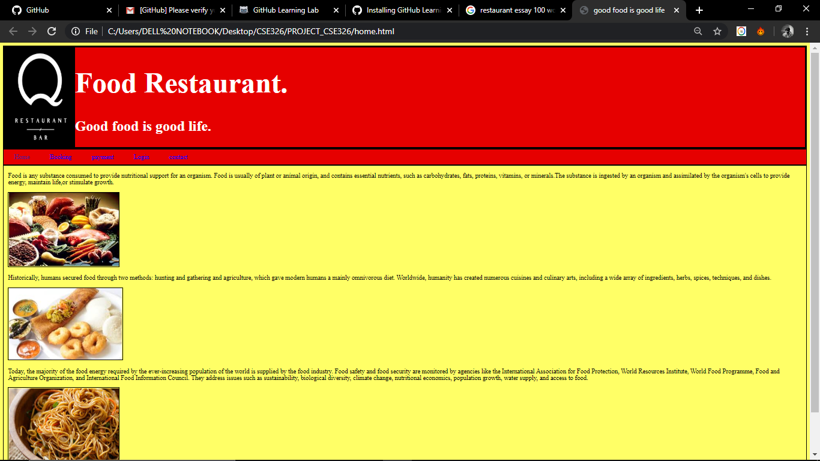

**SCOPE OF THE PROJECT:**

This Project investigates the entry threshold for providing a new transaction service, login page, interactive page channel via the real options approach, where the entry threshold is established by using an Internet restaurant webpage designed for the use of normal users(individuals) .

* Customer must have a User Id and password to login to the system

It was an interactive login page.

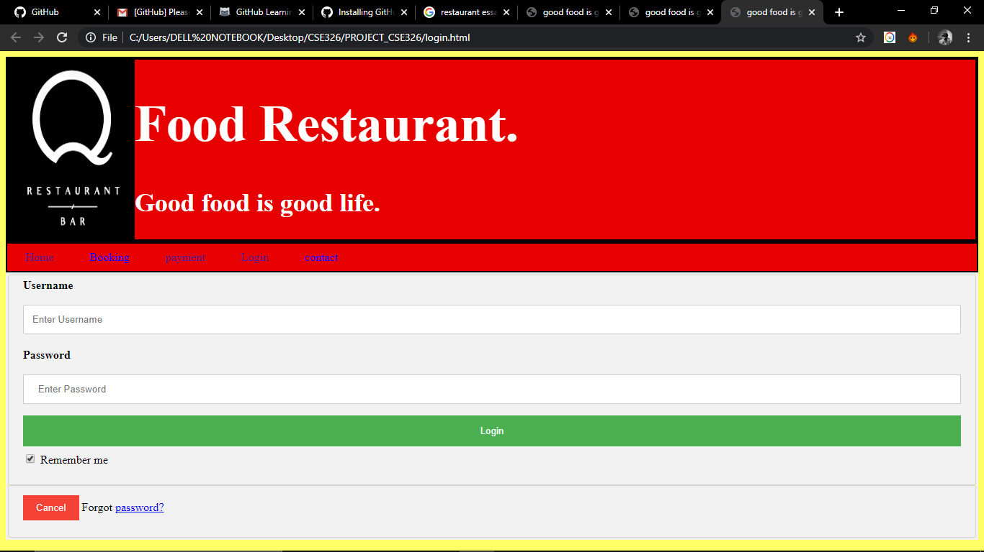

After the valid user logs in he is shown the list of dishes and foods is shown.

* User can make a payment transfer to restaurant.

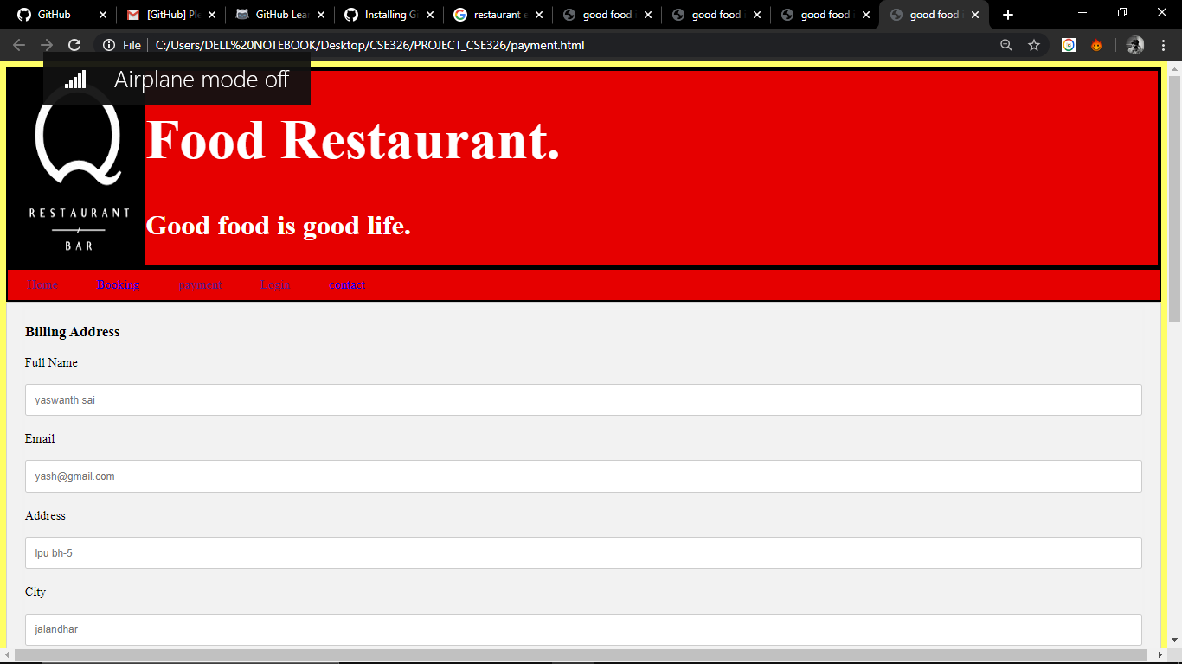

**METHODOLOGY :**

We will code for the elements differently as per the roles are mentioned above. We are going to use all type of basic html tags and attributes like ul,ol,li,div etc.We are trying to make the web page as much interactive as possible.

1. Coding for the basic structure of the page using html and CSS.

2. Styling of the written elements of html file.

3. Finally debugging the source code and rectification of bugs as per our need.

**REFERENCES:**

* [www.w3schools.com](http://www.w3schools.com)
* [www.tutorialspoint.com](http://www.tutorialspoint.com)
* www.google.com