**EVENT REPORT**

**DEBATE**

An oratory-skill event, ‘DEBATE’ was organized by ISTE (India Society for Technical Education) in collaboration with SCIE and E2S2 on April 8,2019 in Workshop Seminar Hall.

It was organized on the occasion of 63rd Foundation day of the institution.

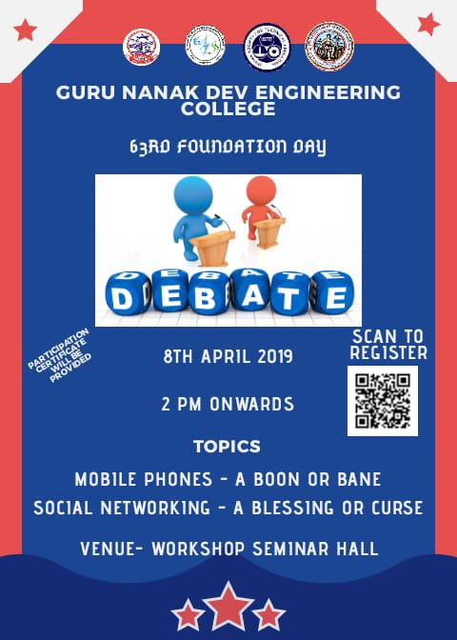

The event was mainly organized to test the critical thinking skills of the students and their presentation of thoughts. The participants were judged on the basis of their content, presentation and organization of their debate. The topics for the same were:-

1. MOBILE PHONES- A BOON OR BANE
2. SOCIAL NETWORKING - A BLESSING OR CURSE

The topics were disclosed 3 days prior to the event and the participants had to prepare either for the motion or against.

Each participant was allotted a maximum time of 3 minutes. During the course of debate, First Bell rang at 3 minutes and he/she had to windup the speech within next 30 seconds after the second ring at 3:30 min nothing was taken into account from the speech. The usage of Written Material during speech delivery was prohibited and only cue reading was allowed . There was no language barrier , participants were given the freedom to speak in either one from Hindi, English or Punjabi.

**Judging Criteria** :- Participants were judged on their :-

1)Content (Ideas, Logic & Effectiveness )

2)Presentation Style ( Delivery, Body Language)

3)Organization and Clarity ( Topic Development , Grammar , Pronunciation)

**List of Organizers:-**

|  |  |  |  |
| --- | --- | --- | --- |
| **S.NO.** | **NAME** | **YEAR/BRANCH** | **ROLL NO.** |
| 1 | Darsbir Singh | D3CSE | 1606667 |
| 2 | Karanjot Singh | D3IT | 1607109 |
| 3 | Arshdeep Kaur | D1CSE | 1805161 |
| 4 | Guneet Kohli | D1CSE | 1805172 |
| 5 | Sandeep | D2EE | 1805365 |
| 6 | Mayank Bakshi | D2EE | 1819955 |
| 7 | Ashutosh | D1CSE | 1805165 |
| 8 | Priyanka | D1EE | 1805321 |
| 9 | Divneet Kaur | D1CSE | 1805169 |

**Winners:-**

|  |  |  |  |
| --- | --- | --- | --- |
| **S.NO.** | **NAME** | **YEAR/BRANCH** | **ROLL NO.** |
| 1 | Maanvi Sharma | D3EE | 1706690 |
| 2 | Harnoor Singh | D1ECE | 1805402 |
| 3 | Achintya Tripathi | D2CSE | 1706390 |

**Some Glimpses of the event:-**

