**JOB RECOMMENDOR SYSTEM**

**STEPS –**

1. **Create Database**
   1. Made a company.csv file containing details – job id , job name, company name, skill
   2. Made a unique-skills.csv file from above, containing unqiue skills .
   3. Made a worked.csv file containing information about which user has worked in which all companies, having a particular skill-set.
   4. Made a aman-rating.csv containing information for which user has which skill.
2. **Extracted skill-set from resume**
   1. Extracted required text from Resume.pdf .
   2. Made tobeRelated.csv for storing his skills.
3. **Get the similar users** 
   1. Created 2-d matrix of form (users,skills) from aman-rating.csv .
   2. To find similar users , we have various algorithms – like Pearson Correlation , Jaccard Similarity and Cosine Similarity

Pearson Correlation =

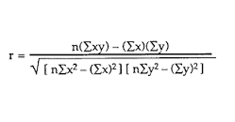

Jaccard Similarity =

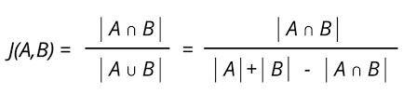

Cosine Similarity = 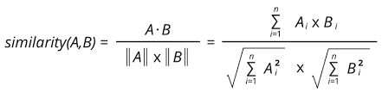

We find the best similarity among the 3 values => having least RMSE ( Root Mean Square Error ) value.

* 1. Using the above similarity method , we find the top 10 most similar users for the given resume.