**About Project:**

This project is a combination of e commerce website and a portfolio. In this project I made a website for a start-up named Power Technologies.

This site does the same work as of the Affiliate marketing site, but not for the sake of commission or earning money, instead helping the customer to get true views and good product in valid price. In our site we will include those site which are well licensed and well known for their product so that customer do not feel cheated or fooled.

This site also include our IT team name and Services they provide with their contact details.

**Aim of Project:**

Help People to know about company.

Help People to buy a product at best price from a genuine seller.

Help people to get services at reasonable price.

Help IT people to provide their services for income or as a social worker.

**Overview of Online Shopping**

****The central concept of the application is to allow the customer to shop virtually using the Internet and allow customers to buy the items and articles of their desire from the store. The information pertaining to the products are stores on an RDBMS at the server side (store). The Server process the customers and the items are shipped to the address submitted by them. The application was designed into two modules first Os for the customers who wish to buy the articles. Second is for the storekeepers who maintains and updates the information pertaining to the articles and those of the customers? The end user of this product is a departmental store where the application is hosted on the web and the administrator maintains the database. The application which is deployed at the customer database, the details of the items are brought forward from the database for the customer view based on the selection through the menu and the database of all the products are updated at the end of each transaction. Data entry into the application can be done through various screens designed for various levels of users. Once the authorized personnel feed the relevant data into the system, several reports could be generated as per the security.

**E-Shopping**

[Online shopping](http://en.wikipedia.org/wiki/Online_shopping) is a form of electronic commerce where the buyer is directly online to the seller's computer usually via the internet. There is no intermediary service. The sale and purchase transaction is completed electronically and interactively in real-time such as Amazon.com for new books. If an intermediary is present, then the sale and purchase transaction is called electronic commerce such as [eBay.com](http://en.wikipedia.org/wiki/EBay.com).

**Number of Modules**

The system after careful analysis has been identified to be presented with the following modules:

1. Customer.
2. Admin Module.
3. Security and Authentication

**Software Requirements**

Operating System : Windows XP/7/8/8.1/10 or Linux

User Interface : HTML, CSS, Bootstrap

Server-side Scripting : PHP Script

Client-side-Scripting : Java Script

Programming Language : PHP

Web Applications : Xampp Server

Database : MySQL

Server Deployment : Apache

Hardware Requirements

Processor : Pentium IV

Hard Disk : 40GB

RAM : 512MB or more

**CONTEXT LEVEL DATA FLOW DIAGRAM**

SELLER

BUYER

**Data flow Diagram**

* A data flow diagram (DFD) is a graphical representation of the "flow" of data through an information system.



**Advantages:**

1. **It simplifies the operation.**
2. **It avoids a lot of manual work.**
3. **Avoids errors by avoiding the manual work.**
4. **User friendly screen to enter the data and enquire the database tables.**
5. **User can easily access the system without much experience.**
6. **Provide hardware and software securities.**
7. **Portable and flexible for further extensions.**

**Introduction of E-Commerce Website**

Electronic Commerce is also known as e-commerce that consists of the purchasing and selling of products or services through electronic systems like computer networks and the Internet. In this modern world of technology, e-commerce is becoming a very significant option for many businesses as there are lots of companies that are interested in [developing their online stores](http://www.perceptionsystem.com/e-commerce-application-development.html).

With increasing demand for online purchasing, more and more businesses are moving to e-store from brick and mortar stores. In the US, more than 60% of people are purchasing goods online from the comfort of their home and this figure is increasing constantly. By considering this percentage, we can say that e-commerce is expanding tremendously because of its complete range of benefits that any industry vertical can enjoy.

Today, e-Commerce has revolutionized the way companies are doing business. Now, consumers can purchase almost anything online 24*7 a day and get an ultimate shopping experience. Before you opt for an e-Commerce business, have a look on its comprehensive benefits that you can enjoy:

1. **Convenience & Easiness:**
2. **Offer Product Datasheets:**
3. **Attract New Customers with Search Engine Visibility:**
4. **Comprise Warranty Information:**
5. **Decreasing cost of inventory Management:**
6. **Keep Eye on Consumers’ Buying Habit:**
7. **Competence:**
8. **Allow Happy Customers to Sell Your Products:**
9. **Selling Products Across the World:**
10. **Stay open 24*7/365:**
11. **Economy:**
12. **Boost Brand Awareness:**
13. **Decrease Costs:**

* **Advertising & Marketing Cost**
* **Personnel**
* **Eliminate Travel Cost**
* **Offer Huge Information**

1. **Analytics:**
2. **Expand Market for Niche Products:**
3. **Scalability:**
4. **Ability of Multi-site:**

**Website Pages:**

**Source Code of Home Page:**

<?php

include("functions/functions.php");

include("includes/db.php");

cart();

?>

<!DOCTYPE html PUBLIC "-//W3C//DTD XHTML 1.0 Transitional//EN" "http://www.w3.org/TR/xhtml1/DTD/xhtml1-transitional.dtd">

<?php

include("header.php");

?>

<!-- end of menu tab -->

<div class="crumb_navigation"> Navigation: <span class="current">Home</span>

<?php

if(isset($_GET['cat'])){

$get_id = $_GET['cat'];

$query = "select cat_title from categories where cat_id='$get_id'";

$run_query = mysqli_query($con,$query);

$row = mysqli_fetch_array($run_query);

$cat = $row['cat_title'];

echo"<span class=current>>$cat</span>"

}

?>

</div>

<div class="left_content">

<div class="title_box">Categories</div>

<ul class="left_menu">

<?php

getcats();

?>

</ul>

<div class="title_box">Manufacturers</div>

<ul class="left_menu">

<?php getbrands(); ?>

</ul>

<br>

<br>

<div class="banner_adds"> <a href="#"><img src="images/bann2.jpg" alt="" border="0" /></a> </div>

<br>

<br>

<br>

<?php

special();

?>

</div>

<!-- end of left content -->

<div class="center_content">

<div class="center_title_bar">Latest Products</div>

<?php

getpro();

get_pro_cat();

get_pro_brand();

?>

<div class="center_title_bar">Recommended Products</div>

<?php getpro3(); ?>

</div>

<!-- end of center content -->

<div class="right_content">

<div class="shopping_cart">

<div class="cart_title"><i>Welcome Guest!</i><br>Shopping cart</div>

<div class="cart_details"><font color="blue"><?php total_items(); ?></font>&nbsp;item(s) <br />

<span class="border_cart"></span> Total:<span class="price"><?php total_price(); ?> </span> </div>

<div class="cart_icon"><a href="cart.php" title="header=[Checkout] body=[&nbsp;] fade=[on]"><img src="images/shoppingcart.png" alt="" width="48" height="48" border="0" /></a></div>

</div>

<br>

<?php

special();

?>

<br>

<?php

special();

?>

<br>

<?php

special();

?>

<br>

<?php

special();

?>

<!-- end of right content -->

</div>

<!-- end of main content -->

<?php

include("footer.php");

?>

</div>

<!-- end of main_container -->

</body>

</html>

**Output:**

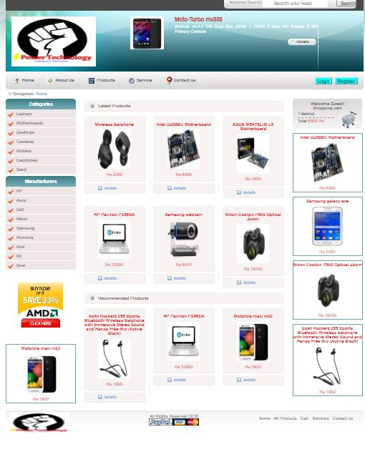

**Source Code of About Us:**

<?php

include("functions/functions.php");

include("includes/db.php");

cart();

?>

<!DOCTYPE html PUBLIC "-//W3C//DTD XHTML 1.0 Transitional//EN" "http://www.w3.org/TR/xhtml1/DTD/xhtml1-transitional.dtd">

<?php

include("header.php");

?>

<!doctype html>

<html>

<head>

<title>About Us</title>

<link rel="stylesheet" type="text/css" href="css/reset.css">

<link href="https://fonts.googleapis.com/css?family=Raleway" rel="stylesheet">

<link rel="stylesheet" type="text/css" href="css/styles.css">

<style>

div.a {

text-align: center;

text-decoration-color: black;

}

</style>

</head>

<body>

<section id="hero">

<h2>Aman Chhabra</h2>

<img src="images/photo.jpg" alt="hero"/>

<a href="port/index.html" target="_blank" class="btn">About me</a>

</section>

<header>

<div class="a">

<h2 style="color:black;font-family: 'Sigmar One', cursive;font-size:50px;">Our Team </p></h2>

</header>

<br>

<section class="content">

<article class="three-col" id="how">

<h3>Head of Graphic Department</h3>

<img src="images/gochu.jpg" alt="first image"/>

<p>

Deepanshu

</p>

<a href="www.github.com" class="btn">Biodata</a>

</article>

<article class="three-col" id="what">

<h3>Head of Android Department</h3>

<img src="images/mustaq.jpg" alt="second image"/>

<p>

Mustaaq

</p>

<a href="https://mmstq.github.io/" class="btn">Biodata</a>

</article>

<article class="three-col" id="facts">

<h3>Head of Security Department</h3>

<img src="images/pic1.jpg" alt="third image"/>

<p>

Aman Chhabra

</p>

<a href="port/index.html " class="btn">Biodata</a>

</article>

<article class="three-col" id="how">

<h3>Head of Networking Department</h3>

<img src="images/dp1.jpg" alt="first image"/>

<p>

Prateek

</p>

<a href="#" class="btn">Biodata</a>

</article>

<article class="three-col" id="how">

<h3>Head of Website Department</h3>

<img src="images/dp2.png" alt="first image"/>

<p>

Madhav

</p>

<a href="#" class="btn">Biodata</a>

</article>

<article class="three-col" id="how">

<h3>Head of Database Department</h3>

<img src="images/dp3.jpg" alt="first image"/>

<p>

Akshay Kumar

</p>

<a href="#" class="btn">Biodata</a>

</article>

<article class="three-col" id="how">

<h3>Head of Software Department</h3>

<img src="images/dp4.jpg" alt="first image"/>

<p>

Vishal

</p>

<a href="#" class="btn">Biodata</a>

</article>

<article class="three-col" id="how">

<h3>Head of SEO and SMO Department</h3>

<img src=" images/dp5.jpg" alt="first image"/>

<p>

Sanjay

</p>

<a href="#" class="btn">Biodata</a>

</article>

<article class="three-col" id="how">

<h3>Head of IOT Department</h3>

<img src="images/dp6.jpg" alt="first image"/>

<p>

Kartavya

</p>

<a href="#" class="btn">Biodata</a>

</article>

<article class="three-col" id="how">

<h3>Head of AI and ML Department</h3>

<img src=" images/dp1.jpg" alt="first image"/>

<p>

Ashish

</p>

<a href="#" class="btn">Biodata</a>

</article>

<article class="three-col" id="how">

<h3>Head of Cloud Computing Department</h3>

<img src="images/dp2.png" alt="first image"/>

<p>

Kunal

</p>

<a href="#" class="btn">Biodata</a>

</article>

<article class="three-col" id="how">

<h3>Head of Home Automation Department</h3>

<img src="images/dp3.jpg" alt="first image"/>

<p>

Mohit

</p>

<a href="#" class="btn">Biodata</a>

</article>

<article class="three-col" id="how">

<h3>Head of Customer Support Department</h3>

<img src=" images/vanshaj.JPG" alt="first image"/>

<p>

Vanshaj

</p>

<a href="https://www.facebook.com/vanshaj.sharma.359" class="btn">Biodata</a>

</article>

</section>

<footer>

<ul>

<li><img src="images/facebook.svg"/></li>

<li><img src="images/twitter.svg"/></li>

<li><img src="images/instagram.svg"/></li>

<li><img src="images/linkedin.svg"/></li>

</ul>

<?php

include("footer.php");

?>

</footer>

</body>

</html>

**Output:**

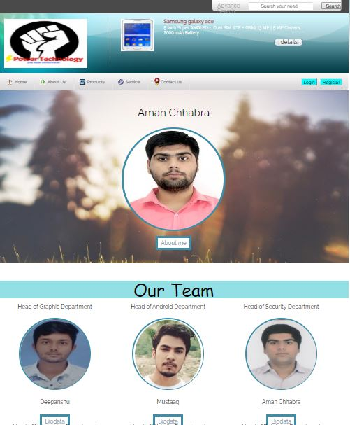

**Source Code of Services:**

<?php

include("functions/functions.php");

include("includes/db.php");

?>

<!DOCTYPE html PUBLIC "-//W3C//DTD XHTML 1.0 Transitional//EN" "http://www.w3.org/TR/xhtml1/DTD/xhtml1-transitional.dtd">

<?php

include("header.php");

cart();

?>

<!-- end of menu tab -->

<div class="crumb_navigation"> Navigation: <span class="current">Home</span>

<?php

if(isset($_GET['cat'])){

$get_id = $_GET['cat'];

$query = "select cat_title from categories where cat_id='$get_id'";

$run_query = mysqli_query($con,$query);

$row = mysqli_fetch_array($run_query);

$cat = $row['cat_title'];

echo"<span class=current>>$cat</span>";

}

?>

</div>

<div class="left_content">

<div class="title_box">Categories</div>

<ul class="left_menu">

<?php

getcats();

?>

</ul>

<div class="title_box">Manufacturers</div>

<ul class="left_menu">

<?php getbrands(); ?>

</ul>

<br>

<br>

<div class="banner_adds"> <a href="#"><img src="images/bann2.jpg" alt="" border="0" /></a> </div>

<br>

<br>

<br>

<?php

special();

?>

</div>

<!-- end of left content -->

<div class="center_content">

<div class="center_title_bar">Service</div>

<table class="table">

<tr class='tr'>

<th class="title_box">NAME:</th>

<th class="title_box">SERVICE:</th>

<th class="title_box">MOBILE NO:</th>

</tr>

<tr class='tr'>

<th>Power Technologies</th><th>Cloud Computing</th><th> 8076626714,<br>8766269191,<br></th>

</tr><tr class='tr'>

<th>Power Technologies</th><th>Robotics</th><th> 8076626714,<br>8766269191,<br></th>

</tr>

<tr class='tr'>

<th>Power Technologies</th><th>Web Development</th><th> 8076626714,<br>8766269191,<br></th>

</tr>

<tr class='tr'>

<th>Power Technologies</th><th>Networking</th><th> 8076626714,<br>8766269191,<br></th>

</tr>

</table>

<br>

</div>

<!-- end of center content -->

<div class="right_content">

<div class="shopping_cart">

<div class="cart_title"><i>Welcome Guest!</i><br>Shopping cart</div>

<div class="cart_details"><font color="blue"><?php total_items(); ?></font>&nbsp;item(s)<br />

<span class="border_cart"></span> Total: <span class="price"><?php total_price(); ?></span> </div>

<div class="cart_icon"><a href="cart.php" title="header=[Checkout] body=[&nbsp;] fade=[on]"><img src="images/shoppingcart.png" alt="" width="48" height="48" border="0" /></a></div>

</div>

<br>

<?php

special();

?>

<br>

<?php

special();

?>

<br>

<?php

special();

?>

<br>

<?php

special();

?>

<!-- end of right content -->

</div>

<!-- end of main content -->

<div class="footer">

<div class="left_footer"> <img src="images/footer_logo.png" alt="" width="170" height="49"/> </div>

<div class="center_footer"> All Rights Reserved 2016<br />

<img src="images/payment.gif" alt="" /> </div>

</div>

</div>

<!-- end of main_container -->

</body>

</html>

**Output:**

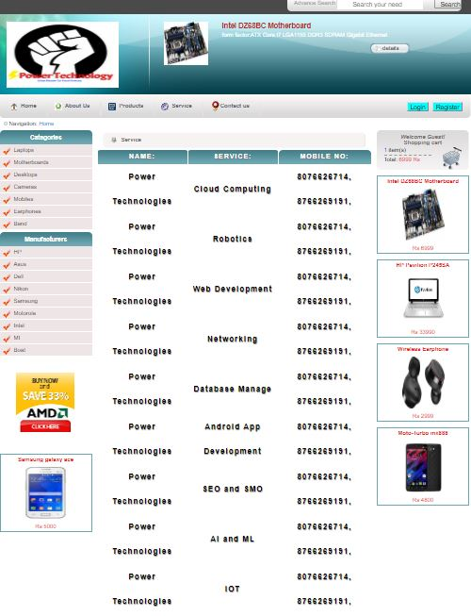

**Source Code of Products:**

<?php

include("functions/functions.php");

include("includes/db.php");

?>

<!DOCTYPE html PUBLIC "-//W3C//DTD XHTML 1.0 Transitional//EN" "http://www.w3.org/TR/xhtml1/DTD/xhtml1-transitional.dtd">

<?php

include("header.php");

cart();

?>

<!-- end of menu tab -->

<div class="crumb_navigation"> Navigation: <span class="current">Home</span>

<?php

if(isset($_GET['cat']))

$get_id = $_GET['cat'];

$query = "select cat_title from categories where cat_id='$get_id'";

$run_query = mysqli_query($con,$query)

$row = mysqli_fetch_array($run_query);

$cat = $row['cat_title']

echo"<span class=current>>$cat</span>";

}

?>

</div>

<div class="left_content">

<div class="title_box">Categories</div>

<ul class="left_menu">

<?php

getcats();

?>

</ul>

<div class="title_box">Manufacturers</div>

<ul class="left_menu"

<?php getbrands(); ?>

</ul>

<br>

<br>

<div class="banner_adds"> <a href="#"><img src="images/bann2.jpg" alt="" border="0" /></a> </div>

<br>

<br>

<br>

<?php

special();

?>

</div>

<!-- end of left content -->

<div class="center_content">

<div class="center_title_bar">All Products</div>

<?php

$get_pro = "select * from products";

$run_pro = mysqli_query($con,$get_pro);

while($row_pro = mysqli_fetch_array($run_pro)){

$product_id = $row_pro['prd_id'];

$product_category = $row_pro['prd_cat'];

$product_brand = $row_pro['prd_brand'];

$product_title = $row_pro['prd_title'];

$product_desc = $row_pro['prd_desc'];

$product_price = $row_pro['prd_price'];

$product_image = $row_pro['prd_img'];

if(isset($_SESSION['u_id'])){

<div class='center_title_bar'>$product_title</div>

<div class='prod_box_big'>

<div class='top_prod_box_big'></div>

<div class='center_prod_box_big'>

<div class='product_img_big'> <a href='javascript:popImage('admin_area/product_images/$product_image','Some Title')' title='header=[<img src=admin_area/product_images/$product_image>] body=[&nbsp;] fade=[on]'><img src='admin_area/product_images/$product_image' height=200 width=185 alt='' border='0' /></a>

</div>

<div class='details_big_box'>

<div class='product_title_big'>$product_title</div>

<div class='specifications'>

$product_description

</div>

<div class='prod_price_big'> <span class='price'>Rs $product_price</span></div>

<a href='details.php?addcart=$product_id' class='addtocart'>add to cart</a> <a href='index.php' class='compare'>Home</a> </div>

</div>

<div class='bottom_prod_box_big'></div>

</div>";

}

else{

echo

<div class='center_title_bar'>$product_title</div>

<div class='prod_box_big'>

<div class='top_prod_box_big'></div>

<div class='center_prod_box_big'>

<div class='product_img_big'> <a href='javascript:popImage('admin_area/product_images/$product_image','Some Title')' title='header=[<img src=admin_area/product_images/$product_image>] body=[&nbsp;] fade=[on]'><img src='admin_area/product_images/$product_image' height=200 width=185 alt='' border='0' /></a>

</div>

<div class='details_big_box'>

<div class='product_title_big'>$product_title</div>

<div class='specifications'>$product_desc</di

<div class='prod_price_big'> <span class='price'>Rs $product_price</span></div>

<a href='index.php' class='compare'>Home</a> </div>

</div>

<div class='bottom_prod_box_big'></div>

</div> ";

}

?>

</div>

<!-- end of center content -->

<div class="right_content">

<div class="shopping_cart">

<div class="cart_title"><i>Welcome Guest!</i><br>Shopping cart</div>

<div class="cart_details"><font color="blue"><?php total_items(); ?></font>&nbsp;item(s)<br />

<span class="border_cart"></span> Total: <span class="price"><?php total_price(); ?></span> </div>

<div class="cart_icon"><a href="cart.php" title="header=[Checkout] body=[&nbsp;] fade=[on]"><img src="images/shoppingcart.png" alt="" width="48" height="48" border="0" /></a></div>

</div>

<br>

<?php

special();

?>

<br>

<?php

special();

?>

<br>

<?php

special();

?>

<br>

<?php

special();

?>

<!-- end of right content -->

</div>

<!-- end of main content -->

<?php

include("footer.php");

?>

</div>

<!-- end of main_container -->

</body>

</html>

**Output:**

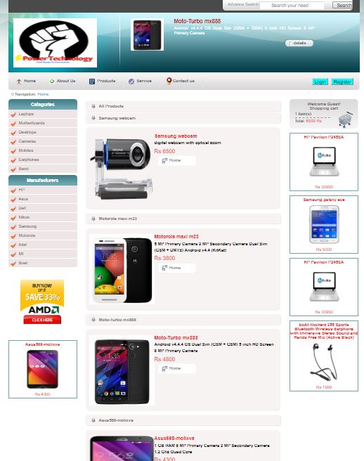

**Source Code of Contact Us:**

<?php

include("functions/functions.php");

include("includes/db.php");

?>

<!DOCTYPE html PUBLIC "-//W3C//DTD XHTML 1.0 Transitional//EN" "http://www.w3.org/TR/xhtml1/DTD/xhtml1-transitional.dtd">

<?php

include("header.php");

?>

<!-- end of menu tab -->

<div class="crumb_navigation"> Navigation: <span class="current">Home</span

<?php

if(isset($_GET['cat'])){

$get_id = $_GET['cat'];

$query = "select cat_title from categories where cat_id='$get_id'";

$run_query = mysqli_query($con,$query);

$row = mysqli_fetch_array($run_query);

$cat = $row['cat_title'];

echo"<span class=current>>$cat</span>";

}

?>

</div>

<div class="left_content">

<div class="title_box">Categories</div>

<ul class="left_menu">

<?php

getcats();

?>

</ul>

<div class="title_box">Manufacturers</div>

<ul class="left_menu">

<?php getbrands(); ?>

</ul>

<br>

<br>

<div class="banner_adds"> <a href="#"><img src="images/bann2.jpg" alt="" border="0" /></a> </div>

<br>

<br>

<br>

<?php

special();

?>

</div>

<!-- end of left content -->

<div class="center_content">

<div class="center_title_bar">About Us</div>

<br>

<div class="about_info">

<p>This site does the same work as of the Affiliate marketing site, but not for the sake of commission or earning money, instead helping the customer to get true views and good product in valid price. In our site we will include those site which are well licensed and well known for their product so that customer do not feel cheated or fooled. The site will show only true reviews given by the registered person or customer to our site, so that fake reviews are avoided. We will provide long term services for a product brought by a site preferred by us to the customer, even if the warranty of the product is expired, we will help the customer to get it repaired or updated with the applicable charges. It will compare the shopping site including their prices, availability of product, etc and give first preference to the best one by considering all points. Through our site no extra charges will be applied . If the customer register for notifying availability of product, he/she will be notified on their mobile number rather than e-mail.</p>

</div>

<br>

<br>

<div class="center_title_bar"><b><u>Contact Us</b></u></div>

<br>

<div class="contact_info"><p> If you have any query related to any Products,Services and have any complain feel free to contact us.</p>

</div>

<div class="center_title_bar"> Email: powertechnologies99@gmail.com </div>

<div class="center_title_bar"> Phone: 8766209191</div>

<img src="images/cont.jpg"alt="" border="0" width="570" height="500"/>

</div>

<!-- end of center content -->

<div class="right_content">

<div class="shopping_cart">

<div class="cart_title"><i>Welcome Guest!</i><br>Shopping cart</div>

<div class="cart_details"><font color="blue"><?php total_items(); ?></font>&nbsp;item(s)<br />

<span class="border_cart"></span> Total: <span class="price"><?php total_price(); ?></span> </div>

<div class="cart_icon"><a href="cart.php" title="header=[Checkout] body=[&nbsp;] fade=[on]"><img src="images/shoppingcart.png" alt="" width="48" height="48" border="0" /></a></div>

</div>

<br>

<?php

special();

?>

<br>

<?php

special();

?>

<br>

<?php

special();

?>

<br>

<?php

special();

?>

<!-- end of right content -->

</div>

<?php

include("footer.php");

?>

</div>

<!-- end of main_container -->

</body>

</html>

**Output:**

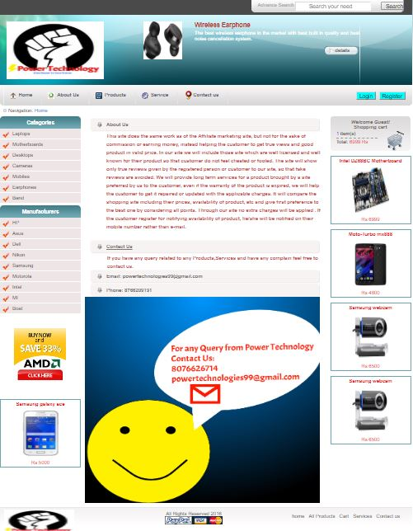

**Admin Login:**

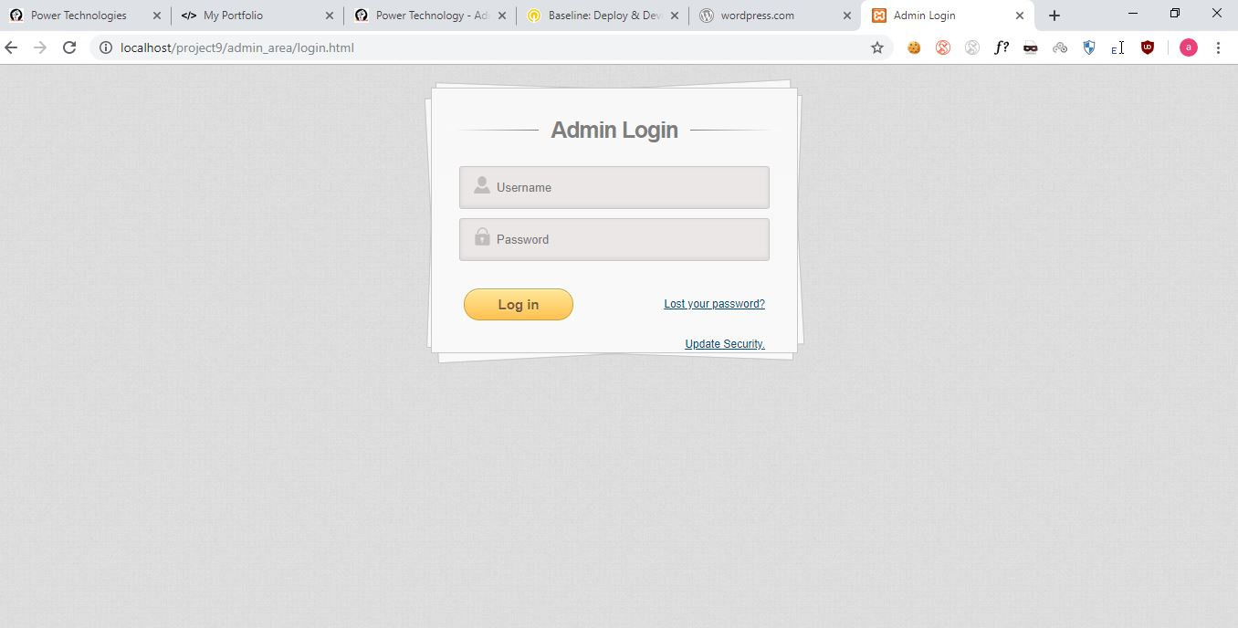

**Admin Insert Product:**

