1. Ensure that Ansible package is installed on the control node and also Python installed in master and client nodes.
a. Create a static inventory file called /home/student/ansible/cert-inventory as follows:
- node1 is a member of the dev group.
- node2 is a member of the test group.
- node1 is a member of the prod group.
- The prod group is a member of the webservers group.
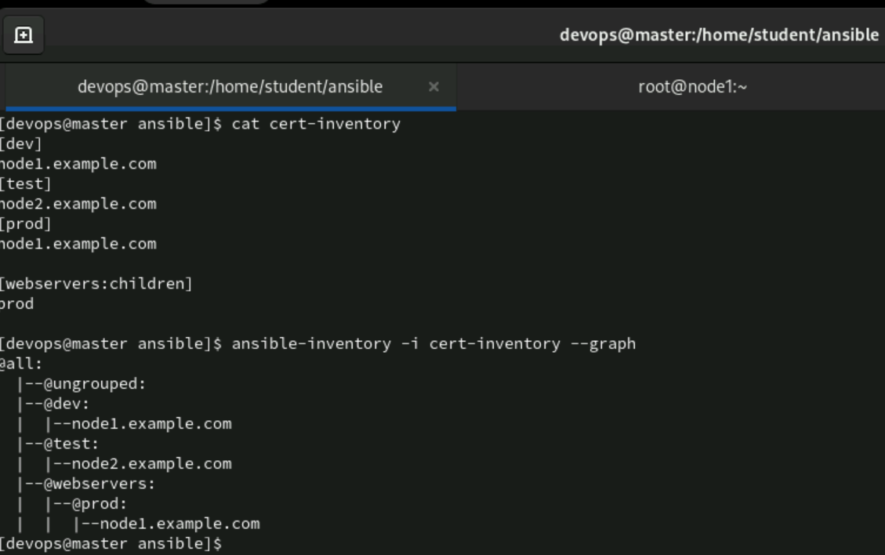

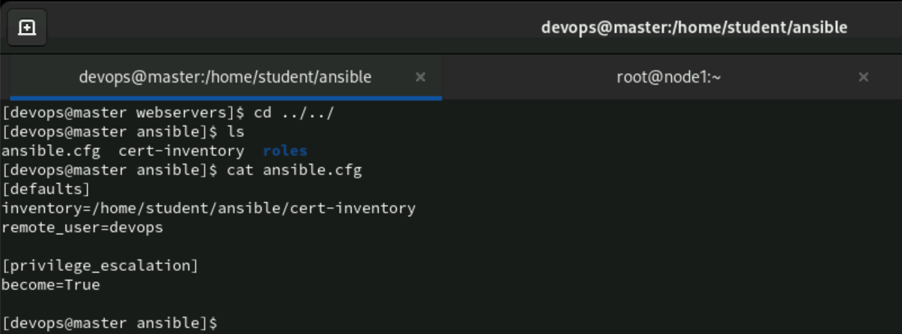

b. Create a configuration file called ansible.cfg as follows:
- The host inventory file /home/student/ansible/cert-inventory is defined.
- The location of roles used in playbooks is defined as /home/student/ansible/roles.
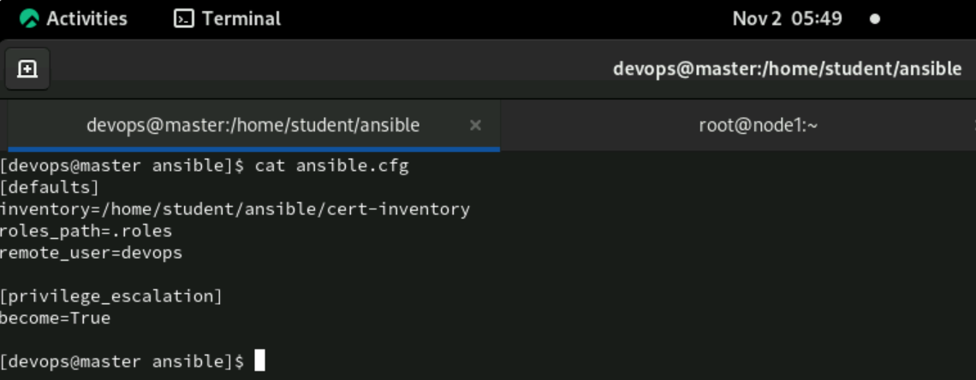

2. Using Ansible Ad-hoc Commands
a. Using an ad-hoc command, create a user on the dev group named auto-user with the following requirements:
- UID: 2050
- Comment: devops engineer
- Shell: /bin/sh
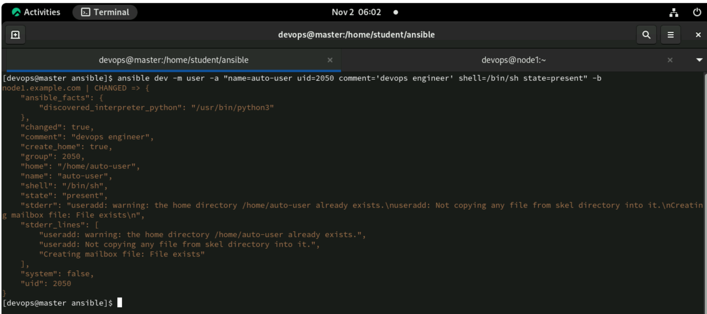
b. Using an ad-hoc command, install the 64-bit package dialog on the test host.
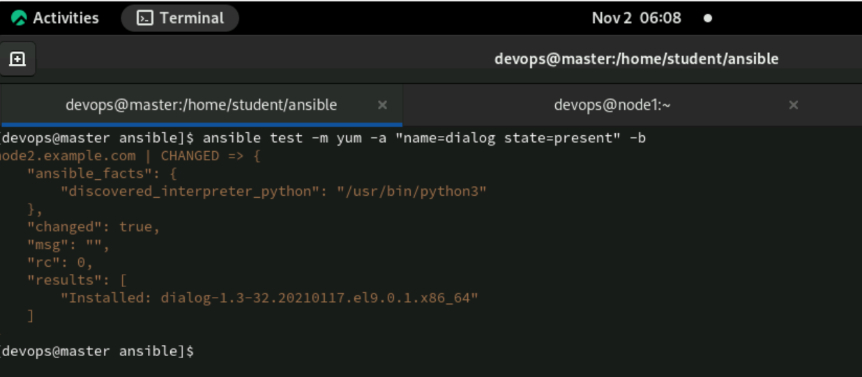
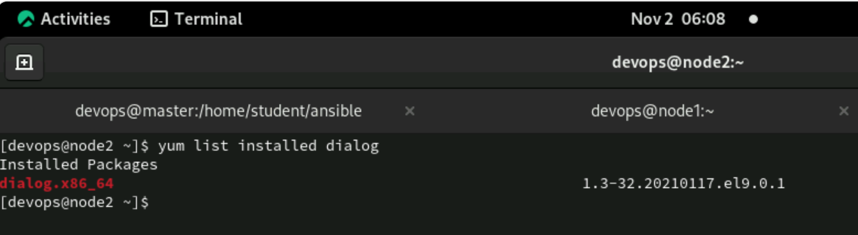

3. Create a Simple Playbook
Create a simple playbook named simpleplay.yml. It should create 5 users on both nodes in the prod group with the following requirements.
Hint: Use listofhash.
- Name: ex-user1, ex-user2, ex-user3, ex-user4, ex-user5
- UID: From 2100 to 2104
- Comment: For all the 5 users, it should be Infra-user.
- Password: redhat123 (should be encrypted with SHA512) for all the users.
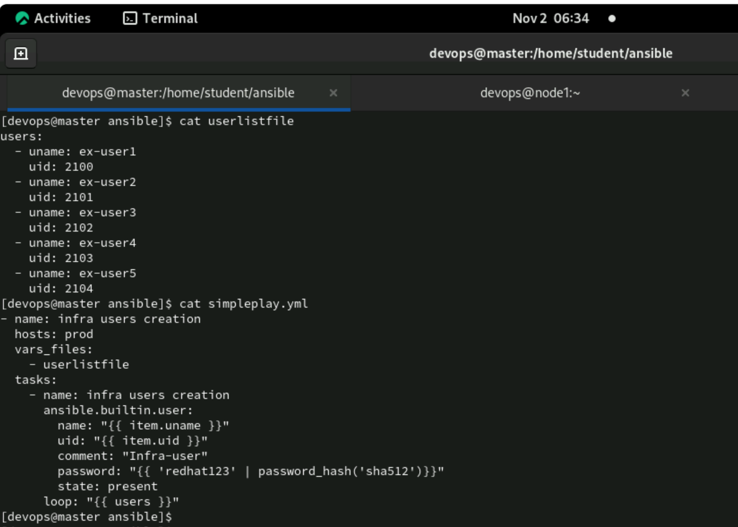

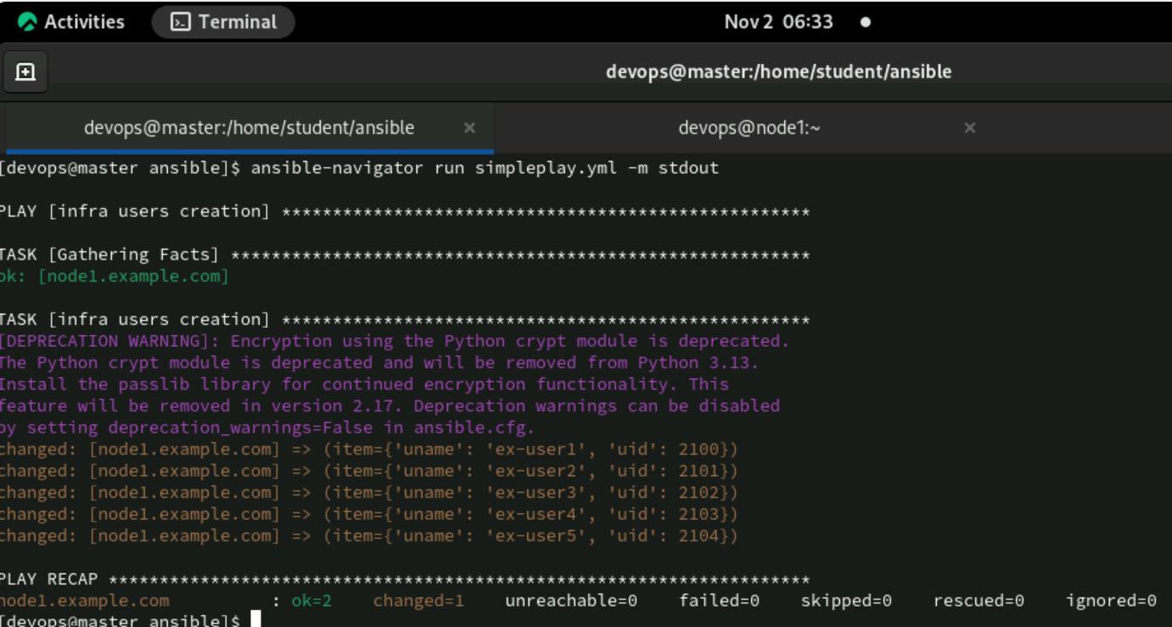
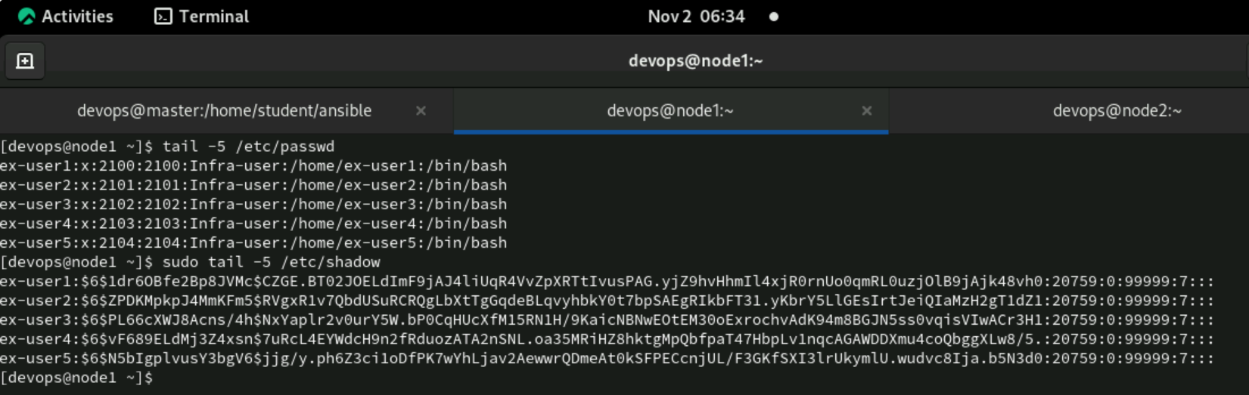
4. Create an HTTPD Playbook
Create a playbook named httpd.yml so that the package httpd should be installed on both nodes.
Follow the below instructions while installing:
- Sample configuration file named httpd.conf should be copied to /mnt/httpd.conf on managed hosts.
- Firewall should be installed along with the httpd package.
- Firewall should allow HTTP protocol permanently.
- The service should be enabled and started permanently.
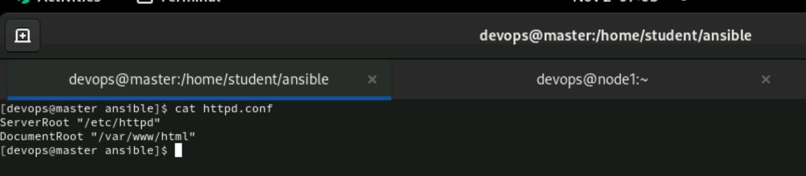
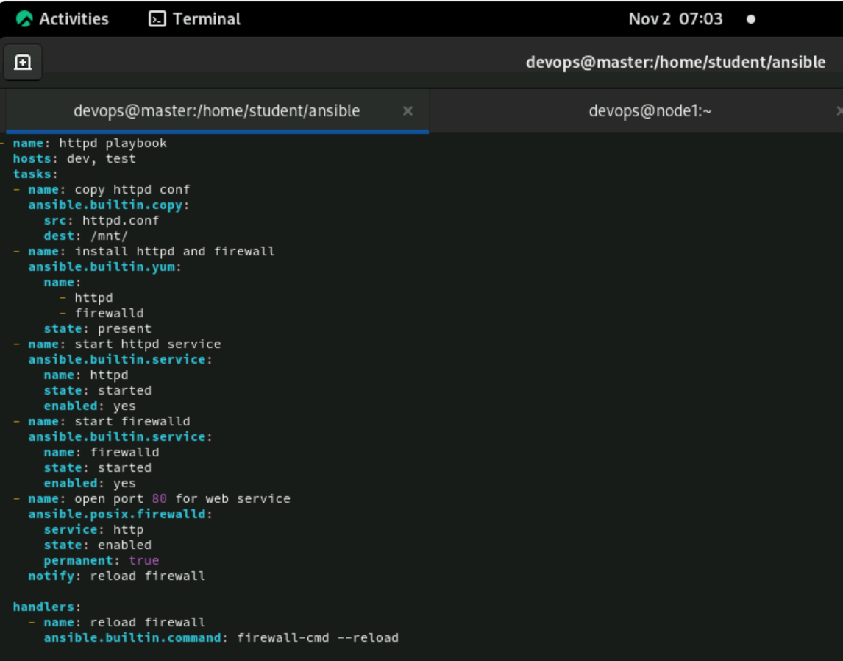
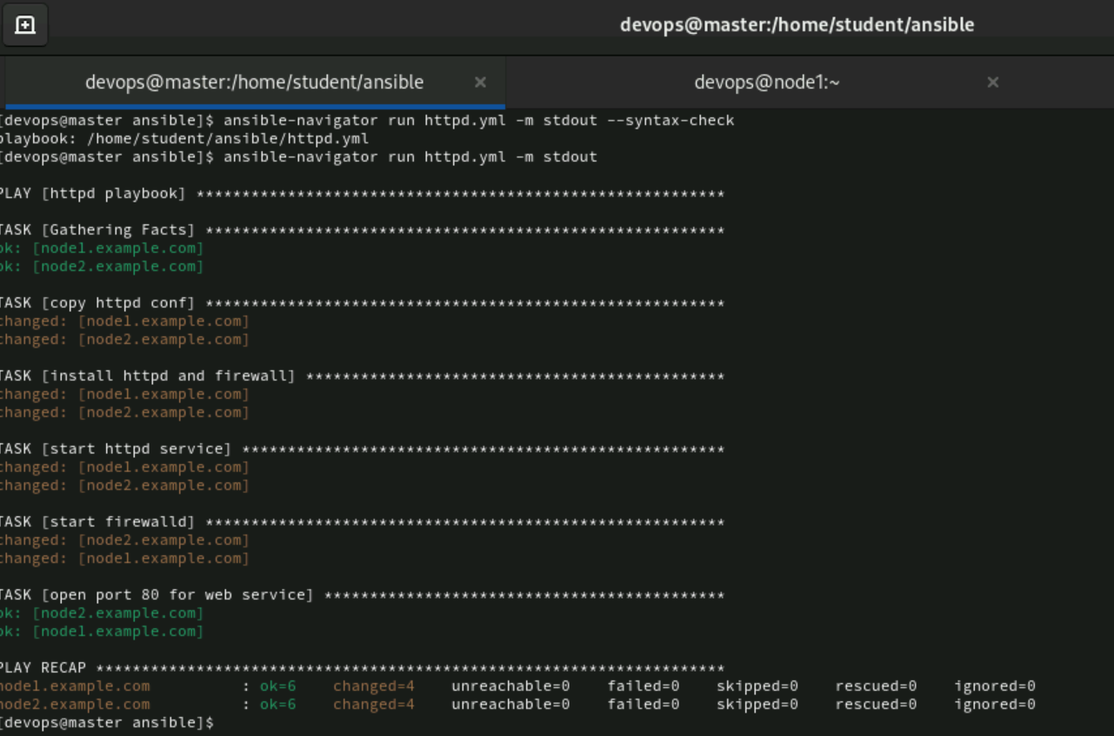
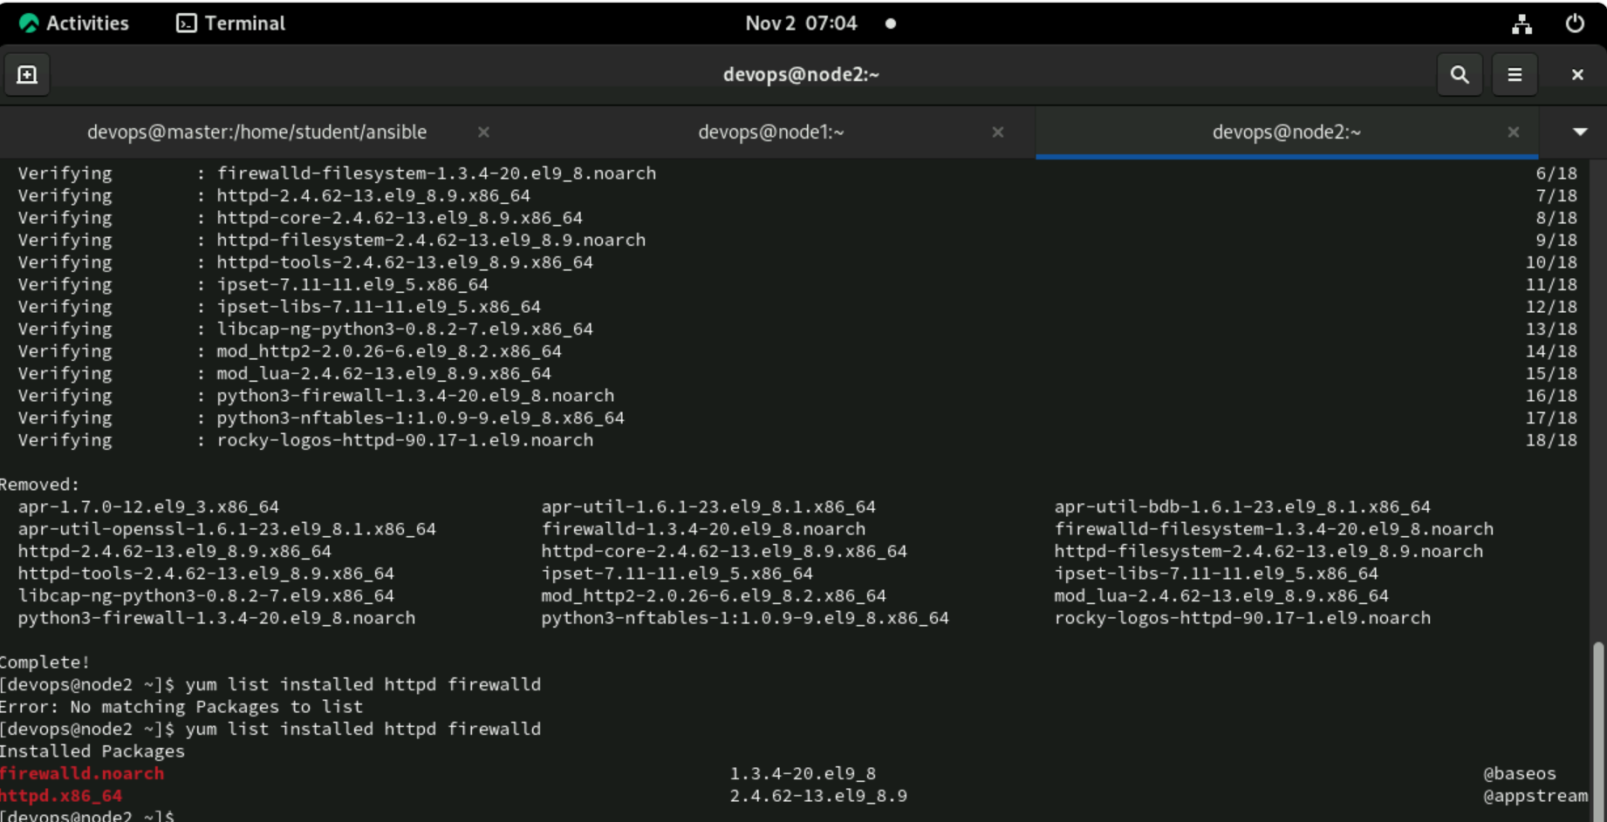
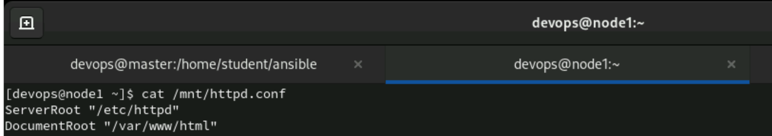
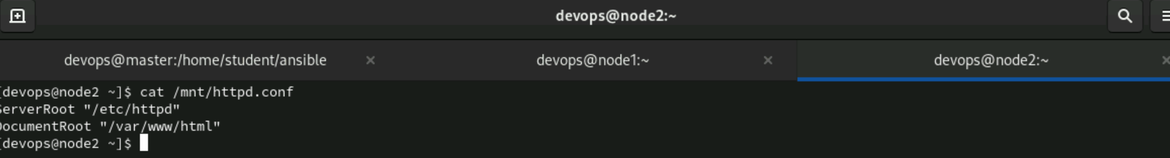
5. Gather the below details on both the nodes. Each node should have the file named /mnt/myhostdetails and it should have the below details; The file name should be report.yml
<IPAddress> # <hostname> # <OS-Distribution> # <OS-Family>
Note that the above details should be required in the same format without any deviation.
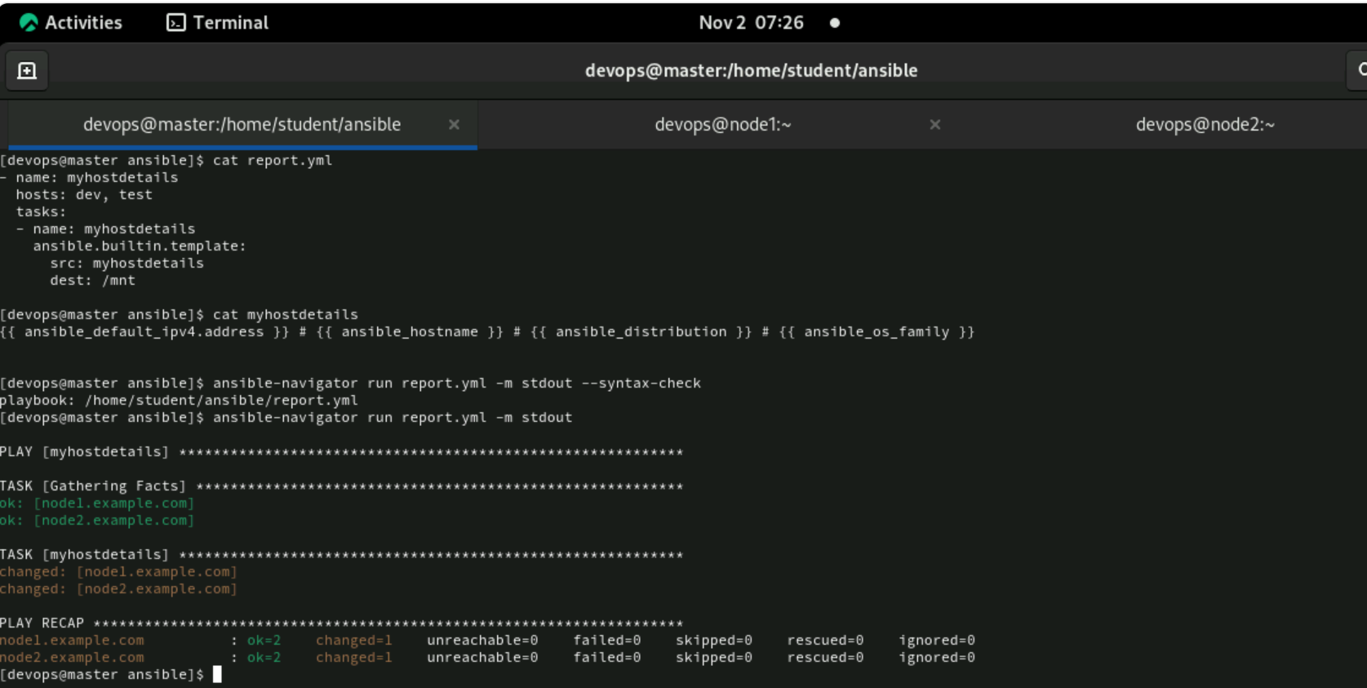
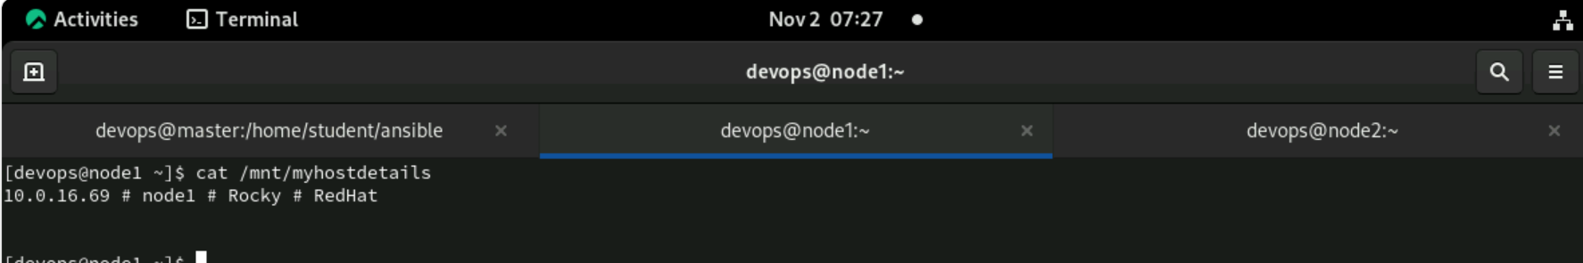
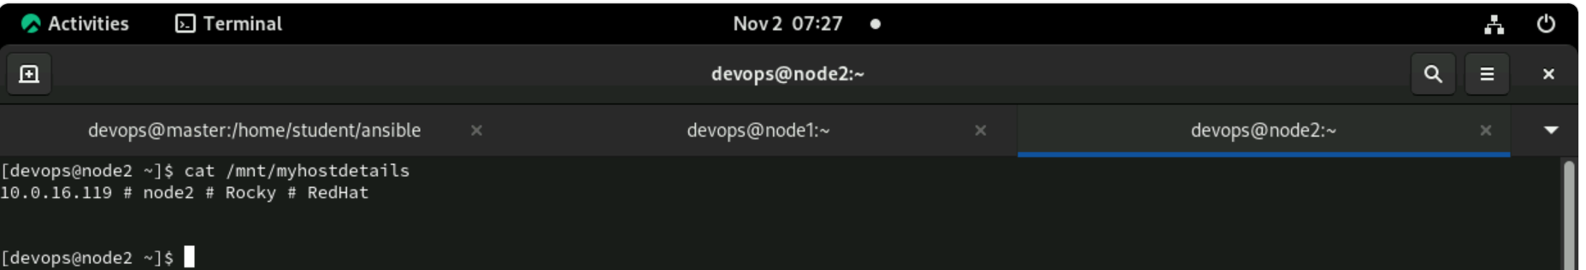

6. Fetch the file /etc/resolv.conf on both nodes and keep it in master under /tmp folder in the standard format. Make the file name as fetch.yml.


