7. Create a simple role for installing and configuring webserver: Use below details while configuring.
- It should be configured on both the nodes.
- Firewall should be installed and configured to allow HTTP protocol.
- Respective services should be enabled to ensure that I will start the service post reboot.
- Use handler to trigger the restart of httpd.
- While curl http://node1.example.com it should give the output as below:
"Nothing is free Lunch"
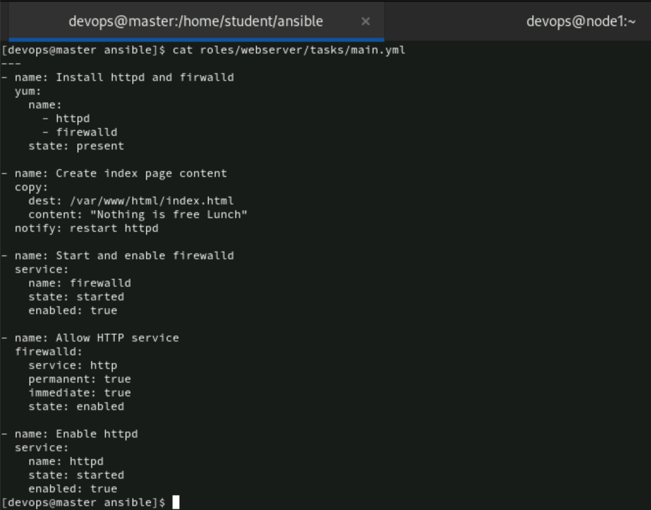
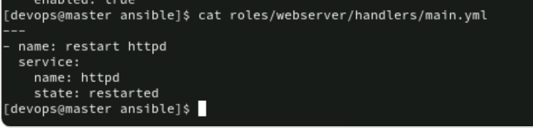
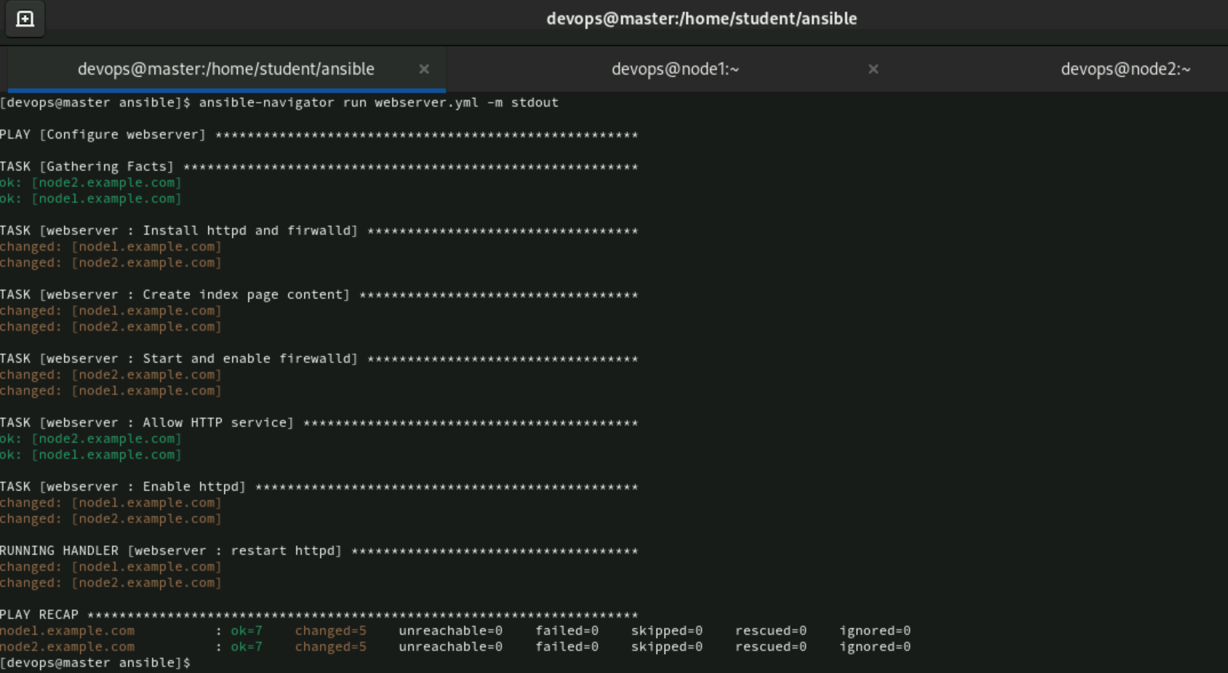
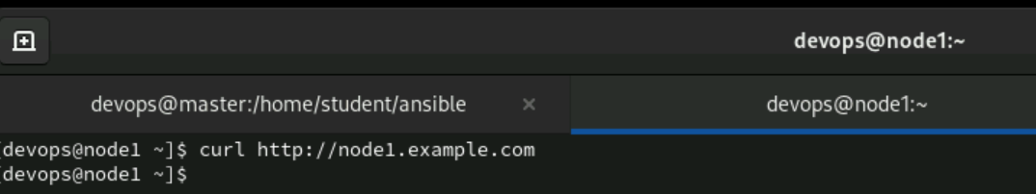
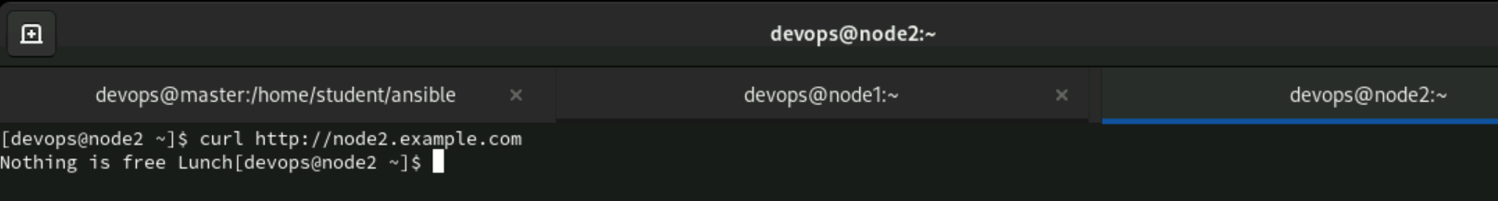

8. Create a role in the name of smtp.yml.
The tasks should have installed with postfix and service started using handlers.
While configuring, create a template to extract the hostname on the file /mnt/postfix-smtp on the nodes should have the content as below;
“SMTP protocol using port 25 on this host


