Amandyk Saleshev

Student ID: 72675

Software Development 3th year

Mini project in Android Studio.

1. I already had a Android Studio and I will not show how I installed this.

I created empty with the name ‘switch_app’ Activity in Android Studio.

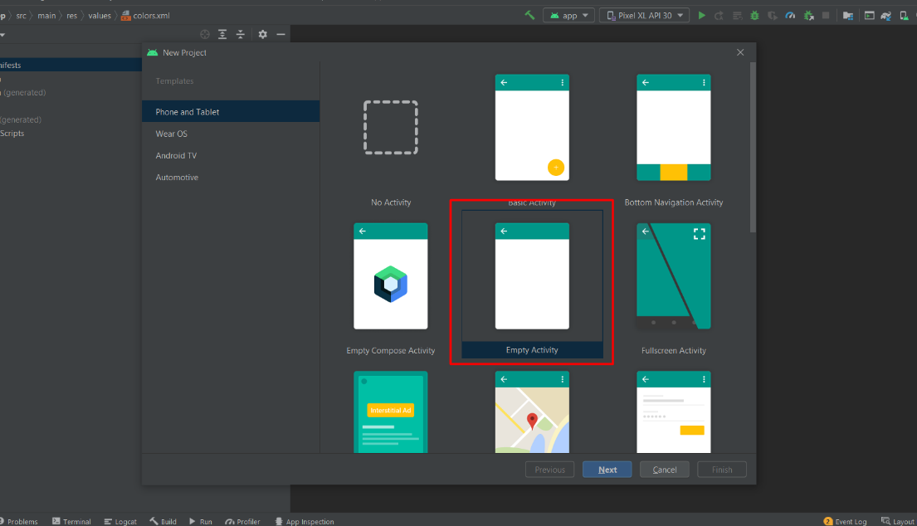

1. After this I created the 2nd empty Activity.

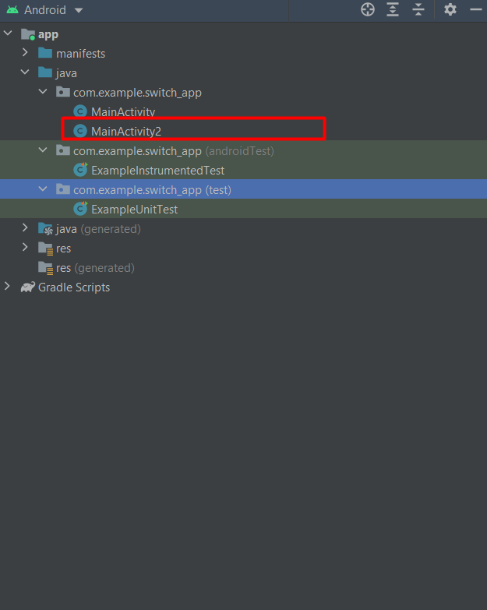

3.After creating 2 layouts, I changed design of my application using “Split” mode.

I changed from Constraint Layout to Relative Layout. Also as you can see I added to all subjects specific ID.

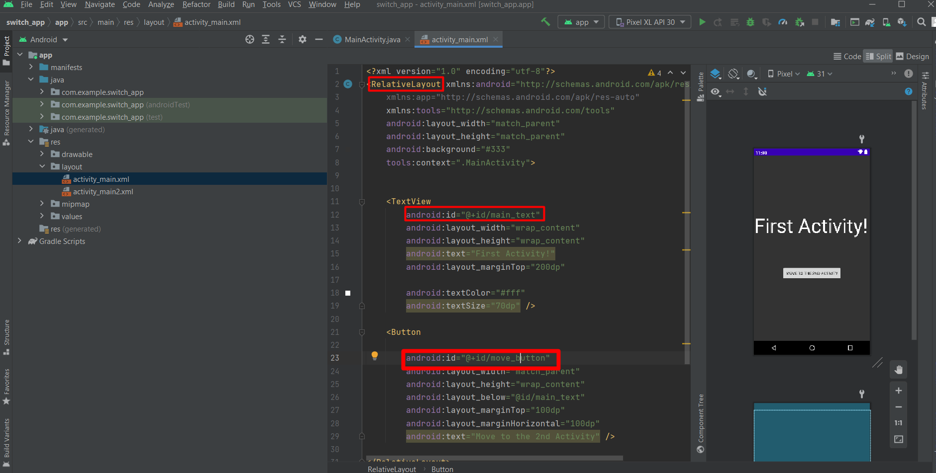

4.And the same I did in the 2nd Activity.

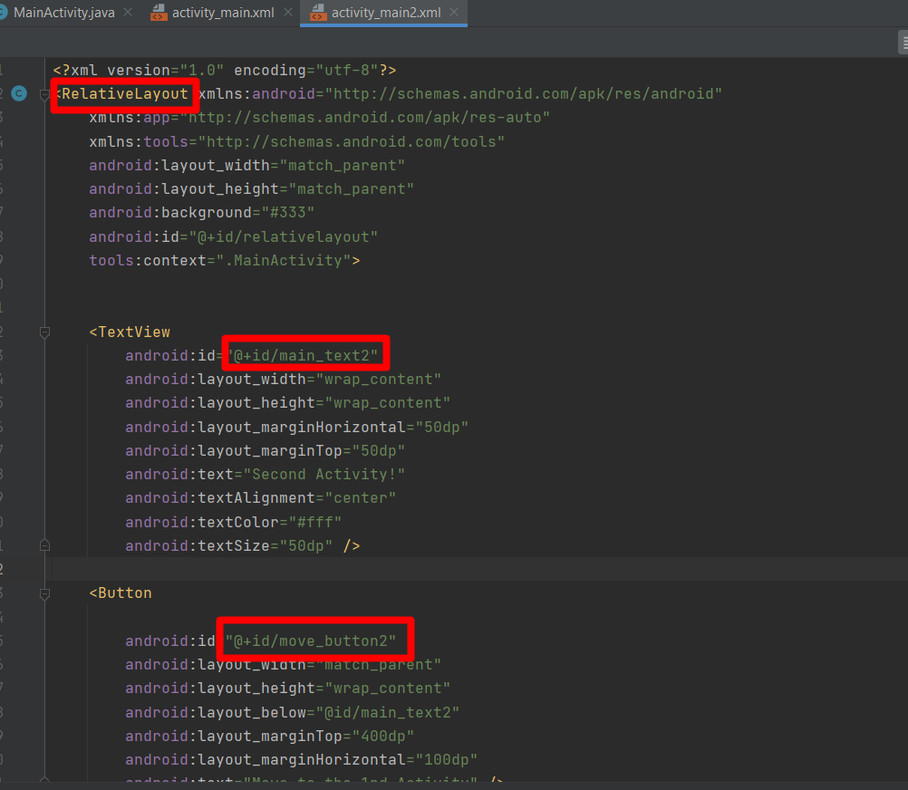

5.After I finished design-step I started code in MainActivity.java and MainActivity2.java.

Here I imported Views and Button widget to use it. As you can see here, I wrote code to change layout from 1st Activity to the 2nd Activity.

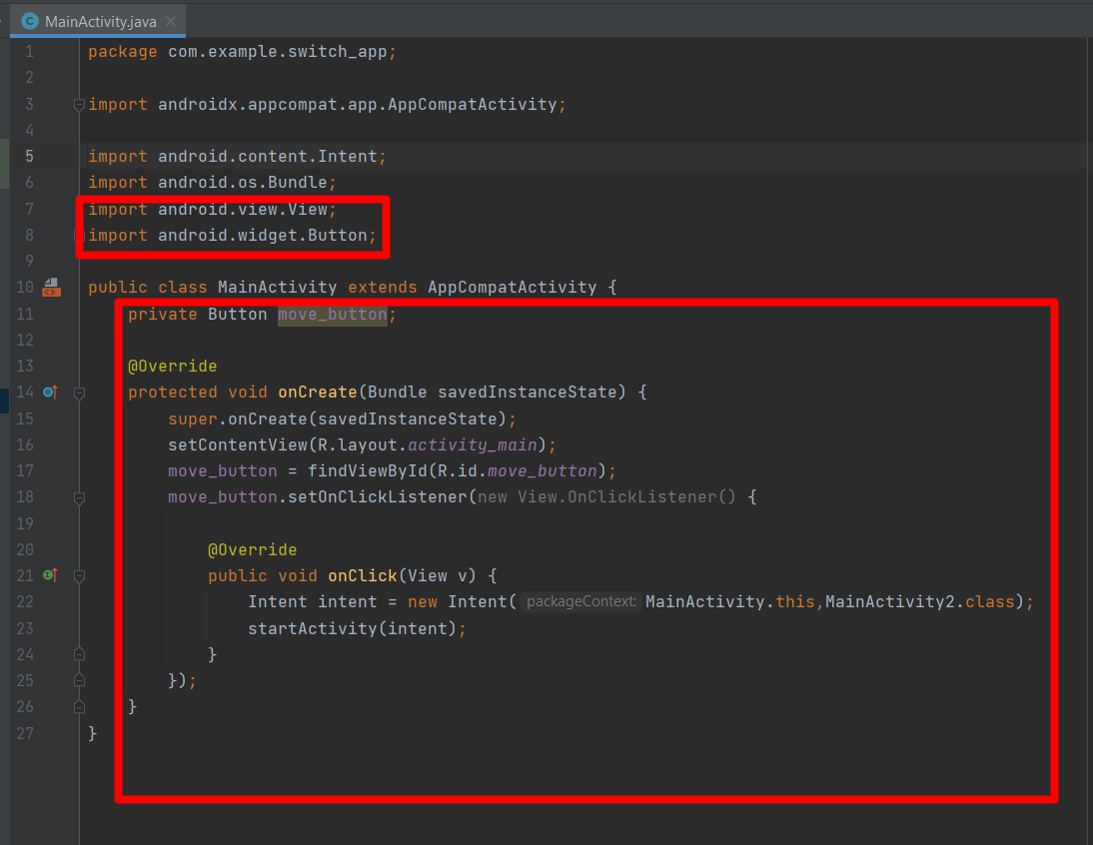

6. In the MainActivity2.java I did almost the same, but here I also added 3 buttons and used Relative Layout to change background by click

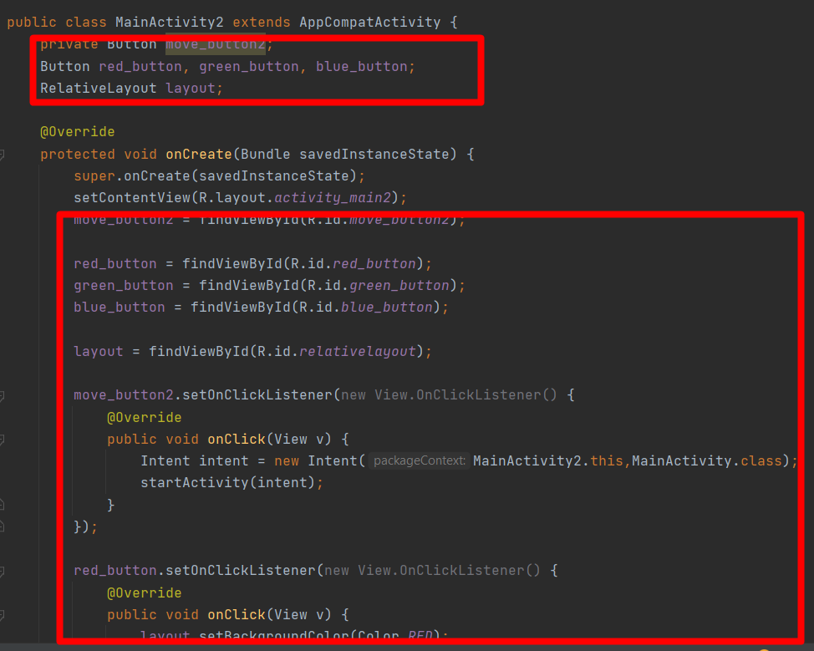

7. In the end of this, I would like to show how it looks and works. In main page I have only 1 button. Here in this page you we can move to the next page.

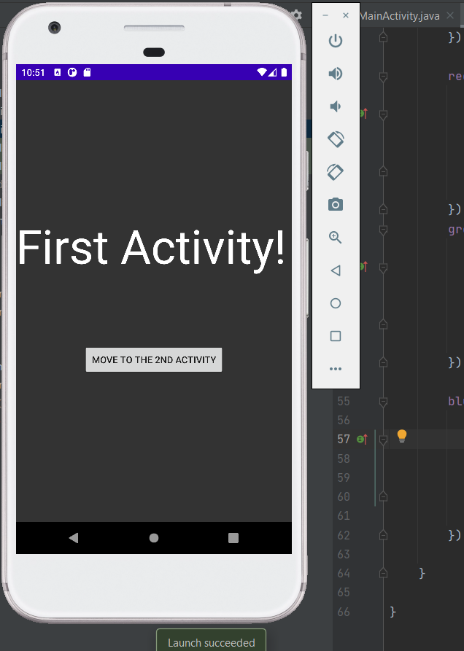

8

8. In the next page we have 4 possibility. We can change color of background to 3 color is green,

Blue, red. Also we can go back to main page.

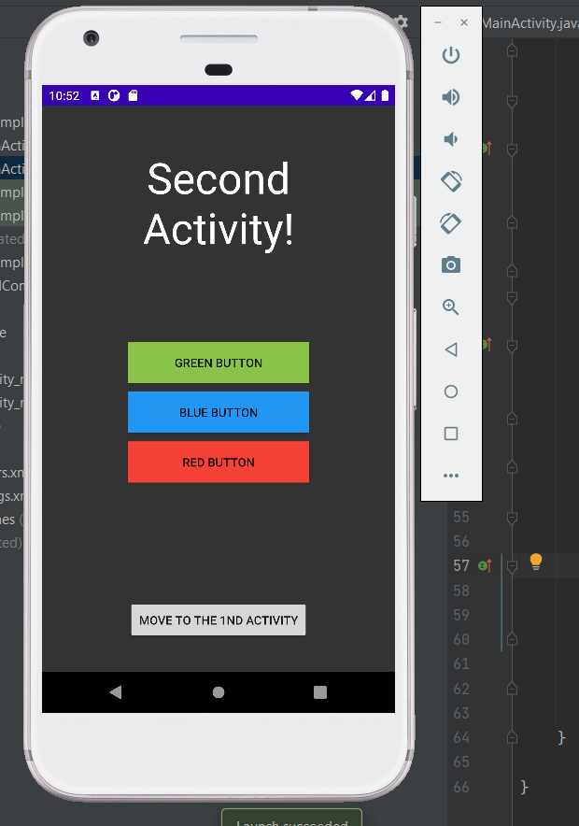

9. In this lesson I understand how works Android Studio. I know that is only beginning. I know that string, colors we have to add to the specific files. For example we want to change text in our button. Would be better if we add first text in ‘values/strings.xml’ and after this we will call this text by specific ID.