SECINFO_DENIED CHECK:

* Execute T-Code SA38 and run the following report: ZBC_CONS_GWLOG_MSGS

* Select “SECINFO_DENIED” as shown below.

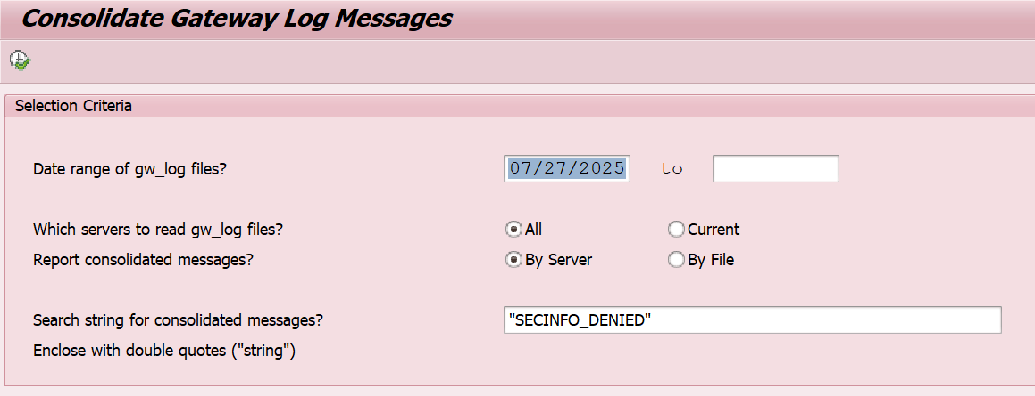

* If you see no messages all is good.

* If you see some secinfo_denied messages then proceed to do the following, go to T-Code SMGW -> Expert functions -> External Security -> Maintenance of ACL files.

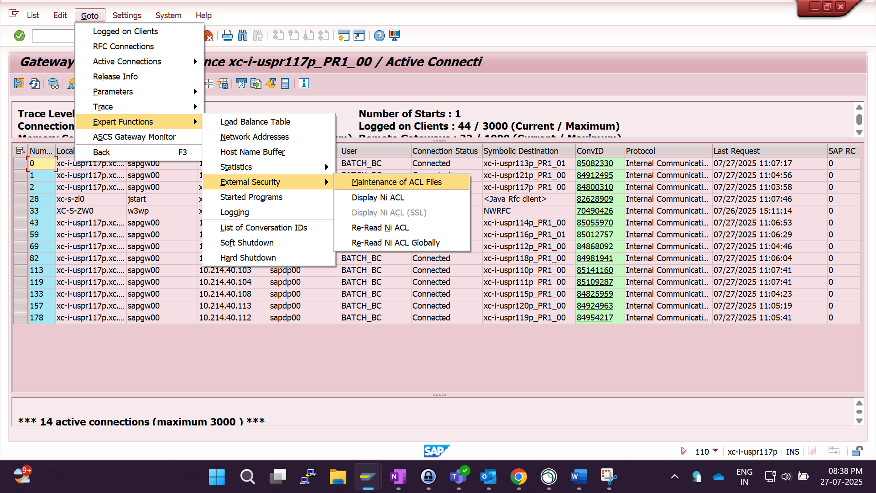

* Insert a standard line. P/D will be P. Put the error you see in TP field, USER would be *, USER-HOST is local, HOST is internal, local.

