**Car Parking System**

Aman Bilaiya

(2018CSB1069)

Aman Dhawan (2018CSB1070)

Design and implementation of car parking system on FPGA.

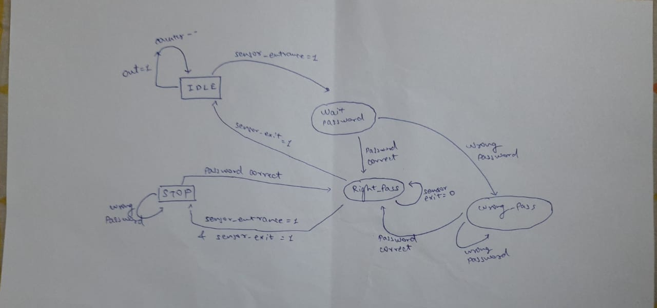

**Resource utilization**

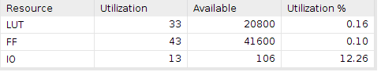

**Resources Used**

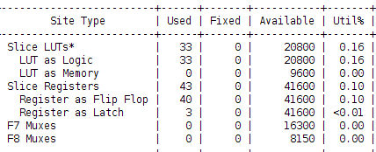

**Percentage Utilization**

