IN1901
Microcontroller Based Application Development Project
Final Report
Portable Seed Viability Conservation System
(IoT-Based Humidity and Temperature Controlled Seed Storage)
Supervisor: Mr. B.H. Sudantha

Group No: 38 Group Name: Wired Warriors
Index Number | Name
244179C | Rathnayaka R.M.D.S.
244134K | Nadeeja J.M.S.
244024A | Athapaththu A.H.M.A.N.
244110J | Kumara N.P.I.L.R.
244021L | Ariyawansa K.T.H.A.

Bachelor of Science Honours Information Technology (BSc Hons (IT))
Faculty of Information Technology
University of Moratuwa

Table of Contents
1. Introduction
1.1 Problem in Brief
1.2 Significance of Study
1.3 Aim and Objectives
2. Literature Study
3. Proposed Solution
3.1 Features of the Proposed Solution
3.2 Nature of the Solution
3.3 Schematic / Block Diagram
3.4 3D Design
3.5 Final Product
3.6 Components and Technologies Required
4. Seed Storage Standards
5. Future Improvements
6. Individual Contribution
6.1 Rathnayaka R.M.D.S – 244179C
6.2 Nadeeja J.M.S. – 244134K
6.3 Aththapaththu A.H.M.A.N. – 244024A
6.4 Kumara N.P.I.L.R. – 244110J
6.5 Ariyawansa K.T.H.A. – 244021L
7. Budget
8. References

1. Introduction
Seed conservation plays a vital role in agriculture, biodiversity preservation, food security, and scientific research. Seed viability gradually declines when seeds are exposed to unsuitable environmental conditions such as high temperature and excessive humidity. Therefore, maintaining optimal storage conditions is critical to ensuring long-term seed preservation.
The long-term viability of seeds depends on precise environmental control, particularly low temperature and low relative humidity. Without these conditions, seeds deteriorate rapidly, leading to reduced germination rates and lower yield from harvest. Traditional Sri Lankan storage conditions are often inadequate for preserving seeds over extended periods.
Many small-scale farmers, seed banks, research institutions, and agricultural organizations lack access to expensive commercial storage facilities equipped with advanced climate-control systems. As a result, there is a growing need for an affordable overall solution that can automatically maintain ideal storage conditions while providing continuous monitoring capabilities.
This project is the Portable Seed Viability Conservation System a microcontroller-driven solution to address these challenges. The system integrates temperature sensors, automated environment control mechanisms, and real-time remote monitoring through a web dashboard within a compact, portable, and cost-effective enclosure.

1.1 Problem in Brief
The current practices used in traditional seed storage facilities face several significant challenges that directly affect seed longevity and quality:

• Inconsistent Environmental Conditions:

Conventional storage facilities often fail to maintain stable temperature and humidity levels.

• Manual Monitoring Limitations

This method is time-consuming, susceptible to human error, and incapable of providing continuous supervision.

• Infrastructure and Cost Constraints of Modern Storage Facilities
These challenges highlight the need for a practical, accessible, and affordable seed storage solution capable of maintaining optimal environmental conditions needed for a stronger preservation of seed viability.

1.2 Significance of Study
This project contributes to effective seed preservation by developing a practical and accessible technological solution for maintaining seed viability.

• Seed Quality Preservation

By maintaining optimal environmental conditions, the system helps preserve seed germination potential and overall quality for extended periods.

• Preventive Measures

The system continuously monitors storage conditions and automatically responds to unfavorable changes, reducing the risk of seed deterioration.

• Cost-Effectiveness and Accessibility

The low-cost design provides farmers, seed banks, universities, research institutions, and agricultural organizations an alternative to expensive storage equipment.

• Data-Driven Decision Making
The integration of an IoT dashboard and historical data logging allows users to analyze environmental trends and make evidence-based decisions regarding seed storage and management.

• Scalability and Adaptability

The modular architecture of the system allows it to be easily expanded, replicated, or adapted for storing different types of seeds requiring controlled environmental conditions.

1.3 Aim and Objectives

Aim
To develop an automated, IoT-based seed preservation system that maintains optimal environmental conditions for long-term seed storage, while enabling real-time monitoring and data analysis, and helps preserve seed viability by supporting climate control.

Objectives
• Continuously monitor the temperature and humidity of the system in real time using DHT22 sensors. Readings will be captured every 2 seconds with ±0.5°C and ±3.5% RH accuracy
• Automatically regulate internal climate using Peltier cooling modules, PTC heaters, Nichrome wire heaters, and silica gel-based dehumidification mechanisms.
• Automate system control using Arduino Mega-based logic with predefined environmental thresholds.
• Enable real-time remote access and monitoring through an IoT web dashboard connected via an ESP8266 Wi-Fi module.
• Provide historical data tracking, tray weight monitoring, and door-open alerts to improve operational transparency and research capabilities.
• Reduce seed moisture content to below 5% using PTC heaters before long-term storage.

2. Literature Study
Seed viability is fundamentally governed by two environmental parameters: temperature and relative humidity. Research consistently demonstrates that seeds stored under cool, dry conditions can remain viable for decades, whereas seeds stored in warm, humid environments deteriorate within months. The orthodox seed storage rule, first described by Harrington (1972), states that seed longevity doubles for every 1% reduction in seed moisture content and for every 5°C reduction in storage temperature. This principle underpins all modern seed banking practices.
The Millennium Seed Bank at Kew Gardens and the Svalbard Global Seed Vault represent the gold standard in seed conservation, maintaining seeds at −18°C and approximately 5% relative humidity. While these industrial-scale facilities are beyond the reach of local institutions, they validate the fundamental principle that controlled-environment storage is the most reliable method for preserving seed viability.
Within the Sri Lankan environment, the Department of Agriculture's Plant Genetic Resources Centre (PGRC) maintains a national seed bank, yet the reach of formal conservation infrastructure remains limited, particularly for endemic species outside agricultural interest. Research published on seed governance in Sri Lanka highlights the vulnerability of endemic seed stocks to the country's ongoing agricultural and economic pressures.
Existing IoT-based environmental monitoring solutions, such as those employing the DHT22 for temperature and humidity sensing and ESP8266 or ESP32 microcontrollers for wireless connectivity, have demonstrated their effectiveness in agricultural applications ranging from greenhouse monitoring to cold chain management. However, purpose-built seed conservation systems combining active climate control (Peltier cooling, PTC heating, and dehumidification), weight sensing, RFID-based access control, and a remote IoT dashboard remain largely absent from the low-cost, portable device market.
Studies and literature on Peltier-based thermoelectric cooling confirms its suitability for compact, low-power applications where refrigerant-based compressor cooling is impractical. The integration of silica gel for passive dehumidification, periodically regenerated using PTC heaters, represents an established technique in the archival and seed storage communities. Reed switches for door-seal detection and weight sensors for seed inventory management add operational robustness that is absent in most consumer storage solutions.
This review confirms both the scientific foundation for the proposed system's design parameters and the significant gap in accessible, IoT-integrated seed conservation hardware suitable for deployment in Sri Lankan research and farming contexts.

3. Proposed Solution
The Portable Seed Viability Conservation System is a self-contained, IoT-enabled hardware device that automatically regulates the internal environment of a multi-tray seed storage enclosure. The system pre-dries seeds using Nichrome heaters to reduce moisture content below 5%, then maintains optimal storage conditions — targeting 8°C and 25% RH — through a combination of Peltier cooling, PTC-heated silica gel dehumidification, and fan-assisted airflow. An RFID module secures access, while weight sensors track seed inventory on a per-tray basis. All sensor data is transmitted via ESP8266 to a web dashboard, providing real-time visibility and historical data logging for remote researchers and conservationists.

3.1 Features of the Proposed Solution
1. Climate Control Sub-system:
- Peltier Modules for active cooling (target 8°C internal temperature)
- PTC Heaters for pre-storage seed drying (reduce moisture content to < 5%)
- PTC Heaters for periodic silica gel regeneration
- Outdoor and side fans with servo motor-controlled vents for directed airflow
2. Sensing and Monitoring:
- DHT22 Sensors for real-time temperature and humidity measurement
- Weight Sensors for per-tray seed mass tracking
- Limit Switches for tray position detection
3. Security and Access Control:
- RC522 RFID Module for door locking and access authentication
- LED indicators: green (door open status) and red (unauthorized access alert)
4. User Interface:
- LCD Display for local real-time readings and system status
- Speaker for audible alerts (door open, threshold breach, system warnings)
- Tray controller buttons for manual tray-in / tray-out operation
5. IoT Connectivity and Dashboard:
- ESP8266 (NodeMCU) Wi-Fi module for cloud data transmission
- Web dashboard displaying: current temperature, current humidity, silica gel box humidity (Box 1 & 2), tray weight (Tray 1 & 2), and door-open alerts
- Historical data logging for long-term trend analysis and research

3.2 Nature of the Solution

The system block diagram illustrates the full signal flow from input sensors through the Arduino Mega microcontroller to output actuators and the ESP8266 IoT gateway.
Input sensors include the DHT22 (temperature and humidity), reed switch (door seal), tray buttons (tray in/out), RC522 RFID module (door lock), limit switches (tray travel limits), weight sensors (seed mass), PTC heater (silica gel status), and Nichrome heater (seed pre-drying).
Output actuators include outdoor fans with servo motors, side fans with servo motors, Peltier cooler module, Peltier heater module, gear motors (tray drive), LCD display, LEDs, and a speaker. The ESP8266 Wi-Fi module bridges the microcontroller to the web application dashboard, which reports current temperature, humidity, silica gel box humidity, tray weights, and door alerts.
The system architecture is centered on an Arduino Mega microcontroller, which serves as the primary processing and control unit. All input sensors: DHT22 sensors, reed switches, limit switches, weight sensors, PTC heaters (feedback), and the RFID module feed data into the Arduino Mega. The microcontroller processes these inputs and drives output actuators including outdoor and side fans (with servo motors), Peltier modules (both cooling and heating modes), gear motors for tray operation, LED indicators, an LCD display, and a speaker.
An ESP8266 Wi-Fi module is connected to the Arduino Mega and handles all IoT communication, transmitting sensor readings to a remote web server. The web application dashboard provides users with live access to the following data streams:
- Current internal temperature and humidity
- Silica gel box humidity levels (Box 01 and Box 02)
- Tray seed weights (Tray 01 and Tray 02)
- Door open / unauthorized access alerts
The system also incorporates a pre-storage drying phase: before seeds are placed into long-term storage, Nichrome wire heaters reduce the seed moisture content to below 5% (verified using the moisture content formula: MC% = ((Wi − Wf) / Wi) × 100, where Wi is the initial weight and Wf is the final weight after drying). Only after this pre-drying step are seeds sealed in the storage trays for conservation.
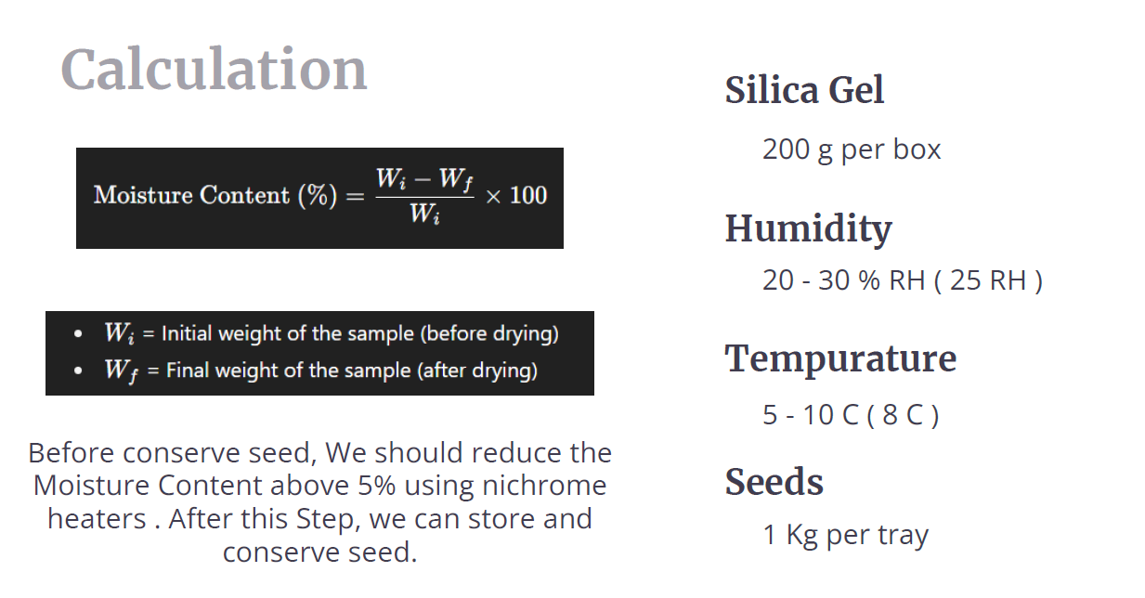

3.3 Schematic Diagram
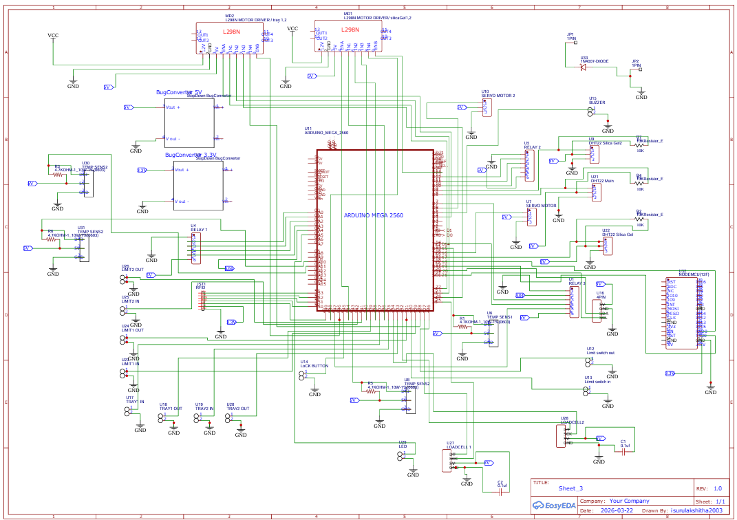
3.4 3D Design
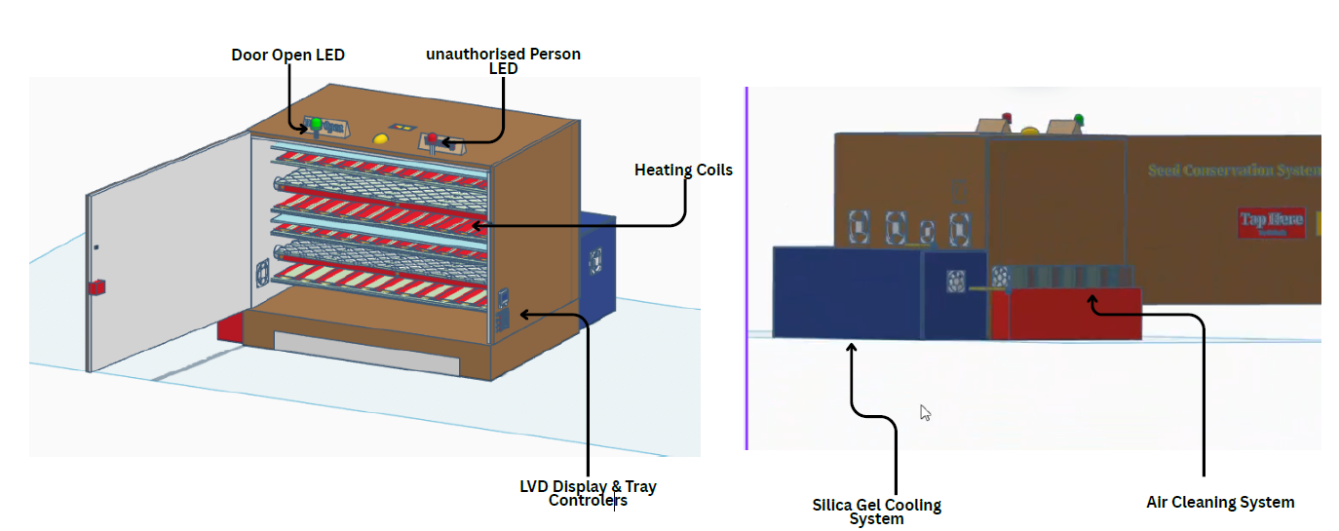
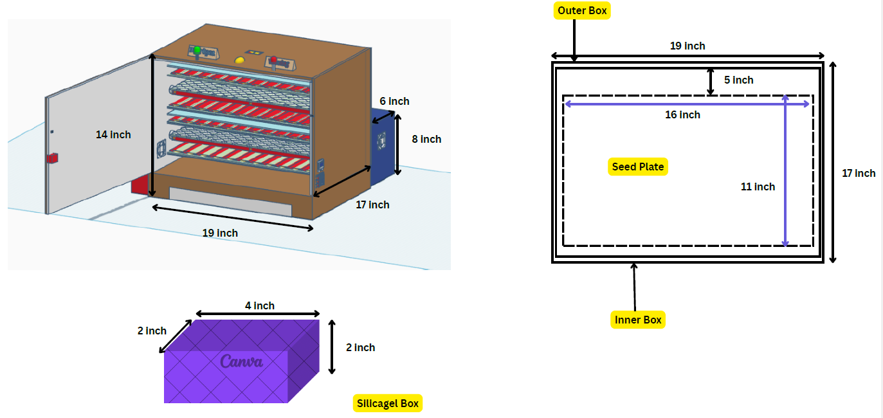

3.5 Final Product

3.6 Components and Technologies Required

1. Microcontroller and Connectivity
- Arduino Mega: Serves as the central control unit, managing all sensor inputs and actuator outputs. Its large number of GPIO pins accommodates the system's diverse peripheral requirements.
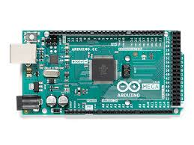
- ESP8266 Wi-Fi Module (NodeMCU): Provides wireless IoT connectivity, transmitting sensor data to the web server and enabling remote dashboard access. The ESP8266 module operates at 3.3V logic level, which is standard for its onboard Wi-Fi transceiver, and is interfaced with the Arduino Mega accordingly.

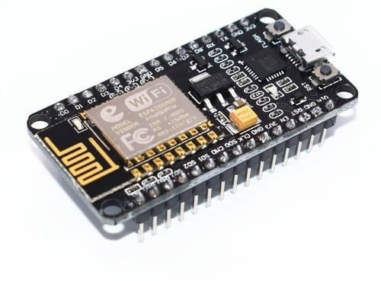

2. Sensors
- DHT22 Sensor (×2): Precision digital temperature and humidity sensors. Each unit is powered at 3.3V–5V and communicates via a single-wire protocol, providing readings every 2 seconds with ±0.5°C temperature accuracy and ±2–5% RH humidity accuracy.

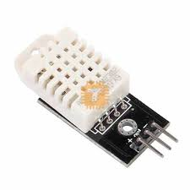

- Weight Sensor: Load cell-based sensor measuring seed mass per tray, enabling inventory tracking and change detection.
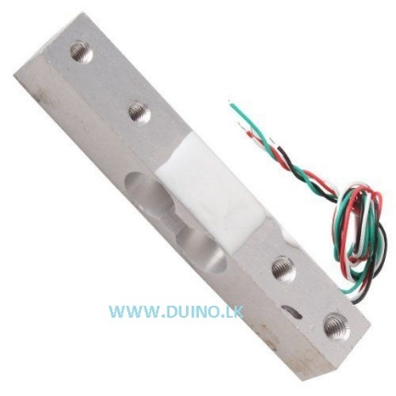

- Limit Switch: Mechanical switches detecting tray travel boundaries for safe automated tray operation.

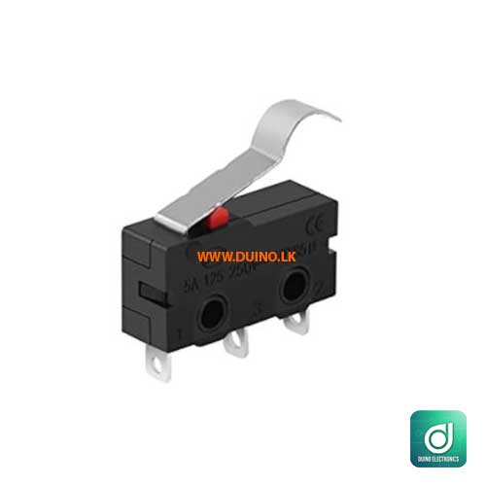

- RC522 RFID Module: Radio-frequency identification module operating at 13.56 MHz, used for door locking and access authentication.

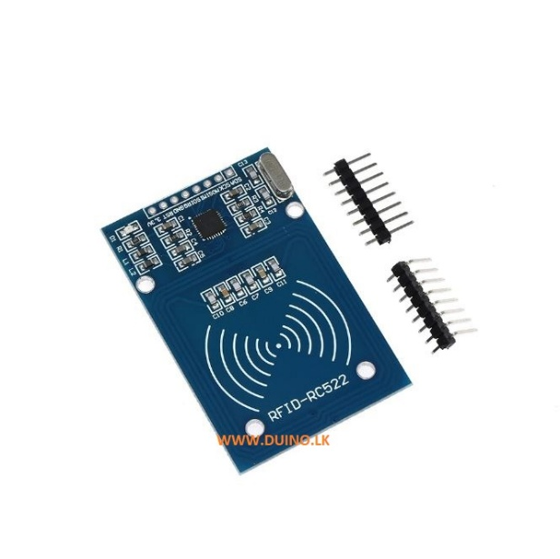

3. Climate Control Actuators
- Peltier Modules (×3): Thermoelectric coolers used for active temperature reduction within the storage chamber. Each module draws heat from the cool side to the warm side when current is applied, and can be reversed to provide gentle heating if required.

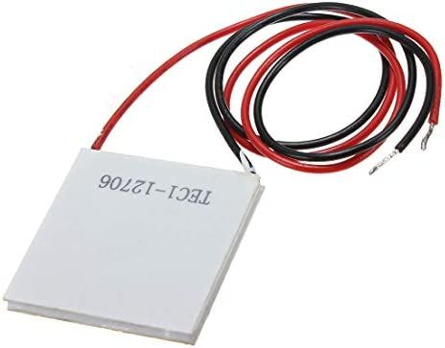

- PTC Heaters (×2): Positive Temperature Coefficient ceramic heaters used to periodically regenerate silica gel by driving off absorbed moisture, restoring dehumidification capacity. The PTC heaters operate at 12V and are switched via relay modules under Arduino Mega control, consistent with other high-current actuators in the system.

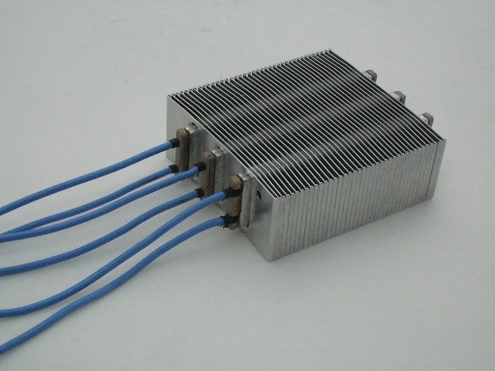

- Cooling Fans (80×80×10 mm, ×6; 40×40×10 mm, ×3): Fan modules for heat dissipation from Peltier module warm sides and internal air circulation. The fans are powered at 12V, drawing from the same relay-switched supply rail used for the Peltier modules.

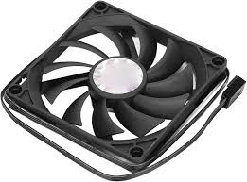
- Servo Motors (×3): Control motorised vent dampers (outdoor and side vents) to direct airflow. The servo motors operate at standard 4.8V–6V signal logic but are powered from the system's 12V rail via a dedicated regulator.
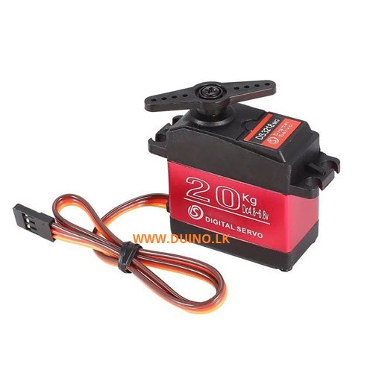
- Gear Motors (×4): Drive the tray-in / tray-out mechanism, enabling automated tray positioning. The gear motors are rated at 12V DC and are driven through relay modules to handle the current required for tray-in/tray-out operation.
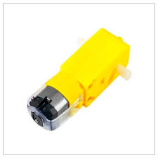

4. User Interface Components
- LCD Display (16×2 or 20×4): Local display mounted on the front panel, showing real-time temperature, humidity, AQI, and system status messages.

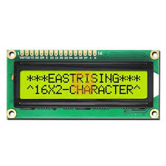

- LEDs (×3): Green (door open status), yellow (warning), red (unauthorized access / alert). The LCD display operates at 5V, powered directly from the Arduino Mega's 5V supply rail, consistent with standard 16×2 character LCD modules.
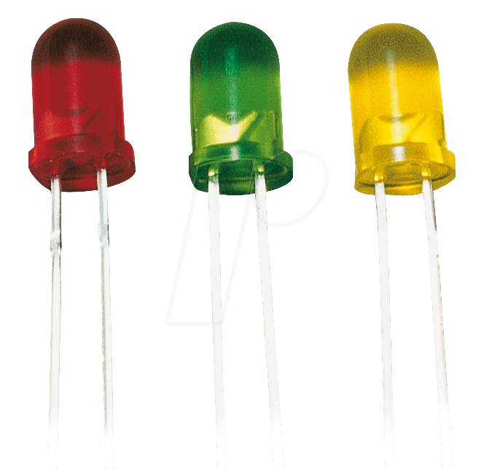
- Speaker: Provides audible alerts for threshold breaches, door-open events, and system notifications. The speaker is driven at 5V directly from the Arduino Mega's digital output
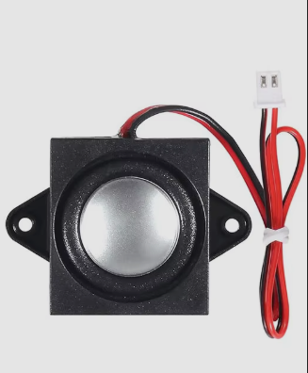

- Push Buttons: Manual controls for tray-in / tray-out operation.
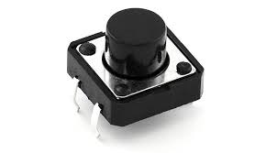
- 12V Power Adapter: Main power supply for the system.

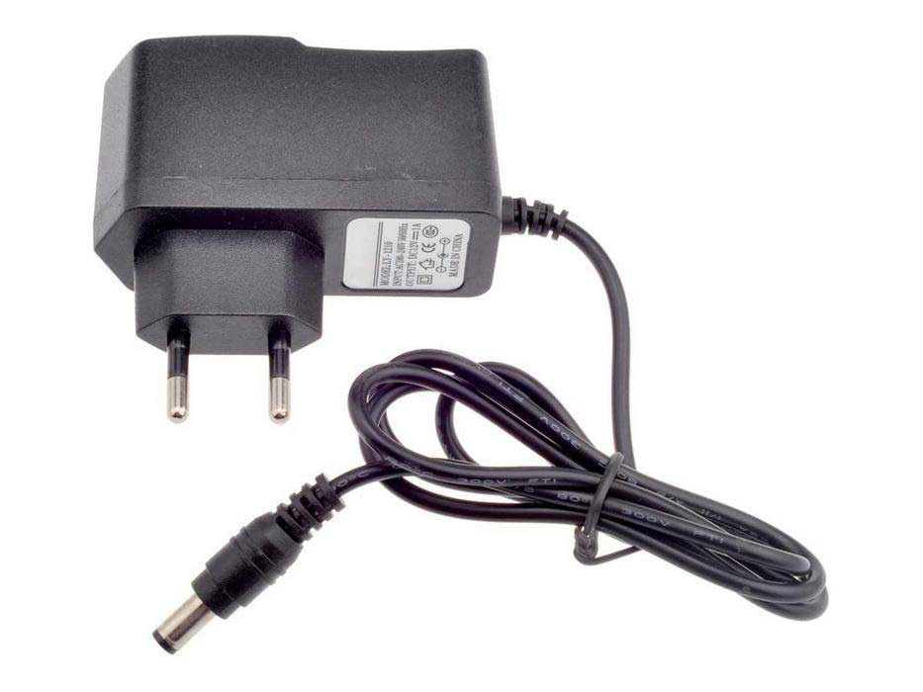
- Relay Modules: Electrically isolate and switch power to high-current components (Peltier modules, heaters, fans) under Arduino control.

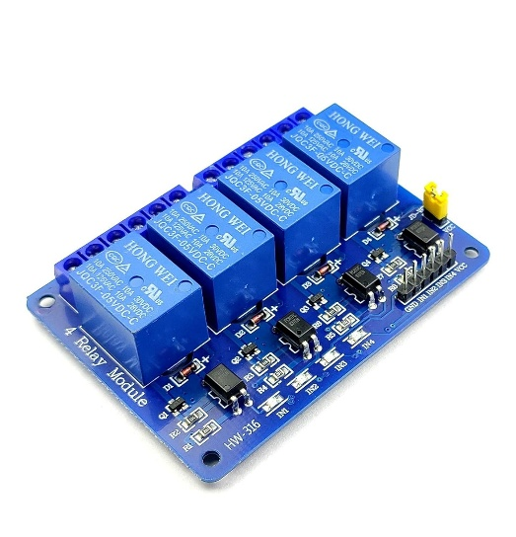

4. Seed Storage Standards
The system's operational parameters are based on established international seed conservation guidelines and the specific requirements of endemic Sri Lankan seed species. The table below defines the optimal, acceptable, and critical threshold ranges for each monitored parameter:

Parameter | Optimal Range | Acceptable Range | Critical (Out of Range)
Temperature | 5 – 10 °C (target 8 °C) | 0 – 15 °C | < 0 °C or > 15 °C
Relative Humidity | 20 – 30 % RH (target 25 %) | 15 – 35 % RH | < 15 % or > 35 %
Seed Moisture Content | < 5 % (after pre-drying) | 5 – 8 % | > 8 %
Silica Gel Load | 200 g per box | 150 – 250 g | < 100 g
Seed Load per Tray | 1 kg | 0.5 – 1.5 kg | > 2 kg

The moisture content formula used to verify pre-storage seed drying is:
Moisture Content (%) = ((Wi − Wf) / Wi) × 100
Where Wi is the initial weight of the seed sample before drying and Wf is the final weight after drying with Nichrome heaters. Seeds are only transferred to the conservation chamber once their moisture content is confirmed to be below 5%.
These parameter targets are consistent with guidelines published by the International Seed Testing Association (ISTA) and align with the Department of Agriculture's Plant Genetic Resources Centre (PGRC) recommendations for long-term orthodox seed storage.

5. Future Improvements
- Mobile Application Integration: Develop a dedicated Android/iOS mobile application to complement the web dashboard, providing push notifications for threshold alerts, RFID access logs, and tray weight history directly on a smartphone.
- Climate-Zone Profiles: Implement pre-programmed storage profiles calibrated to each of Sri Lanka's major climate zones (wet zone, dry zone, intermediate zone, and montane zone), allowing one-touch selection of appropriate temperature and humidity targets based on seed origin.
- Solar Power Compatibility: Integrate a solar charging module and battery backup to enable truly off-grid operation in remote conservation areas and botanical gardens without reliable mains power.
- Barcode or QR Code Seed Tracking: Integrate a barcode scanner or QR code reader to log seed species, collection date, provenance, and batch information directly into the web dashboard, creating a complete digital seed inventory.
- Cloud Database Integration: Migrate from a simple web server to a cloud database (such as Firebase or AWS) for scalable, long-term historical data storage with multi-user access and data export for research publications.

6. Individual Contribution
6.1 Rathnayaka R.M.D.S. – 244179C
My primary hardware contribution was the integration and programming of the system's core sensing and local-interface components: the DHT22 temperature/humidity sensor, the DS18B20 (DS1820) digital temperature sensor, the RC522 RFID access module, the buzzer, and the LCD display screen.
6.1.1 Understanding the Components
The DHT22 is a digital sensor combining a capacitive humidity element and an NTC thermistor, communicating over a single-wire protocol with ±0.5°C and ±2–5% RH accuracy. The DS18B20 is a separate 1-Wire digital temperature sensor used to cross-verify chamber temperature at a secondary point in the enclosure, offering ±0.5°C accuracy over its usable range and a unique 64-bit serial address that allows multiple units to share a single data line. The RC522 module operates at 13.56 MHz and communicates with the Arduino Mega over SPI, reading the UID of MIFARE-standard RFID cards for access authentication. The buzzer provides audible alerts, and the LCD screen gives on-device visibility of temperature, humidity, and system status without requiring the web dashboard.
6.1.2 Wiring and Hardware Setup
The DHT22 was wired to a dedicated digital input pin with a 10 kΩ pull-up resistor between data and VCC. The DS18B20 was connected on the Arduino Mega's 1-Wire bus, also with a 4.7 kΩ pull-up resistor, and positioned at a separate point in the enclosure from the DHT22 to provide a secondary temperature reference. The RC522 was connected to the Mega's hardware SPI pins (MOSI 51, MISO 50, SCK 52, SDA/CS 53), with a dedicated RST pin, and powered from the 3.3V rail with series resistors on MOSI/SCK to protect its 3.3V logic from the Mega's 5V lines. The buzzer was driven from a digital output pin through a transistor switch, and the LCD was wired either via I2C (SDA/SCL) or in 4-bit parallel mode to the Mega's 5V rail.
6.1.3 Programming and Integration
The DHT22 and DS18B20 were both read using their respective Arduino libraries (DHT library and OneWire/DallasTemperature), with readings cross-checked against one another to flag sensor drift or failure. Validated temperature and humidity values feed the system's control logic and are forwarded to the ESP8266 for dashboard transmission. I implemented the RFID authentication routine using the MFRC522 library, comparing scanned UIDs against an authorised list, triggering door release on a match and an alarm sequence through the buzzer on a mismatch. The LCD firmware cycles between temperature, humidity, and status screens, and displays door-open and access alerts in real time, while the buzzer sounds distinct tone patterns for door-open events, threshold breaches, and unauthorised access attempts.

6.2 Nadeeja J.M.S. – 244134K
My primary contribution was the integration and control of the Peltier thermoelectric cooling modules, finalising and consolidating the overall Arduino firmware, and designing the IoT dashboard (website) used for remote monitoring.
6.2.1 Understanding the Peltier Module
A Peltier module operates on the Peltier effect: when DC current passes through the junction of dissimilar semiconductor materials, heat is absorbed on one face and expelled on the other, allowing solid-state cooling without moving parts or refrigerants. The modules used are rated at 12V DC, capable of a temperature differential of up to 65°C under no-load conditions, and multiple units were deployed to achieve the target 8°C internal temperature.
6.2.2 Hardware Setup and Control Logic
Each Peltier module was mounted with its cold face toward the chamber interior and its hot face against an external heat sink, with thermal paste applied at both interfaces and cooling fans attached to the heat sinks to dissipate expelled heat. The modules are switched via relay modules under Arduino Mega control, with flyback diodes across relay coils to suppress inductive spikes. I implemented the relay-switching logic that activates cooling when the sensed temperature exceeds the upper threshold (10°C) and deactivates it below the lower threshold (5°C) to prevent over-cooling.
6.2.3 Code Finalizing and Website Design
Beyond the Peltier subsystem, I was responsible for finalising the complete Arduino codebase — merging each member's individual modules (sensing, climate control, access control, tray handling) into a single integrated sketch, resolving pin conflicts, standardising the data-packet format sent to the ESP8266, and optimising the main control loop for timing and stability. I also designed the web dashboard, including the layout for live temperature, humidity, silica gel box humidity, tray weight, and door-alert widgets, historical data charts, and the responsive front-end styling used to present incoming ESP8266 data to remote users.

6.3 Aththapaththu A.H.M.A.N. – 244024A
My primary hardware contribution was the design and implementation of the air filtering system, along with the four PTC heaters and four fans installed within the main tray system.
6.3.1 Understanding the Air Filtering System
The air filtering subsystem removes particulate matter and manages air exchange within the storage chamber, helping maintain clean, stable internal conditions and preventing contamination of stored seeds during ventilation cycles. It works alongside the fan-driven airflow to circulate filtered air through the tray compartments.
6.3.2 Hardware Setup
The filtering unit was fitted at the chamber's air intake point, with the four dedicated fans positioned within the main tray system to draw air through the filter media and distribute it across the trays. The four PTC heaters installed in the same tray system were mounted to provide localised, switch-controlled heating support to this airflow path, powered at 12V and switched through relay modules under Arduino control, consistent with the other high-current actuators in the system.
6.3.3 Programming and Integration
I implemented the relay-control logic for the four PTC heaters and four fans, driving them according to temperature and airflow requirements sensed elsewhere in the system, with the Arduino Mega switching them on and off based on defined thresholds. Status of these actuators is included in the system's internal control state and reflected in the overall climate-control response reported to the dashboard.

6.4 Kumara N.P.I.L.R. – 244110J
My primary contribution was producing the system's schematic diagram and implementing the complete silica gel dehumidification system, including its two gear motors, four limit switches, and PTC heater.
6.4.1 Schematic Diagram
I designed the full system schematic showing the signal flow between the Arduino Mega, all input sensors, and all output actuators, including the sensor-to-microcontroller wiring, relay-switched high-current lines, and the ESP8266 IoT gateway connection, to serve as the reference wiring diagram for hardware assembly and troubleshooting.
6.4.2 Understanding the Silica Gel System
The silica gel system provides passive dehumidification: silica gel absorbs moisture from the chamber air, and is periodically regenerated by driving off the absorbed moisture with a PTC heater. Two gear motors handle mechanical movement of the silica gel trays/mechanism, while four limit switches detect travel boundaries to prevent over-travel and ensure safe, repeatable positioning.
6.4.3 Hardware Setup
The two gear motors were wired through relay modules to handle their drive current, rated at 12V DC. The four limit switches were positioned at the mechanical travel extremes of the silica gel mechanism and wired to digital input pins with pull-up resistors, signalling the Arduino Mega when the mechanism reaches its end positions. The PTC heater dedicated to this subsystem was mounted adjacent to the silica gel chamber and relay-switched in the same manner as the system's other high-current heating elements.
6.4.4 Programming and Integration
I implemented the firmware controlling the gear motors' direction and run time, using the four limit switch states to stop motor travel precisely at each end position and prevent mechanical binding. The PTC heater regeneration cycle is triggered based on silica gel box humidity readings, running until target humidity is restored, after which the heater is deactivated and the mechanism returns to its resting position. Status of the silica gel subsystem (box humidity and regeneration state) is reported to the IoT dashboard.

6.5 Ariyawansa K.T.H.A. – 244021L
My primary contribution was the integration and programming of the load cell and HX711 weight-sensing system, along with the design of the system's PCB.
6.5.1 Understanding the Weight Sensor (Load Cell and HX711)
The weight-sensing system uses a strain gauge load cell paired with an HX711 24-bit ADC amplifier. The load cell deforms elastically under load, and its strain gauges (arranged in a Wheatstone bridge) produce a microvolt-level differential signal too small for direct microcontroller measurement. The HX711 amplifies this signal with a programmable gain of 64 or 128 and digitises it at 24-bit resolution, giving a resolution of roughly 0.1 g on a 5 kg-rated cell, well within the requirement for tracking per-tray seed loads.
6.5.2 Wiring and Hardware Setup
The load cell was mounted beneath the tray using a platform bracket, with its four-wire output (excitation+, excitation−, signal+, signal−) connected to the HX711 module. The HX711 communicates with the Arduino Mega via a two-wire interface (DOUT and PD_SCK), powered at 5V from the Mega's supply rail.
6.5.3 Programming and Calibration
Programming was carried out using the HX711 Arduino library. The calibration procedure involved first performing a tare operation (zeroing the scale with an empty tray in place), then placing a known reference weight (500 g calibration mass) on the tray and recording the raw ADC count, from which a calibration factor was derived and stored in EEPROM. This calibration factor converts raw ADC values to grams for all subsequent readings. To reduce measurement noise, the firmware averages ten consecutive HX711 readings before reporting a final weight value. The system polls both tray weight sensors every 10 seconds, and the readings are included in the IoT data packet transmitted to the web dashboard, allowing remote operators to monitor seed inventory levels and detect unexpected mass changes (such as spilled seeds or tray removal) in real time.

6.5.4 PCB Design
I designed the system's PCB to consolidate the sensor and actuator wiring into a single board, laying out power and signal traces for the microcontroller interface, relay-driven high-current lines, and low-voltage sensor connections, reducing loose wiring and improving the reliability and neatness of the final enclosure assembly. Since we decided to use a single layer PCB, manual rerouting of the wires was needed.

7. Budget
Component | Quantity | Unit Price (LKR) | Total Price (LKR)
Arduino Mega | 1 | 5,200 | 5,200
DHT22 Sensor | 2 | 340 | 680
ESP8266 Wi-Fi Module | 1 | 410 | 410
RC522 – RFID Module | 1 | 210 | 210
Cooling Fan (80×80×10) | 6 | 340 | 1,940
Cooling Fan (40×40×10) | 3 | 290 | 870
12V Power Adapter | 1 | 2,100 | 2,100
Gear Motors | 4 | 1,700 | 6,800
Servo Motors | 3 | 400 | 1,200
PTC Heaters | 2 | 2,500 | 5,000
Speaker | 1 | 300 | 300
LCD Display | 1 | 1,200 | 1,200
Nichrome Wire | – | 1,200 | 1,200
Box (Enclosure) | – | 10,000 | 10,000
LED | 3 | 50 | 150
Peltier Module | 3 | 630 | 1,890
Total |  |  | 39,660

8. References
Department of Agriculture – Plant Genetic Resources Centre (PGRC), Sri Lanka: https://doa.gov.lk/pgrc-gb/
Save Plants – Best Practices for Rare Plant Conservation: https://saveplants.org/best-practices/why-conserve-rare-plants/
Seed Governance in Sri Lanka During the Social and Economic Crisis (ResearchGate): https://www.researchgate.net/publication/370209577_Seed_Governance_in_Sri_Lanka_During_the_Social_and_Economic_Crisis
Sustainable Development Goals – Seed Conservation Research (RUSL): https://sdg.rjt.ac.lk/archives/3799
Harrington, J.F. (1972). Seed Storage and Longevity. In: Kozlowski, T.T. (ed.) Seed Biology, Vol. 3. Academic Press, New York.
International Seed Testing Association (ISTA). Rules for Seed Testing. ISTA, Bassersdorf, Switzerland.
Arduino LLC. Arduino Mega 2560 Datasheet. Available at: https://store.arduino.cc/products/arduino-mega-2560-rev3
Aosong Electronics. DHT22 Datasheet. Available at: https://www.sparkfun.com/datasheets/Sensors/Temperature/DHT22.pdf
ALLDATASHEET https://www.alldatasheet.com
Maxim Integrated (Analog Devices). DS18B20 Programmable Resolution 1-Wire Digital Thermometer Datasheet. https://www.analog.com/en/products/ds18b20.html
NXP Semiconductors. MFRC522 Standard Performance MIFARE and NTAG Frontend Datasheet. https://www.nxp.com/docs/en/data-sheet/MFRC522.pdf
Hands-On Technology. TEC1-127xx Thermoelectric Cooler Module Specification Sheet. https://www.handsontec.com/dataspecs/peltier.pdf
Silica Gel Structure and Desiccant Regeneration Properties
https://www.streampeakgroup.com/silica-gels-structure-and-its-desiccant-properties/
Avia Semiconductor. HX711 24-Bit Analog-to-Digital Converter (ADC) for Weigh Scales Datasheet. https://cdn.sparkfun.com/datasheets/Sensors/ForceFlex/hx711_english.pdf

