Amanda Neves
Principal Product Designer
[City, State] • [personal email] • [phone] • [LinkedIn URL]
Data → Insight → Action → Autonomy → Governance

SUMMARY
Principal Product Designer with 25+ years at Microsoft, leading UX for agentic security and AI experiences across Microsoft Security, enterprise device management, and platform-level design systems. I take ambiguous problems from concept to Public Preview, establish reusable patterns adopted across teams, and align design, PM, engineering, and research toward coherent product experiences.
Currently: leading UX for agentic security experiences across Microsoft Security — extending agent-session and playbook patterns across first-party products. (Most recent work; pre-release, details confidential.)
SELECTED WORK — ONE MULTI-YEAR ARC
Four connected projects tell one story: helping IT and security administrators move from manually querying data, to acting on it, to orchestrating agentic work, to governing autonomous systems at scale.
01 — AGENTIC OPERATIONS
Intune Agents & Agentic Management
Experience strategy & interaction design · Four agents to Public Preview (Ignite 2025)
BEFORE Admins manually investigated and coordinated remediation across disconnected consoles — spending more time coordinating than solving problems.
AFTER Agents investigate, build durable plans, and present actionable recommendations while keeping the admin firmly in control.
PROBLEM
Traditional management forces admins to gather info across tools, interpret alerts, build remediation plans by hand, and track progress across fragmented workflows. Agents raised a new question: how do you design an experience where AI doesn’t just answer, but investigates, plans, and executes?
MY ROLE
Principal Product Designer leading experience strategy and interaction design for agentic administration across Intune and Security Copilot. Delivered four strategic Intune agents to Public Preview on schedule for Ignite 2025 (under embargo) — leading end-to-end design for the Vulnerability Remediation and Policy Configuration agents, and design strategy for Change Review and Device Offboarding. Drove workflow definition, information architecture, the agent interaction model, session concepts, and cross-product alignment.
PROCESS
- Started from Intune admin jobs-to-be-done — mapping triggers, recommendations, investigations, plans, and actions rather than designing a chatbot.
- Challenged the mental model: separated agent administration (config & governance) from agent-generated work (operational output in Copilot).
- Developed session-based workflows: start a session → agent investigates → builds a plan → admin reviews → plan becomes durable and actionable.
KEY DESIGN DECISIONS
Agents produce durable artifacts, not ephemeral chat
Why: admins must revisit, audit, share, and continue work — chat transcripts can’t support that.
Human approval gates stay critical
Why: security actions carry organizational risk and demand accountability — progressive disclosure over full automation.
Cross-product orchestration
Why: customers think in outcomes, not products — detection in Defender, investigation by an agent, remediation into Intune.
A shared Agent section in the Intune Design Toolkit
Why: championed reusable components and guidance so future agent work is consistent and faster to build — patterns adopted across teams, not one-off features.
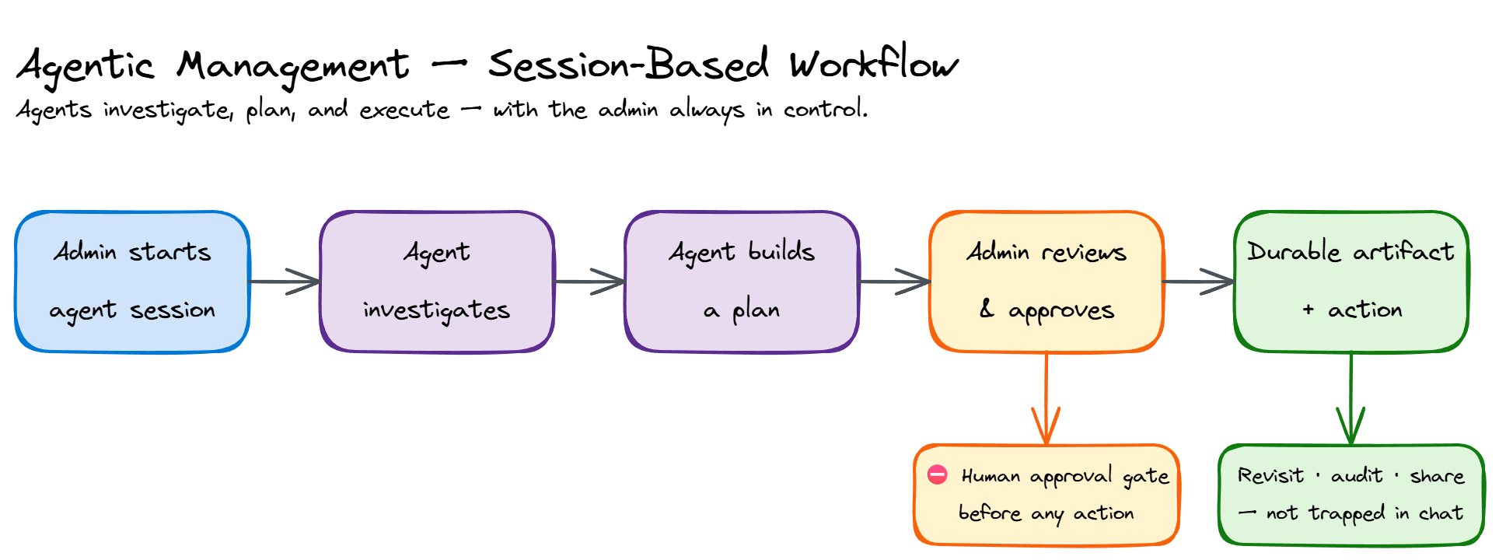
Abstracted agent session flow — a diagram I recreated for portfolio use (not internal artwork).
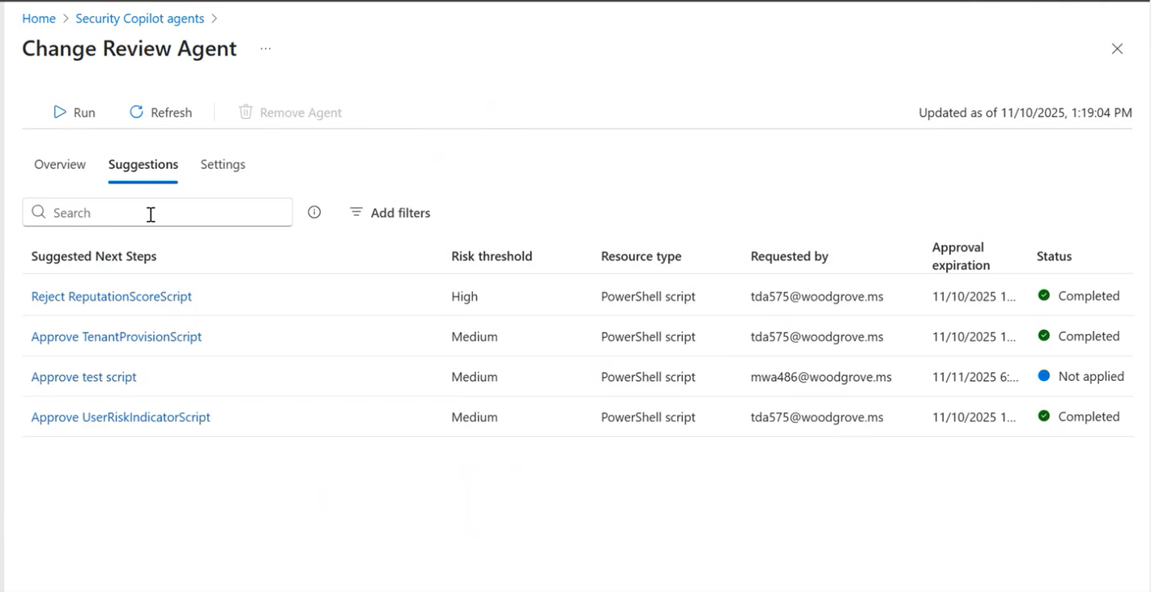
Change Review Agent — same Suggestions/approve pattern. Multiple shipped Intune agents reuse the framework I led (published by Microsoft).
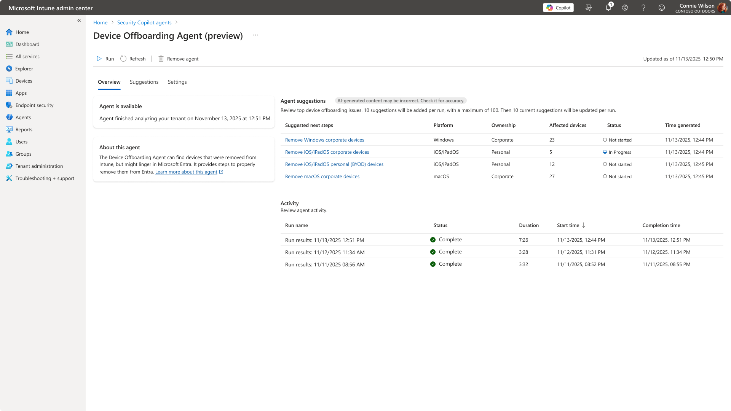
Device Offboarding Agent — shared agent framework. Evidence of pattern adoption across teams; my contribution is the design system, not the pixels.
02 — AI-ASSISTED EXECUTION
CVE Vulnerability Remediation Agent
Lead UX · Public Preview → GA planning
BEFORE Security teams found problems; IT teams manually translated them into fixes — slow, fragmented, coordination-heavy.
AFTER The agent converts vulnerability intelligence into remediation plans, ready for administrator review and approval.
PROBLEM
A single CVE requires understanding risk, identifying affected devices, creating deployment groups, choosing a strategy, and deploying — usually stitched together by hand across security and IT teams.
MY ROLE
Lead UX for the Intune Vulnerability Remediation Agent — author, presenter, reviewer, and design owner across Public Preview and GA planning. Led design from start to finish, establishing new patterns for prioritization workflows and remediation guidance, and led the Intune agent demo for the first public showcase of Security Copilot Agents to the press (RSA).
KEY DESIGN DECISIONS
Generate remediation plans automatically
Why: surface impacted devices, recommended actions, and deployment guidance instead of forcing admins to build plans from scratch.
Keep the administrator in the loop
Why: admins review, customize, and approve before anything deploys.
Dedicated vulnerable-device groups
Why: targeted groups simplified execution and established clear remediation scope.
Deliberate MVP simplification
Why: a strong tradeoff story — reduced interaction complexity for the MVP (plans, review, approval) while keeping an ambitious autonomy roadmap: assisted → automatic → safe rollouts → expanded coverage.
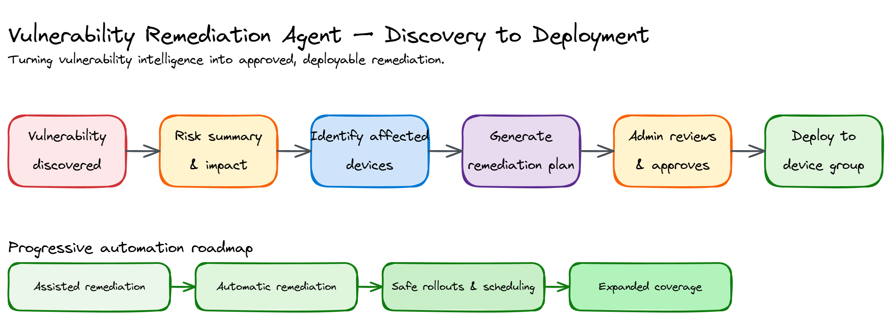
Abstracted remediation flow I recreated (discovery → plan → approval → deploy).
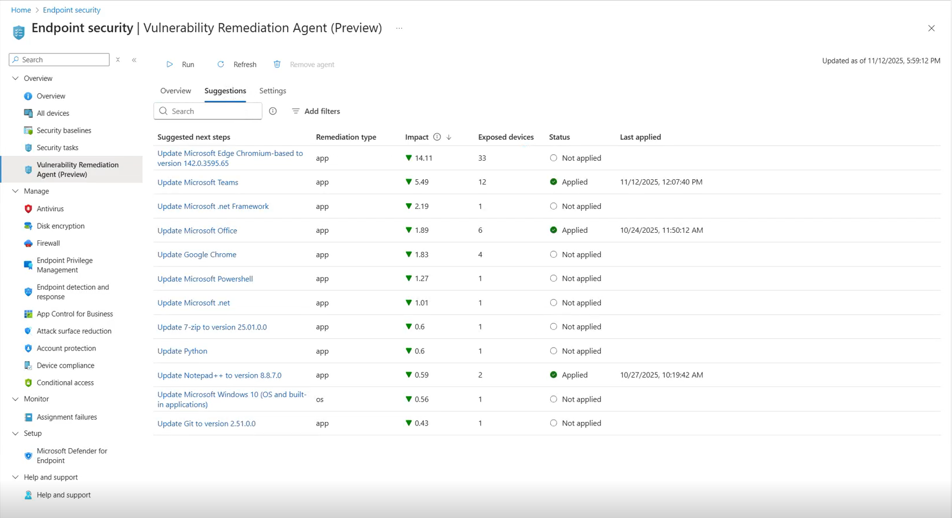
Prioritized suggestions — shipped feature, published by Microsoft (learn.microsoft.com).
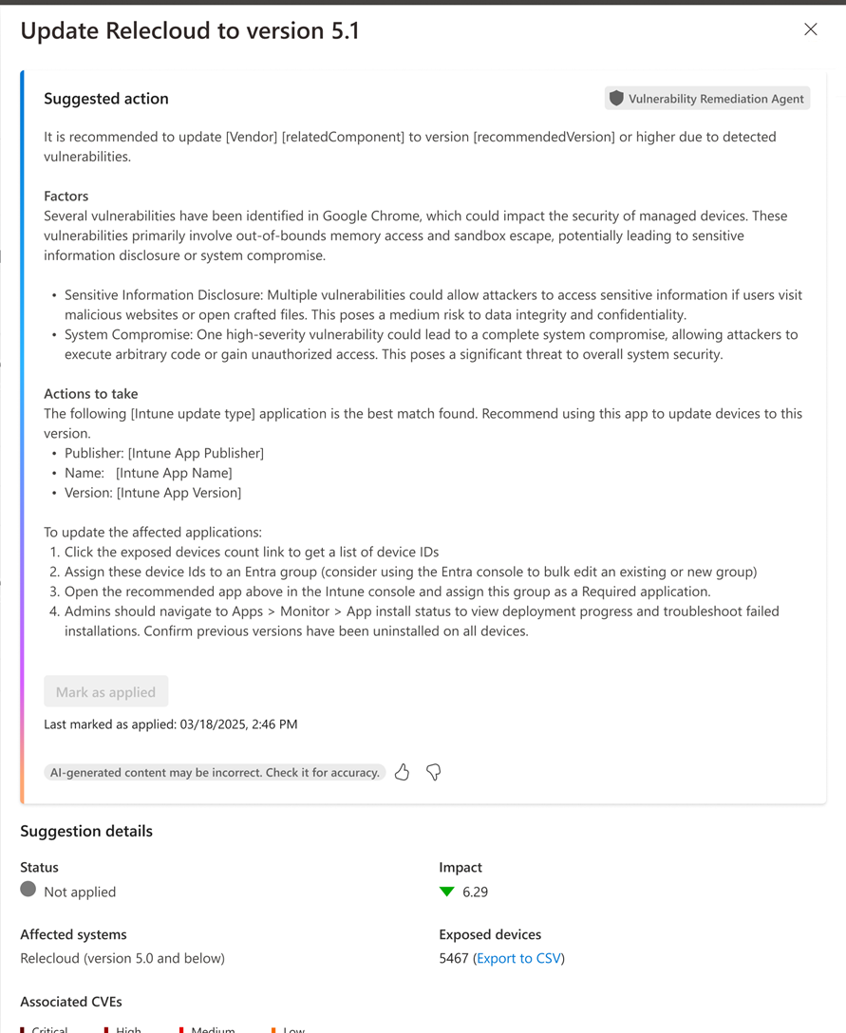
Suggestion detail & remediation steps — published by Microsoft. My contribution is the interaction design and flows, not the pixels.
03 — AI-ASSISTED ANALYSIS
NL2KQL Copilot (Natural Language → KQL)
Lead designer · Approved for Private Preview
BEFORE Valuable operational data required specialized query skills — KQL, exports, scripts, custom dashboards.
AFTER Natural language became the interface to enterprise management data.
PROBLEM
Admins needed answers from device and management data but had to learn KQL, export data, and build scripts — leaving many insights inaccessible to non-experts.
MY ROLE
Lead designer for the Device Query Copilot / NL2KQL proof-of-concept and interaction model, including dedicated Figma POC flows. Established the foundational Intune Resource Graph / Explorer design and enabled a smooth design-ownership handoff to a teammate, and mentored a designer on analytics IA and entry points.
KEY DESIGN DECISIONS
Focus on common admin questions
Why: target recurring scenarios (inventory, configuration, compliance, app & update status) instead of exposing full query power at once.
Make AI-generated queries transparent
Why: the real challenge wasn’t generating KQL — it was building trust. Show the generated query, validate it, handle errors gracefully.
Reduce reliance on exports and scripts
Why: let admins ask natural-language questions directly against Intune data.
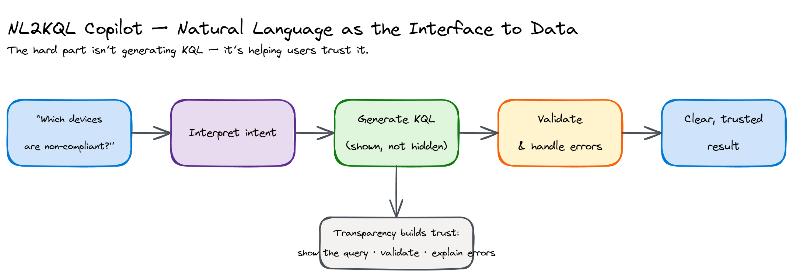
Abstracted intent → query → validated-result flow I recreated for portfolio use.
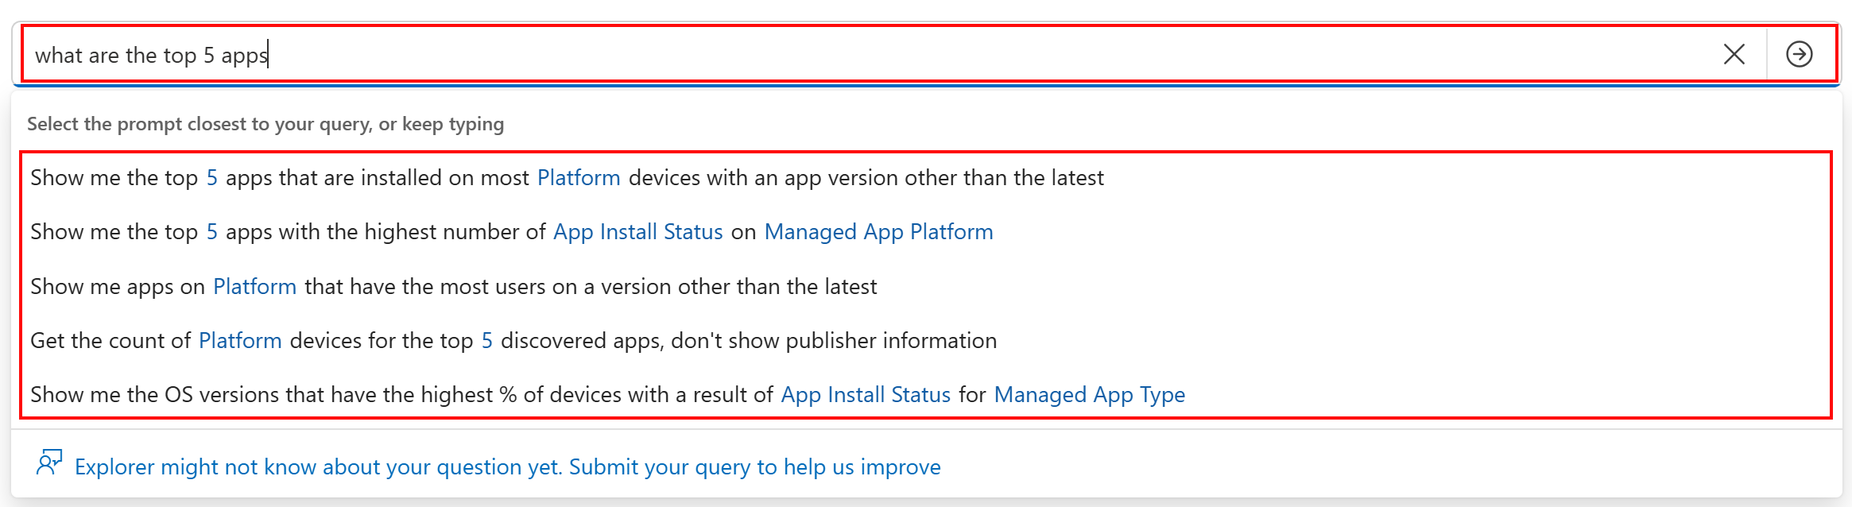
Natural-language prompt (Intune Explorer) — shipped feature, published by Microsoft.
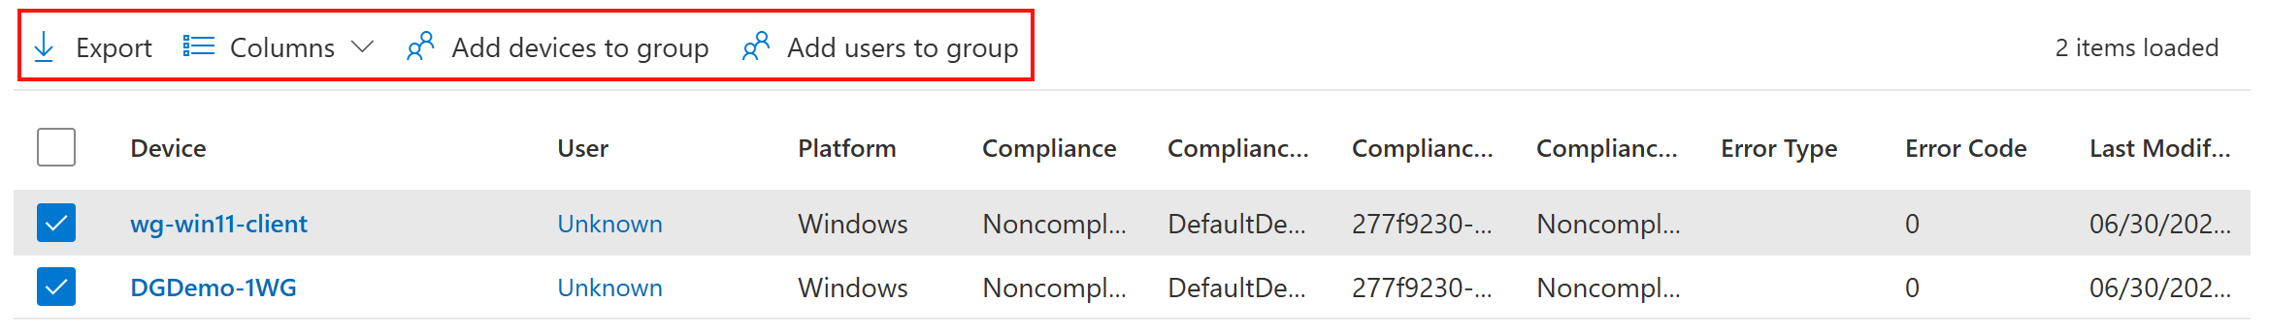
Results view — published by Microsoft. My contribution is the NL2KQL interaction model and trust patterns.
04 — MANAGING AGENTS AT SCALE
AI Governance & Administration Patterns
Principal designer · Cross-product patterns & research
BEFORE AI governance was an abstract policy problem, disconnected from day-to-day admin tools.
AFTER Governance became a concrete administrator experience — ownership, observability, approval, and control built into the product.
PROBLEM
The industry shifted from “how do I use AI?” to “how do I manage hundreds of agents safely?” Organizations worried about blast radius, access control, accountability, approval, observability, and ownership.
MY ROLE
Principal designer defining administration and governance patterns that scale across Microsoft admin experiences — agent management, governance frameworks, approval and supervisory models, and control surfaces.
RESEARCH INSIGHTS → DESIGN PRINCIPLES
- Humans remain responsible — admins universally wanted approval, oversight, and accountability for high-impact actions.
- Fleet management matters — the challenge isn’t one agent; it’s centralized oversight, monitoring, and supervisory control over many.
- Governance must be integrated — admins want a single operational experience, not permissions here, logs there, monitoring elsewhere.
SIGNATURE PATTERNS
Separation of management & execution · Durable auditability · Human-in-the-loop checkpoints · Agent observability · Centralized governance surfaces · Clear ownership models
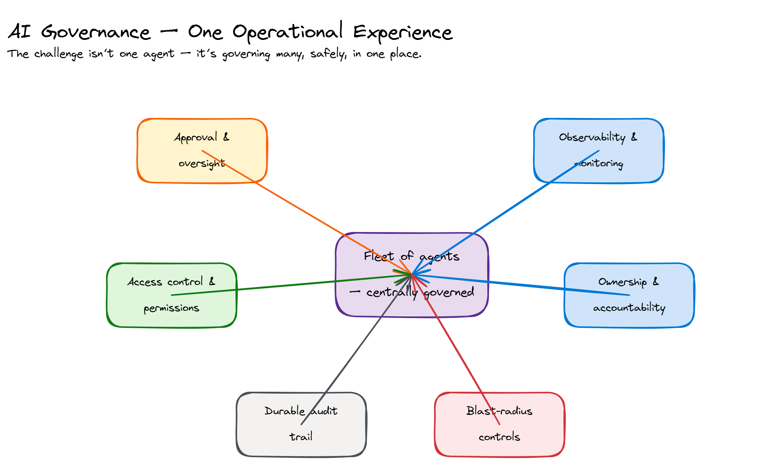
Abstracted governance / administration hub I recreated for portfolio use.
FOUNDATIONAL PRODUCT WORK — WINDOWS 365 / CLOUD PC
Before the agentic arc above, I spent ~3.5 years (roughly 2021–2024) leading admin & management UX for a brand-new product: Cloud PC / Windows 365, delivered through Intune. This is the enterprise foundation the AI work builds on.
05 — NEW-PRODUCT ADMIN UX
Windows 365 / Cloud PC — Provisioning, Health & Shared Cloud PCs
Design lead / Design owner · Pre-launch → Private Preview & GA
BEFORE A brand-new virtualization product with no established admin model — fragmented provisioning, unclear navigation, and no way to see whether Cloud PCs were healthy.
AFTER A coherent admin experience: guided provisioning, a Cloud PC health dashboard, shared/Frontline Cloud PCs, and navigation that matched how admins actually think.
PROBLEM
Windows 365 introduced Cloud PCs into Intune with no precedent for how admins would provision, assign, monitor, and troubleshoot them. Early research showed admins confused Windows 365 / Microsoft 365 / Office 365, and treated provisioning as separate from ongoing management.
MY ROLE
Design lead for the Intune-based Cloud PC admin experiences and Design Owner for Windows 365 Frontline (later Flex) shared Cloud PCs — from the early pre-launch phase through Private Preview and GA. Partnered with PMs Sam Tulimat, Christiaan Brinkhoff, and Colby Hanley, content by Kay Jorgensen, and research by Abena Edugyan.
KEY DESIGN DECISIONS
Guided scenarios for first-time setup
Why: provisioning spanned many objects, settings, and assignments — a guided flow reduced what admins had to assemble and prevented common assignment errors.
Design a Cloud PC health dashboard (“Fitness Tracker”)
Why: admins couldn’t tell if Cloud PCs were healthy — surfacing connection quality, latency, crashes, and health scoring in Endpoint analytics made problems visible proactively.
Own the shared / Frontline (Flex) model
Why: a partial-use, shared-license Cloud PC (up to 4 workers, one at a time) needed its own provisioning, management, and reporting — shipped to Private Preview.
Rename “Windows 365” → “Cloud PC creation” (research-backed IA)
Why: usability research showed the old label caused product confusion; the new name plus a Device Onboarding section matched admin mental models of create vs. manage.
Content strategy for troubleshooting
Why: chose “Attempt to repair connection” over “Troubleshoot” (which already meant something else in Intune) to set correct expectations about what the action does.
Honest scope note: this work is strongest as admin & management UX in Intune, not broad end-user client design; hard quantitative outcomes weren’t tracked, so it’s framed by role, decisions, and shipped surfaces.
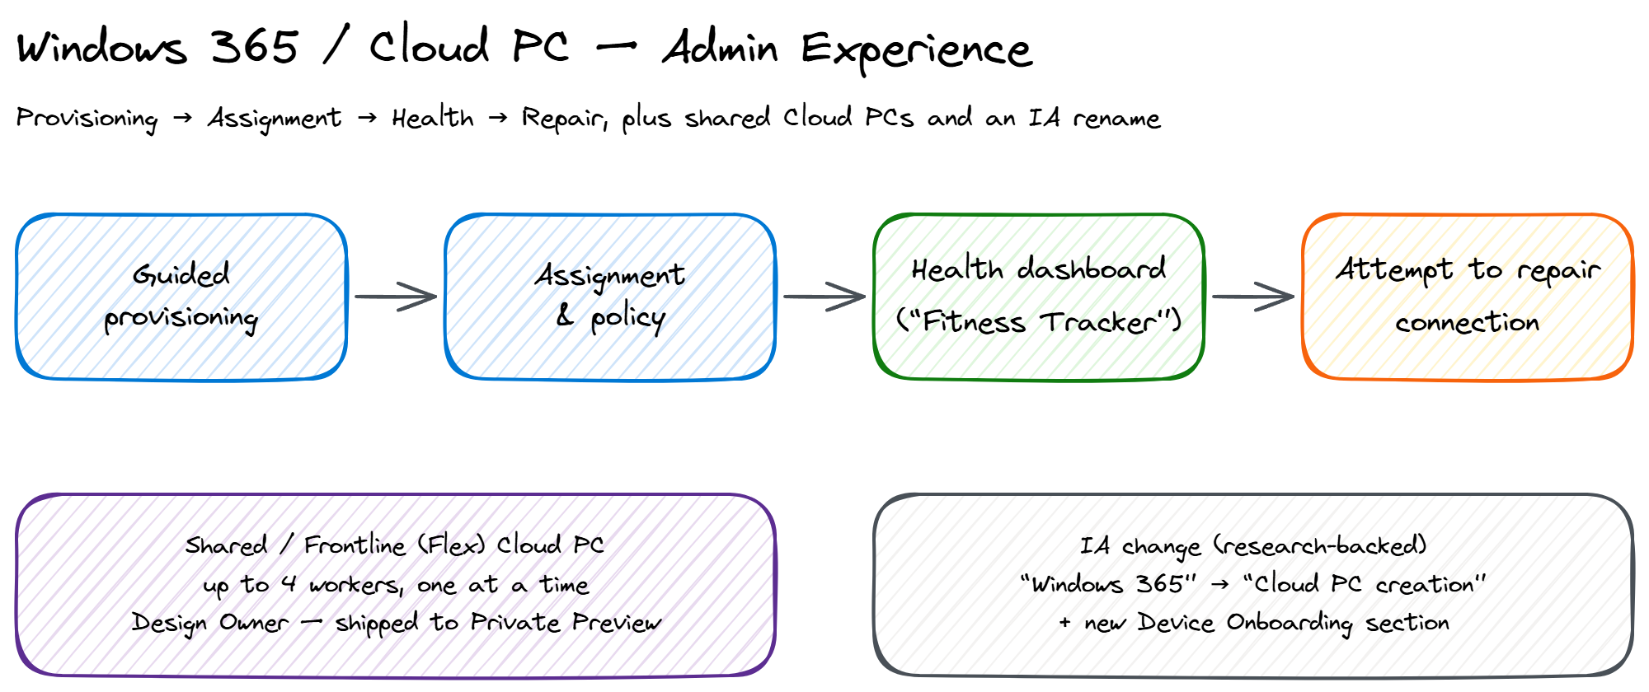
Abstracted Cloud PC admin experience I recreated — provisioning → health → repair, shared (Flex) Cloud PCs, and the “Windows 365” → “Cloud PC creation” IA change.
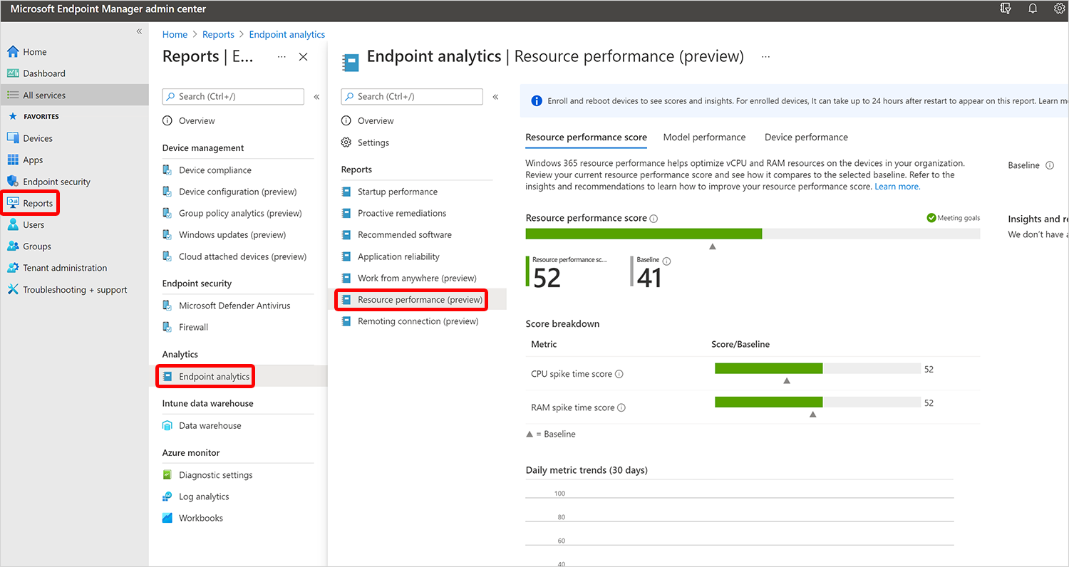
Cloud PC health / resource performance in Endpoint analytics — shipped feature, published by Microsoft.
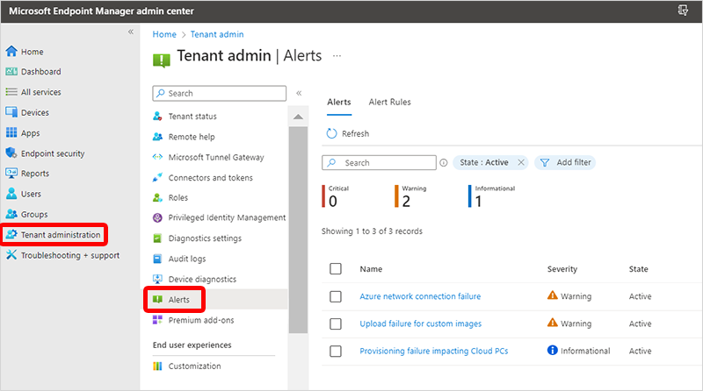
Cloud PC alerts & monitoring — published by Microsoft. My contribution is the design of these management/health experiences, not the pixels.
WHAT COLLEAGUES SAY
Verbatim excerpts from written peer feedback (Microsoft Connect). Names and dates on file.
“Your leadership in laying the foundational design for IRG was nothing short of masterful… I’ve learned so much from watching how you navigate ambiguity with grace and how you advocate for both users and design integrity without ever losing momentum.”
— Arisa Conwell, Senior Product Designer · May 2025
“You deserve a medal for the gauntlet you ran on this agent sprint… you had the most challenging set of conditions to address… your tenacity and commitment were the only reason that work was delivered at all.”
— Sunder Srinivasan, Principal Product Design Manager · May 2025
“You do a great job taking sometimes nebulous requirements from a variety of sources and turning them into amazing designs! I’m always impressed about how you handle it and deliver results.”
— Beth Woodbury, Senior Content Designer · May 2025
“You have the amazing ability to think across both UX and business goals… Your persistence and progress in driving the Cloud PC integration strategy, helping build consensus and creating clarity on the path forward has been impressive.”
— Sindhia Thirumaran, Product Designer · May 2023
“Amanda keeps amazing me with the amount of experience, matureness, and eagerness shaping the future of our Windows 365 product… she returns phenomenal designs afterward that do not need that many edits! A great partner.”
— Christiaan Brinkhoff, PM, Windows 365 · May 2023
“I can give you a tricky set of requirements (often driven by exec, which can be particularly tricky) and have confidence the right design will be built… which takes a load of pressure off me.”
— Matt Shadbolt, PM, Windows 365 · May 2022
CORE SKILLS
AI / Agentic UX • Enterprise & Admin UX • Windows 365 / Cloud PC • Design Systems & Reusable Patterns • Interaction Design • Design Strategy (JTBD, North Star, MVP tradeoffs) • AI-first Prototyping (VS Code + GitHub Copilot) • Accessibility • RBAC • Copilot for Security • Cross-functional Leadership & Mentoring • Figma
Note: This portfolio describes my role, process, and design decisions in my own words. Add only publicly shipped work or abstracted visuals you recreate — never confidential or unreleased company materials.

