# CS 255 System Design Document

## UML Diagrams

### UML Use Case Diagram

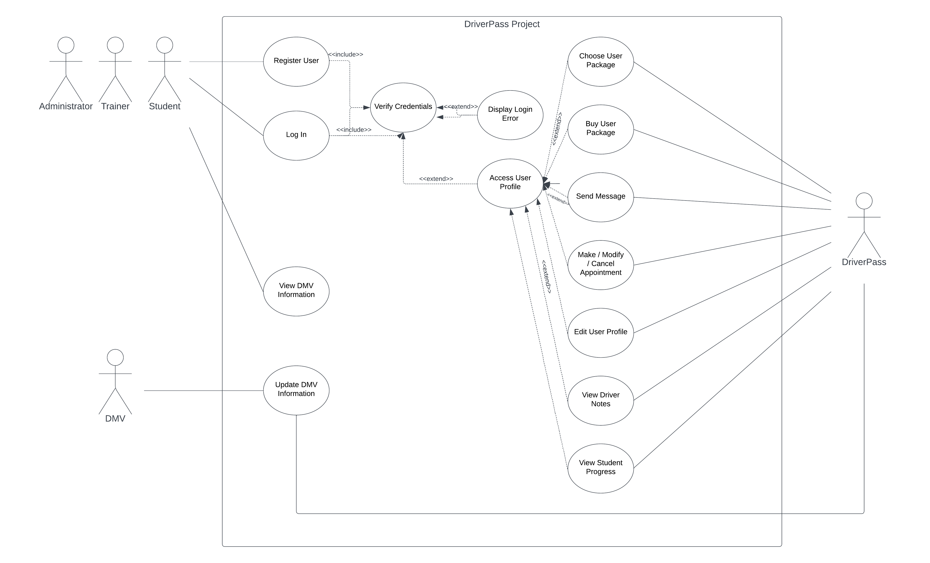

### UML Activity Diagrams

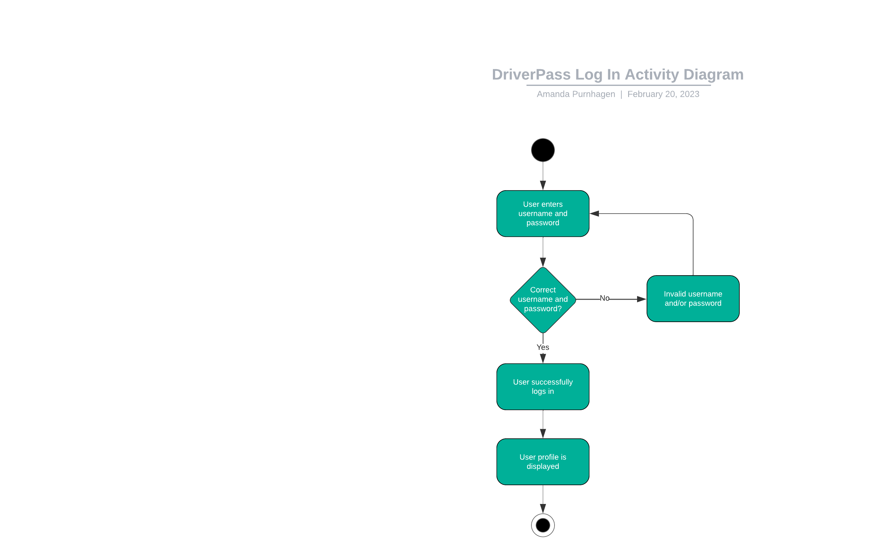

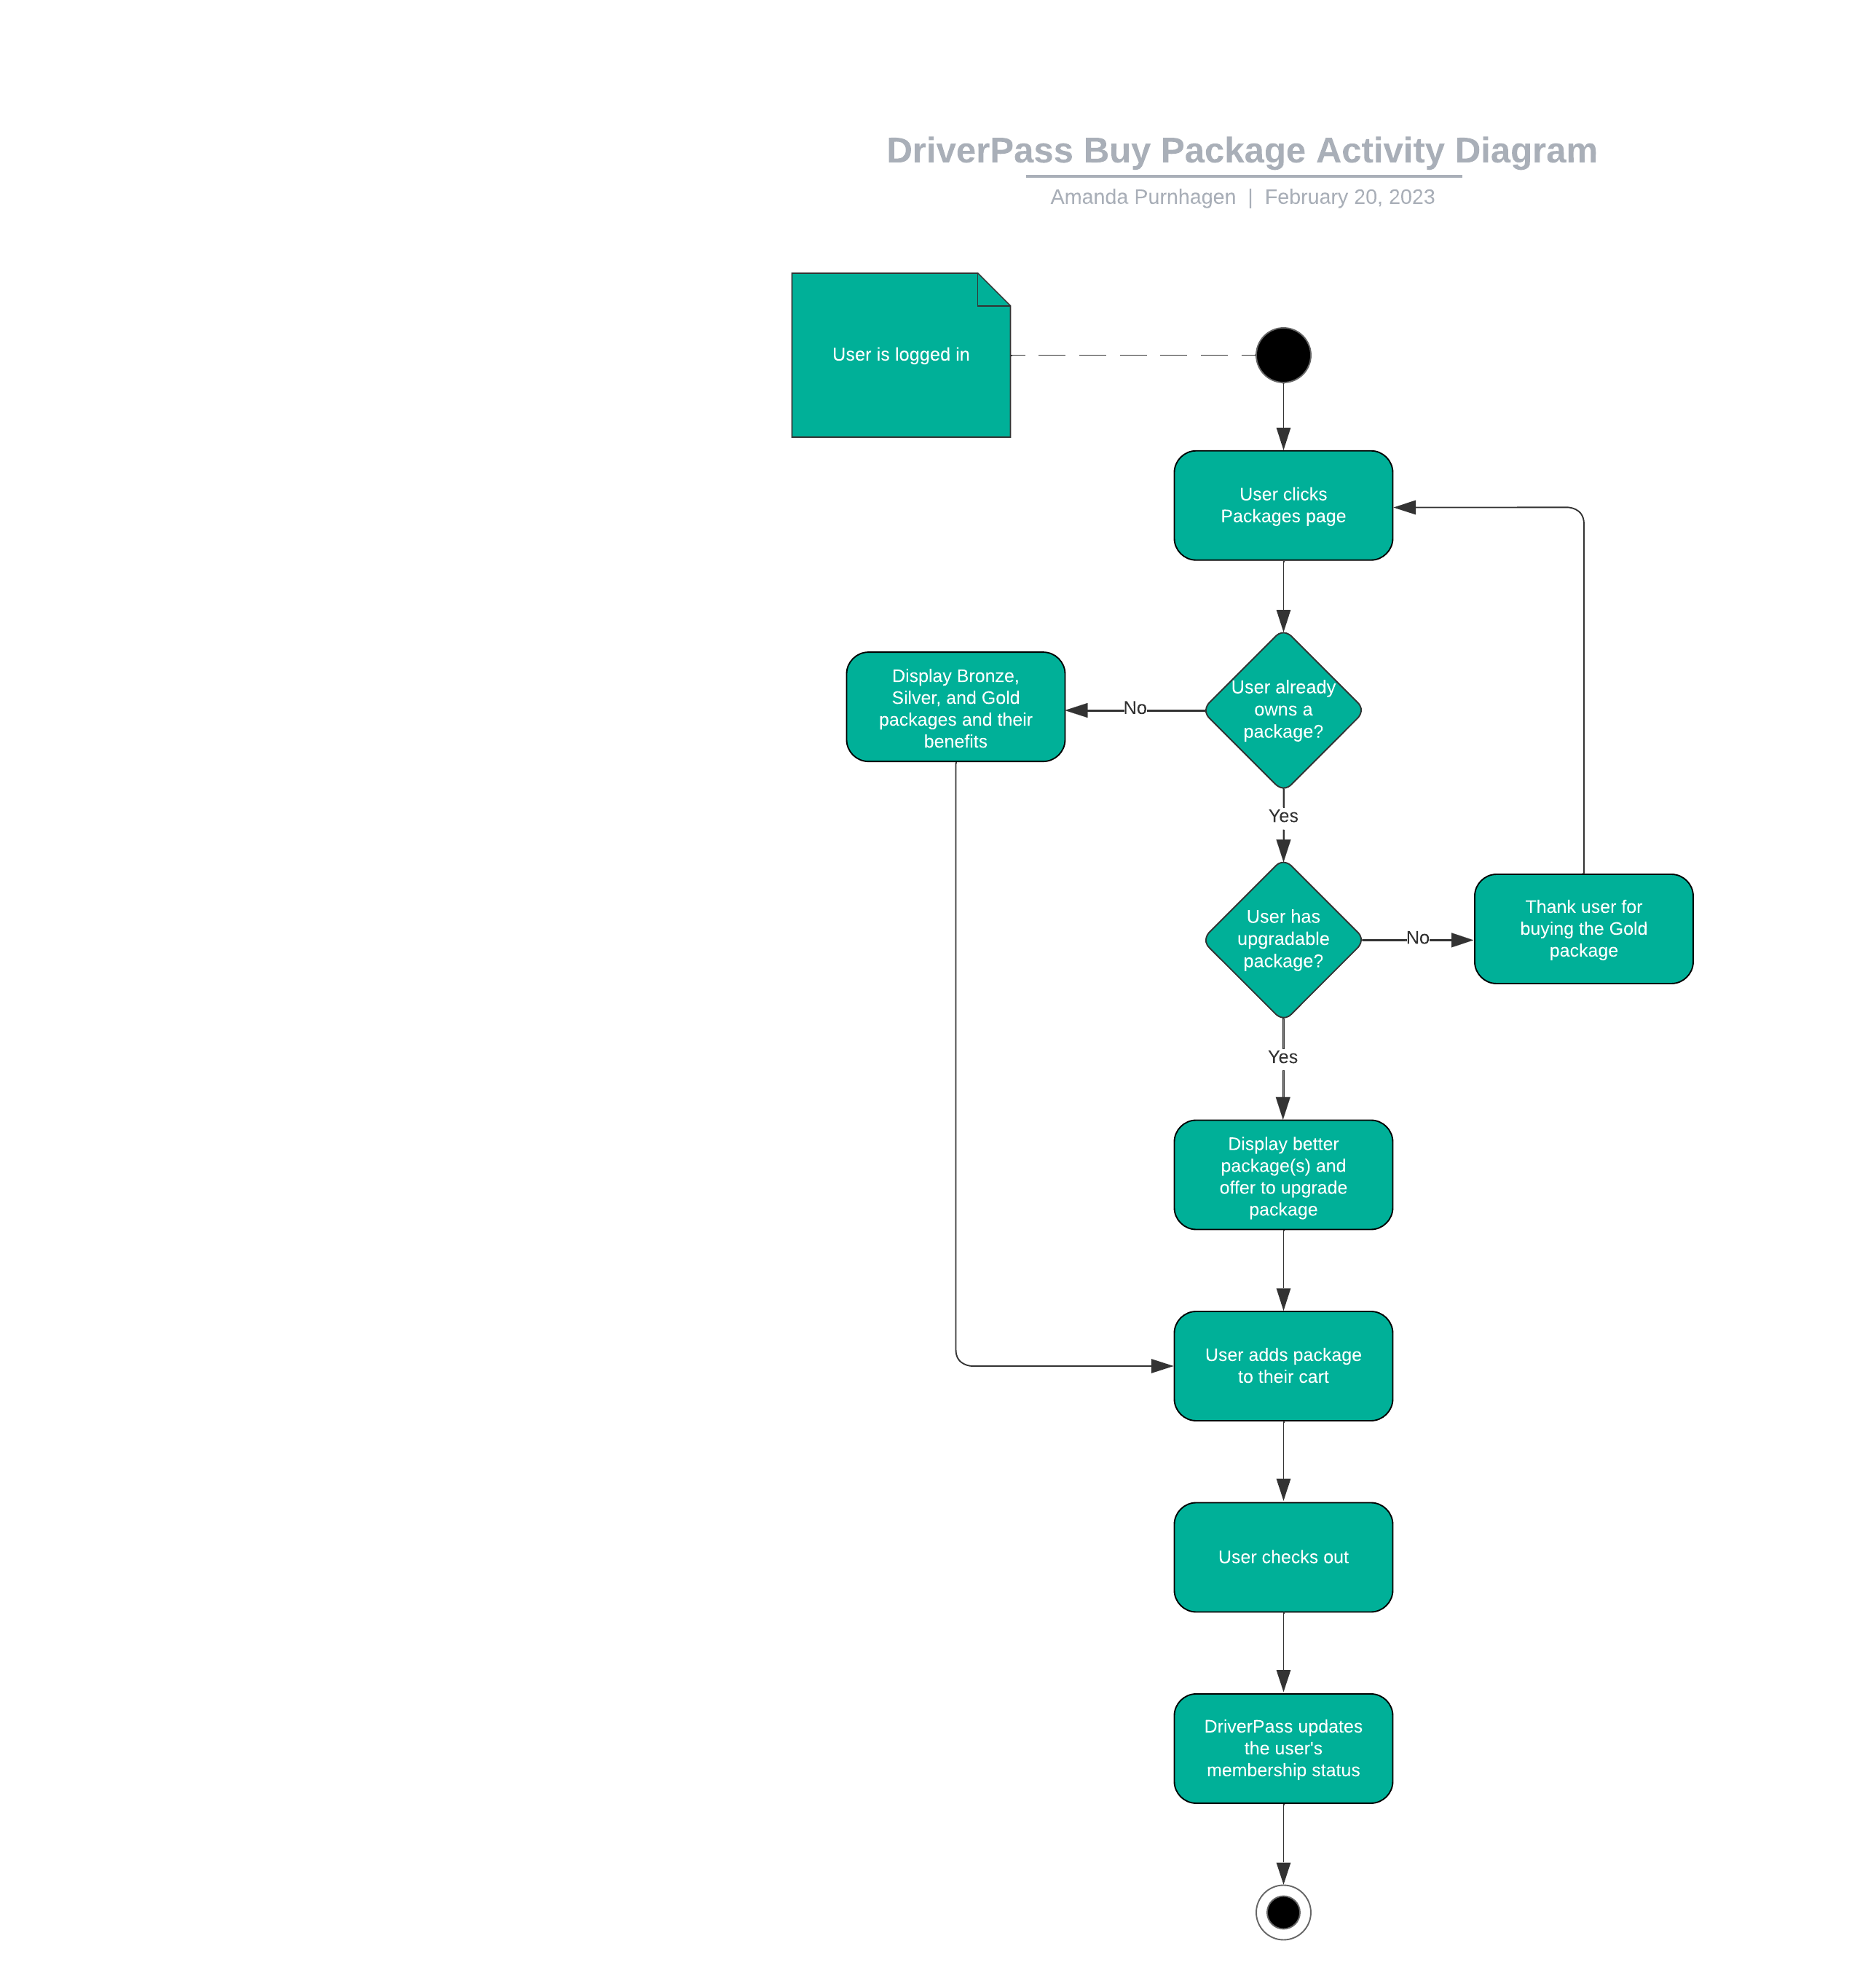

### UML Sequence Diagram

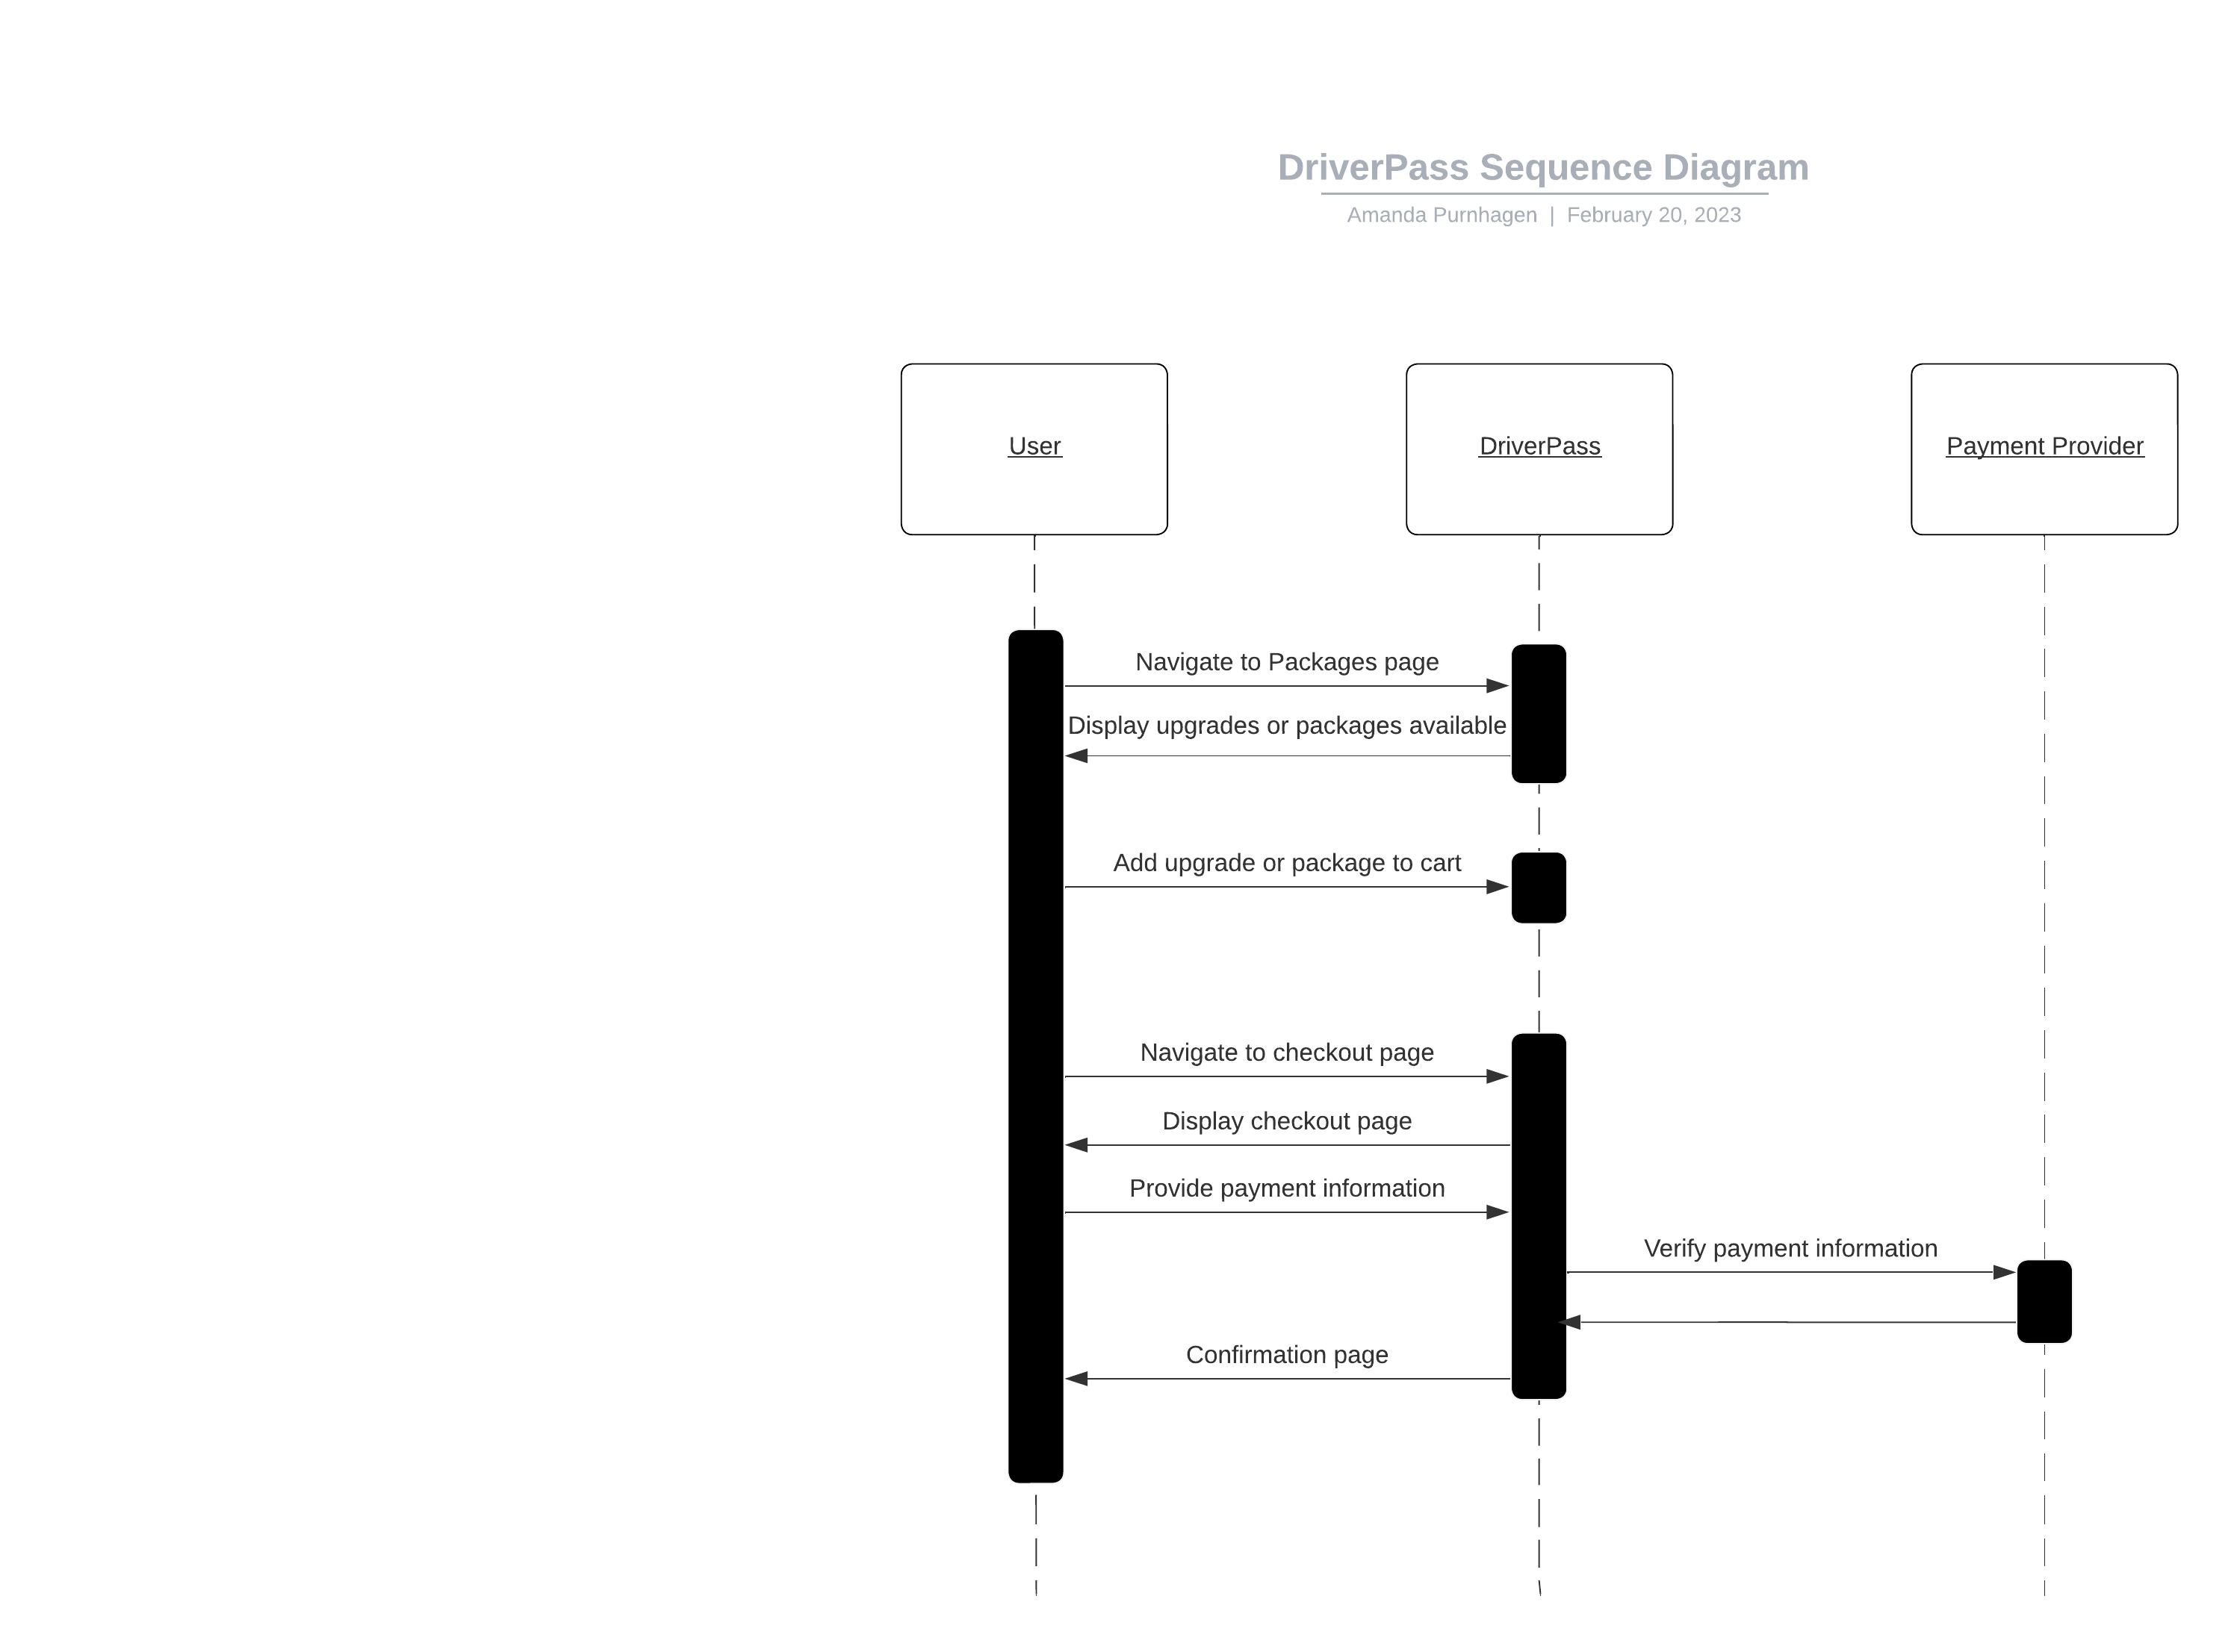

### UML Class Diagram

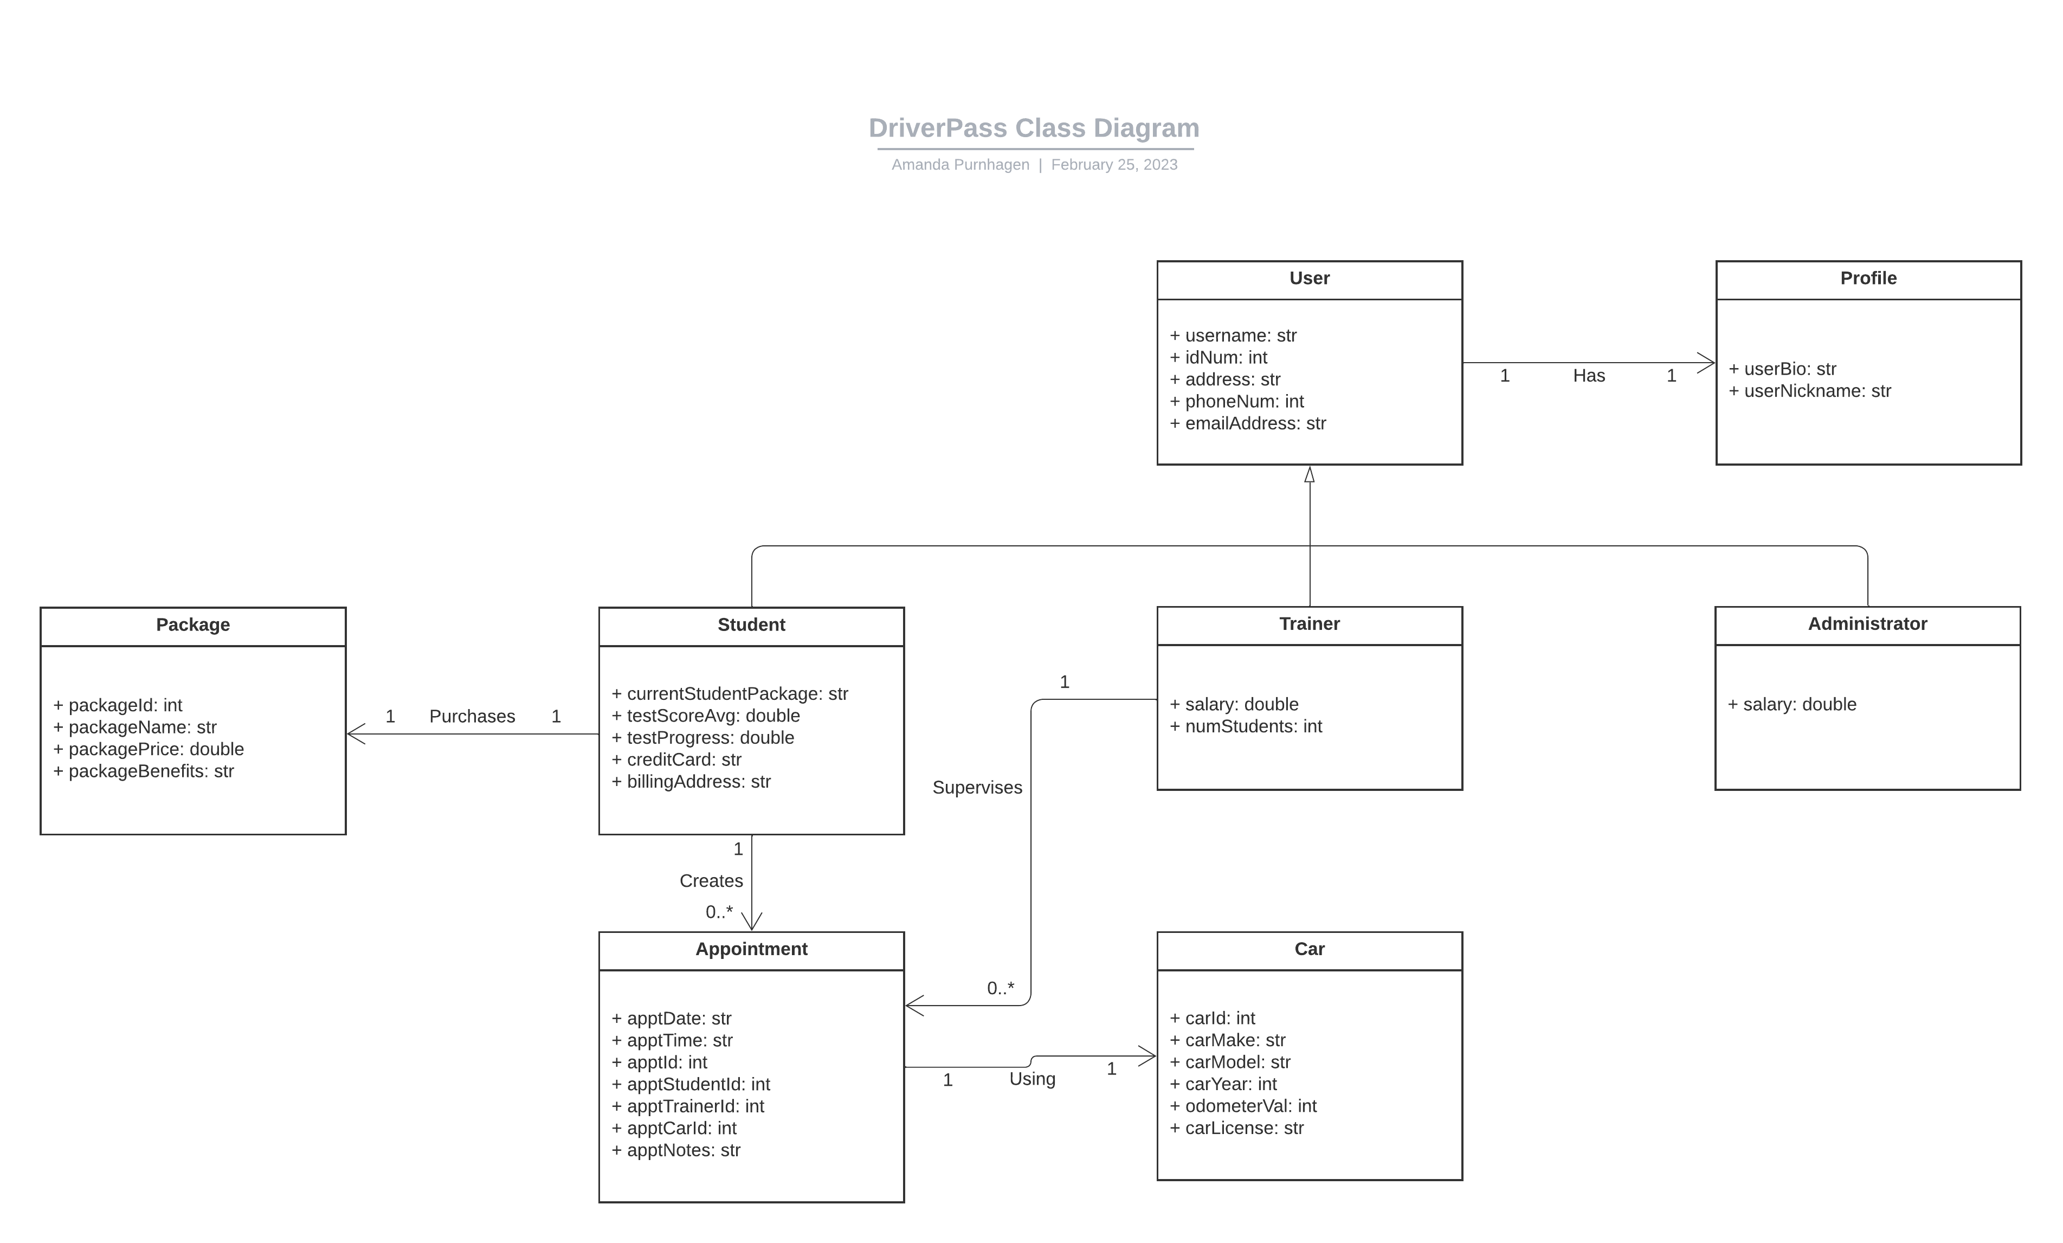

## Technical Requirements

*[Based on the diagrams you have created, describe the technical requirements of your system. These requirements should address the required hardware, software, tools, and infrastructure necessary for your system design.]*

Our consulting company has concluded that the DriverPass system will run on Alpine Linux and include a Redis database linked to the interface. The system will run as a web-based application using a third-party cloud service. Therefore, DriverPass will have low upfront costs for hardware. The system will support users across the nation with a response time of five seconds or less on any major desktop browser or LTE connection. The system will be backed up every night when, on average, the lowest number of users are on. This will ensure that up-to-date data is accessible anywhere. The software will be written in the object-oriented programming language C++ and include the objects displayed in the DriverPass Class Diagram. DriverPass will interact with major payment providers in order to verify and complete transactions. The use of the DriverPass system will of course require access to electricity and internet and will depend on the availability of all third-party services.