Proposal for SPOOL OF THREAD Emoji
Submitted by: Amanda Hickman, Amberley Romo
Date: July 1, 2017

Abstract
We are requesting the addition of a SPOOL OF THREAD to the emoji character set. Though the making, mending and wearing of textiles is a defining characteristic of human society the current emoji character set includes no sewing or textile related emoji. The SPOOL OF THREAD helps fill a significant gap in the tools category.

Introduction
The SPOOL is a cylinder, usually flanged (having a rib, or rim), around which thread is wound for distribution and use. In addition to thread, wire, cable, paper, film, straps or tape may also be wound onto SPOOLS.

Though the emoji character set includes glyphs for a number of tools: 🔨 🔧 and 🔩, there are no glyphs for the making, mending, or maintenance of textiles. Notably, the available tool glyphs are all strongly associated with trades traditionally dominated by men (carpentry, construction, maintenance of machines).

Alongside the NEEDLE AND THREAD, YARN, and SAFETY PIN, this is one of several textile proposals that fill a notable gap in the character set.

History
We were not able to find much data on the history of the spool but the very earliest sewing machines dating to the 1790s depended on thread that was wound onto a spool. Some researchers date the first spools to the mid 1700s shortly after the invention of the spinning jenny. Nonetheless, since spools became widely available in the early 1800s, the spool has been in active use as a core industrial building block and consumer product. A search of Ali Baba yields over 200,000 different spool varieties available for purchase. They come in all sizes, empty or loaded up with thread or plastic filament or welding wire, made out of wood, metal, cardboard or plastic.

Names
(Suggested short name and keywords, as in the Emoji List).
- THREAD
- SPOOL | BOBBIN | FLOSS

Images
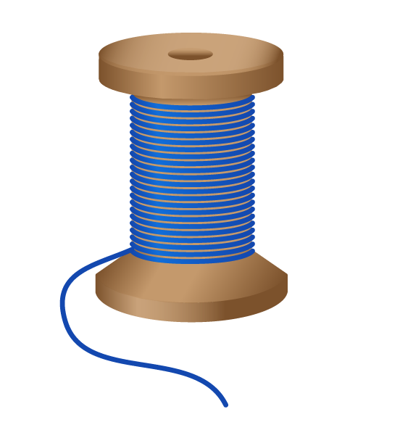

Artwork created by Cherin Sanih

Selection Factors Inclusion

A. Compatibility
We are not aware of an existing SPOOL OF THREAD emoji or icon.

B. Expected Usage Level

Frequency

There is nowhere in the world today where the SPOOL isn't used. Because an emoji for SPOOL or THREAD is requested frequently (see below) and because it has a wide range of possible alternative usages in computing, we believe that the SPOOL will be used very widely.

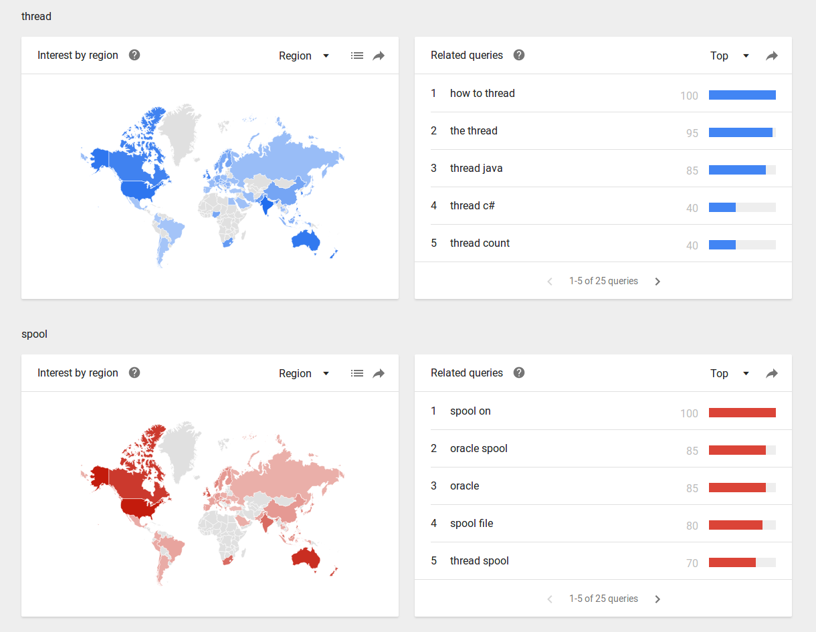

Multiple Usages
In addition to sewing thread, a SPOOL OF THREAD can indicate spools of fishing line, wire, electric cable, or 3D printer filament — all are stored in the same basic manner.

In computing, SPOOLING refers to a process that combines queuing and buffering, so a SPOOL glyph can also be used to indicate waiting line or balancing multiple tasks.

A threaded conversation could also be represented by a SPOOL. Indeed, many Twitter users have remarked that they'd love a glyph to represent "thread" in a threaded conversation:


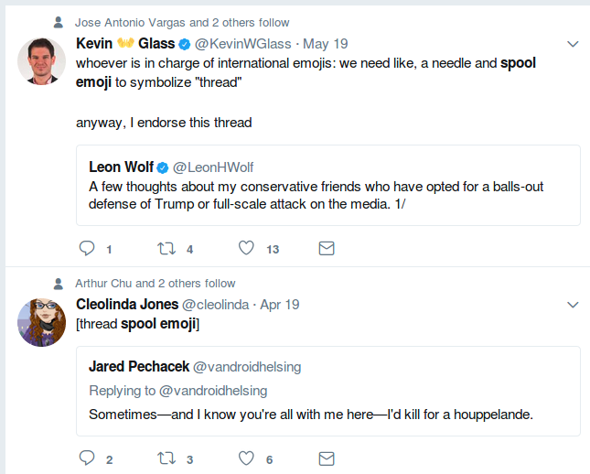

C. Image Distinctiveness
A SPOOL is not likely to be confused with an existing emoji.

D. Completeness
As described earlier, a SPOOL OF THREAD emoji would help fill a notable gap in the tools category.

E. Frequently Requested
SEWING and KNITTING, close cousins in the category of crafting, were among the top emoji requests on Emojipedia in 2016 and 2017. And Twitter users regularly lament the absence of a spool/thread emoji.

Selection Factors Exclusion

F. Overly Specific
Any number of filaments can be stored on a SPOOL — from fine threads to industrial cables. A spool might be made of of plastic, metal, bone or wood. The SPOOL glyph can represent any of these uses.

G. Open Ended
We believe that, along with the SAFETY PIN, KNITTING NEEDLES, YARN, and NEEDLE AND THREAD proposals, this proposal fills a notable gap in the character set. Though the tools for building furniture and machines are well represented in the tools category, the tools necessary to create and maintain textiles are notably absent. This proposal fills that gap.

H. Already Representable
There is currently nothing close. ➰ and ➿ are sometimes used to represent string or thread. 🍝 PASTA or 🍜 STEAMING BOWL emojis are sometimes used because pasta and noodles are thread-like in appearance. But all of these are clearly inadequate.

I. Logos, brands, UI icons, signage, specific people, deities
A search of the WIPO Trademark Database for logos with "Image Class: US.09.01.01" (or "thread or wool, wound or unwound") turns up twelve hundred different logos that incorporate thread, yarn, or spools in some way. These common household objects that are too generic to be a trademark for any one brand.

The images we are submitting do not have any significance that would make them
unsuitable for encoding as a character. There are no copyright, religious, or issues that
reference anyone historic or living.

J. Transient
There is no reason to think that humans will stop winding thread onto SPOOLS anytime soon.

K. Faulty Comparison

Sort location
(Proposed sort location for the emoji in Emoji Ordering)
- Object-textiles, after tool and before medical

Other Information

Author Bios
Amberley Romo (amberleyjohanna@gmail.com) is a software developer and avid knitter. Amberley grew up (and currently lives in) Texas, and has been very involved in the fiber arts communities of both Washington, DC and Austin, TX. She is passionate about knitting as a meditative practice, and community activity.

Amanda Hickman (amanda@velociraptor.info) runs a fellowship program that helps creative technologists collaborate with journalists on storytelling and audience engagement projects. She has been sewing since she was six years old, and cherishes the independence afforded by mending, altering and making her own clothes.

Character Properties
The other character properties are suggested to be defined as follows.
General Category:
Canonical Combining Class:
Bidirectional Class:
Decomposition Type:
Decomposition Mapping:
Numeric Type:
Numeric Value:
Bidirectional Mirrored:
Name:
ISO Comment:
Simple Uppercase Mapping:
Simple Lowercase Mapping:
Simple Titlecase Mapping:

https://www.merriam-webster.com/dictionary/flange
https://en.wikipedia.org/wiki/Sewing_machine#Invention
http://sewalot.com/sewing_machine_threads.htm
https://www.alibaba.com/trade/search?fsb=y&IndexArea=product_en&CatId=&SearchText=spool
http://blog.emojipedia.org/top-emoji-requests-2016/
http://blog.emojipedia.org/top-emoji-requests-2017/
http://www.wipo.int/branddb/en/

