Proposal for YARN and KNITTING NEEDLES Emoji
Submitted by: Amanda Hickman, Amberley Romo
Date: July 1, 2017

Abstract
We are requesting the addition of a YARN emoji as well as a KNITTING NEEDLES emoji. Together these would fill a gaping hole in the extremely limited craft and textile sets.

Introduction
Though the emoji character set includes glyphs for a number of machinery and construction tools (eg. 🔨 🔧 and 🔩) there are no glyphs for the making, mending, or maintenance of textiles. Notably, the available tool glyphs are all strongly associated with trades traditionally dominated by men, while trades and crafts such as knitting and sewing have historically been associated with women's work and interests.

History
The verb "to knit" was added to the Oxford English Dictionary in the 1400s, and knitting remains a hugely important textile production process. Because the simplest knitting needle is indistinguishable from a sharpened stick, and the earliest material that humans would have knit with are all plant or animal based and quick to decompose, we know very little about the early history of knitting. The oldest known example of a knitted object dates back to 11th century Egypt but the complexity of the design of those ancient Egyptian socks suggest that knitting was not new, even then.

YARN is even older than knitting. Our Paleolithic ancestors twisted fibers into yarn tens of thousands of years ago, and there's no reason to think they did not wind it into balls.

Names
(Suggested short name and keywords, as in the Emoji List).
- KNITTING NEEDLES
- KNIT | KNITTING| | FRENCH KNIT | PURL

- YARN
- TWINE | STRING | ROPE | CORD | WOOL

Images
Artwork created by Cherin Sanih / cherinsanih.com

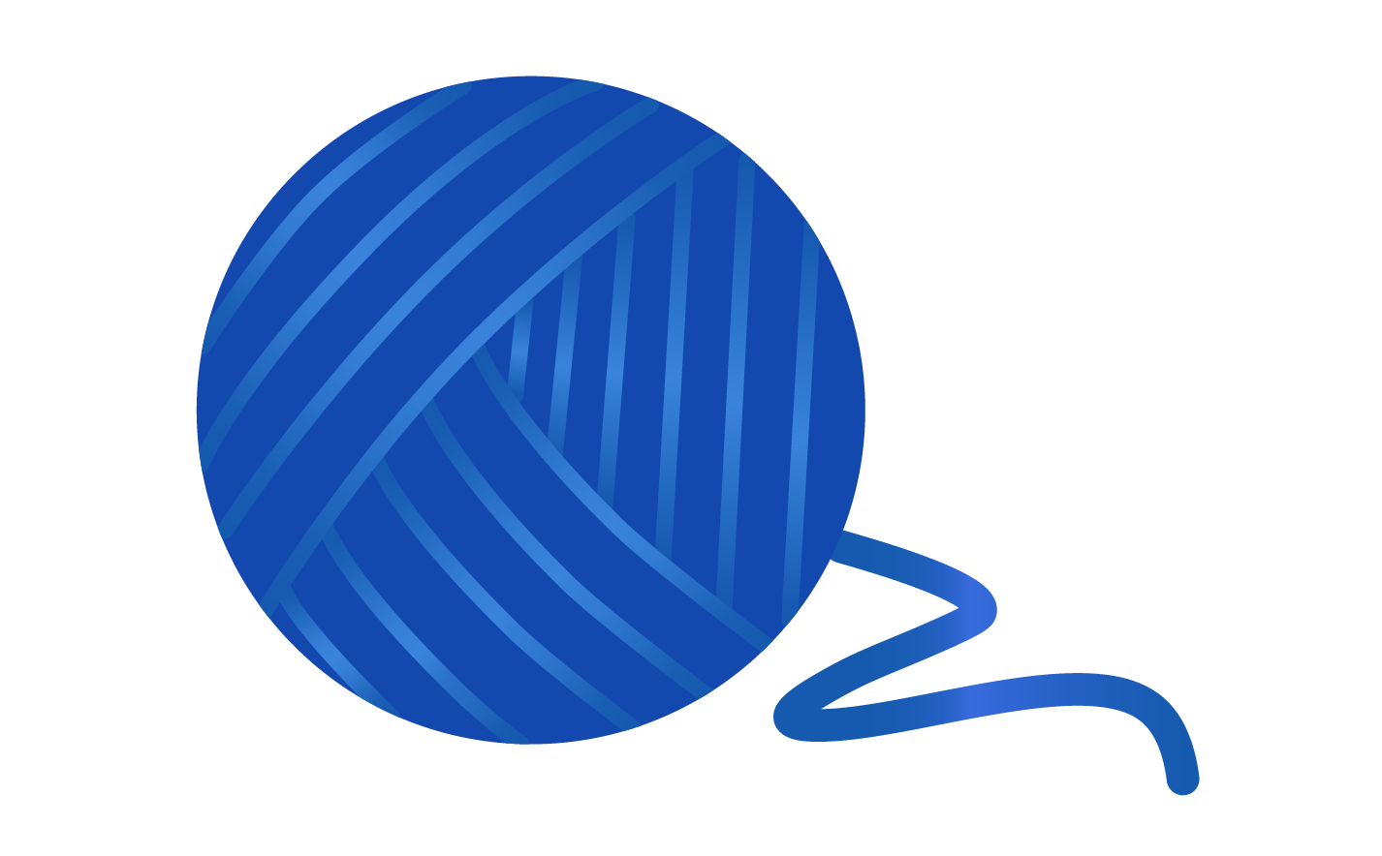
Artwork created by Cherin Sanih / cherinsanih.com

Selection Factors Inclusion

A. Compatibility
Currently, there are no yarn or fiber-art related emojis in use by major platforms. There is a released app (Craftmoji) which supplies craft stickers/imagery.

B. Expected Usage Level

Frequency
There is a very high expected frequency of use, worldwide. The practice of fiber arts in general (including, but not limited to, knitting and crochet) is global. Ravelry, the largest and most prominent online community of “knitters, crocheters, designers, spinners, weavers and dyers” has over 6.5 million registered users. Reddit hosts thriving fiber communities, with countless spinoffs:
- Knitting (56k+ subscribers)
- Crochet (50k+ subscribers)
- Sewing (58k+ subscribers)

The #yarnemoji hash tag has been in active use on Twitter and Instagram since at least 2015.

Variations on "yarn" and "knitting" are hugely popular on Instagram. As of June 2017, Instagram users had used these tags tens of millions of times:
#yarn -- 3,022,054 posts
#knitting -- 7,069,283 posts
#knit -- 4,269,454 posts
#crochet -- 11,406,507 posts

Multiple Usages

A YARN emoji can be used to represent any number of coiled fibers or filaments including twine, rope, or string. YARN can be used to convey a wide spectrum of fiber arts including crochet, macrame, amigurumi, knitting, weaving, and spinning.

A long and elaborate narrative (real or fictitious, but often unbelievable) is also called a YARN, while the telling of such stories is "spinning yarns" -- a YARN emoji can also be used to represent entertaining, complex, or dubious stories and storytellers. And YARN is famously popular as a toy for 🐈 cats.

In computing, YARN is currently the name of a popular package manager. The ball of yarn or string could also be used to represent string theory, a foundational theoretical framework in physics.

In addition to the vital textile production practice, KNITTING can also mean creating unions or uniting people or groups, or furrowing one's brow. Bones KNIT after a fracture and humans often KNIT our fingers when we are considering thoughts. And because the practice of KNITTING textiles is time consuming and labor intensive, there are many opportunities to use a KNITTING NEEDLES emoji to convey dedication, creative scheming, or careful planning (for good or ill).

Knitting and crochet are generally understood to be meditative, and hailed as benefitting one’s mental health, reducing stress levels, and improving hand-eye coordination and focus. So a KNITTING NEEDLES emoji could also be used to convey calm and self care.

C. Image Distinctiveness
YARN and KNITTING NEEDLES emojis would be fully distinct from current emojis.

D. Completeness
The YARN and KNITTING NEEDLES emoji would go a very long way toward closing a giant hole in the current selection of available crafting-related emoji.

We are not aware of an existing YARN or KNITTING NEEDLES emoji, though "Craftmoji" supplies craft stickers/imagery (though not as keyboard-accessible emoji) that include knitting themes.

E. Frequently Requested
Sewing and Knitting are consistently among the top emoji requests. See: 2016 and 2017.

Twitter users regularly lament the absence of a YARN emoji. To wit:
  - https://twitter.com/kentcdodds/status/786220453685633026
  - https://twitter.com/FarahA30/status/787907196763766784
  - https://twitter.com/lucianekmd/status/787129130613559301
  - https://twitter.com/_novasaint_/status/785923988375474176
  - https://twitter.com/SerenaTV__/status/766335413959192576
  - https://twitter.com/amyhoy/status/788520865214390272

Selection Factors Exclusion

F. Overly Specific
YARN may be made from any number of animal (eg. alpaca, angora, wools, silk), plant (eg linen, cotton, bamboo, hemp) or synthetic fibers. A ball of yarn is a very generic form that any number of fibers can take.

Similarly, KNITTING NEEDLES can be accomplished with any number of yarns or twines, and to any number of ends: clothes, blankets, toys, decorations, screens.

G. Open Ended
YARN and KNITTING do not open up a new category of emoji. Rather they help complete the existing set, especially in combination with the several other textile emoji proposals we have submitted.

H. Already Representable
➰ and ➿ are sometimes used to represent string or thread. In combination with the EWE, GOAT or RAM, they can indicate wool, but these are vague approximations. Some knitters use 🍝 PASTA or 🍜 STEAMING BOWL emojis because pasta and noodles are thread-like in appearance.

The recent edition of CHOPSTICKS means that knitting needles on their own would not be visually distinctive, hence there is yarn in the emoji. A combination of knitting needles and yarn would ensure distinction.

I. Logos, brands, UI icons, signage, specific people, deities
A search of the WIPO Trademark Database for logos with "Image Class: US.09.01.01" (or "thread or wool, wound or unwound") turns up twelve hundred different logos that incorporate thread, yarn, or spools in some way. These common household objects that are too generic to be a trademark for any one brand.

The images we are submitting do not have any significance that would make them
unsuitable for encoding as a character. There are no copyright, religious, or issues that
reference anyone historic or living.

J. Transient
Humans have been knitting since at least the 11th century and were working with yarns and other fibers well before that. There is no sign that we're winding down.

K. Faulty Comparison

Sort location
(Proposed sort location for the emoji in Emoji Ordering)

- Object-textiles, to be added after tool and before medical

Other Information

Author Bios (optional)
Amberley Romo (amberleyjohanna@gmail.com) is a software developer and avid knitter. Amberley grew up (and currently lives in) Texas, and has been very involved in the fiber arts communities of both Washington, DC and Austin, TX. She is passionate about knitting as a meditative practice, and community activity.

Amanda Hickman (amanda@velociraptor.info) runs a fellowship program that helps creative technologists collaborate with journalists on storytelling and audience engagement projects. She has been sewing since she was six years old, and cherishes the independence afforded by mending, altering and making her own clothes. She is only just learning to knit.

Character Properties
The other character properties are suggested to be defined as follows.
General Category:
Canonical Combining Class:
Bidirectional Class:
Decomposition Type:
Decomposition Mapping:
Numeric Type:
Numeric Value:
Bidirectional Mirrored:
Name:
ISO Comment:
Simple Uppercase Mapping:
Simple Lowercase Mapping:
Simple Titlecase Mapping: se Mapping: Simple Titlecase Mapping:

http://www.knitty.com/ISSUEspring06/FEAThistory101.html
https://en.wikipedia.org/wiki/History_of_knitting#cite_note-2
http://www.ravelry.com/
http://www.wipo.int/branddb/en/

