Craft Emoji Proposal
To: UTC
Date: July 28, 2017
From: Amanda Hickman, Amberley Romo, Emojination, Jennifer 8. Lee

Summary.

We are proposing a slate of fiber arts emoji to fill a gap.

In 2016 and 2017, emojipedia reported that both KNITTING and SEWING topped their list of emoji most requested by users. Though textiles, and the making and mending of them, are a defining feature of human civilizations, and the core tools in textile production date to our neanderthal predecessors, the emoji character set includes no glyphs that represent the tools of textile production and repair. We propose four new emoji to rectify this

The NEEDLE AND THREAD and SPOOL are universally recognizable as symbols of a tailor or dressmaker’s shop, while a BALL OF YARN clearly and easily meets the need for knitting emoji as well as crocheting and other fiber arts. The universally recognizable SAFETY PIN, which is essential for marking and basting textile projects and for countless other uses, completes the set of textile and crafting emoji.

EMOJI | IMAGE | ALSO REPRESENTS | REASON
Needle and Thread | 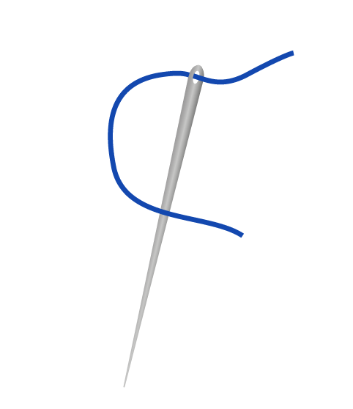 | Medical sutures, tailoring, sewing, mending, quilting, embroidery | Frequently Requested
Spool | 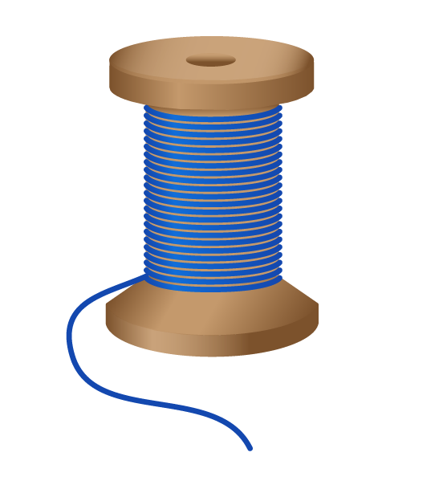 | Bobbin, Floss, spooled or queued computing processes, threaded conversations. | Frequently Requested
Ball of Yarn | 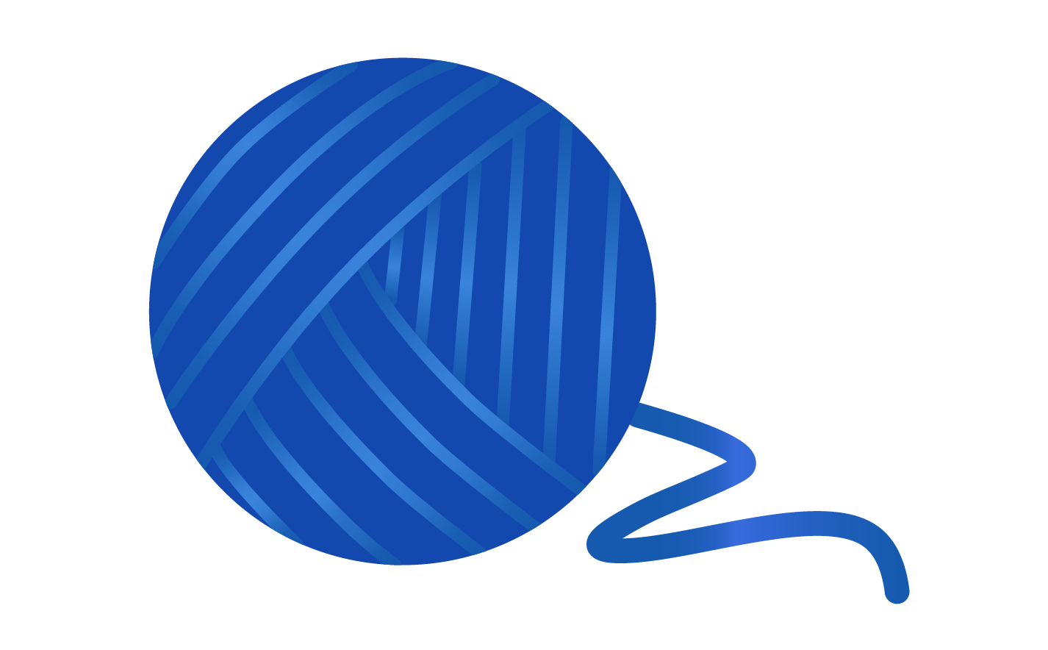 | Twine, string, rope, cord, wool | Frequently Requested
Safety Pin | 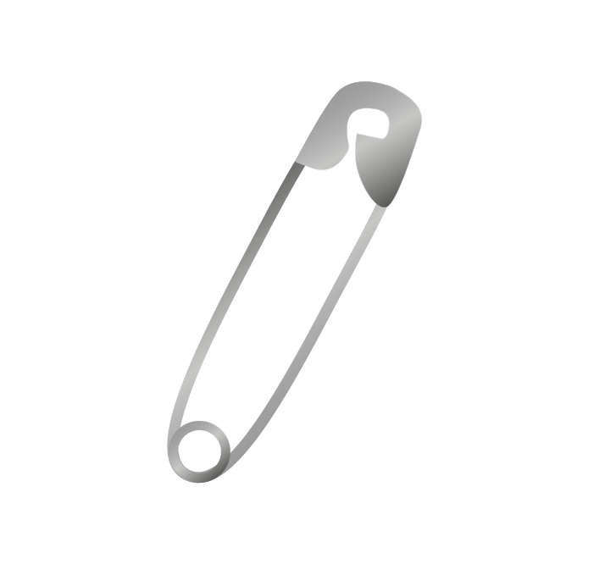 | Kilt pin, diaper pin, quilt pin | Frequently Requested
Images by Cherin Sanih / http://cherinsanih.com. They may be freely distributed in connection with this proposal.

