**Homework 7 - Spatial Point Process**

**Due November 7 at 9:00am**

Name: Briggs, Kerkhove, Ortiz

Worksheet: Spatial point process

Please turn in the assignment as a link to a GitHub repo containing this worksheet as a PDF file and your code.

**Background**

We’re going to simulate and analyze data from a clustered spatial point process. The file generate_clustered_pt_proc.R will be used to generate the data. We will use the Kest() and envelope() functions from the spatstat package to analyze the data.

# Q1: Simulate some data using generate_clustered_pt_proc.R.

Q1.1: Which parameter(s) control the spatial extent of clusters

The spatial extent of the clusters is determined by the xmin, xmax & ymin/ymax

Q1.2: Which parameter(s) control the strength of clustering (i.e., density within clusters relative to outside of clusters)

val.at.center=1

effect.range=10

background=0.001

Q1.3 Generate point pattern data from a complete spatial randomness (CSR) process and a clustered process and paste the two plots below.

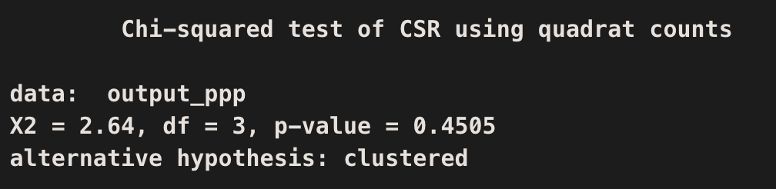

# Q2: Use the quadrat test to determine whether each of these plots differs significantly from CSR. You can either code this yourself or, if that seems daunting, use the quadrat.test() function in the spatstat library. Report the Chi-square statistic and p value for each plot above.

# Q3: Describe the degree of clustering at different spatial scales using a Ripley's K plot. Either code it yourself using eq. 2.8 from Fortin and Dale or use the Kest() function in the spatstat library and the envelope() function to generate an envelope for the null expectation for K for CSR data. Paste the plot below.

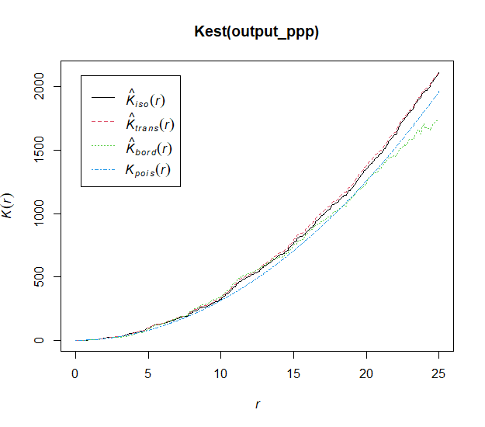

# Q4: Can you generate spatial point process data that are clustered at smaller spatial scales but random at larger scales? Paste a plot of the spatial point pattern and a plot of Ripley's K below.

val.at.center= 1

effect.range=28

background=0.95

