For: JoCN, PLoS computational biology, … ??

Complementary roles of the left and right hemispheres in visual coding

Amanda K Robinson^{1,2}, Tijl Grootswagers³, Sophia Shatek^{2,4}, Marlene Behrmann⁵, Thomas A Carlson²

- School of Psychology, The University of Queensland, Brisbane, Australia
- School of Psychology, University of Sydney, Sydney, Australia
- The MARCS Institute for Brain, Behaviour and Development, Western Sydney University, Sydney, Australia
- Oxford??
- Department of Psychology, Carnegie Mellon University and University of Pittsburgh, USA

Acknowledgements
This work was supported by Australian Research Council (ARC) Discovery Early Career Researcher Awards awarded to A.K.R. (DE200101159) and TG (DE230100380), ARC Discovery Projects awarded to T.A.C. (DP160101300 and DP200101787) and a National Science Foundation grant (BCS2123069) to MB. MB also acknowledges support from P30 CORE award EY08098 from the National Eye Institute, NIH, and unrestricted supporting funds from The Research to Prevent Blindness Inc, NY, and the Eye & Ear Foundation of Pittsburgh. We would like to acknowledge the University of Sydney HPC service for providing High Performance Computing resources.

Abstract

The human brain consists of two hemispheres that must work together to construct a unified perception of the world. Previous work has shown that the left and right hemispheres have different biases for specific visual features; for example, the left hemisphere has stronger responses to high spatial frequency information than the right hemisphere. Characterising how biased information from each hemisphere is integrated is an important step in understanding the cooperative nature of interhemispheric processing. Here, we used electroencephalography and neural decoding methods to investigate information processing within each hemisphere for visual images presented to the fovea. We presented participants (N = 20) with images of objects, faces and words in rapid sequences. Interestingly, the temporal dynamics of information within the left and right hemispheres followed different trajectories, and these differences were characterised by featural biases in each hemisphere. These results provide new insights into the dynamics of visual perception and the importance of the two hemispheres in performing complementary roles in processing visual information.

Introduction
The human brain is a highly integrated system comprising two distinct but interconnected hemispheres that must communicate and coordinate to support perception and cognition. The left and right hemispheres are largely similar in terms of their anatomy and function, with each region within a hemisphere having a homologue in the other hemisphere. Estimates from functional connectivity suggest the hemispheres are approximately 95% symmetrical (Raemaekers et al., 2018). Yet, there are notable functional asymmetries between the left and right sides of the brain. The most well-established example is language processing, which is typically lateralised to the left hemisphere (REF). However, asymmetries are not limited to language; they are also evident across multiple levels of visual processing.
At the level of object recognition, the hemispheres show distinct specialisations for different stimulus categories. Face processing, for instance, demonstrates a robust right hemisphere bias (REF), while word recognition is predominantly left-lateralised (REF). These high-level asymmetries extend to more fundamental aspects of visual analysis. Research has documented complementary hemispheric preferences for local versus global processing, with the left hemisphere associated with processing local aspects of a stimulus and the right hemisphere associated with processing global information from the same stimulus (REF). The hemispheres also differ in their sensitivity to basic shape features: the right hemisphere appears more responsive to curved lines and shapes, while the left hemisphere shows greater sensitivity to rectilinear features (REF). At the most basic level of visual analysis, spatial frequency processing is similarly divided between the hemispheres. Behavioural studies have demonstrated that participants are faster at identifying high spatial frequency stimuli presented to the right visual field (and thus initially processed by the left hemisphere), whereas they are faster at identifying low spatial frequency stimuli presented to the left visual field (right hemisphere) (REF).
Collectively these asymmetries, spanning from object categories to elementary visual features, suggest that each hemisphere is somewhat specialised for particular types of visual information, and that the two hemispheres may construct different perceptual representations from the same sensory input. These findings point to complementary roles for the two hemispheres in visual perception. Understanding how the hemispheres represent information, and whether these representations are redundant or unique, is crucial for developing a complete account of how information is integrated across the brain.
Here, we used electroencephalography (EEG) and multivariate pattern analysis to investigate the representation of visual information within each hemisphere for objects presented to the fovea. Specifically, our goal was to characterise the dynamics and types of information that are preferentially processed within each hemisphere. We employed a rapid presentation paradigm with a diverse stimulus set, providing high statistical power to detect information within each hemisphere. Our analyses revealed that the left and right hemispheres contain both common and unique visual information across the time course of visual processing. Notable asymmetries were found for the processing of colour, rectilinear features, and spatial frequency information. These results suggest greater distinction in information processing between the hemispheres than previously thought, yielding insights into how the two hemispheres perform complementary roles in the service of perception.

Methods

This experiment was previously described in Robinson, et al (2025), where we reported findings focusing on hemispheric processing of lateralised images; here we focus on the central image condition.

Participants
Participants were 20 adults recruited from the University of Sydney (15 females, median age 22 years) in return for payment or course credit. The study was approved by the University of Sydney ethics committee and informed consent was obtained from all participants. Edinburgh handedness scores indicated 17 participants were right-handed, 1 was left-handed and 2 were ambidextrous.

Stimuli and Design
Participants viewed images that appeared on a 1920 x 1080 resolution ASUS gaming monitor while their neural activity was measured with EEG. There were 36 stimuli: four different image exemplars of 6 basic objects: fish, bird, face, boat, tree and tool; and word labels for the same objects in lower and upper case (Figure 1A). Half the trials were words and half were objects (i.e., each word exemplar was presented twice as often as the object stimuli). Images were presented centrally or to the left or right of fixation at 3.24 x 3.24 degrees of visual angle (Figure 1B). Here we just focus on the centrally presented images. All stimuli were presented using Psychopy.

Figure 1. Experimental design.
Note. A) Stimuli. B) Example trial timeline for the central image condition. C) Electrode clusters for left hemisphere and right hemisphere.

Images were presented in sequences of 192 images (Figure 1B). Each trial was presented for 100ms with a gap of 100ms between each trial (5 Hz trial presentation). Each sequence consisted of 96 image stimuli (4 repeats per image) and 96 word stimuli (8 repeats per word stimulus). Within each sequence, trials were presented in random order. There were 12 central sequences in total. Thus, throughout the experiment, there were 48 repeats of each of the 24 image stimuli and 96 repeats of each of the 12 word stimuli for the central condition. To maintain equal trial numbers per class, only 48 repeats for the word stimuli were analysed.

During the experimental session, participants were asked to perform an orthogonal task. They had to monitor the three dots marking the possible image locations (central fixation, left and right) and detect when one turned red (Figure 1B). They had to press a button when they detected a target. This task was designed to be irrelevant to the stimulus images, but also ensure that participants maintained attention across the whole visual field throughout the experiment, regardless of image presentation condition.

EEG recording and preprocessing
EEG data were continuously recorded from 64 electrodes arranged in the international 10–10 system for electrode placement (Oostenveld and Praamstra, 2001) using a BrainProducts ActiChamp system, digitized at a 1000Hz sample rate. Scalp electrodes were referenced to Cz during recording. The EEGLAB toolbox (Delorme and Makeig, 2004) was used to preprocess the data offline. Preprocessing steps are the same as in Robinson et al (2025); briefly, we interpolated noisy electrodes, applied a common average reference, filtered the data (highpass of 0.1Hz, lowpass of 100Hz), created epochs -100 to 800ms relative to stimulus onset, and performed a Laplacian transformation (Perrin et al., 1989).

Neural decoding
We investigated visual representational dynamics in each hemisphere. EEG data were analysed using time-resolved classification methods and implemented using the CoSMoMVPA toolbox (Oosterhof et al., 2016). Decoding was performed separately for left and right hemispheres using clusters of six occipito-temporal electrodes (Figure 1C). At each time point, data were pooled across the 6 EEG sensors, and we tested the ability of a linear discriminant analysis (LDA) classifier to discriminate between the patterns of neural responses associated with 48 repeats of each stimulus. Decoding was performed for all pairs of image combinations for the 36 stimuli (e.g., face1 vs tree2, word-tool1 vs fish4), resulting in 630 unique contrasts across time. Decoding accuracy was assessed by taking the mean across all pairs for each time point, with chance level of 50%. Decoding analyses were performed separately for each participant, and the mean was taken across the group. Accuracy of classifier predictions informed the information in the neural signal, where above-chance classification accuracy (>50%) indicated that the brain was representing information about the images.

Behavioural similarity task
In two separate online experiments, participants rated the similarity between the experimental stimuli using a triplet odd-one-out task (Hebart et al., 2020) with the 36 experimental stimuli. Participants were undergraduate students from the University of Sydney who participated in return for course credit.

On each trial, three experimental stimuli were presented simultaneously, and participants were asked to choose the odd one out by clicking on the stimulus (Figure 2A). In each experiment, there was a separate set of instructions: “choose the one that looks different” (N = 21), or “choose the one that is conceptually different” (N = 21). There were 400 trials in the experiment, and stimulus combinations were randomly chosen.

Behavioural responses were used to construct representational dissimilarity matrices for each task. For each trial, the chosen odd-one-out stimulus was rated as dissimilar (value of 1) from each of the other two stimuli, and the two other stimuli were rated as similar (value of 0). Across all trials of all participants, the dissimilarity of each stimulus pair (e.g., face1 vs word-tree2) was calculated as the mean response for all trials in which those two stimuli were presented together, a measure of whether they were more like each other or the other stimuli in the set.

Representational similarity analyses
To investigate how information is represented in the two hemispheres and in behaviour, we used representational similarity analyses (RSA), which abstracts away from specific activity patterns (e.g., from EEG electrodes over the left hemisphere) to the relationships between different representations. In this case, RSA allowed hemispheric-specific representations to be compared with representations of the other hemisphere as well as models based on image features and behavioural responses. For the neural, image and behavioural models, we constructed representational dissimilarity matrices (RDMs), which quantified the similarity between each image. Each of these RDM models was a 36 x 36 matrix quantifying the dissimilarity for each of the 36 stimuli with each other stimulus. The RDMs were symmetrical across the diagonal, with 630 unique values.

For the neural data, we constructed neural RDMs using decoding accuracy for each pair of images at each time point. Separate 36 x 36 stimulus RDMs were constructed for each hemisphere and time point, where each cell contained the mean decoding accuracy between two stimuli. For the image models, we collated image statistics for each of the 36 stimuli based on spatial frequency, curvature, colour and edges. XXX. The behavioural models were based on the dissimilarity scores from the two behavioural experiments.

For the representational similarity analyses, we investigated how representations varied across the hemispheres. First, we correlated the left and right hemisphere RDMs using Spearman correlation of the lower diagonals of the RDMs (i.e., the unique pairwise values), for every pair of time points. This allowed us to assess how representations were similar across the hemispheres, and whether this similarity was dependent on transfer delays. Next, we assessed how image statistics influenced the neural signal by correlating neural RDMs per hemisphere with the image statistics over time. Finally, we correlated the neural models with the behavioural models. Correlations were performed separately for each EEG participant, and the mean was taken across participants. Group mean correlations were tested statistically and reliable non-zero correlations indicated evidence for the same geometric structure of object representations across the different models and/or modalities.

Figure X. Task and feature RDMs.
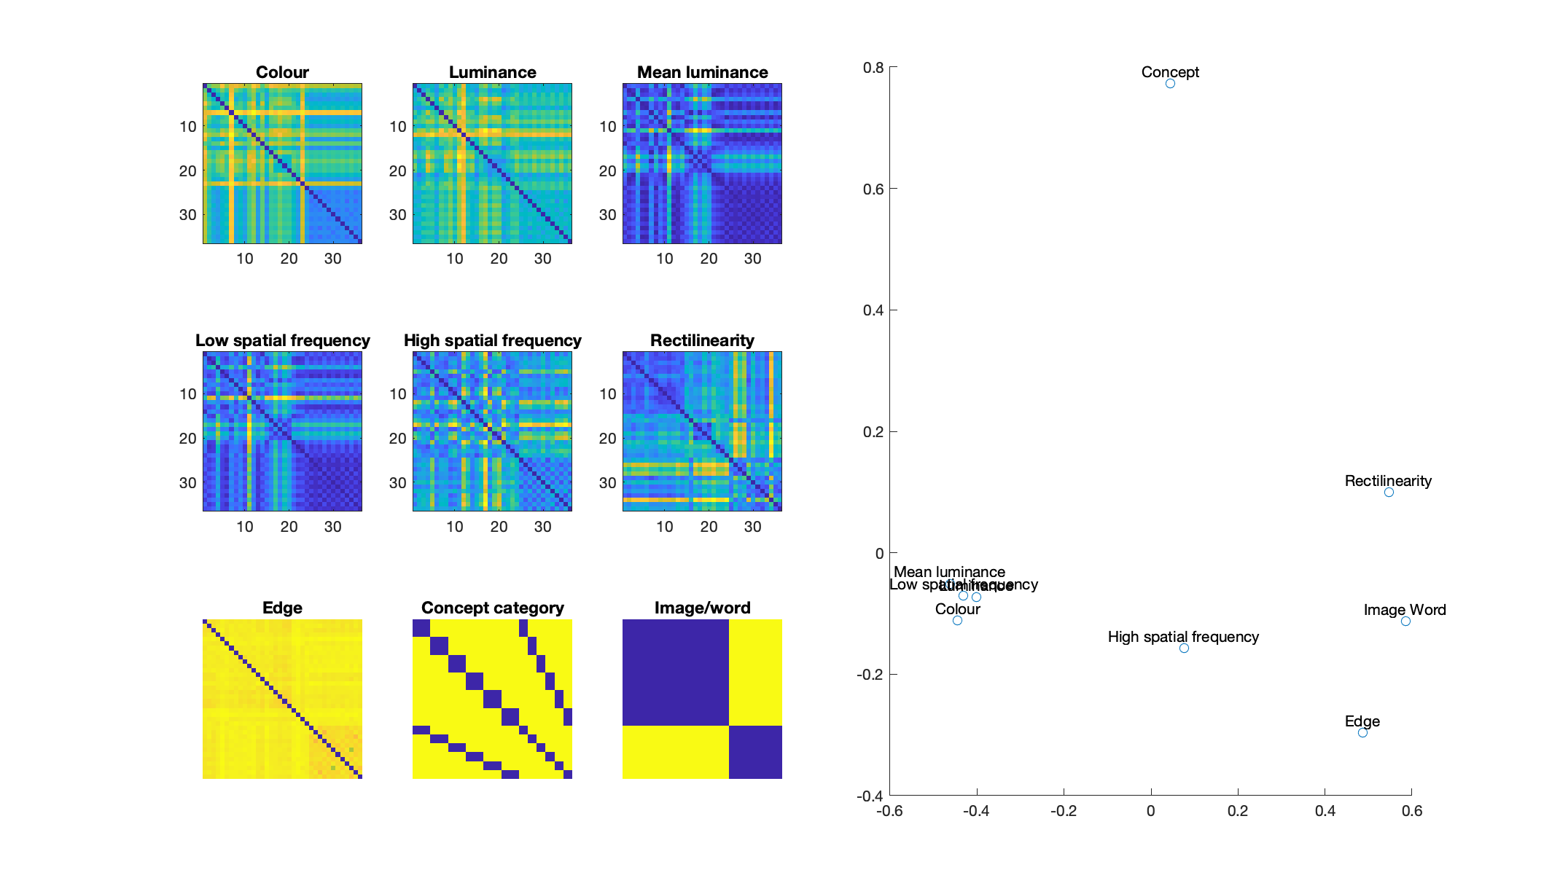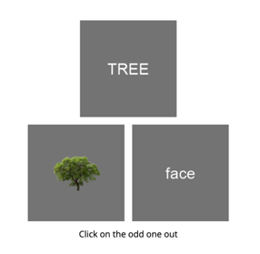
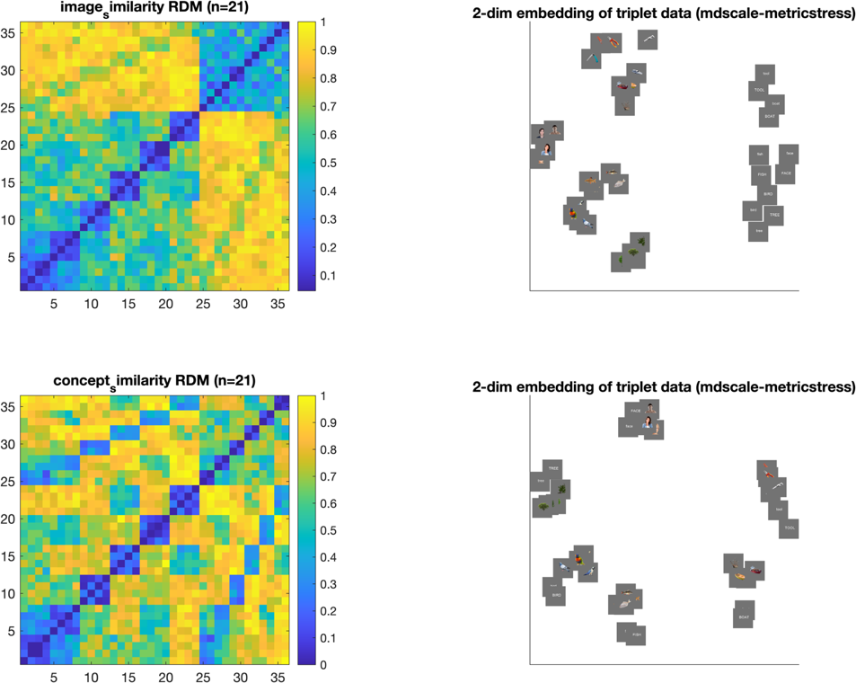

Note. A) Behavioural task design. Three stimuli were presented simultaneously, and the task was to “choose the image that looks different” (image similarity task) or “choose the image that is conceptually different” (conceptual similarity task). B) Dissimilarity matrices representing models of concept category and image/word, used to compare to results from the tasks. C) Dissimilarity matrices from each task reveal structure in the responses based on image/word classification and object type. C) Multi-dimensional scaling plots show how images cluster in the behavioural data. For the image similarity task, words form a separate cluster from the images. For the conceptual similarity task, words and images of the same object cluster together.

Statistical testing
To assess neural information and representational similarity, we used Bayesian statistics to determine the evidence for the alternative relative to the null hypotheses (Dienes, 2011, 2016; Jeffreys, 1961; Rouder et al., 2009; Wagenmakers, 2007). For decoding analyses, the alternative hypotheses of above- and below-chance (50%) decoding were tested. For correlation analyses, the alternative hypotheses of above- and below- zero correlations were tested. We used the ‘BayesFactor’ package in R (Morey et al., 2018). Bayes Factors were calculated using a JZS prior, centred around chance decoding of 50% (Rouder et al., 2009) with default scale factor of 0.707, meaning that for the alternative hypotheses of above- and below- chance decoding, we expected to see 50% of parameter values falling within -.707 and .707 standard deviations from chance (Jeffreys, 1961; Rouder et al., 2009; Wetzels & Wagenmakers, 2012; Zellner & Siow, 1980). A null interval was specified as a range of effect sizes between -0.5 to 0.5.
A Bayes factor (BF) is the probability of the data under the alternative hypothesis relative to the null hypothesis. We consider BF > 3 as evidence for the above- or below-chance decoding, and we refer to periods of time with sustained evidence (two consecutive time points of BF>3) as times when information “could be decoded”, indicating information was represented in the brain, and we refer to the first period of sustained evidence as the “onset” of decoding. We interpreted BF < 1/3 as evidence in favour of the null hypothesis (Jeffreys, 1961; Wetzels et al., 2011).

Results

Behavioural similarity task
We assessed perceptual similarity of the 36 experimental stimuli using online experiments, where participants were presented with three stimuli simultaneously and asked to choose the odd-one-out according to two sets of instructions: “choose the one that looks different” or “choose the one that is conceptually different”. The results revealed that similarity judgements reflect both object category and meaning (Figure 2). To assess how the images were clustered based on similarity judgements per task, we correlated the behavioural RDMs (Figure 2B) with image models based on image/word category and object type using Spearman correlation. Behaviour correlated with a model distinguishing between images and words, regardless of the object meaning, for both the image similarity task (r = .81, p < .001) and the concept similarity task (r = .28, p < .001). Additionally, behaviour correlated with a model distinguishing the six object categories (bird, fish, tree, boat, face, tools), regardless of image/word status, for both the image similarity task (r = .30, p < .001) and the concept similarity task (r = .59, p < .001). Importantly, however, the face/word model had a higher correlation with the image similarity task than the concept similarity task (z = 20.96, p < .001) and there was a higher categorical correlation in the concept task than the image similarity task (z = -9.68, p < .001). Thus, although RDMs from the image similarity task and concept similarity task were very highly correlated (r = .61, p < .001)participants appeared to be choosing the odd-one-out in accordance with instructions: images and words were more dissimilar in the image similarity task than the concept task because they look different despite having the same meaning. This can be seen in the multi-dimensional representation of the RDMs, where in the image task, words clustered separately to different image categories, but in the conceptual task, words cluster with their associated images (Figure 2C). Ultimately these behavioural RDMs were used to compare with the similarity in neural patterns of each hemisphere.

Figure X. Image representations in each hemisphere
Decoding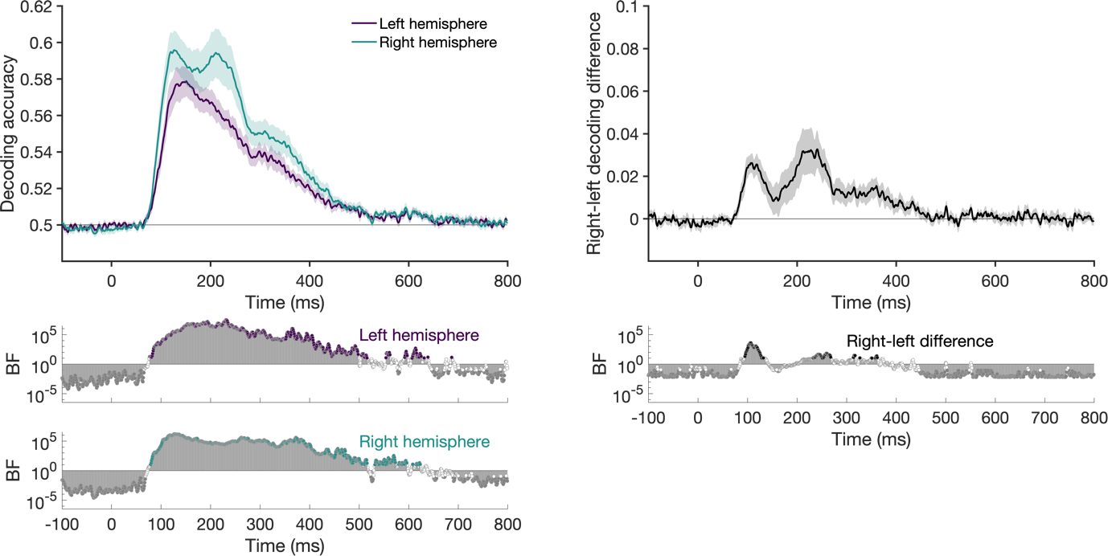
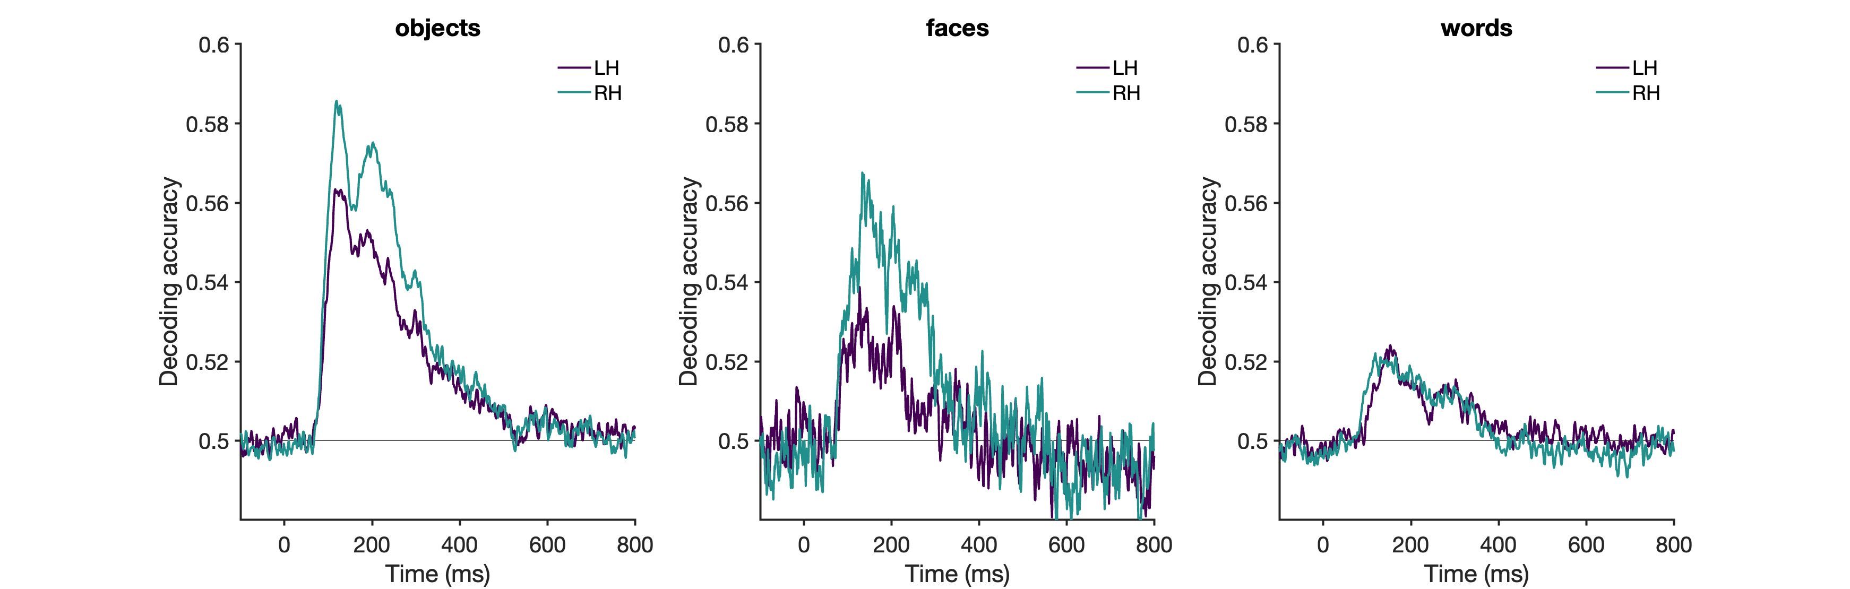Note. Decoding accuracy for each hemisphere, using clusters of electrodes over the left and right hemisphere. Classification shows different dynamics over each hemisphere. Bayes Factors below each plot quantify the evidence for above-chance decoding. Decoding central images by object type, per hemisphere. Objects, faces and words. Right dominance for objects and faces. Similar across hemisphere for words.
Figure 3. Image feature RSA per hemisphere
Z
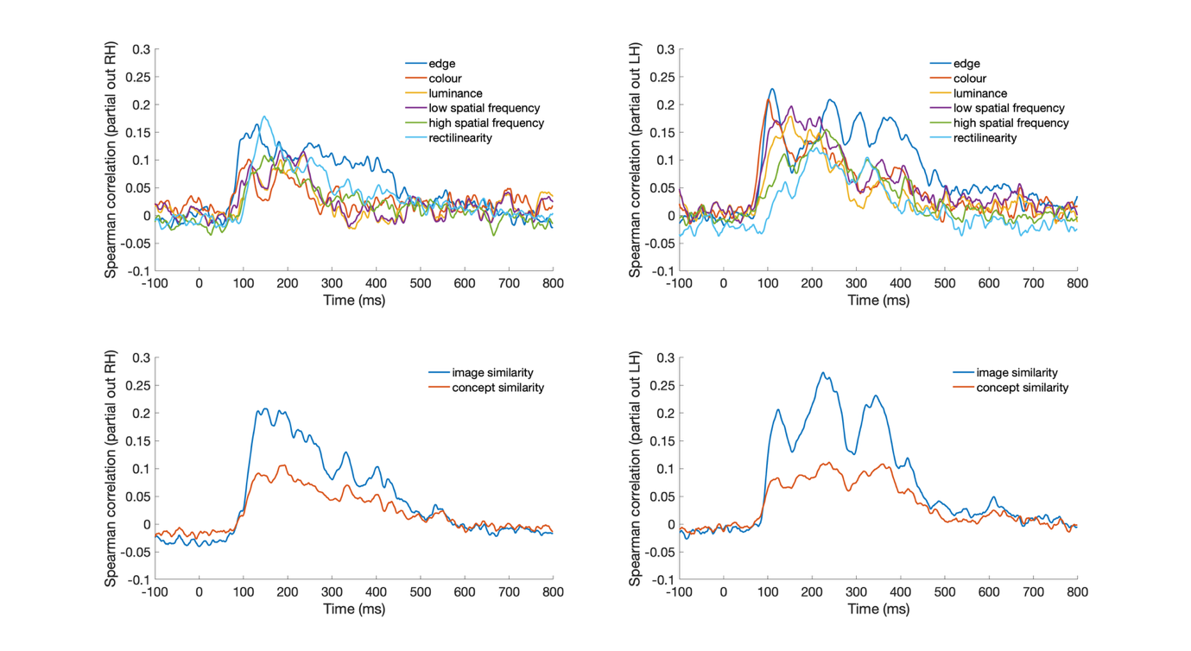
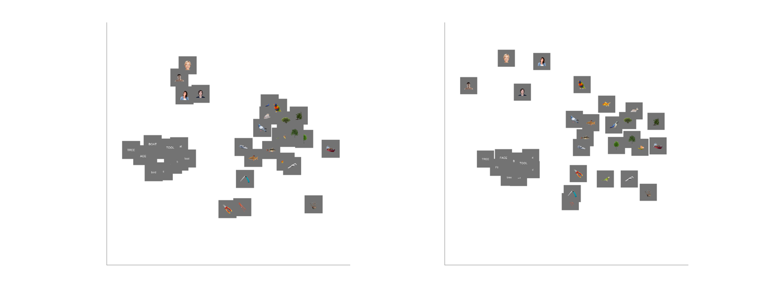
Note. Hemispheric-specific representations that are accounted for by image statistics of presented stimuli
within the left hemisphere (A) and right hemisphere (B). Edge model has highest correlation at early time points. Different dynamics for left and right hemispheres. Most things stronger in RH. Rectilinearity is highest model in LH around 150ms, whereas colour and low spatial frequency are higher in RH.
Middle. Correlations between behavioural results and neural data, separately for image similarity and concept similarity tasks. Strong correlations between both tasks, higher for image similarity task. Image similarity ratings yield a better model than any model based on image statistics. Bottom. MDS left right hemispheres, time point?

Figure 4. Each hemisphere contains unique information.
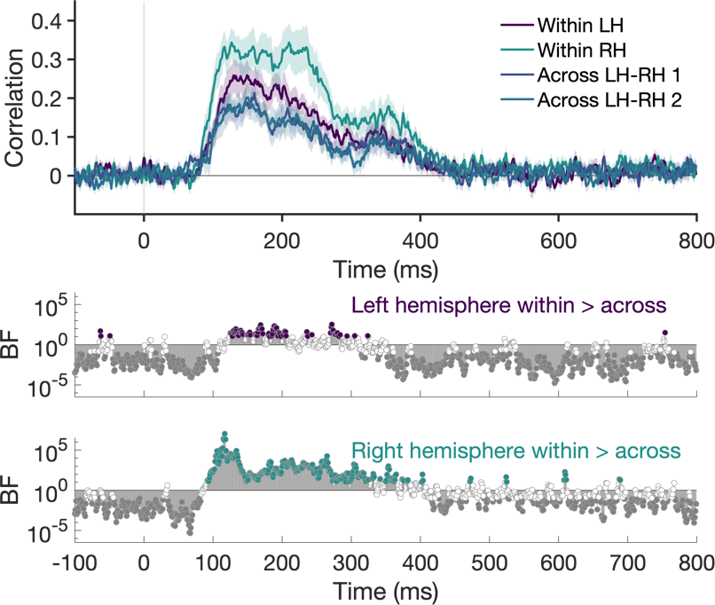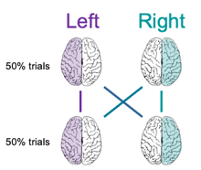
Note. Consistency in representations between left and right hemispheres compared with neural consistency within each hemisphere (split half analyses as shown inset). Results indicate each hemisphere contains unique information over and above the other hemisphere.

Figure 7. Shared information in the hemispheres by hemispheric delay time. 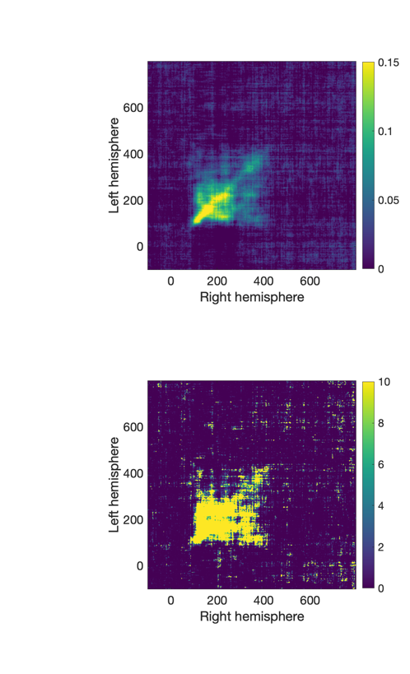 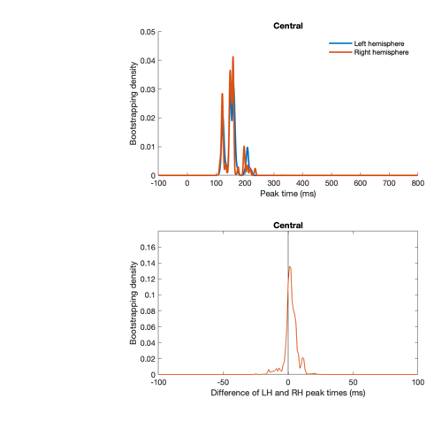
Note. A) Time generalisation RSA approach: RDMs were correlated between LH and RH for every pair of time points. If there is no delay between the hemispheres, the time generalisation plots should look symmetrical around the diagonal. B) Plots show mean correlation (up) and amount of evidence (down) as a function of the delay between the two hemispheres. Greatest information was observed for 0ms delay between left and right hemispheres. C) Estimates of hemispheric delay time from bootstrapping 1000 times. Top: times of peak correlations between the two hemispheres. Bottom: difference between the peak times in the two hemispheres.

Discussion
- First study to show representational dynamics in the hemispheres
- Object representations: traverse hemispheric processing across multiple stages of processing.
- Robust neural responses in both hemispheres
- Clear differences for LH/RH
- Featural biases for LH/RH
- EEG is good tool to investigate hemispheric information

Different dynamics for left and right hemispheres
- Stronger in right
- More peaks in right
- Each hemisphere has more internal consistency than across-correlation
- Indicates that each hemisphere has specific coding dominance, different features and different dynamics
- Feature dominance: rectilinearity in LH, colour in RH. Supports previous studies. Spatial frequency differences across hemispheres, high better in LH and low better in RH.
- Consistent representational timing in LH and RH – highest correlations along the diagonal. Yet still showed interesting dynamics: initial stages do not generalise, but subsequent stages seem to generalise across time.

- Certain amount of representational overlap across the hemispheres, however – still correlate above chance. Redundancy in the system.

Hemispheric biases for objects
- More information in RH than LH for objects and faces

SUPPLEMENTARY INFORMATION

Decoding

Searchlight decoding was conducted to examine which clusters of electrodes had the highest decoding accuracy. Figure 2 shows that highest decoding was roughly bilateral.

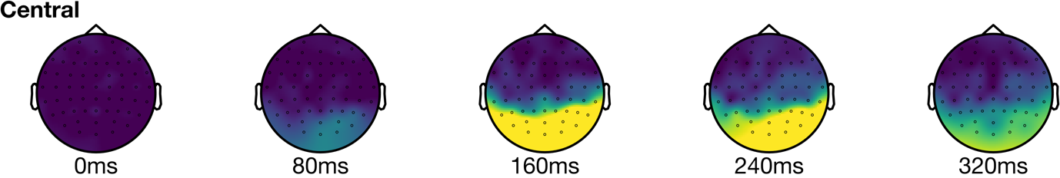
Figure 2. Headmaps showing decoding accuracy at different clusters of electrodes on the scalp. Each headmap represents decoding accuracy at a given time after image presentation. A) Central stimuli. B) Left visual field. C) Right visual field stimuli.

