For: Journal of Neuroscience?

Complementary hemispheric codes for human visual processing
Amanda K Robinson^{1,2}, Tijl Grootswagers³, Sophia Shatek^{2,4}, Marlene Behrmann⁵, Thomas A Carlson²

- School of Psychology, The University of Queensland, Brisbane, Australia.
- School of Psychology, University of Sydney, Sydney, Australia.
- The MARCS Institute for Brain, Behaviour and Development, Western Sydney University, Sydney, Australia.
- Department of Experimental Psychology, University of Oxford, Oxford, UK.
- Department of Psychology, Carnegie Mellon University, Pittsburgh, USA.
- Department of Ophthalmology, University of Pittsburgh, Pittsburgh, USA.

Acknowledgements
This work was supported by Australian Research Council (ARC) Discovery Early Career Researcher Awards awarded to A.K.R. (DE200101159) and TG (DE230100380), ARC Discovery Projects awarded to T.A.C. (DP160101300 and DP200101787) and a National Science Foundation grant (BCS2123069) to MB. MB also acknowledges support from P30 CORE award EY08098 from the National Eye Institute, NIH, and unrestricted supporting funds from The Research to Prevent Blindness Inc, NY, and the Eye & Ear Foundation of Pittsburgh. We would like to acknowledge the University of Sydney HPC service for providing High Performance Computing resources.

Hsiao & Shillcock (2006): supports an early split-style account in reading, with effects showing up by N1.

Jordan et al. (2011): finds evidence for early contralateral projection effects but argues these do not translate into a robust functional split for foveal ord recognition when fixation is tightly controlled.

Steerable pyramid

Abstract
The contralateral organisation of the human visual system means that the left and right brain hemispheres process different visual input, necessitating hemispheric integration for unified perception. Yet, it remains unclear whether the hemispheres have distinct processing cascades or if they are tightly coupled. Here, we used electroencephalography and neural decoding methods to investigate visual processing in the left and right hemispheres. Presenting images to the fovea equated visual input across hemispheres, allowing us to isolate intrinsic hemispheric differences in visual coding. Participants (N = 20) viewed images of objects, faces and words in rapid sequences while performing an orthogonal task. We found different trajectories of visual coding within the left and right hemispheres, and these differences were characterised by featural biases in each hemisphere. The results provide new insights into hemispheric dynamics underlying visual perception and the complementary roles of the left and right hemispheres in processing visual information.

Introduction
The human brain is a divided but highly integrated system comprising two hemispheres that must coordinate for perception. The left and right hemispheres are largely similar in terms of their anatomy and function (Raemaekers et al., 2018) and have notable homotopic connectivity between matched regions (Bryant et al., 2025). This bilateral architecture has computational advantages: redundancy affords robustness to damage and likely increases flexibility (Liu et al., 2026), whereas specialisation allows efficiency and division of labour. In vision, the hemispheres show systematic asymmetries across multiple levels of processing, from fundamental features to high-level categories, suggesting they construct qualitatively different representations from the same input. Characterising when these differences emerge and how they are integrated is therefore a necessary step in understanding the neural basis of visual perception.
Research using visual hemifield paradigms, where stimuli lateralised to one side of space are initially processed by the opposite (contralateral) hemisphere, has demonstrated the two hemispheres differ in their sensitivity to fundamental visual features. For instance, the left hemisphere appears biased toward high spatial frequencies and local detail; the right toward low spatial frequencies and global structure (Ivry & Robertson, 1998; Sergent, 1982; Yovel et al., 2001). Colour processing also shows some degree of lateralisation, with evidence of right hemispheric bias for colour matching (Davidoff, 1976) but left hemispheric bias relating to colour naming (Ting Siok et al., 2009). This distinction, along with suggestions that task decision is more asymmetric than spatial frequency processing (Christman et al., 1991; Peterzell et al., 1989), highlights that asymmetry can emerge behaviourally due to perceptual or decision-level factors.
At the level of visual categories, face processing tends to be right-lateralised (Kanwisher et al., 1997; Rossion et al., 2003) and word processing left-lateralised (Cohen et al., 2000; Dehaene et al., 2010), potentially due to proximity to language regions. Scene processing regions also show hemispheric asymmetries (Stevens et al., 2012; Zhen et al., 2017), consistent with right hemisphere specialisation for visuospatial functions, exemplified by hemi-neglect which is most prominent following right hemispheric damage (Mesulam, 1981). Yet in the intact brain even highly lateralised functions rely on bilateral processing (Behrmann & Plaut, 2014), implying the hemispheres routinely share and integrate information.
Critically, it remains unclear how much category-level asymmetries are dependent on lower level feature biases. Faces are rich in curved contours and low spatial frequency content, while words are rectilinear and high spatial frequency. Understanding feature and category contributions to hemispheric asymmetry therefore requires studying multiple visual categories alongside characterisation of their visual features. The temporal dimension is key to resolving this question. If hemispheric biases reflect low-level feature processing, they should emerge early in the visual response. Electroencephalography (EEG) and multivariate pattern analysis offers a powerful approach to characterise visual representations in the human brain with millisecond precision (Carlson et al., 2020; Robinson et al., 2023). We previously used these methods to understand contralateral hemispheric processing, showing that interhemispheric transfer prioritises conceptual meaning over visual statistics (Robinson et al., 2025).
Here, we assessed the dynamics of visual feature biases within each hemisphere. We presented participants with images of objects, faces, and words at fixation, so that both hemispheres received retinal input from the stimuli. Using time-resolved decoding (Carlson et al., 2020; Robinson et al., 2023) and representational s
imilarity analyses (Kriegeskorte et al., 2008), we characterised what information each hemisphere represents and when. We found that the left and right hemispheres contain both shared and unique visual information, with distinct temporal dynamics. Representational similarity analyses revealed feature-specific hemispheric biases: the left hemisphere preferentially coded rectilinear features, while the right hemisphere was biased toward colour content. Despite these differences, the hemispheres showed tightly coupled temporal representations and both hemispheres exhibited a coarse-to-fine processing cascade. Together, these results reveal greater complementarity in hemispheric visual processing than previously appreciated and provide new insights into how the two hemispheres cooperate to support perception.
Methods

This experimental design was previously described in Robinson, et al (2025), where we reported findings focusing on hemispheric processing of lateralised images; here we focus on the central image condition. All stimuli and code are available on Github (XXXX) and neural data available on OpenNeuro (XXX).

Participants
Participants were 20 adults recruited from the University of Sydney (15 females, median age 22 years) in return for payment or course credit. The study was approved by the University of Sydney ethics committee and informed consent was obtained from all participants. Edinburgh handedness scores indicated 17 participants were right-handed, 1 was left-handed and 2 were ambidextrous. Similar patterns of results were found when analyses were restricted to right-handed participants (see Supplementary Material).

Stimuli and Design
As described in our previous paper (Robinson et al., 2025), participants viewed images that appeared on a 1920 x 1080 resolution ASUS gaming monitor while their neural activity was measured with EEG. There were 36 stimuli: four different image exemplars of 6 basic objects: fish, bird, face, boat, tree and tool; and word labels for the same objects in lower and upper case (Figure 1A). Half the trials were words and half were objects (i.e., each word exemplar was presented twice as often as the object stimuli). Images were presented centrally or to the left or right of fixation at 3.24 x 3.24 degrees of visual angle, but here we just focus on the centrally presented images (Figure 1B). All stimuli were presented using Psychopy.

Figure 1. Experimental design.
Note. A) Stimuli were 36 images of real world objects and words from six different categories: fish, birds, faces, boats, trees and tools. B) Example trial timeline for the central image condition. Images were presented in rapid sequences for 100 ms duration with 100 ms inter-stimulus interval (ISI). C) EEG electrodes for left hemisphere and right hemisphere clusters comprised six electrodes each.

Images were presented in sequences of 192 images (Figure 1B). Each stimulus was presented for 100ms with a gap of 100ms between each image (5 Hz trial presentation). There were 96 image stimuli per sequence (4 repeats per image) and 96 word stimuli (8 repeats per word stimulus). Within each sequence, images were presented in random order. There were 12 central sequences in total. Thus, throughout the experiment, there were 48 repeats of each of the 24 image stimuli and 96 repeats of each of the 12 word stimuli for the central condition. To maintain equal trial numbers per class, only 48 repeats for the word stimuli were analysed.

During the experimental session, participants were asked to perform an orthogonal task. They had to monitor the three dots marking the possible image locations (central fixation, left and right) and detect when one turned red (Figure 1B). They had to press a button when they detected a target. This task was designed to be irrelevant to the stimulus images, but also ensure that participants maintained attention across the whole visual field throughout the experiment, regardless of image presentation condition.

EEG recording and preprocessing
EEG data were continuously recorded from 64 electrodes arranged in the international 10–10 system for electrode placement (Oostenveld and Praamstra, 2001) using a BrainProducts ActiChamp system, digitized at a 1000Hz sample rate. Scalp electrodes were referenced to Cz during recording. The EEGLAB toolbox (Delorme and Makeig, 2004) was used to preprocess the data offline. Preprocessing steps are the same as in Robinson et al (2025); briefly, we interpolated noisy electrodes, applied a common average reference, filtered the data (highpass of 0.1Hz, lowpass of 100Hz), created epochs -100 to 800ms relative to stimulus onset, and performed a Laplacian transformation (Perrin et al., 1989).

Neural decoding
We investigated visual representational dynamics in each hemisphere. EEG data were analysed using time-resolved classification methods and implemented using the CoSMoMVPA toolbox (Oosterhof et al., 2016). Decoding was performed separately for left and right hemispheres using clusters of six occipito-temporal electrodes (Figure 1C). At each time point, data were pooled across the 6 EEG sensors, and we tested the ability of a linear discriminant analysis (LDA) classifier to discriminate between the patterns of neural responses associated with 48 repeats of each stimulus. Decoding was performed for all pairs of image combinations for the 36 stimuli (e.g., face1 vs tree2, word-tool1 vs fish4), resulting in 630 unique contrasts across time.

Hemispheric dynamics were assessed by taking the mean decoding accuracy across all stimulus pairs for each time point per hemisphere, with chance level of 50%. Decoding analyses were performed separately for each participant, and the mean was taken across the group. Accuracy of classifier predictions informed the information in the neural signal, where above-chance classification accuracy (>50%) indicated that the hemisphere was representing information about the images.

Image statistics
To characterise the low-level visual properties of our stimuli, we computed several image statistics for each stimulus. All stimulus images were first rendered by presenting them in PsychoPy using the exact parameters from the experiment (stimulus size of 128 pixels for images and height of 40 pixels for text, presented on a grey background) and capturing each frame to create 768 × 768 pixel images. All image statistics were computed on the rendered images including background, matching the visual input experienced by participants. All images were converted to double precision and, if greyscale, replicated across three channels to ensure consistent processing.
Luminance. Mean luminance was calculated by converting each RGB image to greyscale and computing the average pixel intensity across the entire image.
Colour. Colour information was quantified by converting images from RGB to CIE Lab colour space, which approximates human colour perception. We computed a joint 2D histogram over the a* (red-green) and b* (blue-yellow) chrominance channels, using 32 bins per channel (spanning −128 to 128), yielding a 32×32 histogram that captures the distribution of hues and saturations independent of luminance and without preserving spatial layout. The resulting values were vectorised to create a colour descriptor for each image.
Spatial frequency. We computed spatial frequency content using 2D fast Fourier transforms (FFT). Images were converted to greyscale, the mean pixel intensity was subtracted, then we applied a 2D FFT and shifted the zero-frequency component to the centre of the spectrum. We calculated a radial average profile by computing the mean FFT magnitude at each distance from the centre, collapsing across orientation to obtain a rotation-invariant measure of spatial frequency power. Given our stimulus parameters (237.04 pixels/degree, Nyquist frequency of 118.52 cycles/degree), each point in the 545-element radial profile corresponded to 0.22 cycles/degree. We derived separate measures for low spatial frequencies (0-3 cycles/degree, corresponding to the first 14 points of the radial profile) and high spatial frequencies (≥6 cycles/degree, corresponding to points 28 onwards). These frequency ranges were selected to align with established perceptual categories and known hemispheric asymmetries in spatial frequency processing.
Edge information. Edge content was quantified using Canny edge detection with a threshold of 0.1 applied to greyscale images.
Rectilinearity. The degree of rectilinearity in each image was calculated using V-shaped Gabor filters adapted from the Rectilinearity Toolbox (Nasr et al., 2014). These filters are sensitive to corners and edges with specific vertex angles. The vertex angle (θ) was systematically varied to capture features ranging from straight edges (0°) to 30°, 60°,90°,120° and 150° to capture acute, right and obtuse corners.
Each image was first converted to greyscale and normalised to the range [0,1]. A Canny detector (Canny, 1986) with threshold of 0.1 was used to extract edge contours. V-shaped filters were generated for each combination of spatial frequency (XXXX cycles/pixel) and vertex angle. Each filter was constructed by combining two Gaussian arms forming a V, and windowed with a Gaussian envelope to constrain its spatial extent. To detect angles at different orientations, each filter was applied at 16 orientations (0° to 337.5° in 22.5° steps) and responses were averaged.
For each rotation, the filter was convolved with the edge map, and the absolute value was raised to the power of 8 to enhance selectivity for strong matches. Responses were normalised (min-max) within each spatial frequency across the stimulus set, then averaged across all spatial frequencies to yield a single rectilinearity index per image.
Representational similarity analyses
To investigate the structure of representations in the two hemispheres, we used representational similarity analyses (RSA) (Kriegeskorte et al., 2008), which abstracts away from specific activity patterns (e.g., from strength of electrode responses over the left hemisphere) to the relationships between different representations. In this case, RSA allowed hemispheric-specific representations to be compared with representations of the other hemisphere (Robinson et al., 2025) as well as models based on image features. To characterise neural and feature patterns, we constructed representational dissimilarity matrices (RDMs), which quantified the similarity between each image using a given measure. Each of these RDM models was a 36 x 36 matrix quantifying the dissimilarity for each of the 36 stimuli with each other stimulus. The RDMs were symmetrical across the diagonal, with 630 unique values.

Neural RDMs were created for each hemisphere and time point per participant, and model RDMs were calculated for each of the visual statistics of interest. For the neural data, we constructed neural RDMs using decoding accuracy for each pair of images at each time point. Separate 36 x 36 stimulus RDMs were constructed for each hemisphere and time point, where each cell contained the mean decoding accuracy between two stimuli. For visual statistics, we constructed an RDM for each visual feature (e.g., rectilinearity) by computing pairwise Euclidean distance between all stimuli, except for edge content, for which we used Jaccard distance. This resulted in separate RDMs for edge content, colour, mean luminance, low spatial frequency, high spatial frequency and rectilinearity (Figure 2). As a comparison to these models, we also constructed categorical RDMs representing concept category membership and image versus word stimulus type.

All RSA comparisons used Spearman correlation of the lower diagonals of the RDMs (i.e., the unique pairwise values). To assess the representations of image statistics in each hemisphere, we correlated each of the image statistics models with the neural RDMs per hemisphere with over time.

For cross-hemispheric RSA, we investigated how representations varied across the hemispheres over time. This was done in a split-half manner, using decoding accuracy from odd and even sequences separately. We correlated RDMs for each time point from odd sequences with each time point from even sequences for each hemisphere, giving a measure of time-generalised within-hemisphere consistency. Then, we correlated the left and right hemisphere RDMs using odd sequences in the left hemisphere and even sequences in the right hemisphere, and vice versa, and taking the mean correlations at each pair of time points. This allowed us to assess similarity across versus within the hemispheres, and whether this similarity was dependent on transfer delays.

Spearman correlations were performed separately for each EEG participant, and the mean was taken across participants. Group mean correlations were tested statistically and reliable non-zero correlations were taken as evidence for the same geometric structure of object representations across the different models.

Figure 2. Model RDMs for visual features in the stimulus set.
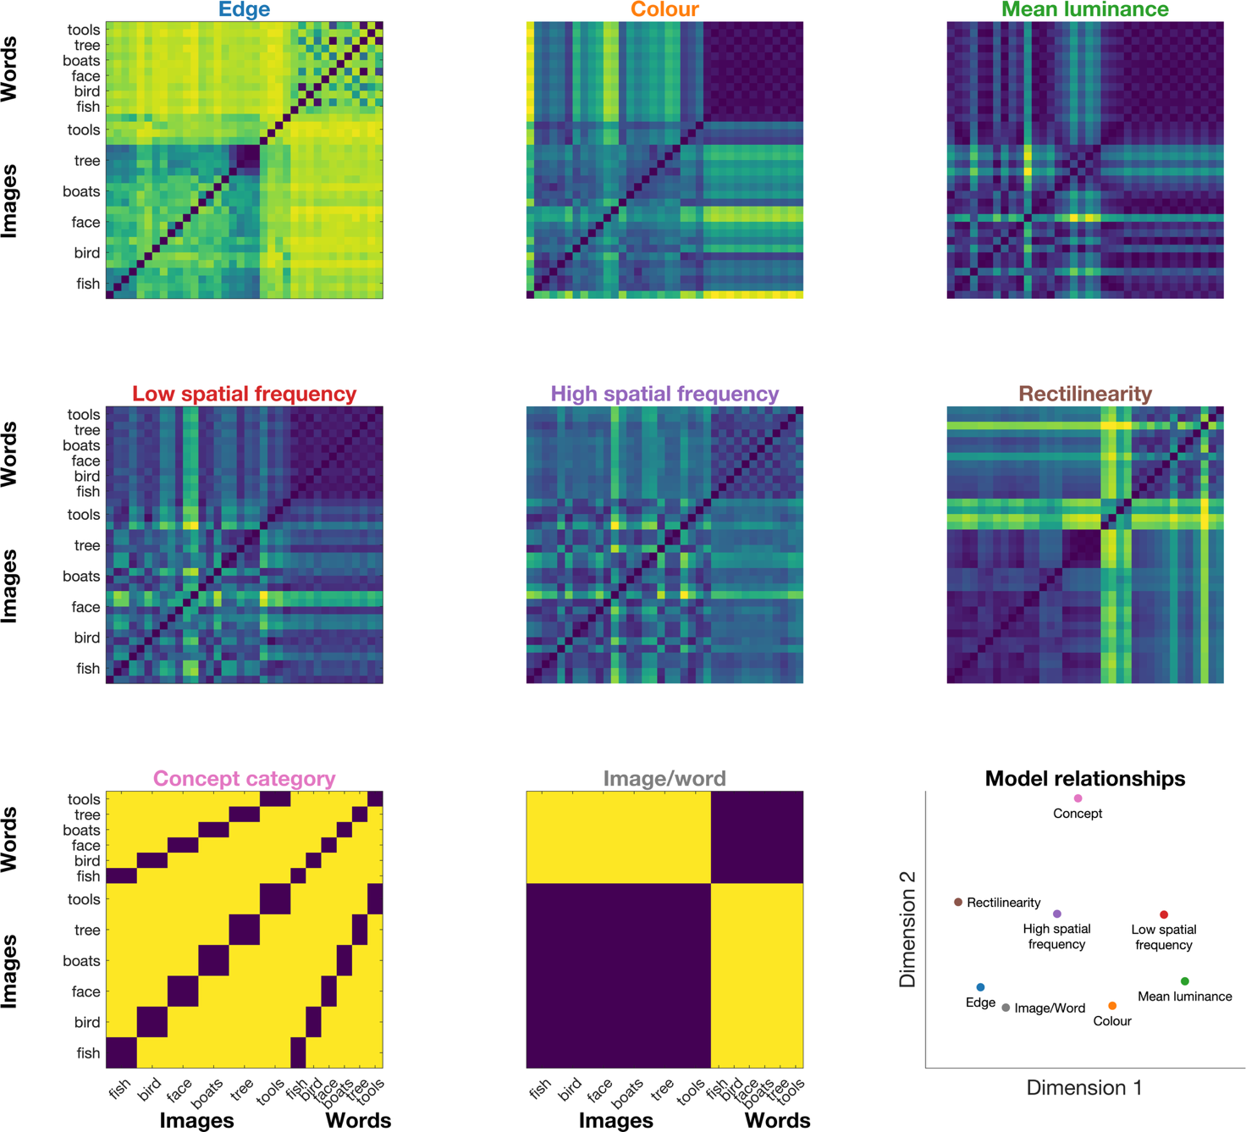

Note. Dissimilarity matrices representing models of visual features, used to assess feature coding in each hemisphere. Six models were constructed based on visual statistics: edge, colour, luminance, low spatial frequency, high spatial frequency and rectilinearity. Two models were constructed based on canonical categories: concept, and image/word. The last plot shows multi-dimensional scaling of the similarity between models, where the distance between models indicates their similarity. Dark colours in RDMs indicate high similarity, while lighter colours indicate low similarity.

Statistical testing
To assess neural information and representational similarity, we used Bayesian statistics to determine the evidence for the alternative relative to the null hypotheses (Dienes, 2011, 2016; Jeffreys, 1961; Rouder et al., 2009; Wagenmakers, 2007). For decoding analyses, the alternative hypotheses of above- chance (50%) decoding were tested. For correlation analyses, the alternative hypotheses of above- and below- zero correlations were tested. We used the ‘BayesFactor’ package in R (Morey et al., 2018). Bayes Factors were calculated using a JZS prior, centred around chance decoding of 50% (Rouder et al., 2009) with default scale factor of 0.707, meaning that for the alternative hypotheses of above- and below- chance decoding, we expected to see 50% of parameter values falling within -.707 and .707 standard deviations from chance (Jeffreys, 1961; Rouder et al., 2009; Wetzels & Wagenmakers, 2012; Zellner & Siow, 1980). Null intervals were specified as a range of effect sizes between -inf to 0.5 (decoding) or -0.5 to 0.5 (correlations) (Teichmann et al., 2021).
A Bayes factor (BF) is the probability of the data under the alternative hypothesis relative to the null hypothesis. In line with conventions, we consider BF > 3 as reliable evidence and BF > 10 for strong evidence for above-chance decoding or non-zero correlations. In line with our previous work (Robinson et al., 2025) we consider the “onset” to be the first period of sustained evidence (ten consecutive time points of BF>10). We interpret BF < 1/3 and BF < 1/10 as reliable and strong evidence in favour of the null hypothesis (Jeffreys, 1961; Wetzels et al., 2011).

Results
To characterise the time course of visual information processing in the brain, we first examined how the left and right hemispheres represented the visual stimuli. To do this, we assessed mean decoding accuracy across all 630 stimulus pairs, indexing stimulus discriminability per hemisphere (Figure 3A). Stimulus content was discriminable in both hemispheres, as indexed by above chance decoding accuracy, but the dynamics of information coding followed distinct patterns in the left and right hemispheres. For the left electrode cluster, decoding accuracy was reliably above chance continuously from 77ms to 498ms (BF₁₀ > 10.58), with a peak at 151ms (57.89%, BF₁₀ = 3.72 x 10⁶). For the right electrode cluster, decoding accuracy was reliably above chance continuously for a similar time period (79ms to 506ms; BF₁₀ > 10.76), with a peak at 127ms (59.59%, BF₁₀ = 1.68 x 10⁶) and a second clear peak at 211ms (59.44%, BF₁₀ = 5.27 x 10⁴).

Next, to explore whether decoding performance and hemispheric trends were driven by stimulus category, we split the pairwise comparisons into six groups: within-face, within-word, within-object, face vs object, face vs word, and word vs object. Note that there were 24 objects, 4 faces and 12 words in the stimulus set, so each of these groups consisted of a different number of stimulus pairs. Hemispheric differences in decoding accuracy were assessed at each timepoint using Bayes factors. Overall, we found clear right hemispheric dominance, with stronger decoding accuracy in the right than the left hemisphere for all category subsets except within words (Figure 3B).

Figure 3. Distinct visual coding dynamics in each hemisphere
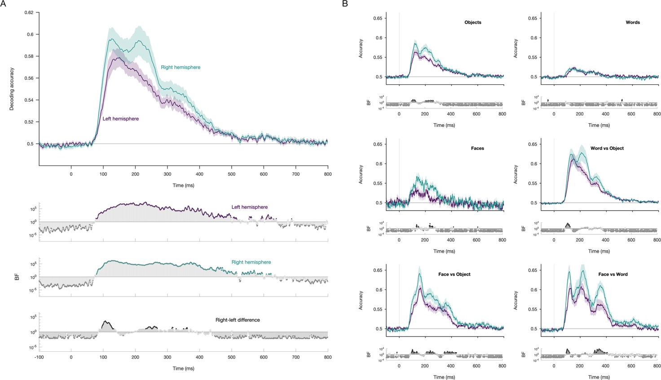
Note. Neural decoding reveals differences in visual representations in the left and right hemispheres. A) Mean decoding accuracy across all 630 pairs of experimental images. Bayes factors below quantify the evidence for above chance decoding per hemisphere and differences between hemispheres. B) Mean decoding accuracy for different stimulus categories: within object, within face, within word, face versus object, word versus object and face versus word. Bayes Factors below each plot quantify the evidence for differences between the left and right hemisphere.

Hemispheric representational geometry
To assess how each hemisphere represents visual stimuli, we used the pairwise decoding accuracy to construct models of representational geometry; that is, we assessed how each stimulus was coded relative to each other stimulus. Figure 4 shows neural RDMs and the two-dimensional visualisation of the similarities between stimuli in terms of their neural representations per hemisphere during a representative time window (120-150ms). Using RSA, we could then compare hemispheric geometry with models of visual features, and compare geometry across the two hemispheres.

Figure 4. Neural dissimilarity across the stimulus set per hemisphere.

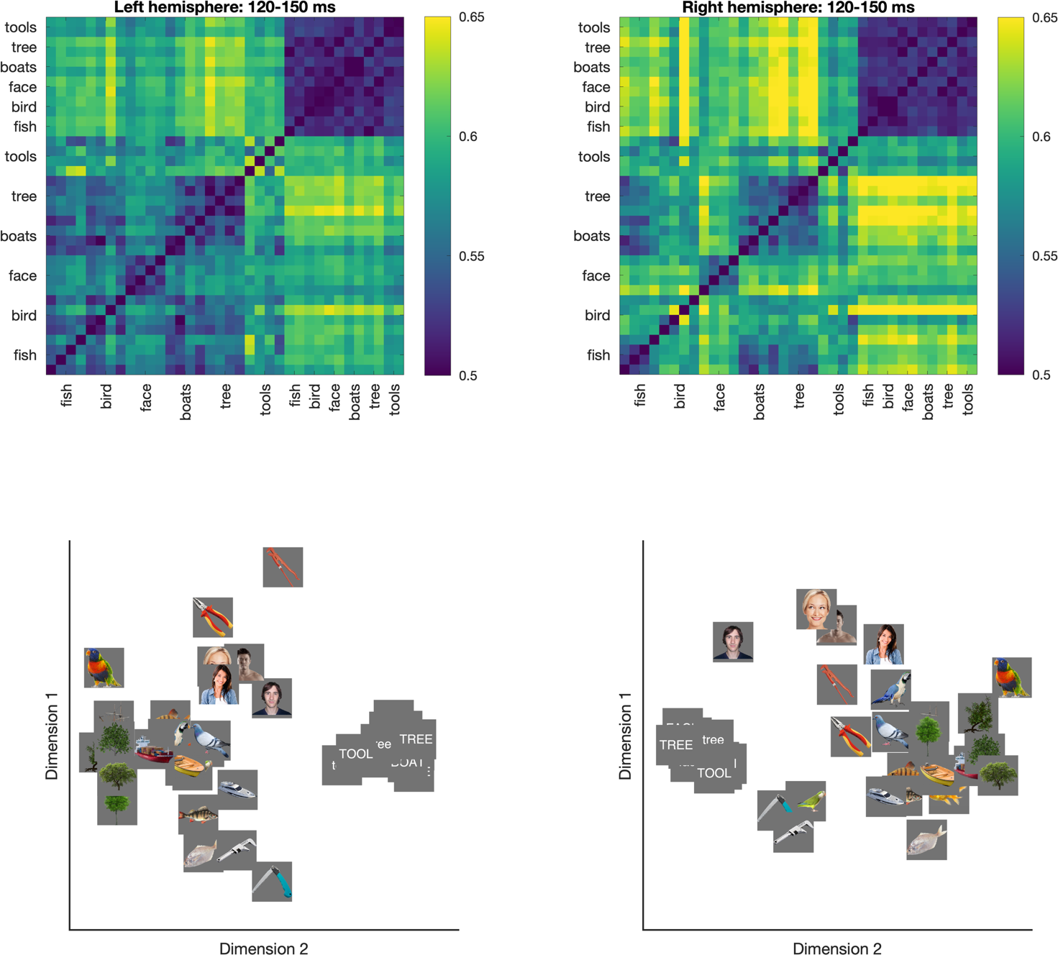
Note. Top: Group mean dissimilarity matrices for a time window 120-150 ms after stimulus onset, indexing decoding accuracy per electrode cluster. Bottom: 2D multidimensional scaling for visualisation of stimulus relationships. Categories such as words, faces and trees seem to form distinct clusters.
Hemispheric feature biases
To characterise how each hemisphere represents visual features, we calculated correlations between neural RDMs from the left and right hemispheres (like those in Figure 4) with a set of models based on image statistics of the presented stimuli (Figure 2) while partialling out the other hemisphere’s RDM. This analysis revealed that each hemisphere contained unique feature-related representations over and above the other hemisphere. Both hemispheres had reliable partial correlations with all models, (Figure 5). However, the hemispheres diverged in their feature profiles (see Table 1 for onset times and peak correlations per feature and hemisphere). Low spatial frequency information was the earliest feature reflected in both hemispheres, consistent with rapid low-level feature extraction in a coarse-to-fine grading. All visual features, except for rectilinearity, had earlier onsets and stronger correlations in the right than left hemisphere. Rectilinearity was the only model to show a left hemispheric bias, with stronger and earlier correlations emerged as the strongest model around 150 ms, whereas she right hemisphere showed stronger correlations with colour and low spatial frequency information. To assess whether these feature representations were largely driven by category differences, we ran the same analyses but restricted to the 20 objects in the stimulus set (i.e., no faces and words; see Supplementary Material). Though the correlations were noisier, which was expected due to less stimulus variation and fewer stimulus contrasts to correlate, the trend in the dynamics was similar: specifically, in comparison to the left hemisphere, correlations were numerically larger for colour and smaller for rectilinearity in the right hemisphere.
Figure 5. Feature representations per hemisphere
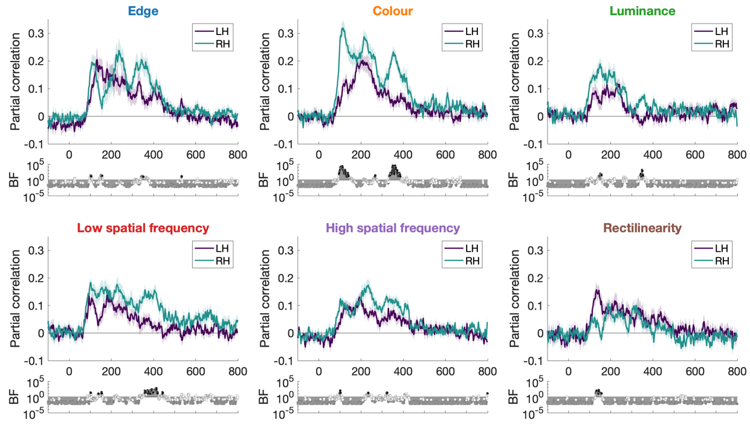
Z
Note. Hemispheric-specific representations reflect image statistics of presented stimuli. Partial neural-feature correlations were higher in the right hemisphere than the left for all features except rectilinearity, which showed stronger correlations in the left hemisphere. Bayes Factor plots reflect differences in partial correlations between the left and right hemispheres.

Table 1. Timing of neural-feature correlation onset and peaks.
 | Left hemisphere |  |  | Right hemisphere
 | Onset time | Peak time | Peak correlation | Onset time | Peak time | Peak correlation
Edge | 102 [100 102] | 133 [131 179] | 0.21 | 92 [90 92] | 237 [236 237] | 0.24
Colour | 110 [106 111] | 209 [182 228] | 0.20 | 77 [76 84] | 115 [111 117] | 0.32
Luminance | 112 [111 209] | 234 [182 241] | 0.12 | 95 [87 95] | 150 [149 150] | 0.19
Low SF | 89 [88 90] | 181 [94 182] | 0.14 | 76 [76 79] | 103 [101 228] | 0.18
High SF | 105 [104 132] | 192 [192 199] | 0.13 | 85 [82 87] | 235 [217 235] | 0.17
Rectilinearity | 113 [113 114] | 133 [132 144] | 0.16 | 299 [187 317] | 188 [188 320] | 0.11
Note. Onset time was calculated as the first of ten consecutive time points with reliable correlations (BF>10). Brackets denote 95% confidence intervals from leave-two-out jack-knifing. Bold values reflect the hemisphere with the reliably earlier time for that visual feature and decoding aspect (onset/peak).

Unique and shared hemispheric representations
Having established that the hemispheres differ in their feature profiles, we next asked how much representational information is unique to each hemisphere versus shared across hemispheres. To address this, we performed a time-generalisation RSA in which RDMs were correlated in a split-half manner across all pairs of time points. Within-hemisphere correlations (left-left and right-right) index representational consistency, while across-hemisphere correlations (left–right) index interhemispheric information sharing. Within-hemisphere consistency was higher than across-hemisphere correlations, particularly along the diagonal where similar time periods were compared, indicating that each hemisphere contains representational structure not fully captured by the other (Figure 6). Examining the across-hemisphere correlations as a function of time delay revealed that interhemispheric similarity was greatest around zero lag, suggesting that information coding in the hemispheres is tightly aligned rather than reflecting asymmetric transfer from one hemisphere to the other.
Figure 6. Unique information is contained within each hemisphere.
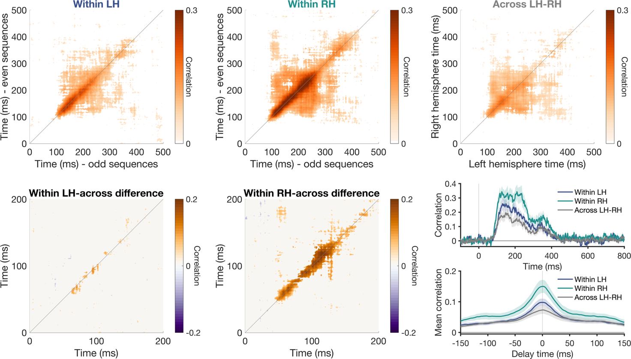
Note. Time generalisation RSA results: RDMs were correlated in a split-half manner for every pair of time points. Matrices show strength of correlation for reliable correlations only (BF>10). A/B) Within left hemisphere (LH) and right hemisphere (RH) correlations reveal consistency whereas across LH-HR correlations reveal interhemispheric information sharing. D/E) Within hemispheric consistency was higher than interhemispheric sharing, particularly for tightly coupled time windows close to the diagonal. F) Within versus across hemispheric consistency as a function of processing time reveals unique information in each hemisphere relative to the information shared across hemispheres. G) Mean correlation as a function of time delay. Greatest interhemispheric correlations were observed for short delays between left and right hemispheres, with a symmetric distribution around 0 ms delay.

Discussion
In this study, we investigated the temporal dynamics of visual representations within the left and right hemispheres. Using EEG and neural decoding methods, we characterised how object, face, and word representations unfold over time in each hemisphere, what visual features drive these representations, and the extent to which hemispheric representations are distinct versus shared. Our findings reveal that the two hemispheres carry complementary rather than redundant visual information, characterised by specific featural biases and different temporal dynamics, yet remain tightly temporally coupled.
The core finding of this study is that each hemisphere contains unique representational information that is not fully captured by the other. Here, the visual input was presented centrally, which means that the left and right hemispheres received fairly equivalent visual input. Yet, we found the hemispheres instantiated partially distinct representational geometries. Within-hemisphere split-half correlations were consistently higher than across-hemisphere correlations, demonstrating that the representational structure within each hemisphere is not simply a scaled copy of a shared signal. However, across-hemisphere correlations were reliably above chance, indicating a degree of shared structure, whether by interhemispheric transfer or independent but similar processing. Nevertheless, the difference between within- and across-hemisphere consistency indicates that each hemisphere makes a distinct contribution to visual processing. These results highlight the importance of considering hemispheric architecture when modelling visual perception.
These distinct hemispheric contributions were characterised by specific featural biases. All six visual features tested were represented in both hemispheres. However, the left hemisphere showed preferential coding of rectilinear features, while the right hemisphere was biased toward colour and low spatial frequency. These findings are somewhat consistent with previous reports of spatial frequency asymmetries across the hemispheres, where the right hemisphere has stronger sensitivity to low spatial frequency content (CITE), though we did not find the classic left bias for high spatial frequency. Importantly, our results go beyond demonstrating category-level lateralisation, such as the well-established rightward bias for faces and leftward bias for words, to reveal the lower-level feature dimensions that may intercorrelate with those asymmetries. These featural biases add to accounts of why certain stimulus categories tend to be lateralised, grounding category-level asymmetries in the underlying feature sensitivities of each hemisphere.
Te two hemispheres also exhibited distinct temporal dynamics. Decoding accuracy was generally stronger in the right hemisphere, which also showed more distinct peaks across time, suggesting a more differentiated processing cascade. The left hemisphere, by contrast, showed a smoother temporal profile. These different trajectories indicate that the hemispheres are not simply processing the same information at different magnitudes, but are engaged in qualitatively different processing sequences. Object and face representations in particular showed stronger information in the right than left hemisphere, consistent with the right hemisphere's known role in global processing. These representational dynamics suggest that visual information traverses multiple stages of processing within each hemisphere, with each hemisphere contributing a different perspective on the same input.
Despite these differences, the time-generalisation analysis revealed that the hemispheres are tightly temporally coupled. The highest across-hemisphere correlations were observed along the diagonal with very short delays, indicating that shared information between the hemispheres is temporally aligned rather than reflecting asymmetric transfer from one hemisphere to the other. This tight coupling suggests rapid interhemispheric communication, consistent with the known speed of callosal transfer (XX ms) and our previous findings of interhemispheric transfer using lateralised stimuli (Robinson et al., 2025). The time-generalisation matrices also revealed an interesting temporal pattern: early processing stages showed limited generalisation across time, consistent with rapidly evolving feedforward representations, while later stages showed broader temporal generalisation, suggesting the emergence of more stable representations. This pattern is similar to previous work (CITES) and was observed in both hemispheres, indicating that despite their different featural biases and temporal dynamics, both hemispheres follow a similar trajectory from transient to sustained coding.
Representational overlap between the hemispheres points to a degree of redundancy in the system. This redundancy may serve an important functional role, providing robustness to the visual system while the unique information in each hemisphere allows for complementary processing. The balance between shared and unique representations may reflect an efficient coding strategy that maximises efficiency and flexibility.
Our use of centrally presented foveal stimuli is noteworthy, as hemispheric differences in visual processing are often studied using lateralised displays. The fact that robust hemispheric asymmetries were observed for foveal stimuli that projected bilaterally demonstrates that hemispheric biases are not merely a consequence of contralateral visual field input, but reflect intrinsic processing differences between the hemispheres. Futhermore, the orthogonal task in this experiment suggests that these hemispheric biases reflect inherent lateralisation of visual processing, rather than differences in response criterion between the hemispheres. This finding broadens the relevance of hemispheric asymmetries beyond lateralised paradigms and underscores their importance for everyday visual perception, where most critical processing occurs in central vision.
Our stimulus set consisted of a diverse set real objects, faces and words. High level visual categories of faces and words have well-documented hemispheric asymmetries. Yet, we found that the same trend in featural asymmetries were still evident when only objects were analysed. The natural variation induced by including multiple stimulus categories in the study is a strength because it provided a broader visual space than if we had restricted to certain categories. This highlights the importance of considering multiple stimulus classes together to understand the visual system as a whole.
EEG proved to be a valuable tool for investigating hemispheric information processing. The high temporal resolution of EEG allowed us to track the rapid evolution of representations within each hemisphere and to characterise the fine-grained temporal dynamics of interhemispheric similarity. While EEG has limited spatial resolution, the use of lateral clusters combined with multivariate decoding methods is sufficient to reveal robust and distinct representational profiles in each hemisphere. Future work using methods with both high temporal and spatial resolution, such as MEG or intracranial recordings, could further refine our understanding of the cortical sources contributing to these hemispheric differences.
In summary, these results demonstrate that the left and right hemispheres make complementary contributions to visual perception, driven by distinct featural biases and different temporal dynamics, while maintaining tight temporal coupling. These findings argue for incorporating hemispheric architecture into models of visual processing, as treating the visual system as a single unified stream overlooks a fundamental organisational principle that shapes how the brain represents the visual world.

References
Behrmann, M., & Plaut, D. C. (2014). Bilateral Hemispheric Processing of Words and Faces: Evidence from Word Impairments in Prosopagnosia and Face Impairments in Pure Alexia. Cerebral Cortex, 24(4), 1102–1118. https://doi.org/10.1093/cercor/bhs390
Bryant, A. G., Shine, J. M., & Fulcher, B. D. (2025). Mapping functional, structural, and transcriptomic correlates of homotopic connectivity (p. 2025.06.10.657943). bioRxiv. https://doi.org/10.1101/2025.06.10.657943
Carlson, T. A., Grootswagers, T., & Robinson, A. K. (2020). An Introduction to Time-Resolved Decoding Analysis for M/EEG. https://doi.org/10.7551/mitpress/11442.003.0075
Christman, S., Kitterle, F. L., & Hellige, J. (1991). Hemispheric asymmetry in the processing of absolute versus relative spatial frequency. Brain and Cognition, 16(1), 62–73. https://doi.org/10.1016/0278-2626(91)90085-m
Cohen, L., Dehaene, S., Naccache, L., Lehéricy, S., Dehaene-Lambertz, G., Hénaff, M. A., & Michel, F. (2000). The visual word form area: Spatial and temporal characterization of an initial stage of reading in normal subjects and posterior split-brain patients. Brain, 123, 291–307. https://doi.org/10.1093/brain/123.2.291
Davidoff, J. (1976). Hemispheric sensitivity differences in the perception of colour. Quarterly Journal of Experimental Psychology, 28(3), 387–394. https://doi.org/10.1080/14640747608400565
Dehaene, S., Pegado, F., Braga, L. W., Ventura, P., Filho, G. N., Jobert, A., Dehaene-lambertz, G., Kolinsky, R., Morais, J., & Cohen, L. (2010). How Learning to Read Changes the Cortical Networks for Vision and Language. Science, 330, 1359–1364.
Dienes, Z. (2011). Bayesian Versus Orthodox Statistics: Which Side Are You On? Perspectives on Psychological Science, 6(3), 274–290. https://doi.org/10.1177/1745691611406920
Dienes, Z. (2016). How Bayes factors change scientific practice. Journal of Mathematical Psychology, 72, 78–89. https://doi.org/10.1016/j.jmp.2015.10.003
Ivry, R. B., & Robertson, L. C. (1998). The Two Sides of Perception. MIT Press.
Jeffreys, H. (1961). Theory of probability (Third). Oxford University Press.
Kanwisher, N., Mcdermott, J., & Chun, M. M. (1997). The Fusiform Face Area: A Module in Human Extrastriate Cortex Specialized for Face Perception. Journal of Neuroscience, 17(11), 4302–4311.
Kriegeskorte, N., Mur, M., & Bandettini, P. a. (2008). Representational similarity analysis—Connecting the branches of systems neuroscience. Frontiers in Systems Neuroscience, 2(November), 4–4. https://doi.org/10.3389/neuro.06.004.2008
Liu, S., Pletenev, A., Haefner, R. M., & Snyder, A. C. (2026). Task learning increases information redundancy of neural responses in macaque visual cortex. Science, 391(6789), 1029–1035. https://doi.org/10.1126/science.adw7707
Mesulam, M. M. (1981). A cortical network for directed attention and unilateral neglect. Annals of Neurology, 10(4), 309–325. https://doi.org/10.1002/ana.410100402
Morey, R. D., Rouder, J. N., Jamil, T., Urbanek, S., Forner, K., & Ly, A. (2018, May 19). Package “BayesFactor.” https://cran.r-project.org/web/packages/BayesFactor/BayesFactor.pdf
Oosterhof, N. N., Connolly, A. C., & Haxby, J. V. (2016). CoSMoMVPA: Multi-Modal Multivariate Pattern Analysis of Neuroimaging Data in Matlab/GNU Octave. Frontiers in Neuroinformatics, 10. https://doi.org/10.3389/fninf.2016.00027
Perrin, F., Pernier, J., Bertrand, O., & Echallier, J. F. (1989). Spherical splines for scalp potential and current density mapping. Electroencephalography and Clinical Neurophysiology, 72(2), 184–187. https://doi.org/10.1016/0013-4694(89)90180-6
Peterzell, D. H., Harvey, L. O., & Hardyck, C. D. (1989). Spatial frequencies and the cerebral hemispheres: Contrast sensitivity, visible persistence, and letter classification. Perception & Psychophysics, 46(5), 443–455. https://doi.org/10.3758/bf03210859
Raemaekers, M., Schellekens, W., Petridou, N., & Ramsey, N. F. (2018). Knowing left from right: Asymmetric functional connectivity during resting state. Brain Structure and Function, 223(4), 1909–1922. https://doi.org/10.1007/s00429-017-1604-y
Robinson, A. K., Grootswagers, T., Shatek, S. M., Behrmann, M., & Carlson, T. A. (2025). Dynamics of visual object coding within and across the hemispheres: Objects in the periphery. Science Advances, 11(1), eadq0889. https://doi.org/10.1126/sciadv.adq0889
Robinson, A. K., Quek, G. L., & Carlson, T. A. (2023). Visual Representations: Insights from Neural Decoding. Annual Review of Vision Science, 9(1), 313–335. https://doi.org/10.1146/annurev-vision-100120-025301
Rossion, B., Joyce, C. A., Cottrell, G. W., & Tarr, M. J. (2003). Early lateralization and orientation tuning for face , word , and object processing in the visual cortex. 20, 1609–1624. https://doi.org/10.1016/j.neuroimage.2003.07.010
Rouder, J. N., Speckman, P. L., Sun, D., Morey, R. D., & Iverson, G. (2009). Bayesian t tests for accepting and rejecting the null hypothesis. Psychon Bull Rev, 16(2), 225–237. https://doi.org/10.3758/PBR.16.2.225
Sergent, J. (1982). The cerebral balance of power: Confrontation or cooperation? Journal of Experimental Psychology. Human Perception and Performance, 8(2), 253–272. https://doi.org/10.1037//0096-1523.8.2.253
Stevens, W. D., Kahn, I., Wig, G. S., & Schacter, D. L. (2012). Hemispheric Asymmetry of Visual Scene Processing in the Human Brain: Evidence from Repetition Priming and Intrinsic Activity. Cerebral Cortex (New York, NY), 22(8), 1935–1949. https://doi.org/10.1093/cercor/bhr273
Teichmann, L., Moerel, D., Baker, C., & Grootswagers, T. (2021). An empirically-driven guide on using Bayes Factors for M/EEG decoding (p. 2021.06.23.449663). https://doi.org/10.1101/2021.06.23.449663
Ting Siok, W., Kay, P., Wang, W. S. Y., Chan, A. H. D., Chen, L., Luke, K.-K., & Hai Tan, L. (2009). Language regions of brain are operative in color perception. Proceedings of the National Academy of Sciences of the United States of America, 106(20), 8140–8145. https://doi.org/10.1073/pnas.0903627106
Wagenmakers, E. (2007). A practical solution to the pervasive problems of p values. Psychonomic Bulletin and Review, 14(5), 779–804. https://doi.org/10.3758/BF03194105
Wetzels, R., Matzke, D., Lee, M. D., Rouder, J. N., Iverson, G. J., & Wagenmakers, E. J. (2011). Statistical evidence in experimental psychology: An empirical comparison using 855 t tests. Perspectives on Psychological Science, 6(3), 291–298. https://doi.org/10.1177/1745691611406923
Wetzels, R., & Wagenmakers, E.-J. (2012). A default Bayesian hypothesis test for correlations and partial correlations. Psychonomic Bulletin & Review, 19(6), 1057–1064. https://doi.org/10.3758/s13423-012-0295-x
Yovel, G., Levy, J., & Yovel, I. (2001). Hemispheric asymmetries for global and local visual perception: Effects of stimulus and task factors. Journal of Experimental Psychology. Human Perception and Performance, 27(6), 1369–1385.
Zellner, A., & Siow, A. (1980). Posterior odds ratios for selected regression hypotheses. Trabajos de Estadistica Y de Investigacion Operativa, 31(1), 585–603. https://doi.org/10.1007/BF02888369
Zhen, Z., Kong, X.-Z., Huang, L., Yang, Z., Wang, X., Hao, X., Huang, T., Song, Y., & Liu, J. (2017). Quantifying the variability of scene-selective regions: Interindividual, interhemispheric, and sex differences. Human Brain Mapping, 38(4), 2260–2275. https://doi.org/10.1002/hbm.23519

SUPPLEMENTARY INFORMATION

Neural sensors sensitive to image content
Searchlight decoding was conducted to examine which clusters of electrodes had the highest decoding accuracy. Figure S1 shows that occipitotemporal electrodes showed the strongest decoding, with accuracy higher over the right hemisphere than the left.

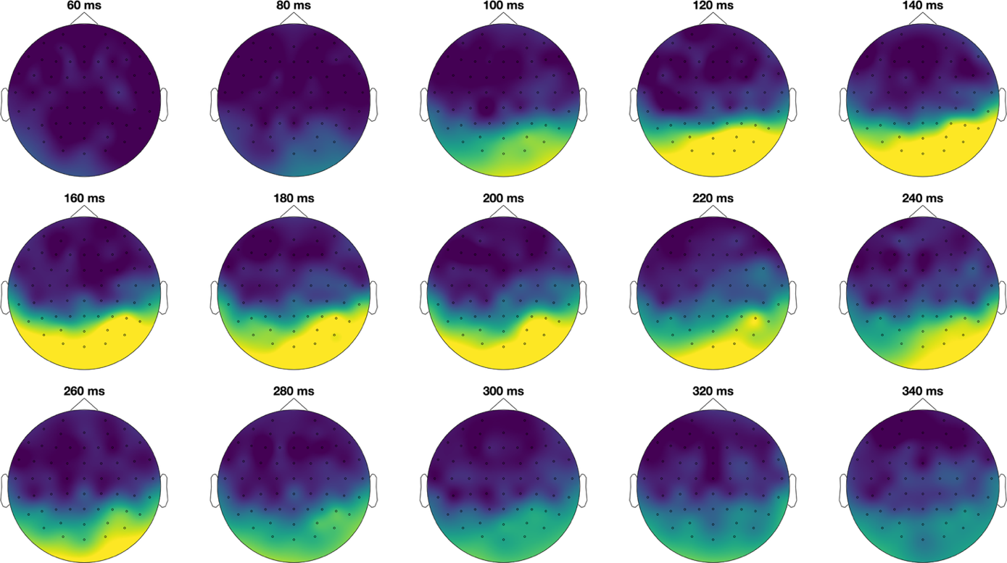
Figure S1. Headmaps showing accuracy for decoding the 36 experimental images at each cluster of electrodes on the scalp. Each headmap represents decoding accuracy at a given time after image presentation.

Right-handers
Decoding accuracy reflected similar hemispheric patterns when restricted to the right-handed participants (N = 17) relative to the full group (N = 20; Figure 3).

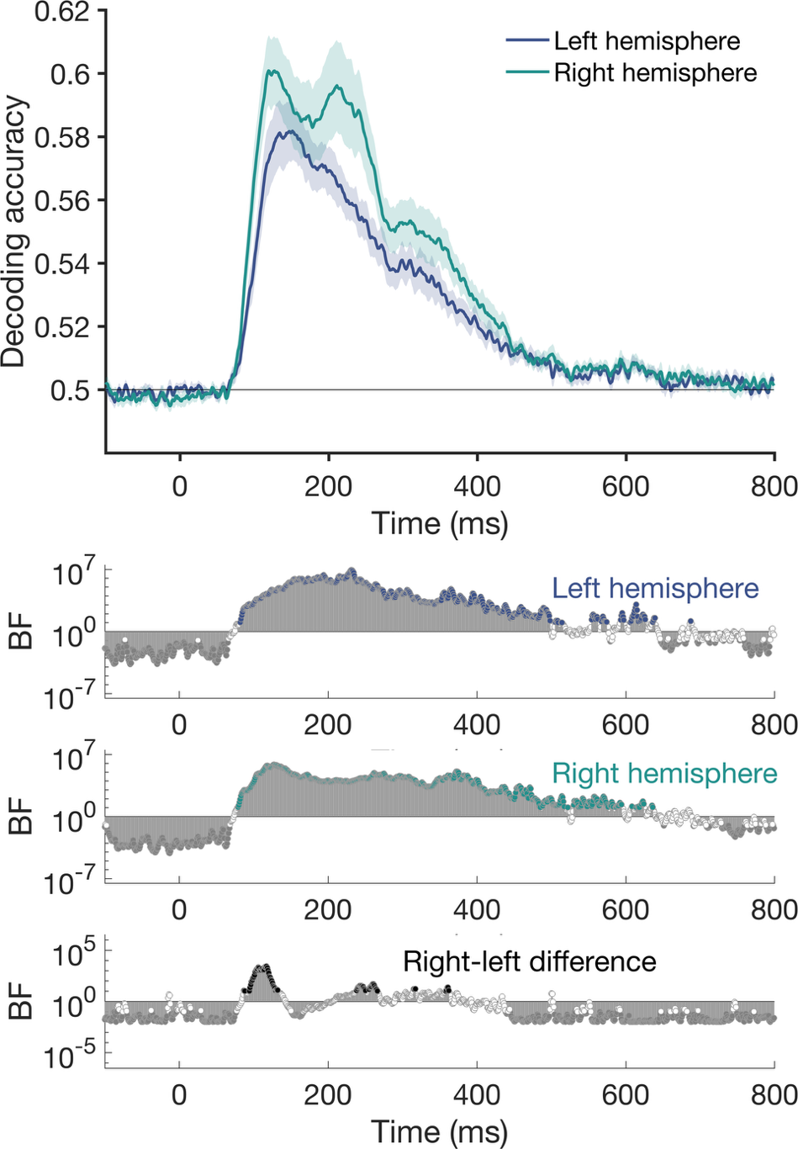
Figure S2. Neural decoding for left and right clusters of electrodes, using right-handed participants only.

Image RSA using separate categories
Figure S4. Neural-feature correlations for the 20 objects (i.e., no face or word stimuli) 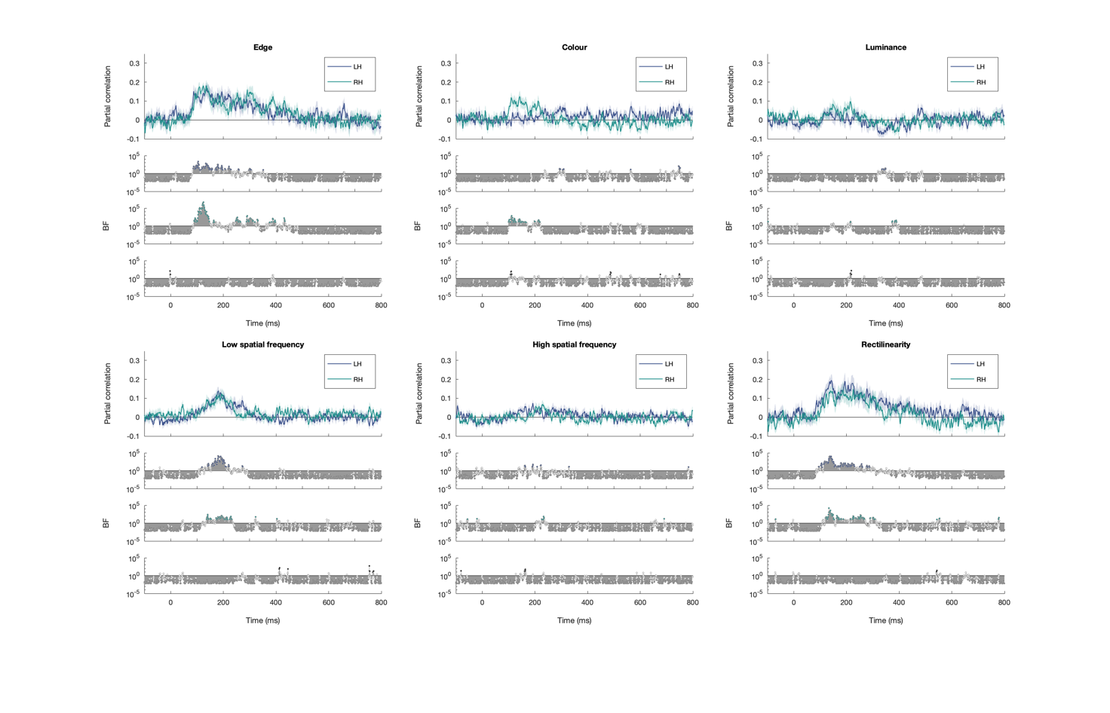
Figure S5. Neural-feature correlations for the 12 words (i.e., no objects or face stimuli) 

