**Does Teaching Experience Affect a Professor’s Student Approval Rating?**

Amanda Shu

**1 Introduction**

Not only do students care about the courses they take, but it is equally important for students to know who teaches those courses. At University of California, San Diego, students refer to Course and Professor Evaluations (CAPE) to help plan out their courses. CAPE is an anonymous survey that is sent to students at the end of every quarter, asking students for feedback on their courses and instructors. These responses are beneficial to both instructors and students; instructors can receive comments that could help them improve their teaching methodology, and students can gain a better understanding from fellow students of courses and professors that they would like to take in the future. Unlike RateMyProfessor, a website that hosts student written reviews of professors, CAPE displays all the courses taught every quarter, and a summary of course and professor evaluations for that specific quarter and course are attached to it. A natural question, then, is to ask if you would see an increase in student approval ratings over time as a professor teaches more courses. General intuition would agree that student approval ratings would increase as a professor gains more teaching experience. However, it can be argued that there would not be an increase if instructors are more focused on their research instead of improving their teaching. It also may be the case that professors have good ratings already, and that there is not much to improve upon. Thus, the purpose of this paper is to determine the effect of a professor’s teaching experience on student approval ratings in the economics department at UCSD, using an OLS regression model. I expect there to be a positive effect, and I will perform a hypothesis test on the regression coefficient to see if there is a significant positive linear relationship between teaching experience and approval ratings.

**2 Data**

The data is taken from the CAPE website, which contains data on 1847 economic courses from summer 2007 to fall 2018. Since the data is survey data, I note that the response rates are low, with the median response rate being 37.5%. Figure 1 is a histogram of response rates, showing a right skewed distribution. It is likely that students who are motivated to fill out the CAPE survey are students with more extreme opinions on the professors (they strongly like or dislike the professor). However, this is only a caution for students interpreting these approval ratings. This will not affect my regression results, as I am interested in seeing a change in student approval ratings as professors gain more teaching experience. Also, I note that 4 response rates were over 100%, which is impossible. Thus, I deleted these observations from my analysis entirely to avoid the possibility of an inconsistent result if those errors are somehow correlated with the professor’s experience.

The CAPE survey asks students if they recommend the instructor (yes/no question) for each of their courses that quarter. I will use the percent of students who recommend the instructor, denoted as *rec_instr*, as my left hand side variable. To measure a professor’s experience (*experience)*, I counted the number of courses the professor has taught up to and including the current course. For example, if a professor has taught 3 courses in fall 2015, spring 2016, and fall 2018, then the professor will have an experience of 1 for the fall 2015 course, 2 for spring 2016, and 3 for fall 2018. A limitation with this method to measure experience is that professors who taught courses before summer 2007, when the CAPE data begins, have their experience discounted. Ideally, I would have CAPE data from the beginning of time to avoid this problem, but that is infeasible so I will explore this dataset as is. As a control variable, I included the number of students enrolled in the course in a variable called *num_enrolled,* which represents the size of the class. Table 1 shows the descriptive statistics for these variables. I also created 87 indicators variables (not included in Table 1) for each economic course that was offered over the period that the CAPE data was taken. For example, the variable *econ100a* is an indicator variable that is 1 if the observation is a Microeconomics A course and 0 if it is not. The course that was dropped to avoid multicollinearity is *econ1*, or Principles of Microeconomics.

Figure 1: Distribution of Response Rates

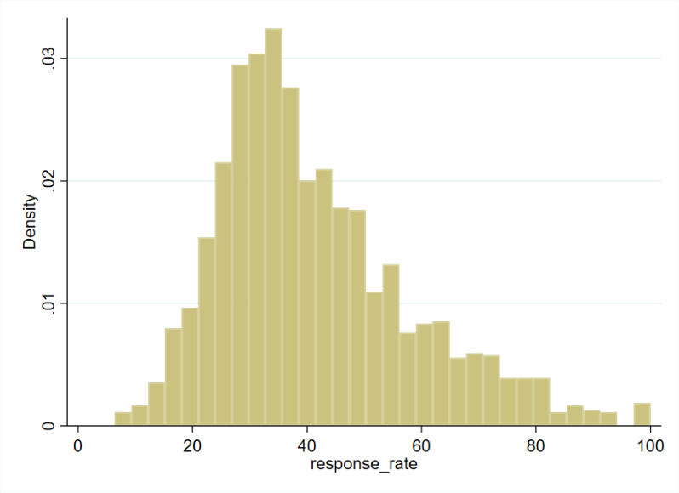

|  |  |  |  |  |  |
| --- | --- | --- | --- | --- | --- |
| Table 1 : Descriptive Statistics of CAPE Data | | | | | |
| Variable | Mean | Standard Deviation | Minimum | Maximum | No. of Obs. |
| Percent of Students Who  Recommend Instructor (%) | 84.558 | 14.036 | 0 | 100 | 1,843 |
| Number of Courses Taught* | 18.617 | 19.871 | 1 | 96 | 1,843 |
| Number of Students Enrolled | 124.107 | 85.588 | 4 | 461 | 1,843 |
| Response Rate (%) | 41.259 | 16.902 | 6.383 | 100 | 1,843 |

*the cumulative number of the courses the instructor has taught prior to and including the current course

Source: Course and Professor Evaluations (http://www.cape.ucsd.edu/)

The data was copy and pasted from the CAPE website and cleaned in R. It contains student filled course and professor evaluations of all economic courses taught starting from summer quarter 2007 to fall quarter 2018.

**3 Model Specification**

I use an OLS regression, with my left hand side variable being the percentage of students who recommend the instructor and my right hand side variable of interest being the professors’ experience, measured by the number of courses the professor has taught up to and including the current course. Larger classes are often harder for professors to teach given they must engage a larger crowd, so teaching a larger class may negatively affect a professor’s approval ratings regardless of the professor’s experience. Thus, the number of students enrolled in the course is included in the regression in order to avoid omitted variable bias. Additionally, with the variety of economic courses taught at UCSD, there is likely to be varying levels of difficulty in the material of the courses. Courses with more difficult material will be harder for students to understand and will be more demanding for professors to teach, which may also negatively affect student approval ratings. Hence, the indicator variables of each economics course controls for varying difficulty levels between the material of these courses. I note that even with the same economic course, there may be varying class sizes between quarters. For example, for econ100a, there may be a class taught in spring 2018 that has 128 students, while the same course will be offered fall 2018 with 239 students. It is for this reason why I include enrollment numbers in addition to the indicator variables of each course rather than just the indicators themselves. Hence, I am estimating the linear effect of *experience* on *rec_instr,* or $β_{1}$ in equation (1). I then perform a one-sided hypothesis test, with the hypotheses stated in (2). I test the null hypothesis that there is no significant linear relationship between *experience* and *rec_instr,* against the alternate hypothesis that there is a significant positive relationship.



$re{c_instr}_{ }=β_{0}+ β_{1}experience+ β_{2}num_enrolled+β_{3}econ120b+…+β_{89}econ173$

$H_{0}: β_{1}=0$

$H_{1}: β_{1}>0$

**4 Results**

I run four regressions, as shown in Table 2, and I perform a hypothesis test on the last regression. In each specification my dependent variable is the percent of students who recommend the instructor. In my first specification, I include only the independent variable of interest, the number of courses a professor has taught up to and including the current course. The result is positive and statistically significant, suggesting that professors who have taught more courses tend to have higher student ratings. However, this association is small as the coefficient is 0.04. In other words, for every additional course a professor teaches, his or her student approval ratings increase by 0.04%.

In my second specification, I added the number of students enrolled in the course into the regression. The class size may affect student approval ratings since larger classes are more difficult for professors to teach. The result is still significantly significant, with the coefficient of interest increasing slightly to 0.049. The coefficient on enrollment size is negative at -0.021, which indicates that increasing enrollment by 100 students while fixing a professor’s teaching experience is associated with a decrease of approval ratings by 2.1%. The results indicate that the sign of the omitted variable bias is negative, so the coefficient result in the first regression underestimated the association between professor’s experience and student approval ratings. In addition, the correlation between experience and enrollment is positive, suggesting that teachers who have taught more courses tend to teach large classes.

In my third specification, I replace the class size variable with the course indicator variables to see if there is omitted variable bias with the indicators as well. The purpose of the course indicators is to control for varying difficulty levels of these courses. In this case, the coefficient on number of courses taught increases to 0.065, suggesting that once again the omitted variable bias is negative and that my first specification underestimates the effect of a teacher’s experience on student approval ratings. This result indicate that some courses will tend to have lower professor approval ratings, regardless of the professor’s experience.

I include both class size and the course indicator variables as control variables in my fourth specification. The coefficient on the number of students enrolled became smaller in magnitude at -0.01, so the effect of class size on student approval ratings is partially accounted for by the indicator variables. The coefficient of professor’s teaching experience increases to 0.068. I conduct a hypothesis test on this coefficient. The null hypothesis is that there is no effect of a professor’s experience on student approval ratings, and the alternate hypothesis is that there is a positive effect. The t statistic is 4.07, so I reject the null hypothesis at the 1% significance level, and I conclude that there is a statistically significant positive effect of a professor’s experience on student approval ratings. However, the effect is quite small. A professor who teaches 100 more courses sees an increase of 6.8% in approval ratings. Since the standard deviation of a professor's teaching experience is almost 20, the result indicates that if you increase experience by 1 standard deviation, student approval ratings increase by about 1.35%. This small effect is further seen by the flat, increasing slope of the added variable plot in Figure 2, which visually depicts the positive linear relationship between the number of courses a professor has taught and the percent of students that recommend the instructor.

|  |  |  |  |  |
| --- | --- | --- | --- | --- |
| Table 2 | Estimates of Effect of Teaching Experience on Student Approval Ratings  Dependent Variable: Percent of Students Who Recommend Instructor | | | |
|  | (1) | (2) | (3) | (4) |
| Number of Courses Taught | 0.040 | 0.049 | 0.065 | 0.068 |
|  | (0.014)** | (0.014)** | (0.017)** | (0.017)** |
| Number of Students Enrolled |  | -0.021 |  | -0.010 |
|  |  | (0.004)** |  | (0.005)* |
| Course Indicators Included? | No | No | Yes | Yes |
| Constant | 83.819 | 86.252 | 84.852 | 86.657 |
|  | (0.459)** | (0.667)** | (1.314)** | (1.628)** |
| R2 | 0.00 | 0.02 | 0.17 | 0.17 |
| Root MSE | 14.017 | 13.907 | 13.085 | 13.07 |
| No. of Obs. | 1,843 | 1,843 | 1,843 | 1,843 |

Standard errors are in parenthesis

* *p*<0.05; ** *p*<0.01

Figure 2: AV Plot of Number of Courses Taught

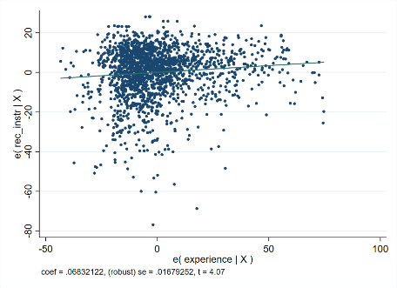

**5 Conclusion**

The result of this paper shows that the number of courses a professor has taught has a positive effect on student approval ratings in the economics department at UCSD. The effect of experience remained statistically significant after adding the control variable of class size and indicator variables for each course. The effect is small, indicating that professors must teach many courses to increase their ratings by a few percent, and that professors who are new to teaching should not expect an increase in their approval ratings after teaching just a few courses.

My result has its limitations as well. First, the data is not ideal, as it does not cover all courses since the beginning of a professor’s teaching and it may contain entry errors. My results would be invalidated if professors whose experience were discounted show different student approval ratings over time or if those data entry errors are correlated with a professor’s teaching experience. Also, since I only used data on the economics department at UCSD, this result cannot be extended towards other departments nor to professors at other academic institutions in general. It would be interesting to see if this result remains the same across all departments at UCSD, a question left for further research.