Reporting on encodings of PCs

PCs are zero indexed in code, here, we will refer to the first as PC 1.

PC 1 vs. PC 2
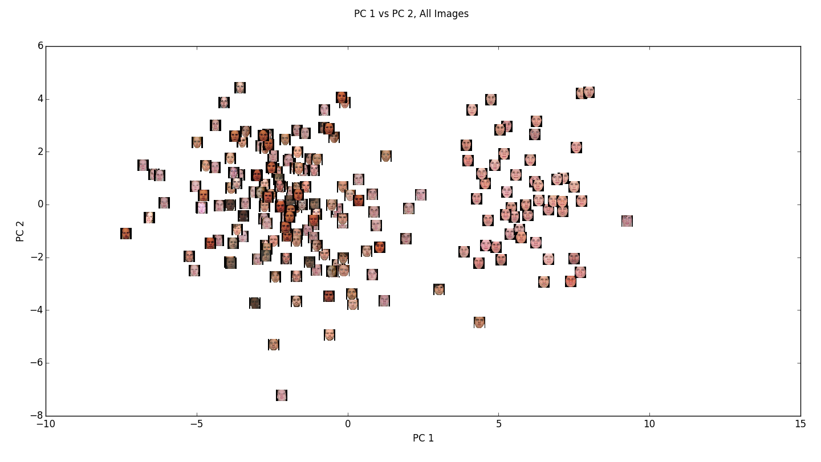
Here, we see clear clustering of the GS dataset, while the other sets are mixed.
By this diagram, it seems that PC 1 still primarily explains dataset variance.

PC 3 vs PC 4
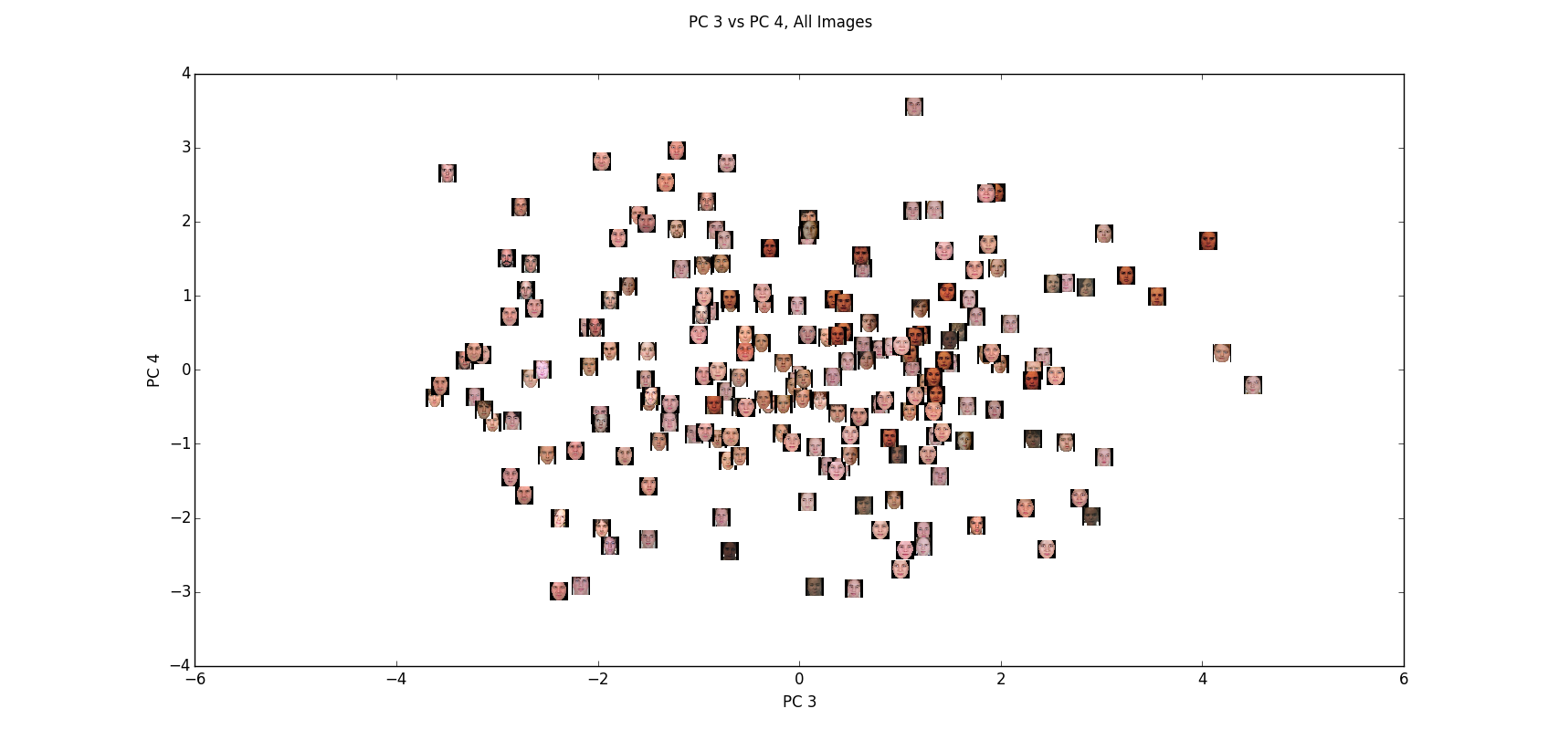
PCs 3 and 4 do not seem to have as much dataset encoding. I will explore their meaning below.

PC 1
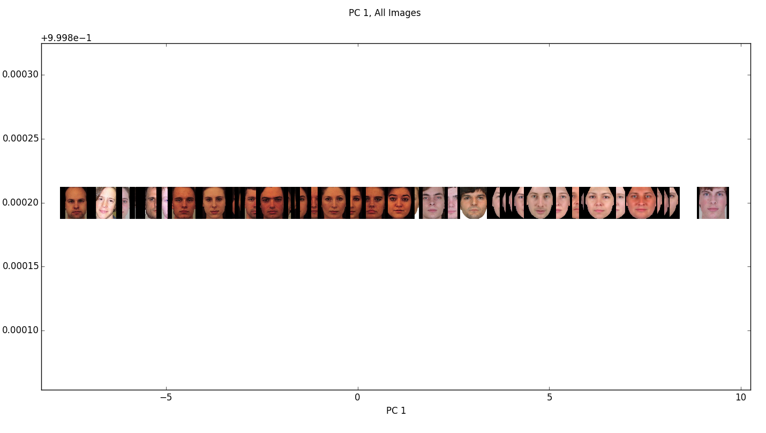
From this plot of PC 1 in one dimension, we can again see the clear clustering of the GH dataset on the right.

It appears that this PC is making the dataset distinction based on the size of the forehead. This would make sense because the GH dataset has cut off all of the foreheads, making them notably shorter than those in other sets.

Here is the lower end of the PC 1 spectrum:
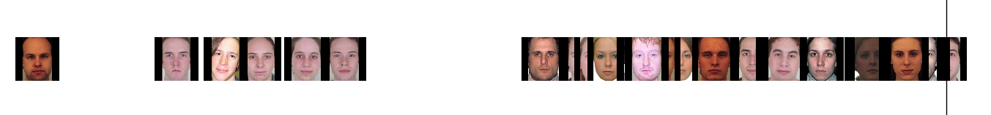

Note the abnormally large foreheads.
...
Here is the upper end of the PC 1 spectrum:
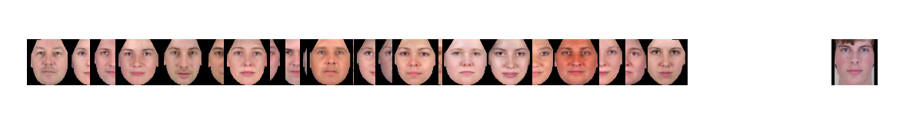

Note the concentration of GH images, and others with small foreheads.

While it is strange that the most variance is explained in forehead size, this may make sense because ¼ of the images come from the GH set which all have apparently smaller foreheads.

* When splitting the same data into the 4 datasets for visualization, the forehead trend can be seen separately in each set:
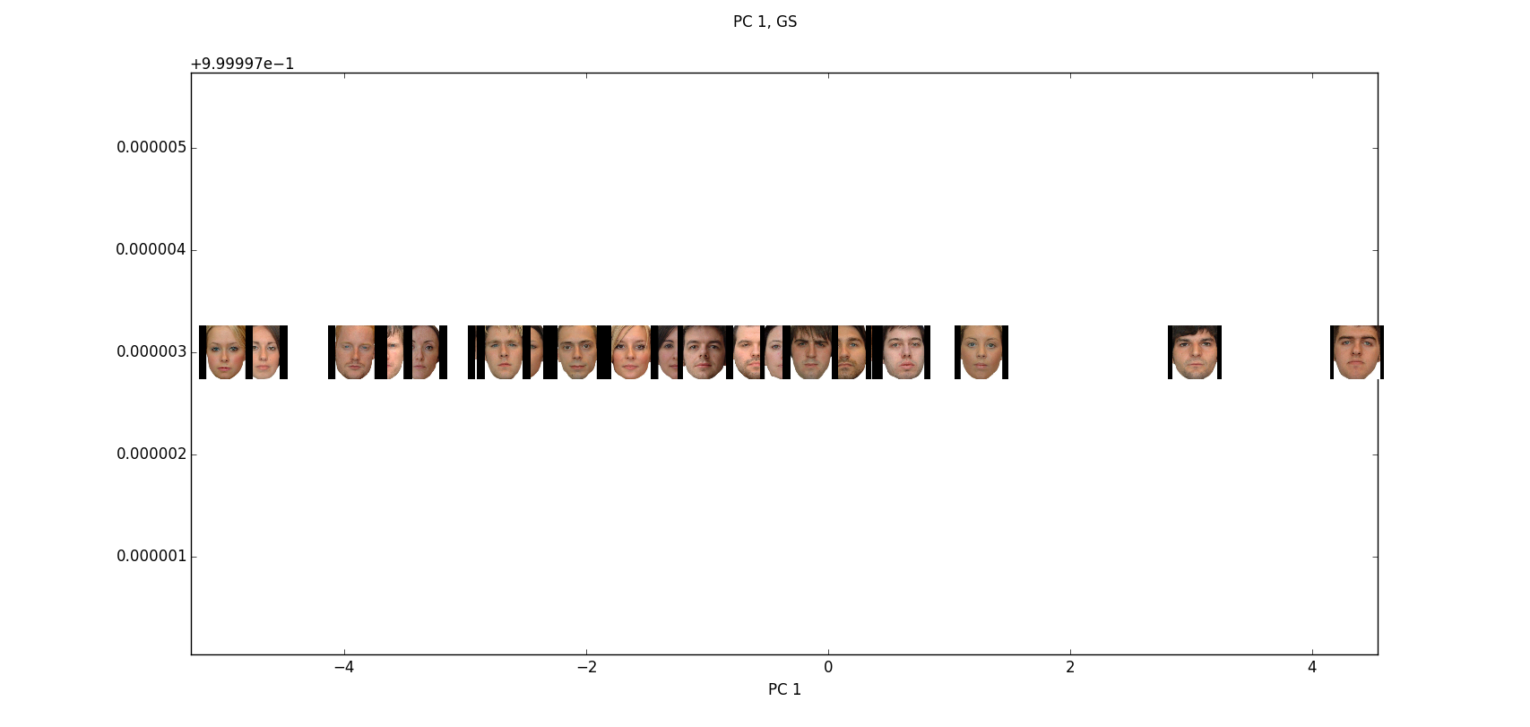
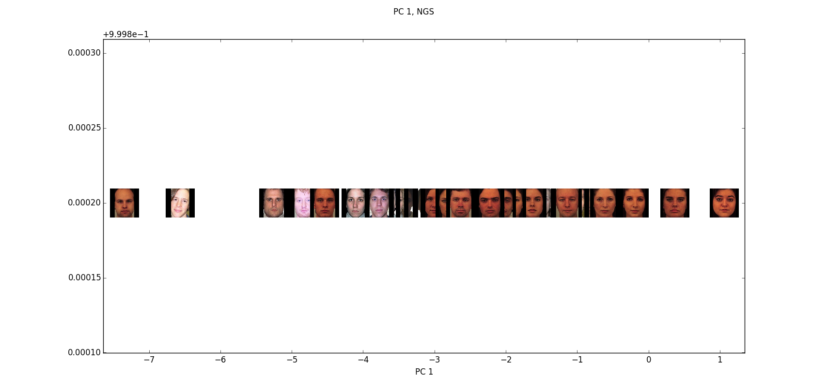
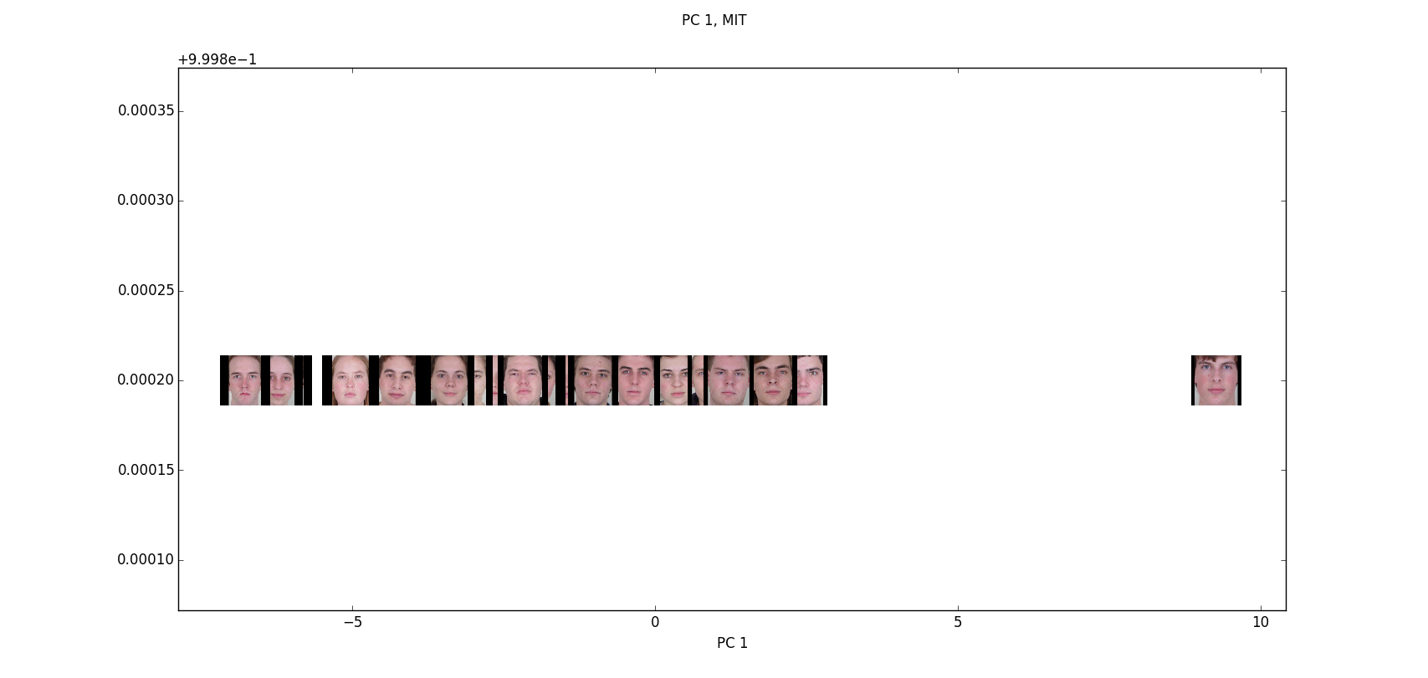

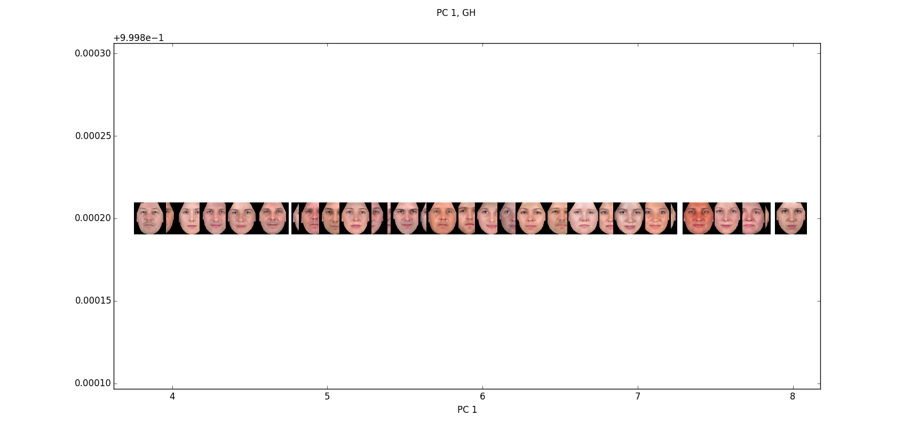

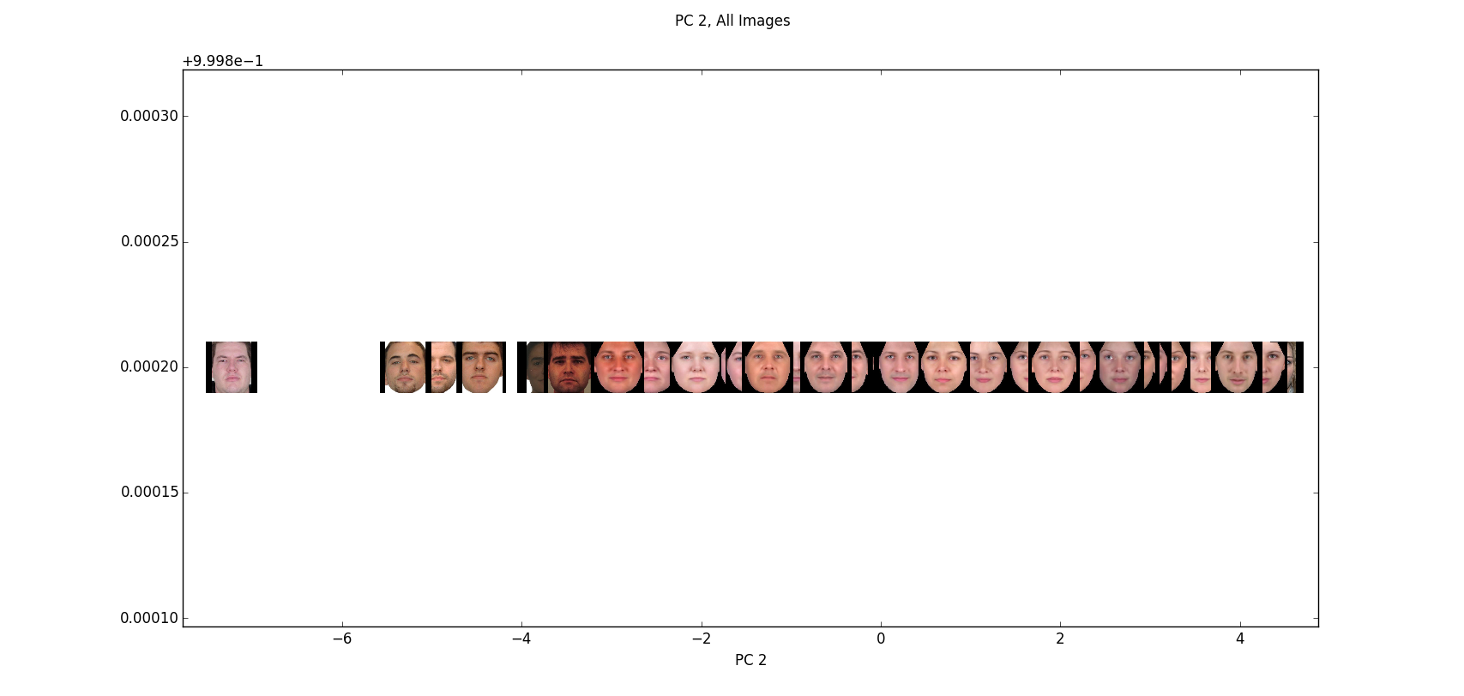
PC 2

This PC appears to code gender, with males on the left and females on the right. There are some occasional oddities, but when you split it into the 4 separate datasets it is fairly clear.

This is because there is still some dataset bias in this PC.
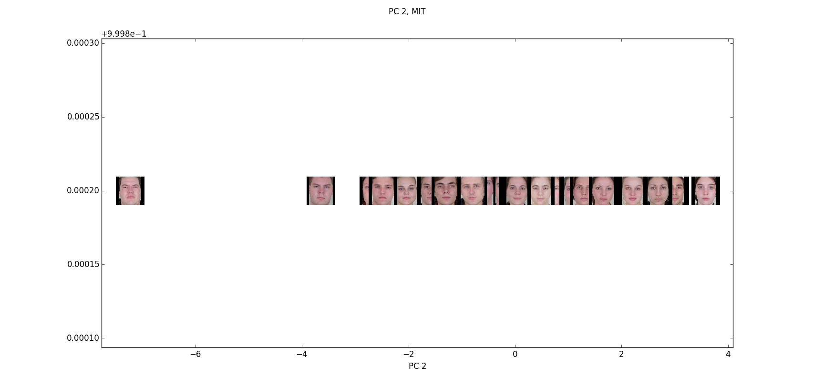
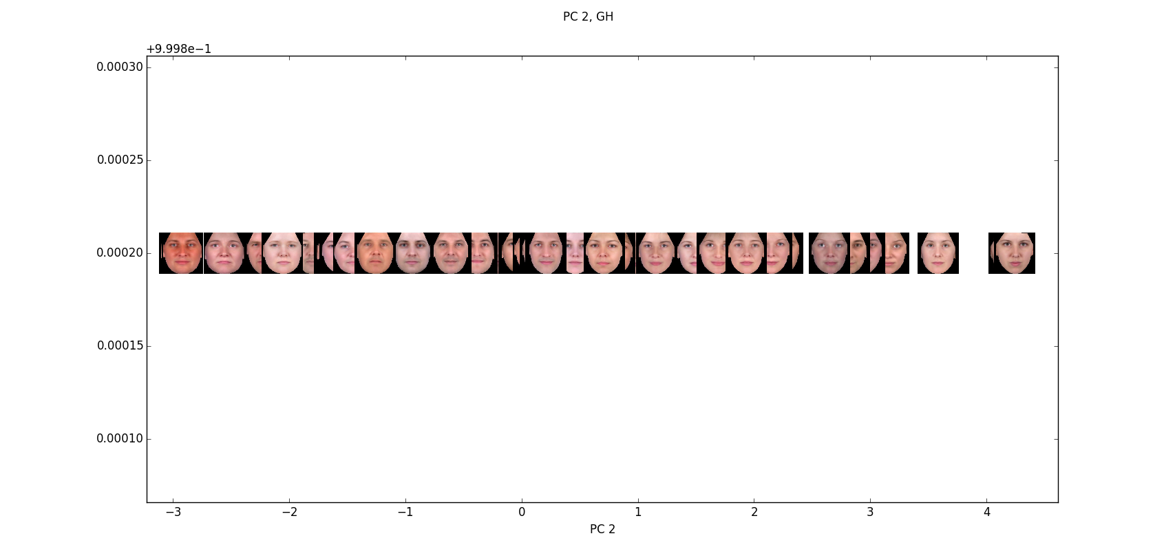
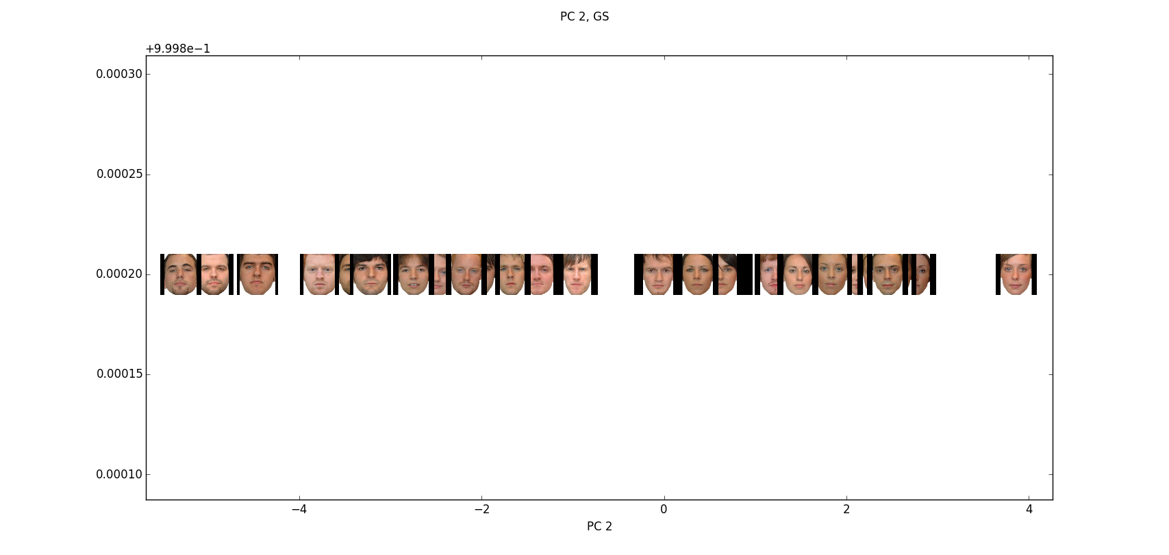
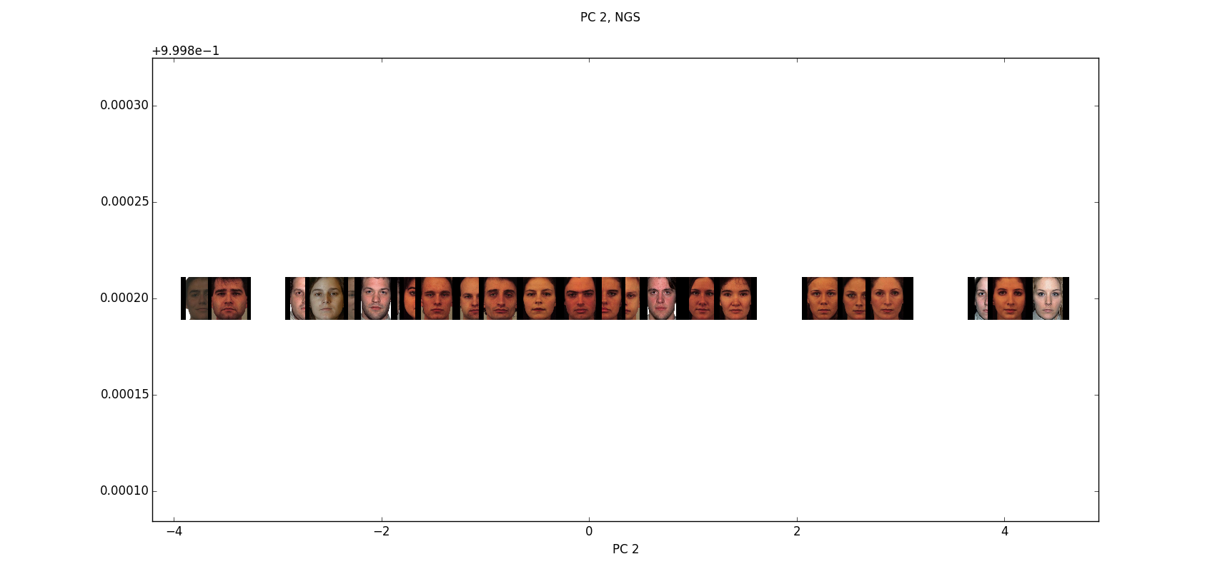
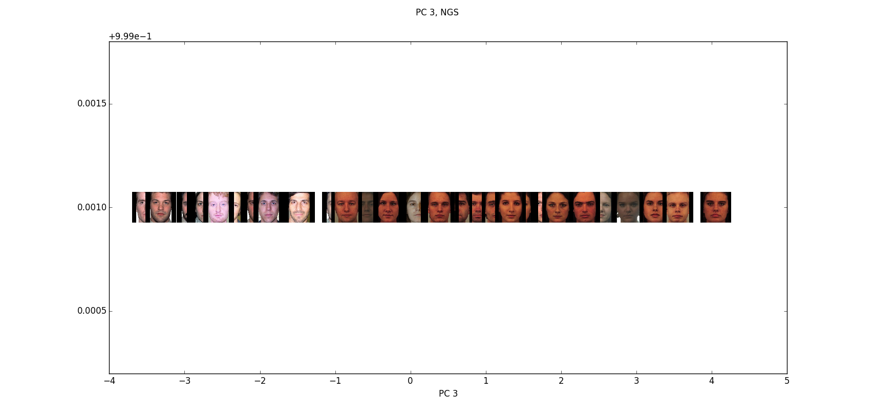

PC 3

This PC seems to describe facial roundness or oval-ness. With rounder faces to the right and longer faces to the left.

