What I did:
- Took the new feature matrix including symmetry and averageness
- Scaled it (preprocessing)
- Re-ran Linear Regression
- Cross validated (k-fold)
- Calculated Correlation, VarScore, MSE
- Recorded average learned weights for each rater
- Average all preference vectors, record and visualize
- Add stdev bars to graph
- Calculate pearson correlation between learned weights and actual feature weights for all 200 photos
- Rank photos, visualize 4 most and 4 least attractive.
- Included ranking list

What I Observed:
- Too many GH dataset faces in most attractive faces
- Too many women in most attractive faces
- The weights of Symmetry and Averageness were not as high as expected
- Might be because they are dependent on rotation of face

What I Want to Do:
- Check if the bias is in the dataset or our model
- Visualize our predicted rankings vs actual average rating ranking
- Check our model on CFD faces (once foreheads are marked)
- I want to verify that my weights make sense by comparing to the ones Amanda calculated without symmetry and averageness
- Check actual weight values
- See if the ranking based on those weights makes more sense
- Gary wants to know what the correlation was before adding symmetry etc.
Cross Validated Linear Regression:

Test Results:
Correlation: 0.346680583151
VarScore: 0.0668041981329
MSE: 1.53157700429

+heartshapeness +lip fullness
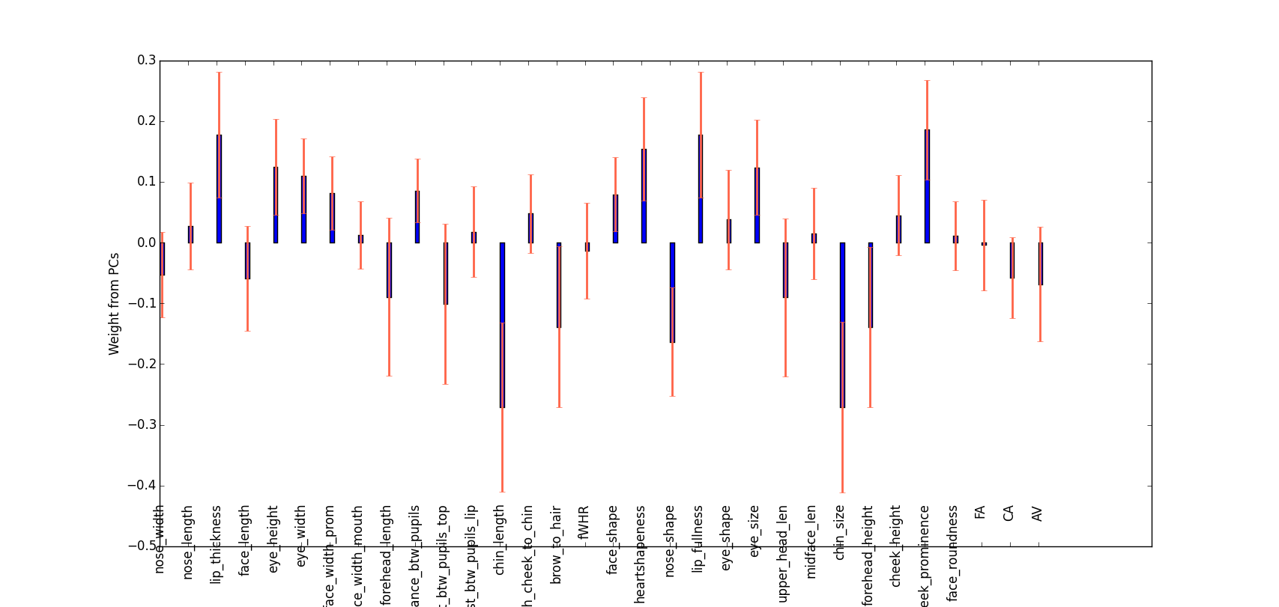
+lip thickness -chin length -nose shape -chin size +cheek prominence

Beatiful Faces According to Average Model Weights
-Asymmetry
-Distance from Averageness
1.
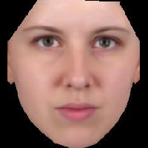

2.
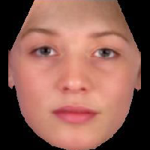

3.
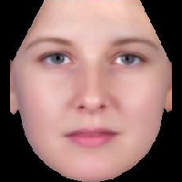

4.
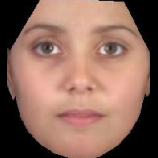

Least Attractive (1 = least)

1.
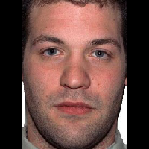

2.
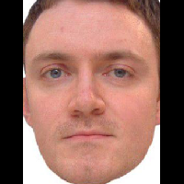

3.
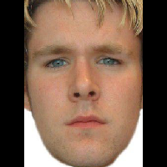

4.
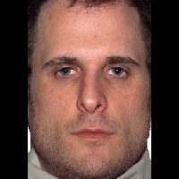

Observations:
Two potentially negative indicators stand out:
“Most Attractive” is mostly women from GH set
“Least Attractive” is mostly men from other sets

