Over the years, mental health has become a less stigmatized topic of conversation. Although this newfound awareness has benefited some people, millions continue to live with mental illness. According to the National Alliance on Mental Illness, one in five adults in the United States experience mental illness each year.[1] Due to an oftentimes highly competitive work environment and abnormal working hours, tech employees are also prone to developing mental health issues.[2]

In the U.S, most workers’ insurance policy and benefits rely on their job — including assistance for mental illness-related needs. Therefore, it’s of utmost importance to investigate the coverage provided by different sized tech companies as people’s quality of life may be at stake. We hypothesize that the size of a tech company (independent variable) affects whether the company offers mental health benefits to its employees (dependent variable). This memo will continue to support this hypothesis.

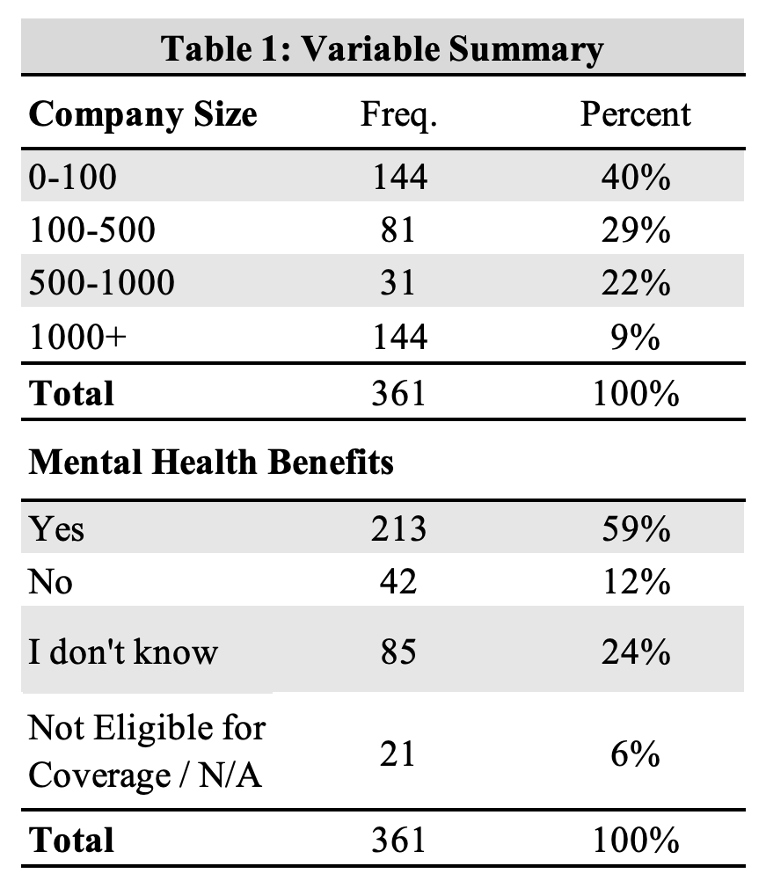To investigate our hypothesis further, we used a dataset derived from the 2018 OSMI Mental Health in Tech Survey, which received 417 responses. Participants were asked a variety of questions, including the size of the tech companies they work at and if they received mental health benefits. Our target population is individuals and entities immersed in the tech industry either as an employee or employer.

The original dataset separated number of employees/company size into six categories, which were 1-5, 6-25, 26-100, 100-500, 500-1000, and more than 1000. We recoded these categories to make them more even. The first three categories, 1-5, 6-25, and 26-100, were recoded to 0-100. We also recoded the final category, more than 1000, to 1000+. After recoding, the company size categories were 0-100, 100-500, 500-1000, and 1000+. Then, we excluded approximately 56 missing values or empty strings, giving us a new total of 361. When asked about mental health benefit offerings, participants chose from the following answer choices: “I don’t know”, “No”, “Not eligible for coverage / N/A”, and “Yes.”

Of the participants who reported working at a company of 0-100 employees, 40.3% reported having mental health benefits while 17.4% reported not having mental health benefits. The gap becomes larger when we look at larger companies composed of 1000+ employees, with approximately 75.2% of these workers reporting having benefits while 5.7% reported not having mental health benefits. We observed similar patterns among the other company sizes as well.

Crosstabulation of these variables show that larger companies composed of 1000 or more employees are more likely to provide mental health benefits compared to smaller companies composed of 0-100 employees. According to our analysis, about 40.3% of participants who work for a company composed of 0-100 employees have mental health benefits. On the other hand, approximately 75.2% of participants who work for a company composed of 1000 or more employees have mental health benefits. This represents an approximately 34.9% difference in mental health benefits based on company size.

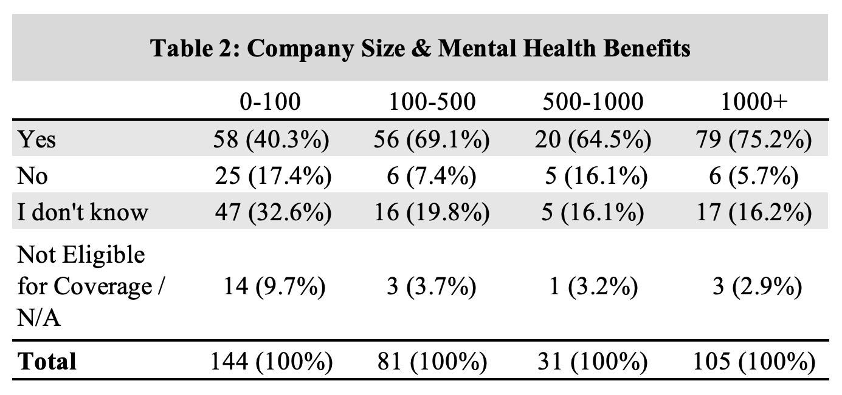A chi-square analysis with an alpha of 0.05 reveals that these findings are statistically significant, X2 (9, 361) = 38.846, p = 0.00001228. After performing the test, we also received a message warning us that our chi-squared approximation may be incorrect because some of the expected values will be small. Still, because our p-value is less than our alpha of 0.05, we can reject the null hypothesis, which states there is no relationship between the company size and mental health benefits variables. The Cramer’s V effect size is 0.19, which suggests weak association between company size and mental health benefit offerings. However, we still recommend that changes in company size will influence whether an employee will receive mental health benefits because our chi-square analysis revealed that our findings are statistically significant.

The OSMI Mental Health in Tech Survey was conducted in 2018. Since then, discussing mental illness has become less taboo. As we continue to spread awareness about mental health, it’s possible that more people have been diagnosed with mental illnesses, in which case, having benefits from one’s employer is important. We are not able to generalize the findings to the population because the OSMI survey had a small sample size. The original survey gathered information from 417 tech employees, but in 2018 when the survey was taken, there were an estimated 11.8 million employees in tech.3 This is a weak point of the data. To remedy this in future analysis, the survey could be distributed to more participants, perhaps around half of the tech employees in the U.S. This would better reflect the experiences of tech employees in the country; we would then potentially be able to generalize the findings.

1. National Alliance on Mental Illness. (2021 March). Mental Health By the Numbers. *NAMI*.Retrieved from <https://www.nami.org/mhstats>
2. Kirsten Barkved. (2020, January 28). Let's Talk: It's Time to Get Serious About Mental Illness in Tech. *iQmetrix*. Retrieved from <https://www.iqmetrix.com/blog/lets-talk-its-time-to-get-serious-about-mental-illness-in-tech>