Harbor Porpoise Sightings and Strandings

Amanda Warlick

### Objective

Conduct exploratory mapping analysis on harbor porpoise sightings and strandings data. Steps taken included deriving and applying mean latitude and longitude coordinates from records in the same quadrants to records where lat and long data are missing. Where no lat and long data existed for a given quadrant, data were derived from survey grid and then applied.

### Summary Figures

The following summary figures were created by summarizing the data by year, month, season, and record types. Kernel density maps were created using the statdensity function in R.

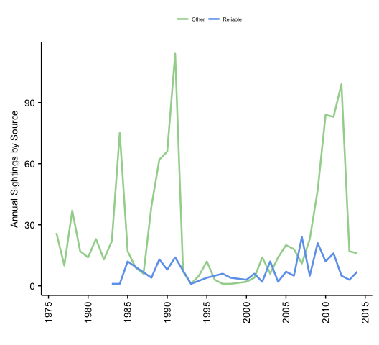

All sightings and strandings by report source.

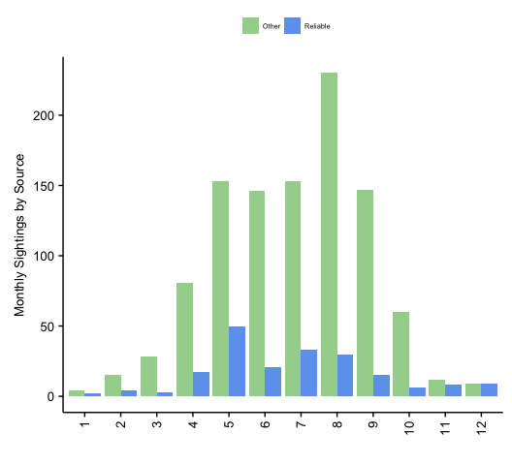

All sightings and strandings summed across months by report source.

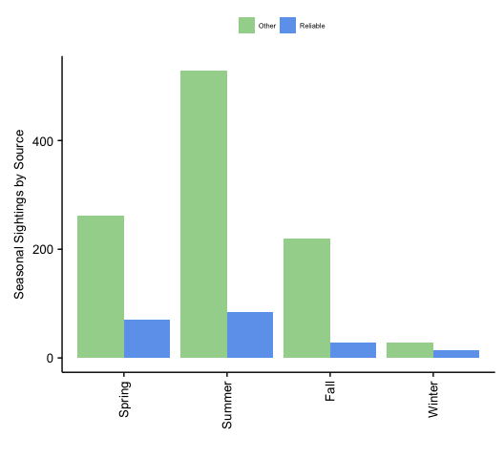 All sightings and strandings summed across seasons by report source.

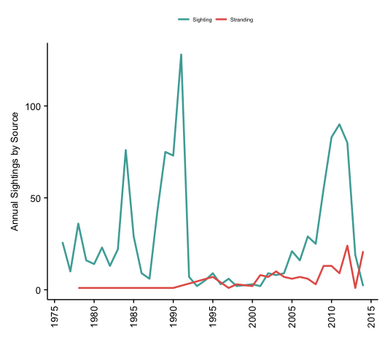

All records per year according to whether they are strandings or sightings.

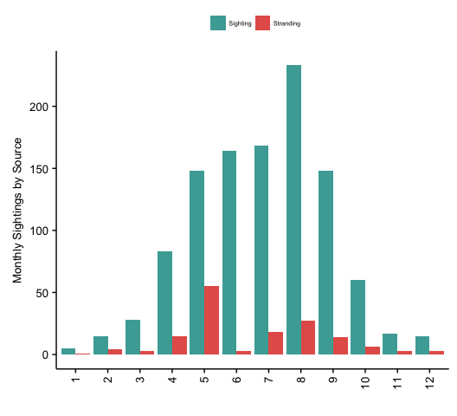

All sightings and strandings summed across months by type of record.

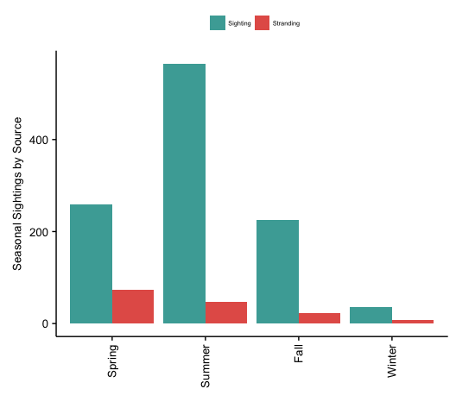

All sightings and strandings summed across seasons by type of record.

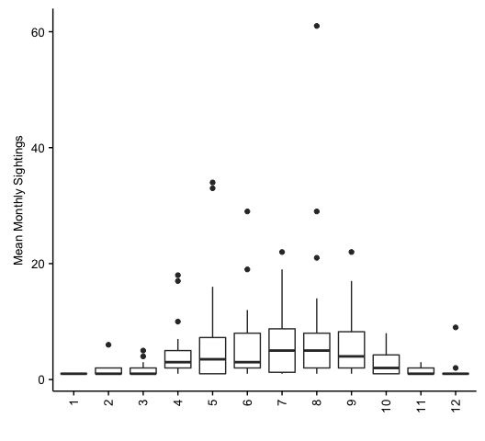

Basic boxplot showing interannual variation within months.

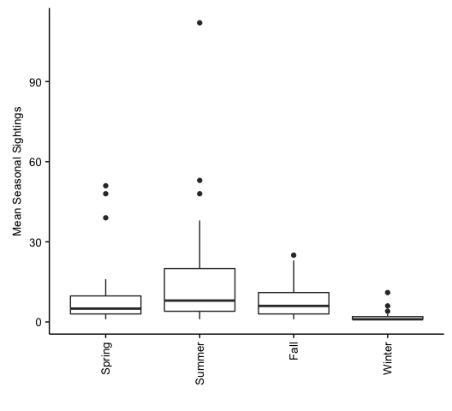

Basic boxplot showing interannual variation within seasons.

### Maps

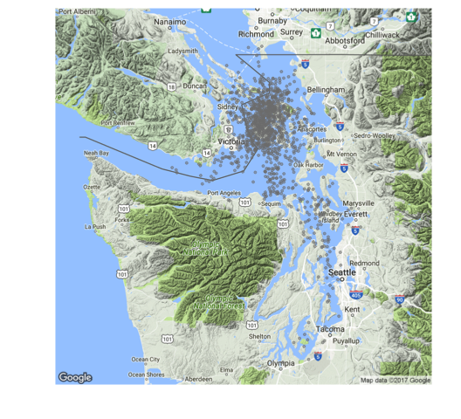

All sightings and strandings, each dot represents a unique record.

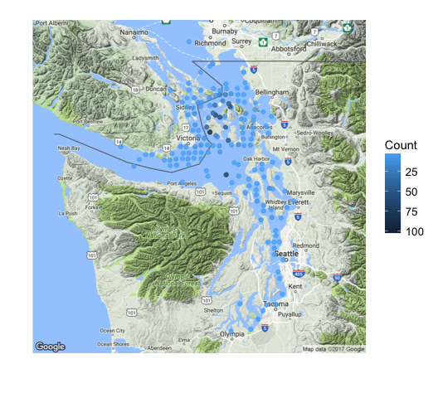

All sightings and strandings per quadrant, each dot representing sum of records in that quadrant, with darker colors representing quadrants with a greater number of records.

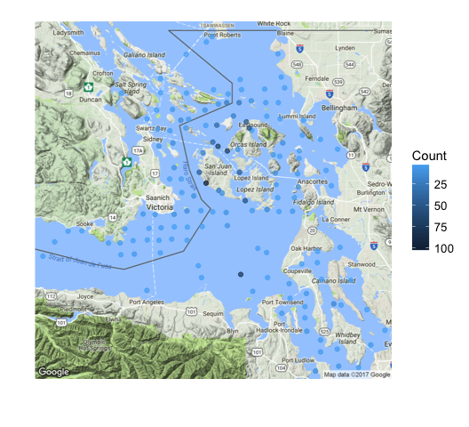

Same as above, zoomed in.

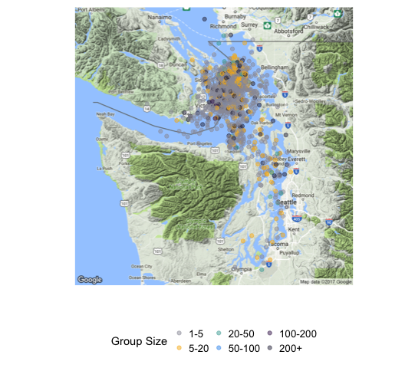

All sightings and strandings, with each dot representing a unique record of a certain group size.

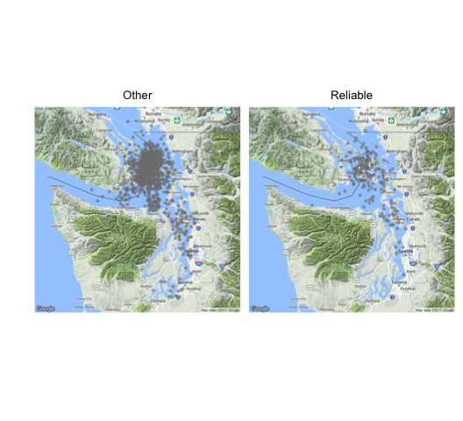

All sightings and strandings, with each dot representing a unique record.

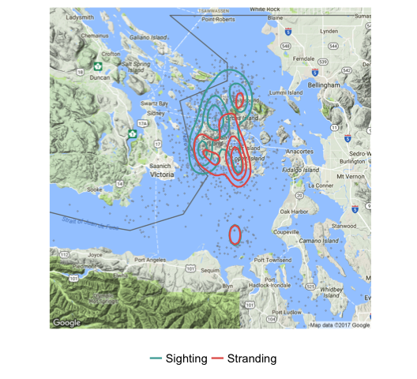

Kernel density plot map showing mostly overlapping hotspots for sightings and strandings.

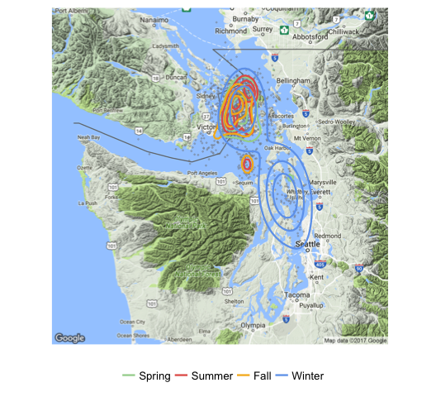

Kernel density plot map showing mostly overlapping hotspots for sightings and strandings Spring, Summer, and Fall, with more broadly distributed records during the Winter. These kernel density contour lines aren't to scale (i.e. many fewer records in winter).