Pigeon Guillemot Data Exploration - Whidbey

# Data Availability and Status

### Adult counts

* 2008-2017 Whidbey
* Have added intern counts for 2010, 2011, 2012 at Rolling Hills (multiple counts/day, once/week);
* Still need to compile same years at Mutiny Sands and Harrington N/S and Shore Meadows
* Intern data are different depending on the intern/year. 2010-2012 is timed counts for 4-5 hours, more recent years are one count per day but multiple survey days per week.
* South Sound: Terence's intern is working on it.
* Sequim: spoke with Ed and Jeff - must be pulled from website (Ryan)

### Prey deliveries/nest survival

* 2008-2014: needs a lot of checking
* 2015-2017: must be compiled by hand (Ryan)
* Intern data 2010-2012 does not contain non-prey visits (VB), which means it is hard to confirm the survey started before prey were being delivered. When they calculated % fledgling success for 2008-2013, they used a 3-week delivery criteria for a successful fledge. I'm thinking we can improve on that, because they probably don't exclude site-year combinations where deliveries have already started at beginning of survey.

### Quality control

* (mis)matching site-date combinations
* Prey deliveries when PG_count = 0
* ~ 10% of cases don’t match between day-level total visits and summed burrow-level visits

### Questions for Frances

* Why do some colonies have so few observation days (Coupeville Wharf)
* Why wouldn't a colony have data for a given year (Hancock South, 2016)
  + *Frances says it’s mostly about beach access and how the sites have changed over time (erosion, accessibility), and they they’ll stop a survey if there is no activity.*

### 

### Burrow counts and study length

Number of burrows identified per site per year seems reasonably consistent (ignore year > 2014). Some sites range more than others in terms of how long the study was conducted each year. Not all sites can be used for looking at nest fate.

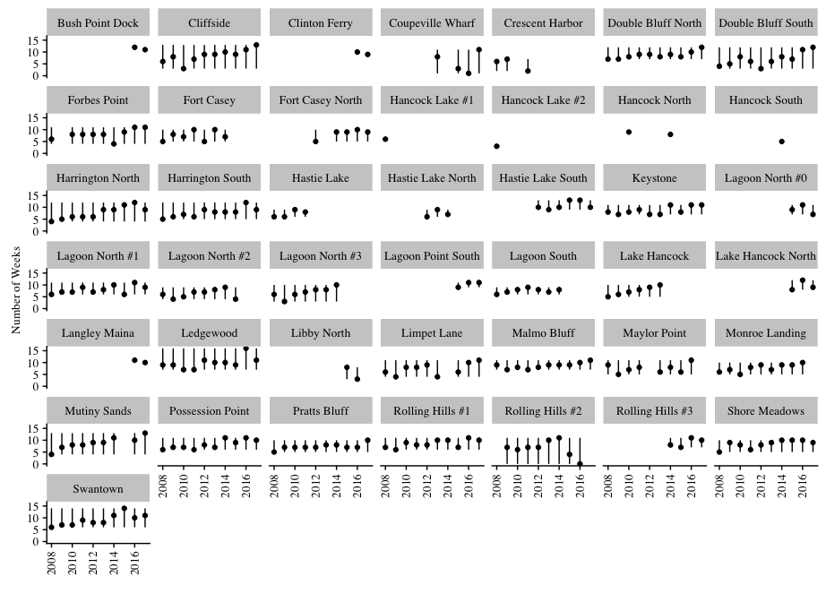

### Adult counts

Many sites show relative consistency in the average number of adults counted per week across years. This consistency is also reflected at the island-level. Counts dropped in 2015 – check, think about more.

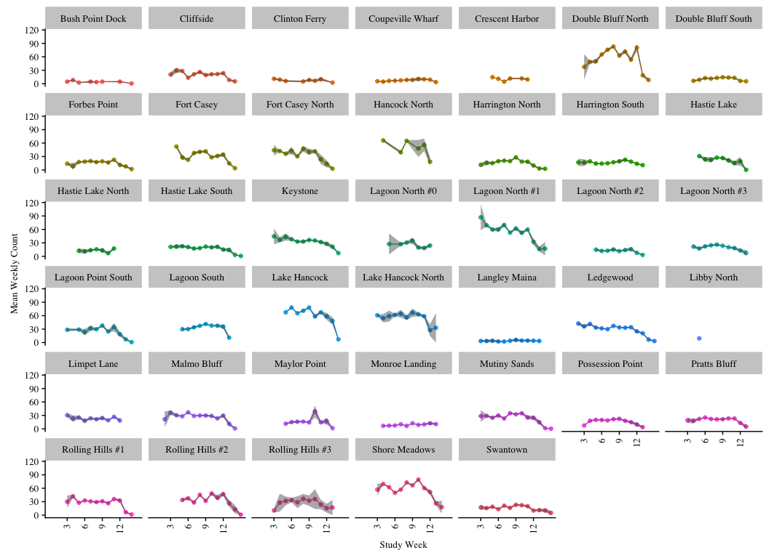

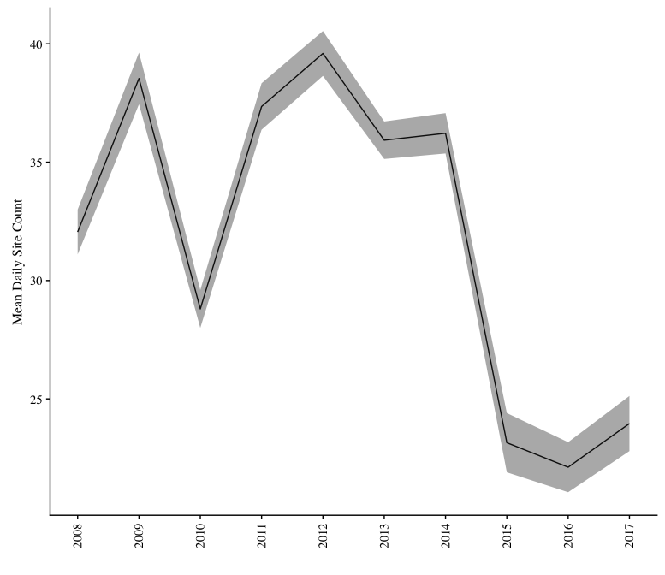

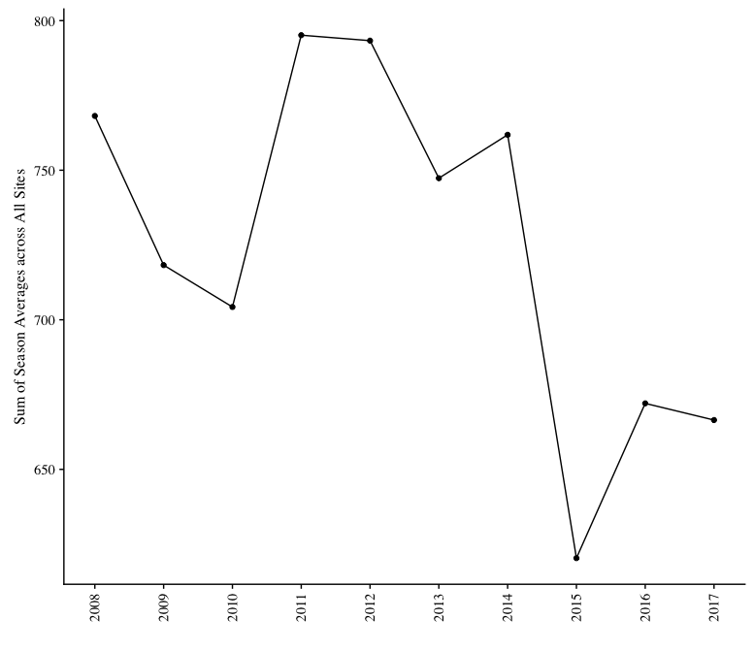

#### 

#### Multiple counts - intern data

We have multiple counts for ~5 colonies. For 2010-2012, we have 10-11 counts per week. For 2015-2017, we have 2-3 counts per week. Variation is less in earlier years because there are 10 counts on the same day, and so are less affected by anything that could be different throughout the week - some days may just be quieter than others (weather/ocean conditions, feeding opportunities, beach disturbance), so probably best not to combine the two types?  
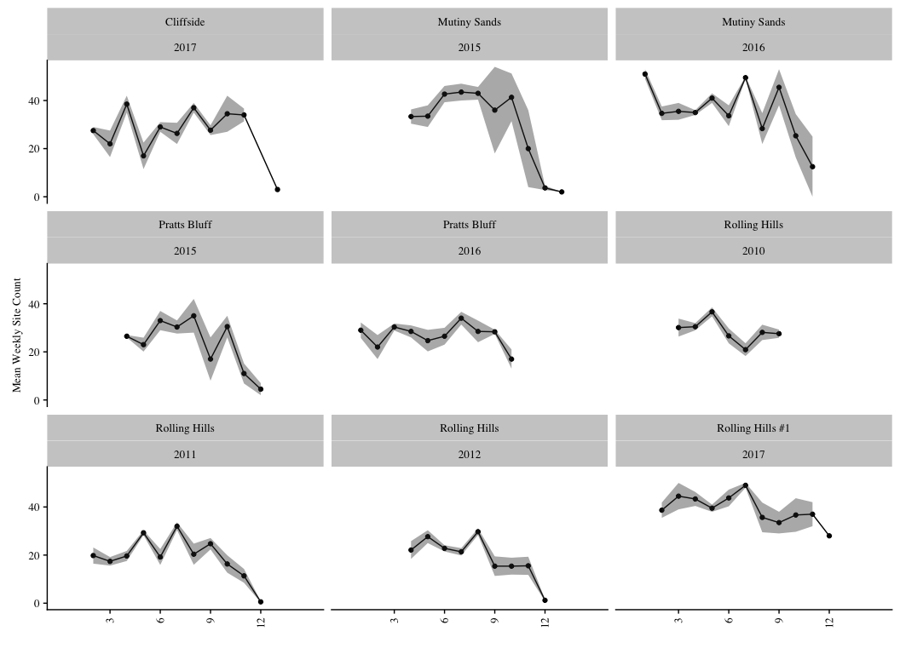

### Prey deliveries

My suspicion is that the seasonal deliveries pattern/peak is smoothed out across years, which is why it is more evident in the island-level figure than at each site.  
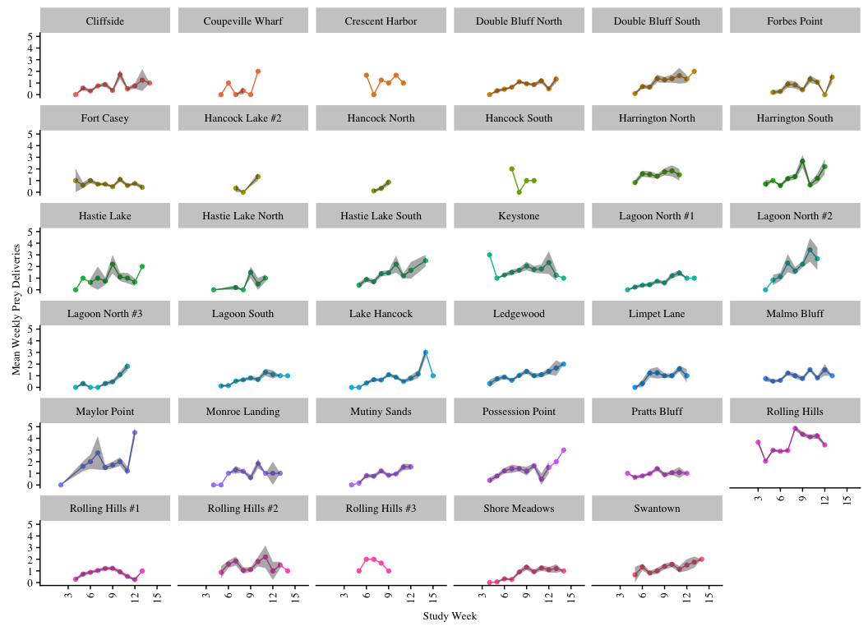

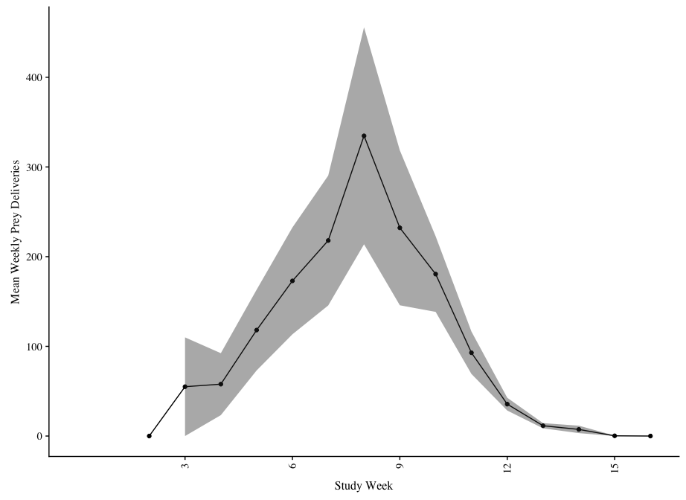

### 

### Prey composition

Not sure we have a use for this, but I was mainly interested in looking for (in)consistencies and general patterns.

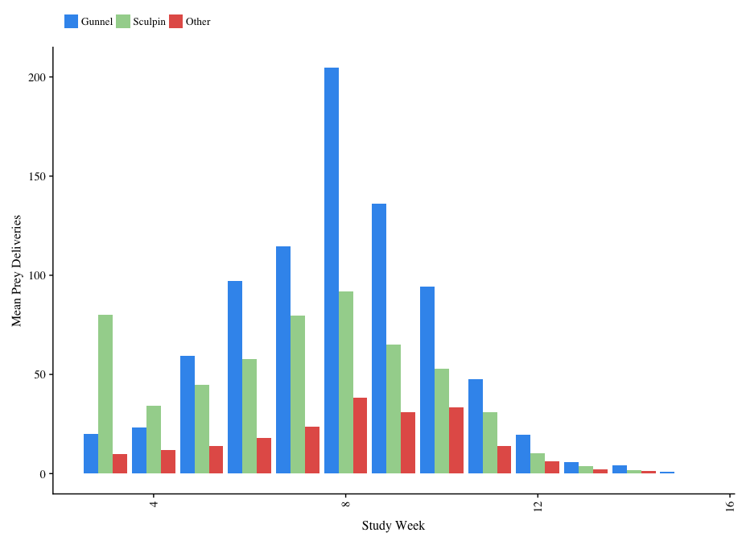

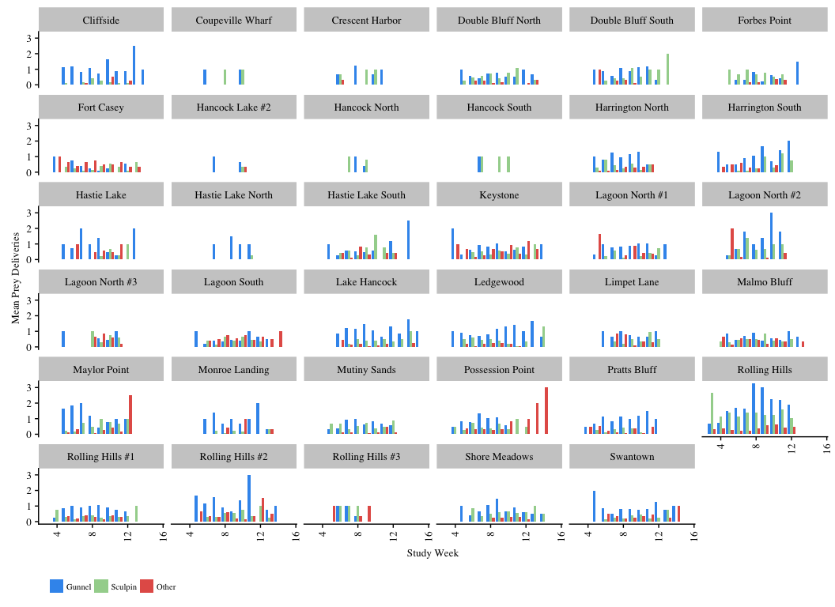

**Initial BUGS modeling efforts**

Following Ch. 3 and Ch. 4 of Kery & Schaub

*Simple GLMs*

1. Adult counts

# mean sd 2.5% 25% 50% 75% 97.5% Rhat n.eff

# alpha 6.323 0.021 6.285 6.309 6.322 6.336 6.364 1.001 2800

# beta1 -0.130 0.037 -0.201 -0.156 -0.131 -0.105 -0.056 1.008 270

# beta2 -0.043 0.017 -0.077 -0.054 -0.043 -0.031 -0.009 1.001 2800

# beta3 0.014 0.022 -0.029 -0.001 0.014 0.029 0.055 1.012 180

# lambda[1] 588.029 21.973 546.845 572.600 587.600 602.800 631.877 1.006 360

# lambda[2] 598.619 13.568 571.700 589.600 598.800 607.700 624.700 1.001 2800

#...

# lambda[10] 437.319 18.594 402.900 424.300 436.700 449.800 475.600 1.005 460

# deviance 101.497 2.870 97.990 99.442 100.800 102.900 108.777 1.001 2800

#

# DIC info (using the rule, pD = Dbar-Dhat)

# pD = 3.971 and DIC = 105.500

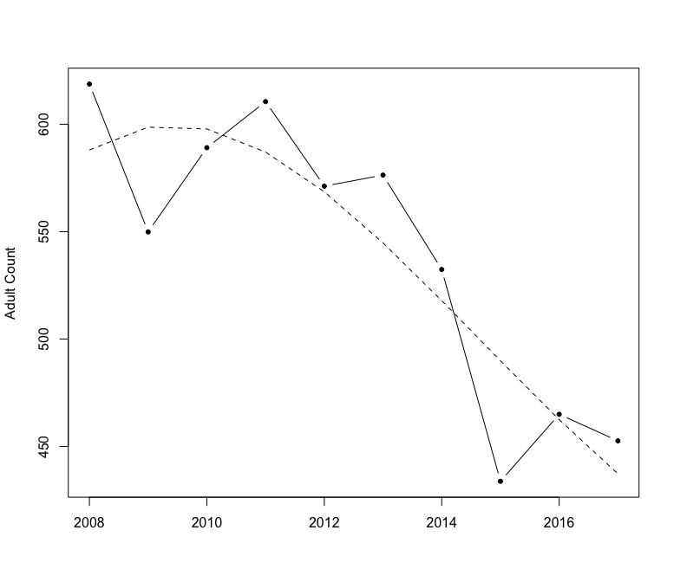

1. Fecundity – need all burrow-level data
2. Percent successful nests – need all burrow-level datas

*GLMMs with site and year random effects*

1. Random year effects

mean sd 2.5% 25% 50% 75% 97.5% Rhat n.eff

alpha 3.401 1.382 0.040 2.683 3.487 4.338 5.699 1.275 13

beta1 -1.418 2.965 -7.513 -3.459 -1.268 0.646 4.014 1.693 6

beta2 -1.664 1.094 -3.587 -2.416 -1.774 -0.929 0.517 1.076 33

beta3 0.641 1.648 -2.195 -0.553 0.549 1.742 4.130 1.615 7

lambda[1] 617.925 24.851 570.200 601.000 617.600 634.500 667.500 1.001 97000

lambda[2] 549.257 23.422 504.200 533.400 548.900 564.800 596.200 1.001 84000

lambda[3] 588.740 24.287 542.200 572.200 588.400 604.900 637.500 1.001 280000

…

sd 2.841 0.180 2.345 2.790 2.899 2.959 2.996 1.069 120

eps[1] 6.698 2.790 1.898 4.586 6.569 8.507 12.430 1.011 230

eps[2] 4.482 1.779 0.957 3.267 4.380 5.697 7.992 1.366 9

…

eps[10] 6.391 2.416 1.876 4.659 6.431 8.123 10.910 1.128 21

deviance 91.211 4.467 84.460 87.960 90.560 93.780 101.700 1.001 130000

DIC info (using the rule, pD = Dbar-Dhat)

pD = 9.993 and DIC = 101.200

1. Adding up to variation by group/site, start w/ null model

# mean sd 2.5% 25% 50% 75% 97.5% Rhat n.eff

# alpha 3.715 0.012 3.693 3.707 3.716 3.723 3.739 1.003 1000

# deviance 3078.771 1.405 3078.000 3078.000 3078.000 3079.000 3083.000 1.007 1100

#

# For each parameter, n.eff is a crude measure of effective sample size,

# and Rhat is the potential scale reduction factor (at convergence, Rhat=1).

#

# DIC info (using the rule, pD = Dbar-Dhat)

# pD = 1.017 and DIC = 3080.000

1. Fixed site effects

mean sd 2.5% 25% 50% 75% 97.5% Rhat n.eff

alpha[1] 3.592 0.051 3.489 3.558 3.592 3.626 3.691 1.001 27000

alpha[2] 4.435 0.035 4.367 4.412 4.435 4.460 4.499 1.003 1100

…

alpha[22] 3.760 0.055 3.654 3.721 3.759 3.796 3.865 1.001 6900

alpha[23] 4.424 0.034 4.358 4.402 4.424 4.447 4.492 1.002 3100

alpha[24] 3.381 0.062 3.258 3.340 3.382 3.422 3.500 1.001 10000

deviance 1695.805 6.933 1684.000 1691.000 1695.000 1700.000 1711.000 1.001 10000

DIC info (using the rule, pD = Dbar-Dhat)

pD = 23.940 and DIC = 1720.000

1. Fixed site and fixed year – not working
2. Random site effects

# mean sd 2.5% 25% 50% 75% 97.5% Rhat n.eff

# alpha[1] 3.592 0.054 3.483 3.556 3.593 3.630 3.696 1.001 9000

# alpha[2] 4.445 0.037 4.373 4.421 4.446 4.470 4.516 1.001 4500

# alpha[3] 2.840 0.085 2.671 2.783 2.842 2.899 3.000 1.002 3400

# ...

# mu.alpha 3.593 0.101 3.394 3.527 3.593 3.659 3.795 1.001 30000

# sd.alpha 0.485 0.079 0.359 0.429 0.476 0.530 0.666 1.001 30000

# deviance 1566.402 7.014 1555.000 1561.000 1566.000 1571.000 1582.000 1.001 29000

#

# For each parameter, n.eff is a crude measure of effective sample size,

# and Rhat is the potential scale reduction factor (at convergence, Rhat=1).

#

# DIC info (using the rule, pD = Dbar-Dhat)

# pD = 23.650 and DIC = 1590.000

1. Random site and year effects – not getting convergence
2. Random site + year + overall trend – not getting convergence

GLMM_siteyr_r_trend <- function() {

#priors

mu ~ dnorm(0, 0.01) #overall intercept

beta1 ~ dnorm(0, 0.01) #overall trend

for (j in 1:nsite) {

alpha[j] ~ dnorm(0, tau.alpha) #random site effects

}

tau.alpha <- 1/(sd.alpha*sd.alpha)

sd.alpha ~ dunif(0, 3)

for (i in 1:nyear) {

eps[i] ~ dnorm(0, tau.eps) #random year effects

}

tau.eps <- 1/(sd.eps*sd.eps)

sd.eps ~ dunif(0, 1)

#likelihood

for (i in 1:nyear) {

for (j in 1:nsite) {

C[i,j] ~ dpois(lambda[i,j])

lambda[i,j] <- exp(log.lambda[i,j])

log.lambda[i,j] <- mu + beta1*year[i] + alpha[j] + eps[i]

} #j

} #i

}

write.model(GLMM_siteyr_r_trend, "GLMM_siteyr_r_trend.txt")

model.fileGLMM_siteyr_r_trend = paste(getwd(),"GLMM_siteyr_r_trend.txt", sep="/")

#bundle etc.

mean.year <- mean(1:length(PG_yearly_island$year))

sd.year <- sd(1:length(PG_yearly_island$year))

win.data <- list(C = t(C), nsite = nrow(C), nyear = ncol(C),

year = (1:length(PG_yearly_island$year) - mean.year)/sd.year)

inits <- function() list(mu = runif(1, 0, 4),

alpha = runif(235, -1, 1),

beta1 = runif(1, -1, 1),

eps = runif(9, -1, 1))

params <- c("mu", "beta1", "alpha", "eps", "sd.alpha", "sd.eps")

ni <- 12000

nt <- 6

nb <- 6000

nc <- 3

Next steps?

* Same Ch 3 GLM approach for fecundity (number of successful nests) and binomial GLM for percent of successful nests
  + First need burrow-level data for 2015-2017
* Add study week into GLMM models
* Figure out what to do with multiple counts?
* Data cleaning/checking
* Try the book exercises
* Think about how the different regions could be combined – random “regional” effect?
* Still compiling references for overall alcids