Colony-level adult counts in July and August according to the minutes from the nearest high tide. Tide data from 10 sites around the island were applied to the colonies they were closest to. Count data were trimmed to July and August so that the population could be considered constant rather than having a seasonal effect with birds coming and going at the beginning and end of the season. Grey band represents the standard error, or variation around the mean count at that given time period away from high tide.

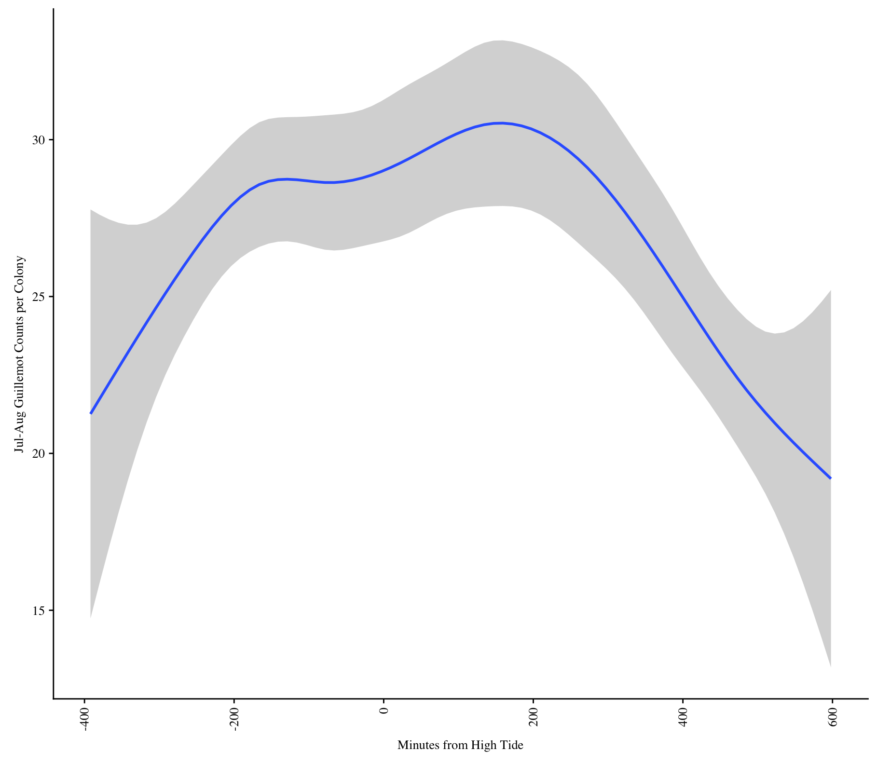

Total island-level counts over the season each year.

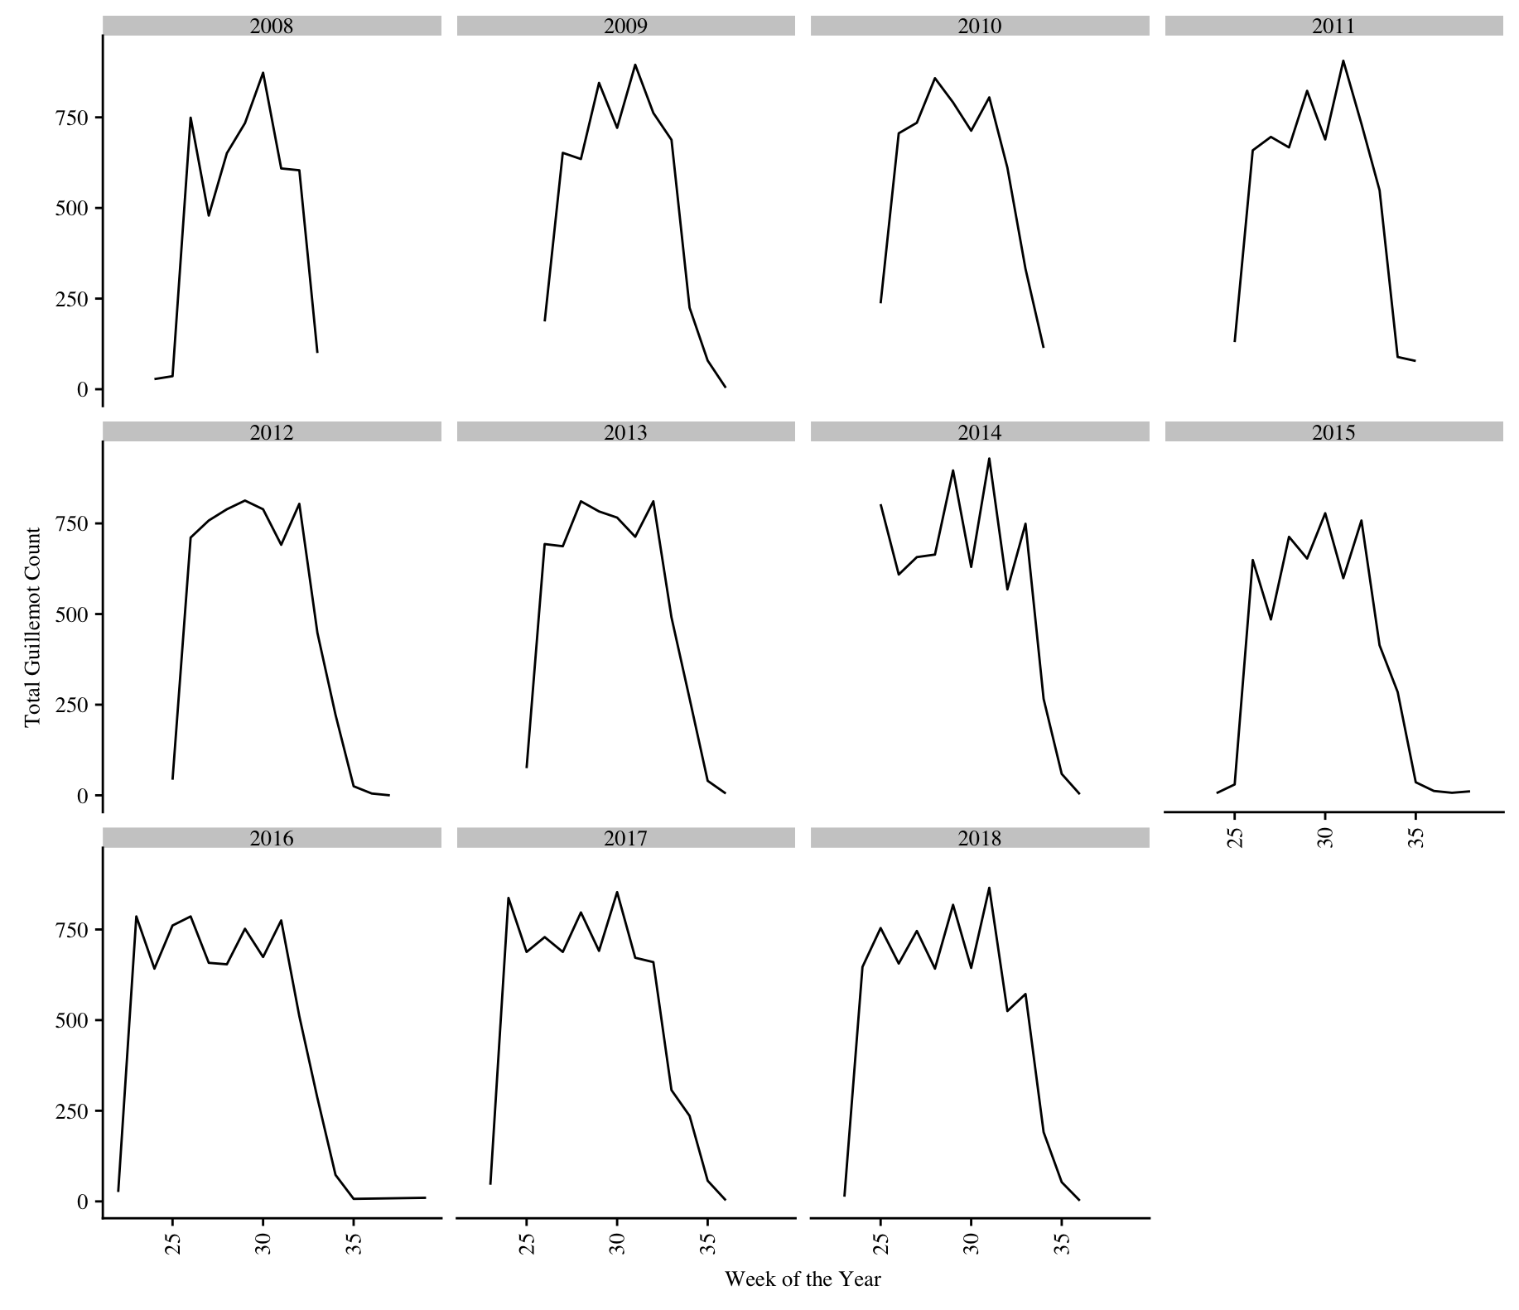

Mean number of prey deliveries across all colonies and years. Grey band is the standard error around the mean.

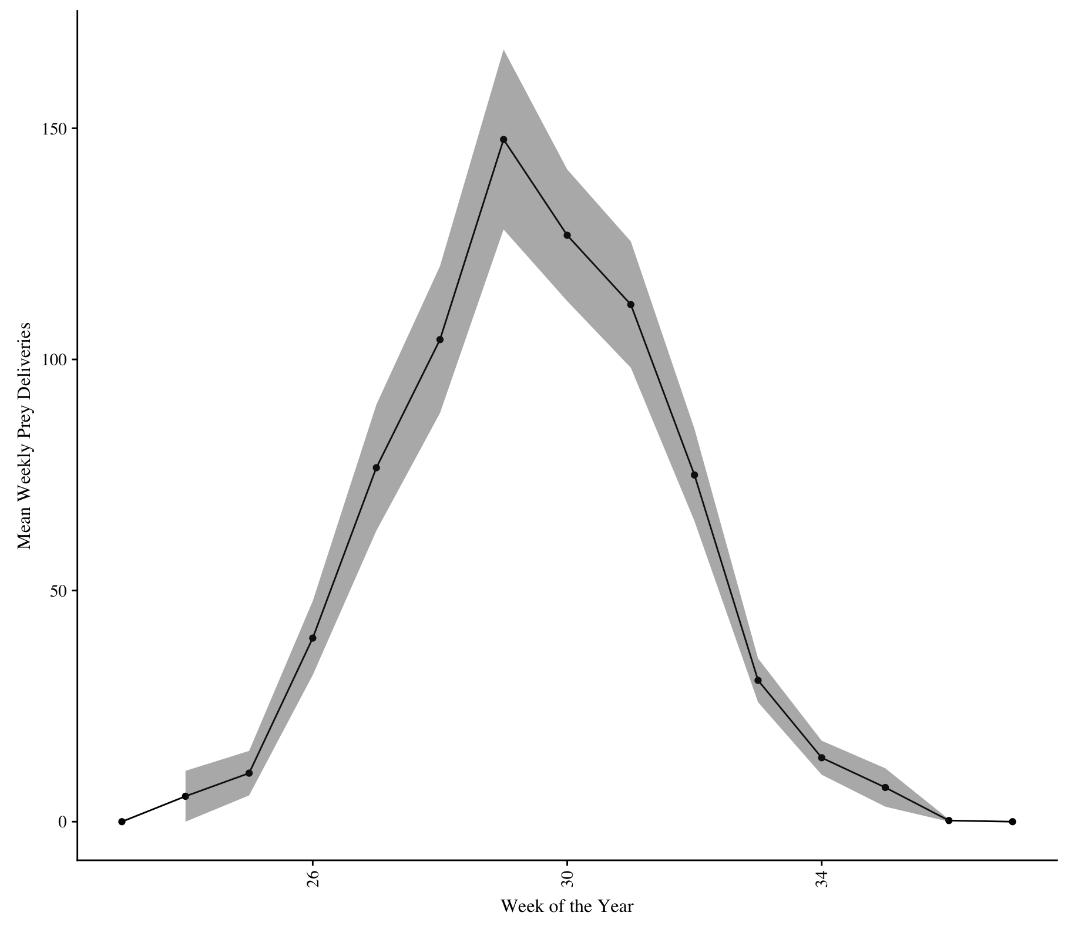

Mean number of prey deliveries over the season across all the years at each colony.

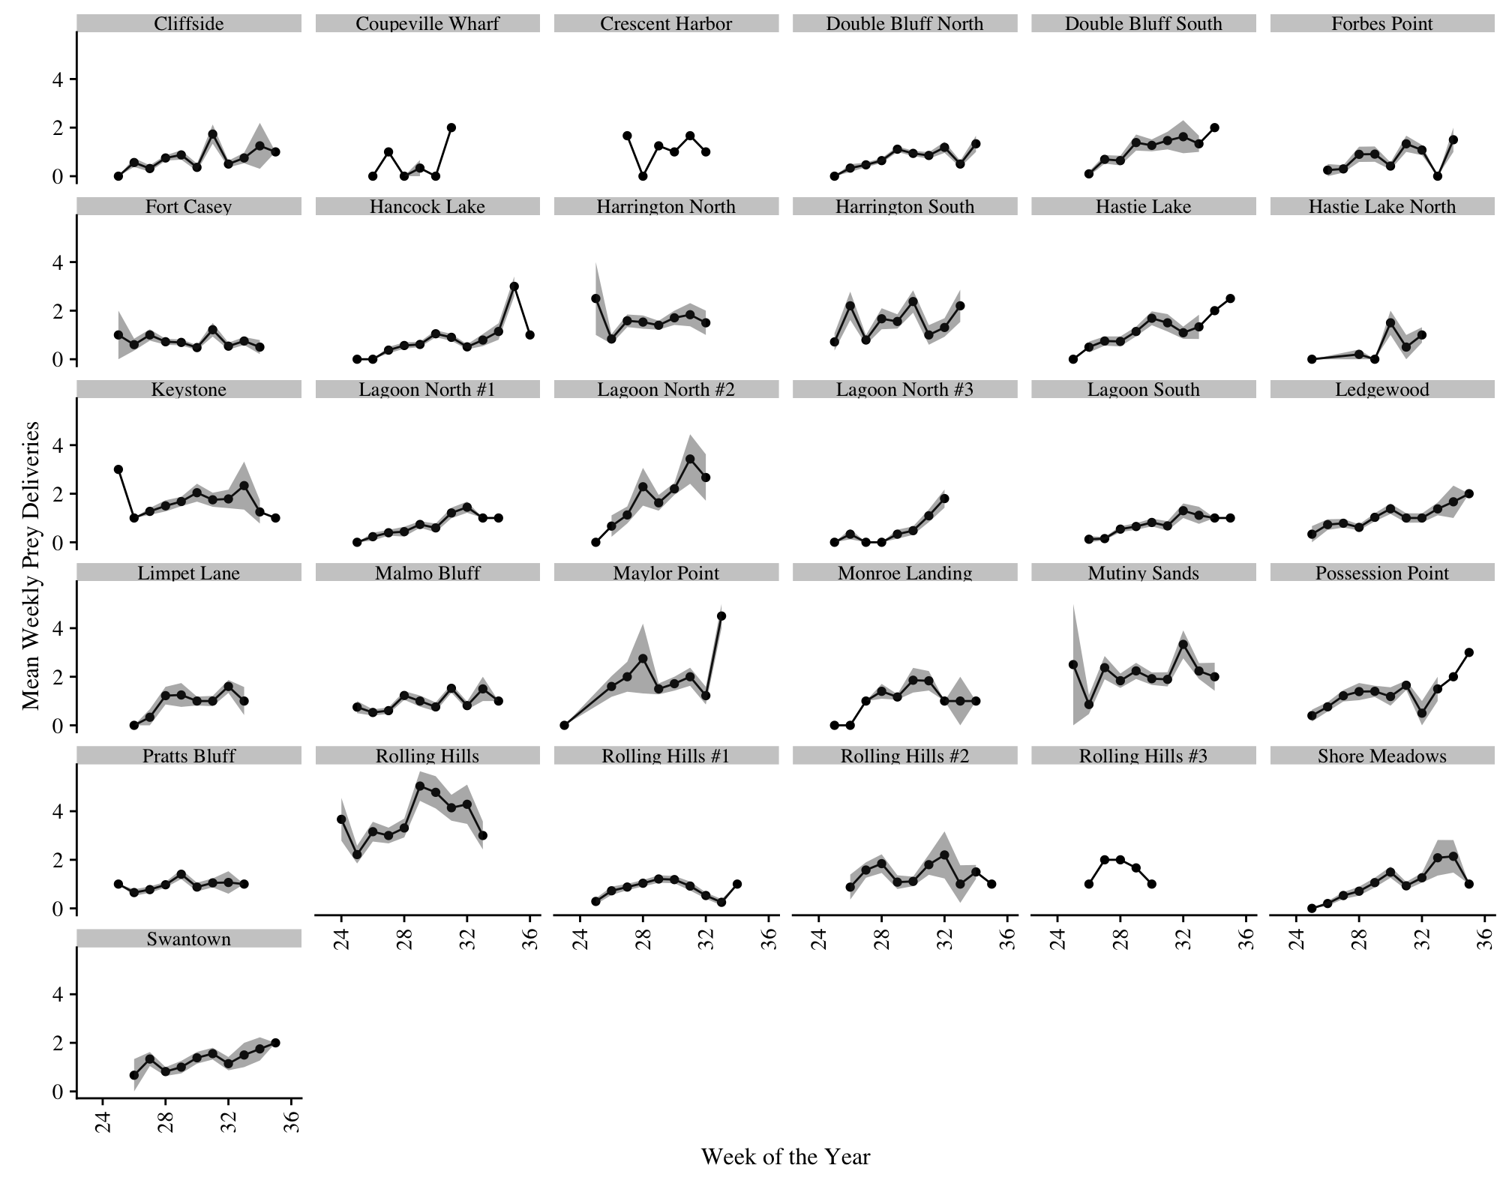

Mean counts trimmed to exclude beginning and end of season, and then summed to the island level. Grey band is the standard error.

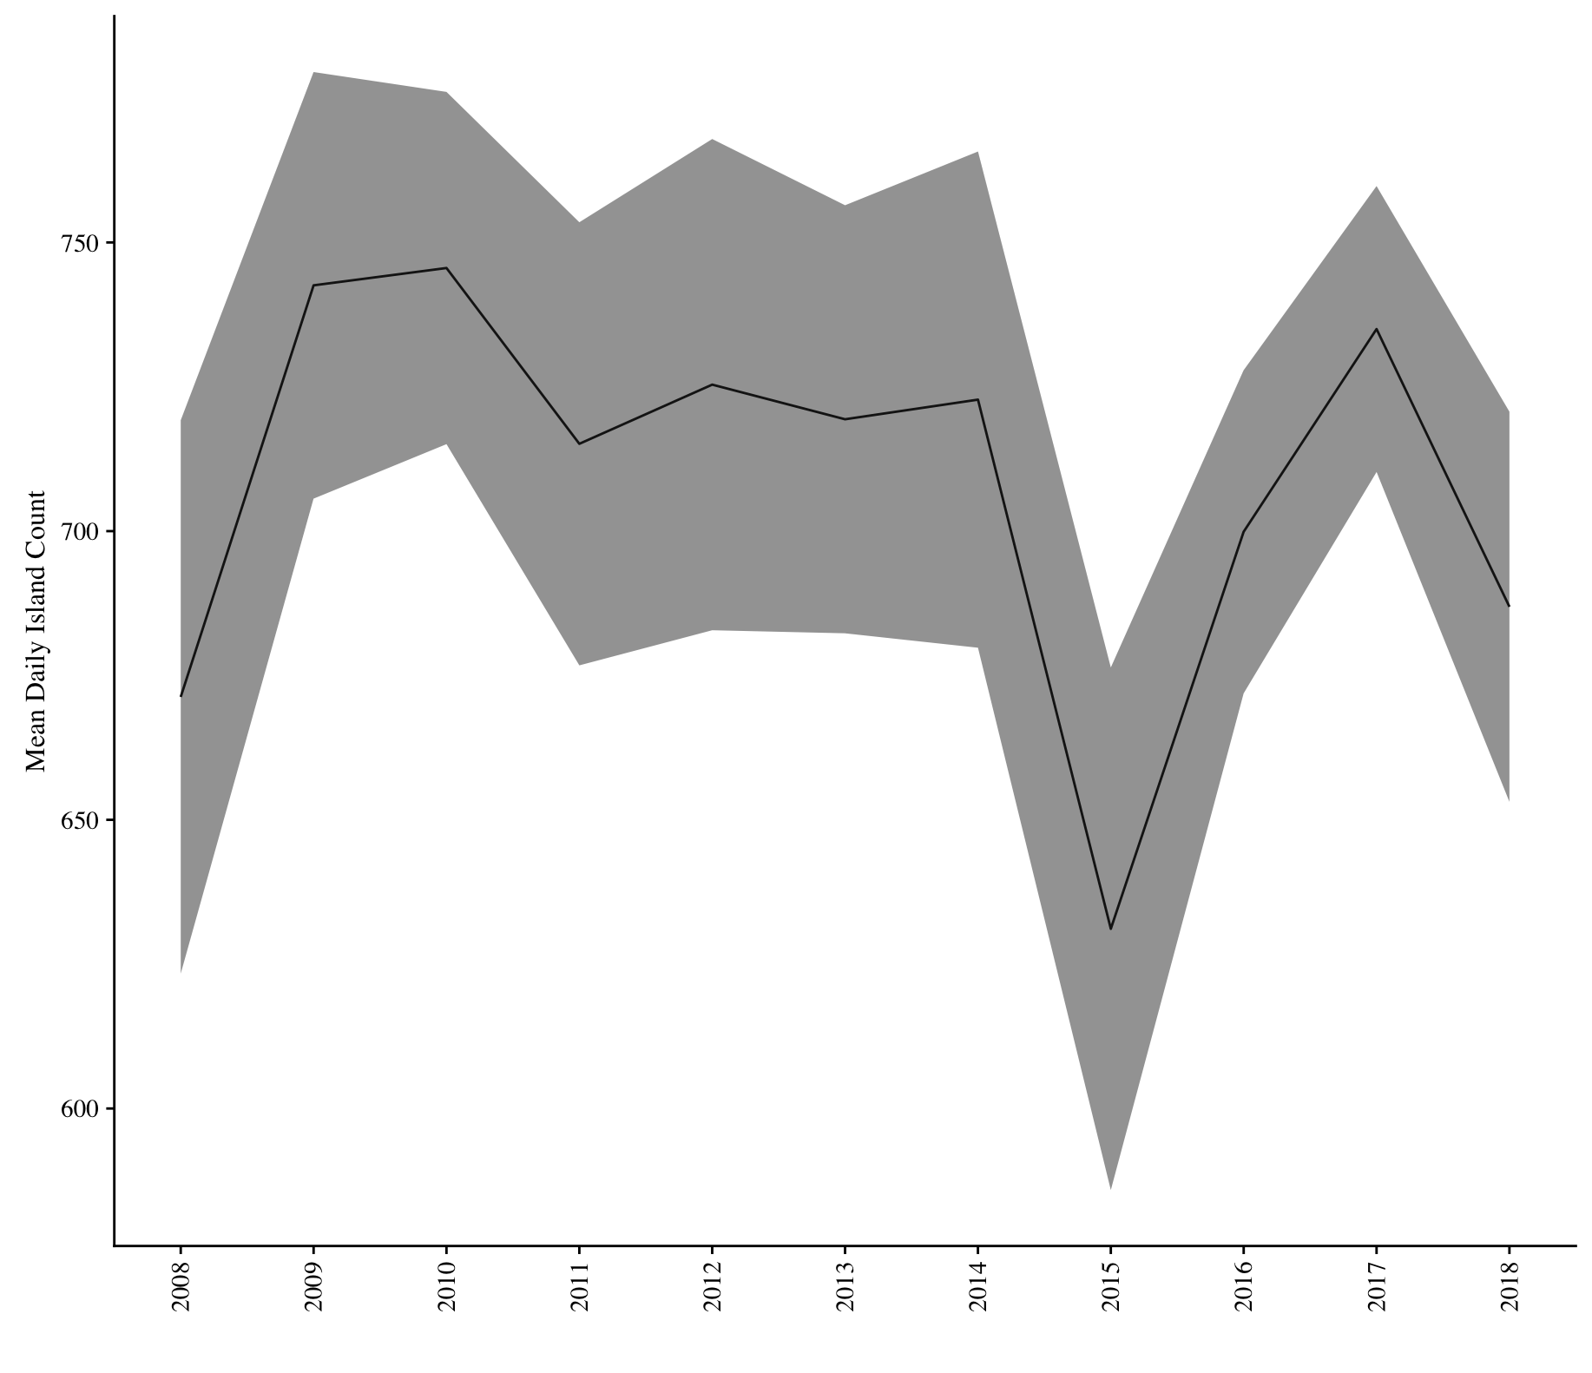

Mean seasonal counts trimmed to exclude beginning and end of season at each colony.

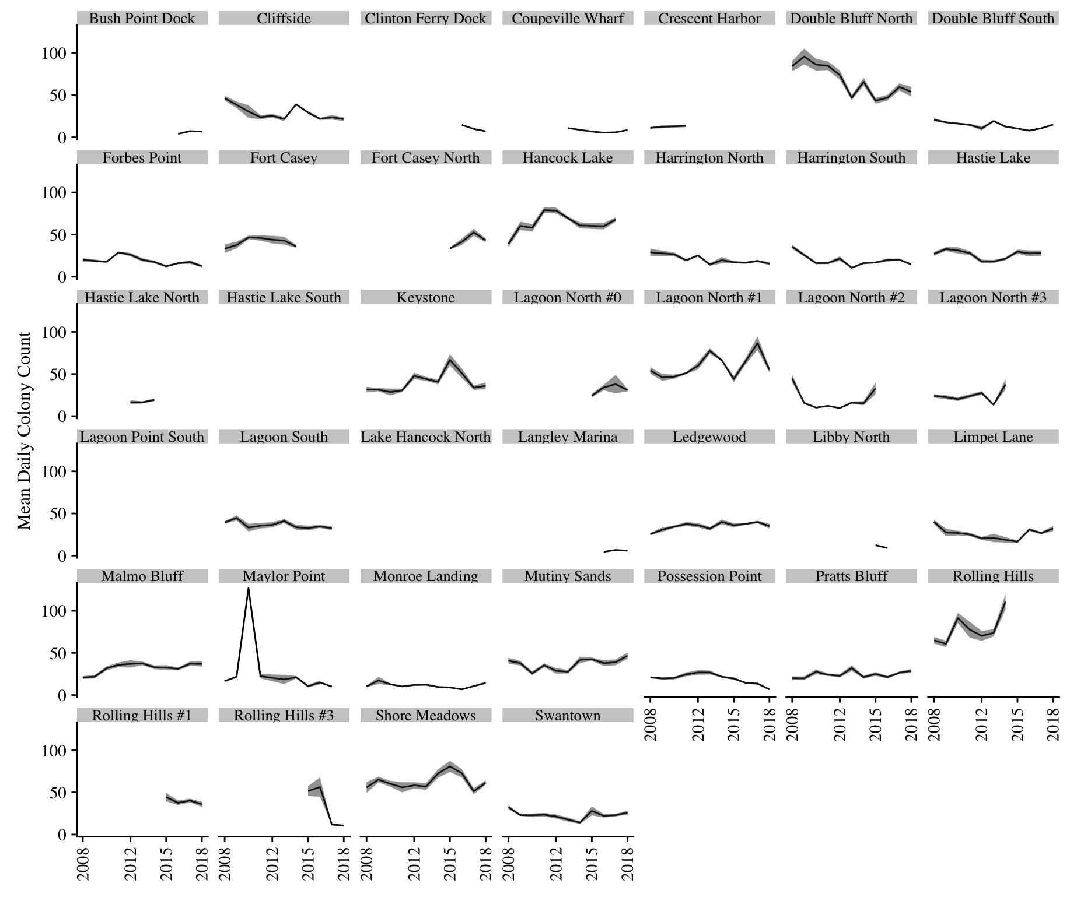

First and last prey visit days each year, with median indicated by black line inside the box, ranges by lines, outliers shown as dots. Boxes can be thought of as where the majority of the points lie. For example, the median of when the first prey delivery occurred in 2008 across the colonies was day ~43 of the season (relative to first volunteer survey) and the median day when the last prey visit occurred in 2008 was ~57. Or, you could say something like “prey deliveries started later in 2008 compared to other years.”

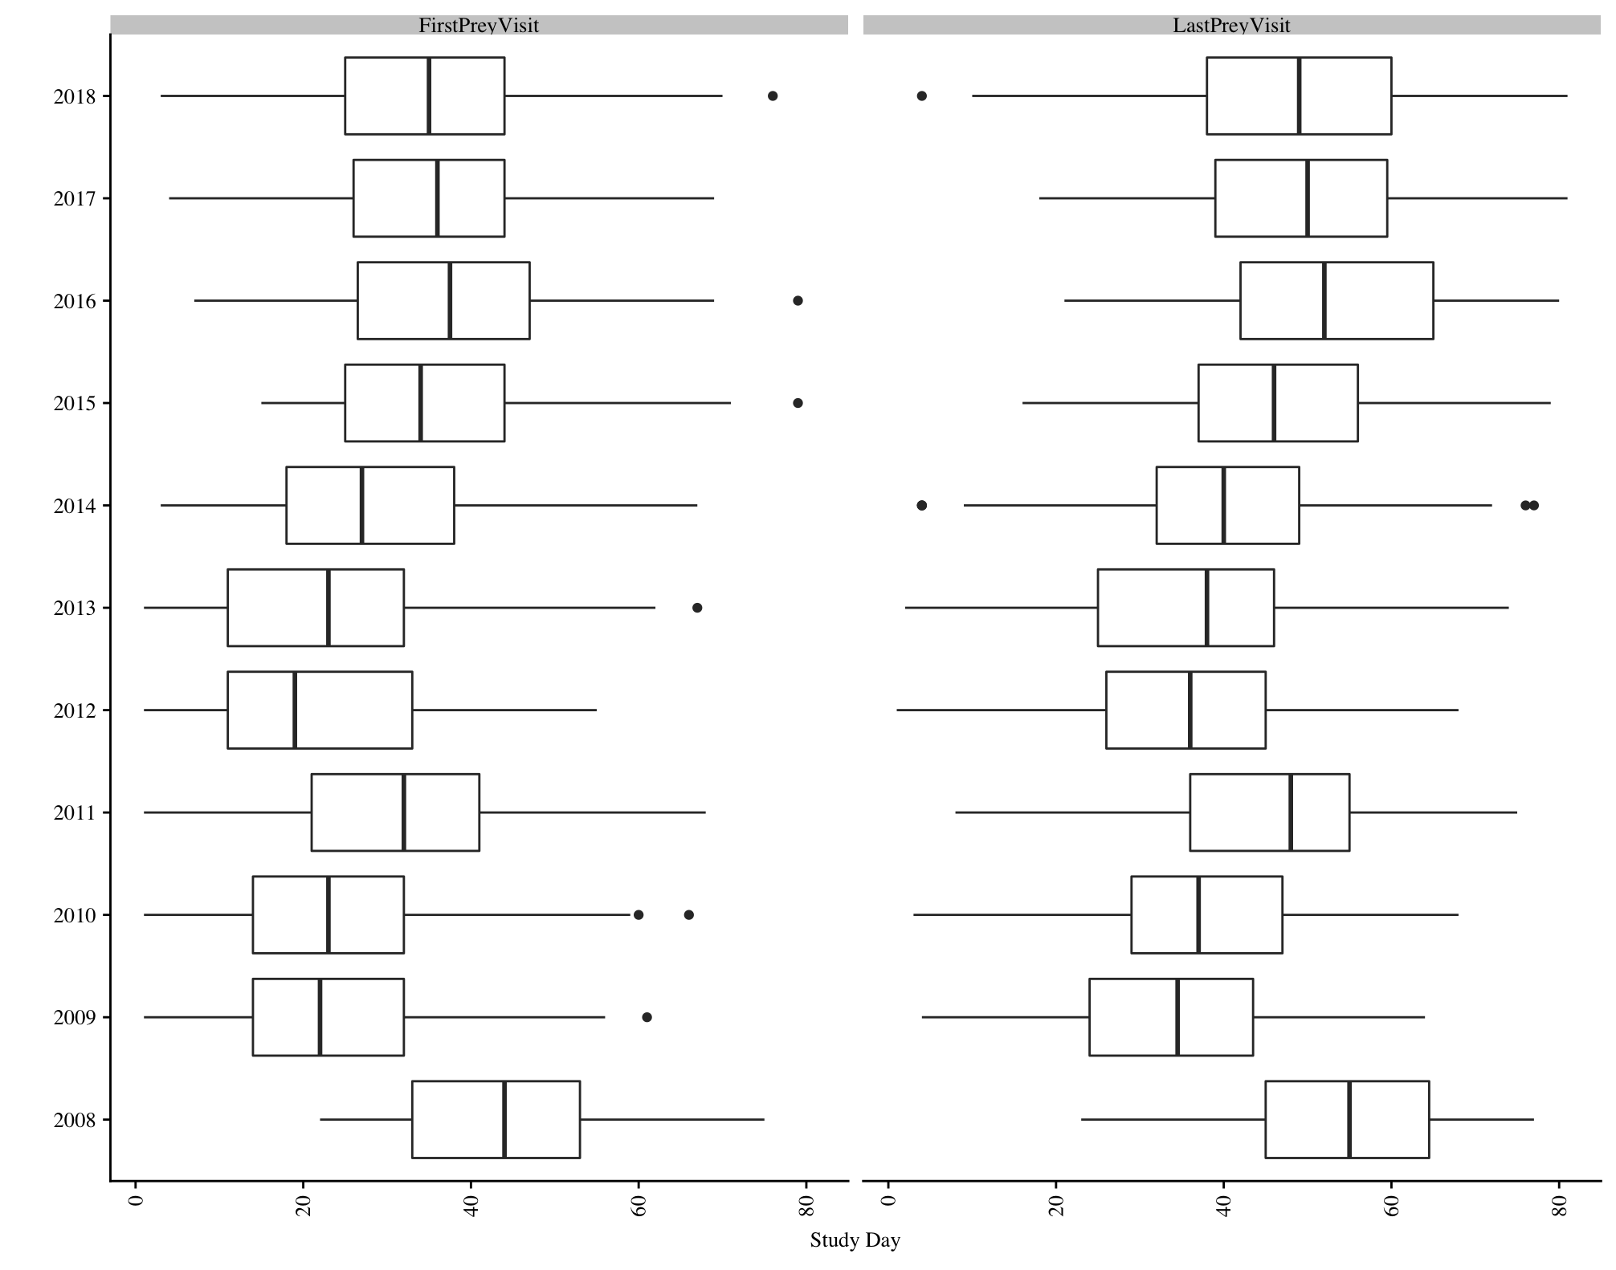

First and last prey visit days for each colony, with median (between years) indicated by black line, ranges by lines, outliers shown as dots. Boxes can be thought of as where the majority of the points lie. For example, the median of when the first prey delivery occurred at Bush Point across the years was day ~39 of the season (relative to first volunteer survey) and the median day when the last prey visit occurred at Bush Point was ~63. Or, you could say something like “generally, prey deliveries last longer at Swantown compared to Shore Meadows.”

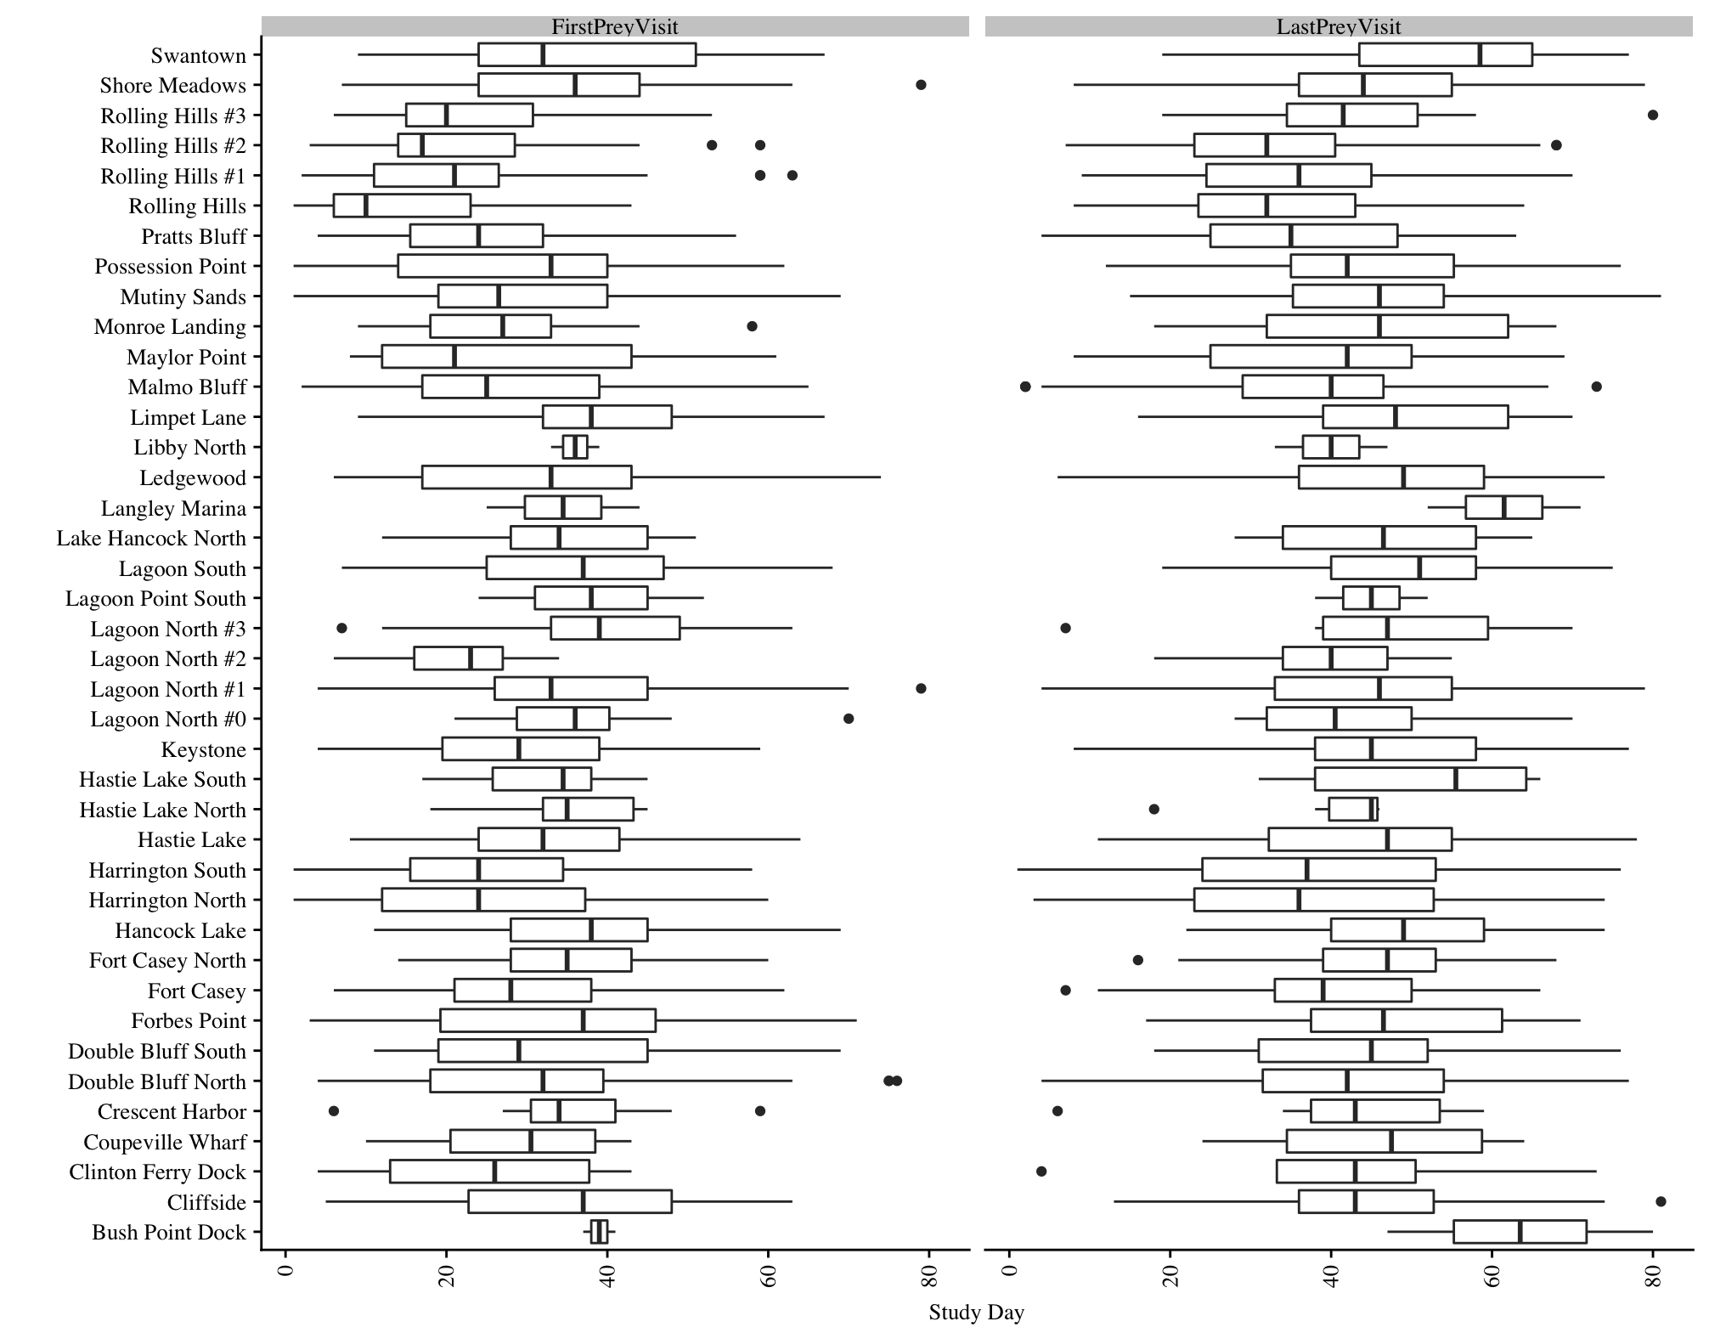

This shows the distribution of all burrow visits during the season, like a histogram would, it shows where the majority of any kind of visit falls, distinguishing prey and non-prey visits by the line color. So, you could say something like “the majority of or the peak of burrow visits happens earlier than the most/majority of prey visits. You could theoretically do something like this for each of the different prey types to show you if prey was changing over the season.

