Title

# Heading 1

Text.

summary(cars)

## speed dist

# Heading 1

Text.

## Heading 2

Text.

### Heading 3

#### Heading 4

##### Heading 5

###### Heading 6

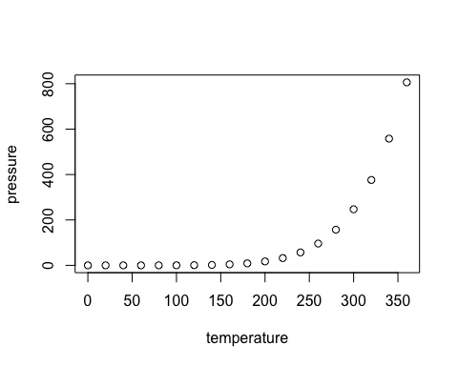

Note that the echo = FALSE parameter was added to the code chunk to prevent printing of the R code that generated the plot.

Test.