## All Stranding Cases & Sex

**Percent of strandings by sex per year – relatively constant over time**

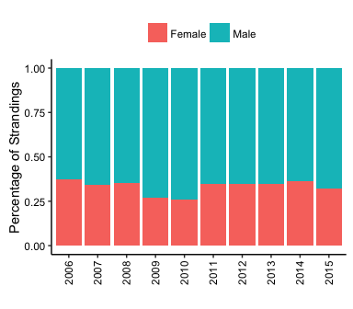

**Percent of strandings by sex per month – female proportion increases in certain months?**

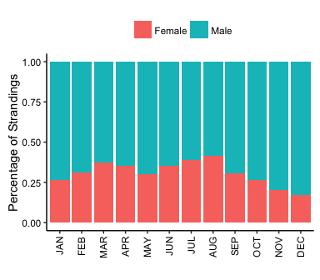

## Human Interaction Cases & Sex

**Human interaction type by sex – lower proportion of females getting shot?**

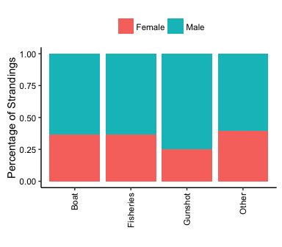

## All Stranding Cases - Age Class and Sex

**Overall, highest proportion of males in subadults and adults**

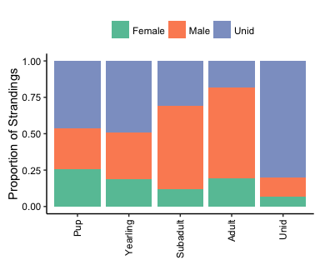

**Temporal Patterns - All Strandings over Years**

#No statistically significant change in all stranding cases in OR and WA combined over time (p = 0.38).

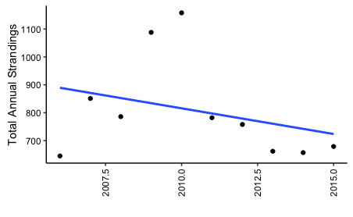

**Temporal Patterns - Human Interactions Cases over Years**

#Regression shows weak but significant increase (6/yr?) of all HI cases, p = 0.04

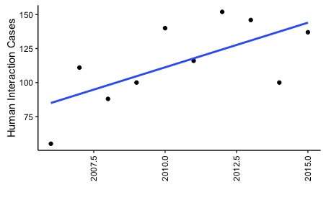

**Human interaction types over time – weak but significant correlation showing gunshot and fisheries cases increasing over time**

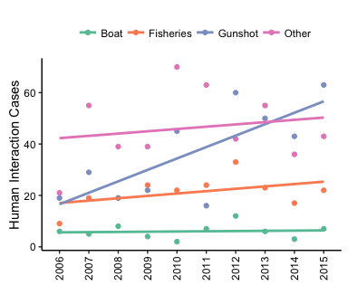

## Patterns in Species

**Harbor seals, CSL, and SSLs strand more than the other three species in terms of all stranding cases and human interactions cases**

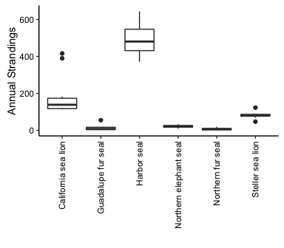

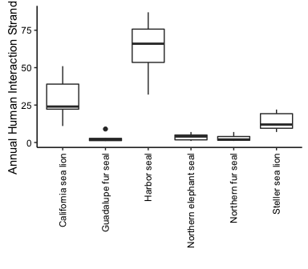

**Much higher proportion of gunshot wounds for Califoria sea lions compared with overall cases in the above figures**

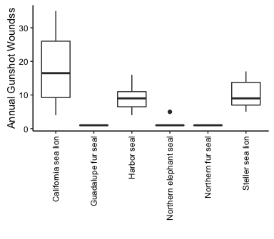

**Different patterns for each species over time, particularly for human interaction cases below, see stats for more specificity**

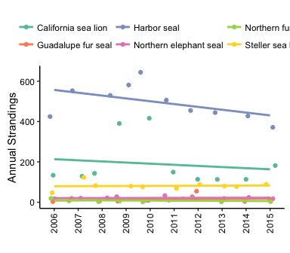

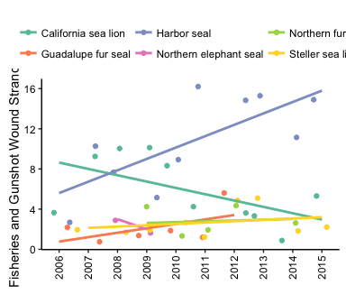

## All Stranding Cases by Sex and Age – Seasonal

**Cases peak in the summer, though proportions of sex remain relatively similar.**

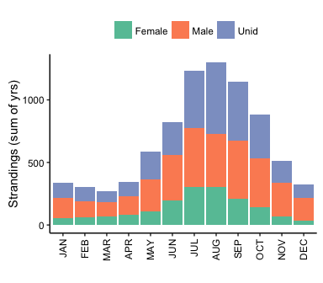

**Greater proportion of pups causing the summer peak.**

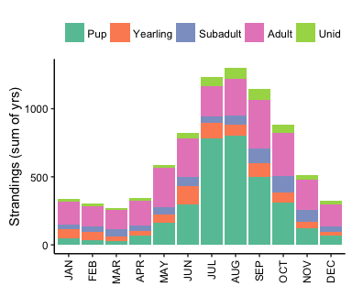

## Human Interactions by Sex and Age – Seasonal

Similar to above in “all cases”, with proportions of sexes possibly remaining relatively constant?

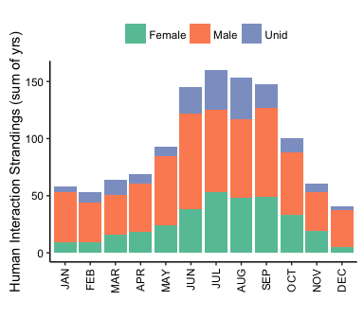

**Similar to above, seemingly reflecting similar age class distribution to “all cases”**

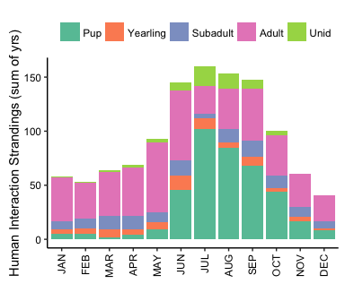

**Greater proportion of fisheries in the summer – look to stats for greater specificity since “other” makes it difficult to discern from this figure.**

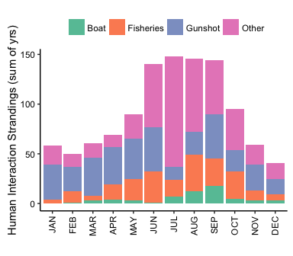

**Shows human interaction cases consistently peaking each year, except perhaps 2006**

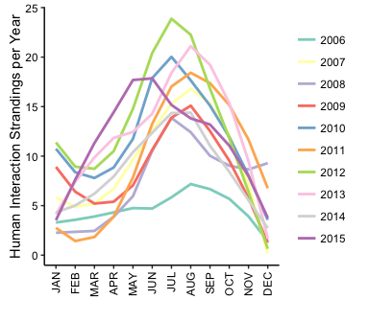

**Shows harbor seals as the source of the summer peak, for both all cases and human interaction cases**

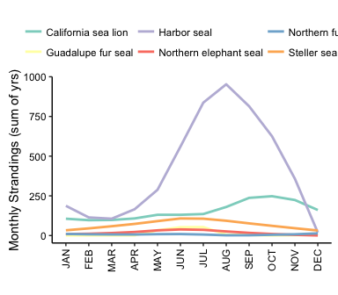

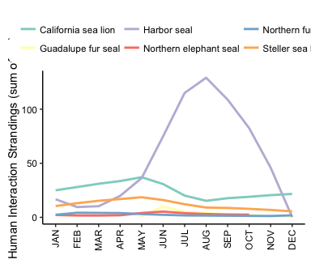

## Spatial Patterns – by State

**Shows smaller proportion of strandings in Oregon, remaining relatively constant over time**

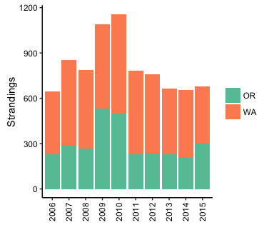

**Proportion of harbor seals lowest in Oregon, CSL and SSL highest in Washington, see table.**

|  |  |  |
| --- | --- | --- |
| Species | Oregon (%) | Washington (%) |
| California sea lion | 75 | 25 |
| Guadalupe fur seal | 59 | 41 |
| Harbor seal | 16 | 84 |
| Northern elephant seal | 61 | 39 |
| Northern fur seal | 59 | 41 |
| Steller sea lion | 68 | 32 |

**Overall strandings and human interaction cases by county in WA, high number of gunshots in Pacific**

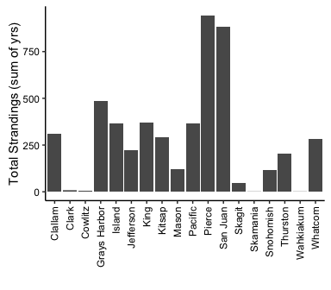

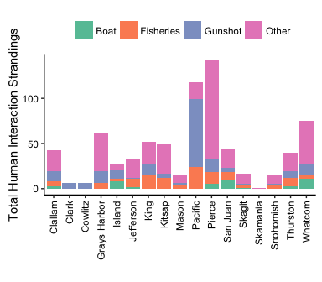

**Tables showing *proportions* of all strandings and human interaction cases per county, with human interaction types summing to 100% across rows (12% of HI cases in Clallam are fisheries interactions and 26% are gunshot wounds).**

|  |  |  |  |  |  |  |
| --- | --- | --- | --- | --- | --- | --- |
| County | All Strandings | Human Interactions | Fisheries | Gunshot | Boat | Other |
| Clallam | 6 | 6 | 12 | 26 | 7 | 56 |
| Clark | 0 | 1 | 0 | 100 | 0 | 0 |
| Cowlitz | 0 | 1 | 0 | 100 | 0 | 0 |
| Grays Harbor | 10 | 8 | 10 | 21 | 0 | 69 |
| Island | 7 | 4 | 11 | 33 | 30 | 26 |
| Jefferson | 4 | 4 | 27 | 3 | 6 | 64 |
| King | 7 | 7 | 29 | 25 | 0 | 46 |
| Kitsap | 6 | 7 | 24 | 10 | 0 | 66 |
| Mason | 2 | 2 | 27 | 13 | 0 | 60 |
| Pacific | 7 | 16 | 20 | 64 | 0 | 16 |
| Pierce | 19 | 19 | 9 | 10 | 4 | 77 |
| San Juan | 18 | 6 | 20 | 11 | 20 | 48 |
| Skagit | 1 | 2 | 18 | 6 | 6 | 71 |
| Skamania | 0 | 0 | 0 | 0 | 0 | 100 |
| Snohomish | 2 | 2 | 25 | 6 | 0 | 69 |
| Thurston | 4 | 5 | 22 | 18 | 8 | 52 |
| Whatcom | 6 | 10 | 5 | 17 | 15 | 63 |

|  |  |  |  |  |  |  |
| --- | --- | --- | --- | --- | --- | --- |
| County | All Strandings | Human Interactions | Fisheries | Gunshot | Boat | Other |
| Clackamas | 0 | 1 | 0 | 100 | 0 | 0 |
| Clatsop | 19 | 56 | 14 | 71 | 7 | 9 |
| Columbia | 0 | 1 | 67 | 33 | 0 | 0 |
| Coos | 17 | 8 | 48 | 11 | 0 | 41 |
| Curry | 10 | 2 | 33 | 50 | 0 | 17 |
| Douglas | 3 | 1 | 0 | 50 | 0 | 50 |
| Lane | 8 | 4 | 62 | 31 | 0 | 8 |
| Lincoln | 33 | 20 | 40 | 18 | 7 | 35 |
| Multnomah | 0 | 2 | 17 | 83 | 0 | 0 |
| Tillamook | 9 | 7 | 39 | 43 | 0 | 17 |

## Oceanographic Conditions

**Initial investigation looks like no significant difference in strandings and human interaction cases in La Nina and El Nino conditions.**

