**Title: Characterization of Pinniped Stranding and Human Interaction Cases along the Oregon and Washington Coasts, 1989 - 2015**

**Abstract**

Strandings can be used as a proxy to assess pinniped health and the impacts of anthropogenic activities in the local marine environment. We used stranding response network data to examine regional and temporal patterns in strandings and human interaction cases across age and sex for six species in Oregon and Washington from 1989-2015. Over the study period, a total of 14,167 pinnipeds stranded along the coasts of Washington and Oregon, 11% of which were documented as human interaction cases. Gunshot wounds and fisheries interactions comprised the majority of human interaction cases overall (36% and 20%, respectively), though the prevalence of these cases varies across species. The number and prevalence of human interaction cases has increased over time in certain counties, likely partly attributable to increased stranding response effort and improved examination techniques over the study period. The spatial distribution of strandings is highly dependent on species, with a higher proportion of California sea lions, Steller sea lions, and northern elephant seals stranding in Oregon and the majority of harbor seals stranding in Washington. Pups, adults, and males stranded in higher numbers than females and other age classes, though these patterns varied across species likely reflecting the varying seasonal distributions and local abundance of each. Stranding hotspots are different across species and types of human interaction types, likely due to the differential distribution of species and human activities along the coast. Despite the challenges and uncertainties inherent in using stranding data as an indicator of pinniped health and anthropogenic impacts, modeling spatio-temporal patterns will be useful for stranding response practitioners and natural resource managers in evaluating the scope and magnitude of threats to pinniped populations in a changing enviornment.

Keywords: pinnipeds, stranding, human interactions, spatio-temporal hotspots, wildlife health, anthropogenic impacts.

**Introduction**

Pinnipeds are subject to a wide range of natural and anthropogenic agents of disease, illness, or injury, and studying the spatio-temporal patterns of pinniped strandings can provide insight into these dynamic and interconnected factors influencing the health of populations vulnerable to human activities. Pinnipeds live at the land-sea interface and are often considered sentinels of ocean health (Aguirre and Tabor 2004; Bossart 2006; Ross 2006; Moore 2008; Bossart 2011), as they strand onshore exhibiting direct evidence of the threats they encounter in their environment. However, factors influencing where and when an animal strands are diverse, numerous, and interdependent, including ocean conditions, winds, prey availability, susceptibility to disease, and changes in abundance, pupping season, or species range (Woodhouse 1991; Brabyn and McLean 1992; Wilkinson and Worthy 1999; Norman et al. 2004; Pyenson et al. 2010; Osinga et al. 2012; Berini et al. 2015; Johnston 2015). Stranding records can therefore provide insight into the animals themselves, changes in their environment, and the ongoing impacts of anthropogenic activities in the local area. This study examines trends in strandings and human interaction cases across six pinniped species in the Pacific Northwest from 1989-2015 to investigate sex and age classes affected by different stranding causes, and how those patterns vary over time and space.

Stranding records have been used around the world as a means of learning more about the demographics of wild populations, how a population may be affected by environmental conditions, the vulnerabilities of certain demographic groups, and how specific threats or conditions may be changing over time. In many cases, strandings of both pinnipeds and cetaceans have been found to correlate with prevailing oceanographic conditions, changing local abundance and distribution of species, and increased reporting effort (Norman et al. 2004; Jepson 2005; Leeney et al 2008; Berini et al. 2015; Huggins et al. 2015a). Grey seal and harbor seal strandings in the northeast U.S. were found to have increased from the late 1990s to early 2000s likely due to a combination of increasing population size, changing prey abundance, prevailing oceanographic conditions, and increased stranding reporting effort (Harris & Gupta 2006; Johnston 2015). Similarly, gray and common seal strandings in the Netherlands increased likely due to a growing population and the resulting changes in seasonal and spatial distribution (Osinga 2012).

On the West Coast, researchers have extensively studied trends in stranding causes across age and sex classes in California sea lions, northern elephant seals, and harbor seals in central California, and have generally found that strandings and human interaction cases have increased over time, that males and pups strand in greater numbers than females or adults, and that strandings have been elevated during El Nino conditions (Steward & Yochem, 1987; Goldstein et al. 1999; Greig et al. 2005; Melin et al. 2000, 2008, 2010; Moore et al. 2009; Keledjian & Mesnick 2013). In the Pacific Northwest, considerable information has been gathered about pinniped haulout locations (Jeffries et al. 2000), and researchers have used stranding data to identify mortality rates and causes in Oregon and Washington, primarily for harbor seals (Stroud and Roffe 1979; Huggins et al. 2013; Lambourn et al. 2013). Norman et al. (2004) identified cetacean stranding hotspots in the Pacific Northwest, and attributed a summer peak in strandings to the increased prevalence of people on beaches, a greater cetacean presence in the area due to seasonal inshore upwelling, and prevailing winds. Patterns in harbor porpoise and orca strandings have been used to examine long-term mortality trends and highlight the importance of consistent response effort and data collection protocols in the region (Barbieri et al. 2013; Huggins et al. 2015a). However, few spatio-temporal analyses have been conducted on long-term stranding patterns for pinnipeds.

We use comprehensive data from stranding response networks to characterize spatio-temporal trends in age, sex, and cause of strandings and human interaction cases in Oregon and Washington over a longer time period than has been assessed to date. We hypothesize that the number of reported strandings and human interaction cases will have risen over the study period due to a combination of increased population sizes, range expansion, and the enhanced stranding response capacity that occurred in the mid-2000s. We also expect that strandings for different species will not be uniformly distributed along the coast, with hotspots for human interaction cases likely occurring in areas with greater human activities and population density. This study provides an initial investigation into the complexities of overlapping human and pinniped uses of a diverse and changing coastal landscape over time, which is particularly relevant given recent and future predicted anomalous ocean conditions in the area.

The quantity and consistency of information contained within stranding records can vary over time and across regions, particularly in an area such as the Pacific Northwest that is characterized by diverse and sometimes remote or isolated beaches covered by a large number of response networks. Huggins et al. (2015b) found that while the rate of reported strandings in Washington rose in the late 2000s, likely due to the increased support from the Prescott Grant Program, the average reporting rate for pinnipeds was only just over 20%. This seemingly high degree of uncertainty illustrates the importance of using stranding data as a window into the health, status, or threats facing pinniped populations, but should be interpreted with this uncertainty in mind. However, despite the caveats inherent in studying stranding records, the information often represents the best and only available data, representing the realities of what we know, what we don’t know, and what we might be able to learn in the future. These analyses are critical to natural resource managers tasked with assessing and monitoring pinniped populations, and additionally useful to ensure that stranding network practitioners have the necessary resources to study, collect, and rehabilitate stranded marine animals. Despite the caveats inherent in studying stranding records, these analyses are critical to natural resource managers tasked with assessing and monitoring pinniped populations, and additionally useful to ensure that stranding network practitioners have the necessary resources to study, collect, and rehabilitate stranded marine animals.

**Methods**

*Species and Region*  
Six pinniped species inhabit coastal and inland waters of the Pacific Northwest, each with unique life history characteristics, local abundance, popultion trends, and ecological behaviors that influence their presence within the study area, and therefore their prevalence in stranding data over time and space. Each of these species will be briefly described below. The coastlines of Oregon and Washington are also variable, ranging in natural landscape (inaccessible rocky intertidal zones, sandy beaches, estuarine deltas, etc.) and socioeconomic development (residential and commercial districts, shipping channels, ports, fishing activities, ecotourism, etc.).

Harbor seals - Harbor seals (*Phoca vitulina*) are the most abundant and widely distributed pinniped in Washington state waters, and are found throughout coastal areas along the U.S. West Coast. Harbor seals are separated into five stocks: California, Oregon/Washington Coast, and newly delineated inland stocks of Southern Puget Sound, Washington Northern Inland Waters, and Hood Canal (Carretta et al. 2016, Huber et al. 2012). The Oregon/Washington Coast stock has been presumed to have reached carrying capacity, and the inland stocks are thought to be stable. Based on a survey conducted in 1999, the coastal stock is estimated to be the largest, followed by the Northern Inland Waters stock, with much smaller estimates for the Hood Canal and Southern Puget Sound stocks (Carretta et al. 2016). Harbor seals exhibit strong haulout site fidelity, hauling out at hundreds of sites depending on time of day, tides, season, or food availability (London et al. 2012). Harbor seals are known to make smaller localized movements to forage opportunistically as opposed to making longer seasonal migrations, with movement patterns depending on prey availability and oceanographic conditions. The timing of peak pupping varies for different areas, ranging from mid-April in the Columbia River to late summer and early fall throughout Puget Sound (Jeffries et al. 2000).

California sea lions - California sea lions (*Zalophus californianus*) are the most abundant pinniped off the coast of California, with an annual growth rate of 5.4% and an abundance estimated at nearly 300,000 individuals (Carretta et al. 2016). Female adults remain near to the primary rookeries off the coast of southern California throughout the year, making shorter local foraging trips until pups are weaned (Melin et al. 2008). Adult and subadult males make winter migratory foraging trips as far north as British Columbia and return south in late spring (Lowry and Forney, 2005). Due to these life history and migratory patterns, individuals generally found in the Pacific Northwest are males traveling en-route to feeding areas in fall and spring months, though an increasing number of females have been sighted in the area and even into Alaska in recent years (Maniscalco et al., 2004).

Steller sea lions - Steller sea lions (*Eumetopias jubatus*) range from Japan throughout the North Pacific and south into California, with two recognized distinct population segments (DPS): Western and Eastern. The Western DPS is listed as Endangered under the ESA while the Eastern DPS, with an estimated 60,000 - 75,000 individuals (Carretta et al. 2016, DeMaster 2014), was delisted in 2013. Breeding and haulout sites for the Eastern DPS are located along the coast of southeast Alaska, British Columbia, Washington, Oregon, and California. Population demographic rates vary by region, with populations decreasing at California rookeries in recent years, but increasing in the northern part of their range (Carretta et al. 2016). During the summer breeding season, adult males remain ashore while females and juveniles make short foraging trips (NMFS, 2008).

Northern elephant seals - Northern elephant seals (*Mirounga angustirostris*) range from Mexico to the Aleutians, making seasonal migrations from rookeries in California and Oregon to feeding areas in Alaska and the central North Pacific. Females and males have vastly different energy demands and therefore different seasonal migration patterns, with males making spring and fall feeding trips and females making an initial two-month foraging trip after pups are weaned in late winter, followed by the summer molting period, and then another eight-month foraging trip during gestation before returning to the rookery to give birth and breed (Le Beouf et al. 2000). The California breeding stock was estimated to be 179,000 individuals in 2010, with a growth rate of 3.8% in recent decades (Lowry et al. 2014).

Northern fur seals - Northern fur seals (*Callorhinus ursinus*) range from southern California far into the North Pacific, with two recognized stocks: California and Eastern Pacific. Primary rookeries are located on the Pribilof and Bogoslof Islands, and to a lesser extent islands off southern California (the latter comprising just 1% of the population during the summer breeding season) (Gelatt et al. 2015). Individuals may also haul out along the coast in the Pacific Northwest or British Columbia outside of the breeding season. Adults remain ashore throughout the summer breeding season and then remain at sea for seven to eight months, with adult females and pups from both stocks migrating to foraging areas off the West Coast (Lea et al. 2009; Orr et al. 2012). Population growth and demographics of the California stock are changing due to the co-occurrence of emmigration and El Nino events.

Guadalupe fur seals - Guadalupe fur seals (*Arctocephalus townsendi*) were hunted nearly to extinction in the late 1800s, with the remaining population centered around islands off the coast of Baja California, Mexico. The population is listed as Threatened under the ESA, but has been rebuilding, increasing by 13% - 21% each year (Esperon-Rodriguez and Gallo-Reynoso 2012). Individuals have been sighted in the Channel Islands and strandings have occurred as far north as Oregon and Washington, suggesting recolonization and expansion of their historic range (Hanni et al. 1997; Lambourn et al. 2015). Similar to other otariids, pupping occurs in early summer, and then females remain close to the rookeries, making brief foraging trips for approximately eight months until pups are weaned (Figureroa-Carranza, 1994).

*Data Sources*  
Data for this analysis were drawn from the NOAA National Marine Fisheries Service national stranding database (accessed October, 2016), including records for all pinnipeds stranded along Oregon and Washington from 1989-2015 (n = 14,167). In Oregon and Washington, there are numerous stranding networks responsible for retrieving and documenting stranded marine mammals and contributing their data to the national stranding database. These response network members have grown in their capacity and coverage over the study period, particularly in the mid-2000s with the implementation of the Prescott grant program, which could in part cause a rise in reported strandings. One of the challenges inherent in using data from this compilation of stranding response networks is that beach coverage, response capacity, and even data reporting protocols vary between members and over time, and any apparent patterns must be interpreted in the context of those challenges. However, when combined, these data illustrate what is known and what remains uncertain about strandings throughout the region.

*Data Characterization*  
The total number of pinnipeds stranded along the coasts of Oregon and Washington were characterized according to sex, age class, and species, and then aggregated by month, year, and stranding location. Records for dead or decomposed animals can be missing certain fields, resulting in "Unknown" or "Unidentified" designations, and are therefore only included in analyses where possible. In addition to examining total stranding cases (both live and dead) across these variables, the number of human interaction cases were also examined. Human interaction (HI) cases are recorded on the Level A stranding intake form, and include "Yes", "No", or "could not be determined (CBD)" designations for whether there is evidence for fisheries interactions, gunshot wounds, boat collisions, or "other" human interactions. Descriptions of "other" human interactions include but are not limited to indeterminant blunt trauma, missing body parts, dog bites, oil, humans feeding or removing animals, etc.

Stranding response networks that have the capacity to conduct necropsies on a higher percentage of stranded individuals will likely have a higher incidence of positive HI findings, while those that conduct fewer necropsies may have a higher incidence of CBD findings. Therefore, the prevalence of HI cases must be compared to the total number of strandings rather than the total number of HI cases. We analyzed two measures of the prevalence of HI cases: (1) the percent composition of human interaction cases (*e.g.* number of fisheries interactions divided by total human interaction cases), which could suggest what type of anthropogenic activity has a higher impact on a given age, sex, or species), and (2) the changing annual prevalence of both combined and individual human interaction types among all stranding cases over time (*e.g.* number of fisheries interactions divided by total stranding cases), which could reveal change in the overall prominence of human interactions independent of changes in population demographics.

*Statistical Analysis*  
Age class, sex, and species - Mean annual and monthly stranding cases were compared across sex and age classes using general linear model (GLM) regressions with a Poisson distribution and log link function in R 3.3.2, with age class, sex, and species as independent variables and mean annual and monthly stranding cases as the dependent variable. Kruskal-Wallis Nemenyi tests (posthoc.kruskal.nemenyi.test function in the PMCMR package) for non-parametric data were conducted to examine significant pairwise differences across categorical variables such as stranding month, age class, and HI types to determine differences between levels of each explanatory variable. Summary statistics were examined both at the regional level for management-relevant patterns and on a more localized state or county level useful for stranding response practitioners.

Temporal patterns - To determine whether strandings and HI cases have changed over the study period, we examined both the number and prevalence over time. We used GLM regressions with a Poisson distribution and log link function for mean annual stranding cases against year and repeated this analysis for each species. Regressions were not conducted for specific age or sex classes. Regressions were repeated for the prevalence of HI cases (human interaction types as a proportion of total strandings) (HELP specify proportion method - linear or pop.test). Annual timeseries trends were also explored using Chow's breakpoint test (strucchange package in R) because stranding network capacity and reporting effort have changed over time. The presence of seasonal patterns were tested using GLM regressions and post-hoc Kruskal-Wallis tests, as above, with month as the independent variable and mean monthly stranding cases as the dependent variable. Monthly analyses were conducted on the subset of individuals that were recorded as being either alive or freshly dead at the time of observation in order to best capture the temporal component of the stranding event.

Spatial patterns - For this analysis, we assume stranding location can be used as a relative approximation for where strandings and human interactions occurred. To determine possible spatial patterns in overall strandings and HI cases, we again used GLM regression with Poisson distribution and post-hoc Kruskal-Wallis tests using county as the independent variable and mean monthly stranding cases as the dependent variable. Stranding hotspot maps were generated with a kernel density estimation (Gatrell et al. 1996) derived from the ggplot2 function geom_density2d in R. Because this function does not take into account the fact that strandings cannot occur on land, these maps are intended as a qualitative visualization rather than a statistical probability for predicting the spatial distribution of stranding cases. Further refining the parameters of the kernel density function or using saTScan analysis (Kulldorff and Nagarwalla 1995; Kulldorff 2001, 2005) could be explored in the future to refine these hotspots.

**Results**

From 1989-2015, local stranding response networks identified and recovered a total of 14,167 stranded pinnipeds along the coast of Oregon and Washington. The majority of these strandings were harbor seals (59%) and California sea lions (19%), followed by a smaller number of Steller sea lions (7%), northern elephant seals (3%), Guadalupe fur seals (1%), and northern fur seals (1%) (Table 1). Approximately 30% were alive and 32% were freshly dead at the time of recovery, with the remaining being in various states of decomposition.

Stranding causes noted in the stranding records include malnutrition, injury, sickness, out of habitat, abandonment, and human interaction. Findings of human interaction comprised 11% of all stranding cases over the study period, including fisheries interactions (n = 310, comprising 20% of all human interaction cases), gunshot wounds (n = 552, comprising 36%), boat collision injuries (n = 73, comprising 5%), and "other" (n = 606, comprising 40%).

*Species*  
As would be expected, average annual strandings are significantly different across species over the study period (chi-sq = 9.8, p < 0.05), ranging from 5 per year for northern fur seals to 307 per year for harbor seals (Figure 1a, Table 1). Harbor seal (59% of total strandings) and California sea lions (19%) were significantly higher than the other species. This is similar to the composition of species within human interaction cases, with harbor seals comprising 55% of HI cases, followed by California sea lions (28%) and Steller sea lions (11%).

Differences between species are apparent when examining the prevalence of human interaction cases for each species (*i.e.*, percentage of cases with evidence of human interaction divided by total number of cases for a given species), and the percent composition of HI cases for each species (*i.e.*, the proportion of human interaction cases comprised of gunshot wounds for a given species). The prevalence of HI cases ranges from 8% for northern elephant seals up to 25% for northern fur seals and 17% for Steller sea lions, the latter two being among the more depleted species occurring in the study area (Table 1). The composition of HI cases by type varies considerably across species (Table 1). Gunshot wounds amounted to 74% of human interaction cases for Steller sea lions and 57% for California sea lions, but only 21% for harbor seals. In contrast, fisheries interactions were a lower proportion of human interactions for those three species, but comprised more than 70% of human interaction cases for Guadalupe and northern fur seals (Table 1). The number of boat collision cases is much lower than the other types of human interaction cases, but was most prevalent for northern elephant seals, amounting to 12% of HI cases (Table 1 and Figure 1b). The changes in these rates over time are detailed below.

*Sex and Age Class*  
All stranding cases - Annual average strandings were significantly different across both sex (chi-sq = 115.5, p < 0.05) and age class (chi-sq = 219.3, p < 0.05), but remained relatively consistent throughout the study period. From 1989-2015, 33% of all stranding cases were male, 17% female, and 50% unidentified (Table 2). Across all strandings, the majority were pups (28%) and adults (22%), with significantly fewer yearlings (7%) and subadults (6%), with the remainder being unidentified (Table 2). Pairwise comparisons showed that mean annual strandings for pups and adults were significantly higher than yearlings and subadults.

Additionally, the sex composition of strandings varies depending on age class and species, with the proportion of females ranging from 12% for subadults to 26% for pups and the proportion of males ranging from 27% of pups to 60% of adults (Table 2). For California sea lions and northern elephant seals, the majority of identified strandings were male, while the sex composition was more equatable for the other species (Table 5). For California sea lions and Steller sea lions, more than half of strandings were adults, while the majority of identifiable strandings for the other four species were pups and yearlings (Table 5).

Human interaction cases - Similar to overall strandings, the number of HI cases is significantly higher for males compared to females (chi-sq = 114.1, p < 0.05), but the prevalence of human interaction cases is similar for males and females (approximately 16%). The prevalence of fisheries interactions and boat injuries is similar between males and females, though gunshot wounds are more prevalent for males (Table 3). For specific age clases, the number and prevalence of HI cases is significantly higher in pups, adults, and subadults and lowest for yearlings (chi-sq = 191.3, p < 0.05) (Table 4). Fisheries interactions are the most common type of HI case for yearlings (38% of all yearling HI cases) and significantly less prominent for pups (16%). Gunshot wounds are most prominent for adults (57% of adult HI cases) and subadults (51%) and less problematic for pups (4%). Boat collisions comprise a small proportion (2-7%) of HI cases for all age classes (Table 4).

*Temporal Patterns*  
All stranding cases - Since 1989, the number of reported stranding cases has increased significantly over time (y = 1.1x, z = 44.7, p < 0.01), with an annual average of 328.8 individuals throughout the 1990s and 659.4 per year since 2000 (Figure 2a). However, annual strandings are changing differently over the study period for each species; increasing for harbor seals (y = 3.1x, z = 55.2, p < 0.001) and California sea lions (y = 1.1x, z = 53.8, p < 0.001) and decreasing for Guadalupe fur seals (y = -11.8x, z = -23.8, p < 0.001), northern elephant seals (y = -6.2x, z = -34.9, p < 0.001), Steller sea lions (y = -2.7x, z = -26.7, p < 0.001), and northern fur seals (y = -19.8x, z = -31.5, p < 0.001) (Figure 3a). Examining these trends at the state level might indicate different rates of change.

Human interaction cases - The overall *number* of HI cases has increased significantly from 1989-2015 (y = 1.1x, z = 27.2, p < 0.001), with an annual average of 20.5 cases throughout the 1990s and 80.4 per year since 2000. Specifically, data show an increasing number of gunshot wounds (y = 6.5x, z = 14.8, p < 0.001), fisheries entanglements (y = 3.7x, z = 9.9, p < 0.001), and boat injuries (y = 1.1x, 25.5, p < 0.001) over the study period (Figure 2b). The *prevalence* of HI cases has also increased overall (y = 0.005x, t = 5.8, p < 0.001) and specifically for gunshot wounds (y = 0.03x, t = 7.5, p < 0.001), fisheries entanglements (y = 0.02x, t = 3.6, p < 0.001), boat injuries (y = 0.001x, t = 6.1, p < 0.001), and other (y = 0.03x, t = 6.1, p < 0.001), with the overall rate of combined HI cases exceeding 20% in 2012, 2013, and 2015 (Figure 4).

Examining whether human interaction cases are changing over time is most meaningful at the species level. Similar to overall strandings, the *number* of HI cases is increasing for harbor seals (y = 1.9x, z = 10.5, p < 0.001) and California sea lions (y = 1.1x, z = 24.9, p < 0.001) and significantly decreasing for the other species (Figure 3b). The *prevalence* of HI cases has increased for California sea lions (y = 0.003x, t = 1.9, p < 0.05) and northern fur seals (y = 0.08x, t = 1.8, p < 0.1), and decreased for northern elephant seals (y = -0.08x, t = -2.0, p < 0.05) (Figure 4b). More specifically, it is evident that the prevalence of gunshot wounds has decreased for harbor seals (y = -0.07x, t = -2.1, p < 0.05) and increased for Steller sea lions (y = 0.06x, t = 1.7, p < 0.1) and that fisheries entanglements have increased in northern fur seals (y = 0.29x, t = 6.9, p < 0.001) and Guadalupe fur seals (y = 0.19x, t = 3.4, p < 0.001).

On a seasonal basis, a peak in total strandings is evident, with significantly more strandings occurring May through October compared to November through April (chi-sq = 795.3, p < 0.001). However, the timing of this peak is different for each species. California sea lion strandings are low in February and high in May and August through November. Guadalupe fur seal strandings peak in June, harbor seals April through September, northern elephant seals in April, northern fur seals in May, and Steller sea lion strandings are significantly lower in September and October. The age class composition of stranded animals varies seasonally, ranging from 10-20% pups when strandings are lower in the winter to 60% when strandings are higher during July and August. The number of human interactions cases peaks significantly in the summer only for harbor seals (Figure 5a). The prevalence of HI cases shows a seasonal peak, ranging from 11% to 23% of cases depending on the month (Figure 5b). The proportion of fisheries interactions cases is higher in June and August than other months, while boat injuries and gunshots do not change significantly throughout the months of the year (Figure 5c).

*Spatial Patterns*  
Over the study period, more strandings occurred in Washington and fewer occurred in Oregon, with the percentage of annual strandings in Oregon ranging from 8% to 58% and averaging 35% for the whole study period (Figure 6). Similarly, 35% of all HI cases occurred in Oregon and the remaining 65% in Washington. However, the specific types of HI cases are differently distributed between the two states compared with overall strandings and combined HI cases, with approximately 32% of boat collisions, 50% of fisheries interactions, and 42% of gunshot wounds, and 16% of "other" cases occurring in Oregon. The lower percentage of "other" HI cases in Oregon is likely due to the fact that the majority of those cases are harbor seal pups, and a disproportional number of harbor seal stranding occurs in Washington, as described above. The higher percentage of boat-related injuries in Washington could be attributed the prevalence ferry and shipping traffic and recreational boating opportunities throughout Puget Sound and the Salish Sea.

At the county level, strandings were not evenly distributed along the coast (chi-sq = 796.1, p < 0.001). In Washington, strandings were highest in San Juan, Island, King, Pierce, and Grays Harbor counties (Figure 7). Similarly, the number of HI cases were significantly higher in Grays Harbor, Pierce, and Pacific counties, with a disproportionately higher number of cases in Pacific county compared with all strandings, the majority of which were gunshot wounds. Combined human interaction cases increased in Clallam (y = 1.0x, z = 6.8, p < 0.001), Grays Harbor (y = 2.0x, z = 4.2, p < 0.001), Pacific (y = 2.1x, z = 4.7, p < 0.001), and Pierce (y = 2.3x, z = 5.3, p < 0.001) counties. Kernel density plots show different hotspot areas for different human interaction types, with boat collision injuries and fisheries interactions largely occurring in Puget Sound and gunshot wounds additionally occurring at the Columbia River (Figure 8).

In Oregon, the majority of strandings occurred in Clatsop, Tillamook, Coos, and Lincoln counties (Figure 7). These counties were also where the majority of HI cases occurred, though a disproportionately higher number occurred in Clatsop, the majority of which where gunshot wounds. Combined human interaction cases increased in Clatsop (y = 4.1x, z = 2.4, p < 0.05) and Clallam (y = 1.0x, z = 5.7, p < 0.001) counties. Kernel density plots show fisheries interaction and boat injury cases as being concentrated along the northern Oregon coast, while gunshot wounds are distributed further south (Figure 9).

Species - Individual species strandings were not equally distributed between the two states, highlighting their differing distributions and life history characteristics. Guadalupe fur seal, northern elephant seal, and northern fur seal strandings were distributed approximately 60% in Oregon and 40% in Washington while California sea lion and Steller sea lion strandings were approximately 70% in Oregon and 30% in Washington. In contrast, harbor seal strandings were approximately 15% in Oregon and 85% in Washington (Figure 7, Table 1). Stranding hotspots were apparent in Puget Sound, along the northern tip of the Olympic Peninsula, and at the mouth of the Columbia River for northern elephant seals, California sea lions, and Steller sea lions, whereas northern and Guadalupe fur seal strandings only exhibited hotspots along the outer coast and harbor seals primarily in Puget Sound (Figure 10). In Oregon, Guadalupe fur seals and Steller sea lion strandings were distributed along the coast while stranding hotspots for the other four species were concentrated in the northern part of the state (Figure 11).

**Discussion**

Our results highlight spatio-temporal stranding hotspots in Oregon and Washington from 1989-2015. Our data show that harbor seals are the most commonly stranding species in Washington while the other species strand more frequently in Oregon, that strandings exhibit a seasonal peak, that more males have stranded than females though the sex composition varies by age, that the prevalence of human interactions varies by sex, age class, and species, that the number of strandings and human interactions has changed over time, and that strandings and specific human interaction types are clustered in certain counties along the coast. Though Huggins et al. (2015b) found that stranding reporting rates both changed over time and were different across species, seasons, and network areas, this variation likely remains relatively consistent over time and space (*i.e.* any given reporting biases that have arisen were probably rooted in logistical issues specific to a given place or situation, and remain true to that area). Therefore, while reported strandings at minimum underestimate the true volume of strandings, the long-term spatio-temporal patterns across sex and age class and the relative changes in the prevalence of human interactions cases reflect and can be explained by natural and anthropogenic characteristics of the region and respective species, as described in more detail below.

*Age Class and Sex*  
Patterns in the age class and sex of strandings remained relatively constant over time, with males, pups, and adults stranding in higher numbers overall and the sex composition varying across age classes and species. These findings are similar to other studies that have found a higher proportion of males in overall strandings compared to females (Colegrove et al. 2005, Greig et al. 2005; Soulen et al. 2013). Many studies have found that males of various age classes (but particularly young animals) had a greater number of human interaction cases (Greig et al. 2005, Delong et al. 1990, Kiyota and Baba 2001; Kaplan Dau et al. 2009), while here we found that while there were a higher *number* of male HI cases, the *prevalence* of human interaction cases was similar for both males and females (~16%).

Our finding of a higher percentage of adult strandings differ from others where young animals have comprised the majority of strandings and human interaction cases (Greig et al. 2005; Goldstein et al. 1999; Hanni and Pyle 2000; Kaplan Dau et al. 2009). This higher proportion of adults is likely due to having more adults migrating through or hauling out in the region compared to other study regions such as California where there are a higher prevalence of pups near the rookeries. Similarly, the slightly higher prevalence of HI cases in adults and subadults rather than pups and yearlings (16% versus 8-11%) as in other studies is likely due to the spatial distribution of different age classes for each species, as noted above.

*Species*  
Looking more closely at the composition of age class and sex of strandings is more informative at the species level considering that the different demographic and behavioral characteristics of each species largely determines when and where pupping, weaning, and foraging occur along the coast. For example, the majority of California sea lion strandings were male, reflecting the fact that many females largely stay around the rookeries in California. Our findings were similar to that of Lee (2016), where California sea lions were primarily males while Steller sea lions were more equitably distributed between males and females. Further analysis of each individual species could potentially elucidate the connections between patterns in strandings and the seasonal use of important reproductive and foraging habitat at a finer spatio-temporal scale using known haulouts (Jeffries et al. 2000), proxies for upwelling, wind and current patterns, or specific prey distributions.

The overall prevalence of human interaction cases for all species over the study period was approximately 11%, similar to the prevalence found in California (7.5% - 16%) and Cape Cod (10%) (Goldstein et al. 1999; Kaplan Dau et al. 2009; Moore et al. 2009; Bogomolni et al. 2010; Keledjian and Mesnick 2013). Similar to other studies (Moore et al. 2009; Bogomolni et al. 2010), the prevalence of HI cases varied considerably across species, being highest for northern fur seals, Steller, and California sea lions, and lower for northern elephant seals and harbor seals (Table 1). This disparity is likely due to a combination the different age classes prevalent for each species and each species having different foraging habits, behavioral tendencies, and preferred habitat and prey.

*Temporal Patterns*  
We examined mean annual strandings and human interaction cases, and the prevalence of each human interaction type over the study period. Our results indicate that total annual reported strandings significantly increased over the study period, though this pattern is different for each species. Harbor seals and California sea lion strandings increased over time, while strandings of the other species slightly decreased over time. This observed increase in the number of reported strandings likely reflects increasing abundance and increasing stranding response effort rather than being symptomatic of declining population health. The noticeable and extended seasonal peak in harbor seal strandings likely reflects that these strandings are primarily pups, and pupping in Washington occurs throughout spring and summer depending on the area.

The *number* of HI cases increased over the study period for harbor seals and California sea lions, mirroring the rise in overall strandings. Additionally, the *prevalence* of HI cases has increased significantly over time for California sea lions and northern fur seals, and decreased for northern elephant seals. More specifically, the prevalence of gunshot wounds has decreased for harbor seals and northern elephant seals and fisheries entanglements have increased in northern fur seals and Guadalupe fur seals. In California, human interaction cases increased over time throughout the 1990s, averaging 7.5% (Goldstein et al. 1999), which is lower than results presented here. Over a longer time period in California, the prevalence of human interaction cases amounted to 16% of California sea lion strandings from 1983-2010, with fisheries interactions and gunshot wound cases significantly increasing over time (Keledjian and Mesnick 2013). It is difficult to theorize about potential explanations for these observed trends because both the pinniped populations and human activities can be simultaneously changing over time and space.

*Spatial Patterns*  
As expected, overall strandings and HI cases are not distributed equally along the coast at the state and county levels, likely due to the distribution of both the animals and stranding response network effort. From 1989-2015, more pinnipeds stranded in Washington, though the proportion between the two states varied over the study period for each species.

Overall strandings - The number and relative distribution of species stranded along the coasts of Oregon and Washington (Table 1) can be largely explained by the local abundance and demographic characteristics of each species. The absolute number and relative distribution of strandings are different across species, and stranding hotspots are similar to those that have been previously identified for cetaceans and pinnipeds (Norman et al. 2004; Lee 2016). In Washington, harbor seals primarily strand in Puget Sound due to the large number of haulouts and rookeries in the area. Guadalupe fur seal stranding hotspots do not occur north of the Columbia River (Figure 10), as few individuals likely range farther north or into inland Washington waters. Similarly, northern fur seal strandings did not exhibit clustering in northern Washington or Puget Sound, possibly due to individuals spending more time foraging offshore or near rookeries in Alaska. Approximately two-thirds of Steller sea lion strandings during the study period occurred in Oregon, likely due to the three large breeding sites along the coast. These results align with findings from other coastal areas where patterns in marine mammal strandings reflect either local abundance or seasonal distribution of species (Woodhouse et al. 1991; Norman et al. 2004; Maldini et al. 2005; Leeney et al. 2008; Pyenson et al. 2010; Peltier et al. 2014; Frungillo et al. 2014; Johnston 2015).

Human interactions - These species each have different behaviors, preferred prey, foraging strategies, and adaptability to changes in their environment that could affect their likelihood of encountering human activities and becoming entangled, shot, struck by a vessel, or ingesting marine debris. It is therefore unsurprising that the prevalence of HI cases varies across species, age classes, and sex (Table 1, Table 3, and Table 4). California sea lions and male pups have been cited as being particularly inquisitive and therefore more likely to become entangled, though California sea lions were second to northern fur seals and Steller sea lions in this study. Similar to our findings, studies have noted northern fur seals as having a relatively high prevalence of entanglement, evident in rookery field surveys and stranding data (Fowler 1987, Delong et al. 1990; Antonelis et al. 2006). Additionally, Colegrove et al. (2005) found the prevalence of human interaction cases in central California varied annually, but was higher in harbor seals than northern elephant seals, also similar to the results presented here.

In Washington, human interactions were disproportionately higher in San Juan and Pierce counties, where nearly one-quarter of HI cases were gunshot wounds. In Oregon, human interactions were disproportionately higher and increased over time in Lincoln, Tillamook, Coos, and Clatsop counties. Nearly half of all HI cases in Oregon were recorded in Clatsop, the majority of which were gunshot wounds. Clatsop county includes Astoria, an economically important fishing port, and the area has seen an increased number of fisheries interactions in recent years (Lee 2016), particularly with animals foraging up into the Columbia River. However, this higher number of HI cases could also be attributed to the higher necropsy rate in the northern part of the state (Lee 2016).

*Future Directions*  
This characterization and hotspot mapping analysis is important for informing management and conservation measures and can support decision-making for stranding response practitioners. Though these results present one of the most comprehensive summary statistics of human interactions cases for pinnipeds in this region, further analysis of each individual species could ascertain whether it is likely that certain age classes overlap to a greater extent in time and space with anthropogenic activities in areas we identified as hotspots for human interaction cases. While strandings and human interaction cases can coincide with or have a higher reporting rate from dense human population centers, they can also occur offshore or in more isolated areas, and therefore go undetected. More refined spatio-temporal cluster modeling that includes measures of pinniped abundance, prey abundance or distribution, and proxies for oceanographic conditions (such as Evans et al. 2005, Soulen et al. 2013, Truchon et al. 2013, Peltier et al. 2014, and Berini et al. 2015) could further elucidate and even predict the magnitude and spatial distribution of strandings, and therefore areas or species that are at a higher risk for human impacts and therefore in need of enhanced management attention.

**Conclusion**  
Spatio-temporal patterns in the age and sex of pinniped strandings in Oregon and Washington since varied for each of the six species that are found in the study area. The distribution and number of strandings along the coast and throughout the year are likely due to the local abundance and demographic characteristics of each species, with harbor seal pups stranding primarily throughout Puget Sound and the Salish Sea during pupping season, and other species strand more broadly across all age classes and along the coast. The number of strandings and the prevalence of human interaction cases has increased over time, largely attributed to a combination of changing population size, enhanced stranding response effort, and expanding anthropogenic activities. Stranding hotspot maps show discrete areas of high-density strandings, which are different across species and types of human interaction cases. Stranding data may contain gaps and inconsistencies, but are an invaluable resource for conservation and management of these marine mammal species. More refined spatio-temporal modeling techniques could further elucidate the connections between stranding clusters, forage species availability, prevailing oceanographic conditions, and anthropogenic activities that all impact the short and long-term health of these pinniped populations in a changing environment.

**Figures and Tables**

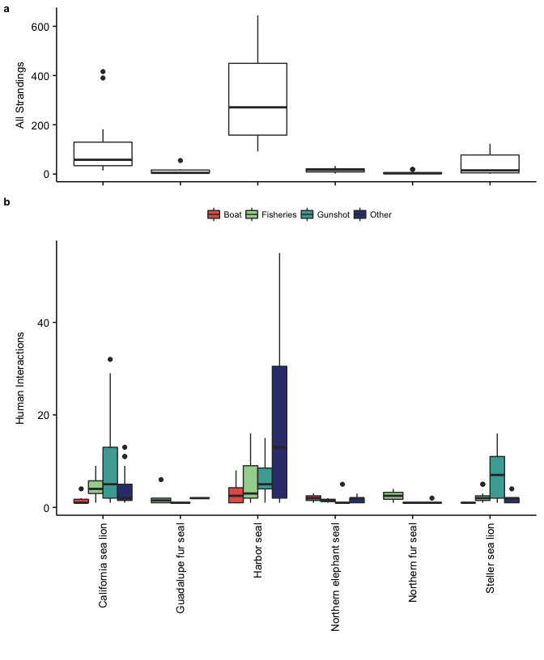

Figure 1: (a) Boxplot of annual stranding cases for each species, showing higher average strandings for harbor seals and California sea lions; and (b) boxplot of annual human interactions by type, showing a high number of gunshot wounds for California sea lions and Steller sea lions and other cases for harbor seals.

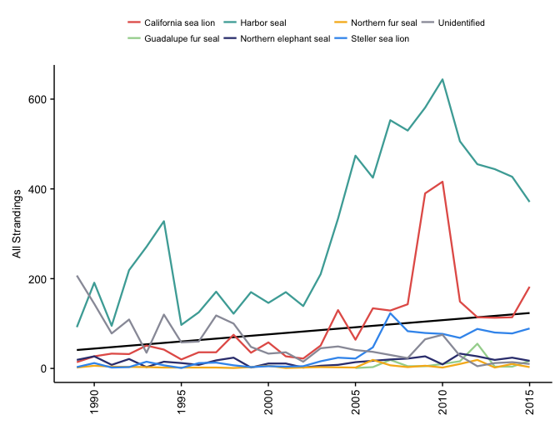

Figure 2: Increasing annual strandings (n = 14,167) over the study period denoted by black regression line (y = 1.1x, z = 44.7, p < 0.01) likely at least in part due to Prescott Grant Program in the mid-2000s; and increasing strandings in harbor seals (y = 3.1x, z = 55.2, p < 0.001) and California sea lions (y = 1.1x, z = 53.8, p < 0.001) and decreasing for Guadalupe fur seals (y = -11.8x, z = -23.8, p < 0.001), northern elephant seals (y = -6.2x, z = -34.9, p < 0.001), Steller sea lions (y = -2.7x, z = -26.7, p < 0.001), and northern fur seals (y = -19.8x, z = -31.5, p < 0.001). Regression lines not shown for individual species for readability.

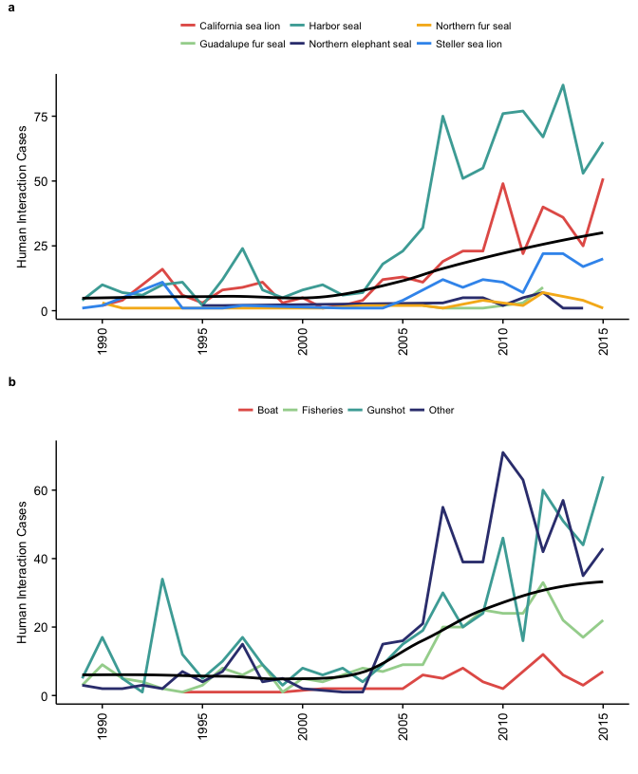

Figure 3: (a) Annual combined HI cases overall () and per species shows increasing for harbor seals (y = 1.9x, z = 10.5, p < 0.001) and California sea lions (y = 1.1x, z = 24.9, p < 0.001) and significantly decreasing for the other species, and (b) HI TYPES.

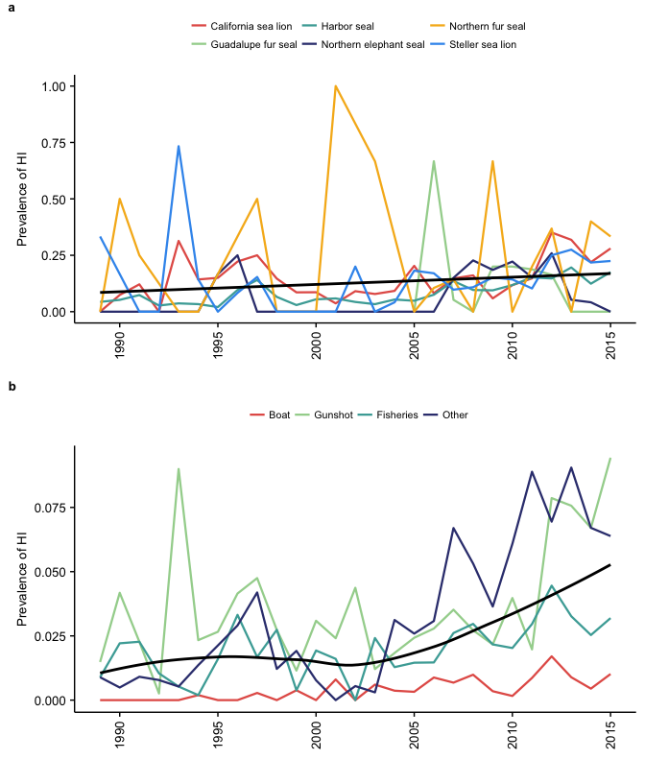

Figure 4: Prevalence of human interaction cases (a) increasing for all combined species (denoted by black regression line, y = 0.005x, t = 5.8, p < 0.001, r-sq = 0.55) and increasing for California sea lions (y = 0.003x, t = 1.9, p < 0.05) and northern fur seals (y = 0.08x, t = 1.8, p < 0.1), and decreasing for northern elephant seals (y = -0.08x, t = -2.0, p < 0.05); (b) increasing for all types combined () and for each HI case type: gunshot wounds (y = 0.03x, t = 7.5, p < 0.001), fisheries entanglements (y = 0.02x, t = 3.6, p < 0.001), boat injuries (y = 0.001x, t = 6.1, p < 0.001), and other (y = 0.03x, t = 6.1, p < 0.001). Regression lines not shown for individual species and HI case types.

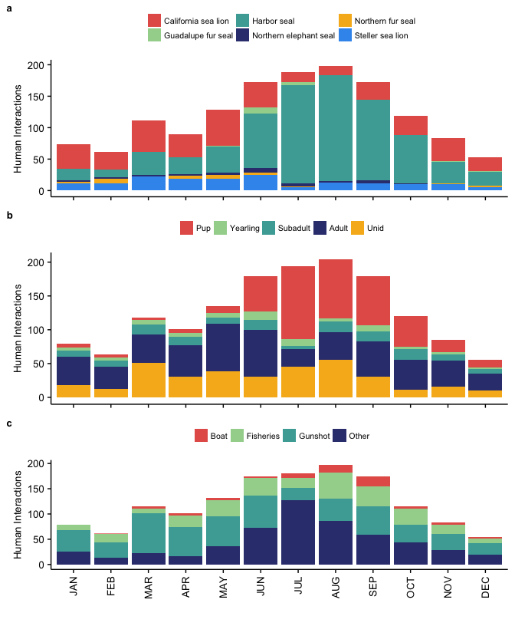

Figure 5: Sum of human interaction cases across years for each month according to (a) species; (b) age class, showing summer peak for human interaction cases for pups; and (c) human interaction type, showing a high number of fisheries cases in August and other in July.

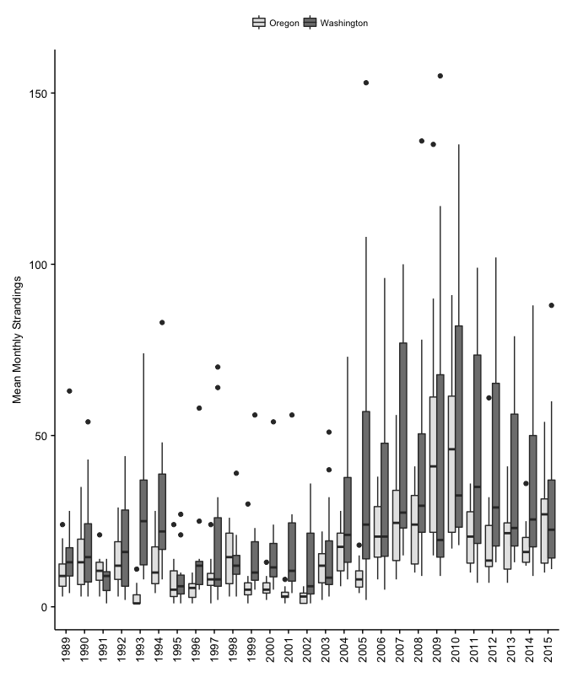

Figure 6: Boxplot of monthly strandings over the study period shows increasing average and variability in both states.

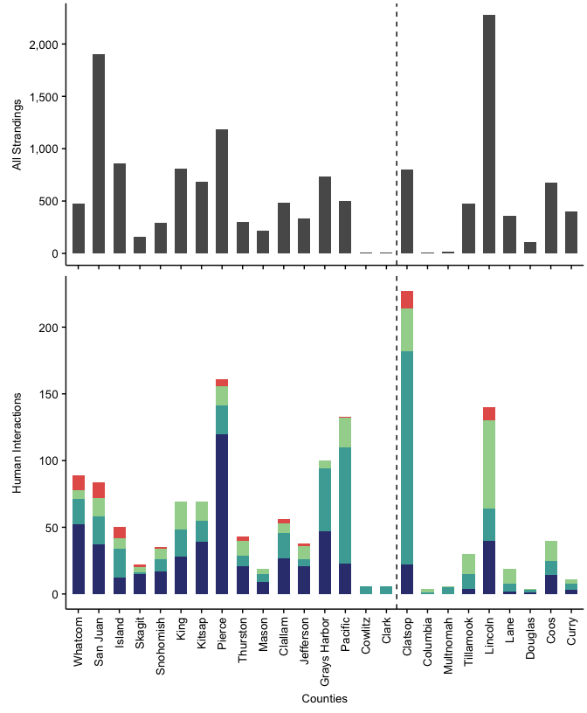

Figure 7: Total strandings (above) and human interaction cases (below) for counties in Washington (left of dashed line) and Oregon (right of dashed line) show higher strandings in Lincoln, San Juan, and Pierce, and proportionally higher HI cases in Clatsop and Pacific.

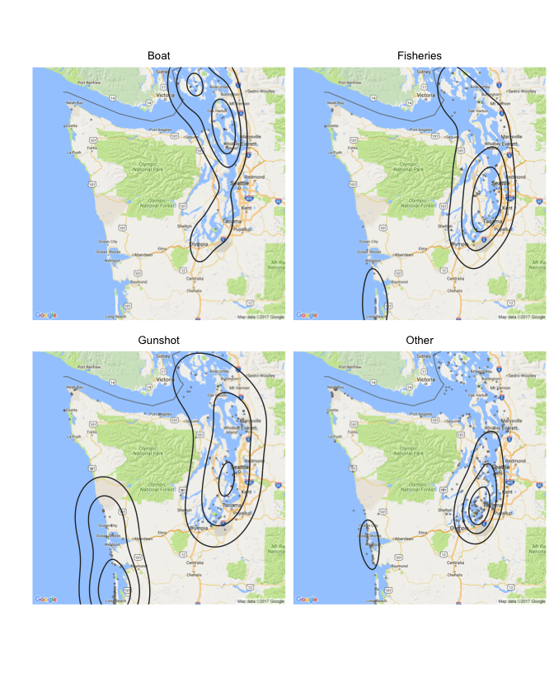

Figure 8: Kernel density plot showing hotspots of human interaction cases in Washington, with fisheries and boat collisions distributed throughout Puget Sound, and gunshot wounds occurring along the southern coast, particularly at the Columbia River.

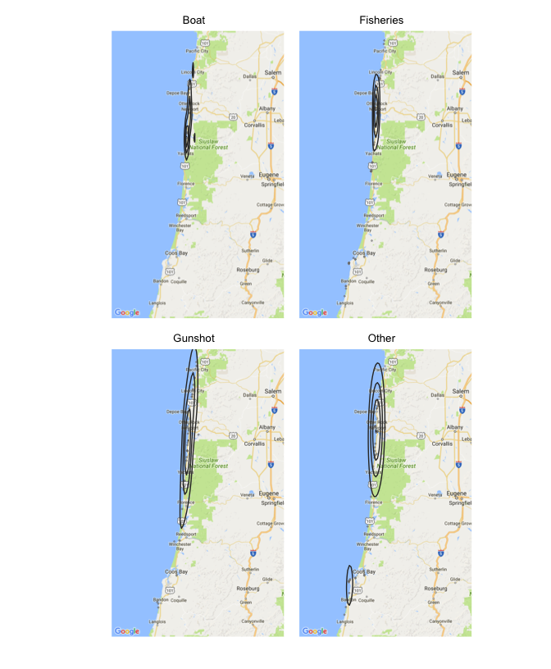

Figure 9: Kernel density plot showing hotspots of human interaction cases in Oregon, with fisheries and boat collisions distributed along the northern coast, and gunshot wounds focused near Astoria and the Columbia River.

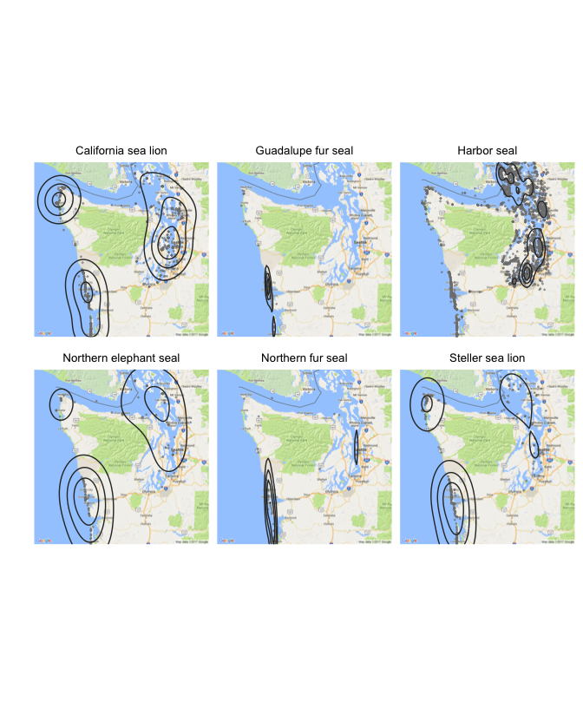

Figure 10: Kernel density plot of species stranding hotspots in Washington.

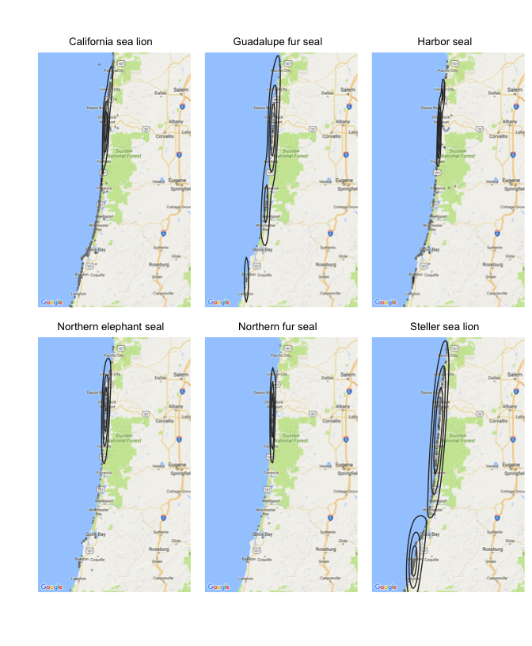

Figure 11: Kernel density plot of species stranding hotspots in Oregon.

Table 1: Species composition of all strandings (n = 14,167), the prevalence of human interaction cases (HI/all cases) for each species, and the composition of human interaction type (number of specific type/all HI cases) for each species.

|  |  |  |  |  |  |  |  |  |  |
| --- | --- | --- | --- | --- | --- | --- | --- | --- | --- |
| Species | Total (n) | All Strandings (%) | OR (%) | WA (%) | Prevalence of HI (%) | Fisheries (%) | Gunshot (%) | Boat (%) | Other (%) |
| California sea lion | 2637 | 19 | 68 | 32 | 15 | 20 | 57 | 4 | 19 |
| Guadalupe fur seal | 139 | 1 | 58 | 42 | 13 | 72 | 6 | 0 | 22 |
| Harbor seal | 8290 | 59 | 15 | 85 | 10 | 18 | 21 | 6 | 55 |
| Northern elephant seal | 424 | 3 | 65 | 35 | 8 | 9 | 33 | 12 | 45 |
| Northern fur seal | 116 | 1 | 59 | 41 | 25 | 74 | 4 | 0 | 22 |
| Steller sea lion | 966 | 7 | 67 | 33 | 17 | 16 | 74 | 1 | 8 |
| Unidentified | 1595 | 11 | 64 | 36 | 4 | 37 | 34 | 3 | 26 |

Table 2: Number and percentage of male, female, and unidentified strandings at each age class across all years and the average sex composition of strandings across all age classes.

|  |  |  |  |  |  |  |
| --- | --- | --- | --- | --- | --- | --- |
| Age | Female (N) | Female (%) | Male (N) | Male (%) | Unid. (N) | Unid. (%) |
| Pup | 1014 | 26 | 1072 | 27.0 | 1856 | 47.0 |
| Yearling | 168 | 18 | 287 | 31.0 | 468 | 51.0 |
| Subadult | 106 | 12 | 482 | 55.0 | 295 | 33.0 |
| Adult | 567 | 18 | 1896 | 60.0 | 706 | 22.0 |
| Unid | 584 | 11 | 960 | 18.0 | 3706 | 71.0 |
| Average | -- | 17 | -- | 38.2 | -- | 44.8 |

Table 3: Sex composition of all strandings (n = 14,167), the prevalence of human interaction cases for each sex, and the composition of human interaction type for each sex.

|  |  |  |  |  |  |  |
| --- | --- | --- | --- | --- | --- | --- |
| Sex | All Strandings (%) | Prevalence of HI (%) | Fisheries Interactions (%) | Gunshots (%) | Boat Injuries (%) | Other (%) |
| Female | 17 | 16 | 17 | 32 | 6 | 45 |
| Male | 33 | 17 | 15 | 47 | 5 | 33 |
| Unid | 50 | 5 | 35 | 20 | 3 | 42 |

Table 4: Age composition of all strandings (n = 14,167), the prevalence of human interaction cases for each age class, and the composition of human interaction type for each age class.

|  |  |  |  |  |  |  |
| --- | --- | --- | --- | --- | --- | --- |
| Age | All Strandings (%) | Prevalence of HI (%) | Fisheries Interactions (%) | Gunshots (%) | Boat Injuries (%) | Other (%) |
| Pup | 28 | 11 | 16 | 4 | 7 | 73 |
| Yearling | 7 | 8 | 38 | 19 | 5 | 37 |
| Subadult | 6 | 16 | 21 | 51 | 5 | 23 |
| Adult | 22 | 17 | 17 | 57 | 5 | 21 |
| Unid | 37 | 7 | 27 | 42 | 2 | 29 |

Table 5: Age class and sex composition of all strandings (n = 14,167) by species shows very different composition according to species.

|  |  |  |  |  |  |  |  |  |
| --- | --- | --- | --- | --- | --- | --- | --- | --- |
| Species | Total (n) | Male (%) | Female (%) | Pup (%) | Yearling (%) | Subadult (%) | Adult (%) | Unidentified Age (%) |
| California sea lion | 2637 | 76.3 | 1.1 | 0.3 | 9.1 | 14.6 | 51.6 | 24.5 |
| Guadalupe fur seal | 139 | 32.4 | 33.8 | 0.7 | 91.4 | 2.2 | 2.9 | 2.9 |
| Harbor seal | 8290 | 24.6 | 23.2 | 44.3 | 4.4 | 3.7 | 14.1 | 33.5 |
| Northern elephant seal | 424 | 35.1 | 13.9 | 18.2 | 18.2 | 12.3 | 5.4 | 46.0 |
| Northern fur seal | 116 | 24.1 | 39.7 | 26.7 | 31.0 | 7.8 | 4.3 | 30.2 |
| Steller sea lion | 966 | 40.9 | 33.7 | 14.1 | 6.8 | 12.4 | 53.7 | 12.9 |

**Appendices: Additional Tables and Statistical Analyses**

Table 6: Proportion of all strandings, proportion of human interaction cases (%), and the composition of human interaction case types for each county in Washington (n = 9,022).

|  |  |  |  |  |  |  |
| --- | --- | --- | --- | --- | --- | --- |
| County | All Strandings (%) | Human Interactions (%) | Fisheries (%) | Gunshot (%) | Boat (%) | Other (%) |
| Clallam | 5 | 6 | 12 | 34 | 5 | 48 |
| Clark | 0 | 1 | 0 | 100 | 0 | 0 |
| Cowlitz | 0 | 1 | 0 | 100 | 0 | 0 |
| Grays Harbor | 8 | 10 | 6 | 47 | 0 | 47 |
| Island | 10 | 5 | 16 | 44 | 16 | 24 |
| Jefferson | 4 | 4 | 26 | 13 | 5 | 55 |
| King | 9 | 7 | 30 | 29 | 0 | 41 |
| Kitsap | 8 | 7 | 20 | 23 | 0 | 57 |
| Mason | 2 | 2 | 21 | 32 | 0 | 47 |
| Pacific | 6 | 14 | 17 | 65 | 1 | 17 |
| Pierce | 13 | 16 | 9 | 13 | 3 | 75 |
| San Juan | 21 | 9 | 17 | 25 | 14 | 44 |
| Skagit | 2 | 2 | 18 | 5 | 9 | 68 |
| Snohomish | 3 | 4 | 23 | 26 | 3 | 49 |
| Thurston | 3 | 4 | 26 | 19 | 7 | 49 |
| Whatcom | 5 | 9 | 8 | 21 | 12 | 58 |

Table 7: Proportion of all strandings (%), the proportion of human interaction cases (%) and the composition of human interaction case types for each county in Oregon (n = 5,145).

|  |  |  |  |  |  |  |
| --- | --- | --- | --- | --- | --- | --- |
| County | All Strandings (%) | Human Interactions (%) | Fisheries (%) | Gunshot (%) | Boat (%) | Other (%) |
| Clackamas | 0 | 1 | 0 | 100 | 0 | 0 |
| Clatsop | 16 | 47 | 14 | 70 | 6 | 10 |
| Columbia | 0 | 1 | 75 | 25 | 0 | 0 |
| Coos | 13 | 8 | 38 | 28 | 0 | 35 |
| Curry | 8 | 2 | 27 | 45 | 0 | 27 |
| Douglas | 2 | 1 | 25 | 50 | 0 | 25 |
| Lane | 7 | 4 | 58 | 32 | 0 | 11 |
| Lincoln | 44 | 29 | 47 | 17 | 7 | 29 |
| Multnomah | 0 | 1 | 17 | 83 | 0 | 0 |
| Tillamook | 9 | 6 | 50 | 37 | 0 | 13 |

**References**

Aguirre A.A. and Tabor GM. 2004. Marine vertebrates as sentinels of marine ecosystem health. EcoHealth. 1: 236–238.

Antonelis, G.A., J.D. Baker, T.C. Johanos, R.C. Braun, and A.L. Harting. 2006. Hawaiian monk seal (*Monachus schauinslandi*): status and conservation issues. Atoll Research Bulletin 543: 75–101.

Barbieri, M., Raverty, S., Hanson, M.B., Venn-Watson, S., Ford, J.K., and J.K. Gaydos. 2013. Spatial and temporal analysis of killer whale (*Orcinus orca*) strandings in the North Pacific Ocean and the benefits of a coordinated stranding response protocol. Marine Mammal Science 29.4: E448-E462.

Bogomolni, A., K.R. Pugliares, S.M. Sharp, K. Patchett, C.T. Harry, J.M. LaRocque, K.M. Touhey, and M. Moore. 2010. Mortality trends of stranded marine mammals on Cape Cod and southeastern Massachusetts, USA, 2000 to 2006. Diseases of Aquatic Organisms 88: 143-155.

Bossart, G.D. 2011. Marine mammals as sentinel species for oceans and human health. Veterinary Pathology 48(3): 676-90.

Bossart, G.D. 2006. Marine mammals as sentinels species for oceans and human health. Oceanography 19(2): 134-37.

Carretta, J.V., Oleson, E.M., Baker, J., Weller, D.W., Lang, A.R., and others. 2016. U.S. Pacific marine mammal stock assessments: 2015. NOAA-TM-NMFS-SWFSC-561. Washington, DC. National Oceanic and Atmospheric Administration.

Colegrove, K.M., Greig, D.J., and F.M.D. Gulland. 2005. Causes of live strandings of northern elephant seals and Pacific harbor seals along the central California coast, 1992-2001. Aquatic Mammals 31(1): 1-10.

DeLong, R.L., Gearin, P.J., Bengston, J.L., Dawson, P. and S.D. Feldkamp. 1990. Studies of the effects of entanglement on individual northern fur seals. In: R.S. Shomura and M.L. Godfrey (eds.), Proceedings of the Second International Conference on Marine Debris, 2–7 April, 1989, Honolulu, Hawaii. NOAA Technical Memorandum NMFS SWFSC 154. pp. 492–493.

Esperon-Rodriguez, M., and J.P. Gallo-Reynoso. 2012. The re-colonization of the Archipelago of San Benito, Baja California, by the Guadalupe fur seal. Revista Mexicana de Biodiversidad 83:170-176.

Figureroa-Carranza, A.L. 1994. Early lactation and attendance behavior of the Guadalupe fur seal females (*Arctocephalus townsendi*). University of California, Santa Cruz, California.

Fowler, C.W. 1987. Marine debris and northern fur seals: a case study. Marine Pollution Bulletin 18: 326–335.

Gatrell AC, Bailey, TC, Diggle, P and Rowlingson, BS, 1996, Spatial Point Pattern Analysis and its Application in Geographical Epidemiology, Trans. Inst Br Geogr NS 2: 256- 274.

Gelatt, T., R. Ream, and D. Johnson. 2015. Callorhinus ursinus. The IUCN Red List of Threatened Species 2015:e.T3590A45224953. Available at: <http://www.iucnredlist.org/details/3590/0>

Goldstein, T., Johnson, S.P., Phillips, A.V., Hanni, K.D., Fauquier, D.A. and F.M.D. Gulland. 1999. Human-related injuries observed in live stranded pinnipeds along the central California coast 1986–1998. Aquatic Mammals 25: 43–51.

Greig, D. J., Gulland, F. M. D., & Kreuder, C. 2005. A decade of live California sea lion (*Zalophus californianus*) strandings along the central California coast: Causes and trends, 1991-2000. Aquatic Mammals, 31(1), 11-22. <http://dx.doi.org/10.1578/AM.31.1.2005.11>

Guisan A., Edwards, T.C. Jr, Hastie T. .2002. Generalized linear and generalized additive models in studies of species distributions: setting the scene. Ecological Modelling 157:89–100.

Gulland, F. M. D., & Hall, A. J. 2007. Is marine mammal health deteriorating? Trends in the global reporting of marine mammal disease. EcoHealth, 4(2), 135-150. <http://dx.doi.org/10.1007/s10393-007-0097-1>

Hanni, K.D., Long, D.J., Jones, R.E., Pyle, P., and L.E. Morgan. 1997. Sightings and strandings of Guadalupe fur seals in central and northern California, 1988-1995. Journal of Mammalogy 78(2): 684-690.

Hanni, K.D., and P. Pyle. 2000. Entanglement of pinnipeds in synthetic materials at south-east Farallon Island, California, 1976–1998. Marine Pollution Bulletin 40: 1076–1081.

Harris, D.E. and S. Gupta. 2006. GIS-based Analysis of Ice-breeding Seal Strandings in the Gulf of Maine. Northeastern Naturalist 13(3): 403-420.

Hart, K.M., Mooreside, P., and L.B. Crowder. 2006. Interpreting the spatio-temporal patterns of sea turtle strandings: going with the flow. Biological Conservation 129(2): 283-290.

Huber, H.R., B.R. Dickerson, S.J. Jeffries, and D.M. Lambourn. 2012. Genetic analysis of Washington State harbor seals (*Phoca vitulina richardii*) using microsatellites. Can. J. Zool. 90(12):1361-1369.

Huggins, J.L., Leahy, C.L., Calambokidis, J., Lambourn, D., Jeffries, S.J. and others. 2013. Causes and patterns of harbor seal (*Phoca vitulina*) pup mortality at Smith Island, Washington, 2004-2010.

Huggins, J. L., Raverty, S. A., Norman, S. A., Calambokidis, J., Gaydos, J. K., Duffield, D. A., & ... Barre, L. 2015a. Increased harbor porpoise mortality in the Pacific Northwest, USA: understanding when higher levels may be normal. Diseases of Aquatic Organisms, 115(2), 93-102.

Huggins, J.L, Oliver, J., Lambourn, D.M., Calambokidis, J., Diehl, B. and S. Jeffries. 2015. Dedicated beach surveys along the central Washington coast reveal a high proportion of unreported marine mammal strandings. Marine Mammal Science 31(2): 782-789.

Jeffries, S.J., P.J. Gearin, H.R. Huber, D.L. Saul, and D.A. Pruett. 2000. Atlas of Seal and Sea Lion Haulout Sites in Washington. Washington Department of Fish and Wildlife, Wildlife Science Division, 600 Capitol Way North, Olympia WA. pp. 150.

Johnston, D.W., Frungillo, J., Smith, A., Moore, K., Sharp, B., Schuh, J. and A. Read. 2015. Trends in stranding and bycatch rates of gray and harbor seals along the Northeastern coast of the U.S.: evidence of divergence in the abundance of two sympatric phocid species? Plus One. <DOI:10.1371/journal.pone.0131660>

Kaplan Dau, B., Gilardi, K.V.K., Gulland, F.M., Higgins, A., Holcomb, J.B et al. 2009. Fishing gear-related injury in California marine wildlife. Journal of Wildlife Diseases 45(2): 355-362.

Keledjian, A.J., and S. Mesnick. 2013. The Impacts of El Nino Conditions on California. Sea Lion Fisheries Interactions: Predicting Spatial and Temporal Hotspots Along the California Coast. Aquatic Mammals 39(3), 221-232.

Knox, G. 1964. The detection of space-time interactions. Applied Statistics 13:25–29.

Kreuder, C., M.A. Miller, D.A. Jessup, et al. 2003. Patterns of mortality in southern sea otters (*Enhydra lutras nereis*) from 1998–2001. Journal of Wildlife Diseases 39:495–509.

Kulldorff, M., and N. Nagarwalla. 1995. Spatial disease clusters: Detection and inference. Statistical Methods 14:799–810.

Kulldorff, M. 2001. Prospective time periodic geographical disease surveillance using a scan statistic. J.R. Statist Soc 164(1): 61-72.

Kulldorff, M., Heffernan, R., Hartman, J., Assuncao, R., and F. Mostashari. 2005. A space-time permutation scan statistic for disease outbreak detection. PLoS Med 2(3): e59.

Lambourn, D.M., Garner, M., Ewalt, D., Raverty, S., Sidor, I., Jeffries, S. et al. 2013. Brucella pinnipedialis infections in Pacific harbor seals from Washington State, USA. Journal of Wildlife Disease 49(4): 802-815.

Lambourn, D., D’Agnese, E., Jeffries, S., Wilkinson, K., Huggins, J., Rice, J., Duffield, D., Smith, W., Grigg, M., Raverty, S. 2015. Return of the Guadalupe fur seal to the Pacific Northwest: Stranding and sightings. 21st Biennial Conference on the Biology of Marine Mammals. Dec. 13-18. San Francisco, CA.

Leeney, R.H., Amies, R., Broderick, A.C., Witt, M.J., Loveridge, J., Doyle, J., and Godley, B.J. 2008. Spatio-temporal analysis of cetacean strandings and bycatch in a UK fisheries hotspot. Biodiversity and Conservation 17: 2323. <doi:10.1007/s10531-008-9377-5>

Le Boeuf, B.J., Crocker, D.E., Costa, D.P., Blackwell, S.B., Webb, P.M., and D.S. Houser. 2000. Foraging ecology of northern elephant seals. Ecological monographs, 70(3), 353-382.

Lea, M.A., Johnson, D., Ream, R., Sterling, J., Melin, S., and T. Gelatt. 2009. Extreme weather events influence dispersal of naïve northern fur seals. Biol. Lett. DOI: 10.1098/rsbl.2008.0643.

Lee, K. 2016. Stranding mortality patterns in California sea lions and Steller sea lions in Oregon and southern Washington, 2006 to 2014. Dissertations and Theses. Paper 2995. Portland State University.

London, J.M., Ver Hoef, J.M., Jeffries, S.J., Lance, M.M., and P.L. Boveng. 2012. Haul-out behavior of harbor seals (*Phoca vitulina*) in Hood Canal, Washington. PLoS ONE 7(6): e38180. <doi:10.1371/journal.pone.0038180>.

Lowry, M.S., R. Condit, B.Hatfield, S.G. Allen, R. Berger, P.A. Morris, B.J. Le Boeuf, and J. Reiter. 2014. Abundance, Distribution, and Population Growth of the Northern Elephant Seal (*Mirounga angustirostris*) in the United States from 1991 to 2010. Aquatic Mammals 40(1): 20-31.

Maldini, D., Mazzuca, L., Atkinson, S., 2005. Odontocete stranding patterns in the main Hawaiian Islands (1937–2002): how do they compare with live animal surveys? Pacific Science 59, 55–67.

Maniscalco, J.M., Wynne, K., Pitcher, K.W., Hanson, M.B., Melin, S.R., and S. Atkinson. 2004. The occurrence of California sea lions (*Zalophus californianus*) in Alaska. Aquatic Mammals 30(3): 427-433.

McCullagh, M.J. 2006. Detecting hotspots in time and space. ISG06.

Melin, S. R., DeLong, R. L., & Siniff, D. 2008. The effects of El Niño on the foraging behavior of lactating California sea lions (*Zalophus californianus*) during the non-breeding season. Canadian Journal of Zoology, 86, 192-206. <http://dx.doi.org/10.1139/Z07-132>

Melin, S. R., DeLong, R. L., & Thomason, J. R. 2000. Attendance patterns of California sea lion (*Zalophus californianus*) females and pups during the non-breeding season at San Miguel Island. Marine Mammal Science, 16(1), 169-185. <http://dx.doi.org/10.1111/j.1748-7692.2000.tb00911.x>

Melin, S. R., Orr, A. J., Harris, J. D., Laake, J. L., & DeLong, R. L. 2010. Unprecedented mortality of California sea lion pups associated with anomalous oceanographic conditions along the central California coast in 2009. California Cooperative Oceanic Fisheries Investigations Report, 51, 182-194.

Moore SE. 2008. Marine mammals as ecosystem sentinels. J Mammal. 89(3): 534–540.

Moore, SE., Lyday, S., Roletto, J., Litle, K., Parrish, J.K., Nevins, H., Harvey, J., Mortenson, J., Greig, D., Piazza, M., Hermace, A., Lee, D., Adams, D., Allen, S., and Kell, S. 2009. Entanglements of marine mammals and seabirds in central California and the north-west coast of the United States 2001-2005. Marine Pollution Bulletin. 58: 1045-1051.National Marine Fisheries Service. 2008. Recovery Plan for the Steller Sea Lion (*Eumetopias jubatus*). Revision. National Marine Fisheries Service, Silver Spring, MD. 325 pp.

Norman, S. A., C. E. Bowlby, M. S. Brancato, et al. 2004. Cetacean strandings in Oregon and Washington between 1930 and 2002. Journal of Cetacean Research and Management 6:87–99.

Norman, S.A. 2008. Spatial epidemiology and GIS in marine mammal conservation medicine and disease research. Ecohealth 5:257–267.

Norman, S.A., Huggins, J., Carpenter, T.E., Case, J.T., Lambourn, D.M., Rice, J. et al. 2011. The application of GIS and spatio-temporal analyses to investigations of unusual marine mammal strandings and mortality events. Marine mammal science 28(3): E251-E266.

Orr, A.J., Melin, S.R., Harris, J.D., and R.L. DeLong. 2012. Status of the northern fur seal population at San Miguel Island, California during 2010 and 2011. Pp. 41-58, In: Testa, J. W. (ed.), Fur seal investigations, 2010-2011. U.S. Dep. Commer., NOAA Tech. Memo. NMFS-AFSC-241. 77 pp.

Osinga, N., Shahi Ferdous, M.M., Morick, D., Garcia Hartmann, M., Ulloa, J.A., Vedder, L. et al. 2012. Patterns of Stranding and Mortality in Common Seals (*Phoca vitulina*) and Grey Seals (*Halichoerus grypus*) in The Netherlands between 1979 and 2008. Journal of Comparative Pathology 147(4): 1-16.

Pikesley, S.K., Witt, M.J., Hardy, T., Loveridge, J., Loveridge, J., Williams, R., Godley, B.J., 2011. Cetacean sightings and strandings: evidence for spatial and temporal trends? Journal of the Marine Biological Association of the United Kingdom, <http://dx.doi.org/10.1017/S0025315411000464>

Pyenson, N.D., 2010. Carcasses on the coastline: measuring the ecological fidelity of the cetacean stranding record in the eastern North Pacific Ocean. Paleobiology 36, 453–480.

Ross PS. 2000 Marine mammals as sentinels in ecological risk assessment. Hum Ecol Risk Assess. 6(1): 29–46.

Stewart, B. S., & Yochem, P. K. 1987. Entanglement of pinnipeds in synthetic debris and fishing net and line fragments at San Nicolas and San Miguel islands, California, 1978-1986. Marine Pollution Bulletin, 18, 336-339. <http://dx.doi.org/10.1016/S0025-326X(87)80021-8>

Wilkinson, D. and G. Worthy, Marine Mammal Stranding Networks, 1999. In: Conservation and Management of Marine Mammals (Twiss, J. R. and R.R. Reeves, eds.). Smithsonian Institute Press, Washington, pp. 396-411.

Williams, R., E. Ashe, and P.D. O'Hara. 2011a. Marine mammals and debris in coastal waters of British Columbia, Canada. Marine Pollution Bulletin 62(6): 1303-1316.

Woodhouse, C.D. 1991. Marine mammal beachings as indicators of population events. Marine mammal strandings in the United States: proceedings of the second marine mammal stranding workshop. US Dep Commerc., NOAA Technical Report. NMFS 98:111-115. 157pp.