**The problem:**

Puzzle #3

You have 50 motorbikes, each with it's own rider and a full tank of gas. A full tank can get the bike 100km. You have a crown that needs to be transported by bike and you want to get it as far away as possible. What is the maximum distance that you can transport the crown?

Note: You have all the tools to transfer fuel from tank to tank

Additional note: Bikes all start at the same point. You cannot stack a bike on top of another

**My solution:**

I couldn’t come up with a solution that can precisely be proven by code or math. But here’s what I think that would work (thanks to Matt’s hints).

First let’s break the problem into smaller problems by starting with 1 motorbike, then 2 motorbikes, etc.

If we have 1 motorbike only, the maximum distance it can run is 100 km:

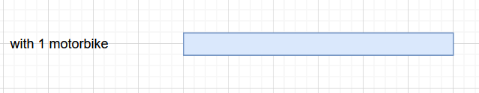

With 2 motorbikes:

Both motorbikes run 50km (half of the gas used), then motorbike #2 transfers all its remaining gas to motorbike #1 so motorbike can run another 100km, which makes the total distance to be **100km * (1 + 1/2) = 150km**.

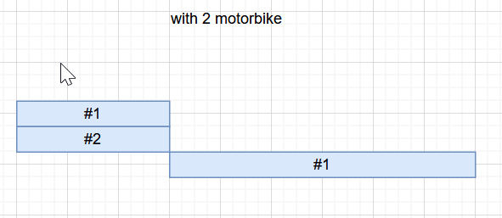

With 3 motorbikes:

All three motorbikes use up 1/3 of the gas, then #3 transfers his remaining gas to #1 and #2 evenly, so that #1 and #2 have full tanks of gas again. At this point the problem becomes the same as having 2 motorbikes. The total distance they can run will be: **100km * (1 + 1/2 + 1/3)**

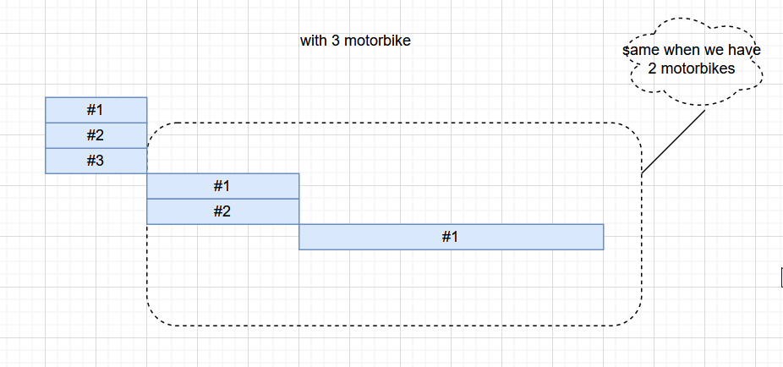

With N motorbikes:

Following this pattern, when we have N motorbikes, all motorbikes first run with 1/N of the gas, then one motorbike distribute his remaining gas to the rest (N-1) motorbikes evenly, and the problem becomes having (N-1) motorbikes. We can get the max distance for N motorbikes to be:

**100km * (1 + 1/2 + 1/3 + … + 1/N)**