1. User Name should be shown at the Top of the Page.

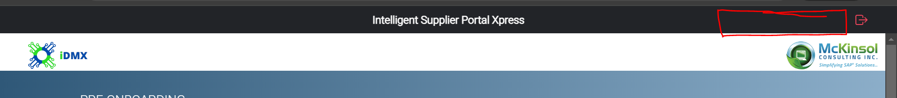

1. Search on the basis of Domain number (Material, article and so on)

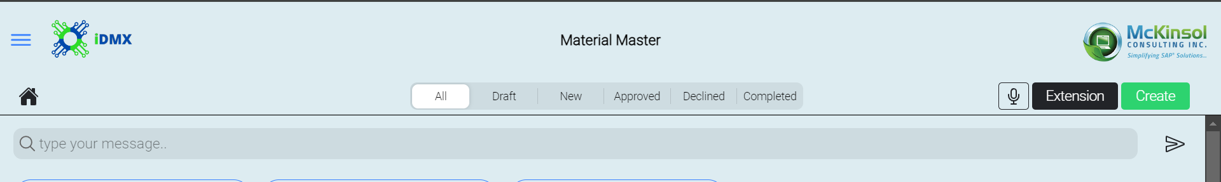

1. Date is getting changed as per the update in the field. it should be creation date only.



1. Change header from created by & on to updated by & on and Comment to Audit Log Action.

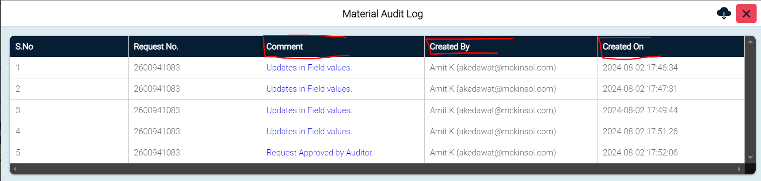

1. In comment header change update in field values to Change and Request Approved by Auditor to Approved or as per Status.

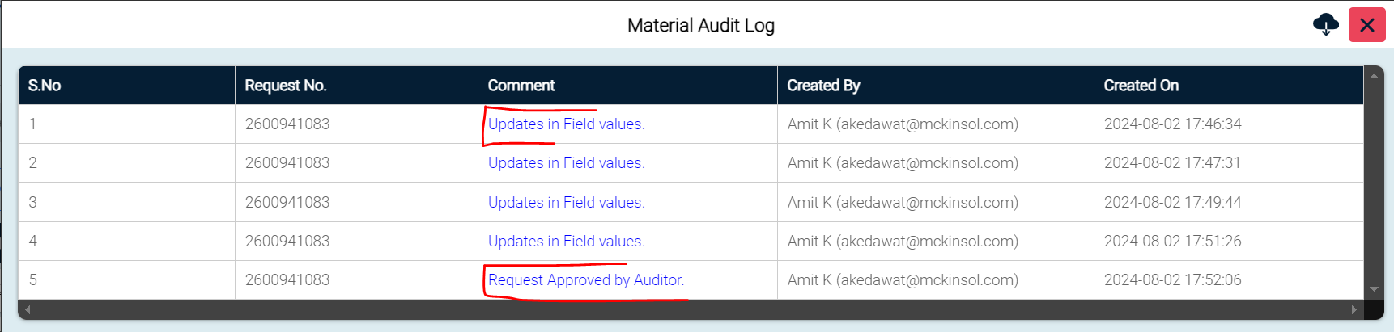

1. Send to SAP status is not shown into Audit log.
2. Dependent fields are showing the different key value for Audit log.

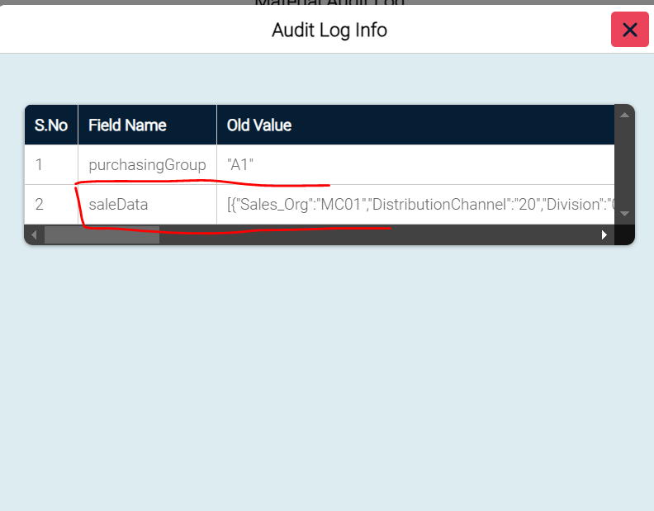

1. All Fields should come from the Front end of iDMX only.
2. Current value –

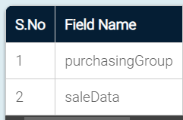

1. New value

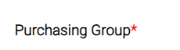

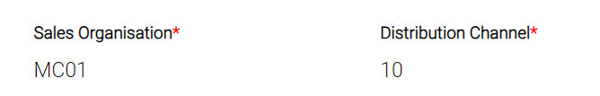

1. Remove user ID which is shown with the unknown details or make it appropriate.

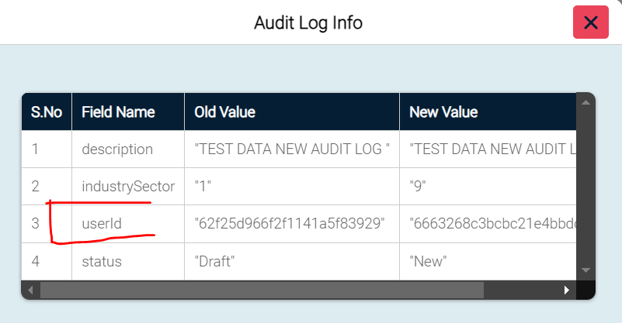

…………………………………………………05/08/2024……………………………………………………..

1. On the top header, Admin name is displayed but user name is shown as Undefined.

Use – [akedawat@mckinsol.com](mailto:akedawat@mckinsol.com) PWD- 123456

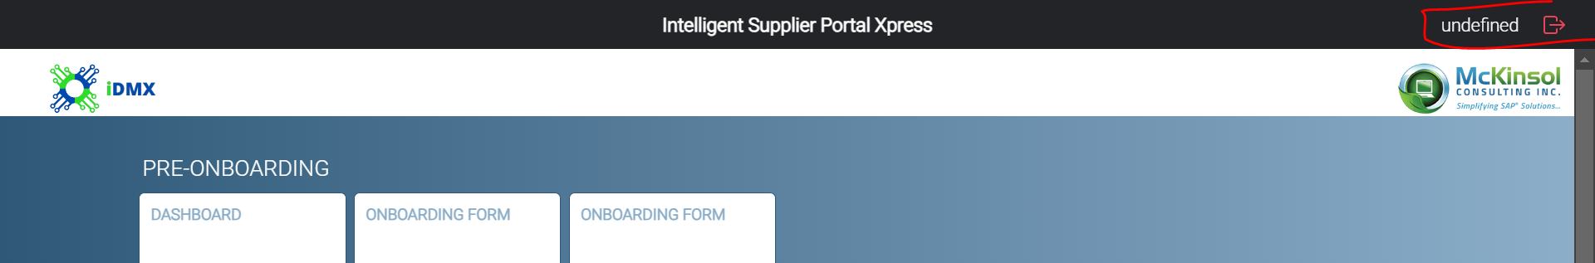

1. No changes value is shown into the Audit log changes functionality.

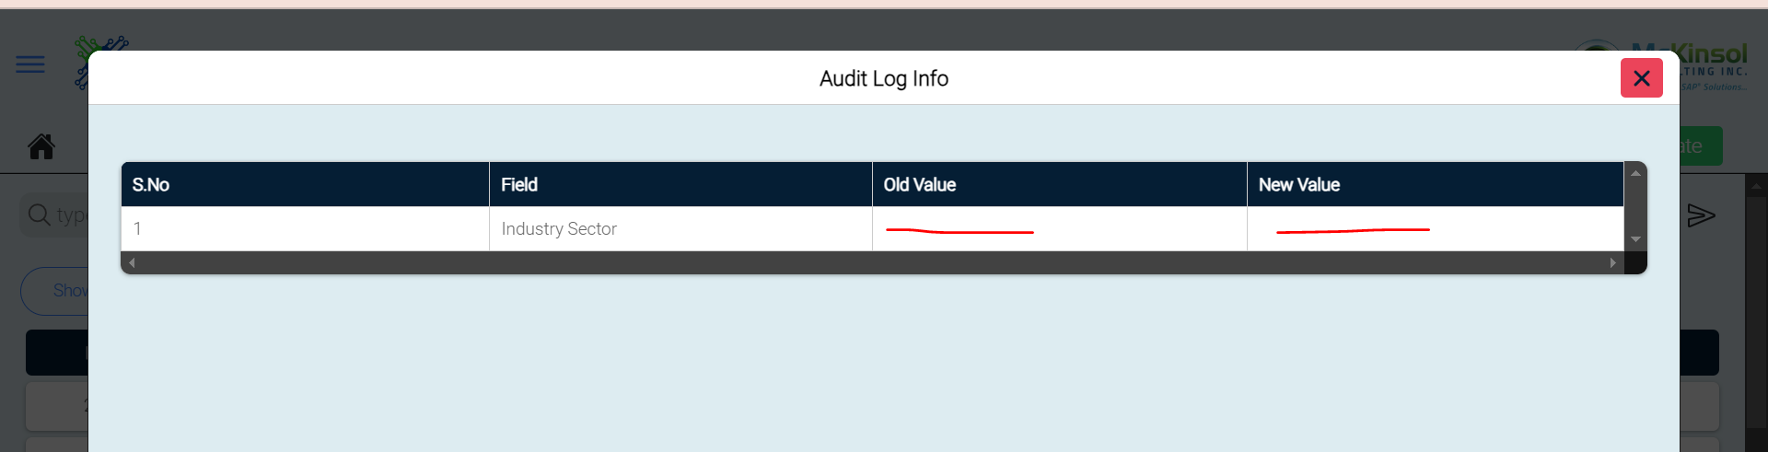

1. Creation Date and time are getting changed but it should be constant. Only update in any data that date will be shown as changed.

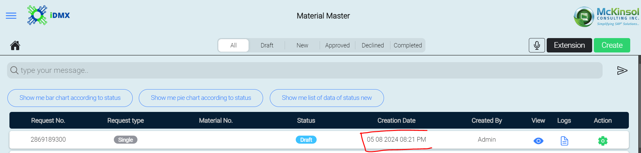

1. If any status is changed, then audit log function should also changed.



1. Please re-arrange the data in center.

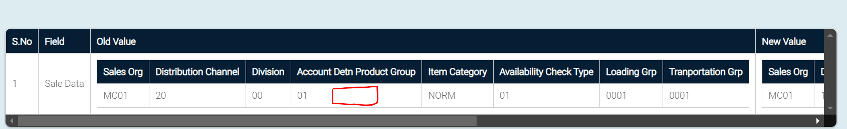

1. Data should be shown in multi-line if we have more than one plant or sales data.

