1. User Name should be shown at the Top of the Page.

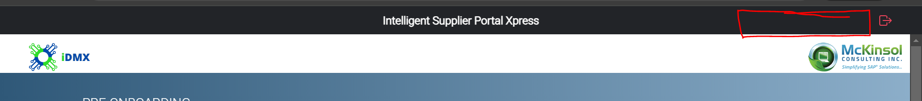

1. Search on the basis of Domain number (Material, article and so on)

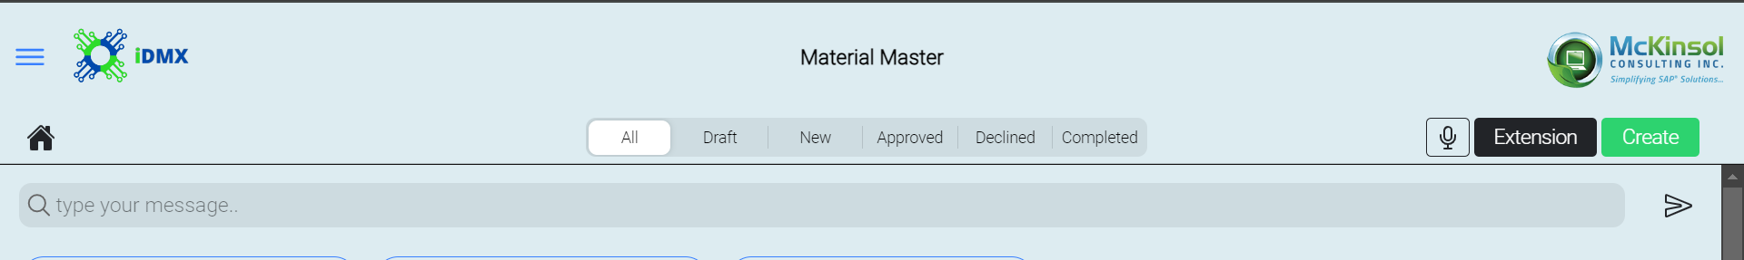

1. Date is getting changed as per the update in the field. it should be creation date only.



1. Change header from created by & on to updated by & on and Comment to Audit Log Action.

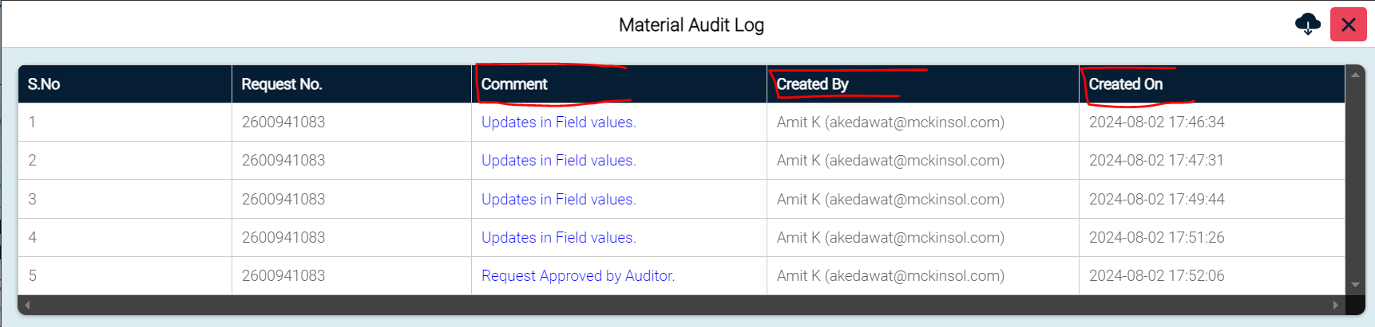

1. In comment header change update in field values to Change and Request Approved by Auditor to Approved or as per Status.

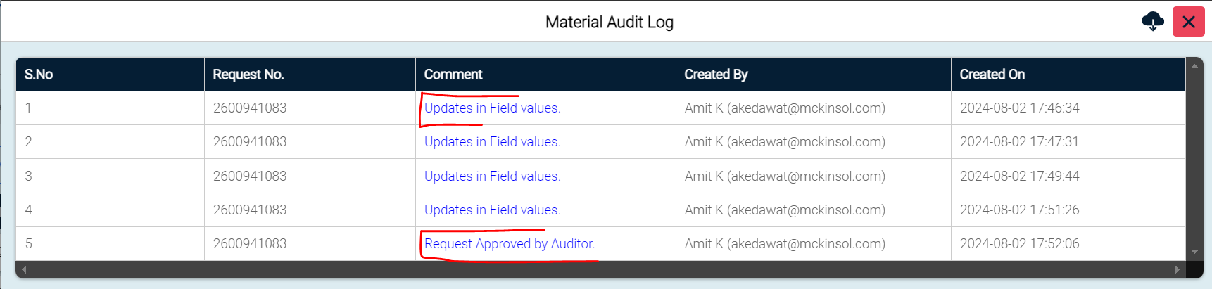

1. Send to SAP status is not shown into Audit log.
2. Dependent fields are showing the different key value for Audit log.

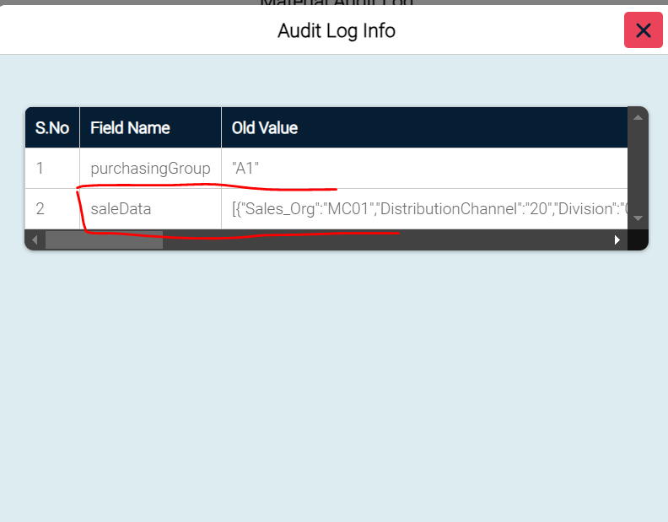

1. All Fields should come from the Front end of iDMX only.
2. Current value –

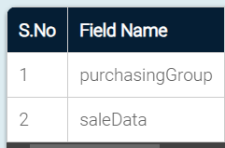

1. New value

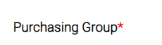

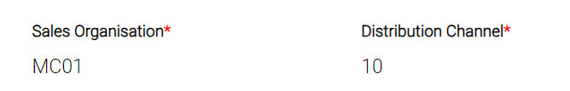

1. Remove user ID which is shown with the unknown details or make it appropriate.

