
OPTIMIZING AI ARCHITECTURE FOR LONG-TERM MEMORY AND EFFICIENCY
A SYNOPSIS OF MINOR PROJECT
submitted in partial fulfillment of the requirements for the award of the degree of
BACHELOR OF TECHNOLOGY
IN
COMPUTER SCIENCE AND ENGINEERING
(ARTIFICIAL INTELLIGENCE & MACHINE LEARNING)
Submitted by:  1. Arpit Bisht (230410101034)  2. Anurag Kumar Singh (230410101032)  3. Anurag Yadav (230410101033)  4. Amandeep Kumar (230410101016) | Under the Supervision of:  Ms. Swati Kashyap  Assistant Professor  Department of CSE

DEPARTMENT OF COMPUTER SCIENCE AND ENGINEERING
Shivalik College of Engineering, Dehradun
October, 2026

CONTENTS
1. Introduction 1
2. Motivation 1
3. Literature Review 2
4. Research Gaps 3
5. Problem Statement 3
6. Objectives 4
7. Proposed Methodology 5
8. Facilities Required 8
9. Timeline 8
References 9

1. Introduction
As Large Language Models (LLMs) transition from ephemeral query tools into long-term collaborative reasoning engines, human interaction paradigms are shifting toward continuous, multi-turn conversations spanning weeks or months. In complex technical domains — such as software architecture design, academic research, and algorithmic problem-solving — users rely heavily on AI systems to maintain consistent state, recall historical decisions, and process highly detailed domain-specific constraints. However, current commercial AI deployments suffer from severe architectural inefficiencies across the interaction pipeline, imposing escalating economic costs, performance latency, and context degradation on the end user.

1.1 Background and Context
Commercial Large Language Model providers (such as OpenAI, Google, and Anthropic) focus their primary engineering capital on training massive foundation models and maintaining direct raw human interaction pipelines. Because commercial API monetization operates on linear token-based billing — where every input and output token directly generates revenue — commercial entities have little to no financial incentive to optimize, compress, or clean user prompts prior to execution. Furthermore, foundation model developers rely heavily on continuous inflows of unstructured, raw human conversational data for dataset enrichment and model alignment. Consequently, default AI platform pipelines shift the burden of token bloat, inefficient memory management, and high latency entirely onto the consumer.
This project responds to that gap by proposing a consumer-side pre-processing and memory-management layer that sits between the user interface and the underlying model runtime, giving the end user direct control over payload optimization and long-term contextual memory rather than leaving these concerns to the platform provider.

2. Motivation
The motivation for this project stems directly from the widening gap between how AI systems are commercially incentivized and what long-term users actually need. As individuals and organizations increasingly depend on AI assistants for sustained, multi-session work, the absence of an efficient, user-controlled memory and optimization layer becomes a real economic and technical liability. The project is motivated by four broad benefits that such a layer would deliver if successfully implemented.
First, operating entirely on the consumer's local device means memory management, graph indexing, and prompt optimization remain under the user's own control, with sensitive historical context and project rules stored locally rather than in flat cloud logs — a strong motivation for privacy-conscious users and organizations handling confidential data.
Second, non-AI token compression combined with targeted subgraph retrieval has the potential to reduce input token volumes sent to commercial API providers by an estimated 40% to 60%, directly lowering operational costs, particularly for global, non-English-speaking users affected by tokenizer inefficiencies.
Third, replacing flat vector-chunk matching with explicit node-edge knowledge graph traversal can eliminate context bleed and reduce the statistical guessing that causes hallucinations, giving the model verified relational pathways instead of approximate similarity matches.
Finally, automated hardware-aware quantization would remove the technical barriers that currently prevent everyday users from running Small Language Models on their own consumer-grade hardware, enabling offline, cost-free local AI execution without manual configuration effort. Together, these anticipated benefits — sovereignty, cost efficiency, reliability, and accessibility — provide the core motivation for undertaking this Minor Project.

3. Literature Review
A systematic analysis of current state-of-the-art architectures reveals key technical approaches and structural limitations in language model deployment, retrieval mechanisms, token compression, and edge quantization.

3.1 Retrieval-Augmented Generation (RAG) vs. GraphRAG
Standard Retrieval-Augmented Generation (RAG) frameworks divide document text into flat, fixed-sized chunks and compute vector embeddings for similarity-based retrieval. While effective for short semantic matching, flat vector retrieval fails in multi-hop relational reasoning (e.g., tracing 'Concept A depends on Tool B, which enforces Rule C'). Unstructured vector chunks frequently introduce context bleed, where details from distinct sessions blend together, causing attention-mechanism confabulations. Recent advancements in GraphRAG convert unstructured text into explicit knowledge graphs composed of atomic Nodes and typed Edges, enabling deterministic subgraph traversals [1][2].

3.2 Prompt Optimization and Algorithmic Token Compression
Efforts to compress prompt context generally rely on secondary LLM summarizers or neural encoder-decoder models. However, using a secondary AI model to compress text introduces additional token costs and execution latency, defeating the purpose of pre-processing. Conversely, non-AI algorithmic compression employs deterministic computer-science rules — such as linguistic stopword filtering, syntactic redundancy stripping, and token-density balancing — to reduce word counts without neural execution overhead.

3.3 Model Quantization and Edge Deployment
Post-Training Quantization (PTQ) techniques (such as GGUF, AWQ, and GPTQ) convert high-precision 16-bit floating-point weights (FP16) into low-bit discrete integers (e.g., INT4 or INT8), reducing memory footprint by 4x to 8x with minimal loss in reasoning capability [3][4]. However, existing edge runtimes require manual configuration of quantization parameters, offloading layers, and thread allocations, creating deployment friction across heterogeneous consumer hardware architectures.

4. Research Gaps
Based on the reviewed literature, the following critical gaps have been identified in existing approaches to long-term AI memory, token management, and local deployment:
- Lack of Sovereign Consumer-Side Interception: Existing optimization frameworks are implemented as server-side modifications or third-party cloud APIs, leaving end consumers reliant on platform-provided billing pipelines.
- Absence of Defragmented Memory Life-Cycles: While knowledge graphs are utilized for static documents, dynamic chat interaction graphs lack real-time defragmentation, entity merging, and automated pruning heuristics.
- Non-Neural Multilingual Optimization: Current multilingual prompt handling relies on neural translation, ignoring deterministic, non-AI intermediate token minimization formats.
Table 1 summarizes the identified gaps against the current state-of-the-art in each domain.
Domain | Existing State-of-the-Art | Identified Limitation / Gap
Long-Term Memory | Flat vector embeddings / text-chunk RAG | Context bleed, relational ambiguity, statistical guessing causing hallucinations.
Token Management | Neural model summarization / manual trimming | High compute overhead; BPE tokenizers inflate non-English text by 3x–4x.
Local Deployment | Manual model selection & static runtime flags | Tedious hardware configuration; suboptimal execution on consumer chips.
Table 1: Summary of research/technical gaps identified from the literature review.

5. Problem Statement
In long-term, multi-turn AI interactions, users face five distinct structural and economic bottlenecks that existing commercial platforms do not address:
- Input Token Bloat and Economic Misalignment: Users frequently submit verbose, structurally unoptimized prompts that repeat background constraints across sessions. Linear API monetization forces users to absorb inflated token bills for redundant text.
- The Flat Memory Trap and Relational Ambiguity: Traditional AI memory systems rely on flat text logs or unstructured vector-embedding chunks. As chat history accumulates over months, unrelated concepts blend together (context bleed), and explicit relational links between concepts are lost, forcing the model to statistically guess and hallucinate.
- Uniform Compute Waste: Standard token-by-token generation allocates identical computational depth and attention to simple factual lookup queries as it does to deep analytical reasoning tasks.
- Multilingual Token Inflation: Standard Byte-Pair Encoding (BPE) tokenizers (such as cl100k) are heavily optimized for English text, fragmenting non-English languages into 3x to 4x more tokens for identical semantic content.
- Hardware Fragmentation Bottlenecks: Deploying Small Language Models (SLMs) on local edge devices currently requires manual trial-and-error to find optimal quantization precision configurations for specific CPU, GPU, or NPU hardware.
These five bottlenecks collectively define the problem this Minor Project seeks to solve: the absence of a unified, consumer-side layer that can intercept, compress, structure, and route AI interactions intelligently before they ever reach a commercial model endpoint.

6. Objectives
The primary objective of this project is to develop an autonomous, consumer-side pre-processing and memory framework that optimizes input token payloads and maintains precise, zero-hallucination contextual memory. The specific, measurable objectives are enumerated below:
1. Design and Implement Local Interception Middleware: Develop a lightweight local client layer that intercepts user prompts on the host device prior to network transmission or local model inference.
2. Construct a Graph-Based Mind-Map Memory Store (Pillar 1): Build an Obsidian-style network graph database using atomic Nodes (facts, tools, constraints) and typed Edges, implementing dynamic defragmentation, entity resolution, and subgraph traversal to prevent context bleed.
3. Develop a Weighted Intent Recognition Engine (Pillar 2): Implement a low-latency heuristic and classification triage engine that calculates query complexity scores to dynamically allocate compute budgets and route tasks between local edge models and cloud APIs.
4. Create a Non-AI Multilingual Token Compression Layer (Pillar 3): Build deterministic computer-science heuristics to strip linguistic redundancies, stopword bloat, and tokenizer inefficiencies without secondary neural network overhead.
5. Build an Automated Hardware-Aware Quantization Profiler (Pillar 4): Develop a device profiling tool that analyzes CPU instruction sets, RAM bandwidth, GPU availability, and NPU hardware to automatically configure local Small Language Models (SLMs) at optimal GGUF precision tiers.
6. Evaluate Performance and Economic Impact: Conduct quantitative benchmarks measuring payload compression ratio, retrieval precision, hallucination reduction, memory footprint, and total token API cost savings across multi-turn chat workflows.

7. Proposed Methodology
The system architecture is structured as an end-to-end local pre-processing pipeline operating directly on the consumer's device. The architecture coordinates four specialized technical pillars into a unified sequential execution workflow.

7.1 End-to-End System Architecture and Workflow
When a prompt is submitted, the execution flow proceeds through five distinct stages, illustrated in Fig. 1 below.
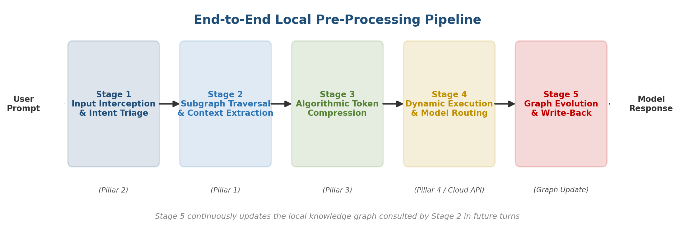
Fig. 1: End-to-end local pre-processing pipeline showing the five execution stages.
- Stage 1 – Input Interception & Intent Triage (Pillar 2): The raw prompt is ingested locally. Pillar 2 analyzes syntactic complexity, code presence, and constraint density, assigning an intent score (Low, Medium, or High) and compute budget.
- Stage 2 – Subgraph Traversal & Context Extraction (Pillar 1): Based on the assigned intent budget, Pillar 1 locates target entity nodes on the local knowledge graph and performs multi-hop subgraph traversal, extracting only verified connected facts while avoiding unrelated memory branches.
- Stage 3 – Algorithmic Token Compression (Pillar 3): The retrieved context and raw user prompt are passed through non-AI compression heuristics, stripping conversational filler, stopword bloat, and linguistic redundancies across target languages.
- Stage 4 – Dynamic Execution & Model Routing (Pillar 4 / Cloud API): If the intent score is Low/Medium, the lean payload is routed to a locally quantized edge SLM configured by Pillar 4. If High, the payload is dispatched to an upstream cloud API with minimal token overhead.
- Stage 5 – Graph Evolution & Write-Back: The generated response and newly identified concepts are parsed into atomic nodes and edges, updating relationship weights and triggering background defragmentation.

7.2 Detailed Specification of the Four Pillars
Fig. 2 shows how the four technical pillars connect to the central local orchestration layer that coordinates them at runtime.
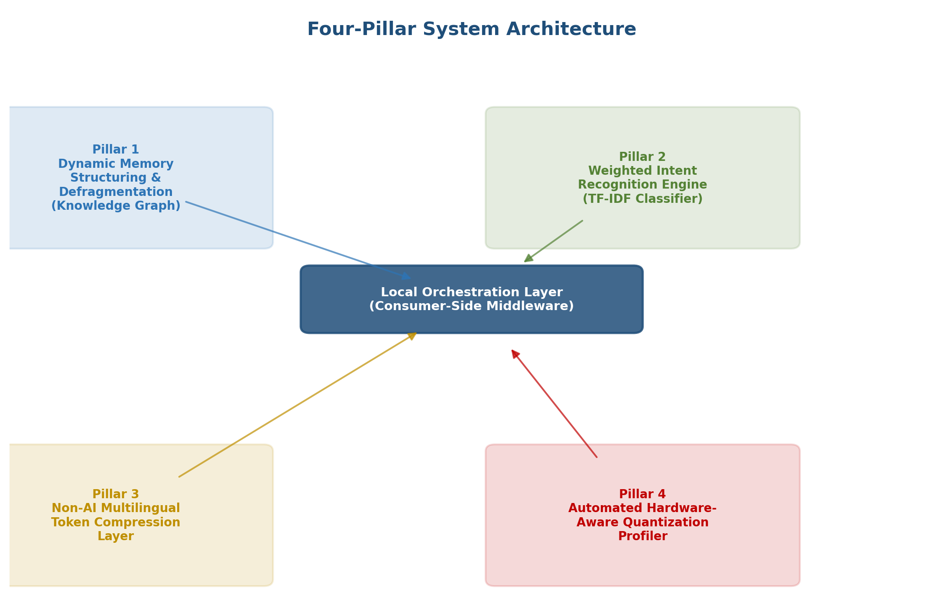
Fig. 2: Four-pillar system architecture coordinated by the local orchestration layer.
Pillar 1: Dynamic Memory Structuring & Defragmentation. The memory architecture is represented as a directed network graph G = (V, E), where V denotes discrete entity nodes (concepts, tools, projects, rules) and E represents typed, weighted relational edges (e.g., depends_on, uses, enforces). During chat sessions, an entity-extraction parser identifies key concepts and updates the local graph store (built using NetworkX / SQLite). Defragmentation heuristics run during write-back to merge duplicate entities, prune stale relationships, and resolve contradictory rules.
Pillar 2: Weighted Intent Recognition Engine. Pillar 2 acts as a gatekeeper using a lightweight rule-based classifier and TF-IDF feature extractor. It evaluates prompt length, syntactic structure, logical keyword density, and programming code blocks. The complexity score determines the depth of subgraph search in Pillar 1 and sets the token budget for Pillar 3, preventing uniform compute waste.
Pillar 3: Non-AI Multilingual Token Compression Layer. Pillar 3 compresses combined context and prompt strings deterministically without secondary neural network calls. It executes pattern-matching regex filters, linguistic stopword removal, and character-encoding normalizations. By targeting non-English tokenization bottlenecks (such as UTF-8 character fragmentation in BPE tokenizers), it achieves high token compression ratios while preserving code syntax and explicit constraints.
Pillar 4: Automated Hardware-Aware Quantization. Pillar 4 profiles host device hardware at startup using system inspection utilities (psutil, torch.cuda, NPU interfaces). It evaluates total RAM, VRAM, memory bandwidth, and SIMD instruction sets, matching device metrics against a quantization matrix to automatically load local edge SLMs (e.g., 4-bit or 8-bit GGUF via llama.cpp) at maximum throughput.

7.3 Tools, Frameworks, and Technologies
Table 2 lists the primary tools, libraries, and frameworks proposed for implementing each pillar.
Module / Pillar | Technologies / Tools Used | Role in Implementation
Pillar 1: Knowledge Graph | Python 3.12, NetworkX, SQLite, GraphRAG | Node-edge memory storage, graph defragmentation, and subgraph traversal.
Pillar 2: Intent Recognition | scikit-learn, Regex, TF-IDF Classifier | Query complexity scoring, compute budgeting, and task routing.
Pillar 3: Token Compression | tiktoken, spaCy, NLTK, Custom Regex | Deterministic stopword removal, token-density optimization, BPE measurement.
Pillar 4: Hardware Quantization | llama.cpp, GGUF formats, psutil, PyTorch | Device hardware profiling, automated GGUF model loading, and local execution.
Table 2: Tools, frameworks, and technologies mapped to each system pillar.

8. Facilities Required
The development, testing, and implementation of the proposed framework require standard computing hardware and open-source software development tools. No specialized or high-cost proprietary facilities are required beyond standard academic computing laboratory infrastructure.

8.1 Hardware Requirements
- Host Processor: Standard x86_64 CPU (Intel Core i5/i7 10th Gen or AMD Ryzen 5/7) or Apple Silicon (M1/M2/M3).
- System RAM: Minimum 16 GB DDR4/DDR5 RAM for running embedded local graph stores and 4-bit quantized SLMs.
- Accelerator (Optional): NVIDIA GPU with 6GB+ VRAM (CUDA support) or Apple Integrated Neural Engine / Unified Memory for Pillar 4 acceleration.
- Storage: 20 GB free Solid State Drive (SSD) space for housing model weights (GGUF format) and local SQLite graph files.

8.2 Software Requirements
- Operating System: Cross-platform compatibility across Linux (Ubuntu 22.04 LTS), macOS, or Microsoft Windows 11.
- Programming Environment: Python 3.12, VS Code IDE, and Git version control system.
- Open-Source Libraries: NetworkX, SQLite3, tiktoken, scikit-learn, spaCy, llama-cpp-python, psutil.
- Cloud API Access (for Benchmarking): Standard OpenAI / Anthropic API keys for measuring token consumption and latency reduction against upstream endpoints.

9. Timeline
The proposed Minor Project is planned for completion within a single academic semester (approximately 14 weeks). The work is divided into eight sequential phases aligned with the four technical pillars and the final evaluation stage, as summarized in Table 3.
Phase | Activity | Duration (Weeks)
1 | Requirement finalization and detailed literature review | Week 1 – 2
2 | Design and development of Pillar 1: Knowledge graph memory store | Week 3 – 5
3 | Design and development of Pillar 2: Weighted intent recognition engine | Week 5 – 6
4 | Design and development of Pillar 3: Non-AI token compression layer | Week 6 – 8
5 | Design and development of Pillar 4: Hardware-aware quantization profiler | Week 8 – 10
6 | Integration of all four pillars into the local orchestration layer | Week 10 – 11
7 | System testing, benchmarking, and performance evaluation | Week 11 – 13
8 | Documentation, report preparation, and final presentation | Week 13 – 14
Table 3: Proposed project timeline and phase-wise activity schedule.

References
[1] Edge, D., et al. (2024). From Local to Global: A GraphRAG Approach to Query-Focused Summarization. arXiv preprint arXiv:2404.16130.
[2] Lewis, P., et al. (2020). Retrieval-Augmented Generation for Knowledge-Intensive NLP Tasks. Advances in Neural Information Processing Systems (NeurIPS), 33, 9459–9474.
[3] Frantar, E., et al. (2023). GPTQ: Accurate Post-Training Quantization for Generative Pre-trained Transformers. International Conference on Learning Representations (ICLR).
[4] Dettmers, T., et al. (2022). QLoRA: Efficient Finetuning of Quantized LLMs. arXiv preprint arXiv:2305.14314.
[5] Vaswani, A., et al. (2017). Attention Is All You Need. Advances in Neural Information Processing Systems (NeurIPS), 30.
[6] OpenAI (2023). GPT-4 Technical Report. arXiv preprint arXiv:2303.08774.
[7] Gerganov, G. (2023). llama.cpp: Port of Facebook's LLaMA model in C/C++. GitHub Repository.
[8] Radford, A., et al. (2019). Language Models are Unsupervised Multitask Learners. OpenAI Blog.

