**Abstract:**

The smARTdraw application true to its name is developed as a digital equivalent of a real time slate. SmARTdraw is an Android Application that implements an intelligent canvas interface that aids learning of alphabets etc. It has 2 parts, one emulating the slate and the second a user-friendly way of drawing UML diagrams. It aims to replace the handheld slate and chalk. The application caters to all age groups.

**The SLATE:**

Apart from the standard drawing and erasing, the user can make use of the additional functionalities provided. Features include changing the color, size of the brush, changing the color of the background, adding text, addition of dynamic pages et al. It also gives the user freedom to save and share what has been drawn. The image can be converted into a pdf file if required.

**The Unified Modelling Language Diagrams:**

This enables the user to draw UML diagrams with ease. Its functionalities include explicit buttons for each shape (rectangle, line, circle etc.). In addition, they can be saved as images which can be edited, implemented and shared.

The smARTdraw application is developed to make the classrooms more interactive and learning fun. Furthermore, the children can take this knowledge home and share it with their parents, educating them in the process. It aims at empowering every household in rural India with education through the Aakash Tablet.

It is an open source application designed with a single purpose – education in a low resource environment.

**Table of Contents:**

1. Introduction :
   1. Purpose
   2. Scope
   3. Intended Audience
   4. Glossary
   5. References
2. Overall Description:

     a. Product Perspective

      b. Product functions

     c. User Characteristics

     d. Constraints

     e. Assumptions and Dependencies

3. Specific Requirements

      3.1 External Interface Requirements

     a. User Interfaces

b. Hardware Interfaces

c. Software Interfaces

3.2 Functional Requirements

1. Slate Draw

2. Slate UML

3.3 Non Functional Requirements

1. Performance Requirements

2. Safety Requirements

3. Security Requirement

4**.** Software Quality Attributes

3.4 Behavioral Requirements

1. Use Case Diagram of the Application

2. Use Case Diagram for Slate

3. Use Case Diagram for UML

4. DFD for the Application

5. DFD for the Slate

6. DFD for the UML

**1. Introduction**

1. a. Purpose:

The smARTdraw application is an Android Application that implements an intelligent canvas interface that aids learning of alphabets etc. Although the primary aim is the emulation of a real slate for children, it can be extended to adults. It is a means of learning and practicing what has been taught by the teachers in school. Children can go home and review their saved work. The UML Diagram part of the application is aimed at creating a user-friendly interface for drawing flowcharts. It is well endowed with features for enabling the same.

1. b. Scope:

The dual feature of this application enables it to be used by children and adults alike. Users can implement both UML diagrams and text to give an elaborate description of any topic. In addition to ease of use, it is eco-friendly and timesaving. It is the only app with dual feature which can be used by all age groups people. With this app a person can even write a book which can be later converted into pdf along with uml diagram explanation. It not only gives comfort but also saves paper.

1. c. Intended audience:

Intended audience of SRS for smARTdraw includes:

Testers: Professionals

Users: Students, Professors

1. d. Glossary:

|  |  |
| --- | --- |
| Term | Definition |
| Android | Linux based operating system |
| Android Canvas | A drawing surface that handles compositing of the actual bits against a Bitmap or Surface object. |
| Software Requirements Specification | A document that completely describes all of the functions of a proposed system and the constraints under which it must operate. For example, this document. |
| Unified Modelling Language(UML) | Programming Language used for object oriented software development |
| UML Diagram | It is a partial graphical representation (view) of a model of a system under design, implementation, or already in existence. |
| Android 2D | The Android framework APIs provides a set 2D drawing APIs that allow you to render your own custom graphics onto a canvas or to modify existing Views to customize their look and feel |

1. e. References:

* developer.android.com
* IEEE STD 830-1998. (Revision of. IEEE STD 830-1993). IEEE Recommended Practice for Software Requirements.

**2. Overall Description:**

2. a. Product Perspective:

This product is developed on the lines of pre-existing applications (not open source) that provide the functionality of drawing. Furthermore, the feature of drawing UML diagrams has been inculcated.

2. b. Product Functions:

The smARTdraw contains both SLATE and UML. However, they cannot be used concurrently. The application output is primarily for the Aakash tablet but can be downloaded onto any Android device.

2. c. User Characteristics:

The intended users will be children (ages 5-15) and Professors. Users are not expected to have a very high level of technical expertise to use the application .Although; prior knowledge about the UML Diagrams will prove to be beneficent.

2. d. Constraints:

The user will not be able to run both parts of the application simultaneously. The product is developed only for devices that support Android and cannot be used on any other platform.

2. e. Assumptions and Dependencies:

There are several assumptions at the time of this document’s drafting that are still being explored. We have assumed that user interaction with the application will only be through touch. The application will be available only to devices that run on Android operating system.

**3. Specific Requirements:**

**3.1. External Interface Requirements:**

The application is intended to be a stand-alone, single-user system. The application will run on any Android mobile device or an Android emulator. No further hardware devices or interfaces will be required.

**3. 1.a. User Interfaces:**

* Inputs:

The user select from number of available options.

* Outputs:

The application responds to the input by displaying the request in the screen.

* Operating Systems :

Android

* There will be a ‘front page’ where three buttons will be displayed. On selecting:

**Slate Button**: SLATE application will be launched.

**UML Button**: UML application will be launched.

**Exit Button:** Application is closed.

**3.1. b. Hardware Interfaces:**

* Any android operating system supported device.
* micro SD-Card to view the lecture video

**3.1. c. Software Interfaces:**

* Eclipse IDE shall be used as development environment for implementing the modules
* Designing of modules and diagrams is done in UML using MS word and Rational Rose

**3.2. Functional requirements**

**3.2.1 Slate draw**

**3.2.2 Slate uml**

**Slate draw**

3.2.1.1. Select brush and draw:

The user can choose the color of the brush and draw, paint or write with flexibility over screen usage.

3.2.1.2. Erase:

The user will have the ability to redraw the figure or alter it by using the eraser. Further, the size of the eraser can be adjusted as per the user’s whim.

3.2.1.3. Save:

The user can save his figure in the .png format.

3.2.1.4. Conversion to pdf:

The app. will have an extended feature of converting the .png file to .pdf file for using it over higher platforms.

3.2.1.5. Dynamic Pages:

The app. allow user to add any no. of pages and even they can remove if it’s not in use.

**Slate uml**

3.2.2.1 Select shape:

The user will have the ability to choose from a number of shapes like Circle, Rectangle, Ellipse, and Line to be used for drawing the uml diagram.

3.2.2.2 Drag and Drop shape:

The shape can be dragged and dropped to any part of the screen.

3.2.2.3 Text Settings:

The user can write text/instructions inside the uml diagrams. The text can be edited and the text color can be changed.

3.2.2.4 Refresh Option:

The refresh option is incorporated enabling the user to start from scratch.

**3.3Non-functional requirements**

**3.3.1Performance Requirements:**

The application will need to provide a responsive interface. There should be minimal delay in retrieving any content or associated detail.

3.3.1.1. Maintainability: Software needs to be upgraded if required in future.

3.3.1.2. Reliability: System must be reliable and data should persist even after suffering some system crashes or booting of some Android devices

**3.3.2 Safety Requirements**

There is no safety requirements associated with this application.

**3.3.3 Security Requirements**

There is no security requirements associated with this application.

**3.3.4 Software Quality Attributes**

The software is planned to be robust and complete, in order to attract new users,while also providing a usable interface that is clutter free and easy to use.

**3.4.Behavioral Requirements**

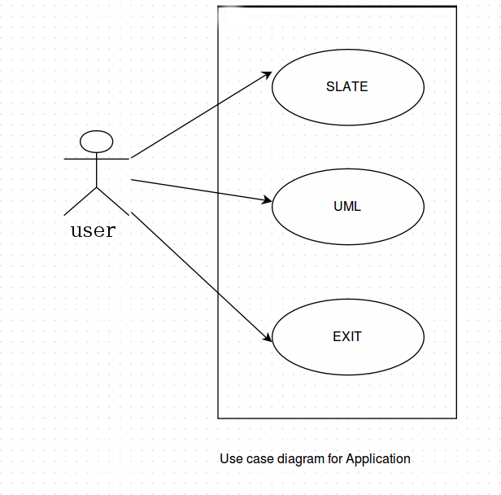

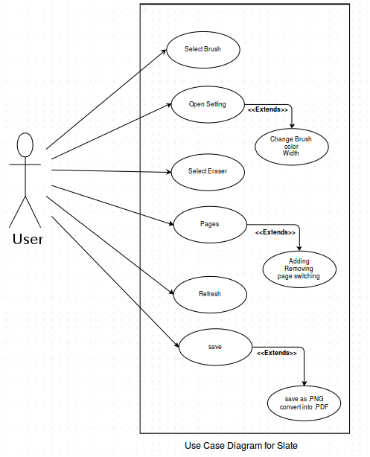

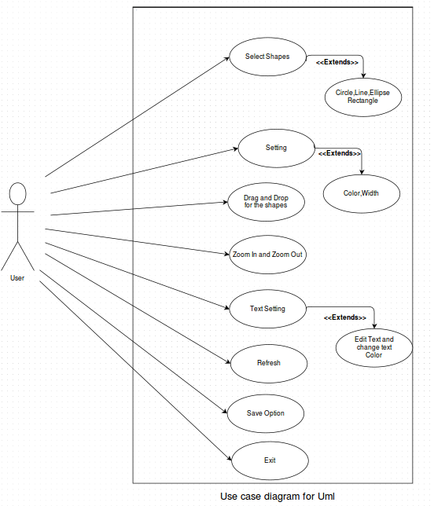

**DATA FLOW DIAGRAMS**

**DFD for Main App**

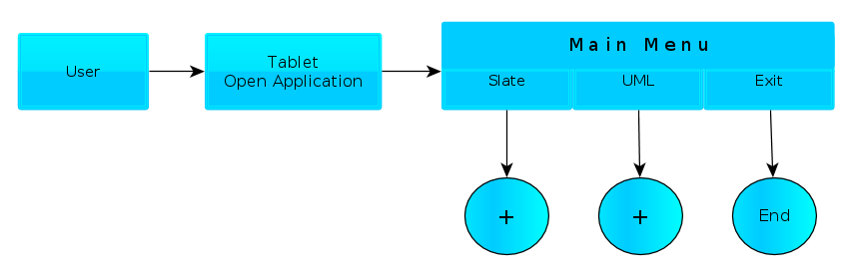

**DFD for Slate App**

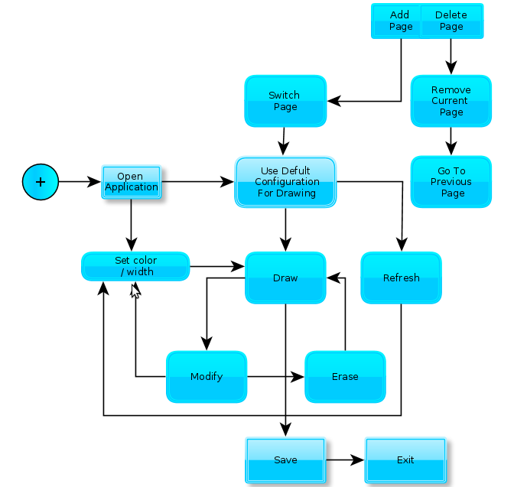

**DFD of UML application**

