Predicting Clicks Using Maching Learniing

Katie Wallis, Philip Fang, Aman Jiddewar & Alex Su

**­­­**

**Data Understanding & Data Cleaning**

For this project, we were tasked with predicting whether a customer would click on a given ad. Looking at the original data, we had 32 million instances consisting of 24 variables designating various categories. The number of instances is too large for data cleaning, therefore we randomly sampled 100,000 so that they represent all of the categories while not bringing too much burden to run. Some of the 24 variables were simply identifiers for the data. As a result, we removed any attribute that had ended in “_ip” or “_id” because these attributes wouldn’t provide our model with information. After removing these variables, we were left with 18 variables that primarily corresponded to anonymized categories. Because of the categorical nature of the variables, the data attributes needed to be transformed into dummy variables by factoring them, which lead to n-1 new binary variables. Because the categories were anonymized, it was difficult to bring in any business domain knowledge to our understanding of the categories. To better understand them, we decided to analyze how each category’s “Click through Rate”, meaning the percentage of time an ad was clicked on. From this we found that overall, the ads had a click through rate of 0.168 for the sample, but some categories’ click through rates varied significantly. We then ranked each category by their perspective frequency and used the average click through rate of 0.168 as a cutoff. Categories with click through rates below the cutoff would be combined into one category called “other” while categories with higher frequencies and representative CTR were kept in the data. Finally, we removed a few of the variables where the “other” category held a large portion of the variable.

**Model Building**

Ultimately, we created three predicative models to solve the challenge: a classification tree, a random forest and lasso regression. To build and optimize models, we knew we would need a validation dataset, which would give us an estimate of performance as we tuned our model. We created this validation set by withholding a small portion of the training dataset each time the model was fit. After each model was fit, we used this validation data to choose between models and to select different tuning parameters such as tree depth for our Classification Tree and alpha in our regression models. Before we could start building and fitting the models, we needed to make sure that the dummy variables (described above) were consistent across the training and validation data. The file titled “Matching Levels” fixes this problem by creating a “factor list” that contains all the variables present in the training data and compares the variables in the validation data to that list. If a variable exists in the validation data that does not exist in the training data, that variable is treated as an NA in the algorithm. This process is also repeated again at the end for the final test data once the best model is chosen.

**Lasso Regression**

Lasso Regression is a type of classifier that combines a classic regression function with the L1 penalty which penalizes a function using the absolute value of the length of the coefficients. In so doing, Lasso Regression performs regularization, which combats the common problem of overfitting in models by penalizing more complex models. Because this type of regression uses the L1 penalty as opposed to the L2 penalty which is used in ridge regression, the penalty function actually performs feature selection as some coefficients are set to 0. The degree to which the model is penalized for being complex is determined by the parameter alpha. For this model, we needed to determine what value of alpha would lead to the best model. To do this, we created a grid of possible alpha values in r and comparing the results of each alpha value on the held out validation data. Through this process, we ultimately decided on an alpha value of XXXXXXX which we found to best balance the model in terms of complexity and accuracy.

**Decision Tree**

The next model we tried was a decision tree. The decision tree classifier works by creating a set of “And” rules that split the data into more pure subsets. The goal of the decision tree to take each instance down a path that follows these rules until it gets to a place where all of the instances that follow that path are of the same classification. This classifier is very effective and easy to understand and implement. Just as the L1 penalty was needed in Lasso Regression to prevent a model from becoming overly complex, decision trees have the option of doing pre or post pruning to combat overfitting. For instance, with pre-pruning, the model can stop splitting into smaller subsets if the information gain of that split isn’t enough or if there aren’t enough nodes in the resulting subsets. For post-pruning, the model may be cut back to a certain depth. This pruning is extremely important. Without pruning, a decision tree would grow to be very deep, complex and overfit to such an extent that subsets could be created for a single instance. That level of complexity would be picking up on noise in the data and wouldn’t be indicative of overarching patterns in the data.

We created our model using the rpart function, which is a part of the rpart package. This function allows us to make a decision tree with certain set parameters. You can see in the code, we created a very large decision tree and set parameters with the rpart.control function. Once we had created a large complex tree, we used the prune function (which is also a part of the rpart library) to prune the tree in a way that optimizing model performance on the out of sample validation data. Below in the graph, you can see the relationship between the models performance and the size of the tree. At first when the model is very simple, adding more complexity to the model is beneficial as it allows the model to pick up on patterns in the data. However, you can see at a certain point, higher complexities lead to much worse performance as the model becomes overfit and picks up on noise within the training data. The sweet spot comes at the minimum of this graph where complexity of patterns being discovered is balanced with the problems of overfitting.

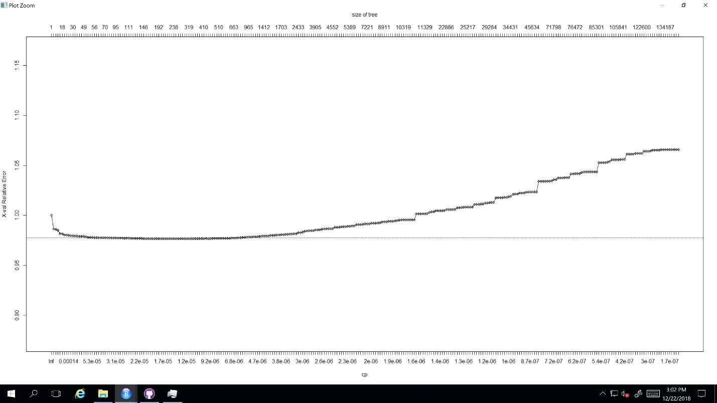

**Random Forests**

Two random forest models were built to predict whether someone had clicked on an ad—One with bagging and one without. Random forests are ensemble methods of decision trees. Because they include many trees within them, they tend to be more robust. Random Forests work by having many different decision trees that all vote for their predicted classification. Ultimately, the classification with the most votes from the decision trees becomes the prediction of the random forest. To force the decision trees to differ from one another, random subsets of the attributes are considered at each split rather than having all of the attributes be considered each time. Because different attributes are being considered each time, the trees within the forest are forced to go down different paths through the data. Additionally, “bagging” also known as Bootstrap Aggregating can be used. In Bootstrap aggregating, data from the training dataset are sampled with replacement to create a new dataset that is the same size as the original but that may have duplicates. Different bootstrapped samples can be used for different trees, causing the trees to differ more. Because there are many models within the Random Forest, Random Forest models tend to be more robust and accurate. The prediction isn’t determined just by one model, so the models are less prone to overfitting and anomalies in the data.

In our code, we ran the random forests using the random forest function from the random forest library. With this function, we were able to specify that 500 decision trees would be created. A second parameter, mtry, was also specified. mtry determines the number of randomly selected attributes will be used at each split. For our trees, we removed 4 attributes randomly when determining which attribute to split on.

**Model Selection**

As with all machine learning problems, we evaluated the performance of our model on hold-out samples. In this case, when we are trying to compare models we used the validation data. Accuracy does not tell the whole story as a metric. Instead to determine which model was best, we looked at both Log Likelihood values and ROC curves.

|  |  |  |  |
| --- | --- | --- | --- |
| **Model** | **Log Likelihood** | **AUC** | **Parameters** |
| Decision Tree (using rpart)(Full train data rows) | 0.402 | 0.726 | minsplit = 1, minbucket = 1, cp = 0, usesurrogate = 0,  folds of cross validation = 5 |
| Logistic Regression |  |  | Alpha = |
| Decision Tree (using rpart)(100000 rows) | 0.414 | 0.675 | minsplit = 1, minbucket = 1, cp = 0, usesurrogate = 0,  folds of validation = 5 |
| Random Forests with Bagging(100000 rows) | 0.411 | 0.681 | Mtry = 22  Ntree= 500 |
| Random Forests without Bagging(100000 rows) | 0.412 | 0.684 | Mtry = 5  Ntree = 500 |

Ultimately, it was decided that the Decision Tree using rpart was the best model to use with an AUC of 0.726 and a Log Likelihood value of 402. (Please see ROC curves of the models in the appendix.) While typically Random forests are safer, more robust models, in this case they became too computationally expensive given the number of rows in the dataset. Each time we ran the random forest model with the full dataset, it gave us error of “cannot create vector of size 12GB”. The results of decision tree using rpart were not far from random forest as shown in above table. Hence we used decision tree and pruned the tree for CP 5.78265e-07, which had least error on validation set for 5 folds cross validation.

**Future Analysis**

Our Decision Tree model worked well for the data, but there are some concerns about how well the model is compared to ensemble methods which tend to be safer. Had we had more time and more computational power, we would have looked more into the random forests and would have considered building an ensemble model between the decision tree and lasso regression. Furthermore, we would want to explore neuro networks further. We did attempt to run a neuro network for this dataset, but struggled to get it to work with such a large dataset.

**Appendix**

**ROC Curves**

**Project Overview**

First_File_To_Run.R

This file contains code that will store data files and code files location into variables that will be used in remaining files to set the working directories.

Load_Data.R

This file contains code that will load and sample the training data, split that dataset into training and validation datasets.(70%, 30%)

ROCPlot.R

This file contains code for creating ROCPlots.

Execution_Sequence.R

This file runs all the code till testing models and selecting one.

Shrink_Categories_and_Factor.R

This file will shrink the number of categories to max categories allowed in one variable(max categories is 50 in our project)

transform_time_variables.R

This file transforms the time varible 'hour' in our project. We have split it in is_week_day and hour of the day variable.

Matching Levels.R

This file contains sample code for matching the levels in training and test data.

Final_Load_Data.R

This file runs all the code for selected model to run on testdata and writes the probabilities and classes to csv files

Lasso Regression.R

This file contains all the code for running lasso regression.

transform_time_variables.R(Incomplete code)

We tried to use H2O framework for performance tuning but could not get it running.